Case #1 – for 1st year students
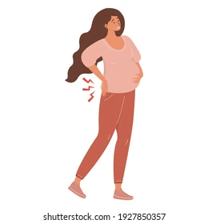
History:
34 y.o. female with complaints of LBP, worse recently after giving birth.
PMHx: depression, anxiety, prev. L ACL reconstruction
PAIN: across low back
3/10 now, 6/10 worst, 1/10 best
AGGS: sitting for long periods, driving, picking things up from ground, lifting new born from crib
EASES: lying down, sometimes walking

Additional Questions to ask pt

Differential Dx List

Objective Exam Planned MUST Include

Possible Interventions

Case #1 – FOR TA’s
Additional info for TA’s:
Nature: achy, dull
Irritability: pain will linger for about an hour when it gets really bad
Social Hx: lives with partner, newborn, 2 dogs in a 2-story town house with stairs to enter and within the home; works as interior designer
Previous PA: triathlete but only walked during pregnancy because she wasn’t sure if it was safe for the baby during pregnancy
Birth Hx: first birth, c-section, hasn’t noticed a change in B/B, no complications, current breastfeeding infant and is thinking about switching to formula
History:
34 y.o. female with complaints of LBP, worse recently after giving birth.
PMHx: depression, anxiety, prev. L ACL reconstruction
PAIN: across low back
3/10 now, 6/10 worst, 1/10 best
AGGS: sitting for long periods, driving, picking things up from ground, lifting new born from crib
EASES: lying down, sometimes walking

Additional Questions to ask pt | Did you have a vaginal delivery or c-section? Were there any complications with the birth? Is this your first birth? Are you experiencing urinary or fecal incontinence? Postpartum mood? Breastfeeding positions? Lactation status? Physical activity level before pregnancy and during pregnancy?
Differential Dx List | Pregnancy-related LBP; SIJ; referred pain from hip; pelvic girdle pain
Objective Exam Planned MUST Include | Vitals; A/PROM (back, hip, SIJ); observation/posture assessment  Neuro Exam  Strength  Balance  Gait  Special Tests
Possible Interventions | Lifting Mechanics  Postural education  Core Stabilization  LE Strengthening

