Play More Community Program
- Background
Cerebral Palsy (CP) is a neurodevelopmental disorder that is termed “the most common physical disability in childhood”.^{3,4} Many individuals with CP demonstrate abnormalities in movement and motor skills.³ Further complications in children with CP include seizure disorders, spinal deformities, OA, delayed growth and development, impaired vision and hearing, speech language disorders, learning difficulties, contractures, and many more.⁵ CP is often diagnosed between 5-24 months of age and is prevalent throughout the lifetime, as it is attributed to injury of the developing brain.^{3,4}
There is a need for increased exercise in this population from childhood through adulthood in order to decrease the risk factors of secondary impairments and comorbidities.¹ By creating a community program that utilizes the social cognitive theory, effective interventions, and appropriate measures to assess change, a positive impact on physical function and quality of life will ensue. A systematic review and meta-analysis by Liang et al. suggests that exercise interventions in patients with CP have beneficial effects on gait speed and muscle strength.⁷ Literature supports exercises such as hippotherapy and constraint induced movement therapy (CIMT) due to the potential to improve posture, hand and UE function, bimanual skills, gait, and overall quality of life in children with CP.^{8,9,12,13}
Hippotherapy has many benefits to physical function in children with CP, but it also contributes to cognition, quality of life, and mental health. The multi-directional movement of the horse provides a graded motor and sensory input which can be utilized in balance and postural control, gait training, strengthening, and increasing range of motion in children with CP.¹⁸ Several studies have demonstrated improved gross motor skills, functional activities, and postural control of the head, trunk, and upper extremities.^{15,19} It has also been shown that the body function, activity, and participation domains of the ICF model were improved through hippotherapy secondary to improved neuromusculoskeletal and movement related functions.¹⁴ The improved balance, strength, and motor function gained from this intervention carryover into improved participation in many other physical activities.
Two recent studies looked at the impact of hippotherapy on quality of life in children with CP.^{8,9} Deutz et al. suggests that hippotherapy not only improves upright posture and gait in children with CP, but it also improves overall quality of life.⁹ Ahn et al. supports this statement suggesting that hippotherapy demonstrates positive effects on attention and quality of life in this population.⁹ Improvement in the numerous physical and psychological functions associated with hippotherapy lead to increased activity tolerance and involvement in real world situations.^{14,19} Hippotherapy has been shown to have more significant and long-lasting effects for children with GMFCS levels I-III compared to those at levels IV and V.^{14,15} Literature suggests the utilization of hippotherapy for 30 minutes 2x per week for 12 consecutive weeks in children with GMFCS levels I-III in order to maximize functional performance and independence.^{14,15,18,19} The program will include 2 hippotherapy sessions/week with a horse handler leading the horse and a trained physical therapist holding the child’s pelvis and providing support as needed. Each session will include a 5-minute warm up and cool down with 10 minutes walking in a clockwise direction and 10 minutes walking in a counter-clockwise direction. When time allows, barn activities will also take place during these sessions including horse grooming, barn chores, and social interaction with other children while preparing for their hippotherapy session.
CIMT is another intervention proven to be beneficial in improving upper limb function, bimanual hand-use and overall activity and participation in this population.^{16,17} CIMT works by immobilizing the less involved limb in order to promote use of the impaired extremity. This intervention has been most widely used in stroke and CP patients and is thought to improve motor functioning through neurological function and angiogenesis for functional reconstruction.²⁰ A benefit of utilizing this intervention in children with CP is the ability to modify the task to engage and motivate the child based on their interests. CIMT will be performed for 2 hours 6 days/week in this community program over a 6-week period to demonstrate improved limb function for over 1 year.²⁰ Each child will complete a one-hour session with a trained physical therapist and will receive a home-exercise program with 1-hour of CIMT activities to be completed with the caregiver. A custom-made glove or cast will be worn on the less affected upper extremity while performing unimanual activities with the more affected hand.
Through the utilization of CIMT, there is an increase in use of the affected arm during activities of daily living (ADL) which further leads to increased participation and activity tolerance.²¹ By allowing increased participation in simple ADL functions such as eating, dressing, playing, etc. children with CP will be more likely to explore and be engaged with their environment. For example, CIMT has demonstrated improvement in reaching, grasping, and manipulating objects in children aged 2-8 years old with a diagnosis of CP.²² The improvement in these motor skills will increase the child’s likelihood to participate in other physical activities such as playing on the playground with peers. Although there is not a direct link between the use of CIMT and improved activity tolerance, there is certainly an indirect link between the two.
The compliance and engagement in many interventions can be especially challenging when working with the pediatric population. Many health behavior theories such as the social cognitive theory can assist in measuring initial adherence and assessing progress in this population. This theory utilizes facilitators and barriers to motivation based on three different stages: pre-intention, intention, and action.¹⁴ This allows providers to assess the stage of change within both the child and caregiver to create treatment programs based on adherence and motivation.¹⁴ The social cognitive theory also demonstrates the importance of parental and peer support in children with CP as their behaviors are often influenced by these individuals.¹⁴ The utilization of this theory will assist in determining adherence and motivation, creating relevant interventions, and also educating caregivers on the importance of their active participation in their child’s therapy.
While ensuring a community program incorporates appropriate interventions, it is also vital to track change and progress throughout the program and over the lifetime of this population. There are many outcome measures to assess progress, impairment, and quality of life in children with CP, including the modified Timed Up and Go (mTUG), the Gross Motor Function Measure (GMFM), and Pediatric Quality of Life Inventory (PedsQL). These 3 evidence-based measures are valid and reliable to use in this population and evaluate gross motor skills, activities of daily living, function, quality of life, and participation.^{23,24}
The mTUG is used across many age ranges and diagnoses to test basic functional mobility.²⁴ Evidence suggests that the mTUG can act as a predictor of gross motor function in children with CP and displays excellent reliability and validity in children aged 3-18 years old.²⁴ This outcome measure is simple to administer, does not take a long time to administer, and can be used to observe and assess gait, functional mobility, and monitor change over time in this population. Cutoff scores for risk of balance deficits in young children are: >8.89 seconds for children 3 or younger and >7.51 seconds for 5-year-olds.²⁷ Further research demonstrated an average mTUG score of 4.63 +/- 0.68 seconds in 8-year-old children.²⁸ This study also notes that there is a significant improvement in the speed of the mTUG test as children progress in age.²⁸ There is not a large amount of data on the mTUG but the minimal detectable change for the TUG is 4.9 seconds.³⁶
The GMFM is another excellent measure that is specific to children with CP. It assesses the capacity to perform gross motor functions and evaluate change in this population. This is a time-consuming measure, but the benefits outweigh the costs for the use in a community program. There is a strong correlation between scores on the GMFM and a child’s Gross Motor Function Classification System (GMFCS) score which is the gold standard for classifying children with CP.²⁴ This measure is validated for evaluative purposes and for its ability to detect change.²³ The GMFM will be beneficial in classifying children with CP in order to create and modify an appropriate intervention program. Each item is scored based on the following: 0) does not initiate 1) initiates 2) partially completes 3) completed. The total score also incorporates distance, time, support needed, accuracy, and tasks.²⁹ Reference values are just beginning to be reported for this measure based on age and GMFM-66 score. The averages for children approaching adolescence are as follows: GMFCS level I= 88, GMFCS level II = 70, GMFCS level III = 56, GMFCS level IV = 38, GMFCS level V = 22.^{30,35} There is no minimal detectable change score listed for this measure, but the minimal clinically important differences are as follows: GMFCS level I= 1.7, GMFCS level II = 1.0, GMFCS level III = 0.7.³⁵
Lastly, the PedsQL demonstrates the ability to measure health-related quality of life in children and their parents. This measure is appropriate for children aged 2-18 years old, takes less than 4 minutes to complete, and demonstrates reliability, validity, and responsiveness to clinical change over time.³¹ For children younger than 8 years old, the recommended cutoff scores for using total functioning to identify children with special health care needs were 83 for mild, 79 for moderate, and 77 for major chronic conditions.³² In children 8 years or older, cutoff scores were 78,76, and 70, respectively.³²
By utilizing the above interventions and outcome measures to create a community program, providers will be able to create effective treatment plans and track progress through evidence-based assessments.
II: Program Goals
This community program aims at promoting activity and participation in children with CP and further improving their quality of life. The following goals are created to ensure success in this 6-week program.
- Participants will improve their mTUG score by 4 seconds to demonstrate decreased risk of balance impairments and improved functional abilities by the end of the 6-week community program.^{28,36}
- Participants will score > 78 (≥ 8 years old) or > 83 (< 8 years old) on the PedsQL measure to meet the cutoff score for improved health-related quality of life by the end of the 6-week community program.³²
- Participants will maintain or improve their GMFM score by at least 1.0 and report increased activity and participation in peer activities by the end of the 6-week community program to demonstrate improved functional independence.^{30,35}
- Participants and their caregivers will report compliance with their 1-hour CIMT home exercise program 6 days/week for the entirety of the 6-week Cerebral Palsy community program to demonstrate adherence to the program and autonomy with self-management of exercise.
III: Methods
- Personnel
  - 5 specially trained hippotherapy physical therapists (PT) and 5 specially trained hippotherapy occupational therapists (OT) will be present 2 days/week and will oversee all hippotherapy sessions for the duration of the 6-week program. This will include the actual horseback riding as well as activities in the barn area.
  - 1 pediatric physical therapist and 1 pediatric occupational therapist will oversee the CIMT sessions 6 days/week for the duration of the 6-week program. They will be in charge of providing the in-session therapy, creating the cast/glove, and teaching the caregivers how to perform the at home CIMT.
  - Local pediatric physical therapists will be present at on day 1 and day 42 to provide the mTUG and GMFM to the children involved in the community program.
  - Local volunteers aged 18+ will be recruited through colleges and the horse farm to serve as horse leaders, help with CIMT sessions, and provide assistance with pick-up, drop-off, and lunch time. Each volunteer will be briefed each morning on their role for the day.
  - 1 bus driver will be hired to transport the children and volunteers from Mebane Community Park to the NC Therapeutic Riding Center every Tuesday and Friday following CIMT therapy. If parents would prefer to transfer their child, they are welcome to.
- Location
  - North Carolina Therapeutic Riding Center: Hippotherapy location. Each participant will pay $300 for the entirety of the community program to participate in hippotherapy lessons and barn activities. Financial aid is available through the NC Therapeutic Riding Center if patients need extra financial assistance.
  - Mebane Community Park: Registration, assessment, and CIMT location. There are picnic tables, sand boxes, ADA accessible playground equipment, walking trails, and many other areas that will be utilized during the CIMT and assessment portions of this program.
- Enrollment and Program Schedule
  - Participants will learn of this program through information shared with local pediatric physical therapists, occupational therapists, speech therapists, school systems, and pediatrician offices.
  - Participants will enroll through email or phone call to the program director. A maximum of 10 children aged 5-15, GMFCS level I-III, will be able to participate in this program due to horse and provider availability.
  - Day 1 will be held on June 3rd, 2023 at the Mebane Community Park. This day will include participant check in, a brief group meeting with caregivers, assessments, and a lunch where children and their families, volunteers, and health care professionals may socialize.
  - The schedule will follow below: 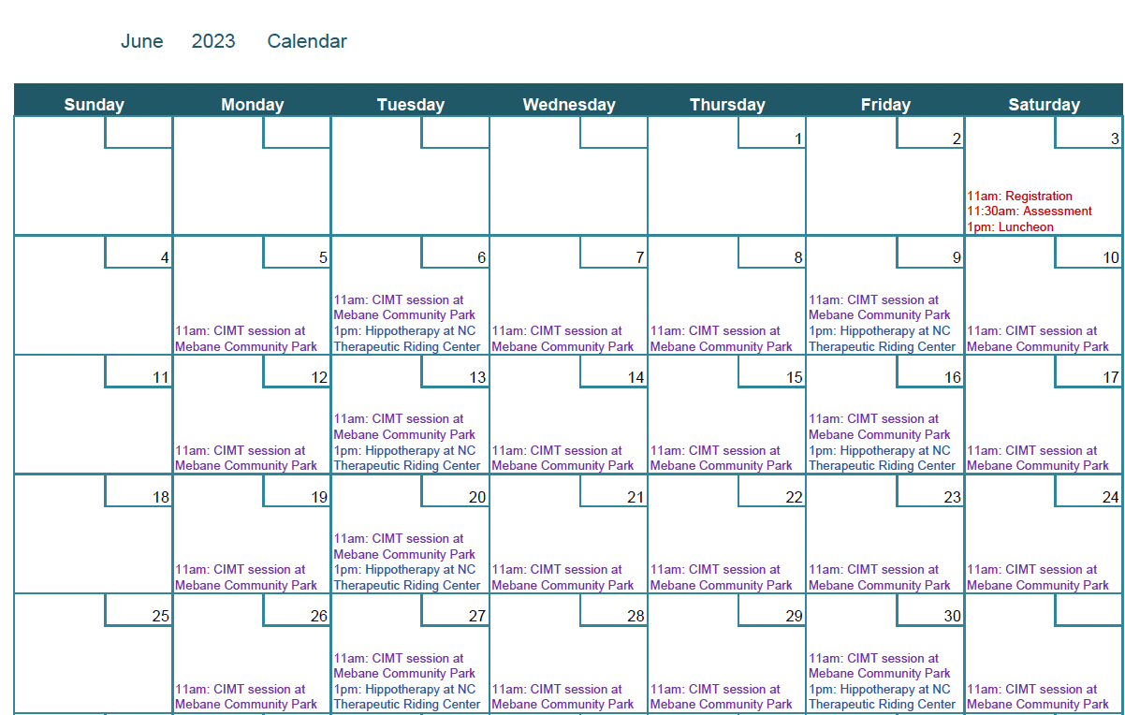
  - 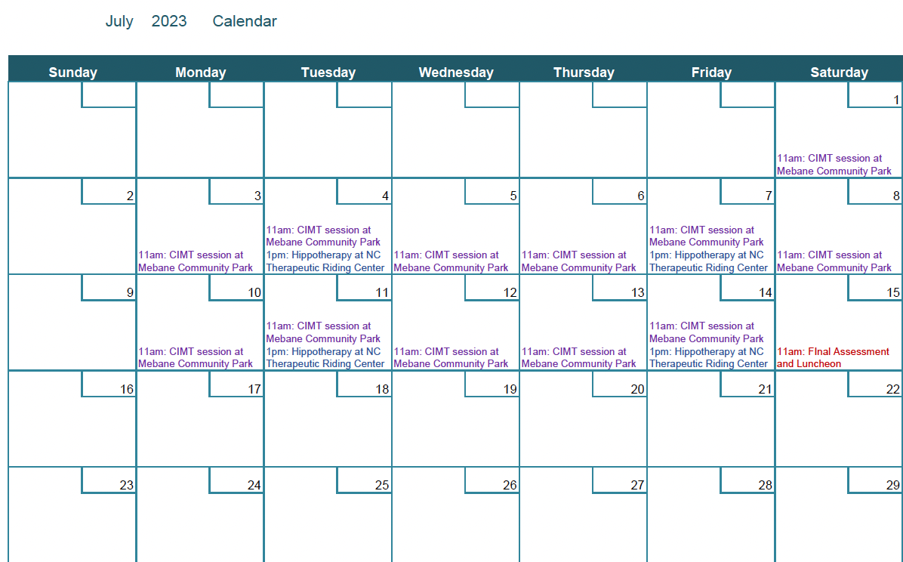
- Intervention Specifics
Participants will be fitted with their glove/cast during day 1 and will be responsible for bringing it to and from each session. Each child will be paired with a volunteer for the entirety of the program that will bring them through each station. While wearing their cast/glove on the less affected arm the child will go through the following stations³⁴, spending 10 minutes at each. A pediatric physical therapist will be present and assisting with instruction and patient/caregiver education.
- Puzzle Station
  - Goal: facilitate motor movements including differing grasps
- Bean Station:
  - Goal: facilitate weight bearing, strength, and sensory integration by having the child seated on knees and searching for toys in a bucket of beans
- Ball Station:
  - Goal: facilitate grasp, throwing, and rolling motion
- Block Station:
  - Goal: facilitate grasp and release
- Bubble Station:
  - Goal: facilitate trunk strengthening and active range of motion by having child reach to pop bubbles in different positions
- Music Station:
  - Goal: facilitate finger isolation utilizing a play piano and play guitar
The CIMT home exercise program will be less structured, and the goals will be explained by the PT on day 1. This will include the child wearing their cast/glove for 1 hour 6 days/week at home while doing any activity including playing, eating, dressing, coloring, etc. that the caregiver and participant decide.
Each Hippotherapy session will begin with 15 minutes of grooming and tacking up the horse. The child may assist for a longer period of time if they arrive to the center early, as volunteers will begin preparing the horses 30 minutes prior to each lesson. Each lesson will begin with a 5-minute warm up of active stretching and postural exercises while seated on the stationary horse. The volunteers will then lead the horses around the ring for 10 minutes in a clockwise direction and 10 minutes in a counterclockwise direction while the PT’s and OT’s give instruction and provide support where needed. To end each session there will be a 5-minute cool-down and 15 minutes spent doing team building through barn chores following each lesson.
Participants will be expected to attend each session or communicate with the program instructor if they will be absent. Caregivers will be responsible for providing transportation to and from the program but are not responsible for transporting children between activities. Caregivers are also responsible for ensuring compliance with the CIMT home program.
Assessments including the mTUG, GMFM, and PedsQL will be performed at the beginning and end of the community program and administered by trained physical therapists with assistance from volunteers. The mTUG requires 2, 27 cm tall chairs with no arm rests placed 3.38 m apart facing each other, a Duplo brick, measuring tape, and a stopwatch.²⁷ The GMFM takes 45 minutes to administer, and requires stairs, 4.5 m of open space, and a stopwatch.²⁹ All that is required for the PedsQL is the score sheet and a pen for each child and this measure should take approximately 4 minutes.³¹
IV: Program Evaluation
It is imperative to evaluate the success of this program and our participants. Assessments of participants utilizing the mTUG, GMFM, and PedsQL will take place on the first and last day of the program. Due to the program being relatively short (6-weeks), the patients will be assessed only 2 times to determine how much improvement has been made during the program and to determine success with program goals. Physical therapists will be looking for a minimal change of 4.9 seconds on the mTUG based on evidence for the suggested minimal detectable change of this measure.³⁶ Scores for GMFCS level I, II, and III should also increase by 1.7, 1.0, and 0.7, respectively, to demonstrate minimal clinically important difference.³⁵ There is not enough literature surrounding the PedsQL to determine the level of change needed, but the program is aiming for a 5 point increase in score, or age-appropriate cut-off scores stated in the literature for this assessment. A brief social cognitive theory (SCT) questionnaire will also be provided to the participants and their caretakers at the beginning and end of the program. This questionnaire will include topics on self-efficacy, intention, situation, social support, and behavioral strategies. The results of this will provide insight on relationship between SCT stage and success in the program as well as any change in stage seen throughout the program.
Satisfaction and suggestion surveys will also be completed by the staff and participants at the end of the 6-week program. This will allow participants to state what they liked and did not like, how beneficial they felt the program was, and suggestions for the future. Staff and volunteers will also complete a survey providing feedback on their satisfaction with the program, if they felt the hours and workload were feasible, if they saw improvement in the children, and suggestions for change in the program.
Lastly, the children will have an attendance sheet that the caretaker is in charge of filling out to track participation in the program. This sheet will also have a place for the caretaker to briefly explain what kind of CIMT exercise was done in the home and for how long.
This cumulative assessment information will be used to determine if participation increased function and quality of life in this population and how to adjust the program in the future to be successful.
V: Conclusion
The Play More Community Program provides evidence-based interventions designed to improve play, function, participation, and quality of life in children with CP. Evidence has demonstrated changes for up to 1-year with similar activities²⁰ in this population and we aim to provide the same results for participants. Participation in this program will not only provide patients with improved stability, posture, and strength, it will also increase the quality of life due to the enjoyment of the interventions and increased peer-related activity participation. Play More allows participants to interact with children of similar diagnoses and impairments while utilizing evidence-based interventions to make great strides in therapy. Evidence-based assessments will also be used to show the participants, caregivers, and therapists how much improvement was made over the 6-week program. Overall, this program aims at improving posture, balance, strength, UE use, activity, participation, and quality of life in children with Cerebral Palsy through evidence based interventions such as CIMT and Hippotherapy.
Resources:
- Verschuren O, Peterson MD, Balemans AC, Hurvitz EA. Exercise and physical activity recommendations for people with cerebral palsy. Dev Med Child Neurol. 2016;58(8):798-808. doi:10.1111/dmcn.13053
- McCoy SW, Palisano R, Avery L, et al. Physical, occupational, and speech therapy for children with cerebral palsy. Dev Med Child Neurol. 2020;62(1):140-146. doi:10.1111/dmcn.14325
- Gulati S, Sondhi V. Cerebral Palsy: An Overview. Indian J Pediatr. 2018;85(11):1006-1016. doi:10.1007/s12098-017-2475-1
- Novak I, Morgan C, Adde L, et al. Early, Accurate Diagnosis and Early Intervention in Cerebral Palsy: Advances in Diagnosis and Treatment [published correction appears in JAMA Pediatr. 2017 Sep 1;171(9):919]. JAMA Pediatr. 2017;171(9):897-907. doi:10.1001/jamapediatrics.2017.1689
- Cerebral Palsy: Hope Through Research | National Institute of Neurological Disorders and Stroke. Accessed August 31, 2022. https://www.ninds.nih.gov/health-information/patient-caregiver-education/hope-through-research/cerebral-palsy-hope-through-research
- Early Detection of Cerebral Palsy | AACPDM - American Academy for Cerebral Palsy and Developmental Medicine. Accessed August 31, 2022. https://www.aacpdm.org/publications/care-pathways/early-detection-of-cerebral-palsy
- Liang X, Tan Z, Yun G, et al. Effectiveness of exercise interventions for children with cerebral palsy: A systematic review and meta-analysis of randomized controlled trials. J Rehabil Med. 2021;53(4):jrm00176. Published 2021 Apr 1. doi:10.2340/16501977-2772
- Ahn B, Joung YS, Kwon JY, et al. Effects of equine-assisted activities on attention and quality of life in children with cerebral palsy in a randomized trial: examining the comorbidity with attention-deficit/hyperactivity disorder. BMC Pediatr. 2021;21(1):135. Published 2021 Mar 19. doi:10.1186/s12887-021-02597-0
- Deutz U, Heussen N, Weigt-Usinger K, et al. Impact of Hippotherapy on Gross Motor Function and Quality of Life in Children with Bilateral Cerebral Palsy: A Randomized Open-Label Crossover Study. Neuropediatrics. 2018;49(3):185-192. doi:10.1055/s-0038-1635121
- Lang, C. P., Boucaut, A., Guppy, M., & Johnston, L. M. (2021). Children with cerebral palsy: A cross-sectional study of their sleep and their caregiver's sleep quality, psychological health and well-being. Child: Care, Health and Development, 47( 6), 859– 868. https://doi.org/10.1111/cch.12897
- Parminder Raina, Maureen O'Donnell, Peter Rosenbaum, Jamie Brehaut, Stephen D. Walter, Dianne Russell, Marilyn Swinton, Bin Zhu, Ellen Wood; The Health and Well-Being of Caregivers of Children With Cerebral Palsy. Pediatrics June 2005; 115 (6): e626–e636. 10.1542/peds.2004-1689
- Jamali AR, Amini M. The Effects of Constraint-Induced Movement Therapy on Functions of Cerebral Palsy Children. Iran J Child Neurol. 2018;12(4):16-27.
- Gelkop N, Burshtein DG, Lahav A, et al. Efficacy of constraint-induced movement therapy and bimanual training in children with hemiplegic cerebral palsy in an educational setting. Phys Occup Ther Pediatr. 2015;35(1):24-39. doi:10.3109/01942638.2014.925027
- Verschuren O, Peterson MD, Balemans AC, Hurvitz EA. Exercise and physical activity recommendations for people with cerebral palsy. Dev Med Child Neurol. 2016;58(8):798-808. doi:10.1111/dmcn.13053
- McCoy SW, Palisano R, Avery L, et al. Physical, occupational, and speech therapy for children with cerebral palsy. Dev Med Child Neurol. 2020;62(1):140-146. doi:10.1111/dmcn.14325
- Gulati S, Sondhi V. Cerebral Palsy: An Overview. Indian J Pediatr. 2018;85(11):1006-1016. doi:10.1007/s12098-017-2475-1
- Novak I, Morgan C, Adde L, et al. Early, Accurate Diagnosis and Early Intervention in Cerebral Palsy: Advances in Diagnosis and Treatment [published correction appears in JAMA Pediatr. 2017 Sep 1;171(9):919]. JAMA Pediatr. 2017;171(9):897-907. doi:10.1001/jamapediatrics.2017.1689
- Koca TT, Ataseven H. What is hippotherapy? The indications and effectiveness of hippotherapy. North Clin Istanb. 2016;2(3):247-252. Published 2016 Jan 15. doi:10.14744/nci.2016.71601
- Park ES, Rha DW, Shin JS, Kim S, Jung S. Effects of hippotherapy on gross motor function and functional performance of children with cerebral palsy. Yonsei Med J. 2014;55(6):1736-1742. doi:10.3349/ymj.2014.55.6.1736
- Wang D, Xiang J, He Y, et al. The Mechanism and Clinical Application of Constraint-Induced Movement Therapy in Stroke Rehabilitation. Front Behav Neurosci. 2022;16:828599. Published 2022 Jun 21. doi:10.3389/fnbeh.2022.828599
- Barzel, A., Ketels, G., Tetzlaff, B. et al. Enhancing activities of daily living of chronic stroke patients in primary health care by modified constraint-induced movement therapy (HOMECIMT): study protocol for a cluster randomized controlled trial. Trials 14, 334 (2013). https://doi.org/10.1186/1745-6215-14-334
- Therapy has long-lasting benefits for children with cerebral palsy | National Institutes of Health (NIH). Accessed November 8, 2022. https://www.nih.gov/news-events/nih-research-matters/therapy-has-long-lasting-benefits-children-cerebral-palsy
- Ketelaar M, Vermeer A, Helders PJ. Functional motor abilities of children with cerebral palsy: a systematic literature review of assessment measures. Clin Rehabil. 1998;12(5):369-380. doi:10.1191/026921598673571117
- Cerebral Palsy Outcome Measures. (2022, February 20). Physiopedia, . Retrieved 15:52, November 8, 2022 from https://www.physio-pedia.com/index.php?title=Cerebral_Palsy_Outcome_Measures&oldid=294579.
- Singh P, Pradhan B. Study to assess the effectiveness of modified constraint-induced movement therapy in stroke subjects: A randomized controlled trial. Ann Indian Acad Neurol. 2013;16(2):180-184. doi:10.4103/0972-2327.112461
- Functional. Motor Assessment. Accessed November 9, 2022. https://www.region10.org/r10website/assets/File/funtmotor.pdf
- Tests & Measures: A Resource for Pediatric Physical Therapy Practitioners / Modified TUG for Preschoolers. Accessed November 20, 2022. https://blogs.elon.edu/ptkids/2017/02/27/modified-tug-for-preschoolers/
- Al-Toaimi NS, Shaheen AAM, Algabbani MF, Gawad RFM. Reference values for the Modified Timed Up and Go Test in Saudi children aged 4-12 years old in Riyadh city: cross-sectional study. Ann Med. 2021;53(1):1905-1913. doi:10.1080/07853890.2021.1986638
- CanChild. Accessed November 20, 2022. https://canchild.ca/en/resources/321-gmfm-scoring
- Hanna SE, Bartlett DJ, Rivard LM, Russell DJ. Reference curves for the Gross Motor Function Measure: percentiles for clinical description and tracking over time among children with cerebral palsy. Phys Ther. 2008;88(5):596-607. doi:10.2522/ptj.20070314
- PedsQL TM (Pediatric Quality of Life Inventory TM). Accessed November 20, 2022. https://www.pedsql.org/about_pedsql.html
- Huang IC, Thompson LA, Chi YY, et al. The linkage between pediatric quality of life and health conditions: establishing clinically meaningful cutoff scores for the PedsQL. Value Health. 2009;12(5):773-781. doi:10.1111/j.1524-4733.2008.00487.x
- NC Therapeutic Riding Center. Accessed November 20, 2022. https://www.nctrcriders.org/
- CIMT Toy/Activity Essentials. Accessed November 20,2022. https://www.scota.net/resources/Documents/CIMT_Toy%20Essentials%20.pdf
- Gross Motor Function Measure- 66 | RehabMeasures Database. Accessed November 27, 2022. https://www.sralab.org/rehabilitation-measures/gross-motor-function-measure-66
- Timed Up and Go| RehabMeasures Database. Accessed November 27, 2022. https://www.sralab.org/rehabilitation-measures/timed-and-go

