Physical Therapy Reference Guide for OA Management:

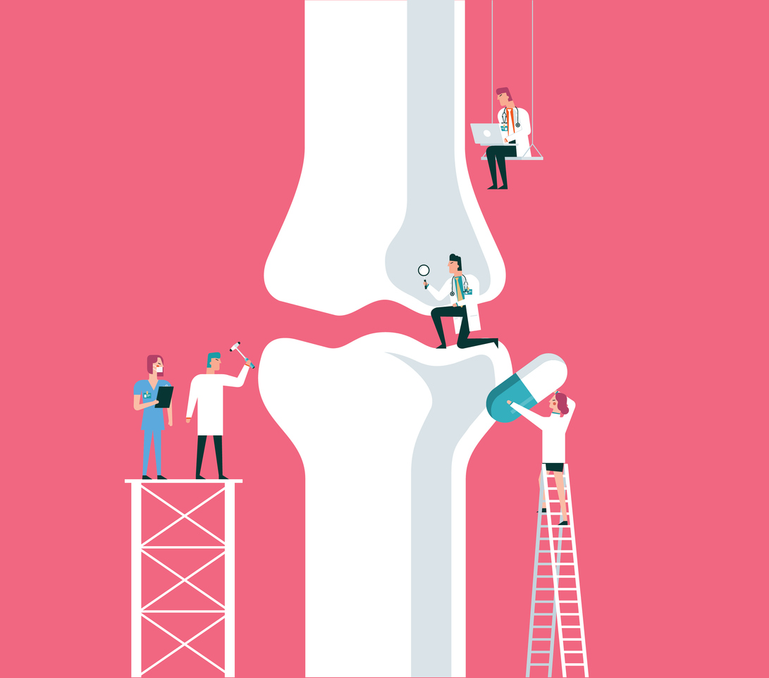

Exercise Recommendations for OA Management:
Exercise can help to reduce stiffness, pain, and disability while improving strength, endurance, quality of life, self-confidence, mental health, physical function, cartilage health, joint protection, and overall comfort.^{1,2}
- General Exercise Recommendations are that individuals participate in 150 minutes every week of moderate intensity physical activity (hard enough so that an individual can talk, but cannot sing during exercise).¹

A typical exercise program for OA management should include:
- A 10-15 minute warm up and 10–15-minute cooldown which can include stretching, aerobic activities like cycling or walking.³
- Strengthening (2x per week progressing to 3x per week with at least 1 day of rest in between).
  - Perform 8-12 repetitions, 2- 3 sets per each exercise.^{4,5}
  - Perform exercises targeting all major muscles - specifically the quadriceps, hamstrings, and hip muscles.⁶⁻⁸
  - Difficulty/intensity should be over 67% of 1 repetition maximum.^{4,5}
  - Rest 30-90s in between sets of exercises for muscle hypertrophy.⁵
  - Each session should take 30-60 minutes each.⁴
  - Include a variety of exercises with a focus on functional activities.⁴
- Aerobic fitness (3x per week)
  - Each session should take at least 30 minutes each time and be at a moderate intensity.⁶
  - Examples of low impact aerobic activities include: aquatic exercise, swimming, cycling, weight lifting, Tai chi, yoga, walking.
- Flexibility (2-3x per week)
  - Static stretching (holding still) is better for knee OA.⁹
  - Perform 3 times for each muscle and hold 45 seconds each just before the point of slight discomfort.
  - Proprioceptive Neuromuscular Facilitation stretching is more effective than static stretching.₉

Other Possible Treatments:
- Weight loss can help reduce joint stress and should be achieved through a combination of both diet and exercise.¹
  - Should aim to reduce body weight by 5% or more for the best outcomes if obese.^{2,11,12}
- Assistive Devices/Bracing can help to improve functional ability and reduce pain.^{2,12}
  - Examples: cane, tibiofemoral bracing.^{1,2,13}
- Self-management programs/coping skills can help improve quality of life.¹¹
  - Examples: healthy sleep routines, stress reduction, activity modifications.
- Tai Chi can help to reduce pain, fatigue, stiffness, risk of falling by improving strength, endurance, ability to breathe, and balance.^{2,6,14}
    - Recommendation: Participate in Sun Style Tai Chi classes that are 1 hour long on 3 days per week.¹⁴
- Shoes/Orthotics may change muscle activation and gait patterns to reduce joint loading.¹⁵
  - Recommendation: Wear shoes with shock absorbing properties or insoles that allow for correct positioning of your foot and lower extremity.¹²
- Heat and/or ice can be used to provide short term pain relief, muscle relaxation, and reduce stiffness or inflammation.^{1,12,16,17}
  - General recommendations (no more than 20 minutes and do not apply directly to skin):
    - Inflammation/swelling - use ice massage or cold pack
    - Stiffness - use heat
    - Pain - use heat or ice - whichever feels best
- Yoga can help to reduce OA symptom flare ups, improve flexibility, balance, strength, pain, functional movements, and both mind and body relaxation.^{1,19}
  - Recommendation: Perform yoga 1-5 times per week for 60-120 minutes per session.²⁰
- Cognitive Behavioral Therapy can help those with widespread pain or depression by improving pain, health related quality of life, mood, and ability to function while reducing fatigue and disability.²¹
- Acupuncture can help to reduce pain.^{1,2}
  - Recommendation: Get acupuncture treatment 2-5 times per week for increased benefits.²²
- Kinesio Taping can help reduce knee pain, stiffness, and the need for medication.^{23,24}
  - Recommendations:
    - Patellofemoral taping may be beneficial for knee OA.^{1,2}
    - Specific Kinesio Taping techniques are more beneficial for reducing knee pain in comparison with nonspecific taping.²³

***There are many other treatment options, however these are the ones with the most evidence to support their use.

Conservative care, like the ones described in this handout, are the recommended forms of treatment that should be tried before invasive procedures. If patients have questions about other forms of care (medicine or surgical), they should contact their physician to determine the best option for them.
References:
- Key priorities for implementation | Osteoarthritis: care and management | Guidance | NICE. Accessed October 10, 2021. https://www.nice.org.uk/guidance/cg177/chapter/Key-priorities-for-implementation
- Kolasinski SL, Neogi T, Hochberg MC, Oatis C, Guyatt G, Block J, Callahan L, Copenhaver C, Dodge C, Felson D, Gellar K, Harvey WF, Hawker G, Herzig E, Kwoh CK, Nelson AE, Samuels J, Scanzello C, White D, Wise B, Altman RD, DiRenzo D, Fontanarosa J, Giradi G, Ishimori M, Misra D, Shah AA, Shmagel AK, Thoma LM, Turgunbaev M, Turner AS, Reston J. 2019 American College of Rheumatology/Arthritis Foundation Guideline for the Management of Osteoarthritis of the Hand, Hip, and Knee. Arthritis Care Res (Hoboken). 2020 Feb;72(2):149-162. doi: 10.1002/acr.24131. Epub 2020 Jan 6. Erratum in: Arthritis Care Res (Hoboken). 2021 May;73(5):764. PMID: 31908149.
- Patient education: Arthritis and exercise (Beyond the Basics) - UpToDate. Accessed February 18, 2022. https://www.uptodate.com/contents/arthritis-and-exercise-beyond-the-basics
- Turner MN, Hernandez DO, Cade W, Emerson CP, Reynolds JM, Best TM. The role of resistance training dosing on pain and physical function in individuals with knee osteoarthritis: A systematic review. Sports Health. 2020;12(2):200-206. doi:10.1177/1941738119887183
- Haff G, Triplett T. Essentials of Strength Training and Conditioning. 4th ed. National Strength and Conditioning Association; 2016.
- Escalante Y, Saavedra JM, García-Hermoso A, Silva AJ, Barbosa TM. Physical exercise and reduction of pain in adults with lower limb osteoarthritis: a systematic review. J Back Musculoskelet Rehabil. 2010;23(4):175-86. doi: 10.3233/BMR-2010-0267. PMID: 21079296.
- Alnahdi AH, Zeni JA, Snyder-Mackler L. Muscle impairments in patients with knee osteoarthritis. Sports Health. 2012 Jul;4(4):284-92.
- Pozzi F, Snyder-Mackler L, Zeni J. Physical exercise after knee arthroplasty: a systematic review of controlled trials. Eur J Phys Rehabil Med. 2013;49(6):877-892.
- Weng MC, Lee CL, Chen CH, et al. Effects of different stretching techniques on the outcomes of isokinetic exercise in patients with knee osteoarthritis. Kaohsiung J Med Sci. 2009;25(6):306-315. doi:10.1016/S1607-551X(09)70521-2
- Stretching and Flexibility Guidelines Update. Accessed November 30, 2021. https://www.acsm.org/all-blog-posts/certification-blog/acsm-certified-blog/2021/03/18/stretching-and-flexibility-guidelines-update
- Bannuru RR, Osani MC, Vaysbrot EE, Arden NK, Bennell K, Bierma-Zeinstra SMA, Kraus VB, Lohmander LS, Abbott JH, Bhandari M, Blanco FJ, Espinosa R, Haugen IK, Lin J, Mandl LA, Moilanen E, Nakamura N, Snyder-Mackler L, Trojian T, Underwood M, McAlindon TE. OARSI guidelines for the non-surgical management of knee, hip, and polyarticular osteoarthritis. Osteoarthritis Cartilage. 2019 Nov;27(11):1578-1589. doi: 10.1016/j.joca.2019.06.011. Epub 2019 Jul 3. PMID: 31278997.
- Key priorities for implementation | Osteoarthritis: care and management | Guidance | NICE. Accessed October 10, 2021. https://www.nice.org.uk/guidance/cg177/chapter/Key-priorities-for-implementation
- Summary of Findings – Tai chi. American College of Rheumatology/Arthritis Foundation. Published online April 5, 2011.
- Song R, Lee E-O, Lam P, Bae S-C. Effects of a Sun-style Tai Chi exercise on arthritic symptoms, motivation and the performance of health behaviors in women with osteoarthritis. Taehan Kanho Hakhoe Chi. 2007;37(2):249-256. doi:10.4040/jkan.2007.37.2.249
- Riskowski J, Dufour AB, Hannan MT. Arthritis, foot pain and shoe wear: current musculoskeletal research on feet. Curr Opin Rheumatol. 2011;23(2):148-155. doi:10.1097/BOR.0b013e3283422cf5
- Kamioka H, Tsutani K, Okuizumi H, et al. Effectiveness of aquatic exercise and balneotherapy: a summary of systematic reviews based on randomized controlled trials of water immersion therapies. J Epidemiol. 2010;20(1):2-12. doi:10.2188/jea.je20090030
- King MR, Haussler KK, Kawcack CE et al. Mechanisms of aquatic therapy and its potential use in managing equine osteoarthritis. Equine Veterinary Education. 2013: 204-209.
- Brosseau L, Yonge KA, Robinson V, et al. Thermotherapy for treatment of osteoarthritis. Cochrane Database Syst Rev. 2003;2003(4):CD004522. doi:10.1002/14651858.CD004522
- Cheung C, Wyman JF, Resnick B, Savik K. Yoga for managing knee osteoarthritis in older women: a pilot randomized controlled trial. BMC Complement Altern Med. 2014;14:160. Published 2014 May 18. doi:10.1186/1472-6882-14-160
- Haaz S, Bartlett SJ. Yoga for arthritis: a scoping review. Rheum Dis Clin North Am. 2011;37(1):33-46. doi:10.1016/j.rdc.2010.11.001
- Cognitive behavioral therapy. September 8, 2016. Accessed March 8, 2022. https://www.ncbi.nlm.nih.gov/books/NBK279297/
- Lin, LL., Tu, JF., Shao, JK. et al. Acupuncture of different treatment frequency in knee osteoarthritis: a protocol for a pilot randomized clinical trial. Trials 20, 423 (2019). https://doi.org/10.1186/s13063-019-3528-8
- Donec V, Kubilius R. The effectiveness of Kinesio Taping® for pain management in knee osteoarthritis: a randomized, double-blind, controlled clinical trial. Ther Adv Musculoskelet Dis. 2019;11:1759720X19869135. Published 2019 Aug 29. doi:10.1177/1759720X19869135
- Melese H, Alamer A, Hailu Temesgen M, Nigussie F. Effectiveness of Kinesio Taping on the Management of Knee Osteoarthritis: A Systematic Review of Randomized Controlled Trials. J Pain Res. 2020;13:1267-1276. Published 2020 May 28. doi:10.2147/JPR.S249567

