SIGNS & SYMPTOMS

Diminished appetite/Weight loss

SOB/Cough w/blood

New wheezing + hoarse voice

Nausea, vomiting, fatigue*

Headaches &confusion*

Suspicious changes in lymph nodes

Frequent respiratory tract infections (bronchitis or pneumonia)

Pain seems out of proportion to injury

Severe pain at night (in hip)

“Sign of the Buttock”

Sharp P! w/WB, Dull Ache w/rest

* Due to Bone Breakdown elevated levels of calcium (hypercalcemia) are found causing sx/sy

BACKGROUND & DESCRIPTION

- Lung adenocarcinoma is a subtype of Non-small cell lung cancer (NSCLC)
- Adenocarcinoma is formed in mucus secreting glands throughout the body and is most prevalent in Lung Cancer
- Usually occur in the periphery and may be found in scars or areas of chronic inflammation
- Staging depends on Tumor, Node and Metastasis, and are designated as either Stage I, II, III or IV(A or B)
- Stage IVB = cancer has metastasized to distant parts of the body outside chest area (ex. Adrenal glands and bones)
- Metastasis from lungs to bone occurs via cancer cells spreading through the blood stream or lymphatics

INCIDENCE & PREVALENCE

- 40% of lung cancer is due to adenocarcinoma
- 2/3 lung cancer diagnoses occur in people over the age of 65
- Mean average diagnosis is 71 yo
- Overall 5 year survival rate is less than 12-15%
- Study by Sugiura et. Al mean survival was 9.7months

The Femur has been reported the most common extra-vertebral site for metastasis in pts w/lung cancer – 12% incidence rate
RISK FACTORS

Hx of smoking, family/personal hx of cancer, mutations of P53 gene, pulmonary conditions, exposure to asbestos/pollutants/radon,

CLINICAL TESTS & SCREENING

Palpation to Hip + surrounding structures
AROM/PROM/MMT to rule in/out MSK condition
Sign of the Buttock
X-ray, MRI, CT, Biopsy, Blood Testing

PT ROLE & TREATMENT

Evaluate: Rule out potential MSK conditions such as Hip OA, fracture and Greater Trochanteric Bursitis

Educate: Pt on concerning sx/sy
Refer: Lung cancer often goes unrecognized until more severe stages becoming a medical emergency

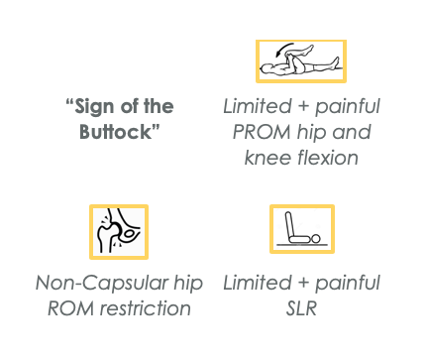

IMMEDIATE REFERRAL

Adenocarcinoma with any sign of metastasis indicates late stage of cancer

Lymph node changes

Unexplained breathing

Worsening of condition disproportionate to activity level

American Cancer Society Cancer Facts & Figures 2008. Atlanta GA: American Cancer Society. 2008:13-15. Available at: http://cancer.org/downloads/STT/2008CAFFfinalsecured.pdf. Accessed February 12, 2020.

Aydinli U, Ozturk C, Bayram S, et al. Evaluation of lung cancer metastases to the spine. Acta Orthop Belg. 2006;72:592-597

Cyriax J. Textbook of Orthopedic Medicine, 8th ed. London, United Kingdom: Bailliere Tindall; 1982:53-57, 375-377.

D’Antonio C, Passaro A, Gori B, et al. Bone and brain metastasis in lung cancer: recent advances in therapeutic strategies. Ther Adv Med Oncol. 2014;6(3):101-114. doi:10.1177/1758834014521110

Goodman CC, Boissonnault WG, Full KS. Pathology: implications for the physical therapist. 2nd ed. Philadelphia, PA: WB Saunders Cp: 2003:607-613, 947.

Goodman CC, Snyder TE. Differential Diagnosis in Physical therapy. 3r ed. Philadelphia, A: WB Saunders Co: 2000:16, 17,26,57,64,161-163,190, 205-212, 215, 239, 336-338, 416-421, 434-469.

Identify Top Lung Cancer Causes & Factors That Put You at Risk | CTCA. https://www.cancercenter.com/cancer-types/lung-cancer/risk-factors. Accessed February 12, 2020.

Lung Cancer Staging | LUNGevity Foundation. https://lungevity.org/for-patients-caregivers/lung-cancer-101/lung-cancer-staging. Accessed February 14, 2020.

Myers DJ, Wallen JM. Cancer, Lung Adenocarcinoma. In: StatPearls. Treasure Island (FL): StatPearls Publishing; 2020.

Signs & Symptoms | LUNGevity Foundation. https://lungevity.org/for-patients-caregivers/lung-cancer-101/signs-symptoms. Accessed February 14, 2020.

Sugiura H, Yamada K, Sugiura T, Hida T, Mitsudomi T. Predictors of survival in patients with bone metastasis of lung cancer. Clin Orthop Relat Res. 2008;466(3):729-736. doi:10.1007/s11999-007-0051-0

