CRITICALLY APPRAISED TOPIC
FOCUSED CLINICAL QUESTION
For the general outpatient physical therapy population (P), how effective is instrument assisted soft tissue massage (I) when compared to traditional manual therapy techniques (C) at reducing pain and improving function and ROM (O) in the upper and lower extremities?

AUTHOR
Prepared by | Rachel LaBella | Date | 11/29
Email address | Rachel_labella@med.unc.edu

CLINICAL SCENARIO
In the outpatient orthopedics population, oftentimes therapists find themselves using instrument assisted soft tissue massage (IASTM) to address patient pain, soft tissue adhesions, range of motion and functional restrictions in addition to relying on traditional manual therapy techniques. The use of IASTM has been thought to be just as effective at addressing the aforementioned problems as well as reducing the strain on the physical therapists themselves. However, use of some specialized instruments can be costly and come with additional certification requirements. I would like to know more about the efficacy and use of IASTM to better determine if these tools produce significant enough results in the patients to justify their additional cost and time requirements.

SUMMARY OF SEARCH
[Best evidence appraised and key findings]
Eight studies met the inclusion criteria including 2 systematic reviews and 5 RCT’s, two of which are ongoing clinical trials found within the Cochrane Database.
- The use of IASTM or compressive myofascial release techniques appear to be effective in improving patient’s ROM notably at the ankle joint.¹
- There are many studies that detail the efficacy of IASTM and associated tools but that are considered to be of low-quality evidence due to high likelihood of publication bias in suspect predatory journals.²
- All the included studies results are likely affected by the variability between practitioners when applying IASTM or soft tissue massage techniques. ^{2,3}
- Single sessions of IASTM, soft tissue massage or patient educated static stretching appear to assist in improving ROM in the LE yet there is no consensus on which treatment is more effective due to lack of long-term follow up. ^{1,4,5}
- With respect to pain and functional performance, both IASTM and myofascial release techniques appear to have a positive effect yet not enough to be clinically significant in terms of muscular strength or identify which treatment is more effective. ^{2,3,6}
CLINICAL BOTTOM LINE
Physical therapists working with the general outpatient population should feel confident in rendering an effective treatment whether they use IASTM or soft tissue massage techniques to address upper and lower extremity pathologies. For therapists who are already certified and have access to specialized instruments, using IASTM on their patients can produce overall positive results. For therapists not certified or without access to specialized instruments, they can be assured they are also delivering and effective treatment. More research needs to be conducted on the long-term effects of IASTM with studies of higher quality and lower risk of bias.

This critically appraised topic has been individually prepared as part of a course requirement and has been peer-reviewed by one other independent course instructor
The above information should fit onto the first page of your CAT
SEARCH STRATEGY
Terms used to guide the search strategy
Patient/Client Group | Intervention (or Assessment) | Comparison | Outcome(s)
“general outpatient”  “orthopaedics”  “Outpatient Orthopedics”  “physical therapy” | Instrument assisted soft tissue mobilization  IASTM  Graston technique  Zuka Tools  Edge Tool | Manual therapy  Soft tissue massage  Soft tissue mobilization | Pain  ROM  Patient-reported function

Final search strategy (history):
Show your final search strategy (full history) from PubMed. Indicate which “line” you chose as the final search strategy.
I started my initial PubMed search by adding in various terms to my search history then combining them until I created lines #35 and #36 which I then combined to create my final search strategy #37 which resulted in 55 articles.

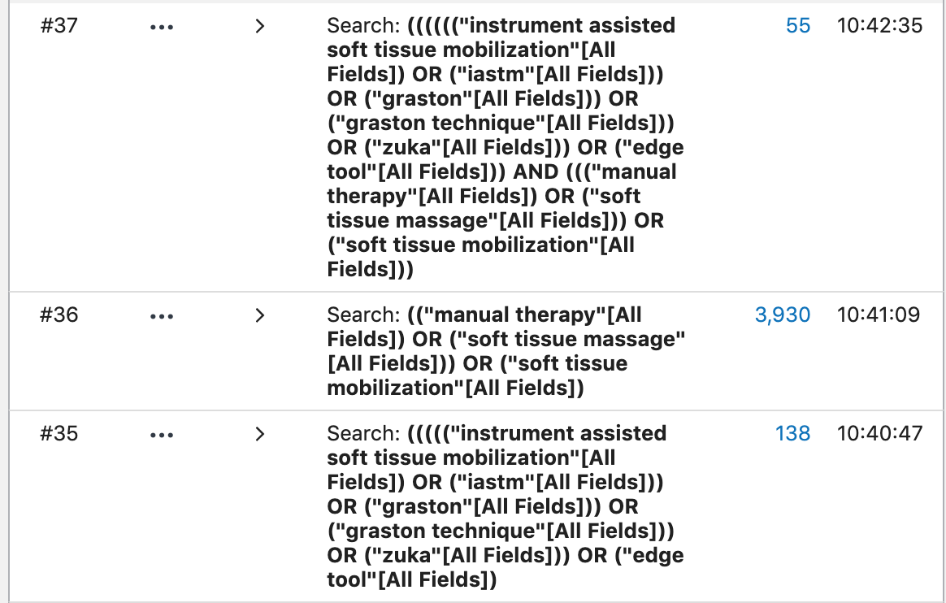
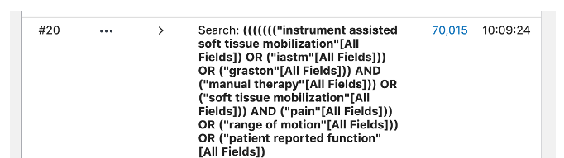
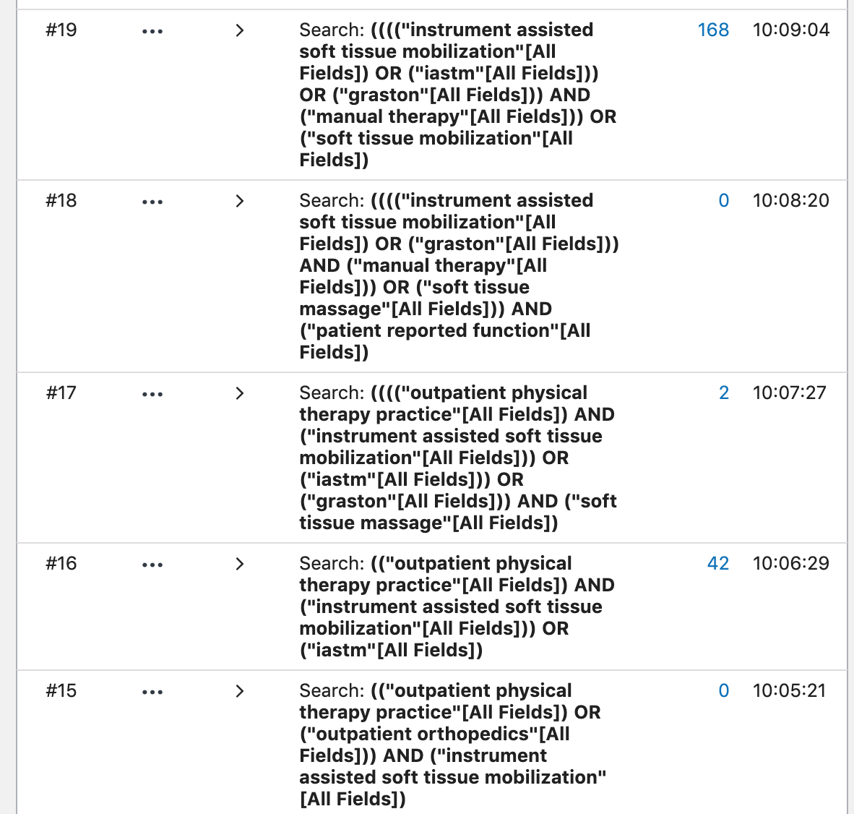
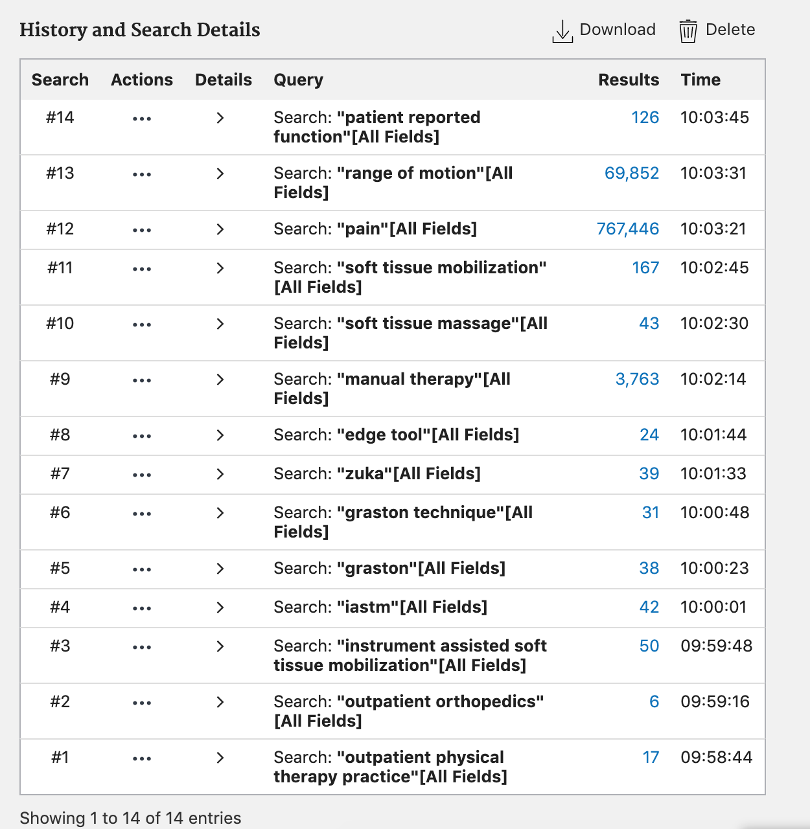

In the table below, show how many results you got from your search from each database you searched.
Databases and Sites Searched | Number of results | Limits applied, revised number of results (if applicable)
PubMed | 55 | 21 – Applied Filters: 10 years, RTC, case study, clinical study, meta-analysis, RCT, systematic review
CINHAL | 123 | 110 – Applied Filters: 10 years
CoChrane | 53 (1 review 53 trials)

INCLUSION and EXCLUSION CRITERIA
Inclusion Criteria
- Patient population is general outpatient orthopedics
- Patient reported outcome measures and objective measures (like ROM) are used to assess effectiveness and impact of the techniques.
- Randomized control trials
- Systematic reviews or meta-analysis
- Case studies and case reports
- Published within 10 years
Exclusion Criteria
- Not published in English
- Poster presentations
- Protocols

RESULTS OF SEARCH
Summary of articles retrieved that met inclusion and exclusion criteria
For each article being considered for inclusion in the CAT, score for methodological quality on an appropriate scale, categorize the level of evidence, indicate whether the relevance of the study PICO to your PICO is high/mod/low, and note the study design (e.g., RCT, systematic review, case study).
Author (Year) | Risk of bias (quality score)* | Level of Evidence** | Relevance | Study design
Cheatham (2016) | AMSTAR – 7/11 | Level 1a | High | Systematic Review
Nazari (2019) | AMSTAR – 8/11 | Level 1a | High | Systematic Review
Stroiney (2020) | PEDro – 5/11 | Level 2b | High | RCT
Gunn (2019) | PEDro – 9/11 | Level 1b | moderate | RCT
Rowlett (2019) | PEDro – 9/11 | Level 1b | moderate | RCT
Stanek (2018) | PEDro – 8/11 | Level 1b | High | RCT
Moon (2017) | PEDro - 6/11 | Level 2b | Low | RCT
Lee (2016) | PEDro – 5/11 | Level 2b | low | RCT
*Indicate tool name and score
**Use Portney & Watkins Table 16.1 (2009); if downgraded, indicate reason why

BEST EVIDENCE
The following 2 studies were identified as the ‘best’ evidence and selected for critical appraisal. Rationale for selecting these studies were:
- The 2019 systematic review by Nazari et al. was chosen primarily due to its high relevancy to all parts of the focused clinical question and scenario.¹ The researchers not only aimed to determine the efficacy of IASTM but also to review the quality and risk of bias of all the studies included. Because it is a systematic review, it is also considered to be of a higher level of evidence allowing clinicians to be more confident in the author’s conclusions.
- The 2018 randomized controlled trial by Stanek et al. was included due to its direct comparison of the IASTM intervention with compressive myofascial release (CMR) which is a commonly used soft tissue massage intervention. ² Additionally it looked at the effects on ROM which was an outcome listed in the original clinical question. Based off the PEDro scale it can be considered to be at a lower risk for bias allowing clinicians to be more confident in the author’s conclusions.
SUMMARY OF BEST EVIDENCE
(1) Description and appraisal of (study title) by (authors, Year)
Aim/Objective of the Study/Systematic Review:
The main purpose of the Nazari et al. systematic review was to synthesize data from multiple trials evaluating the effectiveness of IASTM on conditions in the lower extremity, upper extremity and lumbar spine that affected patient pain levels, function, range of motion, and strength. Additionally, the authors other goal was to assess each trails’ risk of bias and rate the quality of evidence found using the GRADE guidelines.
Study Design
[e.g., systematic review, cohort, randomised controlled trial, qualitative study, grounded theory. Includes information about study characteristics such as blinding and allocation concealment. When were outcomes measured, if relevant]
Note: For systematic review, use headings ‘search strategy’, ‘selection criteria’, ‘methods’ etc. For qualitative studies, identify data collection/analyses methods.
This study is a systematic review of RCT’s where participants received either IASTM or active treatment, placebo, or control (no treatment)
Search Strategy: The authors used a search strategy that included terms such as “instrument assisted soft tissue,” “soft tissue mobilization,” “IASTM” “massage therapy” and more terms specifying particular types of instruments such as “Graston technique” which yielded initially 7381 articles. However, there were many duplicates which were then removed to result in 1519 articles.
Selection Criteria: From the remaining 1519 articles, 20 were approved and met the inclusion criteria of being an RCT, contained participants with or without upper and lower extremity and spinal conditions, use of any IASTM, comparison groups included either active treatment, placebo or sham, or no treatment at all. In all of these RCT’s outcomes must include either or all of the following: “pain, disability and function, ROM, muscle strength, pressure sensitivity and muscle performance.”¹ Those studies excluded were screened out initially based on their title, then eliminated if not written in English, were not randomized or were abstracts or posters. There were initially two independent reviewers to screen relevant articles, apply the selection criteria and assess risk for bias with a third-party reviewer involved if there was a dispute.
Methods: The online search that was conducted involved MEDLINE, EMBASE, CINAHL, and PEDro between January 1998 and March 2018 to encompass the origins and most recent developments in the use of IASTM. Additionally, the authors searched through clinical trial registers catalogues, reference lists of other systematic reviews and references of the original 1519 articles so as to identify as many significant RCTs as possible. The independent reviewers relied on the Cochran Risk of Bias tool which allowed them to categorize the included articles as either low, unclear, or high risk of bias. The authors, in line with their objectives, also assessed the article’s quality of evidence using the GRADE approach which identified individual trials as either high, moderate, low or very low quality. This was done in an effort to allow the authors to express their confidence in the effect estimates.
Setting
[e.g., locations such as hospital, community; rural; metropolitan; country]
The selected articles that were included in this systematic review appeared to collect their data from outpatient therapy settings and gyms at different stages of rehabilitation for different pathologies such as rotator cuff, carpal tunnel, lateral epicondylitis, nonspecific thoracic spine, pain, upper back myofascial trigger points etc. Some evidence was conducted post-op in outpatient therapy settings whereas others were conducted after exercise testing of athletes at their training facilities.
Participants
[N, diagnosis, eligibility criteria, how recruited, type of sample (e.g., purposive, random), key demographics such as mean age, gender, duration of illness/disease, and if groups in an RCT were comparable at baseline on key demographic variables; number of dropouts if relevant, number available for follow-up]
Note: This is not a list of the inclusion and exclusion criteria. This is a description of the actual sample that participated in the study. You can find this descriptive information in the text and tables in the article.
Of the 20 studies that met the inclusion criteria, various IASTM techniques and tools were used on a variety of pathologies. Tools that were used in the trials that were included in this review consisted of the “Graston technique, Sound-assisted soft tissue mobilization, HawkGrip, Ergon, Fascial Abrasion Technique, AStym, EDGE, and AdvantEDGE.” ¹ The pathologies and populations studied in the selected articles include rotator cuff (1), lateral epicondylitis (2), carpal tunnel (1), upper and lower back trigger points (3), chronic nonspecific low back pain (2), patellar tendinitis (1), athletes (3), insertional Achilles tendinopathy (1), chronic ankle instability (1). There were also 4 studies that “recruited individuals without extremity or spinal conditions.” ¹ All of these studies were published between 2000 and 2018, some of which were published in predatory journals, over half of the trials neglected to include funding sources and 9 failed to indicate conflicts of interest.
Intervention Investigated
[Provide details of methods, who provided treatment, when and where, how many hours of treatment provided]
Control
Generally, the studies included in the systematic review either boasted a control group where no treatment was provided or there was a placebo or sham treatment. In some of the studies the control groups were provided with verbal and written education about their pathology. Sham or placebo treatments generally consisted of general exercises anywhere between 1-3 sets of 8-15 repetitions 1-3 times a week for 4-12 weeks.
Experimental
The primary intervention was the use of IASTM either alone or in conjunction with another treatment. The tools that were used in the trials consisted of the “Graston tools, sound-assisted soft tissue mobilization, HawkGrip, Ergon, Fascial Abrasion Technique, Tecnia Gavilan, Astym, EDGE, and AdvantEDGE.” ¹ For the studies that looked at the effect of IASTM in conjunction with another treatment compared to a placebo, the combined approach included either a combination of stretches, strength and balance exercises, patient education, or aerobic warmup exercise on a stationary cycle or treadmill. The comparison groups contained similar interventions with the addition of foam rolling or soft tissue massage provided by the therapist or the patient themselves.

Outcome Measures
[Give details of each measure, maximum possible score and range for each measure, administered by whom, where]
Table 1. Outcome measures in the included studies
 | Measures | N | MCID
Pain | Visual Analogue Scale & Pain Rating Scale | 9 | 21pts
Function and Disability | Foot and Ankle Ability Measure,  Patellofemoral Joint Evaluation Scale*  Disabilities of Arm, Shoulder and Hand Scale  Patient rated tennis Elbow Evaluation  Oswestry Disability index | 5 | 8  11  11  8
Range of Motion | Goniometer or digital inclinometer* | 9
Grip Strength | Handheld Dynamometer | 3 | 6.5-7.0kg
Pressure Sensitivity | Algometer or Dolorimeter* | 3
Muscle Performance | Vertical Jump (cm)*  Peak Power (Watts) *  Peak Velocity (m/s) * | 1
*For these measures that were not allotted a point value for MCID, “either an improvement of 15% or SD (effect size) of .5 points indicated a clinically important change.” ¹
Table 2. Bias and Quality Assessment
Measure | Domains covered | Ratings
Cochrane Risk of Bias Tool | Random sequence generation  Allocation concealment  Blinding of participants and personnel  Blinding of outcome assessment  Incomplete outcome data  Selective reporting  Other bias | Each domain was given a rating of either:  - Low risk  - Unclear risk  - High risk  Then Each study was given an overall rating of  - Low risk (if all domains were low risk)  - Unclear risk (if 1 or more domains were unclear)  - High risk (if 1 or more domains were high risk)
GRADE approach | Quality of evidence – study limitations  Quality of evidence – publication bias  Quality of evidence -imprecision  Quality of evidence- indirectness | Study Limitations – no serious limitations, serious limitations  Publication bias – likely, unclear, not likely  Imprecision – no serious imprecisions, serious imprecisions  Indirectness – no serious indirectness, serious indirectness  Each study was then given an overall quality rating based on the above ratings:  - Very low, unclear, high quality

Main Findings
[Provide summary of mean scores/mean differences/treatment effect, 95% confidence intervals and p-values etc., where provided; you may calculate your own values if necessary/applicable. You may summarize results in a table but you must explain the results with some narrative.]
In this systematic review the authors summarized the quality of evidence for literature that detailed the efficacy of IASTM used in a variety of individuals with or without musculoskeletal pathologies at varying sites on the body. Studies were separated into IASTM and Other treatment vs. Control, IASTM vs. Control (no treatment), IASTM vs. Other treatment, and IASTM with/without other treatment vs. placebo/sham.
Table 3. Main Findings Per subgroup of RCT’s
Category | N | Findings (all with 95% CI)
IASTM + other treatment Vs. Other treatment | 9 Trials  43 Reported Outcomes | - 1 trial with SMD .01-.031 indicated no clinically important differences (elbow tendinopathy)  - 3 trials with no clinically important differences with respect to functional improvement (chronic lateral elbow tendinopathy, chronic ankle instability and patellar tendinitis)  - 4 trials no clinically important differences with respect to pain levels (carpal tunnel syndrome, low back pain, Achilles tendinopathy, lateral elbow tendinopathy)  - 5 trials no clinically important differences with respect to ROM improvements (shoulder, wrist, ankle)  - 2 trials demonstrated clinically significant improvement in LBP and ankle ROM in active individuals however the “95% CI did not exclude the MCID score therefore more data is needed.” ¹
IASTM vs. Control (no treatment) | 6 Trials  15 Reported Outcomes | - 2 trails (with SMD 1.72-2.52) indicated IASTM had large effects with respect to pressure sensitivity.  - 1 trial indicated clinically important difference in LBP in favour of IASTM  - 3 trials indicated no clinically important differences with respect to ROM (shoulder, ankle, athletes & non-athletes)  - 1 trial (with SMD .03-.24) indicated IASTM had small effects with respect to muscular performance (athletes & active individuals)
IASTM vs. Other Treatment | 5 Trials  18 Reported Outcomes | - 2 trials indicated no clinically important difference with respect to functional improvement (nonspecific thoracic pain, lateral epicondylitis)  - 1 trial indicated clinically important difference with respect to functional improvement (lateral epicondylitis) but the “CI did not exclude the MCID of 11 points” requiring more data for more accurate interpretation and conclusions. ¹  - 3 trials indicated no clinically important difference with respect to pain levels (lateral epicondylitis, non-specific LBP)  - 2 trials indicated no clinically important difference with respect to ROM (hip, knee, ankle athletes & non-athletes)
IASTM with or without other treatment vs. Placebo Plus other treatment | 2 Trials  10 Reported Outcomes | - 1 trial indicated no clinically important differences with respect to functional improvement (thoracic spine, ankle instability)  - 1 trial indicated no clinically important differences with respect to pain (nonspecific thoracic spine, chronic ankle instability)

Table 4. Main findings of Bias and Quality persubgroup of RCT
Category | Limitations | Inconsistency | Indirectness | Imprecision | Publication Bias | Overall Quality
IASTM + other treatment Vs. Other treatment (43) | Very serious limitations (43) | N/A (43) | No Serious (20)  Serious (23) | Serious (43) | Likely (43) | Very Low (43)
IASTM vs. Control (no treatment) (15) | Very Serious (15) | N/A (15) | No Serious (9)  Serious (6) | Serious (15) | Likely (15) | Very Low (15)
IASTM vs. Other Treatment  (18) | Very Serious (18) | N/A (18) | No Serious (11)  Serious (7) | Serious (18) | Likely (18) | Very Low (18)
IASTM with or without other treatment vs. Placebo Plus other treatment (10) | Very Serious (10) | N/A (10) | No serious (8)  Serious (2) | Serious (10) | Likely (10) | Very Low (10)
Overall the results of this systematic review appear to highlight that there is very limited evidence, if any at all, that highlight clinically significant improvements in strength, pain, ROM, function when using IASTM which contrasts with the authors literary review of other systematic reviews such as Lambert et al. For those trials that were included that indicated IASTM had moderate to large effects, the authors highlighted the fact that they were “published in suspect predatory journals” at risk for bias. ¹ There is a large quantity of RCT’s that review IASTM but the ones that met the inclusion criteria in this study were all considered to be of very low overall quality of evidence.

Original Authors’ Conclusions
[Paraphrase as required. If providing a direct quote, add page number]
The authors of this study aimed to provide a comprehensive review of the effectiveness of IASTM whether used in addition to other treatments or compared to other treatments, no treatments or sham treatments by reviewing the quality of evidence of the included literature. Many of the included studies were found to have a high risk of bias which lowered their overall quality of evidence leading authors to concluded that the “current evidence does not support the use of IASTM to improve pain, function, or range of motion in individuals without extremity or spinal conditions or those with varied pathologies” on page 1750 of the review. ¹

Critical Appraisal
Validity
[Summarize the internal and external validity of the study. Highlight key strengths and weaknesses. Comment on the overall evidence quality provided by this study.]
The AMSTAR quality assessment of this systematic review indicates a moderate to high confidence with a score of 8/11 indicating the author’s confidence in their current findings. As this article is a systematic review, it is classified as a higher level of evidence which is supported by the two separate reviewers conducting extensive research with the addition of a third party should there be a dispute. Additionally, the fact that the authors rated the quality and bias of each trial using the GRADE scale and identified trials published in predatory journals enabled them to be more confident in their final conclusion. However, the authors chose not to include sources of gray literature, focusing solely on randomized controlled trials, which may have contained more updated or additional information on the clinical significance of IASTM that could have affected the authors’ conclusions.
Interpretation of Results
[This is YOUR interpretation of the results taking into consideration the strengths and limitations as you discussed above. Please comment on clinical significance of effect size / study findings. Describe in your own words what the results mean.]
Overall the systematic review is well researched and achieved the authors original goals to assess effectiveness of IASTM and rate the quality of the included RCT’s using the Cochrane Risk of Bias tool and GRADE assessment. The majority of trials included indicated that there were no clinically significant differences with respect to IASTM’s effects on ROM, pain, strength and function yet some indicated moderate to highly significant results in favour of IASTM. However, the authors found that for these reports where IASTM was favoured there was excessive bias, failure to report limitations, and funding sources making the conclusions of these trials suspect and the authors less confident in the stated conclusions. In contrast, because all the studies were deemed to be low quality evidence, the authors conclusions that IASTM was not effective should therefore also be taken into consideration. Further research should be conducted in an attempt to find higher quality trials with lower bias to better assess the efficacy of IASTM.
Applicability of Study Results
[Describe the relevance and applicability of the study to your clinical question and scenario. Consider the practicality and feasibility of the intervention in your discussion of the evidence applicability.]
The results of this systematic review are moderately to highly applicable to the original question as it identifies a wide variety of patients normally seen in outpatient clinics, includes trials that use IASTM in isolation and IASTM with additional treatment, some trials directly compare IASTM to soft tissue massage, and includes both upper and lower extremity pathologies as well as those in the spine. The review lists a summary of each article but does not contain specific descriptions or protocols for application of IASTM or STM which increases the variability between practitioners and therefore the relative effectiveness of the treatments. Because the authors concluded that IASTM was not any more effective than other treatments, specifically soft tissue massage, practitioners without access to these specialized and expensive tools may render treatment just as effectively as those practitioners with specialized instruments.

(2) Description and appraisal of (study title) by (authors, Year)
Aim/Objective of the Study/Systematic Review:
The purpose of Stanek et al. RCT was to directly compare the effects of IASTM, specifically the Graston technique and tools, and compressive myofascial release (CMR) which often used by therapists when performing manual therapy. However, the authors believed that there would be no significant differences between the two interventions after one session.
Study Design
[e.g., systematic review, cohort, randomised controlled trial, qualitative study, grounded theory. Includes information about study characteristics such as blinding and allocation concealment. When were outcomes measured, if relevant]
Note: For systematic review, use headings ‘search strategy’, ‘selection criteria’, ‘methods’ etc. For qualitative studies, identify data collection/analyses methods.
This study by Stanek et al. is a randomized control trial that consisted of 44 patients, 53 total limbs, who all had dorsiflexion ROM restriction at the ankle. Upon the initial session the participants were required to have 3 different sets of measurements taken and complete the Silfverskiold test by the same clinician who was blinded to treatment allocation. DF ROM was measured via digital inclinometer to improve validity and reliability in positionings of standing weight bearing (WB) DF ROM with knee bent and kneeling WB DF ROM beginning with the knee above the ankle and ending with knee closer to the toes. Individuals were then assigned to either the control, CMR or GT group utilizing block randomization to keep groups even. If there were ever an instance in which both the participants limbs qualified, then the dominant limb was placed in the next group. Each group was required to complete a 5 minute warm up on the bicycle. Afterwards the control group lay in prone for 5 minutes, the CMR group had 1 minute of therapy on the medial and lateral sides of the Achilles tendon and 2 minutes of CMR at the musculotendinous junction, and the GT group had 1 minute of therapy with the GT5 tool followed by 4 minutes of treatment on areas of restriction with either the GT4 or GT3 instrument. The control group intervention was selected based on the authors previous study of other designs After each group received their intervention, the same intake measurements and Silfverskiold test were completed again. One therapist was assigned to complete treatment on all CMR participants and another therapist who was certified in the Graston technique was assigned to complete treatment on all GT participants.

Setting
[e.g., locations such as hospital, community; rural; metropolitan; country]
Data collection occurred in a laboratory setting with access to aerobic equipment and treatment tables similar to those found in outpatient physical therapy settings.

Participants
[N, diagnosis, eligibility criteria, how recruited, type of sample (e.g., purposive, random), key demographics such as mean age, gender, duration of illness/disease, and if groups in an RCT were comparable at baseline on key demographic variables; number of dropouts if relevant, number available for follow-up]
Note: This is not a list of the inclusion and exclusion criteria. This is a description of the actual sample that participated in the study. You can find this descriptive information in the text and tables in the article.
Within this study there was initial a total of 82 individuals, 164 limbs, which was then limited to 44 participants and 53 limbs after apply the inclusion and exclusion criteria. Participants were included if they presented with less than 30 degrees of standing DF ROM, engaged in at least 30 minutes of exercise for 3 or more days in the last week as well as a positive Silfverskiold test used to assess gastroc contracture. The authors chose 30 degrees for their cut-off value based off previous research indicating those individuals with less than this were more predisposed to injury. Those individuals who either had a lower extremity injury, surgery, treatment for triceps surae or had vision or balance impairments were not invited to participate. Overall, there were 25 men, median of 20 years of age, and 19 women, median of 20 years of age with an average height of 172.3 cm between the 53 participants. There were no apparent drop outs as the study consisted of one session, and authors did not include a follow up session to determine long-term effects of the treatment.
Intervention Investigated
[Provide details of methods, who provided treatment, when and where, how many hours of treatment provided]
Control
The control group consisted of 18 randomized limbs of participants who were instructed to perform 5 minutes of cycling then remain lying in prone with feet hanging off the table for 5 minutes after which their measurements were taken again. Authors decided against using a placebo or sham intervention in this case to focus more closely on the effects of the GT and CMR interventions.
Experimental
Seeing as the authors wanted to compare the effects of the Graston technique to the compressive myofascial release technique there were then two intervention groups. The GT group consisted of 17 limbs of participants who were instructed to perform 5 minutes of cycling then receive at minimum 5 minutes of soft tissue massage with the GT5, GT4 or GT3 tools. The CMR group consisted of 18 limbs of participants who were also instructed to perform 5 minutes of cycling then receive at minimum 3 minutes of soft tissue massage from the clinician who utilized their knuckles and thumbs to apply pressure and release soft tissue adhesions. There was only one session conducted for all participants to study the short-term effects of the GT and CMR interventions and no post-treatment education was given to the participants.
Outcome Measures
[Give details of each measure, maximum possible score and range for each measure, administered by whom, where]
The authors primary measure of DF ROM occurred while the patient was in standing as well as kneeling. In standing patients were required to take a step forward with their non-test leg to mimic walking then were required to bend their non-test leg as far as possible without allowing their test leg’s heel to rise in an effort to achieve maximum DF. Additionally, participants were asked to take up a kneeling lunge stance at which point they lunged forward onto their test limb to achieve maximum DF ROM. For both these measures a digital inclinometer attached to the individual’s fibula took the reading as this was determined to be more valid and reliable than having a clinician perform the measure with a goniometer. The authors also decided to take DF ROM measure in weightbearing closed chain activities as they found it to be more valid than open chain measurements which can lead to greater compensatory movement patterns. In addition to the inclinometers the Silfverskiold test, which is designed to identify potential contractures or soft tissue adhesions in the gastroc, was used when participants demonstrated less than 30 degrees of DF from the previous measurements. The authors used this exam as a way to assess the involvement of posterior chain musculature (such as the triceps surae) in limiting DF ROM. For this measure the clinician uses on hand to stabilize and lock the subtalar joint into neutral and the other to stabilize the talonavicular joints and forefoot allowing movement to occur only at the talocrural joint. “if DF was greater than zero degrees with the knee flexed but less than zero degrees with the knee extended the test indicated a soft tissue restriction.” ² Because the techniques work to alleviate soft tissue restrictions, only participants with a Silfverskiold test indicating a soft tissue restriction were included.
Main Findings
[Provide summary of mean scores/mean differences/treatment effect, 95% confidence intervals and p-values etc., where provided; you may calculate your own values if necessary/applicable. Use a table to summarize results if possible.]
Table 6. Standing DF ROM *adapted from Study*²
Group | n | Change (Posttreatment – Baseline) | 95% Confidence interval
Control | 18 | 1.06 +- 1.82 | .13, 1.77
CMR | 18 | 4.83 +- 3.28 | 2.78, 5.97
GT | 17 | 1.75 +- 1.22 | 1.31, 2.38
When looking at the treatment effects for improvement of DF ROM measured in standing, the CMR group should more statically significant results when compared to the control and the GT group with p=.001 as well as a larger effect size (Cohen d = 1.23). The CMR group’s initial mean measurement was 27.7 degrees and its posttreatment measurement was 32.62 degrees while the GT group’s initial mean measurement was 29.13 degrees and its posttreatment measurement was 30.88 degrees. Based off these measurements the CMR group was resulted in a larger degree of change when compared to the GT group.

Table 6. Kneeling DF ROM * adapted from study* ²
Group | n | Change (Posttreatment – Baseline) | 95% Confidence interval
Control | 18 | -.76 +- 5.92 | -3.63, 3.40
CMR | 18 | 4.43 +- 4.08 | 2.59, 6.68
GT | 17 | 3.05 +- 3.79 | 1.46, 5.81
Similar to the previous table, the CMR group again showed more statistically significant results when compared to control and GT group measurements of kneeling DF ROM with p = .005. Again there was a larger degree of change in the CMR group when compared to the GT group by 4.43 degrees versus 3.05 degrees respectively.

Based off of the author’s analysis they were able confident that the CMR was able to produce a more statistically significant result after one session of treatment than the GT group.
Original Authors’ Conclusions
[Paraphrase as required. If providing a direct quote, add page number]
Based on this short-term evaluation of the effects of CMR and GT on individuals reduced DF ROM due to soft tissue restrictions, the CMR group showed greater improvements in ankle DF ROM. Because of the nature of their trial, the authors concluded that “a single CMR treatment was more beneficial than a single GT treatment” which prompted them to support the use of CMR for future patients. ²
Critical Appraisal
Validity
[Summarize the internal and external validity of the study. Highlight key strengths and weaknesses. Comment on the overall evidence quality provided by this study.]
The PEDro scale quality assessment for randomized controlled trials indicates this study by Stanek et al to be moderately to highly valid scoring 8 out of 11 points. A strength of this review is that there was blinding of assessors who measured the key variables including DF ROM in standing and kneeling and the Silfverskiold test reducing risk of bias as well as concealed allocation of subjects. Because of the how the study was conducted however the participants as well as the therapists were unable to be blinded when the intervention was being performed. Furthermore, this trial only consisted of one session with relatively healthy individuals making it difficult to generalize the results to a larger population that may receive therapy for longer periods of time. For instance, individuals with a LE injury were not included in the study, yet these are the individuals more likely to be seen in physical therapy and receive either CMR or GT as part of their treatment session.
Interpretation of Results
[This is YOUR interpretation of the results taking into consideration the strengths and limitations as you discussed above. Please comment on clinical significance of effect size / study findings. Describe in your own words what the results mean.]
Based off these results, it appears that both compressive myofascial release and Graston Technique are acceptable ways to improve DF ROM by targeting soft tissue adhesions in the gastroc and soleus muscles. However, after one session it appears that the CMR produced a more statistically significant result. In the standing DF ROM measurements the CMR group had a p value of .001 and in the kneeling DF ROM the CMR group had a p value of .005 indicating highly statistically significant results. However, both the CMR and the GT groups required application of pressure to soft tissue adhesions by different practitioners. The authors were unable to measure and compare exactly how much pressure was being applied to the participants by the therapists. While IASTM can be helpful to the therapists in reducing fatigue and identifying adhesions, there is a disconnect between the therapist and patient tissue which may prompt the therapist to reduce the amount of pressure placed on the patient. When a therapist relies only on their hands, they may be a better judge of how much pressure to apply. This study was highly relevant as it focused on one of the major outcomes I included in my PICO question as well as directly comparing the intervention (Graston/IASTM) to the comparison group (compressive myofascial release). Yet this study did not include an injured patient population, only one that had a DF ROM deficit, nor did it look at various other joints in the body that may also be affected by soft tissue restrictions. The overall results of this study therefore indicate that both CMR and GT can produce short term benefits to the patient, with CMR being slightly more effective in this instance, but that more research on long term effects at different joints should be conducted.
Applicability of Study Results
[Describe the relevance and applicability of the study to your clinical question and scenario. Consider the practicality and feasibility of the intervention in your discussion of the evidence applicability.]
The applicability of this study I find to be moderate to highly applicable to the clinical question posed in this review as Stanek et al. was able to show not only the benefits of both CMR and GT, but was able to answer in part the question determining which intervention was more effective at targeting ROM. Stanek et al. was able to show that both CMR and GT groups demonstrated improved DF ROM which is expected when working to improve ROM by reducing soft tissue adhesions and increasing overall extensibility of the tissue. They were also able to determine that the CMR group showed more significant short-term results following just one session of treatment. Based off of this study, therapists who have access to Graston tools can be assured that this particular IASTM is effective and can be used to assist patients. However, this study also allows therapists who do not have access to tools to be reassured that their manual skills are just as effective if not more than expensive instruments when attempting to improve ROM. The issue with this study is that it only looks at the short-term effects of relatively healthy individuals at only one joint. I believe the principle behind reducing soft tissue adhesions, thereby reducing ROM restrictions, has been proven correct but whether or not the CMR or GT technique is more effective over a longer period of time and at different joints remains to be seen.

SYNTHESIS AND CLINICAL IMPLICATIONS
[Synthesize the results, quality/validity, and applicability of the two studies reviewed for the CAT. Future implications for research should be addressed briefly. Limit: 1 page.]
Overall, both studies that were selected for this clinically appraised topic review a myriad of benefits and pitfalls with respect to IASTM and how it compares to soft tissue massage techniques used on patients that receive physical therapy in an outpatient setting. The systematic review by Nazari et al was highly relevant to the clinical question as it reviewed populations of individuals most likely to be seen in outpatient physical therapy settings, focused on IASTM treatments and reviewed outcomes that included pain, strength, ROM and function. It was especially interesting to see that the authors were able to separate the included studies into four separate categories including IASTM & other treatment vs. other treatment, IASTM vs control (no treatment), IASTM vs. other treatment and IASTM with or without other treatment vs. placebo plus other treatment. These categories allowed the authors to look at the effects of IASTM in isolation as well as compare them to other treatments or combine them with other treatments which is what would be expected in an outpatient therapy setting. All the included studies in this systematic review were found to be of low-quality evidence due to presence of publication bias or failure to indicate funding sources and limitations. This led authors to concluded that IASTM is no more effective than other treatments, such as compressive myofascial release, in improving pain, strength, ROM and function. Yet because the quality of the evidence is so low, future studies with low risk of bias and higher quality of evidence should be conducted to confirm or deny this systematic review’s conclusions.
The RCT by Stanek et al. was also highly applicable to the proposed question in that it directly contrasted compressive myofascial release (CMR) and IASTM, specifically the Graston technique which is one of the more well know instrument sets used in clinical settings. In contrast to the general findings in the Nazari et al. study, the authors of this RCT found that CMR produced a more clinically significant result in terms of ROM than the Graston technique. However, this study did not look into other outcomes such as strength and pain levels nor did it combine other treatments like what was seen in the Nazari et al. review. Additionally, there was only one treatment session and no long term follow up of participants. Overall, despite the study’s applicability to the question, the quality of the study based on its limitations and the procedure is not high enough to for me to feel confident in choosing one technique over the other. Also, of note is that it was listed in the systematic review by Nazari as being low quality.
Based on the two studies reviewed in this CAT, I conclude that neither soft tissue massage techniques, such as CMR, nor IASTM is more effective than one or the other at improving pain, strength, ROM and function for individuals with upper or lower extremity or spinal pathologies. The evidence currently available is so variable and at high risk for bias that I do not feel confident in identifying the most effective intervention. That being said, both CMR and IASTM can be used to produce beneficial results. Therapists with access to IASTM tools, such as Graston, should feel confident that they are rendering a beneficial treatment and therapists without access to those more expensive tools can also feel confident that their treatment is effective.

REFERENCES
[List all references cited in the CAT]
- Stanek J, Sullivan T, Davis S. Comparison of Compressive Myofascial Release and the Graston Technique for Improving Ankle-Dorsiflexion Range of Motion. J Athl Train. 2018;53:160-167.
- Nazari G, Bobos P, MacDermid JC, Birmingham T. The Effectiveness of Instrument-Assisted Soft Tissue Mobilization in Athletes, Participants Without Extremity or Spinal Conditions, and Individuals with Upper Extremity, Lower Extremity, and Spinal Conditions: A Systematic Review. Arch Phys Med Rehabil. 2019;100:1726-1751.
- Cheatham SW, Lee M, Cain M, Baker R. The efficacy of instrument assisted soft tissue mobilization: a systematic review. J Can Chiropr Assoc. 2016;60:200-211.
- Gunn LJ, Stewart JC, Morgan B, et al. Instrument-assisted soft tissue mobilization and proprioceptive neuromuscular facilitation techniques improve hamstring flexibility better than static stretching alone: a randomized clinical trial. J Man Manip Ther. 2019;27:15-23.
- Rowlett CA, Hanney WJ, Pabian PS, McArthur JH, Rothschild CE, Kolber MJ. Efficacy of instrument-assisted soft tissue mobilization in comparison to gastrocnemius-soleus stretching for dorsiflexion range of motion: A randomized controlled trial. J Bodyw Mov Ther. 2019;23:233-240.
- Stroiney DA, Mokris RL, Hanna GR, Ranney JD. Examination of Self-Myofascial Release vs. Instrument-Assisted Soft-Tissue Mobilization Techniques on Vertical and Horizontal Power in Recreational Athletes. J Strength Cond Res. 2020;34:79-88.
- The Effectiveness Of Ischemic Compression And IASTM In Trigger Point Treatment In Patients With Rotator Cuff Tear. https://clinicaltrials.gov/show/NCT04319250. April 2020.
- The Efficacy Of Instrument-Assisted Soft Tissue Mobilization At Lumbar Region Disc Herniations. https://clinicaltrials.gov/show/NCT04334122. April 2020.

