Medial and Lateral Epicondylalgia: A Physical Therapy Review
Conditions of the elbow and forearm are regularly seen in the outpatient physical therapy settings. In particular, epicondylitis is a painful condition that can affect the medial and lateral aspects of the patient’s elbow. That being said, elbow dysfunction has many names, and in the literature several terms are used interchangeably. One of the most common (misnomers) is “epicondylitis” which refers to an acute inflammation of the epicondyle.¹ Then, there is “epicondylalgia” which refers to elbow pain related to tendinopathy of the common flexor and extensor tendon origins at the medial and lateral origin sites, respectively.¹ For the purposes of this review, “epicondylalgia” will be the preferred term as it covers a broader temporal spectrum for elbow related pain.
Medial epicondylalgia (ME) is commonly referred to as “golfer’s elbow” where lateral epicondylalgia (LE) is commonly referred to as “tennis elbow.” “Golfer’s elbow” is typified by pathology occurring at the medial epicondyle of the humerus while “tennis elbow” is typified by pathology occurring at the lateral epicondyle of the humerus.^{2,3} These conditions are characterized by some sort of mechanical change at the origin site of the wrist flexor and extensor groups and can have numerous approaches to treatment and rehabilitation. Especially in populations with strenuous loading demands these orthopedic issues become debilitating and limit the athletic or occupational activities of an individual. Subsequently, this review will go through the relevant anatomy of the elbow and wrist flexors/extensors, the prevalence/epidemiology of epicondylar injuries, lay out potential mechanisms of injury and etiologies of elbow tendon pathology, current physical therapy evaluation and treatments for epicondylalgia, and briefly highlight non-physical therapy related treatments.
Relevant Anatomy and Biomechanics
Medial Epicondylalgia
As mentioned previously, the term “epicondylitis” is “somewhat of a misnomer as the pathology lies not in the epicondyle, but rather in the tendons attaching to the epicondyle of the humerus.”³ Likewise for a true “-itis” to occur, the tendon would also show signs of inflammation, but most patients seen in clinic have this problem occurring for weeks before seeking medical attention. Histological findings do not show many inflammatory cells; therefore most researchers consider these conditions to be more of a tendinosis.² As a result, the soft tissue anatomy is more relevant to both pathologies.
The common flexor-pronator tendon (CFT) is point where five major muscles on the anterior portion of the forearm converge: pronator teres, flexor carpi radialis (FCR), palmaris longus, flexor carpi ulnaris, and flexor carpi digitorum superficialis.⁴ The CFT attaches to the medial humeral epicondyle anteriorly and proximally to the ulnar collateral ligament (UCL) in a parallel orientation.⁴ This CFT is roughly 3 centimeters long and crosses the ulno-humeral joint line in most individuals.⁴ (See Appendix A) In particular, the bands of the pronator teres and FCR tendons undergo more loading and are stretched during the acceleration phases of throwing and swinging.^{5,6} It is likely because of this tensile stress that professional throwing athletes also show hypertrophy of the humerus and hypertrophy of the forearm flexor-pronator group.⁶ The proximity of the CFT to the ulnar nerve also has influence on potential neuritis, compression, or entrapment syndromes during these sorts of throwing tasks.⁶
Generally, the mechanics of the medial elbow and the flexor-pronator group are most often described during the phases of throwing. The major peaks in angular velocity and extreme valgus force in the acceleration phase of throwing creates stress greater than the tensile strength available in the medial ligamentous and tendinous structures.⁵ These forces are transferred to the deeper medial collateral ligament from the flexor-pronator group, and this repetitive stress loading can lead to degenerative changes which can cause ME.⁵ Repetitive forceful contractions, such as during a tennis serve or golf swing, can result in medial soft tissue tension overloading. One reason the flexor carpi radialis can become more stressed could possibly be due to the larger cross-sectional area (CSA) of the muscle belly itself as well as the tendinous attachment to the 2nd and 3rd metatarsal bases. The combination of large CSA as well as a position likely to receive higher loads, could increase the force demands of that particular muscle.
Lateral Epicondylalgia
The common extensor tendon (CET) is the confluence of extensor carpi radialis brevis (ECRB), extensor digitorum communis, extensor digitorum minimi, and extensor carpi ulnaris.⁷ This common tendon aids in finger and wrist extension while also supinating the forearm.³ The CET attaches onto the humeral epicondyle in a posterior-inferior manner with the ECRB being the most commonly affected muscle^{2,3,8} However, researchers have also found that the supinator and other common wrist extensors can also become affected through excessive and repetitive loading.² Anatomical studies have shown that the ECRB tendon merges subtly with the lateral collateral ligament (LCL), which then blends with the annular ligament of the proximal radioulnar joint.⁹ (See Appendix A) Consequently, significant load distribution takes place between these structures and may suggest why the LCL can become involved in more severe cases of LE.^{2,8,9} In terms of muscle mass, the extensor group has a smaller overall cross-sectional area than the larger and more powerful flexor group.⁷ Repeated and forceful muscle activation of this smaller, thinner muscle group likely exceeds the mechanical capacity for the extensors, thus leading to injury.
Similar to ME, LE also occurs due to forceful repetitive concentric and eccentric loading of the wrist extensors which overload the CET and also transfers these forces to the lateral epicondyle.^{2,3,7} Excessive tensile forces or overstretching from undue use of the wrist extensors creates pathological change in the local tissue and overloads the tendon. Van Hofwegen found with MRI that improper eccentric wrist extension technique (i.e. backhand tennis swing) puts the extensor muscle group under extreme tension in an already lengthened position.⁷ The ECRB, which is analogous to the FCR, is the more commonly affected muscle. Again, this may be due to the central insertion site that sustains wrist flexion/extension moments with both ulnar and radial angulations.
Prevalence
Compared to other orthopedic conditions, the prevalence of these elbow conditions is quite low in the general population. Specifically, the prevalence to LE to ME is about a 5:1 ratio or as great as 7 to 10 times more common than ME. ^{4,7,4,10} These conditions are both commonly seen starting in the 4th decade of life and into the 6th, with it more frequently affecting women than men.^{9,11} Although, some numbers do show no difference between genders.^{2,4} LE prevalence in the general population is roughly 1.0–1.3% in men and 1.1–4.0% in women and ME is roughly 0.3–0.6% in men and 0.3–1.1% in women.¹¹“ However, in athletic or occupational settings, the prevalence of these injuries is much higher. Medial epicondylalgia of the humerus can affect as many as 3.8% to 8.2% in an occupational setting while lateral epicondylalgia of the humerus and can affect anywhere between 10-50% of tennis players over the span of their careers.^{2–4,7} In fact, “estimates of 50% elbow injury for athletes using overhead arm motions have been suggested with 1-3% of the general population experiencing elbow pain.”¹ Studies have reported sports such as tennis, windsurfing, rock climbing, football, archery, javelin throwing, handball, golfing, wheelchair sports, baseball, cycling, and weightlifting have incidences of developing epicondylar pain.^{1,5–7,10,12} Roughly 75% of patients that have epicondylalgia have it in their dominant arm.^{3,5,11}
Mechanism of Injury/Etiology
It seems that the consensus for a mechanism of injury for ME and LE is a repetitive and chronic overuse related injury that causes degenerative tissue changes to the common flexor and extensor tendons of the forearm. “Overuse and repetitive microtrauma of the wrist flexor and extensor tendons are thought to be the mechanism for injury of medial and lateral epicondylitis. Repetitive movements with eccentric contraction (muscle-tendon unit lengthening while contracting) increase susceptibility to epicondylitis.”⁷ This excessive loading leads to micro-tearing in the tendon which produces degenerative responses, resulting in an overall weakened tissue and increased propensity for ultimate tissue failure (i.e. rupture).^{2,7,13} This cascade of degenerative changes is a tendinosis pathology which is described as having fibroblastic hypertrophy, disorganized collagen fiber alignment, vascular hyperplasia, sometimes calcification (in more serious cases), and an overall weakened state of the of the collagen fiber matrix.^{3,7,13}
For ME in particular, most believe that this repetitive eccentric loading of the flexor muscle group combined with a valgus overloading at the elbow leads to the development of epicondylalgia with particular emphasis on the pronator teres and FCR tendon contributions.⁴ Medial elbow joint line strain with a valgus moment “stimulates dynamic stabilization of the joint via eccentric contraction of the CFT.”⁴ Especially during the release portion of a ball throwing motion, the co-contraction of the wrist flexors and pronators may produce even higher levels of stress on the tendon unit.⁴ Although the primary cause is this chronic loading, a single traumatic event like a blow or a sudden/extreme eccentric loading may also result in a true epicondylitis.⁵ ME occurs frequently in baseball players due to the intense valgus forces mentioned during late cocking and acceleration phases of throwing, but the condition also presents itself commonly in other sports as well as occupations like carpentry, plumbing, and meat cutting.^{5,11} In sport, throwing and hitting motions with a wrist extension or supination moment will likely put the greatest stress onto the CFT. Although ME is colloquially called “golfer’s elbow,” it is quite often seen in tennis players due to the vigorous nature of their forehand hitting and serving.^{7,12} However, the condition does occur in golfer’s and is attributed to poor technique during the swing. Ciccotti et al. describes it as “throwing” the club from of apex of the backswing down towards the ball.⁵ This incorrect motion is known as “hitting from the top” and creates similar valgus forces on the dominant elbow as with pitching, leading to chronic overloading. ⁵ In the occupational setting, physical loading effects such as high force demands, hand-arm vibration, and awkward positions can be contributing factors to injury onset.¹¹ Interestingly, there are also correlations with epicondylar pathology and job title, physical load factors, and psychosocial factors that play a part in the development of the issue.¹¹
As for LE, the physical and chronic overloading principles still apply. However, the manner in which the injuries accrue varies on the type of activity. Especially in athletes, racquet/ implement sports have a high prevalence of LE due to incorrect hitting technique, gripping technique extended duration of play, frequency of play, size/shape/ of the racquet, and weight of the racket.^{8,10,12} For tennis athletes in particular, there has been a fair amount of analysis done considering nearly half will experience LE in during their careers.¹² In terms of technique, a late backhand stroke and hit outside of the “sweet spot” are considered two of the basic stresses that can lead to tennis elbow.^{1,10,12} Especially for beginner tennis players that try to utilize a single arm backhand, they generally have trouble stabilizing the racket and hit the ball off-center which increases the wrist flexion/pronation moment and thus increasing the torque demand on the wrist extensor group.^{10,12} Anecdotal evidence from tennis professionals also believe that increased racquet stiffness as well as higher string tensions tend to increase the force applied through the forearm and elbow.¹² However, there is a trade-off due to the increased vibration at higher racquet stiffness ratings.¹⁰ Occupationally, the evidence shows that the conditions for developing LE are similar, if not the same as ME, with repeated elbow extension and flexion in a blue collar working environment to be statistically significant to the onset of either condition. ^{11,14}
Physical Therapy Evaluation
For the physical therapy evaluation and treatment of epicondylalgia, begins with a detailed and relevant patient history in order to begin forming a list of differential diagnoses. Patients with epicondylalgia will commonly complain of point tenderness with symptoms often radiating down forearm, pain exacerbated by activity, decrease in grip strength, early stage inflammatory markers (erythema, swelling, warmth), and sometimes decreases in wrist range of motion.^{2,4–7,9} Symptoms usually have an insidious onset and are generally not related to a singular traumatic event.¹⁵ As these are not trademark symptoms of epicondylalgia, physical therapists must be able formulate a list of possible conditions while also ruling out more serious injuries, especially in athletic populations where the intensity, frequency, and duration demands could be magnitudes higher than the general population. A cluster of symptoms from the subjective report and key physical examination testing together is necessary for the accurate diagnosis of ME or LE.^{2,4,5,7,16} Although imaging is sometimes performed, it is generally accepted that radiological investigation does not add much value to the diagnostic process¹⁵, unless more serious conditions are implicated.
Medial Epicondylalgia
For ME, there is a marked lack of literature as compared to LE. However, a thorough history and assessment will help to determine the likelihood of ME compared to other conditions that may present as elbow pain. For instance, therapists must consider the possibility of ulnar neuritis, ulnar collateral ligament instability (especially in overhead athletes), cervical radiculopathy, and cubital tunnel syndrome as part of the differential diagnosis for ME.^{4–6} The patient history requires detailed and specific questions about frequency, intensity, and duration of activity as well as nature of occupational and recreational activity. Typically ME is associated with overhead throwing, golf, tennis, weightlifting, and football with athletes but occupational settings typically have physical demands such as repetitive forceful gripping (carpentry, automotive work, construction etc.), manual handling of loads greater than 20 kilograms, and exposure to constant vibrations/shock to the elbows and forearms.⁴
Physical examination will likely yield tenderness to palpation 5-10 mm distal to the anterior medial epicondyle that can be accompanied by erythema or swelling.⁴ This tenderness usually occurs over the pronator teres and FCR.⁵ (See Appendix B) Resisted wrist flexion and pronation or the simulation of their daily task demand will likely recreate pain. Patients will generally demonstrate weakness when compared to the contralateral side. “The severity of pain may vary, but is most often present and acute during the offending activity.”⁵ The literature also mentions that range of motion might be full during the initial phases but over time may become limited and lead to a flexion contracture, especially in professional baseball pitchers where 50% have a flexion contracture at the elbow.^{1,5,6} Amin et al. states that a flexion contracture could be secondary to pain and guarding, however most patients present with normal passive and active motion at the elbow and wrist.⁴ During the physical exam, therapists need to perform special tests for neurological involvement and to rule out ligamentous instability. Ulnar neuritis can be tested for by using Tinel’s sign as revealed by local pain and numbness or tingling radiating down the forearm with percussion of the ulnar nerve at the medial elbow.^{4–6} At this point, it would also be prudent to do a sensation test for the ulnar nerve distribution in order to determine if there may be a need to complete a cervical screen. Finally, UCL integrity in throwing athletes should be assessed using the valgus stress test at 20-30 degrees of elbow flexion along with the “milking test” (See Appendix C) to assess for excessive motion and pain, respectively.^{4,7} Although no outcome measures were specifically mentioned in the literature search, the Disabilities of the Arm, Shoulder, and Hand (DASH) questionnaire and handheld dynamometry would provide good objective data to assess efficacy of treatment and interventions.
Lateral Epicondylalgia
As with ME, the examination should begin with a subjective history that covers the patient’s daily activity, occupational, and recreational demands. Assessment of frequency, intensity, and duration of tissue loading will be an important factor in differentiating LE from other possible conditions. For example, clinicians need to keep in mind that LE can present similarly to intra-articular plica, osteochondritis dissecans (OCD), triceps tendinopathy, radio-capitellar arthritis, or posterolateral rotatory instability.^{1,2} Other common conditions include cervical radiculopathy, posterior interosseus nerve (PIN) entrapment, degenerative arthritis, infection, and inflammation/damage to the anconeus.^{2,8} Because LE is often job-related, Duncan et al. states that “jobs involving repetitive elbow flexion and extension (>2 hours/day), overloading of tendons connecting to the epicondyle (>5 kg for more than 2 hours/day), and overexposure to vibrating tools (>2 hours/day), have the highest risk of injury.”³ For sports, age and performance likely play a large role in developing LE. Prevalence of chronic LE tends to be greater in beginner tennis players than experts with peak incidence between the ages of 35-55.¹ Although tennis is the most researched, any sport that requires a repetitive wrist motion, stabilization, and/or powerful gripping can cause an abnormal spike in the loading of underused wrist extensors. Other additional significant risk factors identified in the literature can include smoking and obesity.² These likely apply to ME as well due to their multifactorial effects on overall tissue quality and regenerative ability.
Upon physical examination, acute cases may show signs of swelling and erythema. However, if these symptoms have been ongoing and past the acute stage, then clinicians should be wary of more concerning pathologies as mentioned previously.^{1,3} Patients can have tenderness at the site of the ECRB tendon and lateral supracondylar ridge with potential radiating pain into the forearm following the line of the extensor muscle group.^{3,8} Particular attention should be paid at this point to the distribution of the pain because PIN entrapment may cause pain that extends into the palmar/volar aspect of the forearm.⁷ In terms of range of motion, active and passive movements of the elbow, wrist, and fingers may not show deficits while resisted wrist extension and finger extension should reproduce the patient’s pain.^{2,3,9} Although in more severe cases, pain may limit elbow extension when the patient has their forearm in full pronation.⁸ Coombes et al. mentions along with testing elbow and elbow accessory motion, cervical and thoracic spine function should be a priority, especially if the patient presents with neck pain or diffuse arm pain or paresthesia.⁹ Clinicians should perform neurological testing in order to determine if there is pathology with the radial nerve as there could be nerve root compression in the cervical spine or a radial tunnel type syndrome.⁹
For special tests, Mill’s, Maudsley’s, and Cozen’s are the three that are most commonly recommended in the diagnosis of LE. Mill’s test involves the clinician palpating the patient’s lateral epicondyle while pronating the patient’s forearm, flexing the wrist, and extending the arm (See Appendix D). A positive test will be a reproduction of the patient’s pain at the lateral epicondyle or CET. This test has a sensitivity of 53% but a specificity of 100% according to a recent study by Saroja et al.³ Maudsley’s test involves the clinician resisting 3rd digit extension at the DIP with the patient’s elbow flexed at 90 degrees and the forearm pronated.^{3,15} (See Appendix E). A positive for this test also recreates the patient symptoms at the lateral epicondyle. Maudsley’s has a sensitivity of 88% and a specificity of 0%.^{3,16} Finally, Cozen’s test involves the patient standing with the elbow fully extended, forearm pronated, and the clinician instructs the patient to resist into wrist extension and radial deviation while pressing at the base of the 3rd metatarsal.¹⁵ A positive result will also yield the patient’s pain at the lateral elbow. Sensitivity for this test has been calculated to be 84%.¹⁶ Other tests that might also be used include the “chair test,” comparison of grip strength handheld dynamometry, and performing functional tasks that mimic that patient’s chief activity or aggravating factor. Schnatz et al. suggests that tennis patients should demonstrate racquet gripping technique during off-center impacts or perform similar tasks that recreate the motion (i.e. turning a key, wringing a towel).¹² Outcome measures that are suggested for LE include the Patient Rated Tennis Elbow Evaluation (PRTEE), dynamometry, DASH, and the Patient-Specific Functional Scale (PSFS) as these measures are well-established with good reliability and validity for use across populations.^{9,17,18}
Epicondylalgia Treatments
Due to conflicting research results and variation in recovery, there is no current standardized approach to the treatment of either condition. In particular, there is a scarcity of research for ME rehabilitation, so this review will reference more LE research and apply those principles to both due to the similarity in MOI and pathophysiology. Because the conditions are more a tendinosis type injury, most physical rehabilitation options are focused at loading the tendon to remodel the collagen matrix and increase collagen cross-linkages.¹³
First, non-physical therapy related treatments for epicondylalgia include surgical debridement and/or repair, corticosteroid injections, platelet-rich plasma injections, extracorporeal shock-wave therapy, autologous blood injections, acupuncture, and botulinum toxin A injections.^{2,16,19–23} These approaches do have positive outcomes for patients, however current literature suggests that there are no proven treatments available for LE at this time that change the natural course of the condition.¹⁵ It should be noted that certain remedies would also likely be cost prohibitive to undergo a full course of treatments in the management of this injury. “Savegh et al. performed a meta-analysis identifying 22 high-quality studies performed with randomization and placebo control evaluating the effectiveness of physical therapy, multiple injection modalities, transcutaneous electrical nerve stimulation and extracorporeal shockwave treatment (ESWT). No treatment showed benefit over placebo in the intermediate or long term.”¹⁵ Especially in the case of lateral epicondylalgia, the condition has been shown to be self-limiting with roughly 70-90% of patients improving within a 1 year without active treatment. ^{1,3,9}
Despite this conflicting data about epicondylalgia, many authors agree that pain management and controlling of inflammation would be the first approach. Many suggest the use of NSAIDs, resting, and icing during the initial period to allow pain to subside before physical therapy treatment can be applied.^{1–3,7} Some practitioners suggest the use of counterforce elbow strap for increased compression and force output in tennis athletes.^{4,7,9} It would be at this time that clinicians might also address patient activity reduction and modifications. For example, clinicians may counsel tennis athletes on the type of equipment and modifications that may help alleviate overloading of the tendons. Rackets with a larger surface area, wider head, softer strings (lower tension, thinner strings, more open string pattern), and heavier mass can dampen the initial shock and vibration from hitting and allow for a larger center of percussion (i.e. “the sweet spot”) and reduce torque moment.^{10,12} Suggesting that patients utilize a two-handed backhand stroke is likely the best form of LE mitigation.^{1,12} For throwers with ME, clinicians may need to address movement faults that occur at the shoulder, trunk, and lower extremity. There is also a significant correlation between number of pitches thrown and rates of elbow and shoulder pain in youth pitchers.^{1,24} Youth pitchers should be limit the amount of breaking pitches as well as control for pitch counts throughout an entire season.^{1,25} Overall, it seems that an important part of treating epicondylalgia is patient education which leads to activity modifications to reduce the offending factors at play.¹⁹ ²⁶
After the acute symptoms are alleviated, the focus moves towards stretching and strengthening for return to function and play. Although the entire kinetic chain should be addressed, this review will focus specifically on CFT and CET tendinosis specific treatment. A recent systematic review, concluded that patient education, exercise, manual therapy, and soft tissue massage are appropriate for LE.²⁶ For manual therapy, it is suggested that mulligan mobilizations of the humero-ulnar and humero-radial joints can have immediate effects on the pain and grip strength of patients with LE.⁹ This treatment technique produces 50% improvement in pain and grip strength, but does not have long-term carryover. ⁹
Overall, the research shows that strengthening exercises are still an effective treatment for epicondylar tendinosis (at least in the short term). Despite the benefits there is no established protocol for intensity, frequency, and duration. General guidelines recommend there is graded exposure to loading forces with the use of eccentric loading preferred over concentric, however there a studies that show there is no difference between either.^{9,17,27–29} Concentric and/or eccentric exercise is advocated for patients with tendinopathy and will reduce pain and increase muscle strength so long as loading exposure is not done at a level that exceeds tendon’s current state of capability.^{16,17,19,27,28} A general metric that some clinicians use is not exceeding a 4-5 on the VAS pain scale. Coombes et al. suggests that progression should be dosed by increasing duration of contraction and then increasing load so that exercise addresses motor impairments before moving towards plyometric style exercises.⁹ There are no current guidelines for return to sport although some authors suggest a patient can return once they can tolerate sprint repetitions of concentric and eccentric resistance exercises.⁴ Ultimately, patient activity demands, patient goals, and the natural human recovery process will determine the timeline for return to activity.

Appendix A Anatomy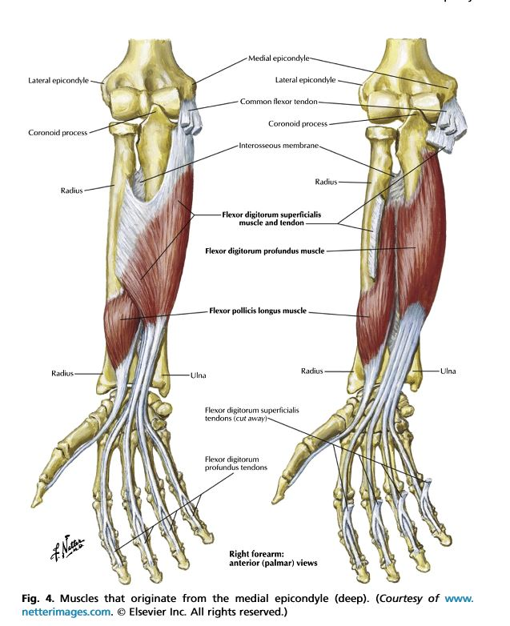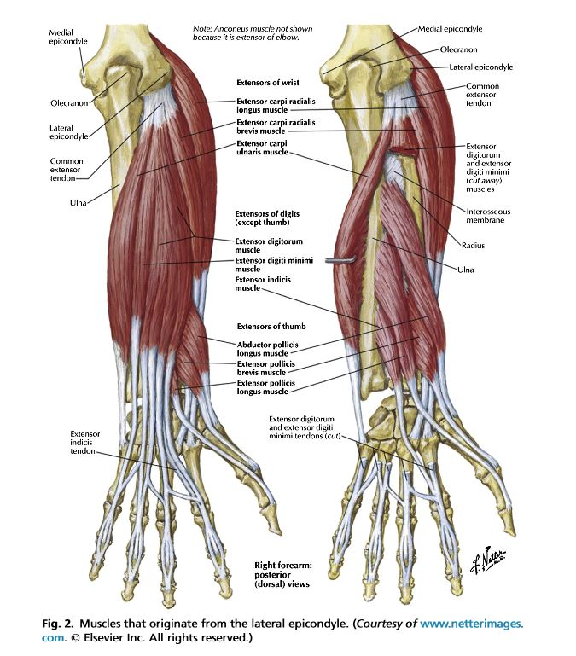

Appendix B- Common Flexor Tendon
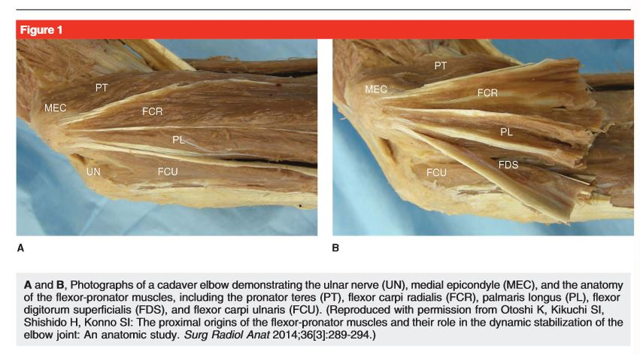
Appendix C
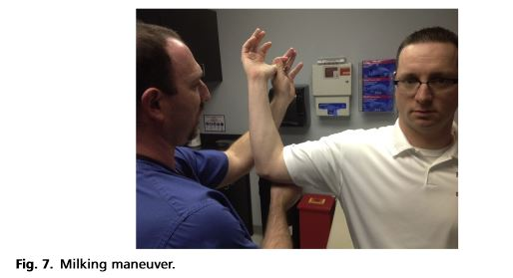
Appendix D
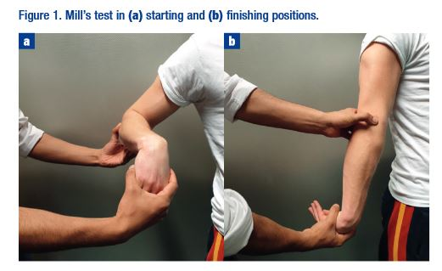

Appendix E
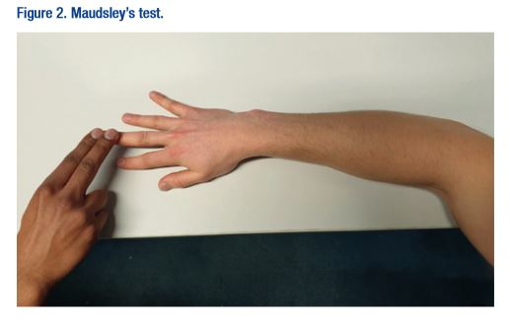

Bibliography
15. Shridhar V, Johns N. Lateral Epicondylitis- Current Concepts. Australian Journal of General Practicioners. 2020;49(11).
16. Johns N, Shridhar V. Lateral epicondylitis: Current concepts. Aust J Gen Pract. 2020;49(11):707-709. doi:10.31128/AJGP-07-20-5519
17. Peterson M, Butler S, Eriksson M, Svärdsudd K. A randomized controlled trial of eccentric vs. concentric graded exercise in chronic tennis elbow (lateral elbow tendinopathy). Clin Rehabil. 2014;28(9):862-872. doi:10.1177/0269215514527595
18. Viswas R, Ramachandran R, Korde Anantkumar P. Comparison of effectiveness of supervised exercise program and Cyriax physiotherapy in patients with tennis elbow (lateral epicondylitis): a randomized clinical trial. ScientificWorldJournal. 2012;2012:939645. doi:10.1100/2012/939645
19. Sims SEG, Miller K, Elfar JC, Hammert WC. Non-surgical treatment of lateral epicondylitis: a systematic review of randomized controlled trials. Hand (N Y). 2014;9(4):419-446. doi:10.1007/s11552-014-9642-x
20. Testa G, Vescio A, Perez S, et al. Extracorporeal shockwave therapy treatment in upper limb diseases: A systematic review. J Clin Med. 2020;9(2). doi:10.3390/jcm9020453
21. Olaussen M, Holmedal Ø, Mdala I, Brage S, Lindbæk M. Corticosteroid or placebo injection combined with deep transverse friction massage, Mills manipulation, stretching and eccentric exercise for acute lateral epicondylitis: a randomised, controlled trial. BMC Musculoskelet Disord. 2015;16:122. doi:10.1186/s12891-015-0582-6
22. Bohlen HL, Schwartz ZE, Wu VJ, et al. Platelet-Rich Plasma Is an Equal Alternative to Surgery in the Treatment of Type 1 Medial Epicondylitis. Orthop J Sports Med. 2020;8(3):2325967120908952. doi:10.1177/2325967120908952
23. Do Nascimento AT, Claudio GK. Arthroscopic surgical treatment of medial epicondylitis. J Shoulder Elbow Surg. 2017;26(12):2232-2235. doi:10.1016/j.jse.2017.08.019
24. Mehta S. Relationship between workload and throwing injury in varsity baseball players. Phys Ther Sport. 2019;40:66-70. doi:10.1016/j.ptsp.2019.08.001
25. Sakata J, Nakamura E, Suzuki T, et al. Throwing injuries in youth baseball players: can a prevention program help? A randomized controlled trial. Am J Sports Med. 2019;47(11):2709-2716. doi:10.1177/0363546519861378
26. Sutton D, Gross DP, Côté P, et al. Multimodal care for the management of musculoskeletal disorders of the elbow, forearm, wrist and hand: a systematic review by the Ontario Protocol for Traffic Injury Management (OPTIMa) Collaboration. Chiropr Man Therap. 2016;24:8. doi:10.1186/s12998-016-0089-8
27. Stasinopoulos D, Stasinopoulos I. Comparison of effects of eccentric training, eccentric-concentric training, and eccentric-concentric training combined with isometric contraction in the treatment of lateral elbow tendinopathy. J Hand Ther. 2017;30(1):13-19. doi:10.1016/j.jht.2016.09.001
28. Couppé C, Svensson RB, Silbernagel KG, Langberg H, Magnusson SP. Eccentric or concentric exercises for the treatment of tendinopathies? J Orthop Sports Phys Ther. 2015;45(11):853-863. doi:10.2519/jospt.2015.5910
29. Cullinane FL, Boocock MG, Trevelyan FC. Is eccentric exercise an effective treatment for lateral epicondylitis? A systematic review. Clin Rehabil. 2014;28(1):3-19. doi:10.1177/0269215513491974
1. Hume P, Reid D, Edwards T. Epicondylar Injury in Sport- Epidemiology, Type, Mechanisms, Assessment, Management and Prevention . J Sports Med. 2006.
2. Vaquero-Picado A, Barco R, Antuña SA. Lateral epicondylitis of the elbow. EFORT Open Reviews. 2016;1(11):391-397. doi:10.1302/2058-5241.1.000049
3. Duncan J, Duncan R, Bansal S, Davenport D, Hacker A. Lateral epicondylitis: the condition and current management strategies. Br J Hosp Med (Lond). 2019;80(11):647-651. doi:10.12968/hmed.2019.80.11.647
4. Amin NH, Kumar NS, Schickendantz MS. Medial epicondylitis: evaluation and management. J Am Acad Orthop Surg. 2015;23(6):348-355. doi:10.5435/JAAOS-D-14-00145
5. Ciccotti MC, Schwartz MA, Ciccotti MG. Diagnosis and treatment of medial epicondylitis of the elbow. Clin Sports Med. 2004;23(4):693-705, xi. doi:10.1016/j.csm.2004.04.011
6. Grana W. Medial epicondylitis and cubital tunnel syndrome in the throwing athlete. Clin Sports Med. 2001;20(3):541-548. doi:10.1016/s0278-5919(05)70268-4
7. Pitzer ME, Seidenberg PH, Bader DA. Elbow tendinopathy. Med Clin North Am. 2014;98(4):833-49, xiii. doi:10.1016/j.mcna.2014.04.002
8. Ahmad Z, Siddiqui N, Malik S, Abdus-Samee M, TytherleighStrong G, Rushton N. Lateral epicondylitis A REVIEW OF PATHOLOGY AND MANAGEMENT. Bone Joint J. 2013.
9. Coombes BK, Bisset L, Vicenzino B. Management of lateral elbow tendinopathy: one size does not fit all. J Orthop Sports Phys Ther. 2015;45(11):938-949. doi:10.2519/jospt.2015.5841
10. Roetert EP, Brody H, Dillman C, Groppel J, Schultheis J. The Biomechanics of Tennis Elbow- An Integrated Approach. Clin Sports Med. 1995;14.
11. Shiri R, Viikari-Juntura E. Lateral and medial epicondylitis: role of occupational factors. Best Pract Res Clin Rheumatol. 2011;25(1):43-57. doi:10.1016/j.berh.2011.01.013
12. Schnatz P, Steiner C. Tennis elbow: a biomechanical and therapeutic approach. J Am Osteopath Assoc. 1993;93(7):778, . doi:10.7556/jaoa.1993.93.7.778
13. Galloway MT, Lalley AL, Shearn JT. The role of mechanical loading in tendon development, maintenance, injury, and repair. J Bone Joint Surg Am. 2013;95(17):1620-1628. doi:10.2106/JBJS.L.01004
14. Walker-Bone K, Palmer KT, Reading I, Coggon D, Cooper C. Occupation and epicondylitis: a population-based study. Rheumatology. 2012;51(2):305-310. doi:10.1093/rheumatology/ker228
15. Shridhar V, Johns N. Lateral Epicondylitis- Current Concepts. Australian Journal of General Practicioners. 2020;49(11).
16. Johns N, Shridhar V. Lateral epicondylitis: Current concepts. Aust J Gen Pract. 2020;49(11):707-709. doi:10.31128/AJGP-07-20-5519
17. Peterson M, Butler S, Eriksson M, Svärdsudd K. A randomized controlled trial of eccentric vs. concentric graded exercise in chronic tennis elbow (lateral elbow tendinopathy). Clin Rehabil. 2014;28(9):862-872. doi:10.1177/0269215514527595
18. Viswas R, Ramachandran R, Korde Anantkumar P. Comparison of effectiveness of supervised exercise program and Cyriax physiotherapy in patients with tennis elbow (lateral epicondylitis): a randomized clinical trial. ScientificWorldJournal. 2012;2012:939645. doi:10.1100/2012/939645
19. Sims SEG, Miller K, Elfar JC, Hammert WC. Non-surgical treatment of lateral epicondylitis: a systematic review of randomized controlled trials. Hand (N Y). 2014;9(4):419-446. doi:10.1007/s11552-014-9642-x
20. Testa G, Vescio A, Perez S, et al. Extracorporeal shockwave therapy treatment in upper limb diseases: A systematic review. J Clin Med. 2020;9(2). doi:10.3390/jcm9020453
21. Olaussen M, Holmedal Ø, Mdala I, Brage S, Lindbæk M. Corticosteroid or placebo injection combined with deep transverse friction massage, Mills manipulation, stretching and eccentric exercise for acute lateral epicondylitis: a randomised, controlled trial. BMC Musculoskelet Disord. 2015;16:122. doi:10.1186/s12891-015-0582-6
22. Bohlen HL, Schwartz ZE, Wu VJ, et al. Platelet-Rich Plasma Is an Equal Alternative to Surgery in the Treatment of Type 1 Medial Epicondylitis. Orthop J Sports Med. 2020;8(3):2325967120908952. doi:10.1177/2325967120908952
23. Do Nascimento AT, Claudio GK. Arthroscopic surgical treatment of medial epicondylitis. J Shoulder Elbow Surg. 2017;26(12):2232-2235. doi:10.1016/j.jse.2017.08.019
24. Mehta S. Relationship between workload and throwing injury in varsity baseball players. Phys Ther Sport. 2019;40:66-70. doi:10.1016/j.ptsp.2019.08.001
25. Sakata J, Nakamura E, Suzuki T, et al. Throwing injuries in youth baseball players: can a prevention program help? A randomized controlled trial. Am J Sports Med. 2019;47(11):2709-2716. doi:10.1177/0363546519861378
26. Sutton D, Gross DP, Côté P, et al. Multimodal care for the management of musculoskeletal disorders of the elbow, forearm, wrist and hand: a systematic review by the Ontario Protocol for Traffic Injury Management (OPTIMa) Collaboration. Chiropr Man Therap. 2016;24:8. doi:10.1186/s12998-016-0089-8
27. Stasinopoulos D, Stasinopoulos I. Comparison of effects of eccentric training, eccentric-concentric training, and eccentric-concentric training combined with isometric contraction in the treatment of lateral elbow tendinopathy. J Hand Ther. 2017;30(1):13-19. doi:10.1016/j.jht.2016.09.001
28. Couppé C, Svensson RB, Silbernagel KG, Langberg H, Magnusson SP. Eccentric or concentric exercises for the treatment of tendinopathies? J Orthop Sports Phys Ther. 2015;45(11):853-863. doi:10.2519/jospt.2015.5910
29. Cullinane FL, Boocock MG, Trevelyan FC. Is eccentric exercise an effective treatment for lateral epicondylitis? A systematic review. Clin Rehabil. 2014;28(1):3-19. doi:10.1177/0269215513491974

