Evaluation and Treatment of Subacromial Impingement Syndrome
Subacromial Impingement Syndrome (SIS) is an umbrella term that refers to a number of different pathologies, most commonly bursitis and rotator cuff tears, with a proposed common etiology.^{1–3} The history of the diagnosis can be traced back to early work by Dr. Charles Neer, who proposed physical pinching of the rotator cuff tendons under the acromion process as a mechanical cause of tears and began the treatment of acromioplasty to relieve this factor.⁴ As this theory has gained more focus, researchers proposed that consistent force between the rotator cuff tendons and the underside of the acromion during overhead activity causes changes in osteoarthritis, osteophytes, joint spurs, and thickened coracoacromial ligament size, reducing the area of the subacromial zone, causing greater impingement-related deficits and rotator cuff tears.^{5,6}
Section 1: History and Risk Factors
Over time, SIS categorization has been broken into different proposed subcategories and characterizations. Others prefer to differentiate external impingement, the more common mechanism that occurs outside the glenohumeral capsule, and internal, or non-outlet impingement, which occurs due to compression of the labrum and rotator cuff tendons within the glenoid.^{1,7,8} Within external impingement, some prefer to further distinguish primary impingement, where the physical pinching of structures under the acromion is the primary issue, from secondary impingement, where impingement signs are a reflection of a larger issue elsewhere, such as deficits in movement patterns, instability, or glenohumeral capsular integrity.^{1,6} Although this paper will discuss methods to differentiate these categories of SIS, the focus of the paper will be on diagnosis and treatment of SIS as a singular diagnosis.
Shoulder issues are among the most common presentations to physicians in the United States, accounting for about 33.2% of visits due to musculoskeletal pain and affecting an estimated prevalence of 7-27% of Americans.⁹ Of these visits due to shoulder pain, SIS is the most common cause, with an estimation of 44-65% of all presentations in a physician’s office due to shoulder pain being related to SIS.^{7,10} Despite this high prevalence, accurate diagnosis of SIS remains a difficulty in practice.² As such, use of the patient’s history and analysis of risk factors are important tools in improving diagnosis. Age is the strongest risk factor for developing a rotator cuff injury, due to a number of factors.⁵ First, older adults generally have worsened tendon strength and elasticity, healing potential, and vascularity.^{5,8} In addition, some theorize that older adults have seen greater repetitions of overhead motions over time, leading to cumulative damage to tendons and structures.¹⁰ While the exact age that the risk increases is variable, adults greater than 50 years old have increased risk of tears, and adults older than 60 years old have worse outcomes.¹⁰ Patients with diabetes are up to 2.11 times more likely to develop SIS, and there is a greater risk in both non-working and working adults.⁵ Patients with a larger body mass index (BMI) have a greater risk, with a BMI > 24 kg/m² associated with worse outcomes, longer duration of SIS symptoms, poorer scapulothoracic and glenohumeral mechanics, and worse healing potential.¹⁰ Up to 83% of patients with a spinal cord injury who use a wheelchair have chronic shoulder pain, with many of them testing positive for impingement due to overuse of upper extremities and development of muscular imbalances.¹¹ Occupation is also strongly associated with SIS, as individuals who perform overhead upper extremity tasks frequently have a higher risk of developing SIS.¹² In addition, individuals who work with vibrating machinery, lift heavy weight or use large voluntary force more than ten times per day, or work overhead for more than one total hour have up to four times higher risk of developing SIS.¹² Even psychosocial job demands carry risk, as there is a significantly lower risk for individuals with high job security than those with high psychosocial job demands.¹²
Some risk factors are related more to shoulder-specific causes. Scapular dyskinesia, which has its own difficulties in agreement with diagnosis, has been associated with SIS.¹³ Despite conflicting opinions, there is evidence that patients with decreased scapular upward rotation and posterior tilting during overhead motion have increased risk of SIS, supported by demonstrations of approximation between rotator cuff tendons and the acromion at a lower point in the elevation cycle in individuals with these scapular characteristics.^{13,14} Increased thoracic kyphosis plays a similar role, as it is related to increased anterior tilt and downward rotation of the scapula, reduced overhead range of motion, and increased occurrence of SIS.¹⁵ Muscular imbalances where the upper trapezius and shoulder internal rotators are more active and there is weakness or underactivity in the serratus anterior, lower trapezius, or rotator cuff muscles have been linked to SIS as well; however, it is not known if these imbalances are a cause of effect of the impingement.^{8,11} Tightness of the posterior shoulder capsule can potentially cause anterior-superior translation of the humerus, scapular protraction, and anterior scapular tilt, all of which reduce the subacromial space.¹⁶ Repetitive high-force overhead use, such as in overhead sports like tennis and swimming, has commonly been linked to SIS, although it is often associated more with internal impingement risk than the traditional outlet impingement.^{8,17} More recently, increased risk has been associated with specific sport factors, such as average ball speed, number of overhead repetitions, and muscular strength in upper limbs.⁸
Acromion shape has explored as a potential factor in SIS, based on the suspected effect on the amount of^{4,18} subacromial space present. Hooked acromion, also referred to as Type III acromion shape, has been linked with increased development of spurs and SIS incidence.^{4,18} Specific morphological factors have been examined under radiograph linked to an increased risk of SIS in patients with a number of specific shapes or sizes.^{4,18} Increased acromial index and acromial slope angle, as well as decreased acromial tilt, are associated with increased risk of SIS and rotator cuff damage.^{4,18} These characteristics are shown in Image 1 in the Appendix.⁴ In addition, individuals with a greater protrusion of the acromion beyond the clavicle or a larger distance from the medial to lateral edges of the acromion are both associated with increased risk of impingement.¹⁸ In general, a large number of factors contribute to the risk of subacromial impingement, including both modifiable and non-modifiable contributors.
Glenohumeral instability has also been linked to secondary impingement of the shoulder.¹ Instability has been linked to impingement, even when the instability is subtle, meaning the individual has suffered from pain and feelings of instability with no history of dislocation.⁶ This has been demonstrated to be a higher risk in athletic populations, especially younger athletes, than in typical populations.⁶ This risk could be due to increased laxity allowing greater motion of the humeral head in the glenoid, especially in the anterior direction during the late cocking phase of overhead throwing, which can stretch the posterior rotator cuff and cause impingement between the posterior humeral head and glenoid.⁸ As a result, there has been documented cases of young athletes who have been diagnosed with SIS and received acromioplasty procedures, with no relief of symptoms until underlying instability was addressed.⁶
Section 2: Diagnosis
When considering other potential diagnoses, the differential diagnosis list often consists of multiple conditions due to the complexity of the shoulder and difficulties in reliable and accurate diagnosis of specific conditions. In fact, there are large amounts of overlap between positive tests in multiple common shoulder conditions.¹⁹ Supraspinatus tendinopathy is often diagnosed along with SIS due to the location of the supraspinatus tendon beneath the acromion, but the use of the empty can test can help to specifically target the supraspinatus musculature.¹⁹ A positive test result, especially when consisting of both pain and weakness during the test, can often rule in pathology to the supraspinatus.¹⁹ Tear of any of the rotator cuff muscles is most accurately identified by a positive lag sign during external or internal rotation of the shoulder.¹⁷ During the Painful Arc test, pain higher than 120° of shoulder elevation typically indicates involvement of the acromioclavicular joint, rather than the subacromial area.^{1,3} the use of the combination of Speed’s Test, Biceps Load II Test, and direct palpation of the long head of the biceps is accurate in differentiating tendinitis of the long head of the biceps from other tendinitis that might be occurring to the rotator cuff under the acromion.¹⁹ Lastly, instability of the shoulder can often be present with, and be a cause of, secondary impingement.⁶ To help test for instability, the combination of the Rockwood Test, Apprehension and Relocation Tests, and a multidirectional scale, such as the Carter-Wilkinson scale, can be applied.⁶
Signs and symptoms of SIS can vary due to the many potential pathologies involved in the condition, but there is some consensus of typical presentations. Although it can vary among individuals, patients with SIS tend to have more subacute or chronic symptoms than acute, and might not be able to report a specific start of symptoms.³ Pain might be located toward the anterior or lateral aspect of the shoulder, especially during overhead motion.^{1,3} Generally, patients with subacromial impingement tend to have full or near-full passive range of motion, but might demonstrate deficits in glenohumeral elevation or internal rotation ranges of motion.¹⁶ Overhead athletes in particular tend to demonstrate more internal rotation deficits, which can be a sign of tightness in the posterior shoulder capsular complex.^{8,16} Neer originally proposed a scale for staging subacromial impingement to differentiate expected symptoms based on level of damage to structures and it is still used in some parts today.^{1,19} In this scale, stage I indicates irritation with mild pain during overhead activity, stage II indicates more severe irritation and partial tearing of rotator cuff tendons with mild to moderate pain during a larger range of activities, and stage III indicates full thickness tears to more severe damage with scapular or rotator cuff weakness in addition to pain at rest, at night, and during activity.^{1,19}
In terms of diagnosis, there is a lack of consensus on which examination techniques are best at diagnosing SIS, likely due to deficits in specificity of the tests.⁹ Traditionally, the Painful Arc Test has been used to determine impingement based on a symptomatic response in the range of 60-120° of overhead elevation, which is the range in which the supraspinatus tendon and humeral head both come closest to the acromion process; although, some evidence indicates this minimal distance can occur earlier, in the range of 30-42 degrees.^{1,20} While often one of the first tests considered for impingement, the Painful Arc test has demonstrated sensitivity ranging from poor to 0.75, and specificity ranging from 0.67-0.90 in diagnosing SIS or non-specific shoulder impairment.^{7,9,19} The other two most commonly recommended and utilized tests are the Hawkins-Kennedy, which demonstrates specificity from 0.26-0.62 and sensitivity from 0.63-0.86, and the Neer Impingement Test, which demonstrates specificity from 0.54-0.60 and sensitivity from 0.72-0.81.^{2,7,9,19} In fact, based on their likelihood ratios, none of these three test provide enough support to justify a single positive test enough to discriminate SIS from other pathologies.² Rather, in using these test singularly, there appears to be more value in ruling out SIS pathology than providing a diagnosis.⁹
To improve detection, multiple clusters of tests have been proposed, with varying levels of accuracy. The combination of Neer and Hawkins-Kennedy tests gives a sensitivity that ranges from 0.78-0.96, so it appears to be useful in combination to rule out impingement pathology.^{19,21} Using a positive test on either Neer or Hawkins-Kennedy improves the sensitivity to 0.96 for ruling out SIS, but a low specificity of 0.41-0.51.²¹ A positive test on 3 out of the 5-test cluster of Neer, Hawkins-Kennedy, Painful Arc, Resisted External Rotation Test, and Jobe Empty Can Test yields a positive likelihood ratio (LR+) of 2.93 and negative likelihood ratio (LR-) of 0.34, with a sensitivity of 0.75 and specificity of 0.74.⁹ Although these clustered tests provide improved diagnostic accuracy, they still fail to meet the recommended threshold of psychometrics to be considered confirmatory tests.² As such, clinicians should not rely only on special tests alone, but take them in combination with patient’s history, signs, symptoms, and other presentation characteristics.
There are tests designed to distinguish internal from external impingement, but many show poor diagnostic accuracy.¹ On the other hand, the Internal Rotation Resistance Strength Tests, also known as the Zaslav Test, has demonstrated a sensitivity of 0.88 and specificity of 0.96 in differentiating internal and external impingement.¹⁹ This test is designed to compare weakness in shoulder external rotators compared to internal rotators with the arm placed at 90° to simulate a potential impingement position with contraction of rotator cuff muscles.¹ If internal rotation strength is more limited than external rotation strength, than this is proposed to indicate internal impingement based on intra-capsular deficits in rotator cuff musculature.¹ While less studied than the traditional impingement tests, early results indicate that this test can be useful in helping distinguish the specific impingement and mechanism behind the injury.
Imaging might be indicated to assist with accurate diagnosis and prognosis of SIS. X-ray or radiographic imaging can be used to quantify the space between the humeral head and acromion, as well as assess the shape of the acromion and presence of calcification in rotator cuff tendons or spurs on the acromion or nearby bone.¹ While it can be used to assess these factors that can contribute to impingement, radiography is typically unable to specifically diagnose SIS since it cannot detail soft tissue damage.¹ On the other hand, MRI imaging can be useful in assessing damage to soft tissues, such as tendinitis, muscle strain, or bursitis, that can be either the cause of effect of impingement syndrome.¹ MRI is most useful in diagnosis of rotator cuff lesions, glenoid labral deficits, and effusion within the subacromial space.²¹ Ultrasound can be used to assess many of the same deficits as MRI, such as rotator cuff lesions, acromiohumeral distance, bursitis, and edema, while at a lower cost and improved portability.²¹ Comparing the two, MRI, while much more expensive, is slightly more accurate at detecting rotator cuff lesions than ultrasound, and also does a better job differentiating partial and complete tears.^{3,21} For many patients, imaging is more helpful for assessing prognosis, as many patients demonstrate deficits on imaging that might not be proportional to their presentation. For example, patients with stage I SIS on MRI have a greater likelihood of achieving full recovery than patients with more advanced stages.¹⁰ Based on this information, many patients do not require imaging for diagnosis of SIS, but might receive a form of soft-tissue imaging in MRI or ultrasound to assesses specific tissue damage, especially prior to surgery to get a better impression of the entire shoulder complex.³
Section 3: Treatment
Treatment for SIS usually consists of a surgical, conservative, or mixed approach. When surgery is advised and implemented, it typically consists of a decompression surgery to the shoulder. This decompression surgery is often an acromioplasty, which removes part of the acromion process to increase space in the subacromial area, and may consist of a bursectomy or other procedure to remove inflamed or damaged tissue.²² There does not appear to be a significant difference in outcomes between the bursectomy procedure alone and a bursectomy with acromioplasty procedure, and avoiding acromioplasty has the benefit of preserving the coracoacromial arch, which can improve stability.²² About 65-80% of patients report improved shoulder function and reduced shoulder pain one year after surgery; however, multiple studies show that there is not a significant difference in pain or function outcomes between patients who are treated for SIS with decompression surgery versus those treated with conservative physical therapy.^{22–24} In addition, surgery is associated with greater risk of complications and a higher overall cost than conservative treatment alone.²⁵ It is important to note that in many patients, up to 30%, surgery is utilized after a failed response to conservative treatment attempts, and 67-90% of these patients report satisfaction with receiving the surgical procedure.^{23,26} In addition, other surgical procedures might address underlying factors, such as arthroscopic labral repairs that function to increase stability at the shoulder, can improve pain, function, and reduce presence of positive secondary impingement findings in patients with shoulder instability.⁶ Based on this information, most patients are advised to perform a trial treatment of conservative therapy before progressing to surgical intervention.
Outside of physical therapy, providers have other treatment options that can be utilized during a course of conservative care. Many providers utilize corticosteroid injections, especially in the beginning of treatment, and the evidence regarding the effectiveness on pain relief and function is conflicting.²⁶ Some providers utilize injection as a first treatment method to help confirm a diagnosis of bursitis or tendinitis in the rotator cuff, with a relief of symptoms supposedly helping to confirm the suspected diagnosis.²⁷ In comparison to other interventions, corticosteroid injection has been shown to have some improvements over physical therapy in range of motion and self-reported shoulder function at 6 weeks, but these improvements are not seen at 6 months; however, there is conflicting evidence that injections have no more benefit than NSAID or placebo in short-term outcomes.^{26,27} It is important for providers to avoid exercising the tissue for two weeks after corticosteroid injection due to potential tissue atrophy and increased injury risk.³ Other interventions that might be utilized include tonoxicam injections, which demonstrate improved pain at rest and shoulder mobility in the short-term compared to placebo, disodium ethylene diamine tetraacetic acid (EDTA) injections, which improve short and long-term outcomes in patients with tendon calcification when used in combination with ultrasound, and acupuncture, which has similar outcomes to steroid injections over short and long-term periods when used with manual therapy.^{3,26} In terms of pharmacological intervention, there is moderate evidence in support of ibuprofen for short-term pain relief, and glyceryltrinitrate patches for improved motion, reduced pain, and improved muscle force generation when compared to placebo patches at both 12 and 24 week follow-up.²⁶
Conservative physical therapy rehabilitation often begins first with a reduction of aggravating activities and a focus on reducing acute pain symptoms.³ It is important when reducing loading to the impinged shoulder to intervene on each of the factors of frequency, duration, and intensity of activity. This is especially key in athletes, who can utilize counting of pitches, hits, repetitions, the speed or intensity at which the motion is performed, the range of motion utilized, and the frequency of practice. Patients who have had symptoms for less than three months are more likely to have a positive outcome from conservative treatment and avoid surgery when compared to patients who have had symptoms for over one year, or more severe symptoms.^{10,25} In addition, patients who have deficits related to function in addition to painful symptoms are more likely to have a recurrence of SIS after recovery than patients who have pain alone.¹⁰ Based on this, providers should educate patients on realistic expectations and prognosis based on their presentation.
While specifics regarding recommended exercise strategy and protocol vary, there is a consensus that exercise improves outcomes in patients with SIS.^{3,23} Based on previously investigated successes of implementing eccentric exercise training in individuals with tendinopathies, the use of similar exercise regimes has been investigated in patients with SIS and compared to general exercise with positive results.²³ One protocol utilized eccentric exercises for the rotator cuff muscles and both concentric and eccentric exercises for the middle trapezius, lower trapezius, rhomboids, and serratus anterior through the use of both bands and free weights for resistance, performed for three sets of fifteen repetitions, once to twice a day for eight weeks.²³ After following this exercise regime, patients that utilized eccentric exercise demonstrated improved patient-reported outcomes in shoulder function, disability, quality of life, and success of treatment, and more patients avoided surgery, with only 20% of the eccentric exercise group undergoing surgery compared to 63% of the general exercise group.²³ In addition, strengthening and neuromuscular retraining exercises for the scapular muscles, including thoracic extensions, range of motion exercises, and stabilization exercises with movement, resulted in improved pain, function, and shoulder range of motion outcomes when compared to interventions that do not consider scapular exercises.^{15,28} While scapular exercises can improve pain and disability outcomes, they have not been shown to impact scapular motion or orientation in patients with scapular dyskinesia.¹⁴ In patients with posterior shoulder tightness and SIS, the use of modified sleeper and modified cross-body stretches in sidelying (Images 2 and 3), when compared to similar treatment programs without these stretches, resulted in less pain during activity, less shoulder tightness, greater glenohumeral internal rotation range of motion, and improved self-reported function.¹⁶
Beyond exercise interventions, there are other treatments that can be utilized by physical therapists as part of a conservative plan. One key element that is often used is manual therapy, which can consist of glenohumeral mobilization, scapular mobilization, and thoracic mobilization or manipulation.^{14,15} In patients with SIS, thoracic manipulation has been shown to improve patient-reported outcomes in shoulder pain and function in short and long-term follow-up.¹⁴ Other research has supported the use of thoracic mobilizations, consisting mostly of grade III posterior-anterior forces, in these patients, as they improved in shoulder range of motion, functional outcome measures, thoracic kyphosis levels, and upper trap muscle tone in four weeks when used in combination with scapular exercises.¹⁵ Lastly, the use of scapular and glenohumeral mobilizations, with the intention of improving motion range and neuromuscular quality, has also been shown to improve pain, disability, and range of motion outcomes.²⁹
In addition to the use of manual therapy, the use of modalities has also been explored. The use of taping has been examined, with the proposed mechanism of improving scapular or glenohumeral alignment and providing constant proprioceptive feedback, but has not shown benefit over placebo and has demonstrated worse outcomes than laser or manual therapy.^{14,29} Both high intensity laser therapy (HILT) and low level laser therapy (LLLT) are theorized to work by reducing inflammation, which lowers pain and allows for increased motion.²⁹ While HILT has demonstrated greater improvements than LLLT, both have shown positive improvements in pain, range of motion, and function when compared to placebo; however, it is unclear if the benefits are still maintained when provided within a physical therapy protocol with other interventions.²⁹ There is also low-quality support for the use of ultrasound for improved pain and function outcomes, as well as greater levels of patient satisfaction with treatment, especially in short-term outcomes and in patients with calcific tendinitis.¹⁷
Following surgery, physical therapy is typically utilized to help improve patient physical outcomes. Traditional post-operative rehabilitation protocols (Image 5) typically utilize assisted range of motion exercises after surgery and avoid active range of motion for six weeks and strengthening exercises for eight weeks. These have been compared to more aggressive exercise protocols (Image 4), which use active range of motion exercises within two weeks or surgery and strengthening within six weeks.^{25,30} While both rehabilitation groups demonstrated significant improvements in pain and function at one year, the progressive exercise group demonstrated greater improvements in glenohumeral extension and abduction range of motion at both three and twelve months, as well as patient-reported function outcomes at six weeks.³⁰ A sample of commonly utilized exercises following surgical procedure is included in the Appendix (Image 6).³¹ Based on this, patients should be guided on a progressive exercise program with a focus on improving motion and strength as soon as safe to do so.
In summary, subacromial impingement syndrome is a complex disorder of the shoulder that often presents with unclear symptomology and a challenging diagnosis. Since it is often used an umbrella term, SIS is often used to refer to a number of pathologies that occur close to the acromion, whether caused by impingement or not. Rehabilitation efforts should focus on exercise-based interventions while addressing loading of the tissues and underlying risk factors.

Appendix
Image 1: Adapted from Balke. et. al. Increased acromial slope and acromion index have been found to correlated positively with SIS, while decreased acromial tilt is associated with greater SIS risk.
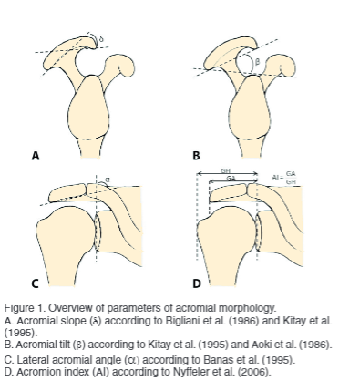

Image 2: Modified Cross-Body Stretch and Image 3: Modified Sleeper Stretch for the posterior shoulder complex. Adapted from Tahran et. al., these stretching exercises resulted in improved outcomes for patients with SIS and posterior shoulder tightness when used as part of a greater treatment plan. Patients are instructed to lay at an angle to avoid direct compressive force on the glenohumeral joint.
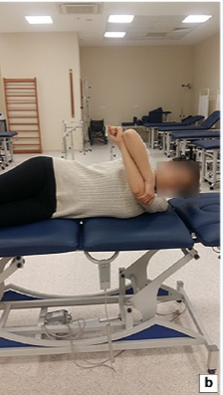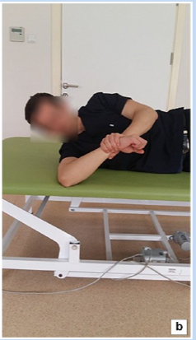

Image 4: Progressive exercise protocol for post-operative rehabilitation following decompression surgery, taken from Hultenheim et. al. Compare to traditional protocol as shown in Image 5. Program 1A performed every two hours starting the day of surgery, Program 2A performed every two hours starting two weeks post-op, and Program 3A performed three times per day starting six weeks post-op. Dynamic eccentric and concentric strengthening exercises in full range of motion are added in eight weeks post-op.
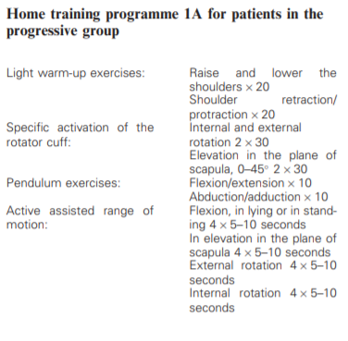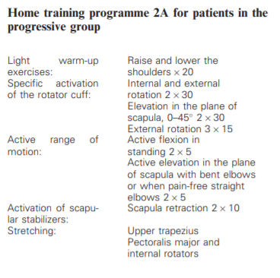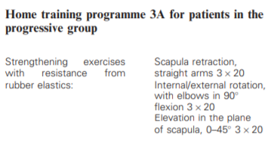

Image 5: Traditional exercise program following decompression surgery, taken from Hultenheim et. al. Program 1B performed three times per day starting the day of surgery, Program 2B performed three times per day starting two weeks post-op, and resistance training started in limited range of motion eight weeks post-op.
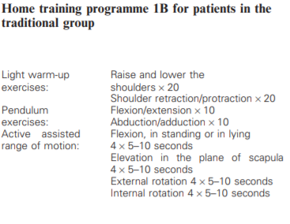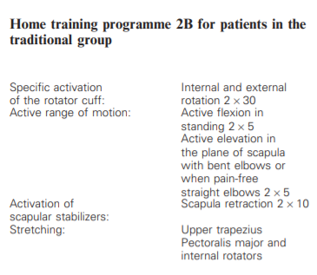

Image 6: Common physical therapy exercises for SIS patients, both for post-operative and conservative rehabilitation. Taken from Christiansen et. al.
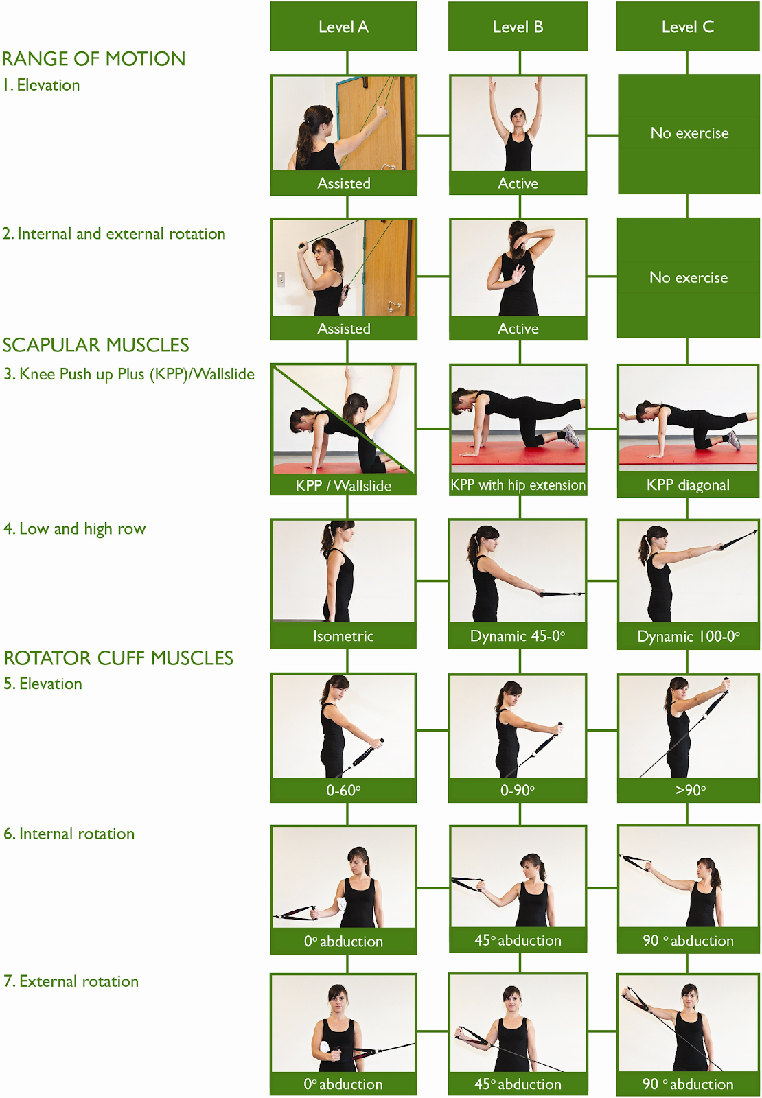
Bibliography
1. Magee DJ. Orthopedic Physical Assessment. 6th ed. St. Louis, Missouri: Elsevier; 2014.
2. Hegedus EJ, Goode AP, Cook CE, et al. Which physical examination tests provide clinicians with the most value when examining the shoulder? Update of a systematic review with meta-analysis of individual tests. Br J Sports Med. 2012;46(14):964-978. doi:10.1136/bjsports-2012-091066
3. Greenberg DL. Evaluation and treatment of shoulder pain. Med Clin North Am. 2014;98(3):487-504. doi:10.1016/j.mcna.2014.01.016
4. Balke M, Schmidt C, Dedy N, Banerjee M, Bouillon B, Liem D. Correlation of acromial morphology with impingement syndrome and rotator cuff tears. Acta Orthop. 2013;84(2):178-183. doi:10.3109/17453674.2013.773413
5. Leong HT, Fu SC, He X, Oh JH, Yamamoto N, Hang S. Risk factors for rotator cuff tendinopathy: A systematic review and meta-analysis. J Rehabil Med. 2019;51(9):627-637. doi:10.2340/16501977-2598
6. Nordenson U, Garofalo R, Conti M, et al. Minor or occult shoulder instability: an intra-articular pathology presenting with extra-articular subacromial impingement symptoms. Knee Surg Sports Traumatol Arthrosc. 2011;19(9):1570-1575. doi:10.1007/s00167-011-1552-7
7. Cotter EJ, Hannon CP, Christian D, Frank RM, Bach BR. Comprehensive examination of the athlete’s shoulder. Sports Health. 2018;10(4):366-375. doi:10.1177/1941738118757197
8. Mackenzie TA, Herrington L, Horlsey I, Cools A. An evidence-based review of current perceptions with regard to the subacromial space in shoulder impingement syndromes: Is it important and what influences it? Clin Biomech (Bristol, Avon). 2015;30(7):641-648. doi:10.1016/j.clinbiomech.2015.06.001
9. Michener LA, Walsworth MK, Doukas WC, Murphy KP. Reliability and diagnostic accuracy of 5 physical examination tests and combination of tests for subacromial impingement. Arch Phys Med Rehabil. 2009;90(11):1898-1903. doi:10.1016/j.apmr.2009.05.015
10. Ertan S, Ayhan E, Güven MF, Kesmezacar H, Akgün K, Babacan M. Medium-term natural history of subacromial impingement syndrome. J Shoulder Elbow Surg. 2015;24(10):1512-1518. doi:10.1016/j.jse.2015.06.007
11. Wilbanks SR, Bickel CS. Scapular Stabilization and Muscle Strength in Manual Wheelchair Users with Spinal Cord Injury and Subacromial Impingement. Top Spinal Cord Inj Rehabil. 2016;22(1):60-70. doi:10.1310/sci2201-60
12. van Rijn RM, Huisstede BM, Koes BW, Burdorf A. Associations between work-related factors and specific disorders of the shoulder--a systematic review of the literature. Scand J Work Environ Health. 2010;36(3):189-201. doi:10.5271/sjweh.2895
13. Lawrence RL, Braman JP, Ludewig PM. Shoulder kinematics impact subacromial proximities: a review of the literature. Braz J Phys Ther. 2020;24(3):219-230. doi:10.1016/j.bjpt.2019.07.009
14. Takeno K, Glaviano NR, Norte GE, Ingersoll CD. Therapeutic interventions for scapular kinematics and disability in patients with subacromial impingement: A systematic review. J Athl Train. 2019;54(3):283-295. doi:10.4085/1062-6050-309-17
15. Park SJ, Kim SH, Kim SH. Effects of Thoracic Mobilization and Extension Exercise on Thoracic Alignment and Shoulder Function in Patients with Subacromial Impingement Syndrome: A Randomized Controlled Pilot Study. Healthcare (Basel). 2020;8(3). doi:10.3390/healthcare8030316
16. Tahran Ö, Yeşilyaprak SS. Effects of modified posterior shoulder stretching exercises on shoulder mobility, pain, and dysfunction in patients with subacromial impingement syndrome. Sports Health. 2020;12(2):139-148. doi:10.1177/1941738119900532
17. Page MJ, Green S, Mrocki MA, et al. Electrotherapy modalities for rotator cuff disease. Cochrane Database Syst Rev. 2016;(6):CD012225. doi:10.1002/14651858.CD012225
18. Zeng Y-M, Xu C, Zhang K, Yu D-G, Zhang J. Prediction of Rotator Cuff Injury Associated with Acromial Morphology: A Three-Dimensional Measurement Study. Orthop Surg. 2020;12(5):1394-1404. doi:10.1111/os.12774
19. Hanchard NCA, Lenza M, Handoll HHG, Takwoingi Y. Physical tests for shoulder impingements and local lesions of bursa, tendon or labrum that may accompany impingement. Cochrane Database Syst Rev. 2013;(4):CD007427. doi:10.1002/14651858.CD007427.pub2
20. Coats-Thomas MS, Massimini DF, Warner JJP, Seitz AL. In vivo evaluation of subacromial and internal impingement risk in asymptomatic individuals. Am J Phys Med Rehabil. 2018;97(9):659-665. doi:10.1097/PHM.0000000000000940
21. Ardic F, Kahraman Y, Kacar M, Kahraman MC, Findikoglu G, Yorgancioglu ZR. Shoulder impingement syndrome: relationships between clinical, functional, and radiologic findings. Am J Phys Med Rehabil. 2006;85(1):53-60. doi:10.1097/01.phm.0000179518.85484.53
22. Donigan JA, Wolf BR. Arthroscopic subacromial decompression: acromioplasty versus bursectomy alone--does it really matter? A systematic review. Iowa Orthop J. 2011;31:121-126.
23. Holmgren T, Björnsson Hallgren H, Öberg B, Adolfsson L, Johansson K. Effect of specific exercise strategy on need for surgery in patients with subacromial impingement syndrome: randomised controlled study. BMJ. 2012;344:e787. doi:10.1136/bmj.e787
24. Dorrestijn O, Stevens M, Winters JC, van der Meer K, Diercks RL. Conservative or surgical treatment for subacromial impingement syndrome? A systematic review. J Shoulder Elbow Surg. 2009;18(4):652-660. doi:10.1016/j.jse.2009.01.010
25. Gebremariam L, Hay EM, Koes BW, Huisstede BM. Effectiveness of surgical and postsurgical interventions for the subacromial impingement syndrome: a systematic review. Arch Phys Med Rehabil. 2011;92(11):1900-1913. doi:10.1016/j.apmr.2011.06.006
26. van der Sande R, Rinkel WD, Gebremariam L, Hay EM, Koes BW, Huisstede BM. Subacromial impingement syndrome: effectiveness of pharmaceutical interventions-nonsteroidal anti-inflammatory drugs, corticosteroid, or other injections: a systematic review. Arch Phys Med Rehabil. 2013;94(5):961-976. doi:10.1016/j.apmr.2012.11.041
27. Burger M, Africa C, Droomer K, et al. Effect of corticosteroid injections versus physiotherapy on pain, shoulder range of motion and shoulder function in patients with subacromial impingement syndrome: A systematic review and meta-analysis. S Afr J Physiother. 2016;72(1):318. doi:10.4102/sajp.v72i1.318
28. Saito H, Harrold ME, Cavalheri V, McKenna L. Scapular focused interventions to improve shoulder pain and function in adults with subacromial pain: A systematic review and meta-analysis. Physiother Theory Pract. 2018;34(9):653-670. doi:10.1080/09593985.2018.1423656
29. Pekyavas NO, Baltaci G. Short-term effects of high-intensity laser therapy, manual therapy, and Kinesio taping in patients with subacromial impingement syndrome. Lasers Med Sci. 2016;31(6):1133-1141. doi:10.1007/s10103-016-1963-2
30. Hultenheim Klintberg I, Gunnarsson A-C, Styf J, Karlsson J. Early activation or a more protective regime after arthroscopic subacromial decompression--a description of clinical changes with two different physiotherapy treatment protocols--a prospective, randomized pilot study with a two-year follow-up. Clin Rehabil. 2008;22(10-11):951-965. doi:10.1177/0269215508090771
31. Christiansen DH, Falla D, Frost P, Frich LH, Svendsen SW. Physiotherapy after subacromial decompression surgery: development of a standardised exercise intervention. Physiotherapy. 2015;101(4):327-339. doi:10.1016/j.physio.2015.01.004

