Delirium & Dementia in Acute Care
Delirium = an acute, transient, usually reversible altered state of consciousness and cognition
Dementia = memory impair + one or more of the following: aphasia (language problems), apraxia (organizational problems), agnosia (inability to recognize objects), disturbed executive function

Distinguishing the Difference
Characteristics | Delirium | Dementia
Onset | Acute | Insidious
Awareness | Altered mental state | Clear until later stages
Progression | Fluctuating, reversible | Progressive decline
Mood | Labile  Worse in PM “sundowning” | History of present sadness  Worse in AM
Delusions | Short-lived, changing; predominantly visual and tactile | More fixed; predominantly auditory
*Patients with dementia are at an increased risk of delirium and may have both*

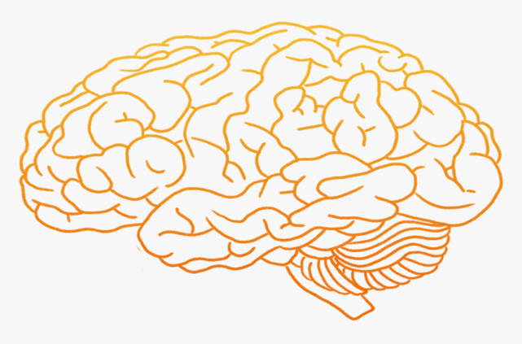
Causes and Risk Factors
Dementia is a result of brain damage. There are a myriad of causes of brain damage such as neurologic, neuropsychiatric and medical conditions.
DELIRIUM
Drugs
Electrolyte disturbances
Lack of drugs
Infection
Reduced sensory input
Intracranial (meds, seizure, stroke)
Urinary/intestinal problems
Metabolic changes
Modifiable Risk factors
Increase: education, physical activity, social contact
Decrease: Hearing loss, hypertension, obesity, smoking, depression, diabetes, excessive alcohol intake, head injury, air pollution

Treatment in Acute Setting
DELIRIUM  Identify and remove cause  Prevention strategies double as symptom management strategies  Optimize environment (dark & quiet at night, stimulation during day)  May benefit from sitter  Pharmacology [ex. neuroleptics for distressing delusions, haloperidol, benzodiazepine (if delirium is caused by benzo or alcohol withdrawal)] | DEMENTIA  *No cure* Treatment depends on type of dementia, symptom management in hospital  Adherence to schedule  Adequate hydration and nutrition  Memory aides  Pharmacology [ex. Acetylcholinesterase inhibitors, AMDA antagonists, behavioral meds including antipsychotics, antidepressants and mood stabilizers]
Approximately 40% of delirium cases me be preventable!
Prevention Strategies: avoid delirium-risk medications, EARLY PHYSICAL MOBILIZATION, adequate hydration and nutrition, cognitive stimulation, minimize sensory deprivation by correction of sensory deficits

Therapy Specific Tips
Reorient patient *except with late stages of dementia
Avoid multitasking
Avoid “elderspeak” (ex. honey, sweetie, dear)
Approach patient from the front
Offer limited choices
Communicate with simple, firm, slow-paced speech and repeat instructions if necessary

ADL participation; advocate for OT if appropriate
Dementia: manage short-term memory – reintroduce self during each encounter, explain each step of a evaluation of intervention, etc.

Delirium: reassess and document status
Multidisciplinary approach
Ensure sensory aides (eyeglasses, hearing aides, etc.)

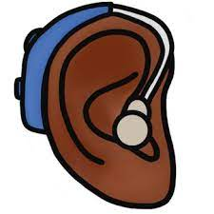
Establish routine if possible (same therapist, same time, etc.)
References
- Livingston G, Huntley J, Sommerlad A, et al. Dementia prevention, intervention, and care: 2020 report of the Lancet Commission. Lancet. 2020;396(10248):413–446.
- Grover S, Avasthi A. Clinical practice guidelines for management of delirium in elderly. Indian J. Psychiatry. 2018;60(Suppl 3):S329–S340.
- Gale SA, Acar D, Daffner KR. Dementia. Am. J. Med. 2018;131(10):1161–1169.
- Gual N, García-Salmones M, Brítez L, et al. The role of physical exercise and rehabilitation in delirium. Eur. Geriatr. Med. 2020;11(1):83–93.
- Pagad S, Somagutta MR, May V, et al. Delirium in cardiac intensive care unit. Cureus. 2020;12(8):e10096.
- CE: Acute Care for Patients with Dementia | CE Article | NursingCenter.
- Rains J, Chee N. The role of occupational and physiotherapy in multi-modal approach to tackling delirium in the intensive care. J. Intensive Care Soc. 2017;18(4):318–322.
- Lippmann S, Perugula ML. Delirium or Dementia? Innov. Clin. Neurosci. 2016;13(9–10):56–57.

