Figures 1 and 2 depict the findings from the analysis of the qualitative interviews. These figures were generated after multiple rounds of coding by several members of the research team. Coding involves combing through transcriptions of each therapist interview and creating key terms or phrases that summarize the thoughts or ideas stated by therapists. These individual codes were then grouped into broader categories and used to create key themes. This iterative process was used with the full research team to enhance the rigor and trustworthiness of the findings.

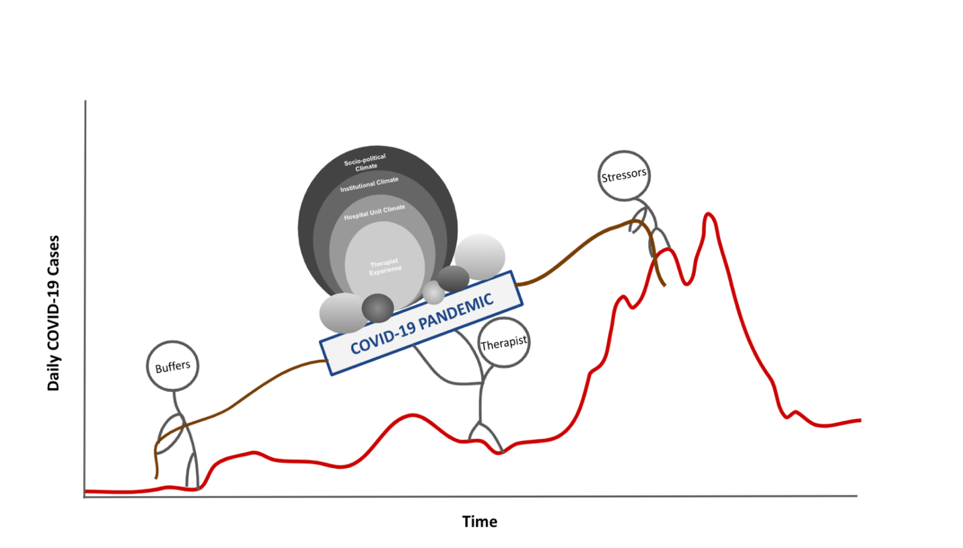
Fig. 1: Impacts of COVID-19 on Rehabilitation Practice Model
Figure 1
Figure 1 illustrates how therapists were impacted and influenced by both stressors and buffers throughout the COVID-19 pandemic. To illustrate this in a more meaningful way, daily cases of COVID-19 diagnoses are used as the ‘hill’ therapists have been climbing and overcoming as frontline healthcare workers. Our analysis revealed that while there were many stressors that therapists encountered during the COVID-19 pandemic, there were also buffers that made coping with these challenging times more manageable. For example, shortages of personal protective equipment (PPE) and the physically taxing nature of donning/doffing PPE were generally considered as stressors, while coping mechanisms such as spending time with immediate family or participating in physical activity outside of their work environment served as buffers to lessen the load and stress felt by many clinicians. The stressors and buffers influence the load that the therapists carry by pulling the therapists in a backward or forwards direction, respectively.
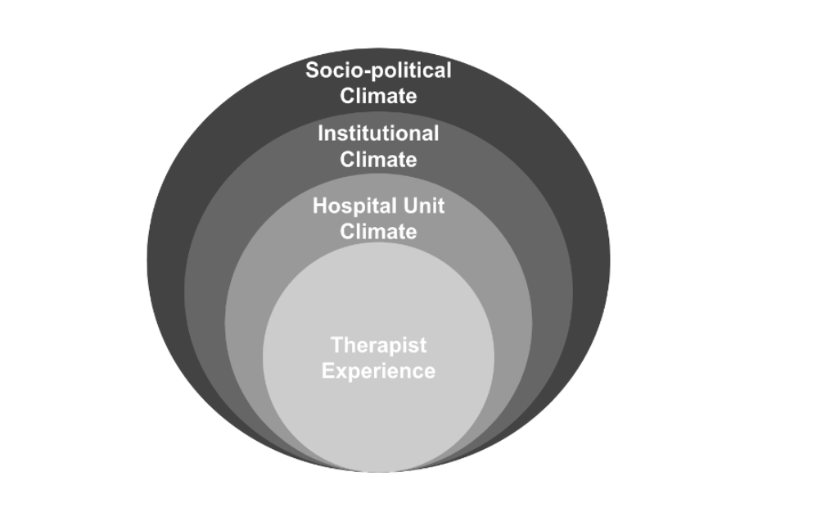
Fig. 2: Key Themes
Figure 2
Figure 2 depicts the load the therapists have dealt with and adapted to during COVID-19. This model represents the four key themes. The model is structured utilizing concentric circles to illustrate the interconnectedness of these key themes, all of which have interacted with one another during the COVID-19 pandemic. Each key theme and its underlying codes are influenced by the adjacent circles, each impacting one another in various ways. Based on qualitative data from interviews, it was found that the socio-political climate surrounding the pandemic directly influenced changes at the institutional level. These institutional policy changes led to changes in individual hospital units and therefore affected the clinician’s experience on each unit. Within each key theme, stressors and buffers were identified that influenced not only the theme itself but also how these themes affected one another. Below are examples of stressors and buffers identified within each of the four key themes. The entirety of the codes, categorized into key themes can be found in table 1.
- Socio-political stressors included stay-at-home orders, mask mandates, public fear, and miscommunication that swept the nation during the pandemic. Buffers included the newfound appreciation for healthcare workers and other essential workers, current and future strides in research that have resulted from the pandemic, as well as the development of a vaccine.
- Institutional stressors included visitor restrictions within hospitals, constant changes in hospital policy, an overall lack of COVID-19 tests, and PPE requirements and shortages. Buffers included the interprofessional relationships that have been fostered during these changes as well as the creation of a new “best practice” protocol amongst rehabilitation professionals in response to COVID-19.
- Hospital unit stressors included challenges with discharge planning, difficulties acquiring interpreter services, patient fears and frustrations, unit-dependent variations in PPE requirements, and a lack of interaction with a patient’s family/caregivers. Buffers included the use of technology to work around in-person restrictions, an increased patient/therapist rapport, and therapists' feelings of safety on COVID units due to appropriate equipment and training.
- Therapists’ stressors such as fearfulness of the virus, lack of control and managing family issues result in burnout, anxiety, frustration. Buffers included adopting new coping mechanisms to deal with these stressors and a heightened appreciation for coworkers.
Table 1. Key Themes and Individual Codes Identified During Semi-Structured Interviews with Therapists
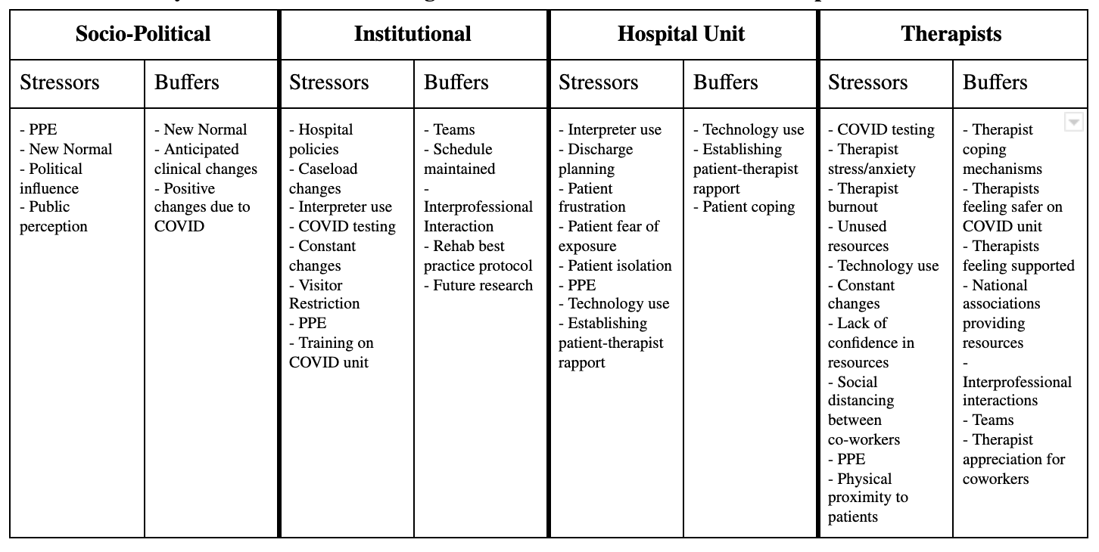

Conclusion
Since the emergence of the COVID-19 pandemic, healthcare workers have dealt with constant changes, regularly adapting to “new normals” of patient care and standard practice. Some of these changes have led to increased stress on rehabilitation therapists, while others have helped to diminish the challenges of working in healthcare during a global pandemic. Despite these major changes, therapists have adopted coping mechanisms to diminish the impact of burnout and depression, demonstrating the continued resilience of these essential workers during COVID-19 and beyond.

