Raiya Feinberg
Outline for PT Annual Exam:
Population | Why
School aged children with Cerebral Palsy | Cerebral palsy (CP) is a neurodevelopmental condition often diagnosed in young children. It affects muscle tone, motor skills, and functional mobility as well as other deficits such as communication, cognition, and behavior¹. While CP is not a progressive disease, the clinical expression of the condition can change over time as the brain grows and matures. Children often experience postural disturbances and motor deficits that progress with age in the early stages of CP and can lead to activity limitation¹. Because of these changes, it is important for this patient population to receive an annual exam to assess changes and recommend intervention based on results.  Children are constantly growing and maturing over time and this is not excluded for children with CP. As years go by, children will grow in height, weight, mental maturity, etc. In order to promote health and wellness amongst this patient population, an annual PT exam to evaluate their equipment needs, nutritional status, tone, home and school environmental needs, etc. would be very beneficial. During periods of rapid growth, a child should be examined for deterioration in physical examination measures, gait changes, and equipment fittings to ensure all assistive devices are properly fitted to the patient’s size². Year by year, a patient’s home and school environments may also change, requiring an adjustment in current interventions. In school aged children, reaching out to a school based PT/OT is important to create a plan for the child to receive more regularly scheduled services on top of a yearly overall exam. More details about these changes are noted in the examination below.  Children with cerebral palsy often demonstrate poor nutritional status as a secondary condition^{3,4}. This can be in the form of under-nutrition, particularly in children with oropharyngeal dysfunction³, or over-nutrition/obesity, which can lead to other major health issues⁴. Annual checks of nutritional and weight status is important to encourage healthy lifestyle habits that can be started from a young age. Referral to a registered dietitian can be made as needed.  Other common co-morbidities associated with CP are impaired cognition, vision and hearing disturbances, epilepsy, and poor gastrointestinal function¹. With these secondary conditions alongside the motor and functional deficits seen with CP, an annual PT exam can help direct management of the disease towards stimulating a child’s development and obtaining the maximal level of independence possible in their daily life¹.

Annual exam: subjective/objective

All questions can be directed to the patient when possible- if not, then direct questions to the patient’s caregiver. (Patients may present with communication deficits and are unable to communicate verbally or they may use an assistive communication device. Discuss with the patient and or caregiver the best way to conduct the subjective examination before beginning).
Question/test | What testing | Positive finding | Clinical reasoning (Evidence if indicated)
What is your past medical history, including any medical diagnoses, surgeries, family history of disease, previous or current injuries, medications, etc.? | Medical history | Previous medical diagnoses= positive | One of the most important things to do before diving into an examination is taking a past medical history on a patient. A past medical history can help you understand their diagnosis while making appropriate clinical decisions for the patient⁵. Past medical histories can tell you about their diagnosis, current medications that could cause side effects you need to know about, past hospitalizations, surgeries, immunization records, and insurance information⁵. All of this is needed to keep an up to date record.  Having a patient’s medical history not only allows you to look into their past but also allows you to respond appropriately to changes/new signs and symptoms that may appear⁵. Screening for red flags and referring to other providers as needed can be accomplished through a medical screen. It is also important to see notes and documentation from other healthcare providers in order to provide the best possible multi-disciplinary care.
What are the current symptoms you are experiencing in your daily life? | Current functional status  *Looking for possible deficits/delays in motor function, milestones, communication, etc. | Current deficits= positive | Although cerebral palsy is not progressive, the clinical presentation of the disease does change over time as a child grows and their brain develops and matures¹. Understanding the current functional status of your patient as well as the current deficits they are facing is important to provide the most appropriate intervention. For children, there are age related motor milestones that are required to be met for proper functional mobility⁶. Children with CP often are delayed in reaching these milestones. Understanding age related norms and comparing them to results from your patient could help determine their delays and the best interventions to help them accomplish milestones.  In children with CP, the deficits often seen are related to motor delays, balance deficits, communication deficits, increased tone/spasticity, cognitive delays, and more¹. Getting a subjective understanding from the patient or caregiver standpoint is important before measuring these deficits objectively (as seen later in the exam process).
How do you currently navigate your environment? Do you use adaptive equipment?  *If yes, check that equipment properly fits child’s size | Current functional status | Use of assistive device= positive | Many children diagnosed with CP will require use of assistive technologies in their daily lives. Some of this may include but is not limited to wheelchairs, walkers, crutches, standing frames, specialized seating for home, cars, and outdoors, communication devices, orthoses, eye glasses, hearing aids, feeding equipment, shower and commode chairs, etc⁷. Understanding what your patient has access to already helps you make recommendations for new equipment or re-fitting old equipment if the child is outgrowing things. Patient and caregiver education about use of assistive devices is important. Using adaptive equipment can have a highly positive influence on a patient’s daily life, helping them to better and more independently move, communicate with others, eat, etc⁷.
Are there barriers in your home setting, such as stairs, that limit your ability to move throughout the house? | Home set up/environmental factors | Stairs/other barriers= positive | Making sure the child lives in an accessible environment is important in encouraging patient independence. If a house is not accessible, there are home modifications that can be made. For instance, in a bathroom, grab bars can be added to the toilet and shower, adaptive seating can be used for the toilet or shower, and floor surfaces can be adjusted to best fit the child’s needs and limit risk of slips⁸. Entrances should be made wheelchair accessible with wide doors, ramps, and non-slip surfaces as needed⁸. Other home adaptations can include improved lighting in the home, changing handles on doors and drawers, moving bedrooms to the main level in a multi-level home, etc⁸. Checking with the patient and family to ensure the patient is living in a safe and accessible environment is important. If not, recommendations and referrals can be made.
Are there barriers in your school setting that limit your ability to move throughout school? | School set up/ environmental factors | Barriers= positive | As mentioned above, while you want the patient to be in a safe and accessible home environment, you also want the best school environment possible. Talking to the patient’s teachers and school-based therapists is important to ensure patient comfort and safety. Accommodations for students can be made in the form of early release from class to allow for additional time in less crowded hallways, physical education class accommodations, special education classes, etc⁹.
Are you currently participating in an IEP (individualized education program) through school? | IEP | IEP= positive | A child can qualify to receive an IEP if the school determines they are in need of special education¹⁰. Cerebral palsy is one of the common diagnoses for children that receive an IEP. IEP’s allow students to create achievable goals and work towards them with a support staff at the school. If a child does have an IEP at school, it would be important to know so you can reach out to the school based PT if needed to discuss possible questions and recommendations for the patient.
Are you involved in any recreational activities? What do you like to do in your free time? | Hobbies/interests, participation in group activities | Participation= positive | Finding out what your patient is interested in can help create goals that they are actually motivated to achieve. If you can set PT goals around recreational activities or hobbies that they are already involved with, the patient may be more likely to actively participate and stay motivated in PT.
How is your nutrition? Can you describe your typical daily diet?  Objective measures of height and weight | Nutritional status  Height  Weight | Poor nutrition= positive  Underweight= positive  Overweight= positive | Feeding problems and oral motor dysfunction are common secondary symptoms of CP¹. Children that have difficulty with chewing or swallowing are at risk for being malnourished and may require a feeding tube if proper nutrition cannot be managed otherwise³. Being malnourished can affect a patient’s ability to actively participate in therapy as their energy levels may be decreased and their overall activity tolerance limited³. On the flip side of this, in children without oropharyngeal deficits, obesity is common amongst children with CP⁴. Poor eating habits mixed with decreased physical activity due to functional mobility deficit caused by CP lead many children suffer from obesity. Taking a child’s height and weight yearly can be important for tracking growth while also measuring BMI and providing patient education on healthy age and height related norms⁴.  An annual PT exam can encourage better health and wellness for children with CP that are struggling with nutritional issues, whether that be under or over eating.
Do you have difficulty with hearing or vision? | Hearing and vision | Difficulty hearing or seeing= positive | Hearing and vision impairments are common secondary impairments of CP¹. Deficits in these sensory modalities may lead to activity limitations and restricted learning as well as delayed development in children¹¹. If a patient or caregiver notes a recent change in hearing or vision senses that has not yet been addressed by the appropriate provider, a referral should be made to a specialist for further assessment. The incorporation of hearing aids or eyeglasses into a patient’s daily life can improve quality of life. If a patient is already using these assistive devices, it should be noted in the chart to ensure use throughout therapy sessions.
Are there any concerns regarding mental health status?  WHO Quality of Life- BREF | Mental health status | Concerns= positive | Instructions and evaluation of the WHO QOL-BREF are linked below¹²:  https://www.who.int/mental_health/media/en/76.pdf?ua=1  The WHO QOL-BREF is a 26 item survey that evaluates general health, mental health, quality of life, and social relationships¹². I recommend having a parent fill this out for their child in order to make sure mental health is being taken into consideration. Many patients with disabilities suffer from hardships in mental health as well as physical health. Mental health can impact physical health recovery. If a parent is concerned that their child may be experiencing symptoms such as anxiety, depression, decreased quality of life, etc. this survey could help make a proper referral to a mental health specialist. There is limited research on appropriate outcome measures for assessing mental health in pediatric populations so referral to a mental health professional that has experience working with children with disabilities would be ideal if the patient or parent has concerns.  *Can give this survey to the parent to complete on behalf of the patient if child is too young to complete on their own- save time by giving this survey to the patient/parent while in the waiting room before the appointment begins.
What are your goals for this year? What are your parents’ goals for this year? | Establishing patient and caregiver goals | Creating goals= positive | It is always important to check with the patient and caregivers to determine their goals for PT. Writing PT goals that revolve around what the patient hopes to achieve will make them more motivated to work hard and participate in PT.
Vital signs | HR, BP, RR, O2 sats | Abnormal vitals= positive | Vital signs are one of the simplest, quickest, and important measures to take for any patient¹³. They give an accurate representation of a patient’s current status and can be used to monitor a patient during activity to improve quality of care by seeing early warning signs¹³.  Normal ranges for vitals are noted in Table 1 of the appendix¹⁴.
Sensation screen of dermatomes | Sensation | Impaired sensation= positive | Before moving to more objective measures of the exam, a patient’s sensation should be screens to ensure they are able to feel and are not at risk for harm due to decreased sensation. To check sensation, simply use a cotton ball to touch individual dermatome levels and ensure the patient is able to feel the cotton touching their skin¹⁵.  A map of dermatomes for the human body can be seen in Table 2 of the appendix¹⁵.
Range of Motion (ROM) | Joint ROM  Ligamentous laxity | Limited or excessive ROM= positive | Many of the secondary conditions of CP, such as spasticity, bony deformities, ligamentous laxity, etc. can affect ROM¹. A quick ROM screen should be performed first, with a more detailed assessment of tone and spasticity performed after. This can include quickly asking the patient to reach their arms towards the sky, in front of them, and to the sides, touch their shoulders, move their wrists and ankles in a circle, bend their knees, flex and extend their hips, etc. This can be either a screen for functional ROM or specific measures using a goniometer for joints¹⁶.
Modified Ashworth Scale | Spasticity | Positive >0 | Muscle tone abnormalities are one of the major signs of cerebral palsy¹. The modified Ashworth scale is the most universally accepted clinical measure to assess muscle tone and spasticity¹⁷. It assesses if and when throughout range of motion the joint “catches” due to muscle tone and is an important component to a full physical examination².  Scoring for the modified Ashworth scale can be found in Table 3 of the appendix¹⁸.
Manual muscle testing (MMT) | Muscle strength | Decreased strength= positive  5= normal  4= good  3= fair  2= poor  1= trace  0= no evidence of contraction | Manual muscle testing is a standardized way to assess muscle strength. The medical research council scale for manual muscle testing grades muscle strength on a scale from 0-5 and is widely accepted as a clinical evaluation tool in children with CP¹⁹. Measuring standardized muscle strength as well as functional muscle strength is important for assessing functional ability and mobility and therefore, other tests will later be performed looking at strength more functionally.
1. Craig test  2. Tibial torsion test  3. Rearfoot and forefoot alignment | Lower extremity skeletal/bony alignment | 1. Normal= 15 degrees  Positive= >15  2. Normal= 20-30 degrees  Positive= >30, increased toe out  3. Positive= abnormal foot alignment | Femoral anteversion, tibial torsion, and structural foot alignment are all important to check in children with cerebral palsy². One of the many secondary conditions of cerebral palsy is ligamentous laxity. This causes the structural integrity of joint to be more lax, and more prone to injury². By assessing bony alignment, you are able to determine the need for bracing and orthoses if the patient is not already using such. Patients with CP often present with gait abnormalities due to structural deformities. Assessing these and providing AFOs or other orthoses could correct for these malalignments and help correct gait mechanics²⁰. If a patient already has orthoses, ensuring they are still a good fit and the patient has not outgrown them is necessary. Check for skin integrity around the site of the orthoses for a proper fit.
Visual analog scale (VAS) | Pain | Positive > 0 | The visual analog scale is a simple tool to measure pain from patient perspective²¹. It is easy for pediatric patients to understand and respond to and can help a therapist understand the current pain level, as well as highest and lowest pain levels experienced by the patient.  The VAS is represented as Table 4 in the appendix²².
Trunk Impairment Scale (TIS) | Postural control | Minimum score= 0  Max= 23  Positive= <17 | The trunk impairment scale is used to look at static and dynamic sitting balance as well as coordination in neurologic patient populations²³. The TIS is a valid tool for assessing trunk control across various levels of motor impairments in children with CP²⁴. Children with CP often have difficulty with postural control and balance and require assistive devices to achieve control¹, this scale is a good way to measure the patient’s abilities and assess their need for intervention.
5 times sit to stand (5xSTS) | Functional mobility/functional strength | Decrease in results from previous visits= positive  Unable to complete test= positive | The 5 times sit to stand is a measure used to look at functional strength and mobility as well as transfer skills²⁵. The 5xSTS is a reliable assessment tool when used on children with CP. It has excellent test-retest and inter-rater reliability and is recommended to be used as a measure of functional mobility and balance in this patient population^{25,26}.
Timed up and go (TUG) | Functional mobility/gait | Decrease in results from previous visit= positive  Unable to complete test= positive | The timed up and go is a measure used to look at functional mobility, balance, and gait²⁷. The TUG is both a reliable and responsive measure in children with CP²⁸. It is easy to administer and takes less than 5 minutes. From this test, a therapist is able to examine the patient’s functional ability to stand up from a chair, ambulate, and return to sitting in the chair without losses of balance²⁷.

Resources/referrals:

Test item | Resource/referral | Reasoning
Nutritional screen | Registered dietitian | As mentioned above, many children with CP demonstrate either feeding difficulties leading to malnutrition and being underweight, or suffer from obesity due to poor nutrition and lack of physical activity. Referring a patient to a registered dietitian can be very beneficial. Dietitians play a key role in the clinical management of nutrition in children with CP²⁹.
Mental health screen | Child psychologist | Growing up with a disability and being seen as different when compared to peers can take a toll on any child. Some children struggle to find coping mechanisms and maintain a positive outlook. For these children, speaking to a counselor, attending behavioral therapy, or joining support groups led by a specialist can be beneficial³⁰. While PT can screen for mental health, it is not within the scope of practice to treat. Referring to a therapist that specializes in working with children with disability is the best option. Therapy can help a child acquire a healthier attitude towards the challenges they face, find coping mechanisms for depression and anxiety, learn to communicate better with family and peers, and so much more³⁰.
Hearing/vision screening | Audiologist/ophthalmologist | As mentioned above, many children with CP have vision and hearing impairments as a secondary condition to CP¹. If a patient or caregiver informs you that this is a recent issue they have notices, referral to the proper specialist is needed. While PTs can perform simple screens for hearing and vision, if an impairment arises and the patient has not yet seen a specialist, the PT needs to refer out, as treating hearing and vision deficits are not within the PT scope of practice. Referring out can allow the patient to receive proper care and acquire adaptive equipment such as hearing aids or eyeglasses to improve their activities of daily living and increase their independence.

Appendix (if indicated):

Table 1: Pediatric Vital Sign Normal Ranges¹⁴.
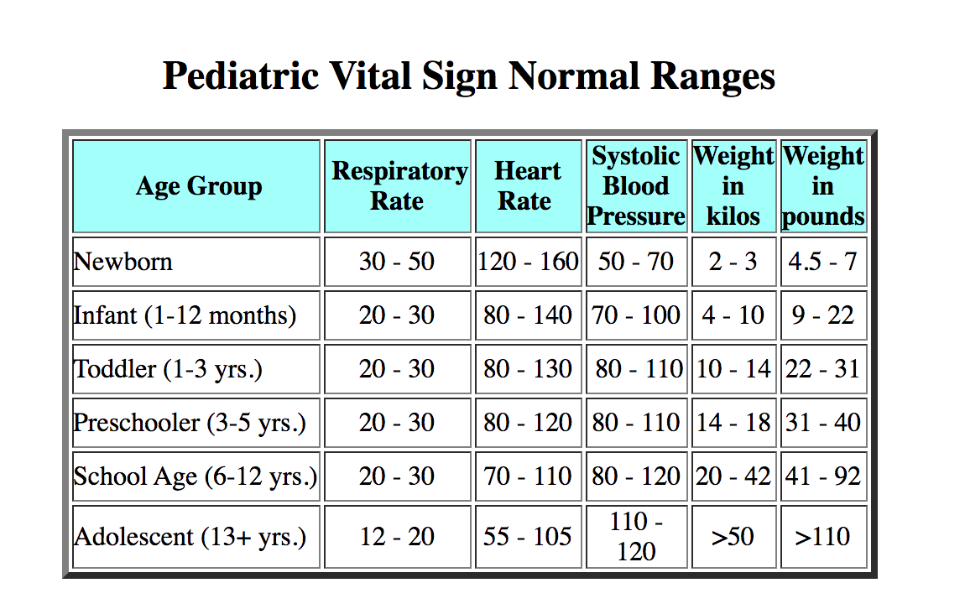

Table 2: Dermatomes¹⁵.
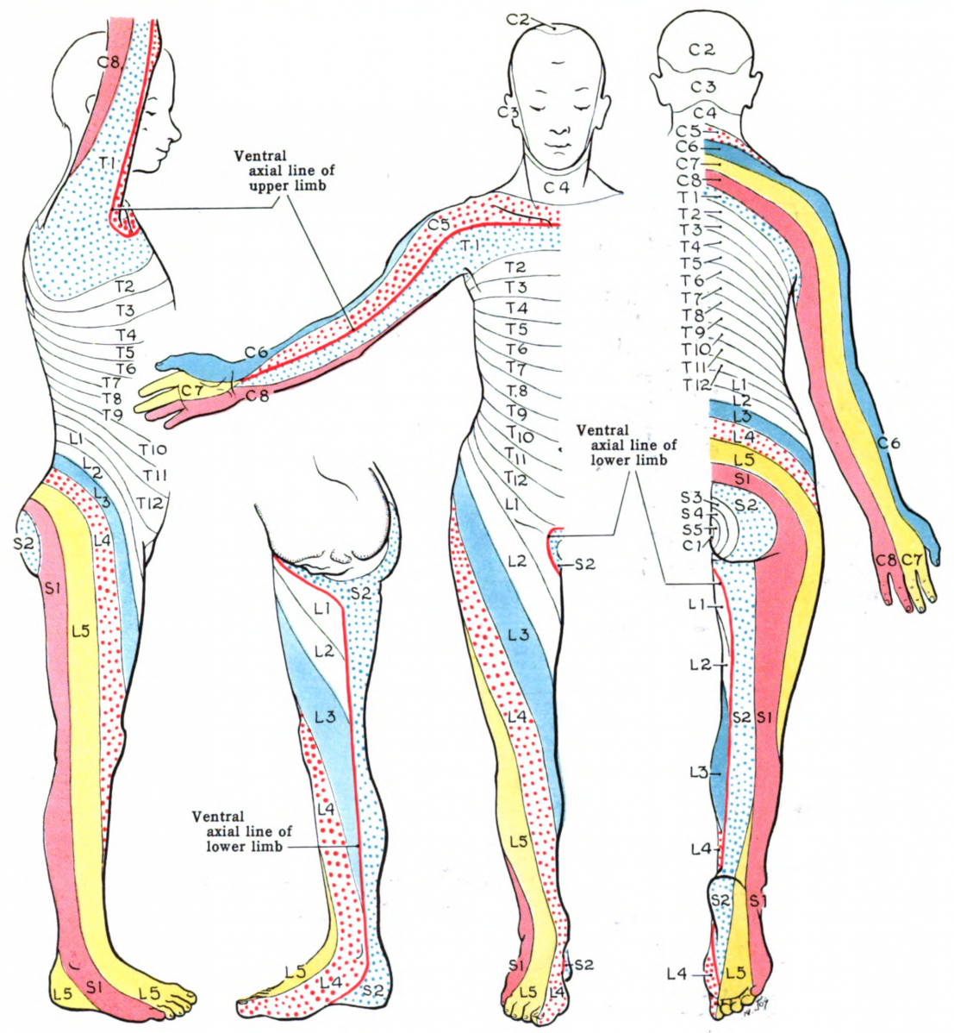

Table 3: Modified Ashworth Scale¹⁸.

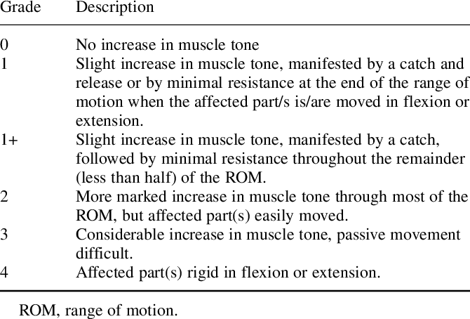

Table 4: Visual Analog Scale (VAS)²².

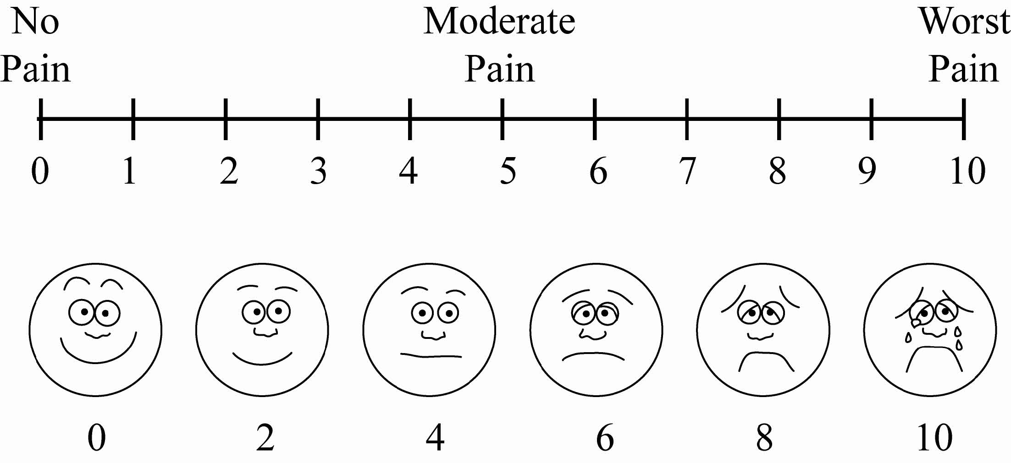

Bibliography

1. Gulati S, Sondhi V. Cerebral palsy: an overview. Indian J Pediatr 2018;85(11):1006-1016. doi:10.1007/s12098-017-2475-1.
2. Johari R, Maheshwari S, Thomason P, Khot A. Musculoskeletal Evaluation of Children with Cerebral Palsy. Indian J Pediatr 2016;83(11):1280-1288. doi:10.1007/s12098-015-1999-5.
3. Bell KL, Samson-Fang L. Nutritional management of children with cerebral palsy. Eur. J. Clin. Nutr. 2013;67 Suppl 2:S13-6. doi:10.1038/ejcn.2013.225.
4. Stevenson RD. Body mass index and obesity in children with cerebral palsy. Dev. Med. Child Neurol. 2018;60(7):639. doi:10.1111/dmcn.13909.
5. history W. Understanding the Importance of Medical History.
6. Early Developmental Milestones | Child Development | Pathways.org. Available at: https://pathways.org/all-ages/milestones/?gclid=CjwKCAjwnef6BRAgEiwAgv8mQUds3e9u_Iu9B--RcdH6gCzujExl6F8lHvhPUKUiSBvJh6yzeK81tRoCqAsQAvD_BwE. Accessed September 10, 2020.
7. Bourke-Taylor H, Cotter C, Stephan R. Young children with cerebral palsy: families self-reported equipment needs and out-of-pocket expenditure. Child Care Health Dev. 2014;40(5):654-662. doi:10.1111/cch.12098.
8. Cho HY, MacLachlan M, Clarke M, Mannan H. Accessible Home Environments for People with Functional Limitations: A Systematic Review. Int. J. Environ. Res. Public Health 2016;13(8). doi:10.3390/ijerph13080826.
9. Mccoy SW, Effgen SK, Chiarello LA, Jeffries LM, Villasante Tezanos AG. School-based physical therapy services and student functional performance at school. Dev. Med. Child Neurol. 2018;60(11):1140-1148. doi:10.1111/dmcn.13748.
10. Individualized Education Programs (IEPs) & Cerebral Palsy. Available at: https://www.abclawcenters.com/practice-areas/types-of-birth-injuries/signs-milestones-developmental-delays/what-is-an-individualized-education-plan-iep/. Accessed September 10, 2020.
11. Rosenbaum et al. A report: the definition and classification of cerebral palsy April 2006. 2006.
12. Version F. AND GENERIC VERSION OF THE ASSESSMENT.
13. Kellett J, Sebat F. Make vital signs great again - A call for action. Eur J Intern Med 2017;45:13-19. doi:10.1016/j.ejim.2017.09.018.
14. Normal Vital Signs. Available at: https://www.rnceus.com/psvt/psvtvs.html. Accessed September 11, 2020.
15. Dermatomes - Physiopedia. Available at: https://www.physio-pedia.com/Dermatomes. Accessed September 11, 2020.
16. Range of Motion - Physiopedia. Available at: https://www.physio-pedia.com/Range_of_Motion. Accessed September 11, 2020.
17. Harb A, Kishner S. Modified Ashworth Scale. In: StatPearls. Treasure Island (FL): StatPearls Publishing; 2020.
18. Modified Ashworth Scale for grading spasticity | Download Table. Available at: https://www.researchgate.net/figure/Modified-Ashworth-Scale-for-grading-spasticity_tbl1_11874478. Accessed September 11, 2020.
19. Boyd RN, Graham HK. Objective measurement of clinical findings in the use of botulinum toxin type A for the management of children with cerebral palsy. Eur. J. Neurol. 1999;6:s23-s35. doi:10.1111/j.1468-1331.1999.tb00031.x.
20. Krasowicz K. The influence of orthotics on lower limbs biomechanics in CP. Ortop Traumatol Rehabil 2019;21(5):389-398.
21. Heller GZ, Manuguerra M, Chow R. How to analyze the Visual Analogue Scale: Myths, truths and clinical relevance. Scand. J. Pain 2016;13:67-75. doi:10.1016/j.sjpain.2016.06.012.
22. Visual Analogue Scale - Physiopedia. Available at: https://www.physio-pedia.com/Visual_Analogue_Scale. Accessed September 11, 2020.
23. Trunk Impairment Scale. Shirley Ryan Ability Lab 2016. Available at: https://www.sralab.org/rehabilitation-measures/trunk-impairment-scale. Accessed September 11, 2020.
24. Pavão SL, Maeda DA, Corsi C, et al. Discriminant ability and criterion validity of the Trunk Impairment Scale for cerebral palsy. Disabil. Rehabil. 2019;41(18):2199-2205. doi:10.1080/09638288.2018.1462410.
25. Five Times Sit to Stand. Shirley Ryan Ability Lab 2013. Available at: https://www.sralab.org/rehabilitation-measures/five-times-sit-stand-test. Accessed September 11, 2020.
26. Kumban W, Amatachaya S, Emasithi A, Siritaratiwat W. Five-times-sit-to-stand test in children with cerebral palsy: reliability and concurrent validity. NeuroRehabilitation 2013;32(1):9-15. doi:10.3233/NRE-130818.
27. Timed Up and Go. Shirley Ryan Ability Lab 2013. Available at: https://www.sralab.org/rehabilitation-measures/timed-and-go. Accessed September 11, 2020.
28. Carey H, Martin K, Combs-Miller S, Heathcock JC. Reliability and responsiveness of the timed up and go test in children with cerebral palsy. Pediatr. Phys. Ther. 2016;28(4):401-408. doi:10.1097/PEP.0000000000000301.
29. Hartley H, Thomas JE. Current practice in the management of children with cerebral palsy: a national survey of paediatric dietitians. J. Hum. Nutr. Diet. 2003;16(4):219-224. doi:10.1046/j.1365-277x.2003.00452.x.
30. Behavior Therapy and Cerebral Palsy | CerebralPalsy.orgCerebralPalsy.org. Available at: https://www.cerebralpalsy.org/about-cerebral-palsy/treatment/therapy/behavior-therapy. Accessed September 11, 2020.

