CRITICALLY APPRAISED TOPIC
FOCUSED CLINICAL QUESTION
For a 17-year old patient with Cerebral Palsy (P), is a lower extremity strength training program (I) compared with a dynamic balance training program (C) more effective in increasing gait distance without (lofstrand OR forearm) crutches (O).

AUTHOR
Prepared by | Shelby Miller | Date | 12/3/2019
Email address | shelby_miller@med.unc.edu

CLINICAL SCENARIO
The clinical scenario/patient encounter that inspired this clinical question was a 17-year old with Cerebral Palsy (CP). He was working on being able to ascend steps, walk across the stage, and descend steps at his graduation, all while using his lofstrand crutches. However, while working on this skill, he expressed his desire to work on walking short distances without the use of his lofstrand crutches. His current level of ability was walking about 20 feet without losing balance and needing to stop on the wall. Therefore, maximum sustained gait distance over a single trial with no loss of balance and without (lofstrand OR forearm) crutches became the outcome measure for this PICO question. The measurement of gait distance, rather than another standardized outcome measure tool, is because this patient’s low level of functioning would likely be too low for the effective use of other possible standardized assessments that go beyond just simply measuring gait distance. Additionally, his need is for improving his maximum distance rather than improving his pace, so inclusion of a timed measure in the outcome is not needed. When given the chance to examine his pure gait analysis without crutches, his main issue was collapsing inward at his knees. It was apparent that his years of compensatory strategies, such as W-sitting with a disengaged core behind his wheelchair in order to access his backpack, had enabled patterns of extreme internal rotation of his hips and knee valgus. These patterns caused the inward knee collapse that then extended through his entire biomechanical chain to affect his gait and loss of balance without crutches. He was very insecure on such a decreased base of support. Therefore, the two main factors affecting his inability to maintain balance for gait distance were his strength and balance. Beyond the obvious first step of teaching him new strategies for accessing his backpack, it could be reasoned that increasing strength of his opposing muscles to increase neutral hip and knee alignment, as well as increasing core strength, would be advantageous to improving his gait without an assistive device. In addition, it could be reasoned that increasing his dynamic balance on a narrowed base of support would be advantageous for this skill. Therefore, the two intervention strategies of strength training versus balance training became the comparisons for this PICO question.
This topic is very important to clinicians, because it emphasizes an importance on patient-centered care. It was this patient’s desire to improve his walking without an assistive device, and each patient may have similar unique desires. Assistive devices are very helpful for increasing independence in everyday life. However, the special motivation for personal goals and accomplishments of independence, such as this patient’s desire to be able to walk short distances without his crutches, is still relevant and important. Furthermore, improving his gait patterns will not only benefit his gait distance without an assistive device, but will also benefit his endurance and sustainability of walking with his crutches. Due to limited amounts of time to spend with our patients, the use of a comparison helps to justify the time, expense, and effort of providing the more effective intervention. Finally, this topic is relevant to clinical practice, because it helps to understand the reasoning of strength and balance factors related to gait translating between walking with the use of crutches and independent walking with no assistive device, particularly in CP. It helps to inform clinical practice decisions related to evidence-based interventions for the PT treatment of patients with CP.

SUMMARY OF SEARCH
[Best evidence appraised and key findings]
Eight studies were located that met the inclusion and exclusion criteria including 7 Randomized Controlled Trials (RCTs) and 1 Case Series.¹⁻⁸
- A 5-week lower extremity strength training program consisting of warm up stretching exercise, squat to stand, lateral step up, stair walk up and down, isotonic exercise of lower limb muscles using adjustable weight cuffs for 2 sets of 10 repetitions in each muscle group, isokinetic exercise utilizing a bicycle, and a cool down exercise 3 times per week for 60 minutes per session is effective for improving gait function in children with CP.⁷
- A 6-week balance training program with visual feedback consisting of static and dynamic balance activities 3 times per week for 30 minutes per session is effective for improving gait symmetry and stance in children with CP.⁶
- Currently, there is no available evidence comparing both a strength training program and a balance training program together in one study in order to assess best practice for improving gait in children with CP. However, individual studies assessing effect of each intervention show promising results for improvements in gait in children with CP following each of the interventions separately.¹⁻⁸ Further research with comparable methods and outcome measures is needed to indicate which intervention method is preferable for improving gait in the treatment of children with CP.¹⁻⁸
- Overall, evidence related to improving gait in children with CP is more widely available for strength training programs as compared to balance training programs, perhaps due to ease of research.¹⁻⁸

CLINICAL BOTTOM LINE
The current available evidence indicates that a 17-year old patient with Cerebral Palsy (CP) may benefit from some combination of lower extremity strength training and balance training within a 5-6 week long program consisting of 30-60 minute sessions at a frequency of 3 times per week. However, the relative efficacy of the two intervention choices compared to each other is currently unknown. Further research with comparable methods and outcome measures is needed in order to establish best practice for improving gait function in children with CP.

This critically appraised topic has been individually prepared as part of a course requirement and has been peer-reviewed by one other independent course instructor
SEARCH STRATEGY
Terms used to guide the search strategy
Patient/Client Group | Intervention (or Assessment) | Comparison | Outcome(s)
“Cerebral Palsy”  “CP”  //  “pediatric”  “adolescent” | “strength training”  “resistance training”  “strengthen*”  “strength*”  “resistance”  “train*”  “(strength* OR resistance) AND train*”  //  “lower extremity” | “balance training”  “balance”  “train*”  “balance AND train*”  //  “dynamic” | “gait”  “distance”  “ambulation”  “amb*”  //  “(without OR “not using”) AND (((lofstrand OR forearm) crutches) OR (“assistive device”) OR (AD))”

Final search strategy (history):

- “Cerebral Palsy” OR CP
- pediatric OR adolescent
- #1 AND #2 … = P
- (strength* OR resistance) AND train*
- “lower extremity”
- #4 AND #5 … = I
- balance AND train*
- dynamic
- #7 AND #8 … = C
- gait OR distance OR amb*
- (without OR “not using”) AND (((lofstrand OR forearm) crutches) OR (“assistive device”) OR (AD))
- #10 AND #11 … = O
{consider number of results for the following to determine need to narrow or widen search}
- #3 AND #6 … = P AND I 25 results
- #3 AND #9 … = P AND C 7 results
- #3 AND #12 … = P AND O 0 results
- #3 AND #6 AND #12 … = P AND I AND O 0 results
- #3 AND #9 AND #12 … = P AND C AND O 0 results
- #3 AND #6 AND #9 … = P AND I AND C 0 results
- #3 AND #6 AND #9 AND #12 … = P AND I AND C AND O 0 results
- Remove outcome measure terms for all consecutive searches to widen search
- Remove “pediatric OR adolescent” to widen search: #3 AND #6 … = P AND I 43 results
- Remove “pediatric OR adolescent” to widen search: #3 AND #9 … = P AND C 26 results
- Remove “pediatric OR adolescent” to widen search: #3 AND #6 AND #9 … = P AND I AND C 0 results
- Remove “dynamic” to widen search: #3 AND #9 … = P AND C 80 results
- Remove “dynamic” to widen search: #3 AND #6 AND #9 … = P AND I AND C 9 results
- Remove “pediatric OR adolescent” and “dynamic” to wide search: #3 AND #6 AND #9 … = P AND I AND C 13 results {THIS WAS THE FINAL STRATEGY}

FINAL SEARCH TEXT =
(((("Cerebral Palsy") OR CP)) AND ((((((strength* OR resistance))) AND train*)) AND "lower extremity")) AND ((balance) AND train*)

Databases and Sites Searched | Number of results | Limits applied, revised number of results (if applicable)
- PubMed  - Cochrane Library  - PEDro  - Web of Science  - CINAHL  - Embase  - Clinicaltrials.gov  - Google Scholar | - 13  - 16 trials, 4 Cochrane reviews  - 4  - 10  - 19  - 13  - 0  - 7770 | I applied limits to my initial PubMed search in order to refine the search strategy that I then used for every database thereafter. Please see my search history for result numbers throughout the process of applying limits. Due to limited number of search results, no further database limits were applied.

INCLUSION and EXCLUSION CRITERIA
Inclusion Criteria
- Patient population with Cerebral Palsy
- Pediatric patient population
- Standardized functional outcome measures used to assess gait distance
- Randomized controlled trials (or systematic review or meta-analysis of RCTs) or Case Series
- Study describes clearly defined training programs that are consistently adhered to within groups
Exclusion Criteria
- Not published in English
- Published before 2004
- Poster presentations
- Quasi-experimental studies
- Narrative review articles

RESULTS OF SEARCH
Summary of articles retrieved that met inclusion and exclusion criteria

Author (Year) | Risk of bias (quality score)* | Level of Evidence** | Relevance | Study design
Surana et al. 2019¹ | PEDro scale: 6/10 (7/11 including criteria 1) | 2b: downgraded because individual RCT rather than systematic review; downgraded again because <80% follow up so deemed low quality RCT | Moderate: included my P, I, C, and O; however, I and C were included in the same intervention group rather than compared to each other | Randomized Controlled Trial (RCT)
Peungsuwan et al. 2017² | PEDro scale: 7/10 (8/11 including criteria 1) | 1b: downgraded because individual RCT rather than systematic review | Moderate: included my P, I, and O; however, I was supplemented by an endurance element rather than a pure form of the intervention, and O included more functional measures than just walking | Randomized Controlled Trial (RCT)
Tedla et al. 2014³ | PEDro scale: 4/10 (4/11 including criteria 1) | 1b: downgraded because individual RCT rather than systematic review | Low: included my P and I, but did not include C or O | Randomized Controlled Trial (RCT)
Salem et al. 2009⁴ | PEDro scale: 6/10 (7/11 including criteria 1) | 1b: downgraded because individual RCT rather than systematic review | Moderate: included my P, I, and O; however, I was supplemented by a functional element rather than a pure form of the intervention, and O included more mobility measures than just walking | Randomized Controlled Trial (RCT)
Eek et al. 2008⁵ | Downs and Black checklist: 16/29 | 4: downgraded because Case Series rather than RCT, cohort study, or case-control study | High: included my P, I, and O; however, O included additional measures than just walking, though measures related to gait were comprehensive | Case Series
Ledebt et al. 2005⁶ | PEDro scale: 3/10 (4/11 including criteria 1) | 1b: downgraded because individual RCT rather than systematic review | High: included my P, C, and O | Randomized Controlled Trial (RCT)
Lee et al. 2008⁷ | PEDro scale: 5/10 (6/11 including criteria 1) | 1b: downgraded because individual RCT rather than systematic review | High: included my P, I, and O; however, O included additional measures than just walking, though measures related to gait were primary and very comprehensive | Randomized Controlled Trial (RCT)
Scholtes et al. 2012⁸ | PEDro scale: 8/10 (9/11 including criteria 1) | 1b: downgraded because individual RCT rather than systematic review | High: included my P, I, and O; however, O included additional measures than just walking | Randomized Controlled Trial (RCT)
*Indicate tool name and score
**Use Portney & Watkins Table 16.1 (2009); if downgraded, indicate reason why

BEST EVIDENCE
The following 2 studies were identified as the ‘best’ evidence and selected for critical appraisal. Rationale for selecting these studies were:
- Lee JH, Sung IY, Yoo JY. Therapeutic effects of strengthening exercise on gait function of cerebral palsy. Disability and Rehabilitation. 2008;30:1439-1444.⁷
- Reasons for selecting this study included its high level of evidence as a Randomized Controlled Trial (RCT), its high relevance to my PICO question, and that it addresses the I element of my PICO question.⁷
- Ledebt A, Becher J, Kapper J, Rozendaalr RM, Bakker R, Leenders IC, et al. Balance training with visual feedback in children with hemiplegic cerebral palsy: effect on stance and gait. Motor Control 2005;9:459–468.⁶
- Reasons for selecting this study included its high level of evidence as a Randomized Controlled Trial (RCT), its high relevance to my PICO question, and that it addresses the C element of my PICO question.⁶
- The reasons for selecting these studies were their high level of evidence as Randomized Controlled Trials (RCTs) and their high relevance to my specific PICO question.^{6,7} Since there was not an individual article available to compare the I and C elements within one study, an article representing each element was included in the best evidence.^{6,7} Therefore, I and C can be individually assessed in their own research and then compared against each other in order to infer relative conclusions. This comparison allows for the drawing of conclusions relating to my specific PICO question based on the combined evidence. While it would be ideal for the articles to have higher PEDro scale scores, it is paramount that the two articles are relevant to the O element of the PICO question so that they are able to be compared.^{6,7} Therefore, these two articles represent the choices for best evidence in order to address my PICO question.^{6,7}
SUMMARY OF BEST EVIDENCE
(1) Description and appraisal of Therapeutic effects of strengthening exercise on gait function of cerebral palsy. by Lee JH, Sung IY, Yoo JY. 2008.⁷
Aim/Objective of the Study/Systematic Review:
The purpose of this study by Lee et al. was to assess whether or not a 5-week program of lower extremity strengthening exercises would be effective for increasing gait function and muscle strength in children with Cerebral Palsy.⁷

Study Design
[e.g., systematic review, cohort, randomised controlled trial, qualitative study, grounded theory. Includes information about study characteristics such as blinding and allocation concealment. When were outcomes measured, if relevant]
Note: For systematic review, use headings ‘search strategy’, ‘selection criteria’, ‘methods’ etc. For qualitative studies, identify data collection/analyses methods.
- Randomized Controlled Trial (RCT)
- Participants included children with Cerebral Palsy (CP) who were classified as grade 2 or 3 of the Gross Motor Function Classification System (GMFCS) and were ages 4-12 years old.
- The participants were randomly allocated into either an experimental, which had 9 children, or control group, which had 8 children.
- The experimental group underwent a 5-week program consisting of lower extremity strengthening exercises, while the control group participated in conventional physical therapy.
- Outcome measures were assessed at pre-training, post-training, and 6-week follow up time points.
- Statistical significance was determined as p<0.05.
- There was no blinding in this study.
- Repeated measures analysis of variance (ANOVA) with time as the main factor was used to evaluate between-group differences in means at three measurement times.
Setting
[e.g., locations such as hospital, community; rural; metropolitan; country]
The setting of this study was the outpatient Department of Physical Medicine and Rehabilitation of the Asan Medical Center at the Uslan University College of Medicine in Seoul, Korea.

Participants
[N, diagnosis, eligibility criteria, how recruited, type of sample (e.g., purposive, random), key demographics such as mean age, gender, duration of illness/disease, and if groups in an RCT were comparable at baseline on key demographic variables; number of dropouts if relevant, number available for follow-up]
Note: This is not a list of the inclusion and exclusion criteria. This is a description of the actual sample that participated in the study. You can find this descriptive information in the text and tables in the article.
- Participants included children with Cerebral Palsy (CP) who were classified as grade 2 or 3 of the Gross Motor Function Classification System (GMFCS) and were ages 4-12 years old.
- Participants were recruited from the outpatient Department of Physical Medicine and Rehabilitation of the Asan Medical Center, Uslan University College of Medicine in Seoul, Korea.
- Exclusion criteria included inability to follow commands from therapists, presence of fixed contracture at the knee or hip joint of greater than 25 degrees, medical or orthopaedic diseases that prevented the child from exercising, history of orthopaedic surgery of the lower limb, or history of injection of an antispastic drug.
- Groups were comparable at baseline on key demographic variables including age, sex, and type of spastic CP.
- Mean age of the participants were 6.3 +/- 2.1 years in the experimental group and 6.3 +/- 2.9 years in the control group.

Intervention Investigated
[Provide details of methods, who provided treatment, when and where, how many hours of treatment provided]
Control
The control group received conventional physical therapy. Their intervention consisted of Neurodevelopmental Treatment (NDT), range of motion exercises, and gait training. Their program lasted for 5 weeks.

Experimental
The experimental group received a lower extremity strengthening program. Their intervention consisted of warm up stretching exercise, squat to stand, lateral step up, stair walk up and down, isotonic exercise of lower limb muscles using adjustable weight cuffs for 2 sets of 10 repetitions in each muscle group, isokinetic exercise utilizing a bicycle, and a cool down exercise. Their program lasted for 5 weeks, at a frequency of 3 times per week and a duration of 60 minutes per session.

Outcome Measures
[Give details of each measure, maximum possible score and range for each measure, administered by whom, where]
Each outcome measure was administered at pre-training, post-training, and 6-week follow up time points. The same physician administered muscle strength and tone measurements. The same physical therapist administered Gross Motor Functional Measure (GMFM), lateral step up, and squat to stand evaluations. Outcome measure evaluations were administered in the outpatient Department of Physical Medicine and Rehabilitation of the Asan Medical Center at the Uslan University College of Medicine in Seoul, Korea. Muscle strength and tone measurements were only taken on the hemiplegic side in participants with hemiplegic CP types and bilateral sides in participants with diplegic CP types.
Functional Test:
- Gross Motor Functional Measure (GMFM): validated assessment of motor status in CP, ability to quantify changes in motor function over time or following intervention, consists of 88-items, the five dimensions include A- lying and rolling, B- sitting, C- crawling and kneeling, D- standing, and E- walking, running, and jumping, only dimensions D, E, and total score were measured in this study due to inclusion criteria of ambulatory children with CP, separate dimension scores as well as a total score can be calculated, each individual item is scored from 0-3, dimension and total scores are expressed in percentage based on a typically developing 5-year-old’s ability as 100%, higher score indicates increased motor performance
Muscle Tone:
- Modified Ashworth Scale (MAS): measurement of resistance to passive stretch, graded from 0 to 4 including 1+, higher score indicates greater increase in muscle tone
Muscle Strength:
- Manual Muscle Test (MMT): measurement of overall major muscle group strength, graded from 0 to 5, higher score indicates greater muscle strength
Lateral Step Up:
- Number of lateral step ups performed during 30 minutes: measurement of functional strength based on ability to perform the task with as many repetitions as possible, number of repetitions of lateral step up achieved in 30 minutes is recorded as the score, higher score indicates increased functional performance capacity
Squat to Stand:
- Number of squat to stands performed during 30 minutes: measurement of functional strength based on ability to perform the task with as many repetitions as possible, number of repetitions of squat to stand achieved in 30 minutes is recorded as the score, higher score indicates increased functional performance capacity
Three-dimensional Gait Analysis:
- Orthotrak 6.2.4 system® (MotionAnalysis, USA) computerized gait analysis: measure of linear parameters, kinematics, and kinetics at patient-selected gait speeds during ambulation, linear parameters include walking velocity, cadence, stride length, and percentage of single and double limb support, passive markers were attached for the gait analysis at various lower limb locations in this study, participants were allowed to use assistive devices for ambulation if necessary in this study

Main Findings
[Provide summary of mean scores/mean differences/treatment effect, 95% confidence intervals and p-values etc., where provided; you may calculate your own values if necessary/applicable. You may summarize results in a table but you must explain the results with some narrative.]
- Statistically significant increases in maximal hip extensor strength were found post-training and maintained at 6-week follow up in the experimental group as compared to the control group (p<0.05)
- No statistically significant changes were found in strength of other muscle groups or muscle tone in either the experimental or control group (p>0.05)
- Statistically significant increases in number of lateral step ups during 30 minutes were found post-training and maintained at 6-weeks follow up in both the experimental and control groups (p<0.05)
- Statistically significant increases in number of squat to stand during 30 minutes were found post-training and maintained at 6-week follow up in the experimental group compared to the control group (p<0.05)
- Statistically significant improvements in GMFM dimension D and E scores were found post-training, but not maintained at 6-week follow up, in the experimental group compared to the control group (p<0.05)
- No statistically significant improvements were found in GMFM total score in the experimental group compared to the control group
- Statistically significant increases in gait speed and stride length were found post-training and at 6-weeks follow up in the experimental group compared to the control group (p<0.05)
- Statistically significant improvements in maximal hip flexion of kinematic data were found post-training in the experimental group (p<0.05)
- Statistically significant improvements in maximal moment of hip flexor of kinetic data were found post-training, but not maintained at 6-week follow up, in the experimental group (p<0.05)

Overall, the results of Lee et al. show statistically significant improvements on some, but not all, domains that were measured over time. They do not show any negative effects of training.
Tables taken from Lee et al.:⁷
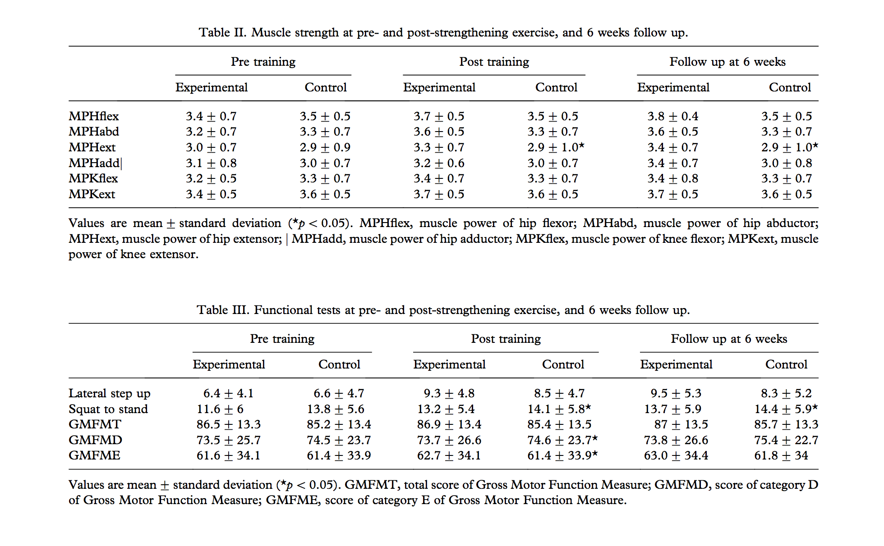
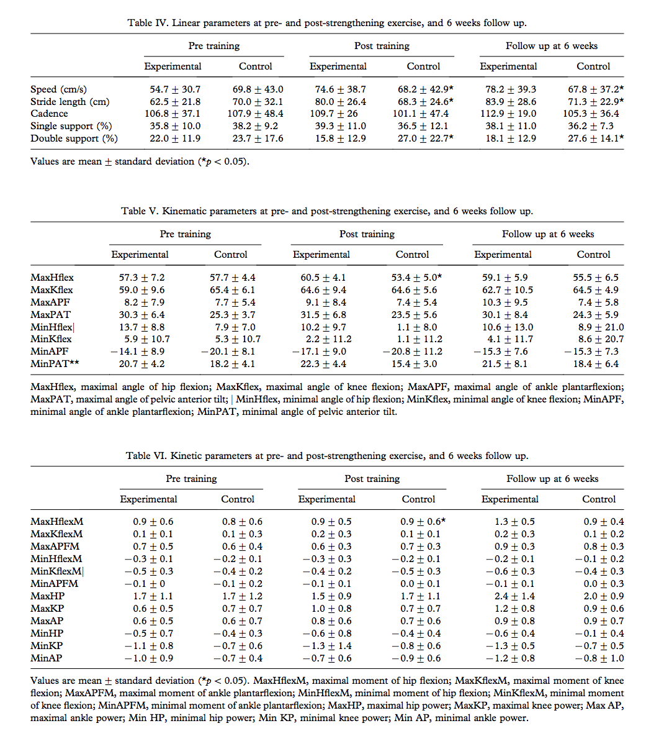
Original Authors’ Conclusions
[Paraphrase as required. If providing a direct quote, add page number]
Lee et al. conclude that “the strengthening exercises contributed mainly to the functional improvement of lower limbs including gait function without significant adverse effects or increase of muscle tone. Additionally, functional improvement acquired by the strengthening exercises was maintained until 6 weeks post-training. Therefore, strengthening exercises could be a useful method to improve the gait function of patients with spastic CP.” (p. 1444)⁷

Critical Appraisal
Validity
[Summarize the internal and external validity of the study. Highlight key strengths and weaknesses. Comment on the overall evidence quality provided by this study.]
Internal Validity: Downs and Black Internal Validity score: 10/13 [No for the following: blinding of subjects, blinding of measurers, and adjustment for confounding]

External Validity: The small sample size and low power of this study reduces its external validity.

Quality Score: PEDro scale: 6/10 [Eligibility criteria: Yes; Random allocation: Yes; Concealed allocation: Yes; Baseline comparability: Yes; Blind subjects: No; Blind therapists: No; Blind assessors: No; Adequate follow-up: No; Intention-to-treat analysis: No; Between-group comparisons: Yes; Point estimates and variability: Yes.]

Strengths: This study used random and concealed allocation, which decreases their risk of bias. They also had baseline comparability of subjects between groups, which decreases their risk of bias. The parameters of this treatment plan were reasonable for a physical therapy plan of care, therefore making the results more clinically relevant. Outcome measures were assessed by the same physician or physical therapist, which eliminates possibility for poor inter-rater reliability during participant evaluations. Plus, the same outcome measures were consistently used throughout the study.

Weaknesses: This study has low power due to its small sample size of 17 participants, which increases its likelihood of Type 2 error. Since the participants were all recruited from the same facility, this limits their randomization and increases their risk of bias. This study did not have blinding of subjects, therapists, or assessors, which increases their risk of bias.

Overall Evidence Quality: The overall evidence quality provided by this study is moderate. While they used randomization and concealment in allocation, they have a very small sample size. However, its usefulness as a high level of evidence being a Randomized Control Trial (RCT) is helpful in considering results as compared to other literature.

Interpretation of Results
[This is YOUR interpretation of the results taking into consideration the strengths and limitations as you discussed above. Please comment on clinical significance of effect size / study findings. Describe in your own words what the results mean.]
The results of Lee et al. demonstrate the use of lower extremity strength training in improving the gait function of children with CP.⁷ This is seen in their 5-week intervention program’s ability to significantly improve GMFM dimensions related to ambulation, muscle strength, task specific functional performance, and aspects of gait function as measured in the study.⁷ While this study is limited in its small sample size and lack of blinding, it consists of a representative population and maintains quality in its experimental design. The intervention program described by this study is reasonable to recreate in a typical physical therapy setting, which enhances its clinical significance. The study also establishes a lack of adverse events related to the program, further making the intervention appealing as a treatment option. This study shows how benefits of the strengthening program are maintained over time, and further follow-up could be used to establish a longer period of retention. Overall, Lee et al. show that a 5-week lower extremity strength training program consisting of warm up stretching exercise, squat to stand, lateral step up, stair walk up and down, isotonic exercise of lower limb muscles using adjustable weight cuffs for 2 sets of 10 repetitions in each muscle group, isokinetic exercise utilizing a bicycle, and a cool down exercise 3 times per week for 60 minutes per session is effective for improving gait function in children with CP.⁷

Applicability of Study Results
[Describe the relevance and applicability of the study to your clinical question and scenario. Consider the practicality and feasibility of the intervention in your discussion of the evidence applicability.]
This study has high relevancy to this CAT’s clinical question and scenario. This is because it directly addresses the specific patient population as well as desired outcome. Additionally, it includes children with CP who are ambulatory, but also accounts for the use of an assistive device. This is ideal for the patient scenario patient who commonly requires the use of loftstrand crutches. However, the patient scenario patient is older than the age range of the children included in the study. Additionally, rather than comparing two interventions, it adds evidence to the choice of strength training as an effective intervention choice. However, this study provides very applicable evidence due to the practicality of the protocol and parameters described. This study clearly defines the activities as well as frequency and duration in a way that could be replicated in a physical therapy clinic. The lower extremity strength training intervention of this study is both effective and feasible to be used clinically as a method for improving gait in children with CP.

(2) Description and appraisal of Balance training with visual feedback in children with hemiplegic cerebral palsy: effect on stance and gait. by Ledebt A, Becher J, Kapper J, Rozendaalr RM, Bakker R, Leenders IC, et al. 2005.⁶
Aim/Objective of the Study/Systematic Review:
The aim of this study by Ledebt et al. was to assess whether or not a balance training program with visual feedback would be effective for improving stance and gait function in children with Cerebral Palsy.⁶

Study Design
[e.g., systematic review, cohort, randomised controlled trial, qualitative study, grounded theory. Includes information about study characteristics such as blinding and allocation concealment. When were outcomes measured, if relevant]
Note: For systematic review, use headings ‘search strategy’, ‘selection criteria’, ‘methods’ etc. For qualitative studies, identify data collection/analyses methods.
- Randomized Controlled Trial (RCT)
- Participants included children with Cerebral Palsy (CP) who were classified as level 1 of the Gross Motor Function Classification System (GMFCS) and were ages 5-11 years old.
- The participants were randomly allocated into either an experimental or control group, with a total of 10 participants.
- The experimental group underwent a 6-week program consisting of balance training sessions.
- Outcome measures were assessed at before training, after 6 weeks, and after 10 weeks.
- Statistical significance was determined as p<0.05.
- There was no blinding in this study.
- Repeated measures analysis of variance (ANOVA) was used to evaluate between-group differences and changes over time with moment of testing as the within-subject factor. The Greenhouse Geisser correction was applied to correct for significant sphericity in the data where it was present. Simple one-way ANOVA was used to evaluate within-group effects of the moment of testing.

Setting
[e.g., locations such as hospital, community; rural; metropolitan; country]
The setting of this study was the Medical Center of the Vrije Univeriteit in Amsterdam in the Netherlands.

Participants
[N, diagnosis, eligibility criteria, how recruited, type of sample (e.g., purposive, random), key demographics such as mean age, gender, duration of illness/disease, and if groups in an RCT were comparable at baseline on key demographic variables; number of dropouts if relevant, number available for follow-up]
Note: This is not a list of the inclusion and exclusion criteria. This is a description of the actual sample that participated in the study. You can find this descriptive information in the text and tables in the article.
- Participants included children with Cerebral Palsy (CP) who were classified as level 1 of the Gross Motor Function Classification System (GMFCS) and were ages 5-11 years old.
- Participants were recruited from the Medical Center of the Vrije Univeriteit in Amsterdam in the Netherlands.
- Inclusion criteria included level 1 rating on the GMFCS, ability to walk independently, participation in a normal educational program, no uncorrected vision or hearing impairments, no surgical intervention in the 12-month period prior to the study, and no botuline toxin treatment or plaster treatment in the 6-month period prior to the study.
- Groups were comparable at baseline on key demographic variables including age.
- Mean age of the participants were 7 years and 2 months in the experimental group and 7 years and 7 months in the control group.

Intervention Investigated
[Provide details of methods, who provided treatment, when and where, how many hours of treatment provided]
Control
The control group did not receive training, but performed the same evaluations as the experimental group. They did not participate in any intervention.

Experimental
The experimental group received a balance training program with visual feedback. Their intervention consisted of static and dynamical balance tasks. This included standing on a force plate with a vertical screen displaying their center of pressure as a red dot. The participants were required to keep the red dot inside a target corresponding to the center of their base of support for static tasks. The participants were required to move the red dot towards various positions of the target for dynamic tasks. The three dynamic tasks performed included a circle task with the target moving around a circular path, a random task with the target moving to unpredictable locations, and a lateral weight-shifting task with the target moving between the center and left or right positions. Distances were progressively increased over successive trials. Their program lasted for 6 weeks, at a frequency of 3 times per week and a duration of 30 minutes per session for a total of 18 sessions.

Outcome Measures
[Give details of each measure, maximum possible score and range for each measure, administered by whom, where]
Each outcome measure was administered before training as a pre-test, after 6 weeks as a post-test, and after 10 weeks as a follow-up. It was unidentified in the study who administered the evaluation, however two trainers were mentioned as giving demonstrations. Outcome measure evaluations were administered in the Medical Center of the Vrije Univeriteit in Amsterdam in the Netherlands. Participants wore their own shoes and ankle foot orthoses throughout the study and for all assessments.
Stance:
- Force plate evaluation: measurement of static and dynamic balance based on ability to maintain center of pressure within a desired target area on a visual feedback system by shifting their weight without moving their feet, participant stands on a force plate with a visual representation of their center of pressure in front of them as a corresponding red dot, static balance is measured based on a quiet standing task and dynamic balance is measured based on a lateral weight-shifting task, demonstration and a practice trial were provided to participants in this study, the position on the participants feet was noted and recreated on every subsequent evaluation in this study, dependent variables are measured and analysed from the force plate including: 1- “time on target during quiet standing”⁶ measured as “percentage of time the red dot was kept within the target area,”⁶ 2- “maximum amplitudes of center of pressure displacement during quiet standing in the forward, backward, towards the paretic and the non-paretic side,”⁶ and 3- maximum amplitudes of center of pressure displacement during dynamic standing when leaning forward, backward, toward the paretic and toward the non-paretic side”⁶
Gait:
- 4-m walkway with 2 force plates evaluation: measurement of gait function based on analysis of walking along a 4-meter walkway with 2 force plates, participants walked at a self-selected speed with no assistive device in this study, 10 gait trails were recorded at each test in this study, dependent variables are measured and analysed from the force plates including: 1- step length “calculated from displacement of the center of pressure along the progression axis during walking and defined as the distance between two successive foot contacts”⁶ and 2- step length as “defined as the relative difference between step length when the paretic leg was swinging forward and when the non-paretic leg was swinging forward as a percentage of the average step length from both sides”⁶

Main Findings
[Provide summary of mean scores/mean differences/treatment effect, 95% confidence intervals and p-values etc., where provided; you may calculate your own values if necessary/applicable. Use a table to summarize results if possible.]
- Statistically significant effects on the maximum amplitude of sway in the forward and backward directions, but not toward the paretic and non-paretic leg, were found in the experimental group (p=0.01 and p=0.006 respectively)
- Statistically significant effects of the moment of time x group interaction were found for the backward and paretic directions (p=0.003 and p=0.028 respectively)
- Statistically significant decreases over time in forward and backward amplitudes were found for the experimental group, but not the control group (p=0.039 and p=0.026 respectively)
- Statistically significant increases over time in time spent on target in quiet stance were found (p=0.023), but no significant interaction effect was found between time and groups
- Statistically significant effects on the maximum voluntary displacement of center of pressure were found in all four directions (p=0.003 forward, p<0.001 backward, p=0.022 paretic side, and p<0.001 for non-paretic side)
- Statistically significant increases over time in forward, backward, and towards the non-paretic side amplitudes were found for the experimental group, but not the control group (p=0.002, p=0.027, and p=0.021 respectively)
- Statistically significant increases over time in step length when the non-paretic leg was swinging forward were found (p=0.017), but not when the paretic leg was swinging forward
- Statistically significant decreases over time in step length asymmetry were found (p=0.021)
- No statistically significant effects of the group x moment of testing interaction were found for step length asymmetry

Overall, the results of Ledebt et al. show statistically significant improvements on some, but not all, domains that were measured over time.⁶ They do not show any negative effects of training.⁶

Tables taken from Ledebt et al.:⁶
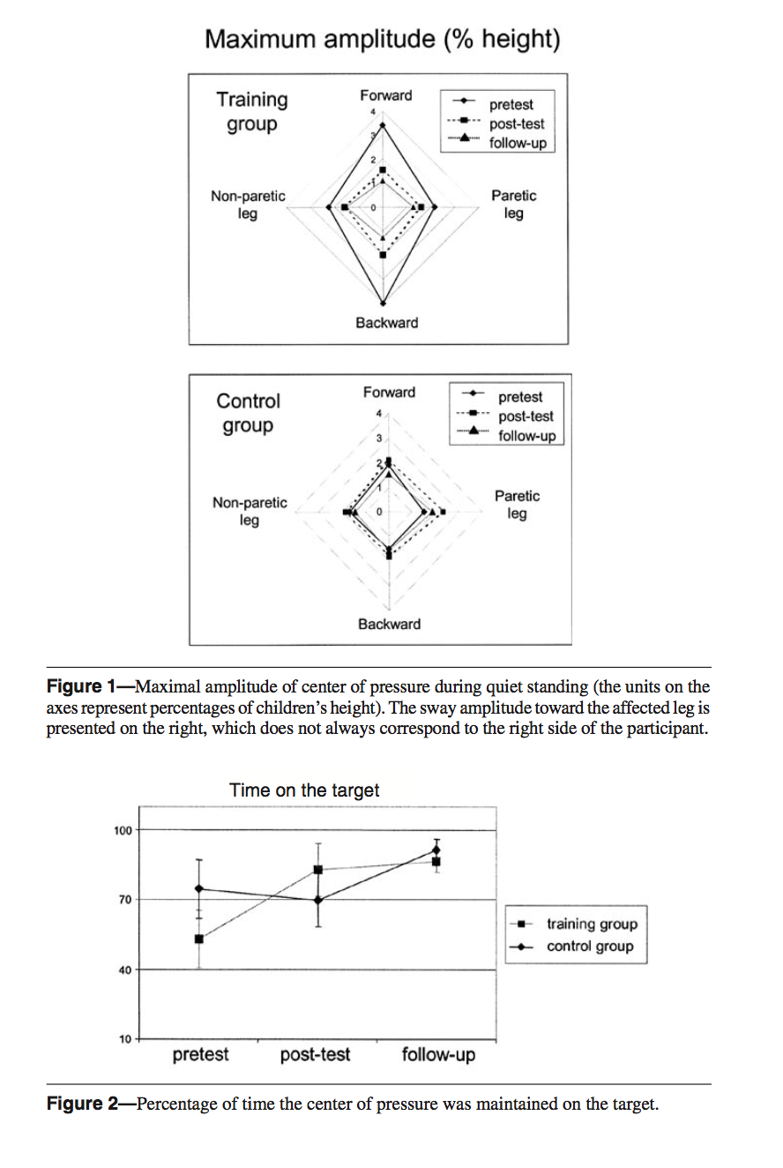

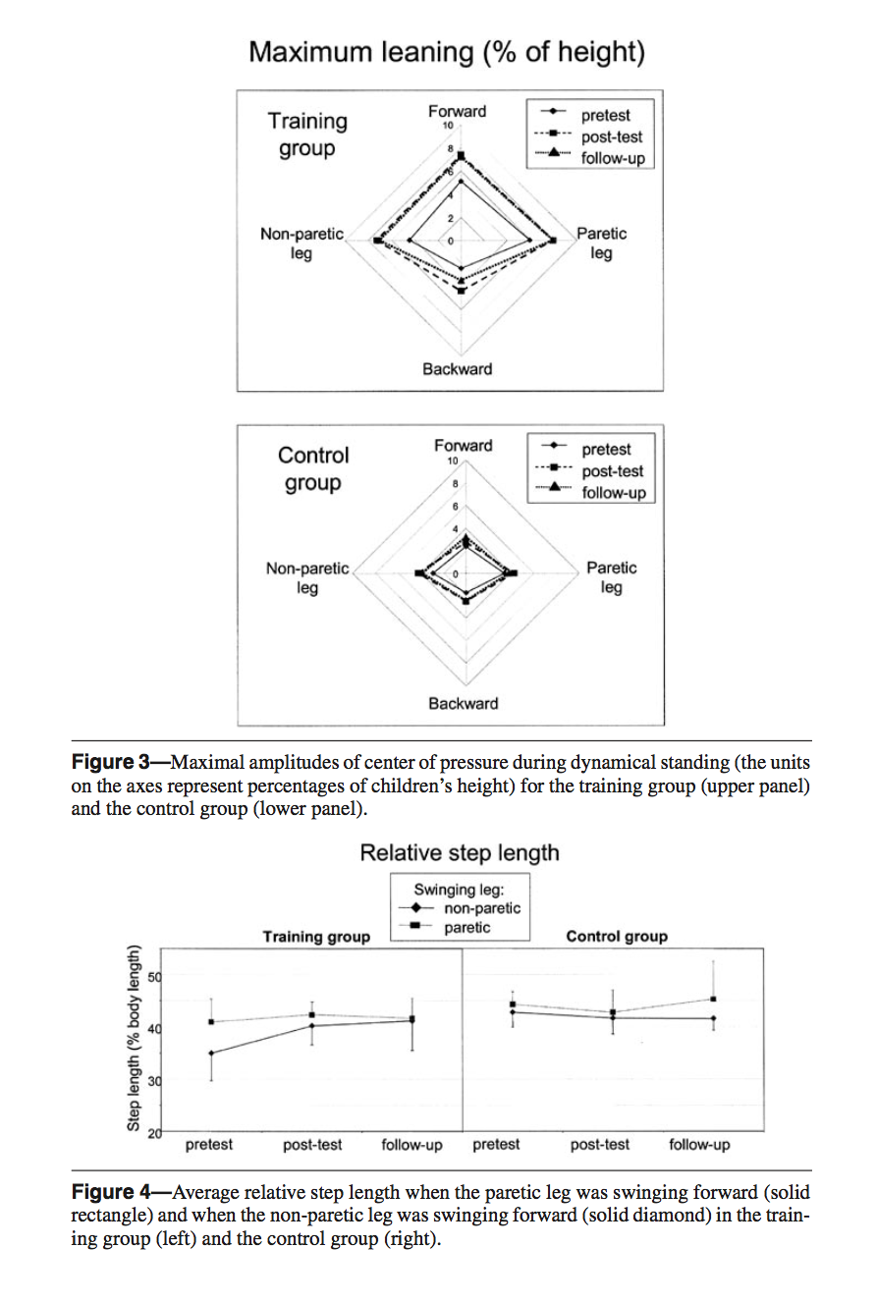
Original Authors’ Conclusions
[Paraphrase as required. If providing a direct quote, add page number]
Ledebt et al. conclude that “balance training with visual feedback, including weight-shifting tasks when standing, might be successfully used in children with hemiplegia. The training improved the tasks that were trained during quiet and dynamical standing and improved gait symmetry indexed by a significant reduction of step length asymmetry between the paretic and non-paretic leg.” (p. 466)⁶
Critical Appraisal
Validity
[Summarize the internal and external validity of the study. Highlight key strengths and weaknesses. Comment on the overall evidence quality provided by this study.]
Internal Validity: Downs and Black Internal Validity score: 9/13 [No for the following: blinding of subjects, blinding of measurers, concealment of assignments, and adjustment for confounding]

External Validity: The small sample size and low power of this study reduces its external validity.

Quality Score: PEDro scale: 4/10 [Eligibility criteria: Yes; Random allocation: Yes; Concealed allocation: No; Baseline comparability: Yes; Blind subjects: No; Blind therapists: No; Blind assessors: No; Adequate follow-up: No; Intention-to-treat analysis: No; Between-group comparisons: Yes; Point estimates and variability: No.]

Strengths: This study used random allocation, which decreases their risk of bias. They also had baseline comparability of subjects between groups, which decreases their risk of bias. The parameters of this treatment plan were unreasonable for a physical therapy plan of care in a standard clinic due to lack of technology and equipment needed. Not many physical therapy clinics have force plate training equipment, therefore making the results less clinically relevant. The same outcome measures were consistently used throughout the study.

Weaknesses: This study has low power due to its small sample size of 10 participants, which increases its likelihood of Type 2 error. Since the participants were all recruited from the same facility, this limits their randomization and increases their risk of bias. This study did not have blinding of subjects, therapists, or assessors, which increases their risk of bias. It would have been helpful for this study to include other formalized outcome measure assessments, such as the GMFM to improve its generalizability.

Overall Evidence Quality: The overall evidence quality provided by this study is moderate. While they used randomization in allocation, they have a very small sample size. However, its usefulness as a high level of evidence being a Randomized Control Trial (RCT) is helpful in considering results as compared to other literature. Generally, it is of lower quality than other studies with higher PEDro scale scores, however, it provides relevant material as best available evidence.
Interpretation of Results
[This is YOUR interpretation of the results taking into consideration the strengths and limitations as you discussed above. Please comment on clinical significance of effect size / study findings. Describe in your own words what the results mean.]
The results of Ledebt et al. demonstrate the use of balance training with visual feedback in improving the stance and gait function of children with CP.⁶ This is seen in their 6-week intervention program’s ability to significantly improve static and dynamic balance in stance as well as significantly decrease asymmetries gait as measured in the study.⁶ While this study is limited in its small sample size and lack of blinding, it consists of a representative population and maintains quality in its experimental design. However, the intervention program described by this study is unreasonable to recreate in a typical physical therapy setting, which decreases its clinical significance. While it is a helpful contribution to the literature on effects of balance training, the equipment and technology required for this specific protocol is unlikely to be found in common physical therapy settings. Therefore, the results of the study must be generalizable to other parameters of balance training in order to be clinically relevant. Overall, Ledebt et al. show that a 6-week balance training program with visual feedback consisting of static and dynamic balance activities 3 times per week for 30 minutes per session is effective for improving gait symmetry and stance in children with CP.⁶

Applicability of Study Results
[Describe the relevance and applicability of the study to your clinical question and scenario. Consider the practicality and feasibility of the intervention in your discussion of the evidence applicability.]
This study has high relevancy to this CAT’s clinical question and scenario. This is because it directly addresses the specific patient population as well as desired outcome. Additionally, it includes children with CP who are ambulatory. However, they do not include children who use assistive devices, which excludes the patient scenario patient who commonly requires the use of loftstrand crutches. Additionally, the patient scenario patient is older than the age range of the children included in the study. Furthermore, rather than comparing two interventions, it adds evidence to the choice of balance training as an effective intervention choice. This study provides evidence that is not as applicable to clinical use because of the poor practicality of the protocol and parameters described. While the study demonstrates effectiveness, the described activities as well as frequency and duration could not easily be replicated in a physical therapy clinic. Rather, they would require more technology and equipment than is readily available in most clinical settings. Therefore, this study has limited applicability for use in the clinic. However, the specificity of their data collection provides evidence that could potentially be generalizable to other forms of balance training. It may add evidence that visual feedback is helpful in improving the effectiveness of balance training in a way that promotes the use of mirrors during balance training. The balance training intervention with visual feedback of this study is effective, but not completely feasible, to be used clinically as a method for improving gait in children with CP.

SYNTHESIS AND CLINICAL IMPLICATIONS
[Synthesize the results, quality/validity, and applicability of the two studies reviewed for the CAT. Future implications for research should be addressed briefly. Limit: 1 page.]
Synthesis of Evidence: The results of this search indicate that a 5-week lower extremity strength training program 3 times per week for 60 minutes per session is effective for improving gait function in children with CP.⁷ Specifically, the lower extremity strength training program that was effective consisted of consisting of warm up stretching exercise, squat to stand, lateral step up, stair walk up and down, isotonic exercise of lower limb muscles using adjustable weight cuffs for 2 sets of 10 repetitions in each muscle group, isokinetic exercise utilizing a bicycle, and a cool down exercise as the intervention.⁷ Additionally, the results of this search indicate that a 6-week balance training program with visual feedback 3 times per week for 30 minutes per session is effective for improving gait symmetry and stance in children with CP.⁶ Specifically, the balance training program consisted of consisted of static and dynamic balance activities as the intervention.⁶ However, there is no current evidence comparing strength training interventions to balance training interventions in order to determine best practice for improving gait in children with CP. The quality of evidence available on this topic is limited.
It should also be noted that my search results yielded much more availability of evidence for strength training as opposed to balance training when assessing effectiveness for improving gait in children with CP.¹⁻⁸ This may be because it is harder to complete research studies based on balance training than it is on strength training, which has led to a wider base of evidence for strength training.
Implications for clinical practice: This evidence indicates that some combination of strength and balance training may be beneficial for improving the gait function of children with CP.⁶⁻⁷ The specific parameters provided in the protocols of these studies can be utilized as guidelines for clinical practice. Evidence supports the use of a 5-6 week long program consisting of 30-60 minute sessions at a frequency of 3 times per week as parameters for a strength or balance training program for children with CP.⁶⁻⁷ Though evidence does not provide clear guidelines for choosing one intervention over another, it is encouraging that both choices have been proven to be effective.⁶⁻⁷ Additionally, literature does not indicate the potential for adverse effects related to either of these intervention options.⁶⁻⁷
While the protocol for strength training programs described in literature are highly feasible and practical for clinical use, the protocols for balance training programs are unrealistic due to the equipment used specifically for research purposes.⁶⁻⁷ Therefore, strength training interventions are already generalizable to clinical practice with patient population. However, balance training interventions may require further research of clinic-based activities in order to prove the efficacy of task specific training that can be utilized in a clinic, rather than only accessible in a research lab.
The evidence for strength and balance training to effectively improve gait function in children with CP is highly relevant to physical therapy practice. This is because strength and balance training interventions are within the scope of practice of physical therapists and can be used as a part of treatment plans in order to reach goals. This literature also provides suggestions for the use of formal outcome measures including the Gross Motor Function Measure (GMFM) to assess gait in children with CP.⁷
Implications for future research: Further research with comparable methods and outcome measures is needed to indicate which intervention method is preferable for improving gait in the treatment of children with CP. The use of clinic-based interventions is important for relevancy and feasibility in applying research results to clinical practice. Therefore, future research should focus on methods that can be replicated in typical clinics so that results are transferrable to real world patient populations. In future research, formal outcome measures, rather than only intervention-based outcome measures should be used to assess effectiveness of interventions. This will help to make results more generalizable. Future research with larger sample sizes is still needed to expand the evidence-base for both lower extremity strength training and balance training programs as interventions to improve the gait function of children with CP.
REFERENCES
[List all references cited in the CAT]
1. Surana BK, Ferre CL, Dew AP, Brandao M, Gordon AM, Moreau NG. Effectiveness of Lower-Extremity Functional Training (LIFT) in Young Children With Unilateral Spastic Cerebral Palsy: A Randomized Controlled Trial. Neurorehabilitation and Neural Repair. 2019;33:862-872.

2. Peungsuwan P, Parasin P, Siritaratiwat W, Prasertnu J, Yamauchi J. Effects of combined exercise training on functional performance in children with cerebral palsy: A randomized controlled study. Pediatric Physical Therapy. 2017;29:39-46.

3. Tedla JS. Strength training effects on balance in spastic diplegia subjects: A randomized controlled trial. Journal of Pediatric Neurology. 2014;2015;12:015-028.

4. Salem Y, Godwin EM. Effects of task-oriented training on mobility function in children with cerebral palsy. NeuroRehabilitation. 2009;24:307-313.

5. Eek MN, Tranberg R, Zügner R, Alkema K, Beckung E. Muscle strength training to improve gait function in children with cerebral palsy. Dev Med Child Neurol. 2008;50:759–764.

6. Ledebt A, Becher J, Kapper J, Rozendaalr RM, Bakker R, Leenders IC, et al. Balance training with visual feedback in children with hemiplegic cerebral palsy: effect on stance and gait. Motor Control. 2005;9:459–468.

7. Lee JH, Sung IY, Yoo JY. Therapeutic effects of strengthening exercise on gait function of cerebral palsy. Disability and Rehabilitation. 2008;30:1439-1444.

8. Scholtes VA, Becher JG, Janssen-Potten YJ, Dekkers H, Smallenbroek L, Dallmeijer AJ. Effectiveness of functional progressive resistance exercise training on walking ability in children with cerebral palsy: A randomized controlled trial. Research in Developmental Disabilities. 2012;33:181-188.

