Jake Tyson
Cervical Spondylosis: Epidemiology, Pathophysiology, Management, and Prevention
Neck pain is an extremely disabling as well as prevalent condition. Approximately two thirds of people will experience neck pain at some point during their lives, and around one third of people have experienced this pain within the past year.¹ Following back pain, neck pain is the most common musculoskeletal cause of primary care consultation around the world, and accounts for an estimated 15% of physical therapy referrals.¹ Neck pain can be extremely disabling for individuals, and puts a burden on the economy and the healthcare system, as it is a chronic disease and often treated with high-cost surgery.
If neck pain is the symptom, the disease is often cervical spondylosis (CS). Spondylosis is a broad category that defines the natural aging and degeneration processes of the spinal structures, related to osteoarthritis and degenerative disc disease.² CS can also occur following traumatic injuries to the neck, but this paper will focus on “wear-and-tear” CS. This disease process often begins early in life, as many people above the age of 30 show radiographic abnormalities of the cervical spine consistent with spondylosis.¹ Disease prevalence increases with age, as spondylotic changes are evident in approximately 25% of adults under age 40, 50% of adults over 40, and 85% of adults over 60!² It is important to understand that degenerative changes evident on a radiograph are often asymptomatic, and neck pain can also occur in the absence of radiographic changes. However, due to the extremely high prevalence of symptomatic CS, it is important to consider this condition when treating any individual with neck pain over the age of 30.
Age is the primary factor contributing to the etiology of CS, as this disease involves degeneration of the spine that progresses throughout the natural aging process.³ However, the boundary between the normal aging process and pathological spondylosis can be difficult to define, so it is important for clinicians to consider other risk factors. Gender is also a risk factor, as the prevalence of the disease is similar between the two genders, but males may experience a greater severity of symptoms and an earlier symptom onset.² Occupation is also a significant risk factor, as individuals exposed to repetitive occupational trauma may be more likely to develop CS.² This may include individuals who are required to carry heavy loads on their necks and shoulders (e.g. movers, stockers), as well as gymnasts and dancers.² Additionally, screen-using occupations are associated with a higher prevalence of the disease (48.5% lifetime prevalence for general population compared to 55% for screen-using workers).⁴ For younger individuals (below 30 years), intensity of work and maintaining static posture for one to three hours per day may increase risk of CS, whereas for people between the ages of 30 and 45, housework intensity has the strongest association with an increased prevalence of this disease.⁴ Exposure to vibration during occupational activities such as vehicle driving is also a risk factor for spondylosis, as full-body vibration may accelerate spinal degeneration.⁴ Menopause may also contribute to CS, as estrogen is important for maintaining collagen content that is protective to the intervertebral discs.⁴ Although obesity is considered a risk factor for many degenerative diseases (e.g. lumbar spondylosis), a 10-year cohort study did not demonstrate a significant association between body mass index (BMI) and CS.⁵ Although a healthy diet and exercise may be protective against the inflammatory and mechanical components of the disease, high body weight is not usually considered a risk factor for cervical degeneration, as the cervical spine is very high in the body and therefore not very affected by body weight. Studies have also shown that sleep quality and duration may affect pathogenesis of CS.⁴ This may be due to several factors, such as emotional stress dysregulation and reduced tissue healing associated with poor sleep quality.⁴ Additionally, fewer hours of sleep increase the load-bearing duration of the spine throughout the day, which can accelerate degeneration from compressive forces.⁴
The degeneration associated with CS typically affects the cervical discs, vertebrae, facet joints, as well as the other joints of the spine and associated soft tissue structures. CS has been defined as "vertebral osteophytosis secondary to degenerative disc disease".³ In other words, degeneration of the discs as the result of the aging process can increase the mechanical stresses on the vertebral column, which can result in osteophyte (bone spur) formation. With age, the proteoglycan matrix of the disc begins to change, and the ratio of keratin sulfate to chondroitin sulfate may increase.³ This leads to subsequent desiccation of the disc, which reduces the size, elasticity, and load-bearing function of the nucleus pulposis.³ The annulus fibrosis is also affected by desiccation, as it is no longer able to withstand axial loads, which leads to further damage of disc fibers and adjacent ligaments (especially under high eccentric loading conditions).³ These degenerative changes lead to a loss of disc height, which predisposes discs to bulges and herniation, creates laxity within the surrounding soft tissues (e.g. posterior longitudinal ligament/PLL, ligamentum flavum), and increases compressive forces within the ventral aspect of the vertebral column.³ As the ventral column becomes compromised, axial loads may be transferred to the dorsal spinal column, resulting in greater load-bearing by the facet joints. As these joints are not designed for load-bearing, this demand leads to hypertrophy of facet joints (osteophyte formation), as well as potential ossification of the PLL.⁷
The alterations in load distribution and cervical disc desiccation ultimately lead to increased kyphosis of the neck.³ Throughout daily activities, discs continue to lose ventral height, which increases the moment arm about the instantaneous axis of rotation (IAR). In a healthy lordotic spine, axial loads are distributed along the IAR, and these forces are attenuated by the vertebral column (see image 1).³ However, as lordotic angle decreases, the moment arm about the center of rotation is increased. The ventral components of the spine are no longer able to bear loads, and more stresses are placed on the dorsal aspects of the spine. As bone and soft tissue are responsive to stress application, these structures will remodel as a result of this imbalance in loading. This leads to new bone in areas of greater stress, and bone resorption in areas where stress is reduced, which will continue to decrease lordotic angle and increase osteophyte formation.³ This degenerative cascade creates a feedforward negative situation in which imbalanced loading conditions leads to further tissue adaptation, osteophyte formation, kyphosis progression, and degeneration of the spine. These changes lead to compression of neural and vascular structures, which contributes to the signs and symptoms consistent with the disease. Halting this progression of kyphosis will therefore help redistribute axial loads along the center of rotation and minimize the transfer of excessive forces to the bony and soft tissue elements of the dorsal column, thereby limiting disease progression.³
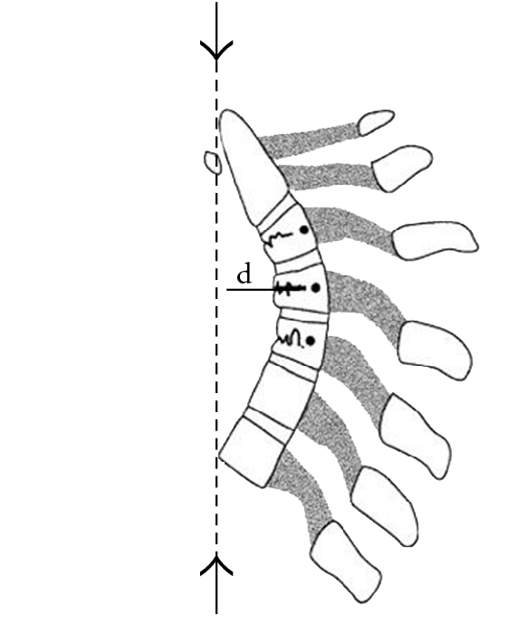
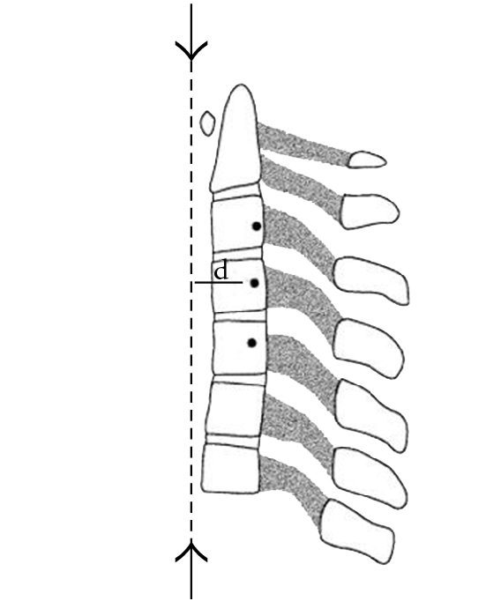
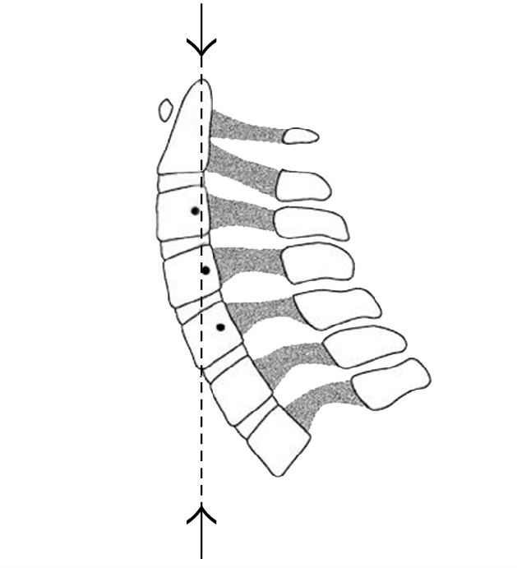
Image 1: ³
A) B) C)
These series of images demonstrate the effects of cervical posture on the degenerative processes of the spondolytic spine. Image A illustrates a healthy, lordotic posture, in which axial forces are applied along the IAR without deviation. In B, the lordotic angle is reduced, which is common with early loss of disc height. The axial forces are now offset from the IAR, which increases the moment arm. This will create a large bending moment, and less external force will be required to produce injury. Larger moment arms lead to greater bending moments, which result in progression of the kyphosis as demonstrated in C.

The pathological changes described above (e.g. osteophyte formation, decreased disc height, facet arthropathy) can lead to the three clinical syndromes of CS, which include axial neck pain, radiculopathy, and myelopathy.⁶ Ultimately, the biomechanical and anatomical changes that occur with CS can lead to vascular and neural compression, loss of function, and pain.³ Manifestation of the signs and symptoms of CS is unpredictable, episodic, and progressive.² Patient presentation will depend on the clinical syndrome, as well as disease duration and patient-specific factors (e.g. anxiety, depression).^{1,6} These three syndromes may occur in any combination, and oftentimes acute neck pain can lead to subsequent chronic axial neck pain and progress to radiculopathy.³
Axial neck pain is the most common syndrome, and is often attributed to factors relating to ergonomics, posture, muscle fatigue, and previous neck injury.⁶ Axial neck pain associated with CS involves facet joint arthropathy, cervical disc degeneration, as well as muscular and ligamentous factors, as these structures contain nociceptive fibers.⁶ A cadaveric study by Lee & Riew confirmed that degenerative CS increases with age, and facet joint arthrosis is the most common in the mid and upper cervical spine.⁸ The C4-C5 level is most commonly affected (29.87% of subjects had significant degeneration at this level), whereas the C6-C7 level was the least frequently affected.⁸ These patients experience neck pain that is exacerbated by certain movements, as well as limitations in cervical range of motion (ROM) and stiffness.⁶ Flexion, extension, lateral flexion, and rotation are often limited.⁶ Rotation to one side is usually more limited than the other, which may indicate ipsilateral atlantoaxial joint involvement.⁶ Atlantoaxial and occipitoatlantal degeneration with associated suboccipital, temporal, and retro-orbital pain commonly occurs in this population, as one third of people with CS will report headaches as a frequent symptom.⁶ These factors may also contribute to dizziness, vertigo, balance impairments, and occasional syncope.¹ Additionally, two thirds of patients with CS will have concomitant unilateral or bilateral shoulder pain, and many others will present with referred pain to the hand, forearm, arm, and between the shoulder blades.^{1,6} These patients may experience pain, tightness, and tenderness to palpation in muscles such as the trapezius, cervical extensors (e.g. splenius capitis), and suboccipitals.⁶ Although neurological involvement is minor until further disease progression occurs, patients with spondolytic axial neck pain may have vague motor and sensory symptoms (upper extremity numbness, tingling, weakness) and even altered reflexes (inverted supinator jerk).¹
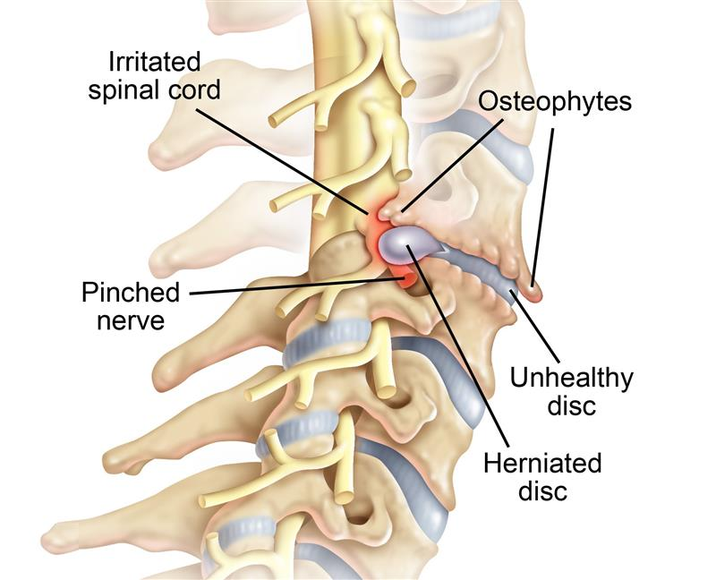
In cervical radiculopathy, nerve roots become compressed due to the narrowing of the intervertebral foramina from degeneration of cervical discs, vertebral joints, and nucleus pulposus herniation (see image 2).⁶ Contrary to axial neck pain, lower cervical nerve roots are more commonly affected by radiculopathy (C5-C6, C6-C7).⁶ The compression can lead to irritation, inflammation, and/or reduced blood supply to the involved roots, ultimately contributing to the pain and dysfunction associated with radiculopathy.⁶ In a study by Cornefjord et al., pigs with chronic nerve root compression showed significantly increased levels of the inflammatory mediator known as Substance P in the affected cervical nerve roots and dorsal root ganglion.⁹ It has also been shown that chronic compression to nerve roots can produce edema and fibrosis of the involved nerves, which can lead to hyperalgesia of the nerve root.¹⁰ Patients with spondolytic cervical radiculopathy will likely present with many of the signs and symptoms consistent with axial neck pain, as well as neurological deficits. These patients will often present with unilateral sensory and motor deficits of the upper extremity that affect a particular myotome and/or dermatomal distribution based on the area of the lesion.⁶ These deficits may include paraesthesia, paresis, and hypoesthesia. They will also commonly have arm pain, impaired reflexes, pain in the scapular region, anterior chest pain, and occasionally may have cervical angina (left-sided arm and chest pain).⁶ Symptoms tend to be aggravated by extension and/or lateral rotation of the head to the affected side, as these movements tend to reduce the space of the intervertebral foramina.⁶ Elevating the arm overhead (shoulder abduction) may relieve symptoms, as this position can reduce compression on the cervical nerve roots.⁶ Ultimately, compression of nerve roots from postural and structural abnormalities can lead to decreased blood flow, increased inflammation, and changes in axonal flow, all of which can contribute to the signs and symptoms of cervical radiculopathy.⁶

Image 2¹¹
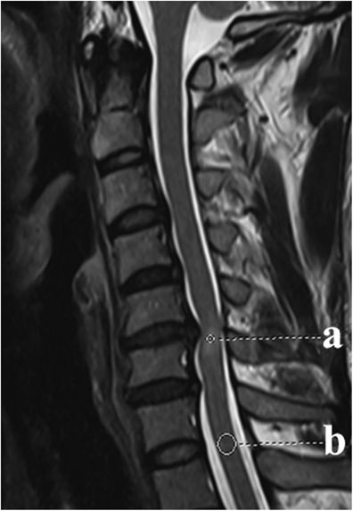
Cervical myelopathy is less common and the most severe of the three clinical syndromes, and may occur in five to ten percent of CS cases.⁶ This condition occurs more often in older patients, and may be considered an extremely debilitating progression of chronic CS (sudden onset in a younger patient may suggest disc prolapse).^{1,6} Cervical myelopathy involves narrowing of the spinal canal due to degenerative processes as well as congenital factors, which can result in compression and damage of the spinal cord and associated neurological dysfunction (see part A of image 3).⁶ A congenitally narrow diameter of the subaxial spine (less than 13mm, as 17-18 mm anterior posterior diameter is considered normal) may predispose individuals to mechanical compression of the spinal cord.⁶ Instability can also be a factor in the pathogenesis of myelopathy. In fact, some researchers have suggested that cervical disc degeneration may be a compensatory strategy that the body uses to promote “autofusion” of an unstable spine in order to protect a vulnerable spinal cord from compression during certain movements.⁶ Myelopathy is insidious in onset, and progresses slowly with early symptoms such as clumsiness and impaired fine motor coordination.⁶ Patients with myelopathy may experience neck pain and stiffness with occasional “stabbing” arm pain, as well as “electric shock” sensations in the extremities associated with neck flexion and extension (known as L’hermitte’s sign).⁶ Certain movements may increase symptoms, as extension decreases spinal canal volume and thickens the spinal cord, which can expose the cord to compression from the ligamentum flavum and/or lamina.⁶ Patients with cervical myelopathy may begin to experience urinary urgency and frequency, as well as gait and balance disturbances.¹ These patients may demonstrate upper motor neuron signs in the legs and lower motor neuron signs in the arms depending on the affected level of the spinal cord.¹ For example, spasticity and exaggerated reflexes are likely to be evident below the level of the lesion, and muscle atrophy and weakness is common above the level of the lesion.⁶ “Myelopathy hand” is a common pathological finding, which includes numbness, muscle wasting, dexterity loss, dysfunctional grasp and release of the fist, and flexor and ulnar drift of the ulnar two digits when finger adduction and extension is attempted.⁶ Cervical myelopathy is considered a “red flag” syndrome, and appropriate and prompt referrals should be made if a physical therapist discovers these symptoms.¹
During an examination of any individual with neck pain, clinicians should consider the three syndromes of CS. The clinician should obtain a thorough patient history to reveal all signs and symptoms that may be consistent with this disease, and also consider any pertinent risk factors (age, occupation, gender, prior injury, etc.). Throughout the subjective examination, the clinician should pay attention to posture, as an increased kyphosis (forward-head posture) is intimately related to the pathophysiology of spondylosis. CS is often diagnosed through signs and symptoms alone, so this portion of the exam is extremely important.² It may be useful to confirm a diagnosis with radiographic or MRI imaging, but patients should be educated that findings on images do not necessarily correlate with symptoms.² MRI may be warranted if a severe pathology is suspected (such as myelopathy), but the findings must be delivered and interpreted with care.²
Objectively, the clinician should perform a thorough upper quarter screen and pay attention to symptom exacerbation and alleviation. The clinician should compare all findings between the involved and uninvolved side. This should include tests of joint mobility, as well as active and passive range of motion of the cervical spine and upper extremities, with overpressure if pain is not elicted.¹⁴ It is expected that patients with spondolytic axial neck pain will have pain with movement, stiffness, as well as reduced rotation to one side more than the other.⁶ Additionally, myotomes and dermatomes from C1-T1 should be assessed through resistive and sensory testing (e.g. manual muscle testing, light touch sensation).¹⁴ Neurological involvement would be unlikely for axial neck pain, but should be expected for radiculopathy and myelopathy.⁶ For radiculopathy, unilateral involvement to specific dermatomal and myotomal levels should be expected, with C5/C6 and C6/C7 being the most affected levels (see image 4).⁶ Unilateral or bilateral neurological involvement may occur with myelopathy, with severe motor and sensory deficits of the upper extremity.⁶ Reflex testing should also be performed. Patients with axial neck pain will likely have intact reflexes, with a possible inverted supinator jerk.¹ For patients with radiculopathy, reflexes will often be diminished or absent. Biceps hyporeflexia may indicate C6 radiculopathy, whereas brachioradialis and triceps hyporeflexia is indicative of C7 radiculopathy.¹⁵ Myelopathy is often associated with upper motor neuron signs below the lesion, such as exaggerated tendon reflexes (e.g. Achilles, patellar), as well as pathological reflexes (clonus, Hoffman’s, Babinski).¹⁶ The clinician should also assess gait and balance (e.g. Romberg test, single leg stance), as well as L’hermitte’s sign if myelopathy is suspected.⁶ It would be useful to include a clinical prediction determine the presence of cervical radiculopathy. The following four criteria are indicative of cervical radiculopathy, with a sensitivity of 0.24 and a specificity of 0.99: positive upper limb tension test A, positive distraction test, involved-side cervical rotation range of motion less than 60 degrees, and positive Spurling’s test A.¹⁷
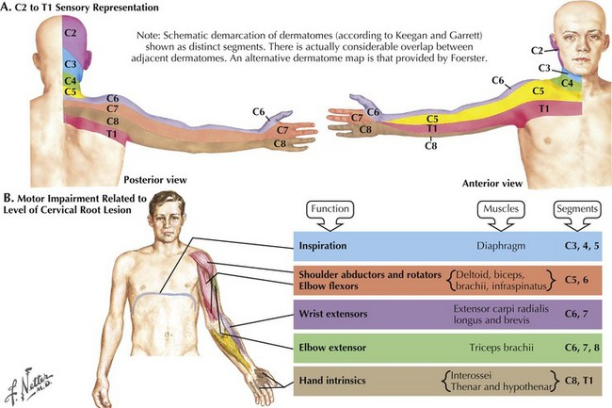

Image 4¹⁸

A differential diagnosis list must be considered during the examination of a patient with suspected CS. Other lesions that could contribute to axial neck pain should be considered, such as whiplash, acute strain, and postural neck ache.² Fibromyalgia as well as psychogenic neck pain may also present in similar manners to spondylosis.¹ Mechanical lesions may cause similar symptoms, such as prolapse of discs and diffuse idiopathic skeletal hyperostosis.² Inflammatory diseases should be considered, including ankylosing spondylitis, polymyalgia rheumatica, and rheumatoid arthritis.^{1,2} People with rheumatoid arthritis often have inflammation that degenerates the upper cervical spine and atlantoaxial joint, so it is necessary to determine whether their cervical symptoms are due to their inflammatory condition or concomitant CS.¹ Metabolic conditions such as gout, pseudo-gout, osteoporosis, and Paget’s disease can also lead to a similar clinical presentation.¹ Red flag conditions that warrant medical referral such as infections should be considered, including osteomyelitis and tuberculosis.¹ Other red flags may include cervical instability (include Sharp Pursor, as well as alar and transverse ligament stability tests), fractures (consider history of severe osteoporosis), primary neurological diseases, and malignancy.¹ Features of a red flag condition may include fever, night sweats, unexpected weight loss, intractable pain at night, extreme tenderness over a vertebral body, excruciating pain, drop attacks, recent surgery or trauma, history of malignancy, inflammatory disease, and/or immunosuppression.¹
Several outcome measures can be utilized during evaluation and to track progress in therapy for patients with CS. As pain is the primary symptom for this disease, self-report measures that can assess pain levels are important to incorporate. The visual analogue scale (VAS) should be used before and after each treatment session, which allows patients to subjectively report their pain levels on a scale from zero to ten.² The Neck Disability Index (NDI) is commonly used for this patient population, as this self-report questionnaire can assess the extent to which neck symptoms affect a patient’s daily functioning.¹⁹ This tool has been found to have excellent test-retest reliability, validity, and internal consistency for chronic, non-specific neck pain, degenerative neck pain, and for patients who have had a cervical fusion surgery.¹⁹ It has demonstrated acceptable responsiveness to treatment for patients with cervical radiculopathy, and excellent responsiveness for cervical fusion surgery.¹⁹ If a patient has spondolytic cervical myelopathy, an additional outcome measure should be used such as the Japanese Orthopaedic Cervical Myelopathy Evaluation Questionnaire (JOACMEQ).² This tool can be used to access the extent and progression of the disease. This self-administered questionnaire contains 24 questions that evaluate the function of the spinal cord and cervical spine, including lower extremity, upper extremity, cervical spine, and bladder function, as well as quality of life.²⁰ The JOACMEQ has been shown to be sufficiently reliable for use in this patient population.²⁰
Regarding physical therapy management of CS, most evidence indicates that a combination of manual techniques and exercise is most effective for reducing pain and improving physical function. Treatment should be individualized to the patient, but should include a progressive supervised exercise program as well as a home exercise program (HEP). Generally speaking, treatment may last for three months and incorporate 15-20 sessions, depending on patient presentation and response to therapy.²¹ As CS is essentially osteoarthritis, similar strategies can be incorporated to treat this condition, with interventions aimed at improving range of motion, increasing synovial fluid distribution, protecting articular cartilage, managing pain, and increasing physical activity and participation. According to clinical practice guidelines, strong evidence supports the incorporation of strengthening, coordination, and endurance exercises to reduce neck pain and cervical symptoms.²² Many clinicians will incorporate isometric exercises to strengthen neck musculature, which may be less aggravating than strengthening exercises that involve a full active range of motion.²² Endurance and strengthening exercises should target the deep neck flexors (e.g. longus capitis, longus colli), which are important stabilizing and postural muscles that may help restore cervical lordosis.²² There is also moderate evidence to support the use of nerve mobilization techniques for patients with cervical radiculopathy.²² These “nerve gliding” techniques may be incorporated into a HEP to help reduce neural symptoms. Postural re-education should be part of the intervention plan, and include both therapeutic exercises targeting key postural muscles as well as patient education and postural awareness techniques. Postural “reminders” may be beneficial, such as the use of sticky-note reminders (“breastbone up!”), as well as postural tape or iPosture monitors. Cervical sleeping pillows can be used to improve sleeping posture, as these pillows may help reduce forward head posture to restore cervical lordosis. Immobilization is often incorporated for patients with evidence of severe CS, as cervical collars will limit movement of the neck to decrease irritation of the affected structures. However, immobilization can lead to atrophy of tissues as well as a reduction in activity and participation, which could lead to further impairments over the long-term. Patients should be educated on how to safely return to normal daily activities while avoiding or modifying aggravating factors, with an emphasis on maintenance of a healthy posture during occupational activities.
Clinical practice guidelines also indicate that manual therapy may be extremely effective modality for patients with CS, and should include techniques such as cervical traction, soft tissue mobilization, non-thrust manipulation, and possibly thrust manipulation.^{2,22} Strong evidence supports both cervical manipulation and mobilization for the treatment of neck pain, headaches, and neck-related disability, especially when combined with exercise.²² For patients diagnosed with CS without radiculopathy, the success of cervical manipulation increases from 39% to 90% with the presence of three or more of the following factors: duration of symptoms <38 days, patient expectation that the treatment will help, difference in cervical ROM greater than 10 degrees from side to side, and mid cervical pain with posterior anterior (PA) spring testing.²² The use of cervical traction may also be indicated for spondylosis with radiculopathy, which may help centralize the symptoms by reducing pressure on spinal discs.²² Traction can be performed manually, as well as with mechanical devices in the clinic and/or at home. Some clinicians may incorporate thermal therapy and/or ultrasound for the treatment of CS, but thermal therapy likely provides only temporary relief of symptoms, and ultrasound appears to be ineffective.²¹
Other conservative treatment options may be incorporated in addition to physical therapy. Non-steroidal anti-inflammatory drugs (NSAIDs) are commonly used for their analgesic effects, as well as for their anti-inflammatory properties, which may decrease nerve root inflammation.²¹ If symptoms are unresponsive to more conservative measures and nonopioid medications, opioid analgesics are often used to treat moderate to severe axial neck pain.²¹ However, these medications are addictive, and may not be effective for neuropathic pain, so they should be used cautiously and sparingly.²¹ Other commonly used medications include muscle relaxants, antidepressants, anticonvulsants, and corticosteroids.²¹ Acupuncture has also demonstrated effectiveness as a short-term pain reliever, but with no strong evidence supporting the use of this treatment over the long-term.²¹ Alternative movement practices such as yoga or Pilates may be a useful adjunct for patients with CS, as these activities emphasize postural alignment, strength and ROM, functional movement and breathing patterns, kinesthetic awareness, and stress management. A randomized controlled trial compared a nine-week yoga intervention to a self-care exercise program for patients with chronic neck pain.²³ At nine weeks, the yoga group had significantly improved pain and neck-related disability as compared to the control group.²³ These significant results were maintained at a 12-month follow-up, indicating that sustained adherence to a yoga program is the most important predictor of long-term efficacy.²³ However, patients should be educated to avoid aggravating positions during movement practices, as extreme ranges of motion (e.g. hyperextension) may further irritate compressed structures.⁶
Before surgery is considered, physical therapy and/or other conservative management options should be the primary treatment strategy for at least the initial three months following symptom manifestation.²¹ Although 70-90% of patients with cervical radiculopathy may have favorable long-term outcomes with conservative treatment only, recurrence rates for chronic neck pain are extremely high.²² Additionally, prognosis for cervical myelopathy remains unclear, and conservatively treated patients often experience gradual, stepwise declines in function over time.²² When surgery is considered, it is important to educate patients on what to expect following these operations so they may be able to make the most informed decision. Evidence suggests that surgically-treated patients may experience greater improvements in pain and function as compared to patients treated with physical therapy alone for a short time period after surgery, but there are no significant differences in long-term outcomes for any three of the clinical syndromes.²¹ One study compared the long-term efficacy of physical therapy treatment alone to anterior cervical decompression and fusion (ACDF) surgery with post-operative physical therapy for patients with cervical radiculopathy.²⁴ At six, 12, and 24 months after the surgery, there were no significant differences between the groups on the NDI or the VAS for arm pain.²⁴ However, at six and 12 months, the surgical group reported significantly less neck pain on the VAS, which become insignificant at 24 months.²⁴ At 12 months, there was a significant difference in the percentage of patients in the post-surgical group who rated their symptoms as “better/much better” (87%) as compared to the physical therapy group (62%).²⁴ However, this difference was insignificant at 24 months (81% and 69%, respectively).²⁴ These results indicate that the ACDF with the addition of physical therapy resulted in more rapid improvements for patients with cervical radiculopathy, but the improvements become statistically indistinguishable from the physical therapy group after two years. As surgery comes with great risks (e.g. surgical complications, development of adjacent level disease)² as well as an excessive financial burden, physical therapy may be the most efficacious treatment option over the long term for these patients.
There are several surgical options available to patients with CS if they are unresponsive to conservative treatment, continue to experience functional decline, exhibit static neurological deficits with radicular pain, and/or the patient has a clinical presentation that concurs with diagnostic findings.²² The goals of surgery for CS are as follows: prevent and/or correct spinal deformities, maintain spinal stability, and improve and/or preserve neurological function.² Nerve root and spinal decompressions are common, which include laminectomy, discectomy, corpectomy, and laminoplasty.²² Decompression surgeries are extremely common, and can be performed with or without arthrodesis (fusion).² A posterior, anterior, or combined approach can be used, which depends on the location of compression (anterior vs posterior), as well as the presence of developmental narrowing of the spinal canal.² Cervical disc replacements may be chosen rather than fusions, as this option could potentially decrease the risk of adjacent level disease progression due to a restoration of normal biomechanical properties of the spine, although studies have failed to verify this over the long-term.²² The surgical approach will depend on many patient-specific factors, as well as the clinical judgment and expertise of the operating surgeon.
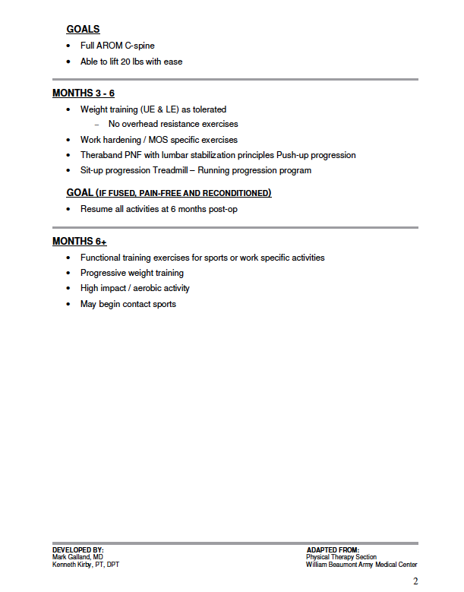
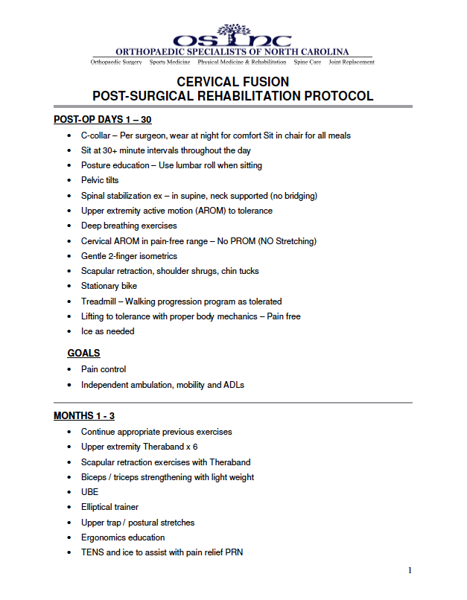
The below diagram (image 5) describes the post-operative rehabilitation protocol for cervical fusion developed by the Orthopaedic Specialists of North Carolina (OSNC).²⁵ In general, physical therapy may commence several weeks after the surgery, and often continues for three to six months depending on the response of the patient.²⁵ Generally speaking, the fusion is considered solid after three months, and all pre-operative activities may be resumed after six months.²⁵ The initial month following surgery should emphasize posture, stability, safety, as well as gentle strengthening, endurance, and breathing exercises (but no stretching).²⁵ Afterwards, the intensity of the exercises should be increased (incorporate therabands, weights), stretching can be commenced, and ergonomics should be emphasized.²⁵ For three to six months after surgery, weight training resistance should be increased (no overhead resistance), running and calisthenics should begin, and eventually higher impact, work-specific, and advanced functional training can be incorporated.²⁵
Image 5²⁴
As CS is extremely common, progressive, and debilitating, it is our role as physical therapists to educate the public on how to prevent, manage, and slow the progression of this condition. As degenerative changes in the cervical spine may begin to manifest earlier than age 30, preventative measures should begin very early in life. People with certain risk factors (occupational exposure to vibration, heavy loading of neck, trauma) should be educated on methods to minimize their risk. Individuals who lift heavy weights during recreational or occupational activities should be educated on proper lifting mechanics to limit excessive stresses on cervical tissues. School physical therapists as well as those working in occupational settings should consider ergonomic influencers of neck position, such as desk and screen height, keyboard placement, back support on chairs, as well as wrist and arm supports. People of all ages should be educated on how to maintain a healthy cervical lordotic posture by minimizing forward head positions, using cues such as “breastbone up!”, and perhaps incorporating external supports such as postural taping or posture monitoring devices. Sleeping posture may be improved by limiting excessive pillowing and perhaps using a cervical pillow to maintain lordosis. Frequent use of screens and maintaining static postures for prolonged periods of time may increase incidence of CS, so individuals should be encouraged to limit screen time, change positions frequently, and avoid a sedentary lifestyle.⁴ All people should be encouraged to find a healthy movement program that they will stick to over the long-term that includes cervical range of motion, strengthening, and postural exercises (e.g. yoga, Pilates, therapeutic exercises). People should also be educated on how lifestyle factors can influence the pathogenesis of this disease. Cigarettes should be avoided at all costs, as tobacco is extremely unhealthy for all body tissues, including spinal discs and articular cartilage.⁴ Additionally, all people should be educated that adequate sleep (7-9 hours) is necessary for tissue healing, emotional regulation, and decompression of spinal discs. Although many risk factors may not be avoided (age, gender), educating the public on preventative measures will likely reduce the tremendous burden that CS has on people’s lives and our healthcare system.
In conclusion, CS is a prevalent and disabling condition that affects people throughout the lifespan. However, this disease may be preventable, and can often be managed effectively through conservative measures. All people with or without a diagnosis of CS should be educated on how to prevent or decrease progression of this condition, especially individuals who are exposed to occupational or recreational risk factors. Conservative management should include exercises, manual therapy, postural education, and possible use of medications and alternative therapies. If decline continues or the patient is unresponsive to therapy, surgery may be considered, which will likely be a decompression and/or fusion, or a cervical disc replacement. Patients will likely require physical therapy for several months following surgery, which will depend on the surgeon’s protocol and patient’s response. Before choosing surgery, patients should be educated that long-term efficacy of surgery is similar to that of physical therapy, and that radiographic findings do not necessarily correlate with symptoms.

References:
- Binder AI. Cervical spondylosis and neck pain. BMJ. 2007;334(7592):527–531. doi:10.1136/bmj.39127.608299.80
- Cervical Spondylosis - Physiopedia. Available at: https://www.physio-pedia.com/Cervical_Spondylosis.
- Ferrara LA. The biomechanics of cervical spondylosis. Adv. Orthop. 2012;2012:493605. doi:10.1155/2012/493605.
- Lv Y, Tian W, Chen D, Liu Y, Wang L, Duan F. The prevalence and associated factors of symptomatic cervical Spondylosis in Chinese adults: a community-based cross-sectional study. BMC Musculoskelet Disord. 2018;19(1):325. Published 2018 Sep 11. doi:10.1186/s12891-018-2234-0
- Mesas AE, González AD, Mesas CE, de Andrade SM, Magro IS, del Llano J. The association of chronic neck pain, low back pain, and migraine with absenteeism due to health problems in Spanish workers. Spine 2014;39(15):1243-1253. doi:10.1097/BRS.0000000000000387.
- Kelly JC, Groarke PJ, Butler JS, Poynton AR, O'Byrne JM. The natural history and clinical syndromes of degenerative cervical spondylosis. Adv Orthop. 2012;2012:393642. doi:10.1155/2012/393642
- Shedid D, Benzel EC. Cervical spondylosis anatomy: pathophysiology and biomechanics. Neurosurgery 2007;60(1 Supp1 1):S7-13. doi:10.1227/01.NEU.0000215430.86569.C4.
- Lee MJ, Riew KD. The prevalence cervical facet arthrosis: an osseous study in a cadveric population. Spine J 2009;9(9):711-714. doi:10.1016/j.spinee.2009.04.016.
- Cornefjord M, Olmarker K, Farley DB, Weinstein JN, Rydevik B. Neuropeptide changes in compressed spinal nerve roots. Spine. 1995;20(6):670–673.
- Cooper RG, Freemont AJ, Hoyland JA, et al. Herniated intervertebral disc-associated periradicular fibrosis and vascular abnormalities occur without inflammatory cell infiltration. Spine. 1995;20(5):591–598
- Image available at: https://www.cervicaldisc.com/Portals/0/EasyDNNnews/29/img-4rev_white-back_v21.jpg
- Levin K. Cervical spondylotic myelopathy - UpToDate. Available at: https://www.uptodate.com/contents/cervical-spondylotic-myelopathy.
- Image available at: https://media.springernature.com/full/springer-static/image/art%3A10.1038%2Fsc.2016.64/MediaObjects/41393_2016_Article_BFsc201664_Fig1_HTML.jpg
- Boren D. The upper quarter screen. Physical Therapy Central, INC. Available at: https://cdn.ymaws.com/www.okpt.org/resource/resmgr/2016_Annual_Meeting_Handouts/Student_Course_-_The_Upper_Q.pdf
- Cervical Radiculopathy- Physiopedia. Available at: https://www.physio-pedia.com/Cervical_Radiculopathy
- Cervical Myelopathy- Physiopedia. Available at: https://www.physio-pedia.com/Cervical_Myelopathy
- CPR for Cervical Radiculopathy- Physiopedia. Available at: https://www.physio-pedia.com/CPR_for_Cervical_Radiculopathy
- Image available at: https://clinicalgate.com/wp-content/uploads/2015/03/B9781437702736000610_f061-001-9781437702736.jpg
- Neck Disability Index. Shirley Ryan AbilityLab. Available at: https://www.sralab.org/rehabilitation-measures/neck-disability-index
- Fukui M, Chiba K, Kawakami M, et al. Japanese Orthopaedic Association Cervical Myelopathy Evaluation Questionnaire: part 3. Determination of reliability. J Orthop Sci. 2007;12(4):321–326. doi:10.1007/s00776-007-1131-4
- Hirpara KM, Butler JS, Dolan RT, O'Byrne JM, Poynton AR. Nonoperative modalities to treat symptomatic cervical spondylosis. Adv Orthop. 2012;2012:294857. doi:10.1155/2012/294857
- Sions M. Neck Pain - PTNow. Available at: https://www.ptnow.org/ClinicalSummaries/quick-detail/neck-pain-58.
- Cramer H, Lauche R, Hohmann C, Langhorst J, Dobos G. Yoga for chronic neck pain: a 12-month follow-up. Pain Med 2013;14(4):541-548. doi:10.1111/pme.12053.
- Engquist M, Löfgren H, Öberg B, et al. Surgery versus nonsurgical treatment of cervical radiculopathy: a prospective, randomized study comparing surgery plus physiotherapy with physiotherapy alone with a 2-year follow-up. Spine 2013;38(20):1715-1722. doi:10.1097/BRS.0b013e31829ff095.
- Galland M, Kirby K. Cervical fusion post-surgical rehabilitation protocol. Orthopaedic Specialists of North Carolina. Available at: https://orthonc.com/uploads/pdf/Cervical_Fusion.pdf

