Ankle and Knee Joint Contractures in Neurologically-Involved Populations:
Physical Therapy Evaluation, Plan of Care, and Special Considerations
Introduction
- Pathophysiology
Multiple sclerosis (MS) is an immune-mediated neurodegenerative disease that damages the myelin, nerves, and oligodendrocytes of the central nervous system.¹ Cerebral palsy (CP) is a nonprogressive neurologic condition often caused by traumatic birth, prematurity, and newborn hypoxia, all of which can lead to physical deformities and limitations, spasticity, and cognitive deficits, among other symptoms.² Ischemic cerebrovascular accidents (CVA) are due to blockages of blood vessels in the brain leading to deoxygenation and subsequent damage of brain tissue that can arise from a variety of diseases and mechanisms.³ Among these three particular neurologic conditions, there are several shared manifestations assessed and treated by physical therapists, one of which is joint contracture. Both myogenic and arthrogenic factors contribute to joint contracture in the neurologic populations, but while myogenic sources are strongly influenced by neurologic dysfunction, arthrogenic changes often result from capsular and other musculoskeletal tissue involvement. The ankle and knee joints are two of the most vulnerable joints to undergo contracture, are frequently affected in the aforementioned populations, and greatly hinder physical autonomy, function, and quality of life when affected.⁴
Joint contracture can be defined as a significant loss of passive range of motion (ROM) of a joint, especially in diarthrodial joints. A diarthrodial joint is the most mobile type of joint, involving both a synovial capsule and synovial fluid in the intraarticular space, which enable maximal safe mobility.⁴ Joint contractures can result from three distinct conditions including congenital disorder, chronic disease, and immobility, and are influenced by both genetic and environmental predisposing factors.⁴ For the populations of interest specific to this paper, a combination of these three conditions is common since people with multiple sclerosis or post-stroke are often subjected to increased immobility, and children with cerebral palsy may be born with congenital joint contractures in addition to the chronicity of the disease heightening their risk of joint contracture(s).⁴ While it can be difficult to diagnose an arthrogenic versus myogenic contracture, differentiation is critical for treatment and plan of care. Additionally, contractures often involve a combination of myogenic and arthrogenic contributions.⁴
Joint contracture may result from a variety of restricting musculoskeletal tissue including muscle, capsule, tendon, ligament, cartilage, skin, and bone. Muscular spasticity involving the imbalance of neuronal signals to the muscles and fascia are often a source of limited motion in neurologic populations, increasing the risk of joint contracture. Immobility-related joint contracture most commonly involves the joint capsule, but can also include muscular tightening due to atrophic changes.⁴ The lack of mechanical stimulation related to immobility is often the underlying etiology in both neurologic and immobility-related contractures.⁴ Specific to the knee joint, the posterior capsule is most frequently involved in flexion contractures. The posterior capsule of the knee maintains a folded arrangement when flexed, which unfolds when extended. When immobilized in flexion, adjacent folds adhere to one another, reducing synovial capsule length. In addition, the synovial capsule experiences reduced fibroblast proliferation in the synovial fluid without appropriate mechanical stimulation. Finally, the collagen fibers that comprise the posterior capsule become disorganized in their orientation with a surplus of type I collagen fibers, both of which increase stiffness and reduce elasticity of the capsule.⁴ Additional changes include amplified fibrosis of the synovium and a loss of glycosaminoglycans, which play a critical role in water retention, thereby increasing collagen cross-links.⁴
- Prevalence
According to a recent cross-sectional study, more than 50% of individuals with MS present with at least one joint contracture, ankle (43.9%) and knee (17%) joint contractures being two of the most common sites of those affected. Based off of these measures, prevalence rates of 28.8% and 5.4% are predicted among the MS population, respectively.⁵ In a large 2018 cross-sectional study of children with CP, 685 of 3,045 children were identified with a knee contracture of 5 degrees or greater (22%). Higher levels of disability and shortened hamstring muscles were correlated with presence of knee joint contracture.⁶ In a study of patients post-stroke, 43% were diagnosed with a joint contracture, which was defined by a 30% or more limitation in joint range motion when compared to the healthy limb.⁷ All of these prevalence rates indicate the need for strong assessment and treatment skills of physical therapists, the primary initial providers for joint contractures.
- Brief Anatomic Review of Relevant Ankle and Knee Joint Structures
The posterior capsule of the knee is the most common source of contracture with knee flexion contractures related to chronic neurologic conditions and immobility related contractures. It has an inner synovial membrane and an outer fibrous membrane that is thicker and tougher. When the knee is flexed, the posterior capsule has many folds to make it compact, which then unfold as the knee is extended. The capsule contains the ligaments, bursae, tendons, and patella, although both the anterior cruciate and posterior cruciate ligaments are intracapsular but extra-articular. The knee capsule is thinnest anteriorly and thickest posteriorly. Several of the enclosed tissues can augment the contracture as well including the ligaments and tendons. Shortening of the hamstring tendons and medial and lateral collateral ligaments can both further reduce the extension of the knee joint.⁸ For an anatomic visual, see Figure I of the Appendix.
The articular capsule of the ankle encompasses the multiple joints that comprise the ankle. It is thinnest anteriorly and posteriorly, and thicker laterally on each side where it encases the malleoli. The anterior capsule is very broad in order to encompass all of the structures within it. Additionally, its synovial membrane attaches to the interosseous ligament between the tibia and fibula. Because it is so broad in width, the fibers are primarily oriented transversely.⁹ The talocrural, also called tibiotalar, joint is the synovial diarthrodial joint responsible for plantar flexion and dorsiflexion, occurring primarily in the sagittal plane. The ligaments and bony structures of the ankle are primary responsible for ankle stability, specifically the talocrural joint.¹⁰ The principle source of ankle contracture is uncontrolled plantar flexor muscle forces either due to spasticity or other muscle imbalances, which allow shortening of joint structures including tendons, ligaments, and the capsule, leading to subsequent contracture at the joint.¹¹ For anatomic visual of the ankle joint, see Figure II of the Appendix.
Evaluation
- Assessment of Joint Contracture
Thorough evaluation of a potential ankle or knee joint contracture should include inspection, active and passive ROM with goniometric measurements, manual muscle testing, gait analysis if patient is ambulatory, spasticity testing, joint mobilization, and muscle flexibility testing. The two components of joint contracture are arthrogenic and/or myogenic in nature. Arthrogenic sources or joint contracture include joint capsule tightening along with shortening of ligaments, the synovial membrane, and other changes. This is contrasted from myogenic sources of contracture, which involve shortening of the muscles. These two types exclude a third, neurologic-based contributor: spasticity, which is related to hyper-reflexive activity, and contributes to the myogenic joint contracture.¹² It is difficult to distinguish decreased joint ROM due to tightening and shortening of structures within the joint from excessive muscular activity related to spasticity in the neurologic populations.¹³ While hand-held dynamometers have not been implemented into clinical settings for reasons of time efficiency and difficulty of use, these devices measure muscle stiffness while calculating electromyographic (EMG) activity to improve differentiation of neural and structural contributions to lost ROM.¹⁴ For these neurologically-involved populations, distinguishing transient spasticity from a joint contracture is imperative to determining appropriate treatment courses. Specific hyper-reflexive activity is distinct from involuntary muscle hyperactivity, often referred to as spastic dystonia. Muscle hyperactivity can lead to fixed shortening, and is treated differently than arthrogenic sources of stiffness and immobility. For the purposes of this paper, muscle spasticity and spastic dystonia will be considered neurologic-related myogenic sources of joint contracture. Ankle joint dynamometers are a relatively new device that should be utilized if possible to help distinguish spasticity sources of lost joint ROM.^{13,15} Dynamic dynamometers are gaining momentum in the literature, but have yet to be implemented in clinic, while stationary dynamometers are still able to produce reliable reports of torque and stiffness, which can then be used to distinguish passive pathophysiologic changes such as joint capsule tightening from spasticity in neurologic populations.¹³ For a visual of the dynamic ankle dynamometer, see Figure 3 of the Appendix.
Spasticity is identified by fast angular motion of the joint. To distinguish either of these two sources of myogenic contracture from arthrogenic contracture, clinicians must measure ROM at a fast angular velocity and compare the ROM to that of a slow angular velocity. Faster angular velocities will elicit the reflexive activity, thereby reducing the attained ROM.¹³ For objective, more reliable measures of ‘fast’ versus ‘slow’ angular velocity testing at the joint, use of the dynamic or static dynamometers are suggested.¹³ Fast velocities are oftentimes considered moving the knee through its full available ROM in less than one second, while slow velocities are considered moving the knee through its full available ROM in at least 5 seconds or more.¹⁶ If using a dynamic dynamometer, slow angular velocities are considered ~20°/sec, while fast velocities are performed as quickly as possible, and typically ~300°/sec.¹³
To objectively identify ROM deficits characteristic of joint contracture, goniometry has been proven reliable.¹⁷ Goniometric measurements of ankle and knee ROM, most commonly focusing on ankle dorsiflexion and knee extension, should be performed passively so as to not allow muscular weakness or spasticity to bias measurements.¹⁸ There is a large gap in the literature objectively defining ankle and knee joint contractures, but Singer et al. define them for the traumatic brain injury population, which can be applied to other neurologically-affected populations. Diagnosing a plantar flexion contracture requires a maximal passive ROM of less than or equal to 0° of dorsiflexion with the knee extended as measured on at least two occasions.¹⁹ Knee joint flexion contractures are commonly considered lacking 10° or more of extension.²⁰ While knee extension is the position cited by the literature when measuring ankle dorsiflexion, it can also be argued that flexing the knee may improve passive ROM measures since spastic muscle tone is often coupled with muscles at adjacent joints.²¹ Therefore, if the knee is extended, it can elicit hip extension and ankle plantar flexion as well. Identifying the effect of muscle tone on the individual’s adjacent joints and their respective ranges of motion may improve results; however, measuring ankle dorsiflexion is more difficult with a flexed knee since the proximal limb is no longer easily stabilized.
In addition to the objective measures of joint contracture including dynamometer and goniometric measures of velocity-dependent losses in ROM and reduced passive joint ROM, there are several other criteria needed to assess and evaluate joint contractures. For ambulatory patients, gait evaluation is necessary since both the knee and ankle joints are critical for functional gait and stability.²² Approximately 5° of dorsiflexion is necessary for typical walking during advancement of the opposite limb, therefore, a loss of ROM to 0° or more is going to be detrimental to ambulation.²³ Similarly, full knee extension occurs in various phases of walking such as initial heel contact and midstance and while standing.²³ Individuals with CP and MS often address energy conservation during PT, and especially among children with CP, crouch gait can lead to excessive muscle work and gait inefficiency. Therefore, addressing risk and potential knee flexion contractures can assist with unloading some of this muscle inefficiency.²⁴ For non-ambulatory patients, assessment of the safety and ease of transfers and positioning that can affect daily function is important to comprehensively examine joint contracture.
Joint mobilizations serve to improve the accessory motions at a joint that may be reduced due to capsular constriction, connective tissue adhesions, and other tissue shortening. Mobilizations are graded from I to IV and are both an evaluation and treatment tool, specifically examining the joint capsule.²⁵ The hypothesized physiologic effects of joint mobilizations are the disrupting of adhesions and capsular restrictions within the joint as well as reflexive relaxation achieved through the stimulation of mechanoreceptors within the joint. One of the listed contraindications to joint mobilizations are neurologic signs, which will be present in all of the patient populations examined in this paper, therefore, joint mobilization assessment should only be assessed once determinants of spasticity have been ruled out and once consent has been provided by the patient or caregiver.²⁵ Manual muscle testing is a foundational method to assess the strength of muscles surrounding the ankle and knee joints that could indicate a potential muscular weakness associated or underlying the contracture. Similarly, if an antagonistic muscle is overpowering an agonist muscle or co-contracting with the agonist muscle being assessed, one can rule in a source of muscular imbalance contributing to the loss in ROM.²⁶
Lastly, subjective report by the patient and/or caregiver(s) is important to evaluate and take into account for treatment approach. Pain is frequently accompanied by both transient and persistent contractures, and on behalf of the caregiver, difficulty with proper positioning is a common toll.^{27,28} Therefore, both pain and caregiver difficulties are relevant considerations among patients with joint contractures, and should be considered when creating the plan of care. Overall, there is a gap in the literature regarding formal and comprehensive joint contracture evaluation, especially in regards to specific sub-populations, but similar to any other physical impairment, it is important to identify all levels of the ICF model affected by the contracture including structural, activity, and participation.²⁹
- Differential Diagnosis
The most important diagnoses to differentiate between when examining a potential joint contracture are myogenic contracture, arthrogenic contracture, and sources of muscular inflexibility. Differentiating between the first two sources of contracture helps determine the appropriate plan of care, while muscular inflexibility can mask as a joint contracture, but requires a different treatment approach.¹³
As previously mentioned, spasticity is a common co-existing symptom and source of lost joint ROM that must be differentiated from structural changes causing decreased ROM. Spasticity is commonly confused or blended with arthrogenic joint contractures.¹³ Shortening of mid-substance muscle tissue is seen in both neurologic and orthopedic populations and can be reversed in most cases. While this is not touched on extensively in the literature, muscular inflexibility is important to differentiate from a joint contracture since it does not require as extensive an examination or dramatic intervention. For example, the Thomas test and the 90/90 Straight Leg Raise for rectus femoris and hamstring flexibility, respectively, are superb resources for differentiating a muscle tightness from a transient or persistent joint contracture.^{30,31}
- Variability in Severity
Contractures vary in severity based on parameters of permanence and degrees of lost ROM. Contractures are labeled as either transient or persistent/progressive.¹⁹ The transient contractures are commonly treatable with conservative measures, while the persistent and progressive contractures may require surgical and/or other medical treatment. Asking the patient and/or caregiver questions about the timeline of changes in joint motion can assist with the determination of whether a joint is a transient or persistent/progressive contracture.¹⁹ Contractures are also often labeled as mild, moderate or severe. These terms are used loosely, without objective identification. In a study on patients post-knee arthroplasty, moderate knee flexion contractures were considered losses of 10° to 30° of knee extension, while severe knee flexion contractures were considered losses of 30° or more of extension.²⁰ Another study defines minimal knee flexion contracture as a loss of 5-10°, mild as 11-15°, moderate as 16-20°, and severe as greater than 20°.³² Ankle dorsiflexion of <10° was considered a contracture.³³
When immobilization is the primary source of joint contracture, the contracture development can be broken down into two primary phases: the early stage and the later stage. During the early stage, it is primarily a myogenic source of contracture including changes of the attaching muscles, tendons, and fascia. As the contracture continues to develop and become more persistent and chronic, the arthrogenic source of contracture becomes involved, which includes changes in the bone, cartilage, capsule, and ligaments.³⁴ The myogenic causes of contracture are more easily reversed. The timeline for when each component of a contracture develops is not well researched, and remains largely unknown, but it has been found that a contracture caused by immobilization for two weeks can usually be completely resolved, but periods of immobilization greater than four weeks result in more permanent damage.³⁴ One study found that arthrogenic contribution to a contracture due to immobilization could be identified starting at 1 week, causing a reduction in ROM of approximately 11.5 degrees, which increased to 43.5 degrees by 4 weeks. The arthrogenic involvement of the joint contractures was identified as 40% at 1 week, but was 63% at 4 weeks, indicating increasing arthrogenic contribution as the severity of the contracture increases.¹²
- Relevant Outcome Measures
Goniometric measures of joint ROM are important for test-retest assessments, indicating improvements or lack thereof with various treatments. For standard goniometric measurements, repeating the measure three times to find a mean of the three improves accuracy of the measure.³⁵ There are several more official outcome measures that are useful when assessing joint contractures including the Gait Profile Score (GPS), Knee Society Score (KSS), Tardieu Scale, Barthel Index, and Motor Assessment Scale (MAS).³⁶ The Gait Profile Score has been utilized in children with CP to help identify functional limitations due to multiple different joint contractures; however, it requires use of 3D camera analysis equipment that may not be available at many clinics.³⁷ Instead, the Observational Gait Scale (OGS) can be performed without expensive technological assistance and is still reliable and valid in assessing gait in children with CP. It also contains specific sections assessing the ankle and knee.³⁸ The Tardieu Scale is an outcome measure that examines muscle reactions to three velocities of stretch in addition to the angle of muscle reaction. It has been determined more effective in differentiating spasticity from joint contracture than the Modified Ashworth Scale.³³ It is less of an outcome measure for assessing joint contractures, and more useful as a differential diagnostic tool to rule in or rule out spasticity-sourced reductions in joint ROM.³⁹ For similar use as the Tardieu Scale, the Unified Dystonia Rating Scale can rule in or rule out postural dystonia that may be affecting joint ROM and masking as a joint contracture.^{40,41} Both the Barthel Index and MAS are aimed at evaluating how joint mobility affects daily functional activities.³⁶ Finally, the Knee Society Score was created for patients post-knee arthroplasty, but identifies risk and severity of contracture at the knee, and can be generalized to other populations with reduced ROM at the knee.⁴² Examples of the score sheets for the OGS and Tardieu Scale along with a link to the online version of the Knee Society Score are located in Appendix B.
Treatment and Plan of Care
- Conservative Treatment Options
While the most effective method of treatment of joint contractures is prevention, this is not always plausible in patients seen in physical therapy. Oftentimes, physical therapists evaluate patients who are either at the beginning stages of contracture or who have a persistent contracture that needs to be treated through modification of their environment. Once a contracture has been confirmed, treatment must be initiated as soon as possible.¹¹ Identifying whether the contracture is due to a muscular imbalance from spasticity or inflexibility, a dysfunction of other musculoskeletal tissue(s) such as the joint capsule, or a combination of the two is critical in determining the treatment plan of care.
Long-duration stretching is a highly utilized treatment intervention in reducing severity of joint contractures, especially those of myogenic nature. There is large variability in parameters of long-duration stretching, but the underlying principle remains the same. Collagenous tissue, which comprises the great majority of musculoskeletal tissues, can become very tense with immobility due to the formation of adhesions, tightening of tissues, and disorganization of collagen fibers within the tissues. As a low level of tension within the elastic range is applied at a steady state to a joint, the fibers gradually accommodate to the new length: a principle known as creep. By maintaining the same level of stress, the tissues accommodate over time and are able to strain to a greater extent.⁵⁷ This same principle has been shown effective in increasing sarcomere length in myogenic tissue.¹¹ Stress-relaxation is a similar, but different principle for long-duration stretching. Stress-relaxation stresses a joint to induce a certain level of strain, but rather than letting the tissue accommodate to that level of stress, the stress is increased as the strain is imposed. To differentiate from creep in which the load of stress is maintained, stress-relaxation maintains the level of strain by increasing loads of stress. Both creep and stress-relaxation achieve tissue relaxation.⁵⁷ A common application of creep is the Dynasplint. It is a spring-loaded device for the joint, providing a constant moment of extension at the knee.⁵⁷ A visual of the knee Dynasplint can be found in Figure 4 of Appendix C. Serial casting or splinting is the common method of applying stress-relaxation at a joint. The Joint Active System (JAS) applies a constant level of strain to a joint with successful outcomes.⁴³ Images of the JAS for the knee and ankle can be found in Figure 5 of Appendix C.
These two dynamic splinting methods of treating joint contracture have been studied in the literature, which found that it is both safe and effective for treating lower extremity joint contractures, and most effective when following joint-specific protocols. However, protocols are very variable and non-specific throughout the literature. Furia et al. performed a systematic review looking at prolonged duration of low levels of torque on lower extremity joint contractures and found that earlier applications and longer durations of stretching were directly correlated with greater improvements in active ROM. Unlike serial casting, dynamic splinting greatly reduces adverse events through the prevention of skin breakdown.⁴⁴ Of the eight studies included in the systematic review by Furia and colleagues, improvements in joint active ROM varied from 7 to 31 degrees. The joints included in the study were the knee, ankle, and toes. One precaution noted for physical therapists treating patients with joint contracture is that very forceful attempts to increase ROM can worsen the patient’s symptoms, therefore, low levels of load application through dynamic splinting are much safer and effective.⁴⁴
Serial casting is also utilized to treat patients with joint contracture. For children with CP, a protocol for casting has been created and implemented, in which a long-leg fiberglass cast increases extension at standard rate of 5 degrees per week following goniometric measurements.²² Repeated wedging is used each week to increase knee extension by 5 degrees, but can be altered should skin breakdown or other adverse events occur. By goniometric measure, the knee flexion contractures began at a mean -16.7 ± 7.8°, ranging from -7 to -50°, and by the end of the intervention, were reduced to -5.6 ± 4.5° with a range of 0 to -28. At a 1-year follow-up, the knee flexion angle was -10.1 ± 7.3°, indicating maintenance of about half of the improvement, but not complete maintenance.²² Another study on serial casting of lower extremities of children with CP reduced both spasticity as measured by the Modified Ashworth Scale, improved ambulatory abilities, and improved ROM of the hip, knee, and ankles. The hip and knee improvements were maintained, while increases in ankle ROM were not.⁴⁵ A study by Pohl et al. also saw improvements in adults with neurologic disorders with fixed joint contractures due to cerebral spasticity. Casts were changed either every 5 to 7 days or every 1 to 4 days. Shorter changing intervals better reduced adverse events and led to greater improvements in ROM.⁴⁶ While serial casting and manual static stretching have also been found to be effective, dynamic splinting reduces the risk of adverse events, is much more functional than serial casts, and does not require as frequent visits to therapy as manual stretching does.⁴⁷
While both principles of creep and stress-relaxation have been identified as successful means of eliciting structural elongation in multiple studies, a systematic review by Katalinic et al. suggests that even these longer-duration forms of stretching do not lead to significant improvements in joint ROM.⁴⁸ One important factor not taken into consideration by Katalinic et al. was the severity or phase of contracture examined in each study. The persistent/progressive contractures are likely arthrogenic in nature, and no longer myogenic in nature, requiring medical attention in addition to or in the place of conservative intervention. Although stretching was not clinically or significantly effective in the studies included in the systematic review, the contractures identified may have been persistent or progressive, which are not typically treated with conservative measures. Rather, transient joint contractures should be treated with conservative interventions such as stretching and weight bearing activity. To contrast the findings by Katalinic et al., the study by Singer and colleagues included participants diagnosed with transient ankle contractures who were able to significantly improve ankle ROM with conservative treatment including progressive stretching and weight bearing activities.¹⁹
Ankle foot orthoses (AFOs) are another conservative measure that can be taken for individuals at risk of ankle contracture. It is most commonly used as a prophylactic measure, in which the ankle is held at a neutral position to prevent plantar flexion contractures. There are both rigid and articulated AFOs, the latter of which allows movement into greater than 0 degrees of dorsiflexion. Articulated AFOs benefit gait speed, peak dorsiflexion, and reduce energy expenditure, but rigid AFOs are noted as more beneficial for children with CP who have severe impairments through their ability to prevent muscle contractures.⁴⁹ In the inpatient setting, AFOs can and should be utilized as a prophylactic measure for patients post-stroke to prevent contracture development on the affected side. In addition, heat modalities and strengthening of antagonistic muscle groups can maximize potential gains in range of motion at the affected joint.^{11,57}
- Pharmacologic
In depth detail of the pharmacologic and surgical interventions for joint contractures is beyond the scope of this paper, but it is important and useful for physical therapists to have general knowledge and understanding about the commonly used interventions. Pharmacologically, there are not many interventions used for treating patients with joint contractures, but Botulinum Toxin (Botox) Type A has been used for reducing spasticity, and can also reduce the risk of fixed shortening occurring in myogenic joint contractures.¹⁵ While Botox is useful in preventing fixed contractures such as those that are primarily arthrogenic, it is only effective in treating the early, myogenic phase of joint contracture.¹⁵
- Surgical
Surgical operation is the primary means of treating fixed joint contractures that has demonstrated lasting long-term effects. For children with CP, one of the common surgical solutions to knee flexion contracture is distal hamstrings lengthening. A study of 85 patients with CP underwent tenotomies of the semitendinosus, semimembranosus, gracilis, and biceps femoris muscles, of which only the semitendinosus was completely tenotomized. Mean popliteal angles prior to surgery ranged from 58.56° to 76.82°, depending upon age group. Post-operatively, popliteal angles increased to 101.94° to 130.5°.⁵⁰ Similarly, Achilles lengthening is the surgical procedure commonly performed on ankles with plantar flexion contractures, in which a short transverse incision is made on the heel. If more severe, two or three incisions may be necessary for further lengthening.⁵¹
Another surgical technique for the treatment of knee flexion contractures is a posterior knee capsulotomy, or a posterior capsule release. This technique is often utilized in older children with CP for which lengthening of hamstring tendons and conservative measures are ineffective. Posterior knee capsulotomies are performed by resecting all scar tissue, then detaching the posterior capsule from its femoral attachment.^{52,53} Similarly, capsular releases can be performed at the ankle to reverse adhesive or other changes causing contracture when conservative measures are unsuccessful.⁵⁴ The arthroscopic capsular release techniques at the ankle are minimally invasive and allow vigorous mobilization shortly after the procedure. Capsulotomies are especially effective for patients who are in the later stage of contracture, in which changes are arthrogenic and commonly involve the joint capsule.⁵⁴
Posterior capsulotomies are commonly performed in conjunction with hamstring lengthening, and sometimes with quadriceps mechanism shortening. A common technique for quadriceps mechanism shortening is shortening of the infrapatellar tendon followed by attaching it back to the patella at its shortened length. This is often accompanied with hamstring lengthening and/or posterior capsular releases in patients with simultaneous quadriceps weakness.⁵³ Again, this technique is primarily for individuals with fixed contractures. Conclusions
In conclusion, the evaluation and treatment of joint contractures in neurologically-involved populations are complex and often require close monitoring. Prophylactic measures allowing total prevention are the best treatment option, but often not an option for patients. Identifying the timeline and performing a comprehensive examination enables practitioners to create an optimal plan of care. Generally, for joint contractures of myogenic nature, conservative measures are very successful and safe to use. Arthrogenic contractures, while more complicated, are usually initially treated conservatively, but often require surgical operation to effectively treat. The neurologically-involved populations that are at high risk of joint contracture include, but are not limited to cerebral palsy, multiple sclerosis, and stroke. Overall, the literature is still deficient in terms of effective treatment options and standardization of interventions, but there are both conservative and surgical options proven successful for various clinical presentations. The presence of spasticity can exacerbate losses of joint ROM and increases the complexity of treatment interventions. Identification of fixed contractures and subsequent referral to neurologists with detailed notes of exam findings at the joint are important for streamlining appropriate treatment for these patients.
Appendices A-C:
Appendix A: Anatomic Reviews
Appendix B: Outcome Measures
Appendix C: Treatment Devices

Appendix A. Anatomic Reviews
Figure 1. Relevant Anatomy of the Knee
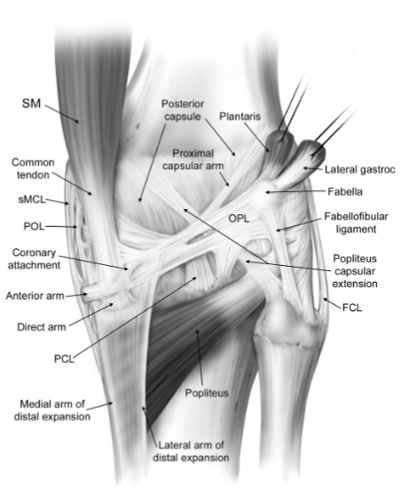
The posterior capsule of the knee encloses the patella, ligaments, menisci, and bursae of the knee. While the anterior and posterior cruciate ligaments of the knee are intracapsular, they are considered extra-articular because their tibial attachments are outside the capsule.⁸

Figure 2. Relevant Anatomy of the Ankle Joint

The ankle joint is comprised of a few joints, all of which the ankle joint capsule is responsible for encasing. The ankle joint capsule encompasses a broad surface area, making it thinner with thin fibers. It is thickest laterally where it encases the medial and lateral malleoli. The joint capsule reaches superiorly as far as the interosseous membrane between the tibia and fibula and laterally branches out to blend with the transverse ligament.⁹
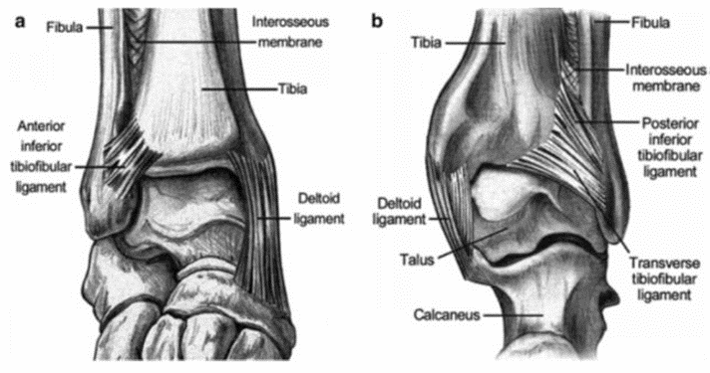

Figure 3. Setup of Dynamic Ankle Dynamometer
The dynamic ankle dynamometer is not yet used in clinical settings, but has been gaining momentum in recent literature. It is able to measure angular force through an accelerometer, joint movement through angular displacement of the device with passive dorsiflexion of the ankle joint, and reflex-mediated muscle activity as determined by EMG.¹³

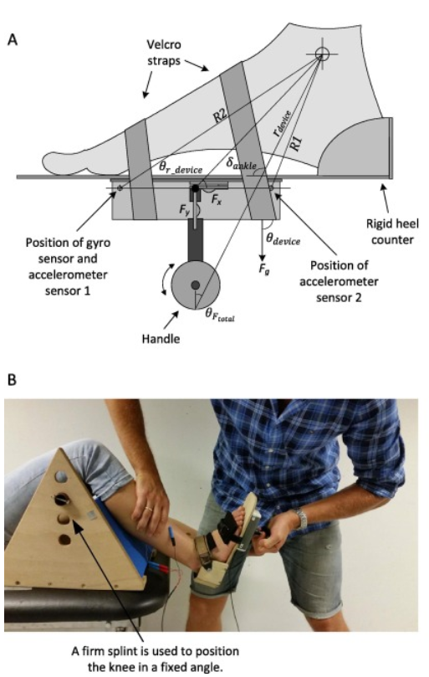

Appendix B. Outcome Measures
Observational Gait Scale⁵⁵:

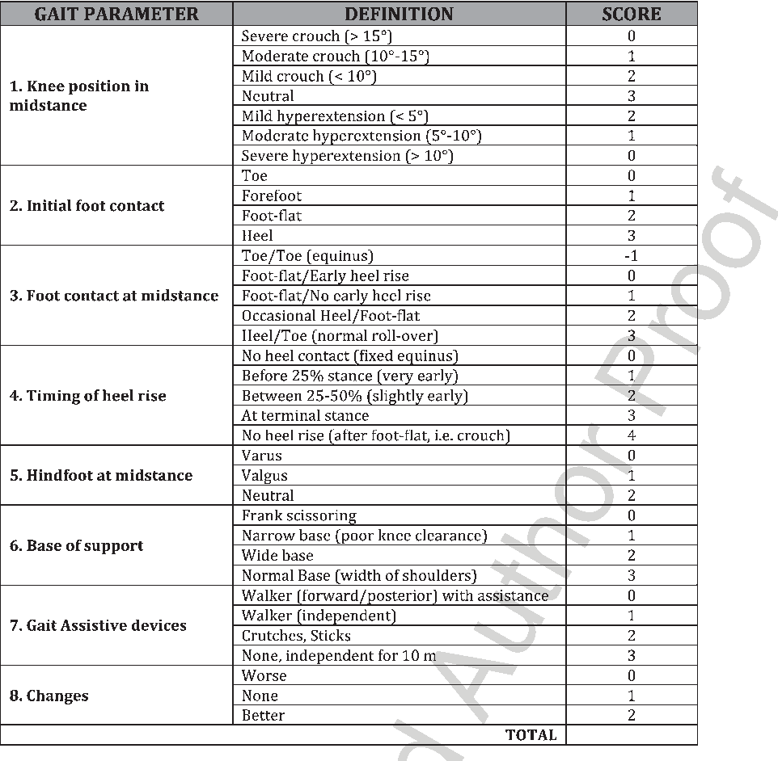

Tardieu Scale:
The Tardieu Scale is an evidenced outcome measure for differentiating spasticity from joint contractures. It takes into account the velocity of stretch and the muscle reaction in addition to the angle at which the muscle reacts. It is not a specific tool for assessing a joint contracture, but is useful in performing a differential diagnosis, especially in the neurologically-involved populations.³³

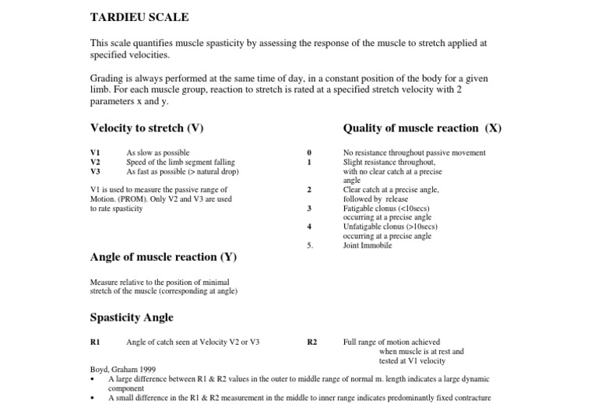

Knee Society Score:
The following link provides access to the online Knee Society Score sheet that provides automatic scoring upon being filled out, and also provides ranges for excellent, good, fair, and poor knee function.^{36,42}

https://www.orthopaedicscore.com/scorepages/knee_society_score.html

Appendix C. Treatment Devices
Figure 4. Knee Joint Dynasplint
The Dynasplint is an application for the knee joint to induce the principle of creep for the purposes of pushing the knee joint into extension. It is commonly used for the treatment of knee flexion contractures.⁵⁶

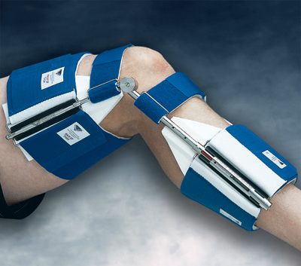

Figure 5. Joint Active System for the Knee and Ankle Joints
The Joint Active System (JAS) is an application of an increasing level of strain at a joint that is progressed as the tissues at the joint accommodate to the current level of stress imposed.⁴³ It is another method of treating joint contractures.

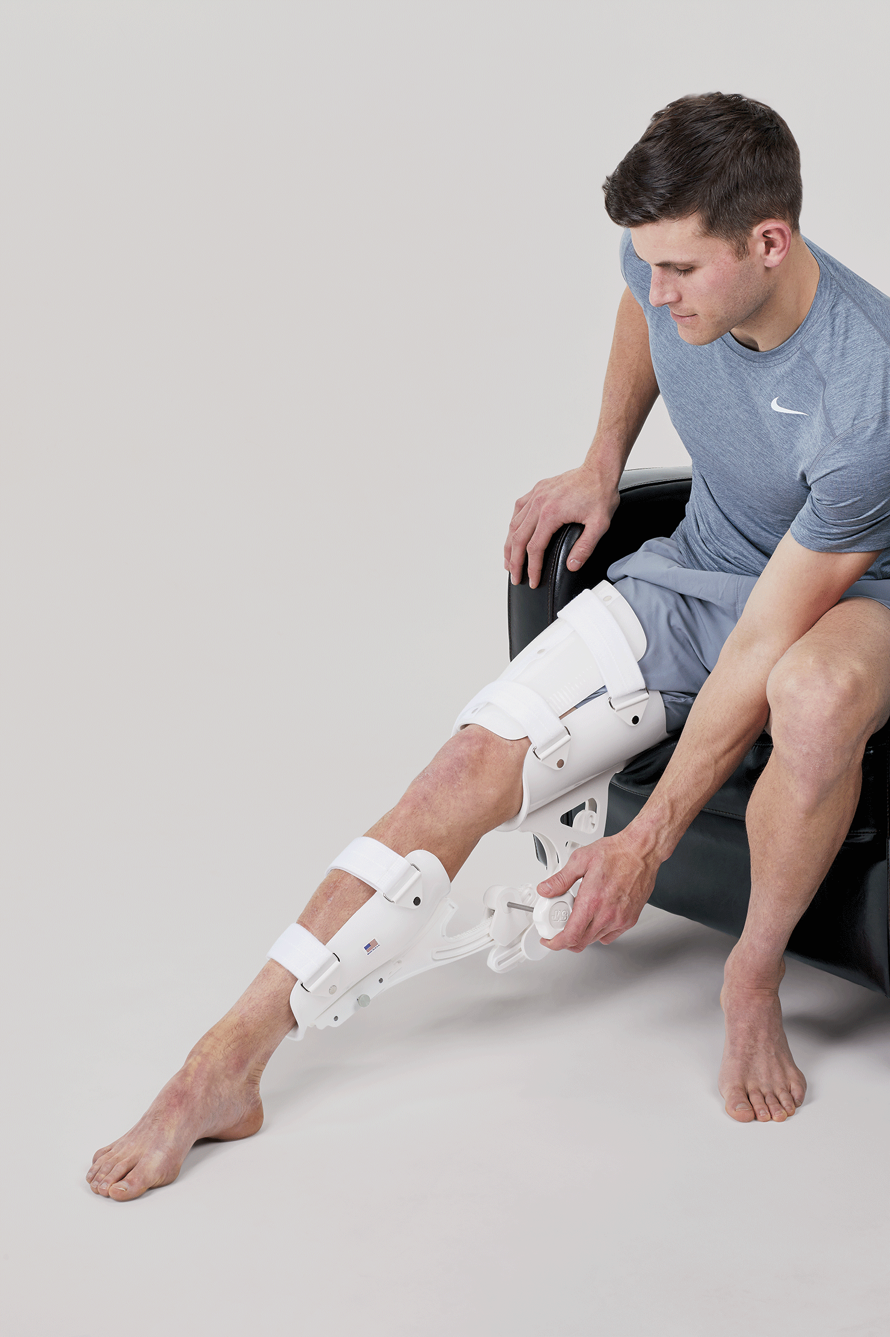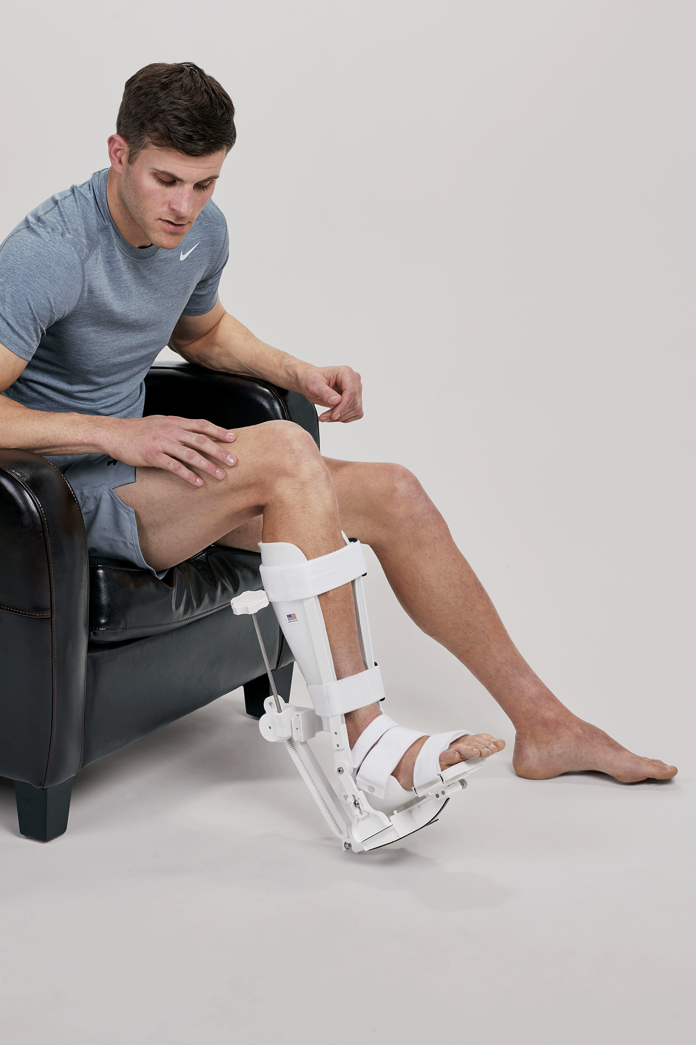

Bibliography
1. Howard J, Trevick S, Younger DS. Epidemiology of Multiple Sclerosis. Neurol Clin. 2016;34(4):919-939. doi:10.1016/j.ncl.2016.06.016
2. Hankins GDV, Speer M. Defining the pathogenesis and pathophysiology of neonatal encephalopathy and cerebral palsy. Obstet Gynecol. 2003;102(3):628-636. doi:10.1016/S0029-7844(03)00574-X
3. Durukan A, Tatlisumak T. Acute ischemic stroke: Overview of major experimental rodent models, pathophysiology, and therapy of focal cerebral ischemia. Pharmacol Biochem Behav. 2007;87(1):179-197. doi:10.1016/j.pbb.2007.04.015
4. Wong K, Trudel G, Laneuville O. Noninflammatory Joint Contractures Arising from Immobility: Animal Models to Future Treatments. BioMed Res Int. 2015;2015. doi:10.1155/2015/848290
5. Hoang PD, Gandevia SC, Herbert RD. Prevalence of joint contractures and muscle weakness in people with multiple sclerosis. Disabil Rehabil. 2014;36(19):1588-1593. doi:10.3109/09638288.2013.854841
6. Cloodt E, Rosenblad A, Rodby-Bousquet E. Demographic and modifiable factors associated with knee contracture in children with cerebral palsy. Dev Med Child Neurol. 2018;60(4):391-396. doi:10.1111/dmcn.13659
7. Sackley Catherine, Brittle Nicola, Patel Smitaa, et al. The Prevalence of Joint Contractures, Pressure Sores, Painful Shoulder, Other Pain, Falls, and Depression in the Year After a Severely Disabling Stroke. Stroke. 2008;39(12):3329-3334. doi:10.1161/STROKEAHA.108.518563
8. The Anatomy of the Posterior Aspect of the Knee: An Anatomic Study | Ovid. https://oce-ovid-com.libproxy.lib.unc.edu/article/00004623-200704000-00009/HTML. Accessed November 15, 2019.
9. Ankle Joint. Physiopedia. https://www.physio-pedia.com/Ankle_Joint. Accessed November 15, 2019.
10. Brockett CL, Chapman GJ. Biomechanics of the ankle. Orthop Trauma. 2016;30(3):232-238. doi:10.1016/j.mporth.2016.04.015
11. Grissom SP, Blanton S. Treatment of upper motoneuron plantarflexion contractures by using an adjustable ankle-foot orthosis. Arch Phys Med Rehabil. 2001;82(2):270-273. doi:10.1053/apmr.2001.19018
12. Sasabe R, Sakamoto J, Goto K, et al. Effects of joint immobilization on changes in myofibroblasts and collagen in the rat knee contracture model. J Orthop Res. 2017;35(9):1998-2006. doi:10.1002/jor.23498
13. Yamaguchi T, Hvass Petersen T, Kirk H, et al. Spasticity in adults with cerebral palsy and multiple sclerosis measured by objective clinically applicable technique. Clin Neurophysiol. 2018;129(9):2010-2021. doi:10.1016/j.clinph.2018.07.004
14. Bar-On L, Aertbeliën E, Wambacq H, et al. A clinical measurement to quantify spasticity in children with cerebral palsy by integration of multidimensional signals. Gait Posture. 2013;38(1):141-147. doi:10.1016/j.gaitpost.2012.11.003
15. Aktaş E, Ömeroğlu H. Botulinum toxin type A injection increases range of motion in hip, knee and ankle joint contractures of children with cerebral palsy. Eklem Hast Ve Cerrahisi Jt Dis Relat Surg. 2019;30(2):155-162. doi:10.5606/ehc.2019.65453
16. van der Krogt MM, Bar-On L, Kindt T, Desloovere K, Harlaar J. Neuro-musculoskeletal simulation of instrumented contracture and spasticity assessment in children with cerebral palsy. J NeuroEngineering Rehabil. 2016;13. doi:10.1186/s12984-016-0170-5
17. Quantitative Evaluation of Lower Extremity Joint Contractures in Spinal Muscular Atrophy: Implications for Motor Function | Ovid. https://oce-ovid-com.libproxy.lib.unc.edu/article/00001577-201807000-00014/HTML. Accessed November 19, 2019.
18. Leung J, King C, Fereday S. Effectiveness of a programme comprising serial casting, botulinum toxin, splinting and motor training for contracture management: a randomized controlled trial. Clin Rehabil. 2019;33(6):1035-1044. doi:10.1177/0269215519831337
19. Singer BJ, Dunne JW, Singer KP, Jegasothy GM, Allison GT. Non-surgical management of ankle contracture following acquired brain injury. Disabil Rehabil. 2004;26(6):335-345. doi:10.1080/0963828032000174070
20. Yan D, Yang J, Pei F. Total knee arthroplasty treatment of rheumatoid arthritis with severe versus moderate flexion contracture. J Orthop Surg. 2013;8:41. doi:10.1186/1749-799X-8-41
21. Neuromechanical coupling in the regulation of muscle tone and joint stiffness - Needle - 2014 - Scandinavian Journal of Medicine &amp; Science in Sports - Wiley Online Library. https://onlinelibrary.wiley.com/doi/full/10.1111/sms.12181. Accessed December 1, 2019.
22. Effectiveness of Serial Stretch Casting for Resistant or Recurrent Knee Flexion Contractures Following Hamstring Lengthening in Children With Cerebral Palsy | Ovid. https://oce-ovid-com.libproxy.lib.unc.edu/article/01241398-200601000-00022/HTML. Accessed November 19, 2019.
23. Gait. Physiopedia. https://www.physio-pedia.com/Gait. Accessed November 19, 2019.
24. Orendurff MS, Chung JS, Pierce RA. Limits to passive range of joint motion and the effect on crouch gait in children with cerebral palsy. Gait Posture. 1998;7(2):165. doi:10.1016/S0966-6362(98)90241-7
25. Joint Mobilization - an overview | ScienceDirect Topics. https://www-sciencedirect-com.libproxy.lib.unc.edu/topics/medicine-and-dentistry/joint-mobilization. Accessed November 26, 2019.
26. Manual Muscle Testing: A Method of Measuring Extremity Muscle Strength Applied to Critically Ill Patients. https://www.ncbi.nlm.nih.gov/pmc/articles/PMC3169254/. Accessed November 26, 2019.
27. Holmes SJ, Mudge AJ, Wojciechowski EA, Axt MW, Burns J. Impact of multilevel joint contractures of the hips, knees and ankles on the Gait Profile score in children with cerebral palsy. Clin Biomech. 2018;59:8-14. doi:10.1016/j.clinbiomech.2018.08.002
28. Omura Y, Yamagami Y, Hirota Y, Nakatani E, Tsujimoto T, Inoue T. Evaluation of the effectiveness of the sliding sheet in repositioning care in terms of working time and subjective fatigue: A comparative study with an experimental design. Int J Nurs Stud. 2019;99:103389. doi:10.1016/j.ijnurstu.2019.103389
29. Saal S, Meyer G, Beutner K, et al. Development of a complex intervention to improve participation of nursing home residents with joint contractures: a mixed-method study. BMC Geriatr. 2018;18. doi:10.1186/s12877-018-0745-z
30. Hansberger BL, Loutsch R, Hancock C, Bonser R, Zeigel A, Baker RT. EVALUATING THE RELATIONSHIP BETWEEN CLINICAL ASSESSMENTS OF APPARENT HAMSTRING TIGHTNESS: A CORRELATIONAL ANALYSIS. Int J Sports Phys Ther. 2019;14(2):253-263.
31. Peeler JD, Anderson JE. Reliability Limits Of The Modified Thomas Test For Assessing Rectus Femoris Muscle Flexibility About The Knee Joint. J Athl Train. 2008;43(5):470-476.
32. Joint Contractures Resulting From Prolonged Immobilization: Etiology, Prevention, and Management | Ovid. https://oce-ovid-com.libproxy.lib.unc.edu/article/00124635-201702000-00004/HTML. Accessed November 26, 2019.
33. Patrick E, Ada L. The Tardieu Scale differentiates contracture from spasticity whereas the Ashworth Scale is confounded by it. Clin Rehabil. 2006;20(2):173-182. doi:10.1191/0269215506cr922oa
34. Wang F, Zhang Q-B, Zhou Y, et al. The mechanisms and treatments of muscular pathological changes in immobilization-induced joint contracture: A literature review. Chin J Traumatol. 2019;22(2):93-98. doi:10.1016/j.cjtee.2019.02.001
35. de Carvalho RMF, Mazzer N, Barbieri CH. Analysis of the reliability and reproducibility of goniometry compared to hand photogrammetry. Acta Ortop Bras. 2012;20(3):139-149. doi:10.1590/S1413-78522012000300003
36. Bartoszek G, Fischer U, Müller M, et al. Outcome measures in older persons with acquired joint contractures: a systematic review and content analysis using the ICF (International Classification of Functioning, Disability and Health) as a reference. BMC Geriatr. 2016;16. doi:10.1186/s12877-016-0213-6
37. pubmeddev, al HS et. Impact of multilevel joint contractures of the hips, knees and ankles on the Gait Profile score in children with cerebral palsy. - PubMed - NCBI. https://www.ncbi.nlm.nih.gov/pubmed/30099242. Accessed November 19, 2019.
38. Mackey AH, Lobb GL, Walt SE, Stott NS. Reliability and validity of the Observational Gait Scale in children with spastic diplegia. Dev Med Child Neurol. 2003;45(1):4-11. doi:10.1111/j.1469-8749.2003.tb00852.x
39. Ashworth Scale / Modified Ashworth Scale. Shirley Ryan AbilityLab - Formerly RIC. https://www.sralab.org/rehabilitation-measures/ashworth-scale-modified-ashworth-scale. Accessed September 10, 2019.
40. Unified Dystonia Rating Scale (UDRS). https://www.movementdisorders.org/MDS/MDS-Rating-Scales/Unified-Dystonia-Rating-Scale-UDRS-.htm. Accessed November 22, 2019.
41. Akbaş AN. Assessments and Outcome Measures of Cerebral Palsy. Cereb Palsy - Curr Steps. September 2016. doi:10.5772/64254
42. Knee Society Score - Orthopaedic Scores. https://www.orthopaedicscore.com/scorepages/knee_society_score.html. Accessed November 22, 2019.
43. JAS EZ Knee Extension. JAS. https://jointactivesystems.com/products/jas-ez-knee-extension/. Accessed November 26, 2019.
44. Furia JP, Willis FB, Shanmugam R, Curran SA. Systematic Review of Contracture Reduction in the Lower Extremity with Dynamic Splinting. Adv Ther. 2013;30(8):763-770. doi:10.1007/s12325-013-0052-1
45. Jain S, Mathur N, Joshi M, Jindal R, Goenka S. Effect of serial casting in spastic cerebral palsy. Indian J Pediatr. 2008;75(10):997-1002. doi:10.1007/s12098-008-0100-z
46. Pohl M, Rückriem S, Mehrholz J, Ritschel C, Strik H, Pause MR. Effectiveness of serial casting in patients with severe cerebral spasticity: a comparison study. Arch Phys Med Rehabil. 2002;83(6):784-790. doi:10.1053/apmr.2002.32821
47. Hepburn GR. Case Studies: Contracture and Stiff Joint Management with DynasplintTM. J Orthop Sports Phys Ther. 1987;8(10):498-504. doi:10.2519/jospt.1987.8.10.498
48. Katalinic OM, Harvey LA, Herbert RD. Effectiveness of Stretch for the Treatment and Prevention of Contractures in People With Neurological Conditions: A Systematic Review. Phys Ther. 2011;91(1):11-24. doi:10.2522/ptj.20100265
49. Comparison of Articulated and Rigid Ankle-Foot Orthoses in Children With Cerebral Palsy: A Systematic Review | Ovid. https://oce-ovid-com.libproxy.lib.unc.edu/article/00001577-201224040-00003/HTML. Accessed November 26, 2019.
50. Bozinovski Z, Popovski N. Operative Treatment of the Knee Contractures in Cerebral Palsy Patients. Med Arch. 2014;68(3):182-183. doi:10.5455/medarh.2014.68.182-183
51. Kim HT, Oh JS, Lee JS, Lee TH. Z-lengthening of the Achilles Tendon with Transverse Skin Incision. Clin Orthop Surg. 2014;6(2):208-215. doi:10.4055/cios.2014.6.2.208
52. Lobenhoffer HP, Bosch U, Gerich TG. Role of posterior capsulotomy for the treatment of extension deficits of the knee. Knee Surg Sports Traumatol Arthrosc. 1996;4(4):237-241. doi:10.1007/BF01567970
53. Beals RK. Treatment of knee contracture in cerebral palsy by hamstring lengthening, posterior capsulotomy, and quadriceps mechanism shortening. Dev Med Child Neurol. 2001;43(12):802-805. doi:10.1111/j.1469-8749.2001.tb00166.x
54. Lui TH. Arthroscopic Capsular Release of the Ankle Joint. Arthrosc Tech. 2016;5(6):e1281-e1286. doi:10.1016/j.eats.2016.07.019
55. Tavernese E, Petrarca M, Rosellini G, et al. Carbon Modular Orthosis (Ca.M.O.): An innovative hybrid modular ankle-foot orthosis to tune the variable rehabilitation needs in hemiplegic cerebral palsy. NeuroRehabilitation. 2017;40(3):447-457. doi:10.3233/NRE-161432
56. Knee Extension Splint | Dynamic Knee Splint. https://www.dynasplint.com/product/knee-extension-splint/. Accessed November 26, 2019.
57. Gross, MT. Voicethread on Ligament, 2019.

