Common Side Effects of Chemotherapy  - Fatigue***  - Numbness/tingling*  - Weakness of hands and/or feet*  - Weak, sore, tired, or achy muscles*  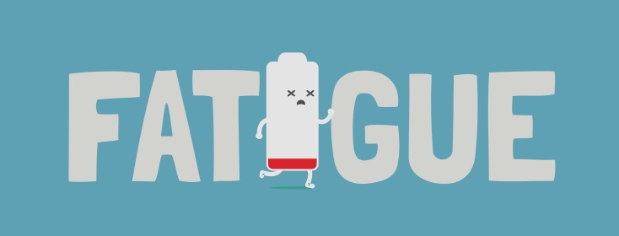  - Muscle Pain*  What is cancer related fatigue?  - Worse than everyday fatigue  - Lasts longer and sleep doesn’t make it better  - Everyday activities can be overwhelming  - Affects every part of a person’s life  - Can last months-years  - Differs from day to day | For more information and tips:  https://www.cancer.gov/about-cancer/treatment/side-effects  https://www.cancer.net/  https://www.ucsfhealth.org/education/tips_for_conserving_your_energy  https://www.cancer.org/treatment/treatments-and-side-effects/physical-side-effects/fatigue/managing-cancer-related-fatigue.html  https://www.mskcc.org/cancer-care/patient-education/managing-related-fatigue  https://sites.duke.edu/ptot/outpatient-services/patient-resources/energy-conservation/ | How can i save my energy?  - Made by: Ashley Lewis
What is energy conservation?  Refers to the way activities are done to decrease muscle fatigue, joint stress, and pain and to better use your body to save your energy!  Energy Saving Tips  - Activities of Daily Living  - Plan ahead to avoid rushing  - Sit down as much as possible  - Change your home to save your energy (ex. place chairs throughout house to allow for rest breaks)  -Wear comfortable, low heeled, slip on shoes  -Try to avoid leaning over and reaching  - Use a rolling walker or cane when walking longer distances  - Maintain normal breathing and stop to rest if you feel tired | - General Tips:  - Take short naps or rest breaks throughout the day (30 minutes or less)  -Sleep 7-8 hours each night  -Try to do moderate exercise daily (ex. walking)  - Develop a daily routine and select tasks that are most important for the day  - Plan ahead and spread activities throughout the day  - Do things slowly  - Ask friends to help with things that are too hard or tiring  - Drink plenty of water and juices and eat a balanced diet  - Reduce & manage stress (deep breathing, meditation, prayer, read, listen to music, walk)  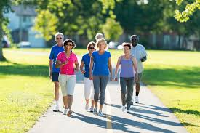  - Avoid activities that make you feel the most tired | 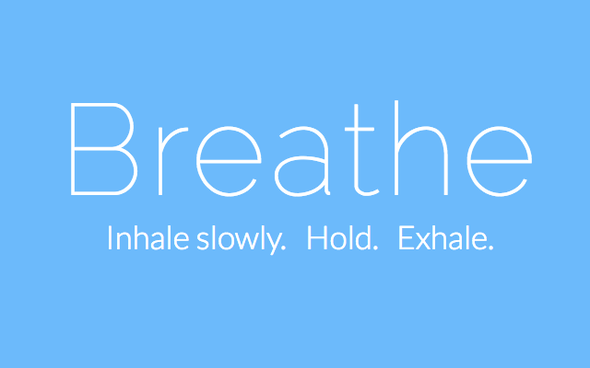  - Housekeeping:  - Schedule household tasks throughout the week  -Ask for help with heavy housework  - Stop working before becoming too tired  - Store frequently used items within easy reach  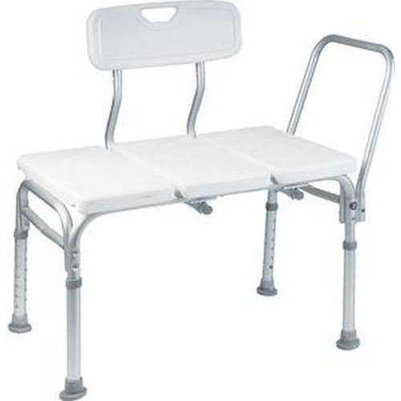  - Install grab bars in shower and shower bench in tub  