The prevention of Anterior Cruciate Ligament (ACL) injuries in soccer players: an exploration of the common mechanisms of ACL injury and prevention protocols

Introduction:
Soccer is one of the most popular sports in the world with an estimated 265 million people participating in soccer.¹ Soccer is one of the most widely growing sports in the United States.² Over 17 million people in the US alone participate in organized soccer.² Playing soccer places an athlete at an increased risk of injury. Soccer is associated with a rate of injury of between 14-35 injuries per 1,000 game hours or 2-8 injuries per 1,000 practice hours.² Anterior Cruciate Ligament (ACL) injuries account of roughly 1.3% of injuries in male soccer players and 3.7% in female soccer players.¹ The rate of ACL injuries varies between 0.06-3.7 per 1,000 hours of play (game or practice).¹ The aims of this paper are to identify mechanisms of injury, risk factors and long-term implications of ACL injuries among soccer players, and to explore current evidence-based injury prevention programs aimed at reducing risk of sustaining an ACL injury in soccer players.
Long term implications of an ACL injury:
ACL injuries can come at a serious cost. Not only are they associated with significant time lost in sport and high financial cost, but they can also lead to increased risk of damage to the knee and soft tissue.^{3,4} Approximately 200,000 ACL injuries occur annually in the US, amounting to $4 billion in operational costs and $7.6 billion in annual total costs.⁵
ACL injuries are also associated with the development of arthritis.⁴ Lohmander et al. found that ¾ of female soccer players reported symptoms that affected their knee-related quality of life 12 years following the initial injury.² Of this sample, roughly 60% had undergone ACL reconstruction surgery.² Half of the sample had radiographic evidence of knee osteoarthritis (OA), and 82% had radiographic knee changes after 12 years.² Non-operative management of ACL injuries further increase the risk of development of OA.⁶ Approximately 70% or more of those who have had an ACL injury, independent to treatment choice, will develop OA after 15-20 years.^{3,5} Of these, 13-15% require a total knee arthroplasty.⁵ Concurrent medial meniscus injury and/or meniscectomy follow an ACL injury also further increase the risk of the development of OA following an ACL rupture.⁶
Individuals who suffer an ACL injury and have subsequent reconstruction often have reduced strength, proprioception, balance and altered neuromuscular control versus a peer who has not sustained an injury.⁵ These factors can increase the risk of re-injury.⁵ A previous ACL injury places a soccer player at an elevated risk of a secondary ACL tear.⁴ A cohort study found that roughly ¼ of female soccer players who tore their ACL had a second tear (either graft rupture or a contralateral ACL injury).⁴ This risk for a secondary tear increased to 34% for those female athletes who returned to play.⁴ Further, the rate of secondary injury was elevated compared to non-soccer player playing age-matched athletic peers.⁴ Given the long-term factors associated with an ACL injury beyond the extent of the acute injury, it is critical to focus attention into the prevention of these injuries in addition to treatment of the injuries if they do occur.
Mechanism of ACL injuries and risk factors for soccer players:
Understanding the mechanism of injury in sport can be essential for the development of injury prevention of injuries. Our current knowledge regarding effective injury prevention programs is in part limited by an incomplete understanding of the mechanism of injuries, such as an ACL injury.^{3,5} Bahr & Krosshaug (2015) proposed that understanding injury prevention first requires an understanding the extent of the problem, then an identification of the mechanism of injury, an introduction of a preventative measure, and finally an evaluation of the efficacy of the intervention.³ Identification of causes of sports injuries, such as ACL injuries can be complicated as they involve predisposing internal risk factors, external exposure risk factors, and an inciting event, all of which are composed of multiple elements.³ For example, while intrinsic risk factors such as age, sex, and anatomy may predispose an athlete, external factors such as sports equipment and field surface may make an athlete susceptible.³ When these external and internal factors are combined with an inciting event, such as a quick deceleration with internal rotation while the foot remains planted, it can lead to an injury.³ Appendix I provides a graphical representation of these factors proposed by Bahr & Krosshaug.³ In summary, an understanding of the ACL’s function, possible mechanisms of ACL injury as well as risk factors are essential prior to developing and evaluating ACL injury prevention programs.^{3,5}
a) Anatomy and Biomechanics:
The ACL serves as the primary restraint of proximal tibia anterior translation on the femur. An anterior shear force applied to the proximal tibia loads the ACL. The magnitude of the force applied to the ACL with anterior shear is affected by the knee flexion angle and the ground reaction force.⁵ A posterior ground reaction force causes a knee flexion moment. This knee flexion moment can be counteracted by the quadriceps producing a knee extension moment.⁵ Along with the production of knee extension, the quadriceps also produce an anterior shearing force of the distal femur on the proximal tibia, loading the ACL. With increasing knee flexion, the anterior force generated by the quadriceps decreases secondary to the patella tendon-tibia shaft angle decreasing.⁵ Appendix 2 provides a graphic representation of these concepts.⁵ Patellar tendon tibia angle is greatest in low amounts of knee flexion (<30 degrees).⁷ Quadriceps contractions can be upwards of 2,000N in the average adult, and significantly higher in youth athletes, which can cause significant anterior shear force on the proximal tibia near full knee extension.⁷ The hamstrings can work to reduce the stress placed on the ACL through co-contraction. The hamstrings produce a posterior shear force of the distal femur on the proximal tibia, thus decreasing the magnitude of the anterior shear force generated from quadriceps contraction.⁵ The pull of the hamstrings produces greater posterior forces with increased knee flexion angle versus in full extension (see appendix 2).⁵ Peak ACL loading, length, and stress thus happens in positions of limited knee flexion.⁵ Loading decreases with increased knee flexion.⁵ Small amounts of knee flexion (10-30*) are associated with increased anterior shear force and increased anterior translation of the tibia on the femur (see appendix 3).^{5,8} Based on these many factors, the ACL is at a higher risk of injury performing a soccer movement in positions of minimal knee flexion (10-30*) versus with significant knee flexion (>45 degrees).⁵
The ACL is also stressed with knee valgus, varus, and internal rotation loads.⁵ These effects are most pronounced when combined with an anterior shear force.⁵ In vivo research has shown that the knee valgus stress only produced increased ACL length when the knee was near full extension, and valgus loading had no impact on ACL length with the knee in flexion.⁵ Isolated internal rotation, valgus or varus produce little strain on the ACL.¹ Markolf et al. found that the in vitro ACL undergoes the highest amount of loading when an anterior shear force and valgus or varus moments are combined with internal tibial torque.⁹ External tibial torque had little influence on ACL stress, and may serve to unload the ACL.⁹ Levine et al. evaluated physiological loading of cadaveric ACLs.¹⁰ They found that a position of anterior tibial shear, knee abduction and tibial internal rotation led to the greatest risk of an ACL injury.¹⁰ Knee abduction was also associated with depression of the subchondral bone and tibial internal rotation was associated with damage to articular cartilage along the posterior lateral aspect of the tibial plateau.¹⁰ Soccer is a sport involving jumping, cutting, acceleration and deceleration thus the ACL is continually loaded in uniplanar and multi-planer dimensions.
ACL loading can also occur from a compressive force along the longitudinal axis of the tibia. This relates the slope angle of the posterior tibial plateau.⁵ A greater angle causes greater anterior shear force generation and increased load on the ACL.⁵ This posterior slope angle may predispose an athlete to an ACL injury.⁵ People who have sustained ACL injuries have greater tibial plateau slopes than an uninjured comparison.^{5,14}
Understanding the purpose of the ACL and factors that include ACL stress help with the understanding of common mechanisms of ACL injury. Very broadly, ACL injuries in soccer players can either be contact or non-contact injuries.¹ Most ACL tears occur without body-to-body contact.¹ 70-84% of ACL injuries are non-contact.¹ Non-contact ACL injuries in soccer can occur during cutting and changes of direction with deceleration, landing a jump, pivoting with the foot planted.¹ These scenarios typically involve the knee near full extension (10-30 degrees of flexion) with or without varus or valgus force where the ACL is put under the greatest amount of stress.¹ This matches the proposed primary mechanism of ACL loading outlined above.⁵ Cochrane et al. observed that over 90% of non-contact soccer ACL injuries occurred when the knee was in less than 30 degrees of flexion in a sample of 34 professional and amateur players.¹¹ As outlined previously, this is the time when the hamstrings offer the least amount of anterior shear shielding and when the quadriceps produce the highest amount of anterior shear, and when patellar tendon tibia angle is greatest, creating a considerable amount of ACL stress.⁵ The position of pivoting with the foot planted and the knee near full extension can cause a valgus/varus load with tibial internal rotation which is the position that Levine et al. identified as posing the most significant risk of ACL injury.¹⁰
Cochrane et al. also found that 37% of non-contact ACL injuries occurred during a sidestepping movement, 32% during landing, 16% with a land and step, and 10% with a stopping or slowing movement.¹¹ Most of these occurred when the athlete was decelerating.¹¹ During deceleration, a high amount of tibial displacement is associated with eccentric quadriceps contraction near full knee extension.⁷ Walden et al. used video analysis to study the mechanisms of ACL injuries in 39 professional soccer players.¹² They observed three predominant mechanisms of non-contact ACL injuries: regaining balance following a kick, landing from a jump, and pressing defensively.¹² Defensive pressing involves a reactive sidestep to attempt to obtain the ball from the opponent with a cutting angle between 30 and 90 degrees and knee flexion less than 20 degrees.¹² This lunge to get the ball also typically involved a valgus load on the plant foot.¹² This position is depicted in Appendix 4. Both pressing and regaining balance after kicking involved the hip abduction, minimal knee and hip flexion.¹² Grassi et al. identified this position of hip abduction, minimal knee flexion and valgus stress as the most common mechanism of ACL injury among a sample of 34 male professional soccer players.¹³ Similarly, Grassi et al. found that most of the non-contact injuries occurred when the player was either pressing, dribbling or tackling.¹³ Walden et al. also observed that 30 of the 39 injuries occurred while the player was making a defensive effort.¹² Defense is typically correlated with unplanned movement tasks. Unanticipated movements have been associated with an increased risk of ACL injury.¹⁴ Most of the non-contact injuries observed by Walden et al. involved knee valgus but dynamic valgus collapse rarely occurred. Also, the majority of the injuries occurred in situations of single leg loading.¹² Many activities in soccer involve landing a jump and decelerating, which both require eccentric quadriceps contraction in which the ACL needs to resist anterior tibial translation.⁷
Direct contact injuries are also another common mechanism of ACL injuries among soccer players.¹² The mechanism associated with contact ACL injuries are variable.¹² Walden et al. identified that all direct injuries resulted from either tackling or accidental collisions.¹² During direct tackling scenarios, the tackles were either from behind which drove the knee into a forceful valgus collapse or a collision injury.¹²
Many potential risk factors may make someone more susceptible to an ACL injury. These include environmental factors, anatomic factors, hormonal and sex factors, neuromuscular control, and biomechanical factors.¹ A few of these will be briefly explored below.
Environmental factors include the sport, the playing surface, the weather, and the footwear. In soccer, a few studies observed higher incidences of ACL injuries on natural grass fields when the conditions are dry.¹ This elevated risk of an ACL injury in dry conditions may be explained by the increased friction between the grass surface and cleats which could lead to a higher torque imposed during cutting or decelerating.¹ This concept of friction between the shoe and the playing surface is further supported by the fact that ryegrass is associated with a lower incidence of ACL tears during soccer practice versus Bermuda grass which is thicker with greater traction.¹ No conclusive findings exist regarding the risk of an ACL injury on turf versus on authentic grass for male or female soccer players.¹
Female soccer players are at a two to three times elevated risk of an ACL injury versus males across ages.^{4,15} Some estimates have shown that high-level female soccer players may have up to seven times the risk of sustaining an ACL injury versus a male player of the same ability level.⁴ Numerous factors have been suggested to increase the risk of ACL injuries in females.⁷ Some of the proposed differences may be explained by anatomy. One factor that has been identified is the difference in pelvic structure and a possible increased Q angle, leading to increased genu valgus in females.¹⁶ Women have a slightly higher patellar tendon tibia angle near full knee extension, secondary to increased anterior-posterior dimension of the proximal tibia, which leads to increased tibiofemoral shear stress as the knee moves into knee extension, increasing strain on the ACL.⁷ This is especially problematic for female athletes who have a more upright style of play.⁷ Estrogen is correlated with increased joint laxity, thus increased risk of ligamentous injury.¹⁶ However, these anatomic and hormonal differences do not fully explain the discrepancy between sex-related ACL injury rates.¹⁶ Other factors may be related to muscle strength imbalance and movement patterns.¹⁶ In comparison to males, females athletes may rely more on quadriceps muscles than on hamstrings.⁷ Male athletes land from a jump with three times the knee flexor moment.¹⁶ A systematic review by Carson and Ford found that females land with increased knee abduction versus males, placing the knee in valgus.¹⁷ This difference is sustained across various landing movements such as single leg hop, drop landing, and vertical jumps, that are all common in high-risk sports.¹⁷ These landing mechanics may place the ACL at greater risk of injury.¹⁷ While changing anatomy and hormonal factors may not be feasible to address through an injury prevention program, programs focused on proper landing mechanics with increased knee flexion and decreased knee valgus may be especially beneficial for female athletes.¹⁷
In summary, the risk factors and common mechanisms of injury for ACL injuries are complex and multifaceted. For soccer players, poor landing or cutting mechanics such as landing with minimal knee flexion and hip abduction may increase the stress placed on the ACL, thus increasing one’s risk for injuries. Sex difference in landing and cutting mechanics may partially explain the sex differences that exist regarding the risk of sustaining an ACL injury including both anatomic and movement pattern factors. Many non-contact ACL injuries have been attributed to a neuromuscular control deficit that occurs during dynamic movements.¹⁸ These deficits lead to increased joint loads and increased stress placed on the ACL.¹⁸ Hamstring to quadriceps strength ratio is often reported when evaluating the risk of ACL injuries.¹⁹ Hamstrings can serve a dynamic stabilizer to help protect the ACL strain by providing a posterior force on the tibia.⁷ The ability to rapidly develop hamstring force during dynamic movements, such as cutting in soccer can be important for stress shielding the ACL.¹⁹ Interventions aimed at improving knee and landing mechanics, increase neuromuscular control at the knee joint and strengthening hamstrings may theoretically reduce one’s risk of sustaining an ACL injury, especially if many of the modifiable risk factors are present.
Injury prevention programs:
Several injury prevention programs aim to reduce the incidence of knee and ACL related injuries. According to a recently published Clinical Practice Guideline by Arundale et al., all soccer players should perform exercise focused injury prevention programs to reduce the risk of significant knee injuries, including ACL injuries.²⁰ They recommend the utilization of two specific training program, the Sportsmetrics protocol or the protocol utilized by Caraffa et al.²¹, to reduce the risk for ACL injuries among soccer players.²⁰
Caraffa et al. utilized proprioceptive training as an intervention to reduce ACL injuries among soccer players.²¹ Caraffa et al. hypothesized that since proprioceptive training has been shown to reduce the risk of ankle injuries and is a component of ACL rehabilitation, it may serve as an intervention to decrease the risk of ACL injuries among soccer players.²¹ Their specific protocol is included below (appendix 5).²¹ The Caffaffa et al. protocol included a multiphase training where athletes performed balance training 20 minutes a day.²¹ The protocol consists of the performance of single leg stance for 2.5 minutes, four times a day. The difficulty of the stance exercise increases utilizing various balance boards in phases 2-5.²¹ Caraffa et al. employed this proprioceptive training program in a prospective cluster controlled study of 40 soccer teams, 600 players total to determine its impact on the incidence of ACL injuries.²¹ They found that their intervention protocol led to a statistically significant reduction in the number of ACL injuries per team during a single soccer season versus a control (0.15 injuries per team/season versus 1.15 injuries per team/season respectively).²¹
Hewett et al. proposed that given the high incidence of noncontact ACL injuries that occur during landing from a jump, especially in female athletes, an ACL injury intervention program should focus on jump training.¹⁶ Further, strengthening the muscular surrounding the knee may help reduce the risk of knee injuries.¹⁶ This hypothesis is tested through the Sportsmetrics prevention program. The Sportsmetrics prevention program includes flexibility, running, strength, core stability and plyometrics.¹⁶ The protocol includes several jumping exercises with a focus on landing technique in addition to full body strengthening and stretching. It consists of 3 phases, each lasting two weeks.¹⁶ The number of reps of each exercise increases between the first and second week in each phase.¹⁶ The Sportsmetrics protocol is outlined in more detail in Appendix 6. This program has been shown to decrease hip abduction/adduction moments, thus reducing the peak landing force.¹⁶ It has also led to increases hamstring strength, and reductions in the hamstring to quad torque ratios and muscle imbalance.¹⁶ Both of these factors are implicated in ACL injuries. Hewett et al. hypothesized that this Sportsmetrics prevention program could reduce the incidence of ACL injuries, especially in female athletes.¹⁶ Hewett et al. conducted a cohort study of 1263 female athletes (soccer, basketball and volleyball players) who performed the Sportsmetrics training program 3 days a week (60-90 minutes to complete) as part of a team for 6 weeks.¹⁶ They measured the incidence of ACL injuries in the female intervention group versus a control of untrained females and a control of untrained male athletes.¹⁶ They found that women who underwent the Sportsmetrics protocol had a significantly lower rate of knee injuries versus untrained females (incidence of 0.12/1,000 athletic exposures versus 0.43/1,000 athletic exposures respectively).¹⁶ Among soccer players, there were zero serious knee injuries (n=97) in the trained group and an incidence of 0.56/1000 athletic exposures in the untrained female group (n=193).¹⁶ This study provides preliminary evidence into the efficacy of a comprehensive strength, flexibility and landing mechanics retraining exercise program in the reduction of ACL injuries specific to the soccer athletes.
Knäkontroll, 2015, developed a similar program to the Sportsmetrics protocol. The Knäkontroll program is a neuromuscular warm-up program that consists of exercises related to knee strengthening, and core stability.²² The Knäkontroll program focuses on proper landing/jumping, squatting and lunging techniques.²² The program aims to reduce dynamic knee valgus during play. Walden et al. evaluated the efficacy of the Knäkontroll program over the course of a season in 309 club teams found that this neuromuscular training program led to a reduction in overall ACL injury incidence rate of 64% in female soccer players (RR: 0.36, 95% CI: 0.15-0.85).²² Both greater compliance and the performance of the intervention more than one time a week were associated with better outcomes.²² The absolute rate difference between the intervention and the control did not reach clinical significance given the relatively rare rate of occurrence of ACL injuries among the sample (7 players in the intervention and 14 in the control).²² More research with a large sample size and over an extended period if time is indicated to determine the actual of the Knäkontroll program, if there is one, specifically in the reduction of ACL injuries.
Another injury prevention program that may have relevance in terms of reduction of ACL injuries among soccer players is the FIFA 11+ intervention program.²³ The FIFA 11+ is a program designed by the FIFA Medical Assessment and Research Centre (F-MARC) specifically for soccer players as a warm-up session which includes strengthening, balance, and jumping exercises.²³ The primary goal of the program is to prevent soccer-related injuries. The FIFA 11+ prevention program includes running drills, strength, plyometrics and balance exercises. The program is intended to be performed at least twice a week.²³ The program focuses on proper lower extremity alignment during activities and good landing mechanics. See Appendix 7 for a sample of the FIFA 11+ protocol. A meta-analysis by Thorborg et al. found that participation in the FIFA 11+ injury prevention program reduced soccer-related injury rates by 39% (IRR 0.61; 95% CI 0.48 – 0.77, p<0.001) in comparison to a control.²³ They found that the FIFA 11+ program reduced knee injury rates by 48% (IRR 0.52; 95% CI 0.38-0.72) in comparison to a control.²³ These results were similar to those of Silvers-Granelli 2015 who found that the FIFA 11+ program reduced the overall incidence of injuries by 46% (RR: 0.54; 95% CI: 0.49-0.59) and the rate of knee injuries by 58% (RR: 0.54; 95% CI: 0.29-0.61) in a randomized cluster controlled trial of college male soccer players.²⁴ Silvers-Granelli 2017 re-evaluated the data set from their earlier study of male college soccer players to determine the impact of the FIFA 11+ injury prevention program on the incidence of ACL injuries.²⁵ Silvers-Granelli 2017 observed that the FIFA 11+ program led to a reduction in the incidence rate of ACL injuries in male college soccer players by 76.4% (RR: 0.236; 95% CI: 0.07-0.81) versus a control.²⁵ This provides promising preliminary results regarding the utility of the FIFA 11+ program for reduction of ACL injuries. The study had a relatively wide confidence interval, given the comparatively rare nature of ACL injuries among male soccer players, especially when evaluating only a single season.²⁵ Despite a large sample size, 1525 subjects, the study was underpowered to perform secondary analysis of ACL injuries in subgroups such as by player position or field type to further differential other external factors that may be contributing to the risk of an ACL injury.²⁵
Research regarding the impact of injury prevention programs on the incidence of ACL injuries is limited secondary to the relatively rare nature of the injury.²⁵ Studies with large sample sizes would need to be conducted to determine the true impact the programs mentioned above on the prevention of ACL injuries. Further research should address the lasting impact of the injury prevention programs regarding injury risk reduction and the utility of the program performed by an individual, apart from a team setting. Additional research should also attempt to improve the quality of the evidence by blinding the participants and assessors, possibly through the use of a sham intervention. Research should also evaluate appropriate dosage for the intervention, including both durations of the programs and number of sessions per week.^{24,25} Evidence is mixed regarding when the programs are most effective, as part of warmup for competition or throughout the day.^{16,21,22,25} Finally, the cost-effectiveness of the intervention should be explored to determine its utility in the real world setting. Larger sample sizes are required to determine the real impact of these programs, and determine if they are reducing the risk of ACL injuries by addressing modifiable risk factors that relate to common mechanisms of injury.
Conclusions:
Available research support for the utility of a comprehensive strength, balance, flexibility and proprioceptive program for the reduction of severe knee injuries. Except for the protocol outlined in Caraffa et al., the other prevention programs aim to decrease the rate of ACL injuries by strengthening muscles around the knee joint and improving landing/jumping mechanics.^{16,21,22,25} Arundale et al. recommend the implantation of a multifaceted injury prevention program for 20 minutes or more multiple times each week.²⁰ They recommend the performance of these programs during the preseason and throughout the season for all youth athletes (ages 12-25).²⁰ These programs are consistent with the known mechanisms of ACL stress and injury that are common in soccer players. Given the high incidence of ACL injuries among soccer players, and the devastating short and long-term impact an ACL injury can have on an athlete, these programs, or similar ones aimed at improving landing mechanics, balance and strengthening quadriceps muscles, should be implemented as routine components of soccer training, especially female athletes.^{16,20,21,22,25}

Bibliography

1. Alentorn-Geli E, Myer GD, Silvers HJ, et al. Prevention of non-contact anterior cruciate ligament injuries in soccer players. Part 1: Mechanisms of injury and underlying risk factors. Knee Surg Sports Traumatol Arthrosc 2009;17(7):705-729. doi:10.1007/s00167-009-0813-1.
2. Lohmander LS, Ostenberg A, Englund M, Roos H. High prevalence of knee osteoarthritis, pain, and functional limitations in female soccer players twelve years after anterior cruciate ligament injury. Arthritis Rheum 2004;50(10):3145-3152. doi:10.1002/art.20589.
3. Bahr R, Krosshaug T. Understanding injury mechanisms: a key component of preventing injuries in sport. Br J Sports Med 2005;39(6):324-329. doi:10.1136/bjsm.2005.018341.
4. Allen MM, Pareek A, Krych AJ, et al. Are female soccer players at an increased risk of second anterior cruciate ligament injury compared with their athletic peers? Am J Sports Med 2016;44(10):2492-2498. doi:10.1177/0363546516648439.
5. Dai B, Mao D, Garrett WE, Yu B. Anterior cruciate ligament injuries in soccer: Loading mechanisms, risk factors, and prevention programs. J. Sport Health Sci. 2014;3(4):299-306. doi:10.1016/j.jshs.2014.06.002.
6. van Meer BL, Meuffels DE, van Eijsden WA, Verhaar JAN, Bierma-Zeinstra SMA, Reijman M. Which determinants predict tibiofemoral and patellofemoral osteoarthritis after anterior cruciate ligament injury? A systematic review. Br J Sports Med 2015;49(15):975-983. doi:10.1136/bjsports-2013-093258.
7. Boden BP, Dean GS, Feagin JA, Garrett WE. Mechanisms of anterior cruciate ligament injury. Orthopedics 2000;23(6):573-578.
8. Fu FH, Bennett CH, Lattermann C, Ma CB. Current trends in anterior cruciate ligament reconstruction. Part 1: Biology and biomechanics of reconstruction. Am J Sports Med 1999;27(6):821-830. doi:10.1177/03635465990270062501.
9. Markolf KL, Burchfield DM, Shapiro MM, Shepard MF, Finerman GA, Slauterbeck JL. Combined knee loading states that generate high anterior cruciate ligament forces. J Orthop Res 1995;13(6):930-935. doi:10.1002/jor.1100130618.
10. Levine JW, Kiapour AM, Quatman CE, et al. Clinically relevant injury patterns after an anterior cruciate ligament injury provide insight into injury mechanisms. Am J Sports Med 2013;41(2):385-395. doi:10.1177/0363546512465167.
11. Cochrane JL, Lloyd DG, Buttfield A, Seward H, McGivern J. Characteristics of anterior cruciate ligament injuries in Australian football. J Sci Med Sport 2007;10(2):96-104. doi:10.1016/j.jsams.2006.05.015.
12. Waldén M, Krosshaug T, Bjørneboe J, Andersen TE, Faul O, Hägglund M. Three distinct mechanisms predominate in non-contact anterior cruciate ligament injuries in male professional football players: a systematic video analysis of 39 cases. Br J Sports Med 2015;49(22):1452-1460. doi:10.1136/bjsports-2014-094573.
13. Grassi A, Smiley SP, Roberti di Sarsina T, et al. Mechanisms and situations of anterior cruciate ligament injuries in professional male soccer players: a YouTube-based video analysis. Eur J Orthop Surg Traumatol 2017;27(7):967-981. doi:10.1007/s00590-017-1905-0.
14. Anderson MJ, Browning WM, Urband CE, Kluczynski MA, Bisson LJ. A systematic summary of systematic reviews on the topic of the anterior cruciate ligament. Orthop. J. Sports Med. 2016;4(3):2325967116634074. doi:10.1177/2325967116634074.
15. Waldén M, Hägglund M, Werner J, Ekstrand J. The epidemiology of anterior cruciate ligament injury in football (soccer): a review of the literature from a gender-related perspective. Knee Surg Sports Traumatol Arthrosc 2011;19(1):3-10. doi:10.1007/s00167-010-1172-7.
16. Hewett TE, Lindenfeld TN, Riccobene JV, Noyes FR. The effect of neuromuscular training on the incidence of knee injury in female athletes. A prospective study. Am J Sports Med 1999;27(6):699-706. doi:10.1177/03635465990270060301.
17. Carson DW, Ford KR. Sex differences in knee abduction during landing: a systematic review. Sports Health 2011;3(4):373-382. doi:10.1177/1941738111410180.
18. Kiapour AM, Murray MM. Basic science of anterior cruciate ligament injury and repair. Bone Joint Res. 2014;3(2):20-31. doi:10.1302/2046-3758.32.2000241.
19. Zebis MK, Andersen LL, Ellingsgaard H, Aagaard P. Rapid hamstring/quadriceps force capacity in male vs. female elite soccer players. J Strength Cond Res 2011;25(7):1989-1993. doi:10.1519/JSC.0b013e3181e501a6.
20. Arundale AJH, Bizzini M, Giordano A, et al. Exercise-Based Knee and Anterior Cruciate Ligament Injury Prevention. J Orthop Sports Phys Ther 2018;48(9):A1-A42. doi:10.2519/jospt.2018.0303.
21. Caraffa A, Cerulli G, Projetti M, Aisa G, Rizzo A. Prevention of anterior cruciate ligament injuries in soccer. A prospective controlled study of proprioceptive training. Knee Surg Sports Traumatol Arthrosc 1996;4(1):19-21.
22. Waldén M, Atroshi I, Magnusson H, Wagner P, Hägglund M. Prevention of acute knee injuries in adolescent female football players: cluster randomised controlled trial. BMJ 2012;344:e3042. doi:10.1136/bmj.e3042.
23. Thorborg K, Krommes KK, Esteve E, Clausen MB, Bartels EM, Rathleff MS. Effect of specific exercise-based football injury prevention programmes on the overall injury rate in football: a systematic review and meta-analysis of the FIFA 11 and 11+ programmes. Br J Sports Med 2017;51(7):562-571. doi:10.1136/bjsports-2016-097066.
24. Silvers-Granelli H, Mandelbaum B, Adeniji O, et al. Efficacy of the FIFA 11+ injury prevention program in the collegiate male soccer player. Am J Sports Med 2015;43(11):2628-2637. doi:10.1177/0363546515602009.
25. Silvers-Granelli HJ, Bizzini M, Arundale A, Mandelbaum BR, Snyder-Mackler L. Does the FIFA 11+ injury prevention program reduce the incidence of ACL injury in male soccer players? Clin Orthop Relat Res 2017;475(10):2447-2455. doi:10.1007/s11999-017-5342-5.
26. Kernozek T, Torry M, Shelburne K, Durall CJ, Willson J. From the gait laboratory to the rehabilitation clinic: translation of motion analysis and modeling data to interventions that impact anterior cruciate ligament loads in gait and drop landing. Crit Rev Biomed Eng 2013;41(3):243-258.

Appendix 1: Injury Causation Model proposed by Bahr & Krosshaug (2005)
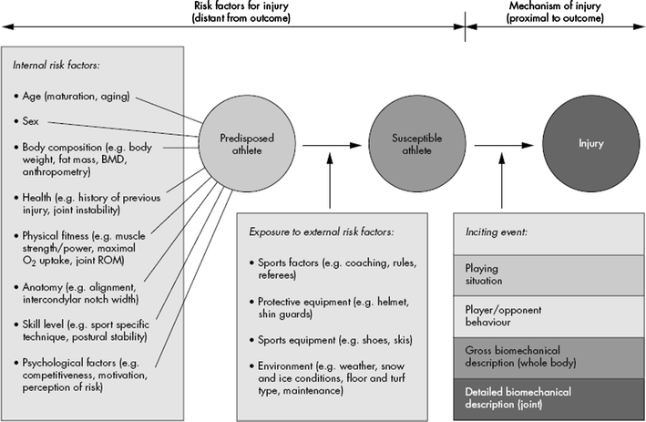

Appendix 2: Anterior and posterior shear forces produced by patella tendon and hamstrings (modified from Kernozek et al 2013)²⁶
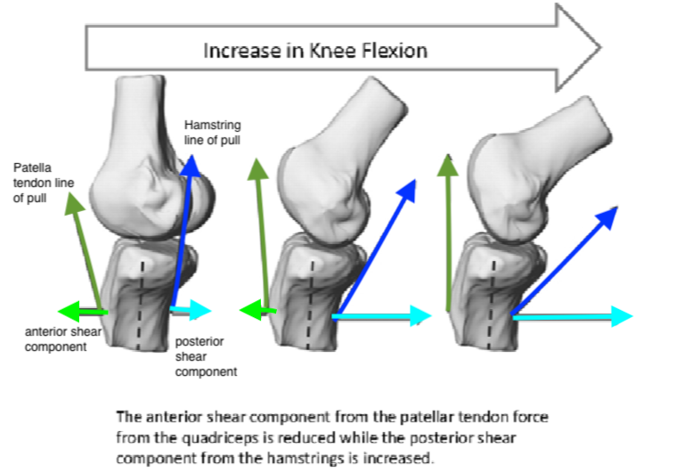

Appendix 3: Anterior Tibial Translation at Various Knee Flexion Angles from FH et al. 1999⁸
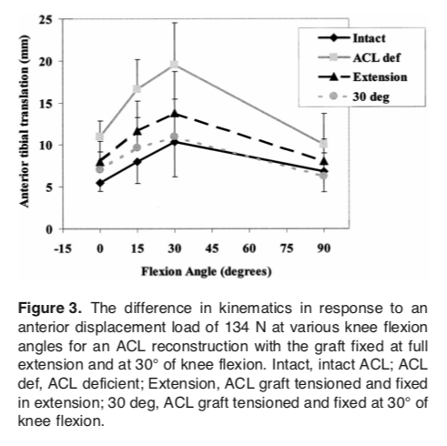

Appendix 4: Mechanism of non-contact ACL – pressing (graphic obtained from Walden et al. 2015)¹²
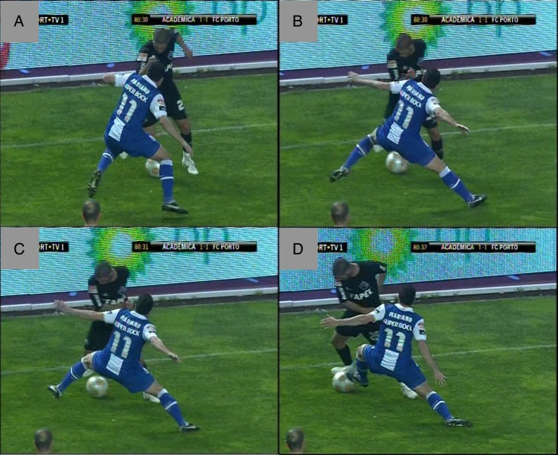

Appendix 5: Caraffa et al. protocol for proprioceptive training in the reduction of ACL injuries
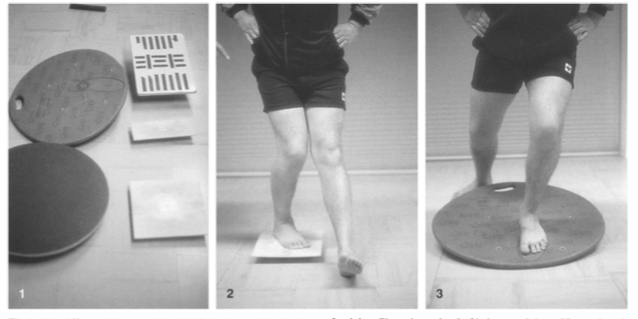
“Phase 1 consisted of balance training without a board. The athletes were instructed to stand alternately on one leg for 2.5 min four times a day. Phase 2 consisted of training each leg alternately on a rectangular balance board, for the same time period each day (Fig. 2). In phase 3 the rectangular board was exchanged for a round board. In phase 4 they trained on a combined round and rectangular board, and in phase 5 the training was performed on a so-called BAPS board (Camp, Jackson, Mich.) or a similar multi- planar board (Fig. 3).”

Appendix 6: Sportsmetrics Protocol – per Hewett et al¹⁶
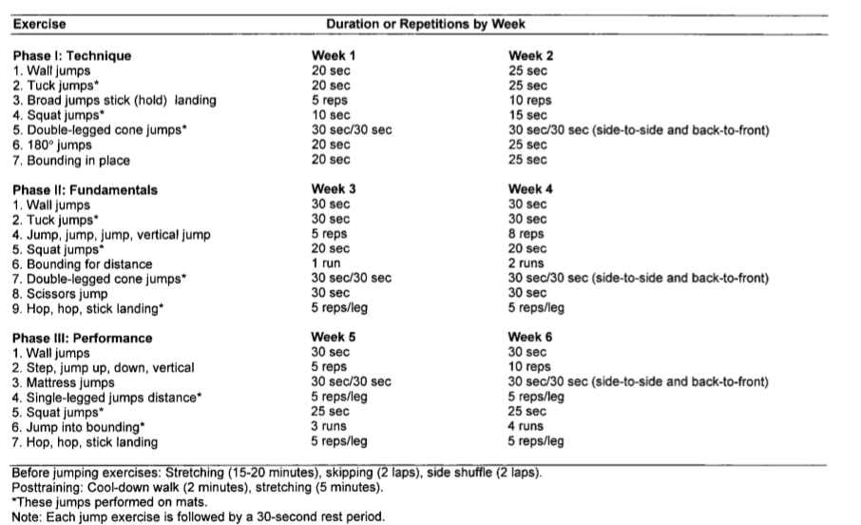
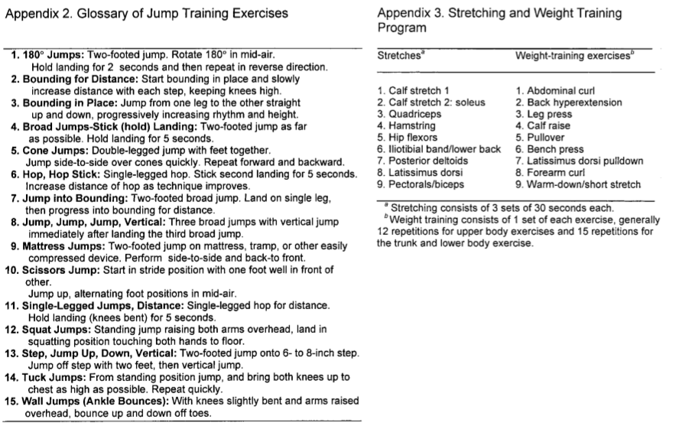

Appendix 7: Knäkontroll neuromuscular warm-up program protocol per Walden et al (2012)²²
Exercise | Instructions | Repetitions/duration
One legged knee squat: | Slow movement with smooth turn, horizontal pelvis and non-supporting foot in front of body with slightly flexed hip and knee
Level A | Hands on hips | 3×8-15 reps
Level B | Hold ball over head with straight arms | 3×8-15 reps
Level C | Hands on hips; mark with non-supporting foot just above ground at 12-02-04-06 o’clock positions | 3×5 reps
Level D | Bend down while holding ball and let ball touch ground outside supporting foot; make diagonal movement upwards and raise ball over head with straight arms on contralateral side | 3×8-15 reps
Pair exercise | Teammate stands slightly oblique in front of you and ball is pressed between lateral sides of feet of non-supporting legs | 3×5-10 reps
Pelvic lift: | Supine position; lift pelvis from ground while keeping back straight
Level A | Both feet on ground and hands across chest | 3×8-15 reps
Level B | One foot on ground and contralateral leg flexed in hip and knee 90° with both hands on knee | 3×8-15 reps
Level C | One foot on football and contralateral leg flexed in hip and knee 90° with arms on ground alongside body | 3×8-15 reps
Level D | One foot on ground and other in air; keep upper arms on ground with elbows flexed 90°; push away supporting foot and land on contralateral foot | 3×8-15 reps
Pair exercise | Teammate stands with flexed knees and supports heel of one of your feet in her hands; hands across chest and lift pelvis | 3×8-15 reps
Two legged knee squat: | Slow movement with smooth turn, back in straight position and feet shoulder-wide apart with soles in contact with ground
Level A | Hold ball in front of body with straight arms | 3×8-15 reps
Level B | Hands on hips | 3×8-15 reps
Level C | Hold ball over head with straight arms | 3×8-15 reps
Level D | Same as level C but continue movement and rise up on toes after returning to starting position and stay briefly in that position | 3×8-15 reps
Pair exercise | Teammate stands next to you approximately 1 m away, facing opposite directions; hold ball between you with one hand and other hand on hip; apply slight pressure on ball while performing knee squat | 3×8-15 reps
The bench: | Lift body and keep it in straight line
Level A | Prone position; support on knees and on lower arms with elbows kept under shoulders | 15-30 sec
Level B | Same as level A but with support on tip of feet | 15-30 sec
Level C | Same as level B, but move foot to side and back to starting position; alternate sides | 15-30 sec
Level D | Lie sideways with support on foot and lower arm with elbow kept under shoulder and other hand on hip; lift hip off ground and stay briefly in that position with good control before slowly returning to starting position | 5-10 reps
Pair exercise | Teammate stands behind you and holds your feet or lower legs; lift the body and walk forward by using hands on ground | 15-30 sec
The lunge: | Take deep step with marked knee lift and soft landing; rear knee should not touch ground
Level A | Hands on hips; move forward with each step | 3×8-15 reps
Level B | Hold ball in front of body with straight arms; rotate upper body while stepping forward and position ball laterally of front leg; move forward with each step and alternate sides | 3×8-15 reps
Level C | Hold ball over head with straight arms; perform forward lunge and push back with front leg and return to starting position | 3×8-15 reps
Level D | Hold ball in front of body with straight arms; perform sideways lunge and return to starting position | 3×8-15 reps
Pair-exercise | Teammate stands in front of you 5-10 m away; perform forward lunge while making throw-in with ball | 3×8-15 reps
Jump/landing: | Make jump with soft landing; stay briefly in landing position
Level A | Stand on one leg with knee slightly bent and hands on hips; make short forward jump and land on same foot; jump backwards to starting position | 3×8-15 reps
Level B | Stand on two legs shoulder-wide apart with hands on back; make sideways jump and land on one foot; alternate sides | 3×8-15 reps
Level C | Take a few quick steps on same spot and make short jump straight forward landing on one foot | 3×5 reps
Level D | Same as level C, but change direction and jump to one side (90° turn); alternate sides | 3×5 reps
Pair exercise | Teammate stands in front of you approximately 5 m away; make two legged jump while heading football and land on two legs | 3×8-15 reps

Appendix 8: FIFA 11+ injury prevention protocol per Thorborg et al. 2017²³
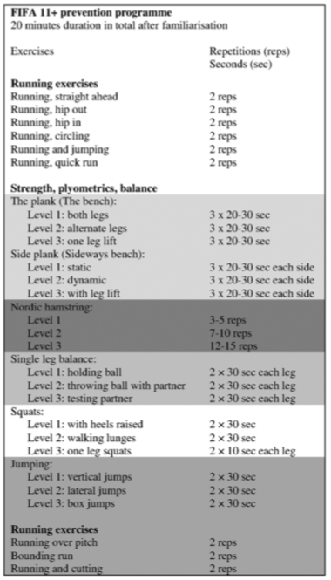
Link to the full FIFA 11+ manual: http://www.yrsa.ca/pdf/Fifa11/11plus_workbook_e.pdf

