Pelvic Pain and Dysfunction: Vaginismus and Vulvodynia

        Chronic pelvic pain (CPP) is defined as pain localized to the pelvis, anterior abdominal wall, below the umbilicus, and often including the lumbosacral back, that lasts more than 6 months. The prevalence of CPP ranges from 5.7% to 26.6% of all women worldwide, but those numbers may be underestimated due to the lack of unified definition of CPP.1 Although CPP can occur in men, it is far more common in women and this paper will focus on the latter. Many different causes of CPP have been reported, and the entire range of diagnoses that fall under CPP is not in the scope of this paper. The diagnoses of vaginismus and vulvodynia both have involvement of the pelvic floor musculature and can contribute to chronic pelvic pain. These diagnoses can both be treated with pelvic floor physical therapy and therefore will be discussed in this paper.

        The pelvic floor has five functions: support, sphincteric, sump pump, sexual, and stabilization.2 The muscles, ligaments, and fascia form a sling to support the bladder, reproductive organs and rectum. The muscles of the pelvic floor provide constriction for the urethral, anal, and vaginal orifices.3 They also act as a sump-pump to pump blood and lymphatic fluid up to your heart. In order to have proper sexual function, the muscles must be strong enough to achieve orgasm and be able to relax to allow penetration without pain. Finally, the pelvic floor assists in stabilization of the core and hips. If there is dysfunction in the pelvic floor musculature, any of these functions can be impaired and lead to chronic pelvic pain.

        The muscles of the pelvic floor can be divided into three layers that are all innervated by nerve routes S2-S4.2 The first layer, the superficial genital muscles, is in charge of the sexual function as well as the voluntary control of the anal canal. It is made up of the superficial transverse perineal muscle, the bulbospongiosis, and the ischiocavernosus.4 The second layer, the urogenital diaphragm, acts to control the sphincter of the urethra and is made up of the external urethral sphincter, deep transverse perineal, compressor urethra, and sphincter urethrovaginalis. 4 The third and deepest layer, the pelvic diaphragm, supports the pelvic viscera like a sling and is made up of the levator ani and the coccygeus. In addition to these three layers, the obturator internus and piriformis muscles help form the walls of the pelvic floor and are innervated by L5-S2.4 See Appendix A for detailed diagrams of the three layers of the pelvic floor muscles. The superficial female genitalia includes the outer and inner labia, the labia majora and labia minora. Inside the labia minora is the vestibule, which contains the urethral opening positioned anterior to the vaginal opening, which is also referred to as the introitus.  As the labia minora bifurcate anteriorly, they form the clitoral hood which covers the body of the clitoris. The vulva is a term used to describe the clitoris, the contents of the vestibule, and the labia.4 Beneath the vulva is the perineal body, which can indicate increased or decreased tension of the pelvic floor based on its positioning of raised for a higher tone pelvic floor or lowered for a lower tone pelvic floor. See Appendix B for a diagram of the superficial female genitalia.2

The first disorder of the pelvic floor musculature addressed by this paper is vaginismus. Vaginismus is classified under “Genito-Pelvic Pain/Penetration Disorders” in the Diagnostic and Statistical Manual of Mental Disorders (DSM5).5 In individuals with this disorder, their pelvic floor muscles will spasm and make it difficult or impossible for penetration to occur. This can happen during a pelvic exam with digits or a speculum, when inserting a tampon, or during sexual intercourse. Those who have had lifelong vaginismus, or primary vaginismus, have never had penetrative intercourse due to the involuntary contraction of their pelvic floor muscles. Secondary vaginismus is the development of this disorder later in life, where the individual could previously have pain-free penetration but now experiences pain and difficulty due to pelvic floor muscle spasms. The pelvic floor spasms are often most noticeable in the first layer of the musculature, which closes the vaginal opening and blocks any penetration. Vaginismus can be different levels of severity, with one grading system ranging from 1 to 5. In this system, 1 indicates a spasm of the pelvic floor muscles that can resolve with reassurance and 5 indicates a spasm of the pelvic floor muscles in conjunction with the patient closing thighs and elevating buttocks to avoid examination and one or more fear response of sweating, nausea, hyperventilation or other indications of fear. Often women with more severe vaginismus will have tight third layer of their pelvic floor musculature, which can cause deep pelvic pain.6 Vaginismus is often accompanied with difficulty maintaining intimate relationships, symptoms of anxiety and depression, and fear of penetration.7

The first case of vaginismus was reported in 1861, and today it is thought to be one of the most common psychosexual dysfunctions in women. The actual incidence of vaginismus is unknown, largely due to the low rate of reporting of symptoms to medical professionals. Women are often embarrassed or ashamed and do not discuss their issues with even friends or family. An estimated between 5-17% of women are affected with various severities of vaginismus in the United States.8 In a study of 301 women in Ghana, 68.1% of women reported symptoms of vaginismus.  In Iran, a study of women from a family planning clinic reported that 12% of women had symptoms of vaginismus.7 Globally, the prevalence greatly varies, but it is clear that this diagnosis is common enough that most pelvic floor physical therapists will treat many patients with vaginismus throughout their career.

The etiology of vaginismus has not been determined and the literature is not in full agreement on what factors contribute to development of the disorder. One study with 110 women found that women with negative sexual experiences in childhood and women with a negative sexual attitude were more likely to have vaginismus.9 The authors also found evidence that individuals with low sexual desire and arousal are more likely to develop symptoms of pelvic floor muscle tension, suggesting these things may be the cause of vaginismus and not just the symptoms.9 In a review looking at the various proposed etiologies of vaginismus, the authors discussed both psychological and biological factors that may presuppose an individual to developing vaginismus. Negative sexual attitudes, sexual ignorance, sexual guilt, dysfunctional intimate relationships, and sexual or physical abuse have all been associated with a diagnosis of vaginismus, but no strong evidence is available to support causation.10

Interventions for vaginismus must treat the biological and psychological components of the disorder, and treatment is most successful when it is multidisciplinary. Many different psychological therapies may be used to treat vaginismus. Systematic desensitization is usually incorporated into psychological treatment. This intervention is where individuals first imagine penetration without pelvic floor spasm and gradually increase to the use of graded dilators until sexual intercourse is possible. Psychologists and therapists use this in combination with relaxation therapy, hypnotherapy, and cognitive behavioral therapy to address the frequent fear component in individuals with vaginismus.7 Sex therapists are trained in relationship and sexual issues and can be an important part of treatment for individuals and couples affected by vaginismus. In a prospective study with 120 women who had primary vaginismus, 93.3% were able to have successful penetration after 3 months of sex therapy. The treatment included systematic desensitization using the patient’s and then partner’s fingers, education on female anatomy, pelvic floor relaxation techniques, and improvements on sexual self-awareness and partner communication.11

Pharmacological interventions include antidepressants, anticonvulsants, anti-anxiety medications, local anesthetics, and botulinum toxin.7 Antidepressants and anticonvulsants have little evidence to improve symptoms of vaginismus, but may be helpful to treat comorbid symptoms of depression.12 Anti-anxiety medications are often prescribed by psychologists in combination with cognitive behavioral therapy to improve symptoms.7 Vaginal diazepam, an intra-vaginal suppository of benzodiazepine, is sometimes prescribed for patients with vaginismus, but the literature is inconsistent. One randomized controlled trial comparing 10 mg of intravaginal diazepam with a placebo did not find a minimal clinically important difference in pain symptoms.13 Conversely, a retrospective chart review with women with high pelvic floor muscular tone found results of decreased sexual pain in participants that had received intravaginal diazepam.14 Botox in the pelvic floor musculature is a promising new intervention that is currently undergoing Food and Drug Administration (FDA) approval for use in vaginismus. In a review of studies assessing the efficacy of Botox in helping patients with vaginismus have pain-free penetration, several case series reported results ranging from 75-100% success. The author of the review noted that Botox alone does not cure the associated psychological problems and those should be further addressed with psychologists and or sex counselors.15 More research is needed to support all of the listed pharmacological interventions.

Pelvic floor physical therapy (PFPT) is another recommended mode of treatment for women suffering from vaginismus. PFPT can include a multitude of treatment methods including education on female pelvic anatomy, manual therapy of stretching the introitus and releasing tight pelvic floor musculature through increased pressure, systematic desensitization with fingers and/or dilators, biofeedback and other pelvic floor relaxation techniques.16 Similar to what was described in treatment by sex therapists, PFPT includes education and systematic desensitization. Because sexual ignorance and negative sexual self-schema are factors associated with vaginismus, addressing female genitalia and improving comfort with self-exploration should be addressed during patient education. Systematic desensitization can be done with the patient’s fingers first, followed by therapist’s or partner’s fingers, and then to progressively larger dilators if tolerated. It is important to assure the patient she is in control and to move slowly with permission at each step to alleviate fear and anxiety.16 Biofeedback is another intervention frequently used in PFPT to improve patient’s awareness and control of muscle tone and to promote relaxation. In a case report with 12 different patients who underwent sexual cognitive-behavioral therapy in conjunction with biofeedback for 12 weeks, all patients were able to have successful sexual intercourse following treatment.17 In a retrospective chart review of 53 women with vaginismus that were treated with PFPT, the authors found that internal manual therapy was the most effective treatment method, followed by education and use of dilators.18 Even though it is agreed that the pelvic floor musculature is dysfunctional in vaginismus, there are still few studies done to support the use of PFPT in these individuals. There are many case reports with positive outcomes, but further research should be done to improve treatment by physical therapists for women with vaginismus.

The second diagnosis often seen in pelvic floor physical therapy that can contribute to chronic pelvic pain is vulvodynia. Vulvodynia is pain in the vulva that has lasted at least 3 months and is not caused by an identifiable cause, such as herpes simplex virus, lichen sclerosis, an obstetric injury or radiation.19 The pain can be described as burning, itching, pressure, raw feeling, or stabbing.20 Recently, a new classification system to categorize vulvodynia has been published. Vulvodynia can be classified by the location, provocation, onset, and temporal pattern. The location can be described as localized, generalized or mixed. Localized vulvodynia would be pain in one specific place, such as the vestibule or clitoris. Vulvodynia can be spontaneous, provoked, or mixed. Provoked vulvodynia indicates pain when the vulva is touched or penetration is attempted, while spontaneous does not have a trigger. Primary vulvodynia indicates that symptoms have always been present, while secondary vulvodynia describes symptoms that occur after normal functioning. Lastly, vulvodynia can be described temporally as intermittent, persistent, immediate, delayed, or constant. The two most common types of vulvodynia are provoked vestibulodynia, localized pain of the vulvar vestibule when touched or penetrated, and generalized vulvodynia, unprovoked pain of the vulva.19 Many studies do not specify types of vulvodynia, but this new classification system will hopefully allow for more accurate diagnosis and treatment of different subsets of the disorder.

The estimated prevalence for vulvodynia ranges from 8%-28% in women of reproductive age.20 In a study of 2,454 women surveyed, 8.3% reported symptoms of vulvodynia. The authors found the prevalence remained the same until a decline after the age of 70. Only 48.6% of women with symptoms of vulvodynia had ever sought treatment, and only 1.4% had received a diagnosis of vulvodynia. Symptoms of vulvodynia were more common in white women when compared to black women but were present in both races.21 Similar to vaginismus, vulvodynia is underdiagnosed and undertreated. This may be due to the sensitivity involved in discussing issues surrounding intimacy or not knowing what normal should feel like. Women with other chronic pain conditions such as fibromyalgia, irritable bowel syndrome, temporomandibular disorder, and interstitial cystitis are up to three times more likely to have vulvodynia. Symptoms of depression and anxiety are more frequent in women with vulvodynia.20

Similar to vaginismus, the cause of vulvodynia is not clear. One idea behind vulvodynia is an implication of a maladaptive central pain processing mechanism, the responsible mechanism for many instances of chronic pain. One episode of pain caused by trauma or inflammation may result in hypersensitivity of pain receptors and cause chronic episodes of pain without apparent cause.22 Initial inflammation could be caused by allergic contact dermatitis or a yeast infection. Some women report an initial event of trauma that triggered their chronic pain. Reported examples of initial trauma are birthing injuries and repairs such as episiotomies, birth with use of forceps, and vaginal birth itself. These initial injuries may cause chronic inflammatory responses on the cellular level. In one study assessing histologic changes in women with provoked vestibulodynia, researchers found increased mast cells, plasma cells and nerve fibers. These are all indications that an acute event has developed into central sensitization of the vulvar area.22 Another review of the etiology of vulvodynia discusses the possible causes by discussing both biological and psychological factors associated with this pain syndrome. Genetic predisposition to infection and inflammation, pelvic floor muscle dysfunction, vestibular mucosa alterations due to hormonal contraception use, and gene variations that inhibit pain regulation have all been implicated in increasing risk of developing vulvodynia. Several psychological risk factors associated with vulvodynia have been identified. Women with depression or anxiety disorders are four times more likely to develop vulvodynia. 20 In a survey of 125 women with symptoms of vulvodynia, the authors found that childhood physical abuse and victimization was associated with an increased risk of developing vulvodynia as an adult.23 Other psychological factors linked to an increase in severity of pain in women with vulvodynia are fear avoidance, pain catastrophizing, and lower pain self-efficacy.20 These factors can attribute to increased chronic pain symptoms throughout the whole body and present more evidence towards many cases of vulvodynia fitting into the category of central sensitization.

Similar to vaginismus, the treatment for vulvodynia should be multidisciplinary. The variety of treatment options available include vulvar care guidelines, psychological interventions, pharmacological interventions, pelvic floor physical therapy, and vestibulectomy.20 Vulvar care recommendations should be made by any health care provider in conjunction with other treatments. These recommendations include guidance on proper laundry products, what clothing to avoid, bathing and hygiene information, contraception options, and lubricant options during intercourse.24 See Appendix B for full vulvar care recommendations.

Psychological interventions can be delivered individually, with a couple, or in a group setting. Sessions should include pain management techniques, communication and understanding about sexual function, and address thoughts and emotions surrounding genital pain and how it affects individual and relational intimacy.25 In a study with a 2.5 year follow up, authors assessed the efficacy of cognitive-behavioral therapy, biofeedback, and vestibulectomy in decreasing self-reported pain during intercourse patients with provoked vestibulodynia. Among 51 patients, there was no significant difference between vestibulectomy and cognitive-behavioral therapy, while biofeedback did have significantly worse pain scores. After long-term follow up, all three treatments were successful in maintaining pain reduction during intercourse for patients. The study also found that patients with increased fear of sex responded worse to vestibulectomy, and this should be considered when deciding what treatments a patient should pursue.26 This study suggests that psychological interventions should be incorporated into standard treatment for patients with vulvodynia, due to the low cost and low risk nature of cognitive-behavioral therapy.

A few different medications are often prescribed in attempt to treat symptoms of vulvodynia. Local anesthetics such as topical lidocaine and Botox injections are sometimes used in attempt to desensitize peripheral nerves. Most research shows between 0-50% efficacy, so these medications are not recommended for sole treatment or long-term treatment of vulvodynia.25 Anti-inflammatory agents such as corticosteroids are sometimes used in attempt to treat the chronic inflammatory effect that vulvodynia can have at the cellular level. Research does not support efficacy of low-dose corticosteroids, and high doses of corticosteroids can have various negative effects on global soft tissue, so corticosteroids are not recommended as a treatment method.25 In a literature review on antidepressant medications used to treat vulvodynia, authors did not find sufficient evidence to support using these medications for treatment.27 Overall, pharmacological therapies for vulvodynia have poor research supporting their efficacy and use for treatment.

Pelvic floor physical therapy is a treatment modality that can be very effective in normalizing movement and pain patterns in women with vulvodynia. Similar to PFPT for vaginismus, treatment sessions may include patient education, internal manual therapy, strength training, and biofeedback.25 Many women with vulvodynia have a tight, shortened pelvic floor with increased tone due to increase stress and tension held in the pelvic floor musculature. An article about treating a short pelvic floor describes different treatment techniques including transvaginal manual therapy and connective tissue manipulation. By identifying tight and painful musculature, often in the second and third layer of the pelvic floor, the therapist provides pressure until the muscle relaxes and the pain alleviates. The patient may also be asked to contract and relax the muscles to improve stretch. Connective tissue manipulation can be done through skin rolling of the lower abdomen and focusing on areas with noted tissue restriction.28It is unclear whether these manual therapy techniques provide the necessary manipulation of the muscle or tissue or if the outside input acts to retrain the nervous system to receive input without processing it as pain. As with any other physical therapy, the patient is assessed for tissue restrictions and weaknesses throughout the pelvis and lower extremity and will be treated with appropriate stretching and strengthening.28 In case control series with eleven women with provoked vestibulodynia compared to eleven control women, the authors assessed the efficacy of a pelvic floor physical therapy program on pelvic floor muscle function and quality of life. The treatment provided included intravaginal manual therapy on soft tissue, use of dilators, biofeedback, pelvic floor strength training with quick contractions and longer holds for endurance, and education on vulvar care. After eight one hour PFPT treatment sessions, the pelvic floor muscle function of the group with vulvodynia was not significantly different than the healthy control, and the participants reported their pain and quality of life was significantly improved.29 Although the sample size was small, this evidence supports pelvic floor physical therapy as a treatment for vulvodynia.

The last common intervention of vulvodynia, specifically for provoked vestibulodynia, is a vestibulectomy. A vestibulectomy is the surgical removal of painful and irritated tissue of the vestibule and is often done when other conservative management is unsuccessful. In a study of 31 women who underwent a vestibulectomy, 100% of women reported reduced pain scores and 57% of women reported no or minimal pain following surgery. Several studies have shown that the procedure is effective in reducing pain in the short-term and long-term.30 In a meta-analysis of 33 studies, the authors found that 70% of patients that underwent a vestibulectomy had significant reductions in pain during intercourse.20 Of course, with any surgery there are risks involved. Risks of a vestibulectomy include bleeding, infection, surgical pain, scar tissue formation, and cyst formation. These are rare but should be discussed between the patient and surgeon when choosing the procedure.25 It should be emphasized that this surgical procedure is only supported in the research for individuals with provoked vestibulodynia, not for other types of vulvodynia.

Vaginismus and vulvodynia are two diagnoses that are commonly seen among pelvic floor physical therapists. Both of these diagnoses can contribute to or be comorbid with a broader diagnosis of chronic pelvic pain. For both diagnoses, there is a lack of proper diagnosis and treatment.10,21 It is not under the scope of physical therapists to diagnose patients with medical diagnoses, but proper subjective and objective measures should be taken to understand the complaint of pelvic pain in patients. If a therapist sees indications of either of these diagnoses that have not been addressed by a gynecologist or other medical doctor, they should report these findings and encourage their patients to receive the proper multidisciplinary care. More research must be done to further investigate the best treatment for diagnoses involving pelvic floor dysfunction. The current evidence for treatment for both conditions discussed above is poor and lacking randomized controlled trials to demonstrate the most therapeutic methods for treatment. As the field of pelvic floor physical therapy continues to grow, there will be many opportunities available to participate in research for both of these conditions as well as other diagnoses that contribute to chronic pelvic pain.

References:

1. Le PU, Fitzergald CM. Pelvic Pain. *Physical Medicine and Rehabilitation Clinics of North America*. 2017;28(3):449-454.
2. Harrington J. The Pelvic Floor. UNC Chapel Hill. 2016.
3. Bharucha AE. Pelvic floor: anatomy and function. *Neurogastroenterol. Motil.* 2006;18(7):507-519. doi:10.1111/j.1365-2982.2006.00803.x.
4. Drake RL, Vogl W, Mitchell AWM. Pelvis and Perineum. In: *Gray's Anatomy for Students*. ; 5:421-423.
5. Pacik PT. Understanding and treating vaginismus: a multimodal approach. *Int. Urogynecol. J.* 2014;25(12):1613-1620. doi:10.1007/s00192-014-2421-y.
6. Maseroli E, Scavello I, Cipriani S, et al. Psychobiological correlates of vaginismus: an exploratory analysis. *J. Sex. Med.* 2017;14(11):1392-1402. doi:10.1016/j.jsxm.2017.09.015.
7. Melnik T, Hawton K, McGuire H. Interventions for vaginismus. *Cochrane Database Syst. Rev.* 2012;12:CD001760. doi:10.1002/14651858.CD001760.pub2.
8. Spector IP, Carey MP. Incidence and prevalence of the sexual dysfunctions: a critical review of the empirical literature. *Arch. Sex. Behav.* 1990;19(4):389-408. doi:10.1007/BF01541933.
9. Reissing ED, Binik YM, Khalifé S, Cohen D, Amsel R. Etiological correlates of vaginismus: sexual and physical abuse, sexual knowledge, sexual self-schema, and relationship adjustment. *J. Sex Marital Ther.* 2003;29(1):47-59. doi:10.1080/713847095.
10. Lahaie M-A, Boyer SC, Amsel R, Khalifé S, Binik YM. Vaginismus: a review of the literature on the classification/diagnosis, etiology and treatment.*Womens Health (Lond Engl)* 2010;6(5):705-719. doi:10.2217/whe.10.46.
11. Jeng C-J, Wang L-R, Chou C-S, Shen J, Tzeng C-R. Management and outcome of primary vaginismus. *J. Sex Marital Ther.* 2006;32(5):379-387. doi:10.1080/00926230600835189.
12. Pasquini M, Picardi A, Speca A, et al. Combining an SSRI with an anticonvulsant in depressed patients with dysphoric mood: an open study. *Clin Pract Epidemiol Ment Health*. 2007;3:3. Published 2007 Feb 8. doi:10.1186/1745-0179-3-3
13. Holland MA, Joyce JS, Brennaman LM, Drobnis EZ, Starr JA, Foster RT. Intravaginal Diazepam for the Treatment of Pelvic Floor Hypertonic Disorder: A Double-Blind, Randomized, Placebo-Controlled Trial. *Female Pelvic Med. Reconstr. Surg.* 2017. doi:10.1097/SPV.0000000000000514.
14. Rogalski MJ, Kellogg-Spadt S, Hoffmann AR, Fariello JY, Whitmore KE. Retrospective chart review of vaginal diazepam suppository use in high-tone pelvic floor dysfunction. *Int. Urogynecol. J.* 2010;21(7):895-899. doi:10.1007/s00192-009-1075-7.
15. Pacik PT. Vaginismus: review of current concepts and treatment using botox injections, bupivacaine injections, and progressive dilation with the patient under anesthesia. *Aesthetic Plast. Surg.* 2011;35(6):1160-1164. doi:10.1007/s00266-011-9737-5.
16. Rosenbaum T. Addressing anxiety in vivo in physiotherapy treatment of women with severe vaginismus: a clinical approach. *J. Sex Marital Ther.*2011;37(2):89-93. doi:10.1080/0092623X.2011.547340.
17. Seo JT, Choe JH, Lee WS, Kim KH. Efficacy of functional electrical stimulation-biofeedback with sexual cognitive-behavioral therapy as treatment of vaginismus.*Urology* 2005;66(1):77-81. doi:10.1016/j.urology.2005.01.025.
18. Reissing ED, Armstrong HL, Allen C. Pelvic floor physical therapy for lifelong vaginismus: a retrospective chart review and interview study. *J. Sex Marital Ther.* 2013;39(4):306-320. doi:10.1080/0092623X.2012.697535.
19. Stenson AL. Vulvodynia: diagnosis and management. *Obstet. Gynecol. Clin. North Am.* 2017;44(3):493-508. doi:10.1016/j.ogc.2017.05.008.
20. Corsini-Munt S, Rancourt KM, Dubé JP, Rossi MA, Rosen NO. Vulvodynia: a consideration of clinical and methodological research challenges and recommended solutions. *J. Pain Res.* 2017;10:2425-2436. doi:10.2147/JPR.S126259.
21. Reed BD, Harlow SD, Sen A, et al. Prevalence and demographic characteristics of vulvodynia in a population-based sample. *Am. J. Obstet. Gynecol.*2012;206(2):170.e1-9. doi:10.1016/j.ajog.2011.08.012.
22. Sadownik LA. Etiology, diagnosis, and clinical management of vulvodynia. *Int J Womens Health* 2014;6:437-449. doi:10.2147/IJWH.S37660.
23. Harlow BL, Stewart EG. Adult-onset vulvodynia in relation to childhood violence victimization. *Am. J. Epidemiol.* 2005;161(9):871-880. doi:10.1093/aje/kwi108.
24. Guidelines for Vulvar Skin Care. SLUCare Physician Group. obgyn.slu.edu.
25. Goldstein AT, Pukall CF, Brown C, Bergeron S, Stein A, Kellogg-Spadt S. Vulvodynia: assessment and treatment. *J. Sex. Med.* 2016;13(4):572-590. doi:10.1016/j.jsxm.2016.01.020.
26. Bergeron S, Khalifé S, Glazer HI, Binik YM. Surgical and behavioral treatments for vestibulodynia: two-and-one-half year follow-up and predictors of outcome. *Obstet. Gynecol.*2008;111(1):159-166. doi:10.1097/01.AOG.0000295864.76032.a7.
27. Leo RJ, Dewani S. A systematic review of the utility of antidepressant pharmacotherapy in the treatment of vulvodynia pain. *J. Sex. Med.* 2013;10(10):2497-2505. doi:10.1111/j.1743-6109.2012.02915.x.
28. FitzGerald MP, Kotarinos R. Rehabilitation of the short pelvic floor. II: Treatment of the patient with the short pelvic floor. *Int. Urogynecol. J. Pelvic Floor Dysfunct.*2003;14(4):269-75; discussion 275. doi:10.1007/s00192-003-1050-7.
29. Gentilcore-Saulnier E, McLean L, Goldfinger C, Pukall CF, Chamberlain S. Pelvic floor muscle assessment outcomes in women with and without provoked vestibulodynia and the impact of a physical therapy program. *J. Sex. Med.* 2010;7(2 Pt 2):1003-1022. doi:10.1111/j.1743-6109.2009.01642.x.
30. Kliethermes CJ, Shah M, Hoffstetter S, Gavard JA, Steele A. Effect of vestibulectomy for intractable vulvodynia. *J. Minim. Invasive Gynecol.*2016;23(7):1152-1157. doi:10.1016/j.jmig.2016.08.822.

**Appendix A: Pelvic Floor Anatomy**

All images retrieved from Gray’s Anatomy for Students, Pelvis and Perineum.4

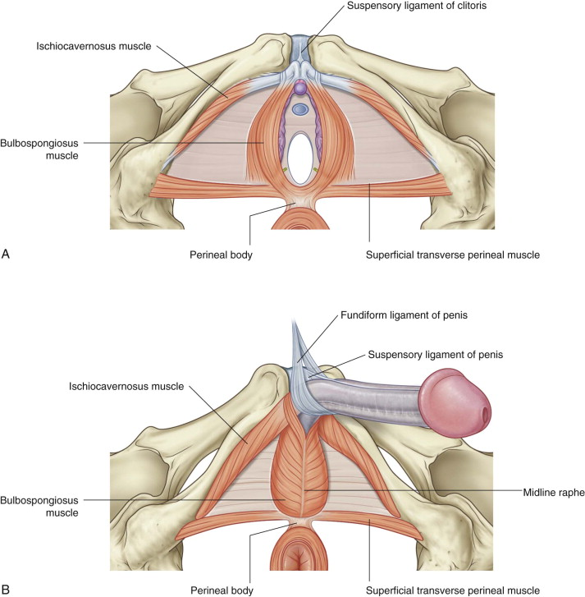

*Figure 1*: Layer 1- Superficial Genital Muscles.

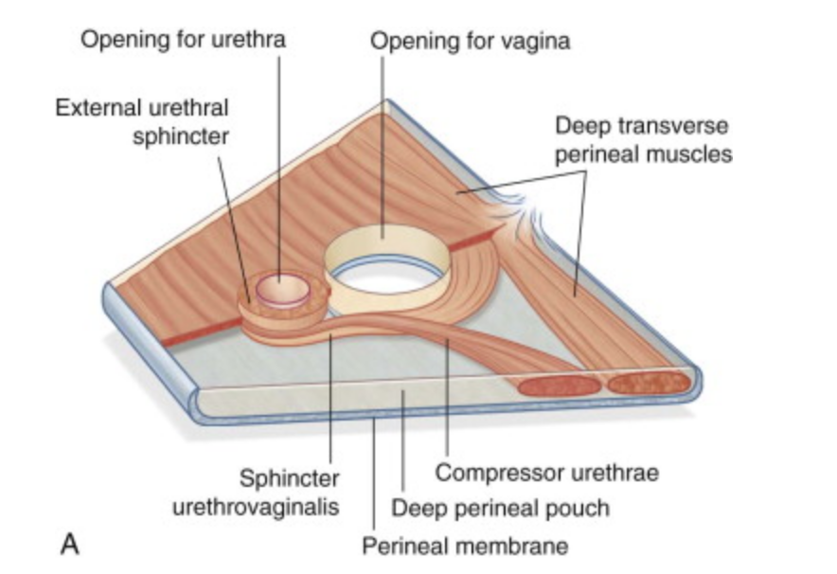

*Figure 2*: Layer 2 – Urogenital Diaphragm.

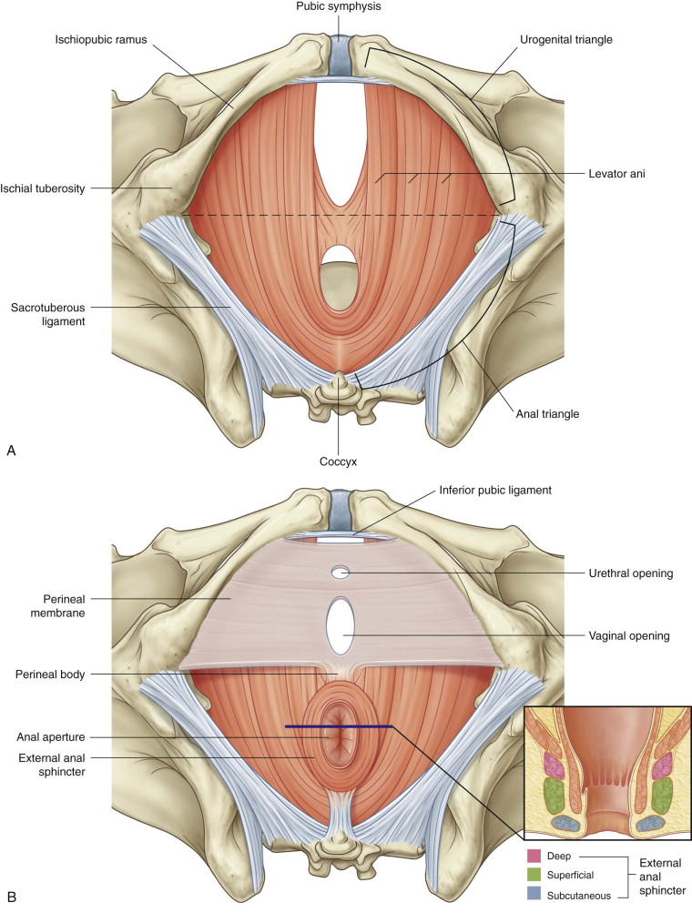

*Figure 3*: Layer 3- Pelvic Diaphragm.

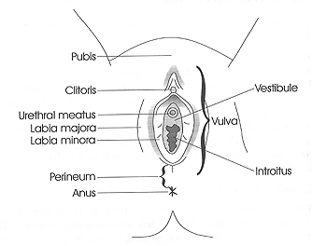

*Figure 4*: Superficial Female Genitalia.

**Appendix B: Vulvar Care Guidelines**



Vuvlar Care Guidelines from St. Louis University Physician Group, Oct 2016.24