The Role of Spinal Stabilization Musculature in Treating Lumbar Pathologies and Low Back Pain

A multitude of muscles may be considered components of the “core” including muscles that attach to the glenohumeral joint or hip; however, this paper will focus on core muscles that attach to the trunk.¹ Muscles, such as the transverse abdominus and lumbar multifidus, can be considered local, or deep, muscles in which core stabilization or motor control exercises can be implemented to target these muscles, whereas muscles, such as the erector spinae, rectus abdominus, and internal and external obliques, can be considered global, or superficial, muscles in which general back strengthening exercises may be implemented.^{1,2,3,4} Local muscles are comprised primarily of shorter, slow-twitch fibers and respond to changes in posture and eccentric loads, while global muscles are comprised primarily of longer, fast-twitch fibers and produce large amounts of torque and movement.⁵ These muscles may provide stability for the spine, but they only comprise one subsystem that provides spinal stability.⁵ In addition to this active subsystem provided by musculature, a passive subsystem consisting of bones and ligaments and a neuromuscular control subsystem also provide stability.⁵ While this paper will focus on the active subsystem, the other subsystems undoubtedly play a role in improving core stability.
Before discussing interventions related to core musculature, the structure and function of a few core muscles will be briefly overviewed though specific details on attachments and biomechanics are beyond the scope of this paper. Figures depicting the anatomy of the following muscles are provided in Appendix A. The abdominal wall is composed of the transverse abdominis and internal and external obliques that are all involved with trunk flexion due to their attachment to the linea semilunaris, and these muscles help form the rectus sheath.¹ The external oblique is the largest and most superficial muscle of the abdominal wall and the internal oblique lies just deep to the external oblique.⁶ The external and internal obliques are involved with rotational forces at the torso and lateral bending.¹ The rectus abdominis is deep to the internal oblique and is a long, strap-like muscle bisected by the linea alba.⁶ It is the strongest trunk flexor.¹ The transverse abdominis, which is the deepest abdominal wall muscle, attaches to the abdominal and lumbodorsal fascia and is primarily comprised of horizontal fibers, except for the inferior fibers that are orientated parallel to the internal oblique.^{1,5,6} The transverse abdominis likewise works with the internal oblique to increase intra-abdominal pressure and stiffen the spine.⁵ The lumbar multifidi span two to three spinal segments and typically only impact local spinal regions.¹ Like the transverse abdominis, the lumbar multifidi stiffen the spine.¹ The erector spinae is composed of three vertically oriented muscles that extend the spine: iliocostalis, longissimus, and spinalis.⁷ The iliocostalis represents the lateral-most column, the longissimus represents the intermediate column, and the spinalis represents the medial column.⁷ The iliocostalis and longissimus can be divided into thoracic and lumbar sections, and the lumbar component directs force in a posterior and caudal direction which causes a posterior shear and extension moment at the spine.¹
An extended period of injury or pain may result in activity avoidance and subsequent core muscle weakness or atrophy and altered spine biomechanics.⁸ It may also cause delayed activation of musculature such as the transverse abdominis.⁹ These stabilizing muscles may control static position and help transfer forces before dynamic movement,¹ and likewise may contract before movement of the extremities.⁵ Core stabilization exercise (CSE) interventions are generally aimed to improve the coordination of trunk musculature and protect the spine from injury.¹⁰ The effects of CSE on various lumbar pathologies, such as lumbar disc herniation, lumbosacral radiculopathy, lumbar spinal stenosis, and non-specific chronic low back pain, will be discussed below. While other conservative and surgical options may often be used for these conditions, CSE will be the primary emphasis of the discussion.
Lumbar disc herniation (LDH) is defined as the localized displacement of disc material that is beyond the intervertebral disc space and can often result in low back and radiating leg pain due to spinal nerve root compression.^{11,12,13} Symptomatic LDH may be prevalent in about 1-3% of the general population.¹⁴ LDH can decrease lumbar curve and cause sacroiliac joint instability and increase the sacral angle of inclination.¹⁵ Diagnosis of LDH can be confirmed by imaging, such as computed tomography (CT) or magnetic resonance imaging (MRI).¹³
Bayraktar et al. compared the effects of land-based and water-based CSE interventions on outcomes in individuals with LDH.¹² Both interventions were 8 weeks with 60-minute sessions performed 3 times per week.¹² The sessions emphasized isolated activation of the transverse abdominus.¹² Both interventions were progressed by changing positions or base of support and increasing resistance.¹² Both interventions resulted in significant improvements in pain, trunk muscle endurance, perceived disability, and health-related quality of life, although no significant differences were found between the groups.¹² Therefore, land- and water-based core exercises may be similarly effective in improving outcomes. Aquatic therapy may be a particularly intriguing option for patients with back pain. The authors note that many patients with back pain may have kinesiophobia, but aquatic therapy may be a safe method that can alleviate pain and could possibly be more amenable or interesting to some patients.¹²
Jeong et al. reported that both a balance center stabilization resistance intervention and a three-dimensional stabilization intervention significantly improved disc herniation index and Korean Oswestry Disability Index, which is related to disability and functional performance, in subjects with LDH.¹⁵ The balance center stabilization intervention also decreased sacral angle.¹⁵ Both interventions comprised of 30-minute sessions performed 3 times per week for 4 weeks and required the use of specialized equipment that induced pelvic movements.¹⁵ Interestingly, the use of pelvic movements appeared to aid in improving lumbar symptoms.¹⁵ Due to the use of specialized equipment, this intervention may not be financially or spatially feasible to directly perform in many clinic environments, but the results suggest that lumbopelvic stabilization exercises may improve outcomes in patients with LDH.
LDH may be considered the most common cause of lumbosacral radiculopathy.¹³ Direct trauma or chemical irritation can likewise cause radiculopathy.⁸ The prevalence of lumbosacral radiculopathy in the general population may range from 9.9% to 25%.¹⁶ Lumbosacral radiculopathy can result in pain, sensory impairment, or weakness along the affected nerve root distribution.⁸ LDH or radiculopathy may also cause changes in the size or distribution of type I and II lumbar multifidus muscle fibers.¹⁷ A CSE intervention addressing radiculopathy can include exercises such as “abdominal hollowing” that activate the transverse abdominus, and can be supplemented by biofeedback and cueing.⁸ Gradually, the exercises can be progressed to more functional positions and activities.⁸ Exercises involving lumbar flexion should be avoided as lumbar flexion can increase radicular symptoms through greater posterior pressure on the disc, so exercises in a neutral or slightly extended position should be implemented.⁸
Hahne et al. conducted a systematic review of conservative treatments implemented on subjects with LDH and radiculopathy and identified a randomized controlled trial (RCT) that they considered high-quality which found that a lumbar stabilization exercise intervention significantly improved pain, trunk flexion range of motion, painless straight leg raise range, and physical functioning.^{13,18} The exercises in this intervention were progressed by changing positions and adding extremity movements or an exercise ball.¹⁸ While there is limited evidence overall, CSE may improve outcomes in patients with lumbosacral radiculopathy.
Lumbar spinal stenosis (LSS), or narrowing of the spinal canal, is often diagnosed through MRI or CT, but there is no established objective definition for LSS.¹⁹ Kalichman et al. incorporated a commonly used cutoff of <12 mm canal diameter to represent “relative” stenosis and <10 mm to represent “absolute” stenosis.¹⁹ Using data from the large Framingham Heart Study, the investigators observed that the prevalence of relative acquired, or developmental, LSS was 22.5% and of absolute acquired LSS was 7.3%.¹⁹ Prevalence increased with increasing age, and absolute, though not relative, LSS was associated with the presence of low back pain.¹⁹ Overall, although LSS is not clearly defined, it appears present in a fairly large proportion of the population and may be commonly associated with back pain.
Like the two above conditions, there appears to be few articles examining CSE and lumbar spinal stenosis. One study implemented a CSE intervention that included exercises such as planks, bridges, and straight leg raises that were performed daily for six weeks.²⁰ This intervention was shown to significantly improve self-reported walking distance and Japanese Orthopedic Association (JOA) score, which assesses subjective symptoms and functional impairments in subjects with LSS.²⁰ Mu et al. implemented a very similar CSE intervention that was continued for four weeks but was compared to a general exercise intervention.²¹ All of the subjects in both groups received middle frequency electrotherapy prior to the interventions, which may influence the results.²¹ Both groups significantly improved in JOA score and self-reported walking capacity, but the CSE group had a significantly larger increase in the outcomes than the general exercise group.²¹ Lumbar lordosis angle measured through radiograph did not significantly change in either group.²¹ Chen et al. also measured the degree of spinal stenosis in the subjects through MRI but did not find a significant correlation between the degree of spinal stenosis and JOA score or walking distance.²⁰ This suggests that symptoms or function do not reliably correlate with the severity of canal narrowing.²⁰ Nevertheless, physical therapists would likely focus on the symptoms more than the canal diameter, and CSE may improve symptoms and function in patients with LSS.
Unlike in the above conditions, there seems to be a far larger number of studies examining CSE interventions and non-specific chronic low back pain (CLBP). 70-85% of individuals may suffer from back pain during some portion of their lives and recurrence rates can be very high.²² About 90% of CLBP may be of a non-specific origin.¹⁷ Wang et al. conducted a systematic review and meta-analysis of 5 RCTs comparing CSE and general exercise interventions in individuals with non-specific CLBP and found that CSE interventions significantly improved pain and functional status at short term follow-up; however, no significant differences were found between the interventions at 6 or 12 month follow-up.²³ CSE interventions may therefore have at least a short-term advantage over general exercise. The studies were considered to have a high risk of bias, which may limit the conclusions drawn from the review, although no adverse events were reported in the studies.²³
A systematic review and meta-analysis of 29 studies conducted a few years later observed more mixed results. Smith et al. found that CSE interventions led to statistically significant improvements in pain and function compared to alternative forms of treatment or control in short and long term follow-up periods among subjects with low back pain; however, these differences were not clinically significant based on minimal clinically important differences (MCID) at any time period.²⁴ Compared to only other forms of exercise, CSE also did not demonstrate clinically significant differences in pain and function at any time period and only statistically significant differences at short and medium term follow-up.²⁴ Many of the studies were considered to be of high quality with a lower risk of bias.²⁴ The authors offer a strong conclusion that CSE interventions can produce beneficial results but not better than any other forms of exercise.²⁴ Clinical significance is a crucial concept to consider and was not discussed in most of the above studies in this paper. As a result, the authors’ conclusions are based on a higher but likely more meaningful threshold from the MCID than the other studies. Examining only statistical significance, this review similarly shows that CSE only seem to consistently produce short term benefits in pain and function better than general exercise. Either way, the results from this review certainly highlight the value of exploring clinical significance.
Nevertheless, a few more recent studies have produced some positive results. A RCT of female nurses with CLBP depicted that an 8-week multi-step CSE intervention led to a significant improvement in pain, functional ability, quality of life, and muscle diameter of the external oblique, internal oblique, and transverse abdominis during an abdominal drawing-in maneuver (ADIM) compared to a wait-list control group.²⁵ The intervention included the ADIM and exercises utilizing a Swiss ball, with progressions in various positions and dynamic movements.²⁵ A large limitation of the study is that 16 of the 36 total subjects dropped out, which could influence the results.²⁵ The investigators also used a sample of health care providers which may differ from the general population. Still, the study shows positive potential of a CSE intervention.
Another study showed that a CSE intervention led to a significantly greater reduction in pain than a routine physical therapy intervention.⁹ The subjects in the CSE intervention group attended 40-minute sessions once weekly for six weeks and performed the same exercises at home twice per week.⁹ The intervention included exercises such as planks, pelvic floor exercises, and diaphragmatic strengthening exercises.⁹ Interestingly, although the pelvic floor and diaphragm are also considered core musculature,⁵ very few studies with CSE interventions seemed to mention exercises specifically targeting these areas. It certainly cannot be determined if these specific exercises influenced the positive results of the study, but further examination of these additional core areas could be helpful. In general, although the two above studies do not assess clinical significance, there is still potential for CSE to produce uniquely positive results.
Based on the above results, general exercise may be similarly effective as stabilization exercises in treating non-specific CLBP. It would also be important to understand if stabilization exercises could reduce low back pain specifically associated with lumbar instability, since instability would be a logical indication for a stabilization intervention. Hicks et al. developed a clinical prediction rule that may help identify patients who may benefit from a CSE program, which includes patients who are younger than 40 years old, have an average straight leg raise of greater than 91 degrees, have aberrant spinal movements, and have a positive prone instability test.²⁶ A list of other various tests that can be used to assess core stability is provided in Appendix B.
Puntumetakul et al. found that a CSE intervention resulted in significantly improved pain intensity, functional disability, patient satisfaction, and the transverse abdominus and internal oblique/rectus abdominus recruitment ratio immediately after the intervention and at 3-month follow-up compared to a control intervention in individuals with CLBP and clinical lumbar instability.⁴ The core stabilization intervention was 10 weeks and consisted of three phases: the first phase emphasized isolated activation of transverse abdominus and lumbar multifidus, the second phase focused on controlling these muscles during extremity movements, and the third phase focused on controlling the muscles during functional tasks.⁴ By contrast, Shamsi et al. found that a CSE intervention led to similar improvements in core stability endurance test times, disability, and pain intensity as a general exercise intervention that focused on activating paraspinals and abdominal muscles in individuals with non-specific CLBP.¹⁰ No significant differences were found between the groups immediately after the intervention.¹⁰ The intervention consisted of 16 total sessions performed 3 times per week and included contraction of local stabilization muscles.¹⁰ Exercises were progressed similarly as the study above, as subjects would contract the local muscles during functional tasks.¹⁰
Focused on objective rather than clinical measurements, Javadian et al. compared an experimental intervention that included core stabilization and general exercises to a control intervention that only included general exercises, which were performed by individuals with non-specific CLBP.²⁷ Lumbar segmental instability can be depicted as excessive vertebral translation or rotation, but both 8-week interventions significantly reduced most of the translation and rotation motions of the L3-L5 vertebral segments after the interventions.²⁷ However, the experimental intervention led to significantly lower translation of L4 and L5 and lower rotation of L5.²⁷ These results therefore indicate that CSE may significantly improve lumbar segmental instability better than general exercise.²⁷ While core exercises may not significantly improve clinical symptoms, it is possible that the exercises may improve lumbar segment kinematics. Producing clinically meaningful results is likely more important, but these results suggest that CSE may provide some benefits for lumbar stability. Since the above studies did not utilize long follow-up periods, longer-term follow-up of clinical symptoms may better capture if improved kinematics will lead to reductions in pain and disability.
Although the results of the effectiveness of CSE over general exercise are mixed, it would be important to confirm if CSE are actually properly activating the desired muscles since few of the above studies objectively analyzed the activation of particular core muscles in the interventions. It could be possible that activating certain group of muscles (i.e. deep vs. superficial) at the appropriate times could lead to more promising results.
Teyhen et al. examined the effects of six specific common core exercises, performed by healthy adults without low back pain, on core muscle thickness.²⁸ A description of the six exercises performed in the study and a graph of the resulting activations of the transverse abdominis and internal oblique muscles are included in Appendix C. The ADIM was measured as a specific exercise but was also incorporated in the other exercises.²⁸ Horizontal side support, or a side plank or side bridge, led to the largest increase in transverse abdominis thickness, whereas the abdominal sit-back and supine lower extremity extender led to smallest change.²⁸ The horizontal side support and abdominal crunch produced the largest increases in internal oblique thickness.²⁸ The ADIM and quadruped opposite upper and lower extremity lift, or bird dog, produced a relatively large increase in transverse abdominis thickness without a large increase in internal oblique thickness.²⁸ From these results, it would appear that the ADIM and bird dog are the most effective exercises for isolated activation of deep core musculature without significant activation of superficial core musculature. While it is not conclusive that isolated deep core activation is more beneficial for treating CLBP, these two exercises should certainly at least be considered in a CSE program. The side plank exercise could also be considered as it produces high transverse abdominis activation, although it may be difficult for individuals with shoulder pathology.²⁸ This would likely be an exercise to omit for patients with shoulder issues.
As a result of the above study, Selkow et al. used only the ADIM, bird dog, and side plank exercises (and progressions of the exercises) in their 4-week CSE intervention and found that the intervention significantly improved transverse abdominis activation and timing (less delayed activation) better than a control group in subjects with and without low back pain.²⁹ Therefore, these three exercises have potential to improve the degree and timing of activation of deep core musculature. A segmental stabilization intervention that was intended to target the transverse abdominis and lumbar multifidus was compared to a superficial strengthening intervention designed to target the rectus abdominis, obliques, and erector spinae in subjects with non-specific CLBP.³⁰ The segmental stabilization intervention, which included exercises in supine hooklying, prone, and quadruped positions, was found to indeed lead to a significant increase in transverse abdominis activation compared to the superficial strengthening intervention that actually led to a slight decrease in activation after the intervention.³⁰ The segmental stabilization intervention also significantly improved pain and disability more than the latter intervention.³⁰ These results suggest that exercises that target superficial core muscles may not necessarily improve activation of deep core musculature, as depicted by Teyhen et al., and there may be an association between increased activation of deep core musculature and improved pain and function.
An 8-month CSE program led to a significant increase in lumbar multifidus cross-sectional area in both healthy women and women with CLBP.³¹ Exercises included supine bridging and extremity movements in various positions while maintaining neutral spine position and were performed twice per week for 45 minutes each.³¹ Another study did not find particular advantages for a CSE intervention. Similar thickness of the obliques and transverse abdominis was found after both a CSE intervention and general exercise intervention in subjects with non-specific CLBP.³² The interventions only significantly differed in right rectus abdominis thickness.³² The CSE focused on contracting deep core musculature while performing other tasks while the general exercise intervention focused on activating paraspinals and superficial abdominal muscles.³²
These studies in general indicate value in several core exercises in improving deep core activation and possibly subsequently improving pain and other outcomes. The ADIM seems to be the most crucial component in activating transverse abdominis, so any interventions attempting this activation should likely include maintaining ADIM during the exercises. Supine bridge, bird dog, and forward and side plank seem to also be particularly effective and have been included in many of the studies demonstrating positive results in this paper.
Overall, it appears that CSE interventions produce similar benefits as general exercise interventions for treating non-specific CLBP. At the most, CSE interventions have been shown to inconsistently produce better effects in the short term, typically related to pain and function. Still, the advantages may not be clinically meaningful. Less research generally appears available for specific lumbar pathologies. Due to this limited amount of research, strong conclusions cannot be established on the effectiveness of CSE on the specific pathologies, although some positive results could be expected. In the above studies, CSE was most commonly compared to general exercises or control groups but not to other conservative or surgical treatments. It would be interesting to observe results from other direct comparisons, particularly with surgical treatment as surgery would induce greater costs and resources.
There is no optimal or “gold standard” CSE program, and the above studies have used a variety of methods to implement CSE, including body weight, exercise balls, specialized equipment, and aquatic therapy, although most of the interventions used similar approaches and progressions. Sessions would often start by focusing on isolated activation of deep core musculature and then progress to changing positions or moving extremities and lastly to more functional movements while maintaining deep core activation. Most of the interventions were of relatively short duration of no more than a couple of months and long-term follow-ups were rarely performed, and when performed, did not produce particularly beneficial results.
Akuthota et al. provided a clear summary of principles for a CSE program that seem to be incorporated in many of the interventions discussed in this paper.⁵ The authors provide a succinct example CSE program that is included in Appendix D. The authors emphasize maintaining neutral spine position and diaphragmatic breathing as well as abdominal bracing during exercises.⁵ Unstable surfaces and the use of exercise balls and other equipment can be used in progressions, but heavy resistance on the lumbar extensors should be avoided.⁵ Many of these exercises are similar to the ones that demonstrated significant core activation in the Teyhen et al. study. The exercises in the program can certainly guide the creation of a potentially effective CSE intervention.
Ultimately, CSE and general exercise interventions may both lead to similarly positive outcomes, such as improved pain and function, in patients with back conditions or back pain. None of the studies or reviews noted adverse effects or events from the CSE or general exercise interventions, so since both interventions are likely to produce similar results, patient and physical therapist preference or the presence of additional impairments, such as lumbar instability or co-morbidities, may guide clinical decisions. At the very least, core exercises should certainly be considered when structuring a therapeutic exercise program, as core musculature seem to have a valuable role in improving outcomes in individuals with lumbar pathologies or non-specific CLBP.

Appendix A – Anatomy of Selected Core Musculature

Figure 1: Overview of Abdominal Wall musculature. From deepest to most superficial: transverse abdominis, rectus abdominis, internal oblique, external oblique. Image reprinted from medcaretips.³³
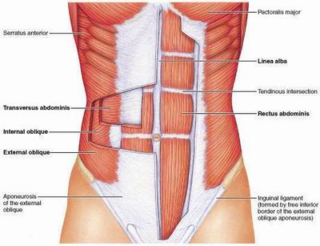

Figure 2: External Oblique muscle. Image reprinted from physio-pedia.³⁴
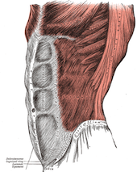

Figure 3: Internal Oblique muscle. Image reprinted from physio-pedia.³⁴
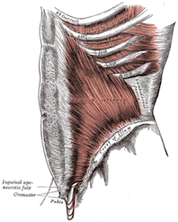

Figure 4: Rectus Abdominis muscle. Image reprinted from physio-pedia.³⁴
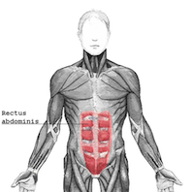

Figure 5: Transverse Abdominis muscle (highlighted in light red). Image reprinted from physio-pedia.³⁴
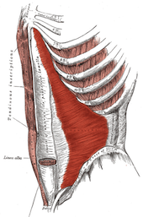

Figure 6: Erector spinae (from lateral to medial: iliocostalis, longissimus, spinalis) and Lumbar Multifidus muscles. Image reprinted from Emory.³⁵
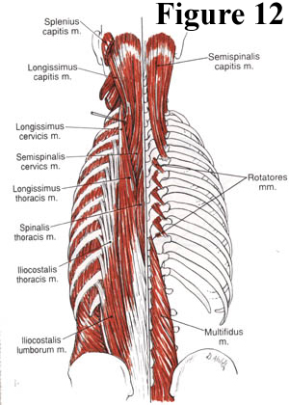

Appendix B – Core Stability Tests

Table 1: List of several core stability tests. Reprinted from Akuthota et al.⁵

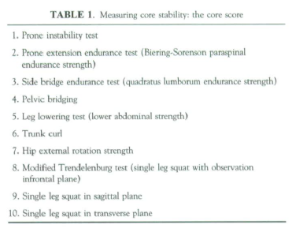

Appendix C – Description and Core Activation of Common Core Stability Exercises

Figure 1: Description of Common Core Stabilization Exercises. Reprinted from article by Teyhen et al.²⁸
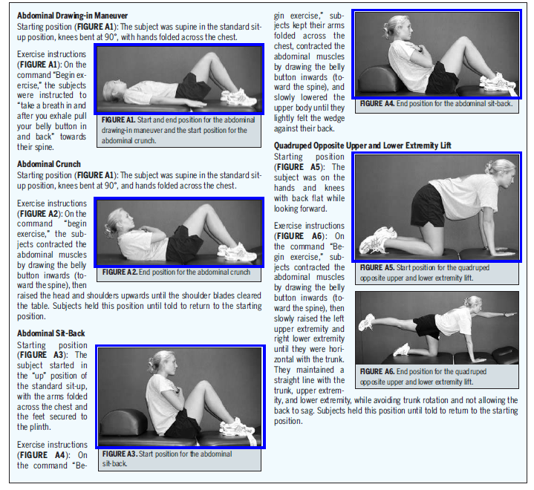
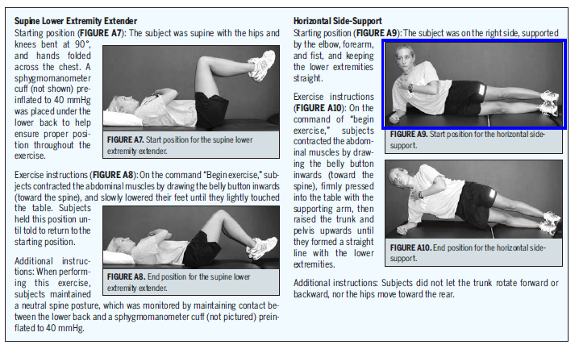

Figure 2: Activation of Transverse Abdominis and Internal Oblique During Core Stabilization Exercises. Reprinted from article by Teyhen et al.²⁸
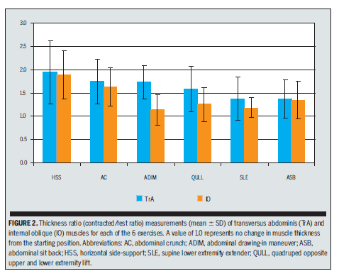

Appendix D – Core Stabilization Exercise Program Example

Table 1: Example structure and characteristics of a core stabilization exercise program. Reprinted from article by Akuthota et al.⁵
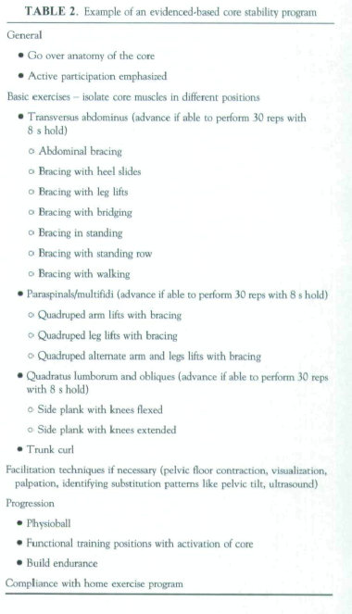

References:
1. Donatelli R. The Anatomy and Pathophysiology of the CORE. In: Sports-specific Rehabilitation. illustrated. Elsevier Health Sciences; 2007.
2. Brumitt J, Matheson JW, Meira EP. Core stabilization exercise prescription, part I: current concepts in assessment and intervention. Sports Health 2013;5(6):504-509. doi:10.1177/1941738113502451.
3. Brumitt J, Matheson JW, Meira EP. Core stabilization exercise prescription, part 2: a systematic review of motor control and general (global) exercise rehabilitation approaches for patients with low back pain. Sports Health 2013;5(6):510-513. doi:10.1177/1941738113502634.
4. Puntumetakul R, Areeudomwong P, Emasithi A, Yamauchi J. Effect of 10-week core stabilization exercise training and detraining on pain-related outcomes in patients with clinical lumbar instability. Patient Prefer. Adherence 2013;7:1189-1199. doi:10.2147/PPA.S50436.
5. Akuthota V, Ferreiro A, Moore T, Fredericson M. Core stability exercise principles. Curr. Sports Med. Rep. 2008;7(1):39-44. doi:10.1097/01.CSMR.0000308663.13278.69.
6. Kernick E. Lecture Presented: Anterior Abdominal Wall, Viscera and Peritoneum at The University of North Carolina DPT Program. Chapel Hill, NC. Fall 2016
7. Edward K. Lecture Presented: Muscles of the Back at The University of North Carolina DPT Program. Chapel Hill, NC Fall 2016.
8. Kennedy DJ, Noh MY. The role of core stabilization in lumbosacral radiculopathy. Phys. Med. Rehabil. Clin. N. Am. 2011;22(1):91-103. doi:10.1016/j.pmr.2010.12.002.
9. Akhtar MW, Karimi H, Gilani SA. Effectiveness of core stabilization exercises and routine exercise therapy in management of pain in chronic non-specific low back pain: A randomized controlled clinical trial. Pak. J. Med. Sci. Q. 2017;33(4):1002-1006. doi:10.12669/pjms.334.12664.
10. Shamsi MB, Rezaei M, Zamanlou M, Sadeghi M, Pourahmadi MR. Does core stability exercise improve lumbopelvic stability (through endurance tests) more than general exercise in chronic low back pain? A quasi-randomized controlled trial. Physiother Theory Pract 2016;32(3):171-178. doi:10.3109/09593985.2015.1117550.
11. Fardon DF, Milette PC, Combined Task Forces of the North American Spine Society, American Society of Spine Radiology, and American Society of Neuroradiology. Nomenclature and classification of lumbar disc pathology. Recommendations of the Combined task Forces of the North American Spine Society, American Society of Spine Radiology, and American Society of Neuroradiology. Spine 2001;26(5):E93-E113.
12. Bayraktar D, Guclu-Gunduz A, Lambeck J, Yazici G, Aykol S, Demirci H. A comparison of water-based and land-based core stability exercises in patients with lumbar disc herniation: a pilot study. Disabil. Rehabil. 2016;38(12):1163-1171. doi:10.3109/09638288.2015.1075608.
13. Hahne AJ, Ford JJ, McMeeken JM. Conservative management of lumbar disc herniation with associated radiculopathy: a systematic review. Spine 2010;35(11):E488-504. doi:10.1097/BRS.0b013e3181cc3f56.
14. Jordan J, Konstantinou K, O’Dowd J. Herniated lumbar disc. Clin Evid 2009;2009.
15. Jeong D-K, Choi H-H, Kang J-I, Choi H. Effect of lumbar stabilization exercise on disc herniation index, sacral angle, and functional improvement in patients with lumbar disc herniation. J Phys Ther Sci 2017;29(12):2121-2125. doi:10.1589/jpts.29.2121.
16. Van Boxem K, Cheng J, Patijn J, et al. 11. Lumbosacral radicular pain. Pain Pract. 2010;10(4):339-358. doi:10.1111/j.1533-2500.2010.00370.x.
17. Cooley JR, Walker BF, M Ardakani E, Kjaer P, Jensen TS, Hebert JJ. Relationships between paraspinal muscle morphology and neurocompressive conditions of the lumbar spine: a systematic review with meta-analysis. BMC Musculoskelet. Disord. 2018;19(1):351. doi:10.1186/s12891-018-2266-5.
18. Bakhtiary AH, Safavi-Farokhi Z, Rezasoltani A. Lumbar stabilizing exercises improve activities of daily living in patients with lumbar disc herniation. BMR 2005;18(3-4):55-60. doi:10.3233/BMR-2005-183-401.
19. Kalichman L, Cole R, Kim DH, et al. Spinal stenosis prevalence and association with symptoms: the Framingham Study. Spine J. 2009;9(7):545-550. doi:10.1016/j.spinee.2009.03.005.
20. Chen C, Lin Z, Zhang Y, Chen Z, Tang S. Does the effectiveness of core stability exercises correlate with the severity of spinal stenosis in patients with lumbar spinal stenosis? Pak. J. Med. Sci. Q. 2017;33(3):631-634. doi:10.12669/pjms.333.12123.
21. Mu W, Shang Y, Mo Z, Tang S. Comparison of two types of exercises in the treatment of lumbar spinal stenosis. Pak. J. Med. Sci. Q. 2018;34(4):897-900. doi:10.12669/pjms.344.15296.
22. Andersson GB. Epidemiological features of chronic low-back pain. Lancet 1999;354(9178):581-585. doi:10.1016/S0140-6736(99)01312-4.
23. Wang X-Q, Zheng J-J, Yu Z-W, et al. A meta-analysis of core stability exercise versus general exercise for chronic low back pain. PLoS One 2012;7(12):e52082. doi:10.1371/journal.pone.0052082.
24. Smith BE, Littlewood C, May S. An update of stabilisation exercises for low back pain: a systematic review with meta-analysis. BMC Musculoskelet. Disord. 2014;15:416. doi:10.1186/1471-2474-15-416.
25. Noormohammadpour P, Kordi M, Mansournia MA, Akbari-Fakhrabadi M, Kordi R. The Role of a Multi-Step Core Stability Exercise Program in the Treatment of Nurses with Chronic Low Back Pain: A Single-Blinded Randomized Controlled Trial. Asian Spine J. 2018;12(3):490-502. doi:10.4184/asj.2018.12.3.490.
26. Hicks GE, Fritz JM, Delitto A, McGill SM. Preliminary development of a clinical prediction rule for determining which patients with low back pain will respond to a stabilization exercise program. Arch. Phys. Med. Rehabil. 2005;86(9):1753-1762. doi:10.1016/j.apmr.2005.03.033.
27. Javadian Y, Akbari M, Talebi G, Taghipour-Darzi M, Janmohammadi N. Influence of core stability exercise on lumbar vertebral instability in patients presented with chronic low back pain: A randomized clinical trial. Caspian J Intern Med 2015;6(2):98-102.
28. Teyhen DS, Rieger JL, Westrick RB, Miller AC, Molloy JM, Childs JD. Changes in deep abdominal muscle thickness during common trunk-strengthening exercises using ultrasound imaging. J. Orthop. Sports Phys. Ther. 2008;38(10):596-605. doi:10.2519/jospt.2008.2897.
29. Selkow NM, Eck MR, Rivas S. Transversus abdominis activation and timing improves following core stability training: a randomized trial. Int. J. Sports Phys. Ther. 2017;12(7):1048-1056.
30. França FR, Burke TN, Hanada ES, Marques AP. Segmental stabilization and muscular strengthening in chronic low back pain: a comparative study. Clinics 2010;65(10):1013-1017. doi:10.1590/S1807-59322010001000015.
31. Kliziene I, Sipaviciene S, Klizas S, Imbrasiene D. Effects of core stability exercises on multifidus muscles in healthy women and women with chronic low-back pain. J. Back Musculoskelet. Rehabil. 2015;28(4):841-847. doi:10.3233/BMR-150596.
32. Shamsi M, Sarrafzadeh J, Jamshidi A, Zarabi V, Pourahmadi MR. The effect of core stability and general exercise on abdominal muscle thickness in non-specific chronic low back pain using ultrasound imaging. Physiother Theory Pract 2016;32(4):277-283. doi:10.3109/09593985.2016.1138559.
33. Muscles of Abdominal Wall | medcaretips.com. Available at: https://medcaretips.com/muscles-of-abdominal-wall/. Accessed December 1, 2018.
34. Abdominal Muscle Anatomy - Physiopedia. Available at: https://www.physio-pedia.com/Abdominal_Muscle_Anatomy. Accessed December 1, 2018.
35. The Vertebral Column and Spinal Cord. Available at: http://www.emory.edu/ANATOMY/AnatomyManual/back.html. Accessed December 1, 2018.

