Written Assignment: Designing an Annual PT Exam
Population | Why
Older Adults (>65 years) | As the population in the United States ages, falls are becoming a growing problem. It is estimated that every year 30% of older adults fall, resulting in injury and costly hospital admissions.¹ An annual physical therapy examination in the older adult population would allow for identification of individuals who are at risk of falling. Identification of these individuals and subsequent implementation of falls prevention strategies, such as strength and balance programs, are associated with falls risk reduction in older adults and can decrease healthcare spending.¹ In addition to identifying older adults who are at risk for falling, an annual physical therapy examination could also be used to identify older individuals who are considered to be in a state of frailty or pre-frailty. Functional performance, gait speed, and functional decline predict survival in the geriatric population and can all be assessed during a physical therapy evaluation.² Evidence has shown that annual functional evaluations can improve function and delay onset of frailty in the older adult population.² Finally, an annual physical therapy examination for older adults would allow for identification of the need for referral to other disciplines. It is a physical therapist’s role to be a health promotor by assessing a patient’s overall health while considering lifestyle factors that may increase risk of certain diseases.³ Health-focused physical therapy practice includes screening for potential psychological and nutrition issues, and may result in subsequent referral to other disciplines.³ An annual physical therapy exam is an important part of a proactive, preventative approach to healthcare in the older adult population.

Annual exam: subjective/objective

Question/test | What testing | Positive finding | Clinical reasoning (Evidence if indicated)
Health History Questionnaire (see appendix 1) | Basic patient information and health history (to be completed prior to visit) | Presence of new/unmanaged risk factors | It is recommended that an individualized falls risk assessment include a review of health history, with a particular emphasis on new risk factors.⁴ In addition to health history, the form also includes a question about the patient’s living situation to determine if the patient lives alone. This is useful information for the therapist to know when considering falls risk, safety, and home exercise prescription for the patient.
Question: Have you fallen in the last 12 months? | Falls History (component of falls risk) | Answer to question is “yes” | Physical therapists should routinely ask patients if they have sustained a fall in the last year.⁴ If the patient’s answer is “yes,” the physical therapist should gather information about the context of the fall to better understand how to best assist the patient in preventing falls in the future.⁴
Vital Signs: HR, SpO2, BP (in supine, seated, and standing positions) | Cardiovascular function, presence of orthostatic hypotension, or presence of hypertension | Positive finding for orthostatic hypotension: drop in SBP >20 mmHg or drop in DBP >10 mmHg within 3 minutes of standing.  Positive finding for hypertension: >139 mmHg SBP or >89 mmHg DBP | NICE and AGS/BGS CPGs recommend assessment of cardiovascular function in older adults by a health care professional, including assessment of heart rate, blood pressure, and presence of orthostatic hypotension.⁴ To evaluate for orthostatic hypotension, blood pressure should be taken in supine, seated, and standing positions. If positive findings are found, the physical therapist would provide educational interventions to the patient and may consider referral to the patient’s primary care physician.
Mini Mental Status Exam | Cognitive Function | </= 24 | The NICE CPG recommends that cognitive assessment is included in a falls risk assessment for older adults.⁴ The MMS has been shown to be a valid and reliable test of cognition and takes only a few minutes to complete.⁵
ABC Scale | Fear of falling (component of falls risk) | <67% | Fear of falling has been shown to be a predictor of falls risk and the ABC score has been shown to predict future falls in community dwelling older adults.⁶
Mini Nutritional Assessment | Malnutrition | 17-23.5 indicates risk of malnutrition  <17 indicates malnourishment | Malnutrition is associated with increased morbidity and mortality, as well as with decreased quality of life.⁷ The MNA has been validated as a practical tool to quickly assess nutrition status in the older adult population.⁷
Medication Review | Presence of polypharmacy (component of falls risk) | Medication use determined to be “excessive, inappropriate, or both.”⁴ | Medication review is recommended to be part of a multifactorial falls risk assessment in older adults as polypharmacy is a risk factor for future falls.⁴ Although current CPGs do not clearly define polypharmacy, it commonly refers to medication use that is excessive and/or inappropriate according to one’s clinical judgement.⁴
Geriatric Depression Scale (short form) | Depression | >5 | Depression is a risk factor for falls according to the Moreland CPG and the GDS is a screening tool specifically designed for use in assessment of older adults.⁴
10-M Walk Test | Gait Speed | Gait speed of <1.0 m/s | Gait speed of less than 1.0 m/s has been shown to be a strong predictor of falls in the elderly population.⁸ A positive finding would warrant the PT providing the patient with home exercises to increase strength and balance.
5x Sit to Stand | Leg Strength (Falls Risk) | >12 seconds | The 5x sit to stand test has been shown to be a reliable and valid measure of physical function in older adults.⁹ This is a functional task that does not take long to administer.⁹ A positive finding would warrant the PT providing the patient with home exercises to focus on lower extremity strength.
Four-Stage Balance Test | Balance | Unable to hold tandem stance, semi-tandem stance, or narrow BOS for at least 10 seconds | Balance assessment is recommended to be a component of a falls risk evaluation.⁴ The four-stage balance test is quick and easy to administer. Additionally, if a certain task is determined to be particularly difficult for a patient, it can easily be prescribed as a home exercise.
Timed Up and Go Test | Functional Mobility (Falls Risk) | >/= 12 seconds | The TUG has been shown to be a reliable and valid test for assessment of functional mobility in the geriatric population.¹⁰ Additionally, it is quick and easy to administer. A positive finding would warrant the PT prescribing the patient home exercises, with a focus on strength and balance, to improve functional mobility.

Resources/referrals:

Test item | Resource/referral | Reasoning
Reports fall in last 12 months OR gait speed is <1.0 m/s | Resources: Educational STEADI resources for fall prevention strategies (see appendix 2) AND prescription of home exercises | A fall in the last 12 months and/or a gait speed of less than 1.0 m/s are both predictors of future falls.^{4,8} Therefore, from a physical therapist’s perspective, this is an issue that must be addressed. In this situation, the physical therapist should provide the patient with educational resources about strategies to prevent falls. The CDC has simple and informative falls prevention (STEADI) brochures available on its website which are targeted to the older adult population. In addition to these educational tools, these at-risk individuals should be started on a personalized strength and balance program to decrease their chance of falling in the future.⁴ The therapist can use the information gained during the examination to select appropriate exercises for the individual and provide the patient with guidelines for intensity and frequency. Endurance and flexibility exercises are also recommended; however, these should be performed in addition to strength and balance exercises.⁴ The physical therapist can also recommend that the patient begin physical therapy, or a group exercise class such as tai chi.⁴
Mini Nutrition Assessment score <23.5 | Referral to a registered dietician | In the older adult population, nutritional deficiencies are associated with an increased risk of becoming frail.¹¹ Nutrient deficiencies are also associated with impairments in physical functioning.¹¹ Since both macro and micro-malnutrition have been associated with onset of frailty, it is important that older people who are malnourished or at risk of malnutrition are identified and receive proper intervention.¹¹ A physical therapist should possess basic nutrition knowledge to help educate patients about wellness and optimize physical function.³ It is within the physical therapist’s scope of practice to conduct nutrition screenings and subsequently refer patients to a registered dietician if a consultation is warranted.³
Mini Mental Status Exam score <24 | Referral to primary care physician | The Centers for Medicare and Medicaid Services have recommended that older adults receive a cognitive screen annually.¹² The Alzheimer’s Association has also recommended that screenings be conducted and that patients who are found to be positive for cognitive impairment be referred for a more thorough evaluation at a primary care visit or with a clinician who specializes in dementia.¹² Such referrals can result in identification of patients in pre-dementia stages.¹² It is the physical therapist’s job to screen each patient for factors that may increase risk of falls, including impaired cognition, and refer to the appropriate healthcare professional.⁴

Bibliography:
- Florence CS, Bergen G, Atherly A, Burns E, Stevens J, Drake C. Medical costs of fatal and nonfatal falls in older adults. J Am Geriatr Soc 2018;66(4):693-698. doi:10.1111/jgs.15304.
- Li C-M, Chang C-I, Yu W-R, Yang W, Hsu C-C, Chen C-Y. Enhancing elderly health examination effectiveness by adding physical function evaluations and interventions. Arch Gerontol Geriatr 2017;70:38-43. doi:10.1016/j.archger.2016.12.009.
- Dean E. Physical therapy in the 21st century (Part II): evidence-based practice within the context of evidence-informed practice. Physiother Theory Pract 2009;25(5-6):354-368. doi:10.1080/09593980902813416.
- Avin KG, Hanke TA, Kirk-Sanchez N, et al. Management of falls in community-dwelling older adults: clinical guidance statement from the Academy of Geriatric Physical Therapy of the American Physical Therapy Association. Phys. Ther. 2015;95(6):815-834. doi:10.2522/ptj.20140415.
- Folstein MF, Folstein SE, McHugh PR (1975). ""Mini-mental state". A practical method for grading the cognitive state of patients for the clinician". Journal of Psychiatric Research 12 (3): 189–98.
- Cleary K, Skornyakov E. Predicting falls in community dwelling older adults using the Activities-specific Balance Confidence Scale. Arch Gerontol Geriatr 2017;72:142-145. doi:10.1016/j.archger.2017.06.007.
- Guigoz Y, Vellas B, Garry PJ. Assessing the nutritional status of the elderly: The Mini Nutritional Assessment as part of the geriatric evaluation. Nutr. Rev. 1996;54(1 Pt 2):S59-65.
- Kyrdalen IL, Thingstad P, Sandvik L, Ormstad H. Associations between gait speed and well-known fall risk factors among community-dwelling older adults. Physiotherapy Research International. October 2018. doi:10.1002/pri.1743.
- Paul SS, Canning CG. Five-repetition sit-to-stand. J Physiother 2014;60(3):168. doi:10.1016/j.jphys.2014.06.002.
- Podsiadlo D, Richardson S. The timed "Up & Go": a test of basic functional mobility for frail elderly persons. J Am Geriatr Soc. 1991;39:142-148.
- Kaiser M, Bandinelli S, Lunenfeld B. Frailty and the role of nutrition in older people. A review of the current literature, Acta Biomed, 2010, vol. 81 Suppl. 1(pg. 37-45)
- Grober E, Wakefield D, Ehrlich AR, Mabie P, Lipton RB. Identifying memory impairment and early dementia in primary care. Alzheimers Dement (Amst) 2017;6:188-195. doi:10.1016/j.dadm.2017.01.006.
Appendix (if indicated):
- Health History Form:
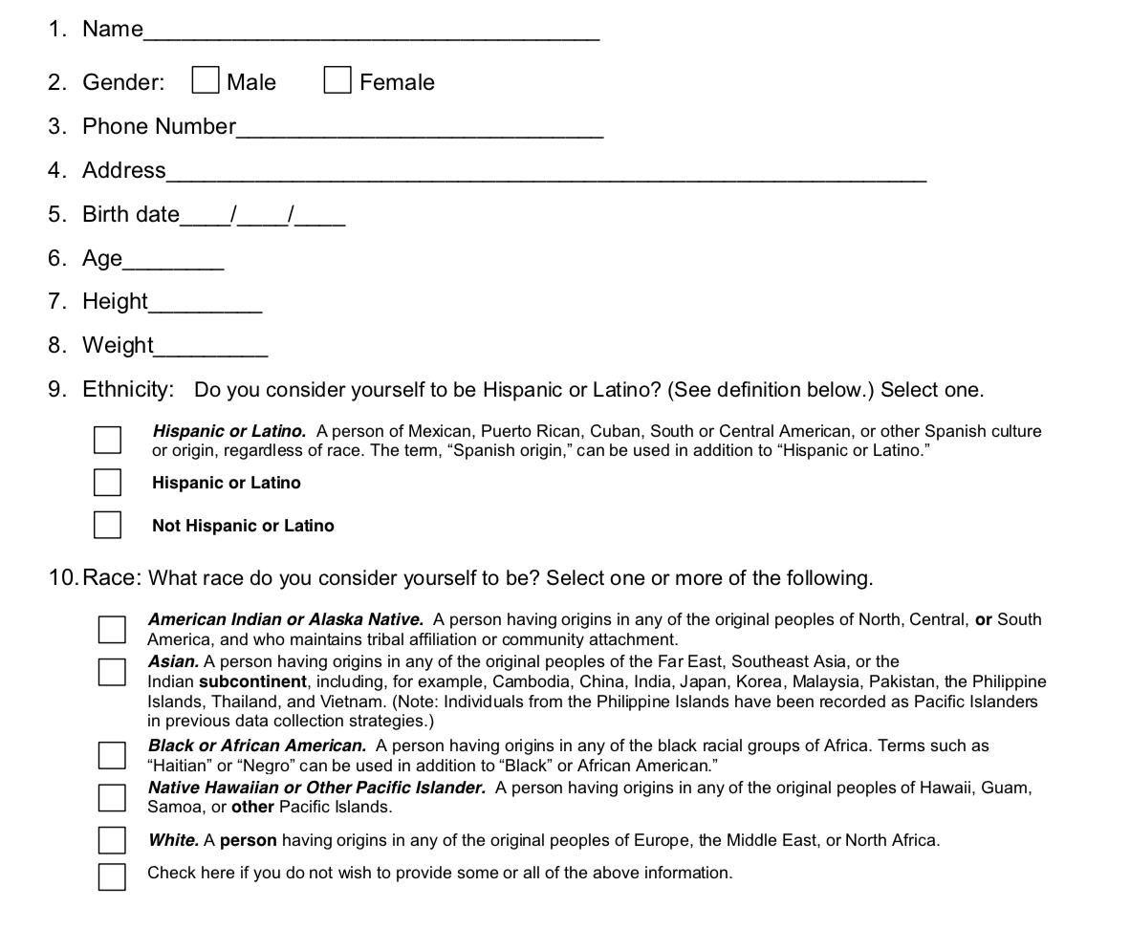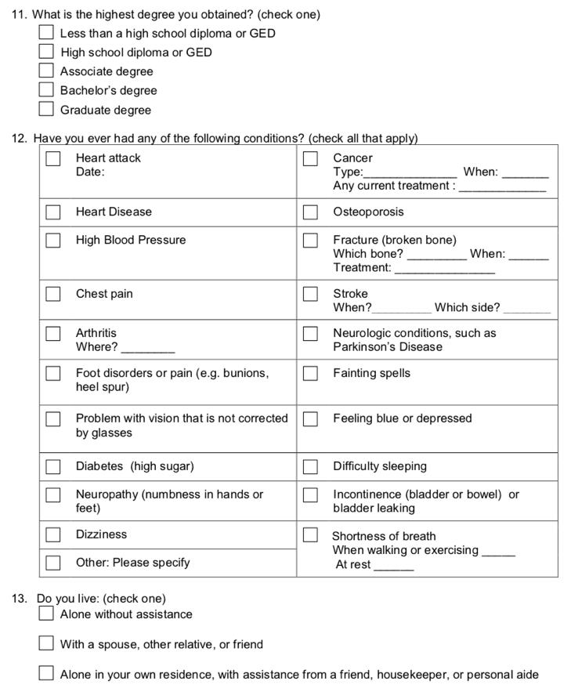
Source: CHAMP Policies and Procedures Manual 2018. https://ncchamp.org/materials. Accessed September 14, 2018.

- STEADI Fall Prevention Resources:
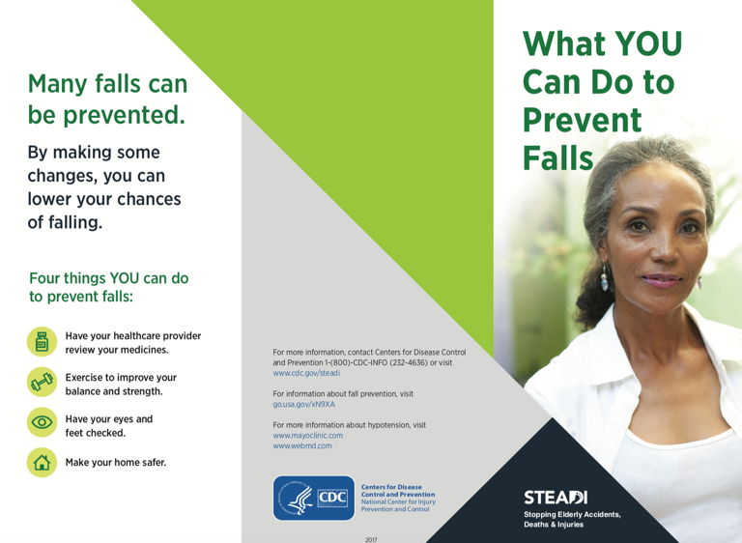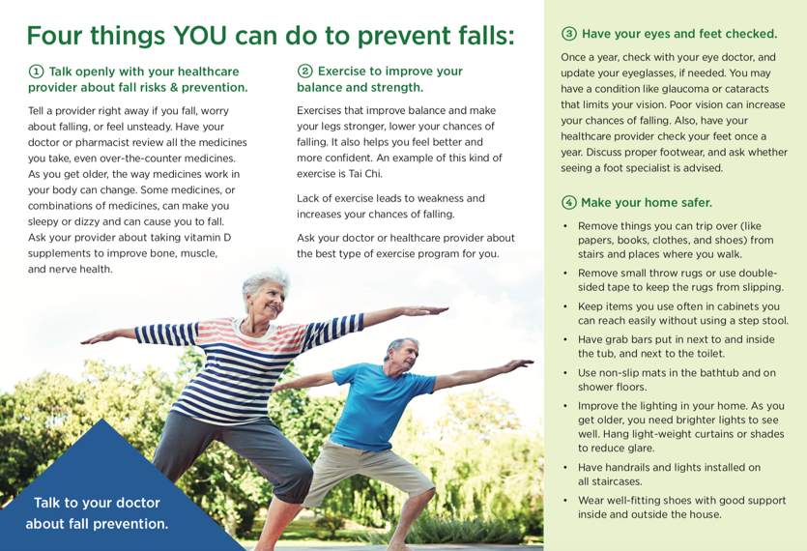
Source: Centers for Disease Control and Prevention. What You Can Do to Prevent Falls. https://www.cdc.gov/steadi/index.html. Accessed September 14, 2018.

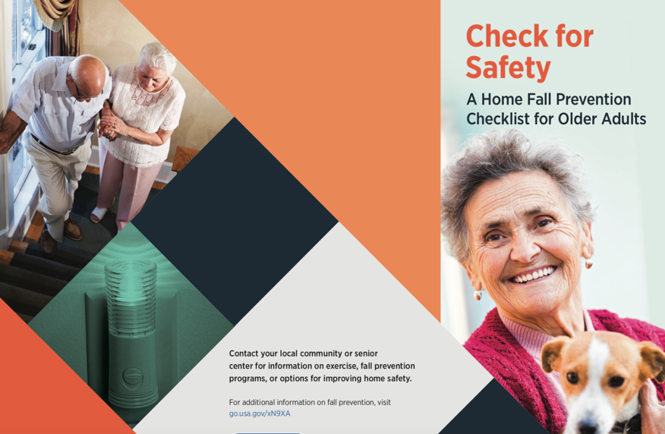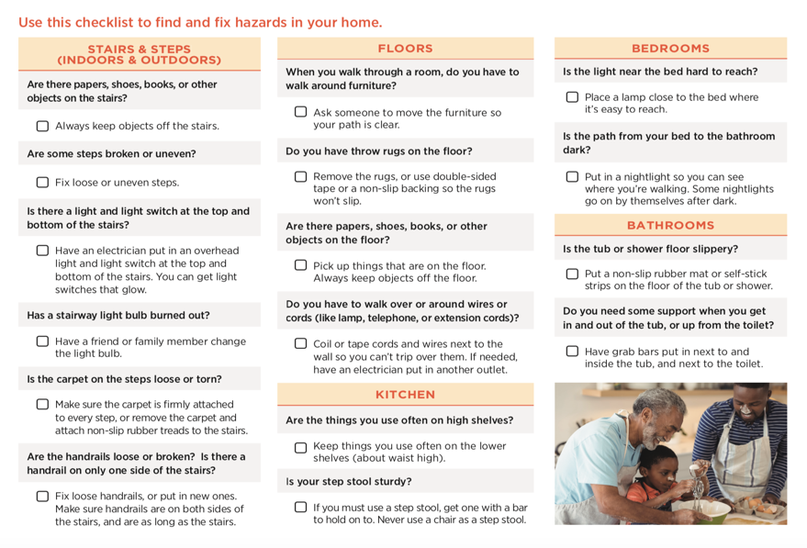
Source: Centers for Disease Control and Prevention. Check for Safety: A Home Fall Prevention Checklist for Older Adults. https://www.cdc.gov/steadi/index.html. Accessed September 14, 2018.

