Spondylolysis and Spondylolisthesis in Young Athletes
Introduction
The athletic population can be prone to many different types of injuries, including low back pain. The incidence of back pain can be up to 30% in some sports, and can cause athletes to miss competitions and not perform to their best ability. ¹ A common source of back pain in the athletic population is spondylolysis and spondylolisthesis. It is estimated that spondylolysis is the cause of pain in 47% of adolescent athletes compared to only 5% in adult athletes.¹ Spondylolysis is a defect in the neural arch, most commonly in the pars interarticularis, and spondylolisthesis is anterior translation of one vertebra on another.¹ Figure 1 illustrates what spondylolysis and spondylolisthesis look like compared to a healthy vertebra. ² The purpose of this paper is to discuss how these conditions affect the athletic population, and how physical therapists can use their skills to evaluate and effectively treat spondylolysis and spondylolisthesis.
Mechanism of Injury
Spondylolysis occurs in approximately 6% of the general population, and 75% of these will also develop spondylolisthesis. ³ The lesion can occur at any vertebral segment, but most commonly occurs at L5.^{1,3} The most common mechanism of injury is due to repetitive hyperextension, twisting, and axial forces to the lumbar spine, which causes mechanical stress and spondylolytic defects of the pars interarticularis.³ In a study by Chosa et al., they examined the biomechanical stress of the pars interarticularis based on a three dimensional L4-L5 vertebral segment. ⁴ The study observed the segment under different types of stress including compression and compression with flexion, extension, rotation and lateral bending.⁴ They found that there was the least amount of stress in the pars interarticularis under compression only, and the highest amount of stress occurred during compression with extension and with rotation.⁴ Spondylolysis has been categorized into five classification systems based on etiology.¹ Dysplastic spondylolysis represents failure of development of the posterior elements, but may have an intact pars.¹ Developmental spondylolysis is found incidentally and is related to genetic predisposition.¹ Acute traumatic results from high-energy trauma and is very rare.¹ Pathologic spondylolysis results from another primary disease process such as malignancy or metabolic bone disease.¹ Lastly, chronic traumatic occurs from a stress reaction to activity, and is the most common type seen in the athletic population.¹ Spondylolysis begins as a stress fracture which can occur unilaterally or bilaterally.⁵ Those that experience a unilateral stress fracture are likely to convert to a bilateral stress fracture due to increased demand of the load on the contralateral side.⁵ If left untreated and with continued stress, the stress fracture will develop into a full fracture, then a non-union, and eventually into spondylolisthesis.⁵ Other risk factors associated with spondylolisthesis include spina bifida occulta, scoliosis, Scheuermann’s disease, excessive lordosis, and cerebral palsy.⁵ The L5 segment is at the highest risk for developing a spondylolysis because of the sacral angle. The L5 inferior facet faces anterior and the superior facet of S1 faces posterior which creates a large anterior shear on the L5 pars interarticularis.⁵ Due to the mechanism of injury, the athletes who have a higher risk for developing this injury include football linemen, gymnasts, swimmers, divers, weight-lifters, track and field athletes, soccer players, and volleyball players. ⁵ Adolescent athletes are at the highest risk for developing a spondylolysis or spondylolisthesis because the spine is still skeletally immature, and specifically the pars interarticularis does not mature until about age 25.⁵
Signs and Symptoms and Differential Diagnosis
When a spondylolysis is present patients will most likely complain of low back pain, especially in extension.⁵ The type of pain can be different for each person depending on the severity of the injury and can be described as a dull ache or a severe sharp pain.^{1,5} In some cases patients may be asymptomatic.⁵ Also, athletes may report pain during exercise or training and decreased or absent pain during rest.¹ Since these are very general symptoms it is important to keep in used clinical reasoning and examination to determine the condition. In the young/adolescent athlete with low back pain, spondylolysis has been shown to the source of pain in 47% of patients.^{1,3,5} Even though this is a really high number, it is important that the clinician keep in mind all possible diagnoses that could be the sources of the problem. Other common sources of low back pain in the athletic population include muscle strain, muscle spasms, herniated vertebral disk, vertebral endplate fracture, and bacterial infection of the vertebral disk. ⁶ Since there are multiple different sources for low back pain in the young athlete, it is very important to perform a thorough evaluation and examination to get a clear picture of what is causing the problem.
Physical Therapy Evaluation
Subjective Information and History:
When first meeting the patient a comprehensive background and history should be taken to obtain any important information that may be helpful to complete the objective portion of the exam. A patient with spondylolysis or spondylolisthesis will most likely report pain in the low back that is increased during activity, especially activities in lumbar extension.^{1,3,5} They may also report pain that radiates to the posterior thigh and buttock.¹ One systematic review by Grodahl et al. reported on the diagnostic utility of patient history and physical examination for spondylolysis and spondylolisthesis. ⁷ Table 1 represents the patient history information asked and the associated specificity and sensitivity scores for each symptom.⁷ They found that during the patient history for spondylolysis, there was moderate sensitivity (73%) for male gender, moderate/high sensitivity for age younger than 20 and sudden onset of symptoms (< 3 months) (81%), and high for participation in sport (85%).⁷ Specificity for these values were low for age (44%), low for participation and sport (34%) and low-moderate for male gender (57%).⁷ When assessing patient history for spondylolisthesis, the systematic review found two studies that investigated sensitivity and specificity for certain patient history items.⁷ Table 2 represents the patient history information and associated specificity and sensitivity for spondylolisthesis.⁷ Both studies found that sciatica as a reported symptoms had low/moderate sensitivity (61% and 68%) and low specificity (27%).⁷ One study in the systematic review also found moderate/high sensitivity in reported symptoms for difficulty falling asleep (75%), waking up because of pain (80%), pain worse with sitting (85%), and pain worse with walking (80%). This information can be useful to the physical therapist because it can help to recognize common patient reported symptoms of spondylolysis and spondylolisthesis, and help to differentiate between different musculoskeletal and/or neurological conditions. The subjective portion of the exam is very important for building trust with the patient, and to allow the physical therapist to determine the appropriate examination methods they would like to use.
Objective Exam:
After completing the patient history and subjective portion of the evaluation, the physical therapist should complete a comprehensive objective exam to determine if there is a possibility the patient has spondylolysis or spondylolisthesis. There are many different objective criteria and tests that should be completed in order to get a complete understanding of the type and severity of the injury. Tables 3 and 4 represent the diagnostic test accuracy for spondylolysis (Table 3) and spondylolisthesis (Table 4) for many different objective measures, which will be discussed in this section.⁷
Initial examination should begin with palpation of the spine, pelvis, and sacroiliac joints for sources of pain in order to identify the specific location of the lesion.¹ Increased pain may be felt with direct pressure to the spinous processes at or above the level of the lesion.⁵ In patients with spondylolisthesis, a palpable step off deformity may be present at the vertebral level of the lesion due to the anterior translation of the vertebrae.^{1,7,8} Palpation of soft tissues of the lumbar spine and hamstring muscles will most likely reveal muscle tightness or spasms due to pain and guarding.^{1,5,8}
After palpation, range of motion, flexibility, and strength should be assessed. Lumbar range of motion should be assessed in all directions including flexion, extension, rotation, and lateral bending.^{1,5} Patients with a spondylolysis will most likely exhibit decreased lumbar range of motion, especially in extension and/or rotation, and may exhibit increased pain in during these motions.^{1,5} Other patients may exhibit hypermobility at the lumbar spine, which can increase shear forces at the L5 level.⁵ After assessing lumbar range of motion, flexibility of the hamstrings and hip flexors should be evaluated.^{1,5,7} Hip flexor tightness can be common in patients with spondylolysis or spondylolisthesis and increased tightness could limit overall extension, which can cause increased forces in the lumbar spine.⁵ Another very common sign in patients with this condition is hamstring tightness, which could be caused from excessive lumbar lordosis.^{1,3,5,7} If the patient exhibits increased pain during lumbar range of motion, strength testing should be deferred for these muscles to prevent an increase in pain. Hamstring and hip flexor strength should be assessed to determine any deficits caused from the lesion.¹ Patient with hypermobility of the lumbar spine tend to have muscle weakness of the abdominal and gluteal muscles, which can often lead to lordotic posture, and increased stress at the pars interarticularis.⁵
After assessing range of motion, flexibility, and strength a neurological exam should be done in order to rule out neurological injury.¹ This is especially important if the patient reports radiating pain down the buttock or posterior thigh. The neurological exam should include myotome and dermatome testing and assessment of deep tendon reflexes.¹ The physical therapist should also ask about numbness, tingling, and any bowel or bladder changes/incontinence during the neurological exam.⁷
There are also a series of special tests that can be utilized to determine if a patient has a spondylolysis or spondylolisthesis. A common test that has been validated to have moderate to high sensitivity (81% and 88%) and high specificity (87% and 100%) is the one legged hyperextension test.⁵ This test is conducted by having the patient stand on one leg and bend into lumbar extension.¹ The test is considered positive if there is increased pain at the level of the lesion.^{1,3,5,7,9} Figure 2 demonstrates how this test is performed in the clinical setting. ⁹ Other tests that can be used during the objective exam include the prone back extension with fixed pelvis test, the coin test, the percussion test with reflex hammer, the sacrum nutation test, the HOOK test, and the MCI control test, however Sundell et al. reported that these tests were not reliable or valid in distinguishing spondylolysis from other causes of low back pain. ¹⁰ In a systematic review, Gondahl et. al also found that the percussion test with reflex hammer, prone back extension with fixed pelvis, and sacrum nutation test had low specificity and sensitivity.⁷ The systematic review did find however that the coin test had moderate sensitivity at 85% and low 16% specificity for detecting spondylolysis.⁷ These special tests can be useful for getting a clear picture of the patient’s deficits, and determine whether the patient has a suspected spondylolysis or spondylolisthesis.
A posture and gait assessment should also be completed to determine any postural or functional deficits related to the injury. These are important for assessing for the condition, but it could also help demonstrate where the source of the problem is coming from. Patients with poor abdominal and gluteal strength often exhibit excessive lordosis posture.⁵ This posture is very common in athletes with spondylolysis, especially in gymnasts, cheerleaders, and dancers.⁵ Patients with spondylolysis or spondylolisthesis may also exhibit scoliosis, which can be a risk factor for developing the condition.¹⁰ Leg length discrepancy and pelvic alignment should also be assessed because any discrepancy could be the source of increased stress in the lumbar spine.¹⁰ A gait assessment may reveal abnormalities such as limping due to pain, excessive knee flexion from excessive hamstring tightness, and decreased cadence and/or step length from increased pain or decreased ROM.¹⁰ These abnormalities are important to assess because abnormal gait in walking can result in poor mechanics during sport, which can lead to more severe injury.
Referrals and Diagnostic Testing:
If the physical therapist suspects a spondylolysis or spondylolisthesis injury after comprehensive evaluation, the athlete should be referred to a physician for X-ray and additional diagnostic testing.^{3,5} If severe neurological symptoms are present during the neurological and other objective assessments the patient should be referred to a neurologist for additional testing and evaluation.
The primary way to confidently diagnose a spondylolysis or spondylolisthesis is by radiograph via X-ray.^{3,5,8} Anteroposterior and lateral views of the thoracolumbar spine will demonstrate the best view of the pars defect.³ Historically the pars defect is seen on oblique views, but the sensitivity of detection on x-ray does not increase that much with oblique views, and the radiation exposure is much greater.⁸ Lateral views can also help determine the degree of slip, slip angle, and sacral inclination in spondylolisthesis.³ Any translation of the vertebrae is typically graded according to the Meyerding scale.¹ This scale divides the percent of slippage into five categories with grade I being <25%, grade II being 25-50%, grade III being 50-75%, grade IV 75-100%, and grade V being spondyloptosis.¹ Spondyloptosis occurs when the vertebra has slipped so far with respect to the vertebra below that the two end plates are no longer congruent.^{1.} Figures 3 and 4 show images of spondylolysis and spondylolisthesis on an x-ray. ¹¹ Although x-ray is the gold standard for diagnosing spondylolysis and spondylolisthesis, early spondylolysis may not show up on traditional x-ray.^{3,5} In this case, more sensitive diagnostic test may be needed to identify the condition. Tests such as bone scans, single-photon emission CT (SPECT), and computed tomography (CT) can detect early and active lesions.³ A SPECT has the ability to show actions of the bone before they would be evident on X-ray, and they can also tell if the area is likely to be symptomatic (hot scan) or asymptomatic (cold scan).⁵ Magnetic resonance imaging (MRI) is typically not indicated unless there are neurological signs and symptoms present.³ If x-ray, CT, and SPECT are all negative of spondylolysis or spondylolisthesis, then an MRI should be used to discriminate between disc degeneration, infection, or tumor.³
Treatment
In most cases, patients with spondylolysis and spondylolisthesis can be treated with successfully with conservative rehabilitation.⁸ Surgery for these patients is indicated when there is continued pain and failed conservative treatment after 6 months, or when the amount of slippage is severe (grades III-V).⁸ Skeletally immature patients with slips more than 50% are recommended to undergo fusion to prevent further slippage.⁸ Surgery would also be indicated for patients with persistent neurological deficits and radiculopathy.⁸
Surgical Management:
Conservative treatment can sometimes fail due to the formation of a communicating synovial pseudoarthrosis at the pars interarticularis, which creates a physical barrier and prevents healing.⁸ When this occurs, surgical intervention is required to debride the area to allow for fusion of the bone.⁸ In patients with continued symptomatic L5 spondylolysis an L5-S1 in situ fusion with autogenous posterior iliac crest bone graft is the gold standard for improvement.⁸ In retrospective analyses this method has success rates approaching 90%.⁸ Patients with spondylolisthesis and more than 50% slippage and/or lumbosacral kyphosis involve either in situ fusion or fusion with reduction and instrumentation depending on the severity and surgeon preference.⁸ The goal of surgery is to reduce the kyphosis and slip angle and stabilize the spondylolisthesis.⁸ After surgery, most surgeons require the patient to be in a rigid brace for at least 3 months. Rehabilitation can begin at 2 weeks and should involve exercises with the spine in a neutral position.⁸
Conservative Management:
As mentioned before, most patients with spondylolysis and spondylolisthesis respond very well to non-operative management.^{1,3,5,8} In one meta-analysis and systematic review, examiners found that at 1 year follow up, children and young adults with spondylolysis and spondylolisthesis with up to 25% slippage were able to return to pain free unrestricted activity with conservative treatment 84% of the time. ¹² Common conservative management consists of a combination of rest from activity, bracing, and rehabilitative exercises.^{3,5,12}
There is currently not a universal agreement for the amount rest required prior to returning back to sport.⁵ Some studies report rest is required for up to 3 month, but other studies have reported that rest can vary from 2 weeks to 6 months depending on the severity of the injury.⁵ The goal of rest from activity is to allow a completely stable, pain free union of the pars fracture.⁵
Another common method used during the rehabilitation process is lumbar bracing.^{5,12} There is mixed evidence about whether bracing is actually an effective intervention during the healing process. In one systematic review examining young patients with spondylolysis, researchers performed a subgroup analysis comparing 137 patients treated without a brace to 334 patients treated with a brace.¹² They found that treatment success in patients without a brace was 86% and 89% in patients using a brace, which was not a statistically significant difference in outcomes.¹² From this information, the authors concluded that the pain relief and improved outcomes did not come from the brace, but rather from the rest from activity.¹² Another study examined 73 children with spondylolysis who wore a rigid lumbar brace that minimized lumbar lordosis and restricted lumbar extension for 23 hours per day for up to 6 months.⁵ The results showed that 80% of the children had good to excellent results and had full return to sport activities within 4-6 weeks.⁵ Since the data is inconclusive about whether braces are effective or not, it is best to use clinical judgement about utilization of a brace. Patients with poor compliance with activity restriction, or patients with more severe lesion may benefit from a brace during the rehabilitation process.
An important part of the rehabilitation process is the physical therapy intervention. Most studies report that exercise should not begin until diagnostic imaging reveals the fracture has healed.^{3,5,12} There is not currently a specific rehabilitation protocol for spondylolysis or spondylolisthesis, but rehab interventions typically consist of spinal stabilization exercises avoiding end range extension and rotation, abdominal strengthening, and progressively incorporating functional and sporting activities.^{1,3,5} It is recommended that initial stabilization exercises involve the spine in a neutral position to decrease pain and avoid end ranges of motion.⁵ In a study by Richardson et al., they compared posterior pelvic tilting, abdominal hollowing, and abdominal bracing exercises to determine the best method for spinal stabilization. ¹³ They reported that abdominal hollowing and bracing were superior to posterior pelvic tilts for recruiting the oblique abdominals and transverse abdominals for spinal stabilization.¹³ This study also found that emphasizing strengthening of the abdominals, gluteals, and spinal extensors within a limited range of motion were effective for improving spinal stabilization.¹³ There has also been evidence to support that training the deep abdominal muscles to co-contract with the lumbar multifidus provides an improved stabilizing effect. ^{12,14} Once patients are pain free, they can begin more activity specific exercises beginning with light aerobic exercise and progressing to more sport activities.^{3,5} Once radiographs show that the lesion is healed, patients have no pain during end ranges of motion, and have no pain during functional and sporting activities, they will be allowed to return to sport.^{1,3,5,8}
The frequency and duration of therapy can be different for each patient depending on the severity of the injury. Ferrari et al. composed a retrospective study to determine how many therapy sessions are required to reach a good outcome in patients with spondylolysis.¹⁴ In 64 patients with spondylolysis, 31 patients received treatment for 5 to 8 sessions and 33 patients received treatment for 9 to 12 session.¹⁴ All patients received the same physical therapy treatment which lasted approximately 1 hour and included supervised spinal stabilization exercises, postural correction, and education aimed to improve pain management.¹⁴ They found that there were similar outcomes for both groups related to lumbar endurance, pain, and disability at the end of the intervention period, which suggest that it is not certain what timeframe is most appropriate.¹⁴ Each patient will heal differently, so it is best to use good clinical reasoning when deciding when the patient is able to return to participation in activity.
Short and Long Term Outcomes
Overall, most patients with spondylolysis or spondylolisthesis are able to return to full, pain free participation in activity within 1 year of the injury.¹² Athletes with higher grade slips have a worse prognosis than low grade slip for return to full activity.⁸ Patients who require surgery may have a longer time to recover, and in rare cases, may not be able to return to contact sports for at least 2 years.⁸ There is currently not a lot of research available for long term outcomes of this injury. One study examined a cohort of 30 first graders who had spondylolysis and completed a 45 year follow up.¹² The participants showed no significant differences in low back pain or function when compared with the aged matched general population.¹² Miller et al. conducted a longitudinal cohort study of 40 young athletes with early detected spondylolysis. ¹⁵ They found that 91% had good or excellent function on the low back outcomes score 11 years after nonsurgical treatment.¹⁵ This study also found that patients with unilateral lesion were more likely to undergo full bony healing, whereas patients with bilateral lesions showed bony degeneration with time.¹⁵ Lastly, they found that patients with spondylolysis tend to have more severe disk degeneration at the level below the defect than the general population after the age of 25.¹⁵ This study is important because it showed that even though patients may perform well functionally and have limited pain, there is a risk that later in older age and adulthood they may develop low back pain and other back problems.
Conclusion
Spondylolysis and spondylolisthesis is not a common condition found in the general population, but it has been found in up to 47% of athletes with low back pain.¹ Because of the high incidence in the athletic population, physical therapists should be aware of the clinical signs and symptoms, and be able to perform a comprehensive evaluation to detect for suspected spondylolysis or spondylolisthesis. Most athletes do very well with conservative treatment and physical therapy, but surgery may be required for more severe cases. There is a high rate of return to sport for patients that sustain this type of injury, which is why it is important for the physical therapist to understand the most effective treatment interventions. Most interventions involve rest from activity, spinal stabilization exercises, abdominal and lumbar muscle strengthening, and progressive return to functional and sport activity. With proper rehabilitation, these patients can have good to excellent short and long term outcomes.

Figures and Tables:
Figure 1: Spondylolysis versus Spondylolisthesis
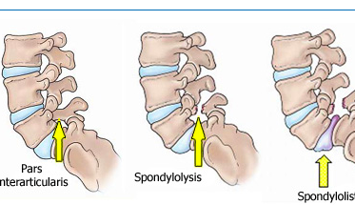

Left: Injury free vertebra, Middle: spondylosis, Right: spondylolisthesis²

Figure 2: One legged hyperextension test.⁹
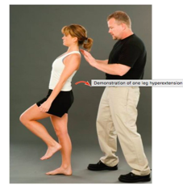

Figure 3: X-ray image of spondylolysis¹¹
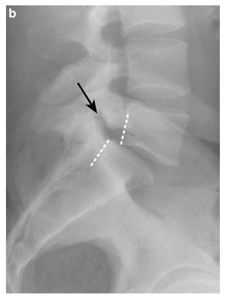

Figure 4: X-ray image of spondylolisthesis¹¹
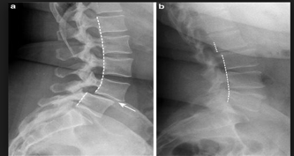

Table 1: Patient history data for spondylolysis⁷:
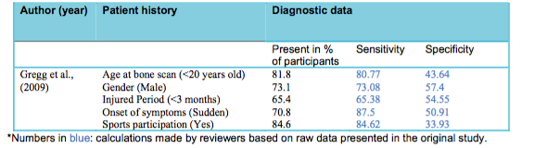

Table 2: Patient history data for spondylolisthesis⁷:
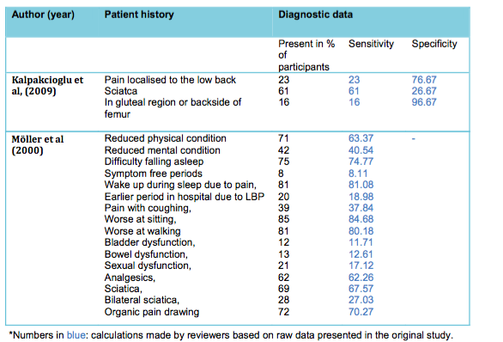

Table 3: Diagnostic Test accuracy data for spondylolysis⁵
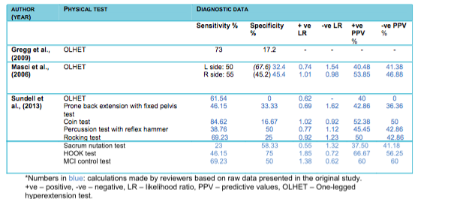

Table 4: Diagnostic Test accuracy data for spondylolisthesis⁵
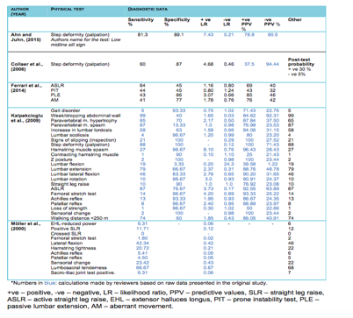

References

1. Cassidy RC, Shaffer WO, Johnson DL. Spondylolysis and spondylolisthesis in the athlete. Orthopedics 2005;28(11):1331-1333.
2. Washington Joint Institute. Spondylolysis & Spondylolisthesis. Washington Joint Institute at Ortho Besthesda 2007. Available at: https://www.orthobethesda.com/spondylolysis-spondylolisthesis/. Accessed December 3, 2018.
3. Bouras T, Korovessis P. Management of spondylolysis and low-grade spondylolisthesis in fine athletes. A comprehensive review. Eur. J. Orthop. Surg. Traumatol. 2015;25 Suppl 1:S167-75. doi:10.1007/s00590-014-1560-7.
4. Chosa E, Totoribe K, Tajima N. A biomechanical study of lumbar spondylolysis based on a three-dimensional finite element method. J. Orthop. Res. 2004;22(1):158-163. doi:10.1016/S0736-0266(03)00160-8.
5. Lawrence KJ, Elser T, Stromberg R. Lumbar spondylolysis in the adolescent athlete. Phys. Ther. Sport 2016;20:56-60. doi:10.1016/j.ptsp.2016.04.003.
6. Petering RC, Webb C. Treatment options for low back pain in athletes. Sports Health 2011;3(6):550-555. doi:10.1177/1941738111416446.
7. Grødahl LHJ, Fawcett L, Nazareth M, et al. Diagnostic utility of patient history and physical examination data to detect spondylolysis and spondylolisthesis in athletes with low back pain: A systematic review. Man. Ther. 2016;24:7-17. doi:10.1016/j.math.2016.03.011.
8. Radcliff KE, Kalantar SB, Reitman CA. Surgical management of spondylolysis and spondylolisthesis in athletes: indications and return to play. Curr. Sports Med. Rep. 2009;8(1):35-40. doi:10.1249/JSR.0b013e318194f89e.
9. Spondylolysis in Young Athletes . Physiopedia. Available at: https://www.physio-pedia.com/Spondylolysis_in_Young_Athletes. Accessed December 6, 2018.
10. Sundell CG, Jonsson H, Ådin L, Larsén KH. Clinical examination, spondylolysis and adolescent athletes. Int. J. Sports Med. 2013;34(3):263-267. doi:10.1055/s-0032-1321723.
11. Imaging Techniques for the Diagnosis of Spondylolisthesis. Musculoskeletal Key 2017. Available at: https://musculoskeletalkey.com/imaging-techniques-for-the-diagnosis-of-spondylolisthesis/. Accessed December 3, 2018.
12. Klein G, Mehlman CT, McCarty M. Nonoperative treatment of spondylolysis and grade I spondylolisthesis in children and young adults: a meta-analysis of observational studies. J. Pediatr. Orthop. 2009;29(2):146-156. doi:10.1097/BPO.0b013e3181977fc5.
13. Richardson C, Jull G, Toppenberg R, Comerford M. Techniques for active lumbar stabilisation for spinal protection: A pilot study. Australian Journal of Physiotherapy 1992;38(2):105-112. doi:10.1016/S0004-9514(14)60555-9.
14. Ferrari S, Villafañe JH, Berjano P, Vanti C, Monticone M. How many physical therapy sessions are required to reach a good outcome in symptomatic lumbar spondylolisthesis? A retrospective study. J. Bodyw. Mov. Ther. 2018;22(1):18-23. doi:10.1016/j.jbmt.2016.10.006.
15. Miller SF, Congeni J, Swanson K. Long-term functional and anatomical follow-up of early detected spondylolysis in young athletes. Am. J. Sports Med. 2004;32(4):928-933. doi:10.1177/0363546503262194.

