Patellar Tendinitis in Elite Soccer Players
Although many in the United States may argue that baseball or football hold the title of most popular sport in the world, Soccer reigns supreme. It is estimated that half of the global population are followers of the sport. This 4-billion-person following is the most concentrated in Europe and the Americas. The sport has been traced back to early Second Century Ancient China, but has also been speculated as originating with the Romans, Greeks, or Japanese.¹
In addition to the large number of individuals that follow the sport of soccer, there is an estimated 260 million soccer players worldwide. The nature of the sport and its physical demands contribute to many injuries, both acute and chronic. Most research and evidence has been focused on acute injuries such as knee, ankle, hamstring, as well as traumatic injuries that may threaten the career or life of the individual. These have risen to the forefront due to their impact on playing careers as well as financial burdens placed on professional clubs or organizations.²
Among these injuries are those that involve tendon. Tendon is a relatively avascular tissue composed mostly of type I collagen. Its primary function is to connect muscle to bone, with parallel fibers that are able to withstand and respond to stresses placed upon it. Acute injuries of tendon can include partial or complete ruptures, while chronic injuries are called tendinopathies until further specification occurs. A tendinopathy is noticeable when there is an increase in pain in the area of a tendon and also a decrease in general performance either due to the pain or to impairments in the tendon’s function. Often these injuries are associated with inflammation, also known as tendinitis.³
Breaking down the composition of tendon further, there is a hierarchical fibrillar arrangement that includes type I collagen molecules align into fibrils. These fibrils form fibers, then fascicles, and lastly the tendon unit (appendix A). These collagen fibrils are abundant in the extra cellular matrix, and contribute to the overall strength of the tissue. Other associated molecules include proteoglycans, elastin, glycoproteins and these are integral in the fibrillogenesis of type I collagen.³
The collagenous component of tendon can be responsible for up to 95% of the dry weight of the tissue. The properties of collagen only allow for approximately 10% strain, detailing the stiffness of the tissue. This trait is beneficial because it prevents excessive forces being placed on bone causing bone failure.⁴ Tendons connect to muscles via a myotendinous junction called an enthesis. This is a fibrocartilaginous tissue that is rich in type II collagen. This area of the tendon is dissimilar to other portions of the tissue, creating different responses to stresses, both in normal conditions and in pathological.³
Tendinopathy is a term used for chronic tendon injury of unspecified nature that includes symptoms of pain, decreased strength, decreased range of motion, and point tenderness along the affected structure. This injury included microscopic tears along the tendon with collagen fibril disorganization, increased extracellular matrix content, neovascularization, and hypercellularity. These changes can alter the properties of the tendon, which elicits pain. There is no consensus on the pathogenesis of this injury; however, one hypothesis is that there is failed healing and degeneration of the tissue.³
Diagnosis of the condition can be achieved by a subjective and objective exam, with pain elicited in the site of injury as well as palpable inflammation or crepitus possible upon palpation. Observation of functional movement may demonstrate discrepancies in load bearing, as compared bilaterally, decreased range of motion (tight quadriceps and hamstrings), decreased strength (most often in the quadriceps), and decreased overall power. The onset of pain is often at the start of physical activity, however, the pain becomes more constant with greater injuries or with prolonged episodes of injury.⁵
Imaging can be completed to confirm or refute initial diagnosis. The imaging methods of choice are ultrasound and MRI. Ultrasound is capable of locating lesions within the tendon via the use of the soundhead and connected monitor (Appendix B). These changes are most common just inferior to the inferior pole of the patella, indicating the site of injury of the patellar tendon. Other findings may be thickening of the tissue, calcifications present, and even bony discrepancies at the inferior pole of the patella. Although this imaging cannot determine any intraarticular issues, its specificity and sensitivity for patellar tendinopathy are 94% and 58%, respectively.⁵
MRI is able to highlight intraarticular issues as well as the changes in tendon and bone witnessed by the ultrasound (Appendix C). The main limitations of MRI are the high cost associated with the examination, the limited availability of equipment, and also the time necessary for the results. The sensitivity of MRI for patellar tendinopathy is 78%, while the specificity is 86%, noting that the MRI has higher validity than that of the ultrasound making it the more recommended imaging procedure. However, the likelihood of getting an MRI for every athlete that is suspected to have patellar tendinopathy is very slim.⁵
Neovascularization is also present in many cases of patellar tendinopathy. Often, these new, abnormal vessels arise from the Hoffa fat pad, located posterior and inferior to the inferior pole of the patella. This phenomenon can contribute to the symptoms of patellar tendinopathy in that nerve receptors, such as mechanoreceptors and glutamate NMDA receptors, are present in these vessels. Studies have also shown that neovascularization promotes pain transmission through a neural in-growth within the tendon, described as an inflammatory response to the injury. Currently, it is unknown whether the vascular or nerve component are the prominent factor in tendinopathy.⁶
Patellar tendinopathy is not the most prominent injury in soccer, with various resources stating either ligamentous injury to the ankle or knee or hamstring strains as the top offenders. However, patellar tendinopathy or “jumper’s knee”, as some have coined it, is prevalent in the sport.⁷ Volleyball and basketball have higher incidence rates of patellar tendinopathy due to the increased jumping activity throughout participation as well as the hard playing surface. Soccer players are predisposed to this injury by another mechanism that is prolonged, repetitive stress of the quadriceps and patellar tendon withstood throughout the physical demands of the sport.²
There is limited evidence regarding predispositions to patellar tendinopathy. Some sources report that males are at a greater risk, as well as those that are taller, with greater body mass, Type II Diabetes, and reduced dorsiflexion range of motion.^{2,3} Other contributors are high amounts of physical activity, especially jumping or weight training, and also activities on hard surfaces such as basketball and volleyball.² Another possible relationship is colder temperatures weather and their impact on the number of incidences of patellar tendinitis. This was observed in the Hagglund et al study without significance, however it could be further studied to determine its influence.²
The prevalence of patellar tendinitis in elite soccer players was studied by Hagglund et al. Their sample included three prospective cohort studies, including 51 European professional teams over the course of 2001-2009. All players on these teams were invited to participate in the study resulting in 2229 participants. Within this cohort, 137 patellar tendon injuries were reported, representing 1.5% of all injuries recorded in the study. Of this number, four of these affected the distal aspect of the patellar tendon, leaving 133 proximal injuries. The median days missed post-injury was five, with 75% of players returning in 12 days. Additionally, 20% of these injuries were recurrences.²
The primary focus of treating a tendinopathy is to decrease pain. This is often achieved through the use of topical analgesics and/or non-steroidal anti-inflammatories. Once the pain has been decreased to a manageable level, the introduction of functional rehabilitation begins. Exercises that are eccentric in nature have been the most popular choice in this treatment regime³; however, in recent years, studies have argued its efficacy.⁸ Mallaiaras et al stated that up to 45% of individuals with tendinitis completing an eccentric exercise intervention strategy do not respond to the treatment. Their conclusion urged the need for physical therapists to use a combined approach of eccentric and concentric loading to achieve greater outcomes. Additionally, those in the elite athlete population may benefit greatly from heavy load training in order to elicit tendon adaptation to prevent recurrence.⁸
In order to play through patellar tendinitis, athletes will try almost anything to decrease the pain and maintain their functional capacity. Patellar tendon straps are a common “band-aid” strategy that have been shown to significantly decrease pain in some studies. The theory behind this is that the pressure exerted on the tendon by the strap during flexion and extension can reduce the amount of tensile force the tendon experiences.⁹ Further, a study on cadaveric specimens demonstrated that there was less pressure placed on the infrapatellar fat pad and a decrease in patellofemoral contact area and contact pressure, thus decreasing knee pain.¹⁰ Another study, by Villar et al, utilized a patellar strap in 37 military service members with anterior knee pain, finding that 25 of these individuals had significant decreases in symptoms. Those that did not have these positive outcomes were found to have severe degenerative changes in the patellofemoral cartilage, needing more invasive methods of intervention for significant improvements. Perhaps if these individuals were provided with a patellar strap at initial onset of symptoms, their degenerative changes may have been prevented or slowed.¹¹
Therapeutic modalities have often been used in conjunction with a rehabilitation program to treat tendinopathy. These include iontophoresis, ultrasound, dry-needling, extracorporeal shock wave therapy (ESWT), and low-level laser therapy. Literature on dry needling suggests that the physical break-up of degenerative changes and the bleeding that ensues can help to promote healing. ESWT is less understood, but it has been used in clinical trials for the last 10 years. A study in 2007 showed a significant decrease in pain at one month, continuing to improve for two years, with the addition of ESWT.¹²
Platelet-rich plasma (PRP) injections have been used to treat various musculoskeletal conditions, including tendinopathy. Although this was introduced in the 1970s, there has been a recent increase in use, especially in the athletic population. In 2013, 86,000 athletes in the United States were treated with PRP.¹³ This method of enhancing the healing process can be used in conjunction with other conservative methods of treatment as well as with surgical intervention. Location of injection is found either by the use of ultrasound imaging or palpating to find the most sensitive and painful area of the tissue.¹⁴
The way in which this intervention works is by concentrating the platelets and growth factors in blood via the use of a centrifuge, as previously stated. These growth factors include platelet derived growth factor (PDGF), insulin-like growth factor (IGF), fibroblast growth factor (FGF), transforming growth factor- β (TGF- β), epidermal growth factor (EGF), vascular endothelial growth factor (VEGF), and endothelial cell growth factor (ECGF). These naturally produced healing aids are increased in number and then reintroduced into the area of tissue with the most need. This therapy has a very low negative outcome, with only 2-5% of patients reporting adverse symptoms or events. Common side effects include tenderness and pain, often resolving in 48 hours.¹⁴
In 2010, the World Anti-Doping Agency (WADA) placed PRP on the banned list, highlighting IGF as concerning as it could be used as an ergogenic substance. The committee stated that this therapy could give athletes an unfair advantage, however, there was an exception for tendon injections as long as there was a therapeutic use documented. In 2011, all uses of PRP were allowed after there was no evidence in the therapy’s impact on performance enhancement. This decision was based on the lack of evidence as a whole in regard to PRP’s systemic effect. Wasterlain et al sought to determine the effects of the therapy to either support or refute WADA’s concerns.¹³
The study by Wasterlain et al found that there were significant increases in the systemic circulation of growth factors, including IGF, VEGF, and FGF after PRP injection. Additionally, there was an increase in Human Growth Hormone (HGH) 24 hours post injection. The amount of increase is comparable to the amount of increase seen after exercising or HGH injection. Due to this, there is a potential controversy in using this treatment method in elite athletes under the standards of WADA.¹³
ESWT has been used in patellar tendinopathy with some success. This treatment is thought to produce tissue-healing effects through regeneration and repair while also inhibiting pain receptors.¹⁵ The acoustic waves produced can increase growth factor production due to the capillary rupturing that occurs. In addition, the mechanical pressure can increase cell membrane permeability, further aiding the healing process. Looking to the research, studies promote the use of this modality in combination with an eccentric exercise regime. In order to treat, the device is placed on the most painful point on the patellar tendon when the knee is extended.¹⁵
Manual therapy is a common treatment used in addition to modalities, bracing, and therapeutic exercises. Under this umbrella is the method of deep friction massage (DFM), developed by Dr. Cyriax as a way to facilitate healing. The process in which this occurs is by increasing fibroblastic activity, breaking down adhesions within the collagen, and promoting optimal alignment of the fibers. Ideally, this will result in decreased pain, increased function, and enhanced healing.¹⁶
This treatment is not without its limitations, specifically the variance between the clinicians providing the intervention. These include pressure, frequency, duration, and the number of treatment sessions.¹⁶ The essential principles of DFM, as developed by Dr. Cyriax, include the following:¹⁷
1. Location must be found through palpation
2. Friction is applied perpendicular to the fiber arrangement
3. Therapist’s fingers and the patient’s skin must move as one. No sliding across the skin.
4. The application must be deep and have a sufficient sweep
5. The patient must be at rest in a comfortable position

An exercise program focusing on a combination of eccentric and concentric strengthening exercises as well as functional movement training to return to pain-free sport is the ideal rehabilitation protocol (Appendix D). The most common exercise to focus on eccentric loading of the Quadriceps and patellar tendon is that of single leg squats on a decline board (Appendix E). Some studies have speculated at the mechanism of eccentric loading and its impact on tendon healing, stating that the lengthening of the muscle while contracting essentially squeezes out the blood flow in the new vessels in the tissue in combination with collagen synthesis, growth factor production, and changes in normal tendon blood flow.¹⁸
Best practice for physical therapists is to make all attempts at non-invasive treatment methods prior to recommending a return to a physician for injection or surgery. When reaching this impasse with patients, an injection may be the next most-feasible treatment option. High Volume Image Guided Injection (HVIGI) can be utilized in these cases, where the visual guide may help to remove neovascularization and decrease the amount of nerve ingrowth. The syringe is guided by ultrasound imaging, injecting Bupivacaine, Hydrocortisone, and Saline.
Corticosteroid injections have been used as a “quick-fix” intervention for patients with patellar tendinopathy, especially athletes. The process of these medications is to decrease inflammation by inhibiting proinflammatory cytokine synthesis. These have demonstrated some short-term effects, however, there are no long-term effects associated with an injection. Potential adverse outcomes include tendon rupture. This in combination with the lack of effect duration has deterred many physicians and patients from using this method.¹⁴
Recommendations for injections include avoiding injecting directly into the tendon, refraining from strenuous activity for several weeks post-treatment, and repeating the intervention no sooner than three to four weeks after.¹⁹ Adverse effects observed with corticosteroid injection include impaired healing and the increased risk of rupture. The most common drug used in these situations is Dexamethosone. A study by Zhang et al sought to discover the effects of Dexamethosone on tendon stem cells as they are key players in the tendon healing process. Their study found that the introduction of Dexamethosone actually caused the stem cells to proliferate at lower rates and also induced non-tendon stem cell differentiation. Within these stem cells were those of bone, fatty tissue, and cartilage-like tissues. This alteration is a factor in the weakening of the healing tendon and adds to the increased risk of rupture.²⁰
A recent study by Blomgran, Hammerman, and Aspenberg found that the introduction of systemic dexamethasone early in the remodeling phase in rats that underwent an Achilles transection demonstrated an improvement in tendon healing. This was observed through better collagen alignment and also the reduction in number of cytotoxic T cells. Cytotoxic T cells have been shown to delay fracture healing in both mice and humans, so their limitation may potentially have a significant effect on tendon healing. The relationship between systemic and local introduction of corticosteroids is unknown; however, these findings suggest that there may be more benefit to local injection than was previously discovered.²¹
Should conservative methods be unsuccessful, surgical intervention may be recommended. Approximately 10% of athletes choose to undergo surgery after their symptoms persist through prior interventions.²² Unfortunately, surgery may have as low as a 50% positive response rate in those with patellar tendinopathy.²³ A minimally invasive method to treat patellar tendinopathy is the Arthroscopic Patellar Release (APR). This procedure is completed with an arthroscopic ablation probe to complete the focal synovectomy in the area of the inferior pole and the proximal portion of the tendon. Should there be involvement of Hoffa’s Fat Pad, the hypertrophic areas would be removed as well. Lastly, the ablation probe denervates the transitional zone at the inferior pole and in other symptomatic areas.²²
Evidence has shown that surgical intervention is useful in treating recalcitrant cases of patellar tendinitis. These patients most often have the greatest pain levels and decreases in function at the time of surgery, compared to those that responded to conservative management. Some studies have shown that an open procedure gains greater positive outcomes as compared to arthroscopic.²⁴
Other risk factors for tendon injury include prednisone, Fluoroquinolones, and Statins. Many individuals, especially those in the latter part of their lives, are prescribed prednisone to manage systemic diseases. Diseases most often correlated to atraumatic Achilles tendon rupture are rheumatoid arthritis, hyperparathyroidism, lupus erythematosus, gout, and chronic renal failure. This is due not only to the effects from the condition, but also the long-term use of steroids, such as prednisone.²⁵
Fluoroquinolones, antibiotics often taken for respiratory infections or urinary tract infections, have been shown to significantly effect tendon in a negative way. Examples of these are ciproflaxin, levofloxacin, and olfolaxicin. This medication can cause tendinitis or even tendon rupture. The occurrence of rupture is rare, but it is important to know that the risk is there for individuals taking these medications. Proposed mechanisms of effect on tendon tissue include direct injury via apoptosis or necrosis, promotion of local release of harmful substances such as nitric oxide and free radicals, inhibition of topoisomerase II which causes toxicity within the mitochondria, and other effects on the extracellular matrix such as collagen degradation.²⁶
A case of fluoroquinolone induced tendon rupture occurred with a 47-year-old runner presenting to the Emergency Department with bilateral knee pain and the inability to walk. Two weeks prior to the injury, the patient was taking ciproflaxin for an acquired respiratory infection. He stated that he fell all of a sudden while descending the stairs causing significant anterior knee pain and then he could not get up. The observation showed superiorly riding patellae, inflammation, a gap between the inferior poles, and lack of knee extension. X rays showed bilateral patella alta and an Insall-Salvati ratio >1.5. This lead to the diagnosis of bilateral patellar tendon rupture.²⁷
A potential differential diagnosis that is often overlooked is that of Recurrent Anterior Peroneal Nerve Entrapment Syndrome (Appendix G shows the location of the affected nerve). Tenderness may be experienced along the lateral border of the patellar tendon, but there is also peroneal muscle and nerve involvement. The muscles may have an increase in tone and neurodynamic restrictions of the peroneal nerve may be present. Looking distally, examination of the cuboid could show a subluxation, which may be treated with the cuboid whip maneuver. Once this is completed with successful return to normal position of the cuboid, the patient may have a decrease in symptoms. To further promote the eradication of the syndrome, stretches for the peroneal musculature can help to decrease the tightness and return the patient to pain-free activity.²⁸
Other differential diagnoses include Osgood-Schlatter Disease, Iliotibial Band Friction Syndrome, and giant cell tumor of the patellar tendon sheath.^{29,30} To differentiate between these conditions, the aforementioned diagnostic tools may be used (Ultrasound and/or MRI) as well as a thorough subjective and objective examination. Although giant cell tumors are benign, they cause anterior knee pain when they affect the patellar tendon. These growths are often palpable, leading to referrals to specialists for official diagnosis through imaging and needle aspiration biopsy. If diagnosed, removal via surgical excision is generally successful, with some incidences of local recurrence.³⁰
In conclusion, patellar tendinopathy can be a debilitating condition for elite soccer players, causing them to lose training and match time. In order to treat these athletes most effectively to gain long-term results, a combination of medication, modalities, manual therapy, rehabilitation, and potentially surgical intervention must be administered.¹² The rehabilitation component should include eccentric, concentric, and functional exercises to improve strength and biomechanics in attempt to prevent future patellar tendinopathies.⁸ An alternative treatment is the injection of PRP, enhancing the healing process through eliciting growth factor production.^{13,31} Should there be little to no improvement with these conservative methods, injections of corticosteroids have shown some success; however, care must be taken to not inject directly into the tendon to decrease the risk of rupture.²⁰ Finally, surgical intervention has been successful in cases of recalcitrant tendinopathies due to their lack of response to conservative methods.^{22,32}
Prior to any season’s initiation, a thorough physical examination with subjective health history must be administered to determine predispositions, health concerns, etc. Within this, careful consideration must be taken in regards to tendon health if the athlete has completed a dose of antibiotics within the last 90 days due to its influence on tendon strength.²⁶ Another risk factor includes the long-term use of oral corticosteroids to treat systemic conditions, placing those athletes on high alert for tendinopathies or rupture.²⁵ Prevention of these injuries is just as important as successful management for both the athlete and their associated club.

Resources
1. ​What Are The Most Popular Sports In The World? - WorldAtlas.com. Available at: http://www.worldatlas.com/articles/what-are-the-most-popular-sports-in-the-world.html. Accessed November 27, 2017.
2. Hägglund M, Zwerver J, Ekstrand J. Epidemiology of patellar tendinopathy in elite male soccer players. Am J Sports Med 2011;39(9):1906-1911. doi:10.1177/0363546511408877.
3. Nourissat G, Berenbaum F, Duprez D. Tendon injury: from biology to tendon repair. Nat Rev Rheumatol 2015;11(4):223-233. doi:10.1038/nrrheum.2015.26.
4. Gross MT: Chronic tendinitis: Pathomechanics of injury, factors affecting the healing response, and treatment. J Orthop Sports Phys Ther 16:148-161,1992
5. Figeuroa D, Figueroa F, Calvo R. Patellar tendinopathy: diagnosis and treatment. J of the Am Acad of Orthop Surg. 2016;24:184-192
6. Knobloch K. The role of tendon microcirculation in Achilles and patellar tendinopathy. J Orthop Surg Res 2008;3:18. doi:10.1186/1749-799X-3-18.
7. Prevent Common Injuries in Soccer: Knee Injuries - U.S. Soccer. Available at: https://www.ussoccer.com/stories/2014/03/17/11/14/prevent-common-injuries-in-soccer-knee-injuries. Accessed November 27, 2017.
8. Malliaras P, Barton CJ, Reeves ND, Langberg H. Achilles and patellar tendinopathy loading programmes : a systematic review comparing clinical outcomes and identifying potential mechanisms for effectiveness. Sports Med 2013;43(4):267-286. doi:10.1007/s40279-013-0019-z.
9. Rosen AB, Ko J, Simpson KJ, Brown CN. Patellar tendon straps decrease pre-landing quadriceps activation in males with patellar tendinopathy. Phys Ther Sport 2017;24:13-19. doi:10.1016/j.ptsp.2016.09.007.
10. Bohnsack M, Halcour A, Klages P, et al. The influence of patellar bracing on patellar and knee load-distribution and kinematics: an experimental cadaver study. Knee Surg Sports Traumatol Arthrosc 2008;16(2):135-141. doi:10.1007/s00167-007-0428-3.
11. Villar R. Patellofemoral pain and the infrapatellar brace: a military view. Am J Sports Med 1985;13(5):313-315
12. Childress MA, Beutler A. Management of chronic tendon injuries. Am Fam Physician 2013;87(7):486-490.
13. Wasterlain AS, Braun HJ, Harris AHS, Kim H-J, Dragoo JL. The systemic effects of platelet-rich plasma injection. Am J Sports Med 2013;41(1):186-193. doi:10.1177/0363546512466383.
14. Moraes VY, Lenza M, Tamaoki MJ, Faloppa F, Belloti JC. Platelet-rich therapies for musculoskeletal soft tissue injuries. Cochrane Database Syst Rev 2014;(4):CD010071. doi:10.1002/14651858.CD010071.pub3.
15. Thijs KM, Zwerver J, Backx FJG, et al. Effectiveness of Shockwave Treatment Combined With Eccentric Training for Patellar Tendinopathy: A Double-Blinded Randomized Study. Clin J Sport Med 2017;27(2):89-96. doi:10.1097/JSM.0000000000000332.
16. Chaves P, Simões D, Paço M, Pinho F, Duarte JA, Ribeiro F. Cyriax’s deep friction massage application parameters: Evidence from a cross-sectional study with physiotherapists. Musculoskelet Sci Pract 2017;32:92-97. doi:10.1016/j.msksp.2017.09.005.
17. Chamberlain GJ. Cyriax’s friction massage: A review. J Orthop Sports Phys Ther 1982;4(1):16-22. doi:10.2519/jospt.1982.4.1.16.
18. McCreesh KM, Riley SJ, Crotty JM. Neovascularity in patellar tendinopathy and the response to eccentric training: a case report using Power Doppler ultrasound. Man Ther 2013;18(6):602-605. doi:10.1016/j.math.2012.09.001.
19. Sanchez-Yamomoto D, Bush T, Bursitis and Tendinitis; Injection therapy basics; corticosteroids often relieve symptoms when other treatments do not. J Musculoskeletal Medicine. 2002; 19 (1):13-20
20. Zhang J, Keenan C, Wang JH-C. The effects of dexamethasone on human patellar tendon stem cells: implications for dexamethasone treatment of tendon injury. J Orthop Res 2013;31(1):105-110. doi:10.1002/jor.22193.
21. Blomgran P, Hammerman M, Aspenberg P. Systemic corticosteroids improve tendon healing when given after the early inflammatory phase. Sci Rep 2017;7(1):12468. doi:10.1038/s41598-017-12657-0.
22. Lang G, Pestka JM, Maier D, Izadpanah K, Südkamp N, Ogon P. Arthroscopic patellar release for treatment of chronic symptomatic patellar tendinopathy: long-term outcome and influential factors in an athletic population. BMC Musculoskelet Disord 2017;18(1):486. doi:10.1186/s12891-017-1851-3.
23. Barker-Davies RM, Nicol A, McCurdie I, et al. Study protocol: a double blind randomised control trial of high volume image guided injections in Achilles and patellar tendinopathy in a young active population. BMC Musculoskelet Disord 2017;18(1):204. doi:10.1186/s12891-017-1564-7.
24. Everhart JS, Cole D, Sojka JH, et al. Treatment options for patellar tendinopathy: a systematic review. Arthroscopy 2017;33(4):861-872. doi:10.1016/j.arthro.2016.11.007.
25. Hersh BL, Heath NS. Achilles tendon rupture as a result of oral steroid therapy. J Am Podiatr Med Assoc 2002;92(6):355-358.
26. Bidell MR, Lodise TP. Fluoroquinolone-Associated Tendinopathy: Does Levofloxacin Pose the Greatest Risk? Pharmacotherapy 2016;36(6):679-693. doi:10.1002/phar.1761.
27. Rosa B, Campos P, Barros A, Karmali S, Gonçalves R. Spontaneous bilateral patellar tendon rupture: case report and review of fluoroquinolone-induced tendinopathy. Clin Case Rep 2016;4(7):678-681. doi:10.1002/ccr3.592.
28. Rousseau E. The anterior recurrent peroneal nerve entrapment syndrome: a patellar tendinopathy differential diagnosis case report. Man Ther 2013;18(6):611-614. doi:10.1016/j.math.2012.10.003.
29. Hertling D, Kessler RM. Management of common musculoskeletal disorders: physical therapy principles and methods. Philadelphia: Lippincott Williams & Wilkins; 2006.
30. Kılıçaslan ÖF, Katı YA, Kose O, Erol B, Sezgin Alikanoglu A. Giant cell tumor of the patellar tendon sheath: A rare case of anterior knee pain. Cureus 2017;9(9):e1690. doi:10.7759/cureus.1690.
31. Dupley L, Charalambous CP. Platelet-Rich Plasma Injections as a Treatment for Refractory Patellar Tendinosis: A Meta-Analysis of Randomised Trials. Knee Surg Relat Res 2017;29(3):165-171. doi:10.5792/ksrr.16.055.
32. Kruckeberg BM, Chahla J, Ferrari MB, Sanchez G, Moatshe G, LaPrade RF. Open Patellar Tendon Tenotomy, Debridement, and Repair Technique Augmented With Platelet-Rich Plasma for Recalcitrant Patellar Tendinopathy. Arthrosc Tech 2017;6(2):e447-e453. doi:10.1016/j.eats.2016.10.025.
33. Bianchi S, Martinoli C, Abdelwahab IF. Ultrasound of tendon tears. Part 1: general considerations and upper extremity. Skeletal Radiol 2005;34(9):500-512. doi:10.1007/s00256-005-0956-1.
34. Rutland M, O’Connell D, Brismée J-M, Sizer P, Apte G, O’Connell J. Evidence-supported rehabilitation of patellar tendinopathy. N Am J Sports Phys Ther 2010;5(3):166-178.

Appendix A – Tendon Composition³
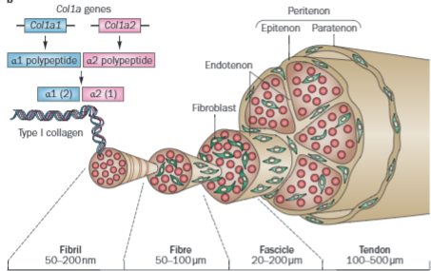

Appendix B – Ultrasound Image of Patellar Tendinitis³³
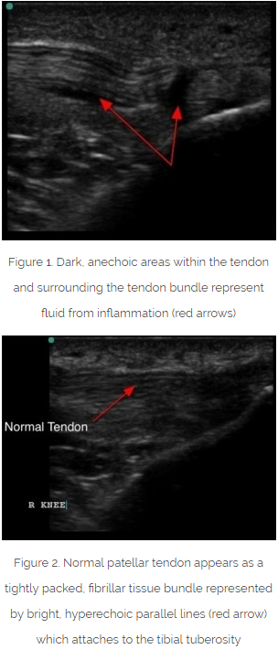
Appendix C – MRI Imaging of Patellar Tendinitis***Figueroa

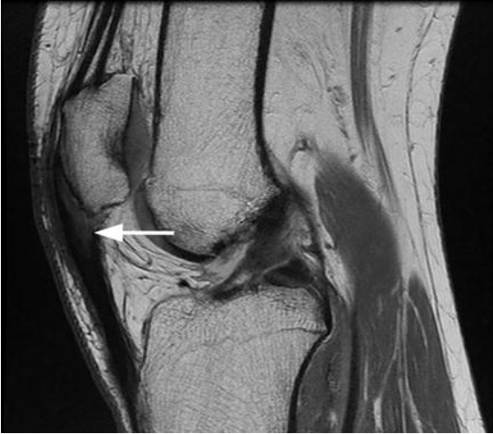
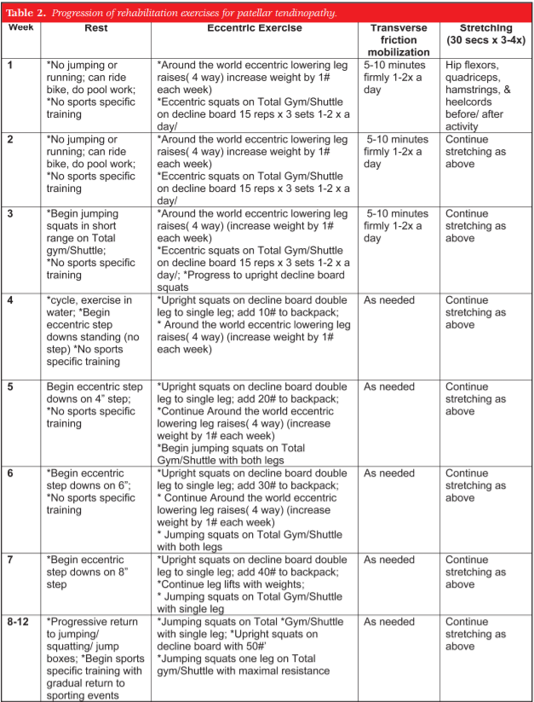
Appendix D – Evidence Based Rehabilitation Protocol³⁴
Appendix E – Eccentric Loading with Decline Squats¹²

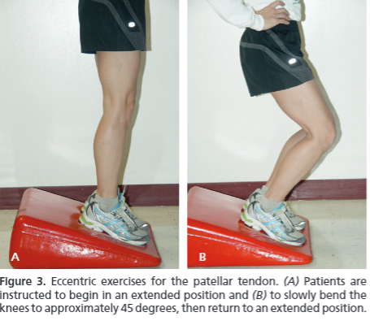
Appendix F – Open Surgical Procedure²⁷
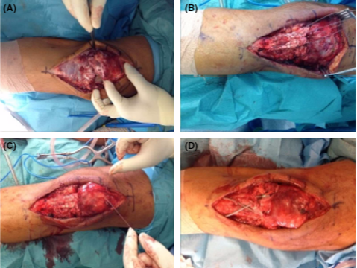

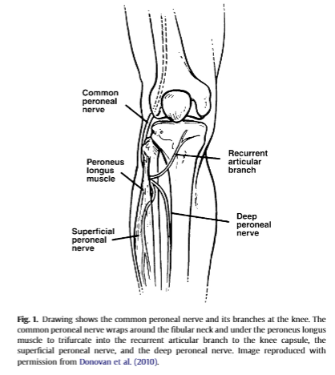
Appendix G - Recurrent Anterior Peroneal Nerve Location²⁸

