Diagnosis and Management of Patellofemoral Pain Syndrome
Physical activity is a necessary component to maintain overall health, and is often involved in favorite hobbies such as running and participation in sport. The physical and psychological benefits of these hobbies are undeniable, but unfortunately the wear and tear they cause on the body can limit participation if pains and other signs of dysfunction are not properly addressed. In particular, the knee endures repetitive loading and various soft tissue forces during a vast majority of different activities, leading to the rise of the multifaceted patellofemoral pain syndrome (PFPS). This common cause of knee pain has been reported in as much as 25% of the general population to some degree, and those who are more active or participate in sports are especially likely to be affected.^{1,2} PFPS affects both young and old, and is a particular concern for women, who are 2.23 times more likely to develop it than men.^{3,4}
PFPS is typically regarded as an overuse injury rather than the result of acute trauma, with the cardinal symptom being pain around the patella and the anterior aspect of the knee during and after activity. Joint stiffness, crepitus, and popping may also be reported.⁵ The pain caused by this syndrome can be limiting to activity and affect quality of life, and may have associations with other knee pathologies. Those with PFPS experience abnormal loading at the joint that, over time, may result in degeneration of the cartilage and underlying bone, leading to osteoarthritis.⁶ This same abnormal loading and altered biomechanics make those with PFPS also at a possible increased risk for anterior cruciate ligament injury.⁷ In addition, those suffering with PFPS have been found to have worsened dynamic standing balance, further placing them at risk for other injuries.⁸ These biomechanical and functional implications justify the need for prompt recognition and evidence-based management to rehabilitate and prevent recurrence of PFPS.
Etiology
No one precise cause of PFPS exists, it is instead commonly a consequence of a combination of biomechanical, structural, and soft tissue abnormalities that become exacerbated with overuse or repetitive loading. Although often unclear, a discussion of the proposed mechanisms behind PFPS is needed before moving forward to diagnosis and management recommendations. At the heart of the involved structures is the patella, a sesamoid bone anterior to the tibiofemoral joint that serves to increase the leverage of the quadriceps muscle. Resting in the trochlear groove of the femur, the patella is stabilized by the quadriceps and patellar tendons superiorly and inferiorly, and by retinacula laterally and medially.⁹ The iliotibial (IT) band also attaches to the patella laterally.¹⁰ These structures are illustrated together in Appendix A, Figure 1. The quadriceps muscles act directly on the patella, with the vastus medialis obliquus (VMO), a component of the vastus medialis, receiving particular attention as an instigator of PFPS. The force vector of each quadriceps component on the patella can be seen in Appendix A, Figure 2. Structures that do not directly attach to the patella can still influence its tracking movement and endured contact pressures, such as the hamstring and gluteal musculature.¹¹
Appreciation of the contribution each of these structures can make towards the development of PFPS begins with an understanding of their role in the alignment and kinematics of the patella and knee joint. Those with PFPS have been found to have several biomechanical deviations, which are thought to contribute to the development and persistence of this syndrome. An increased Q-angle and increased knee valgus remain commonly cited factors of causation due to the increased lateral force exerted on the patella in these conditions, although this may not be found in all cases.^{10,12} As described by Park and Stefanyshyn, “Q-angle is defined as the angle between the line connecting the anterior superior iliac spine (ASIS) to the center of the patella, and the extension of a line from the tibial tubercle to the same reference point on the patella” and is illustrated in Figure 1 of Appendix B.¹² Juhn cites several studies that find similar Q-angles in those without and without PFPS, and suggests that it may not be a sole contributor to the syndrome. This is further exemplified in the studies by Park and Stefanyshyn and by Liebensteiner et al. The first found that an increased Q-angle did not result in an increase in valgus moment at the knee while running, and the latter found no differences in frontal plane alignment in those with and without PFPS.^{12,13} Therefore, although commonly used, this measure of alignment should be interpreted carefully and alongside other findings when determining a possible cause of PFPS.
In terms of proximal kinematic differences, a systematic review by Neal et al. found that runners with PFPS demonstrate increased peak hip adduction, increased internal rotation of the femur, and increased contralateral hip drop compared to controls during runnning.¹⁴ Distally, those with PFPS have increased internal rotation of the tibia, and increased dorsiflexion and rearfoot eversion at heel strike.^{10,15} These contribute to valgus positioning of the knee, suggesting a more dynamic lack of stabilization could be a cause of altered knee loads rather than a more static factor such as Q-angle.
As mentioned previously, the function and balance of the VMO compared to other soft tissue forces acting on the patella has been a central component in proposed PFPS etiologies, yet this concept is surrounded by mixed research. Cowan et al. found that those with PFPS activate their vastus lateralis (VL) before the VMO during stair-stepping, a difference that controls did not demonstrate, thus supporting the idea that VMO dysfunction may contribute to PFPS.¹⁶ However, a study by Cavazzuti et al. found no differences in timing between the VMO and VL in those with PFPS compared to those without.¹⁷ Beyond the matter of timing of muscle firing is that of imbalance, and Sawatsky et al. found that weakness in the VMO compared to the VL did not result in changes in pressure location, distribution, or contact area at the patellofemoral joint.³ Additionally, Besier et al. found that those with PFPS have “the same distribution of quadriceps forces as pain-free individuals during walking and running”. This study also found that those with PFPS showed increased quadriceps and hamstring co-contraction at heel-strike, implying that the hamstrings may have a role in PFPS by increasing contact forces.¹⁸ Patil et al. similarly found no differences in VMO to VL activation, but did see increased lateral hamstring activation in those with PFPS.¹⁹ In all, these studies suggest that attention should be paid to all forces that act on the knee, not solely the VMO.

Diagnosis
Unsurprising given the complexity surrounding the cause of PFPS, diagnosis is primarily a diagnosis of exclusion. However, there are components for examination that are recommended for PFPS, most of which involve assessment of the factors previously discussed as possible contributors to the development of PFPS. While gathering the patient’s history, if they report aforementioned symptoms or are a member of the typically affected populations, this will be the first finding supporting PFPS, particularly if the onset was after an increase in activity type, frequency, or duration. However, since it presents so similarly to other knee pathologies, objective examination must be comprehensive.
Palpation of the patella may be useful in ruling out PFPS in that swelling or tenderness of the patella itself are not typical of PFPS and therefore may be indicative of other pathologies. Joint noise, such as crepitus or popping, is often seen yet is not specific to PFPS.⁵ Patellar position and mobility should be thoroughly addressed, for which there are several means. Glide describes the lateral and medial displacement of the patella and can be observed by comparing the midpoint of the patella in relation to the femoral epicondyles, which can be objectively recorded by measuring the distance between the midpoint and each epicondyle. This can be observed both at rest and during contraction of the quadriceps, noting any change in position. Lateral glide is common in PFPS.²⁰ Patellar tilt describes the height of the medial and lateral borders relative to the surface of the femur. An illustration of examples of both glide and tilt can be seen in Appendix C, Figure 1. The patellar tilt test was shown to have a strong positive likelihood ratio for ruling in PFPS.²¹ This test is performed on a passively extended knee, holding the patella with the thumb and index finger, and simultaneously compressing the medial border and lifting the lateral border. A positive result is when the lateral border cannot be lifted to achieve a normal orientation, indicating tightness in the lateral structures that may be interfering with normal patellofemoral mechanics.⁵ An illustration of the performance of this test can be seen in Appendix C, Figure 2.
An assessment of alignment is recommended throughout the literature. Statically, this can be done by assessing Q-angle as previously described. However, research regarding this measure is inconsistent and instead favors evaluation of dynamic alignment. Collado and Fredericson recommend this be done during stepping up and down from a stool or during single-leg squats. During these motions, the therapist should not only observe the movement and tracking of the patella, but also make note of any particular movement patterns. Patterns such as knee abduction or poor hip control demonstrated by hip adduction and contralateral hip drop are associated with PFPS.²⁰ Abnormal tracking of the patella during these activities or during seated knee extension may present in the form of the “J” sign, in which the patella swiftly moves laterally as the knee moves from flexion to terminal extension instead of moving straight.^{5,20} This maltracking is a sign of increased lateral tension, and an illustration of this movement can be seen in Appendix C, Figure 3.
Manual muscle testing and range of motion assessment of the lower extremity should be included as a routine part of assessment. In particular, weakness of the quadriceps and the gluteal muscles is associated with PFPS.^{5,10} Also, reduced flexibility in the quadriceps, hamstrings, and IT band are frequently seen in PFPS.⁵
Lastly, an analysis of gait, as well as running if applicable for the patient, is a beneficial component of the examination for this population. Similar to the need to assess dynamic alignment with a slow stepping motion, alignment of the knee should be observed during functional activity. In addition, parameters of the patient’s gait and run should also be noted. Barton et al. found that those with PFPS exhibited an increase in support time, decrease in cadence and decrease in stride length during running and walking.¹⁵ Deviations in walking or running form and manipulation of these parameters could influence the onset of pain in the affected individual.
Imaging is generally not indicated in this population for diagnosis of PFPS, but may be useful to rule out other pathologies. For instance, if the patient reports recent trauma or surgery, radiography may be warranted. Radiographs can detect the presence of fractures, osteoarthritis, physeal damage, osteochondritis dissecans, and bone tumors. Also, magnetic resonance imaging (MRI) may be used to assess for stress fractures, soft tissue tears, or cartilage damage.⁵
Many other pathologies may present as pain in the anterior region of the knee with an insidious onset, so familiarity with these will aid in the exclusion process often required to reach a diagnosis of PFPS. The table in Appendix B, Figure 4 provides an overview of these pathologies and defining characteristics that may separate their presentation from that of PFPS. In summary, PFPS typically does not involve joint effusion or swelling, a characteristic that separates it from several other conditions, including prepatellar bursitis, osteochondritis dissecans, cartilage injury, and chondromalacia patellae.⁵ As discussed previously, some pathologies may have radiographic findings if imaging is performed, whereas PFPS would not demonstrate any findings on imaging other than displaying malalignment of the patella more readily. Specific location of tenderness can also help to differentiate PFPS, with which tenderness is “behind or around the patella”, medial, or lateral retinaculum. Tenderness more localized over the joint line would be more characteristic with meniscal injury, throughout the quadriceps and patellar tendons more in line with a tendinopathy, and along the femoral condyles could mean collateral ligament damage. If the patient is an adolescent, consideration should be given to Sinding-Larsen-Johansson syndrome and Osgood-Schlatter disease, both of which are found in this age group and present with pain at the proximal and distal attachments of the patellar tendon respectively. Lastly, screening of the lumbar spine and hip is recommended, as these sites could refer to the knee.⁵

Interventions
Once a therapist has reached the conclusion that they are seeing PFPS in the patient, many of the recommended interventions target the proposed etiologies and deficits possibly found during the assessment. The first approach to managing this syndrome is activity modification. While relative rest is indicated due to this condition’s connection to overuse, a therapist must have more developed, individualized recommendations than simply telling the patient to stop doing all activity. For runners, this could mean recommend that they decrease the distance they run, and how many times a week they run. They also may need to find another form of aerobic activity to maintain their cardiorespiratory endurance while decreasing the loading on their knee, which could include cycling, swimming, or elliptical use. If there is a specific exercise they do, such as squats or lunges, that provokes symptoms, help the patient find alternative exercises that target what they are trying to achieve with the provoking exercise.⁵ It is also recommended that patients do not over-exert themselves during their exercise. Neal et al. found that the running biomechanics characteristic of those with PFPS, such as the aforementioned hip adduction and contralateral hip drop, also become evident in healthy individuals as they fatigued.¹⁴ Therefore, even if the patient works to improve their running mechanics, continuing to exercise in a fatigued state could compromise their form and increase the chance of recurrence. In addition to addressing the factors of running distance or duration, modification of their mechanics may also be beneficial. Neal et al. found that retraining running mechanics, with a specific focus on reducing hip adduction, resulted in significantly reduced pain and improved function in runners with PFPS. To facilitate this in the clinic, the authors recommended the use of video or a mirror in front of a treadmill to give the patient visual feedback.¹⁴ There is also evidence supporting that an increased cadence can result in less stress on the patellofemoral joint, with Lenhart et al. finding that a 10% increase in step rate resulted in a 10.4% decrease in the average patellar contact pressure.²²
The use of therapeutic exercise is at the forefront of treatment for PFPS. Strengthening of the quadriceps is the most commonly used intervention, and has been shown to have positive results.²³ Attempts to selectively target the VMO in strengthening are often incorporated as well due to its perceived role in PFPS. The recommendation for how to accomplish this focus on the VMO is generally to include hip adduction into knee extension exercises. Choi et al. studied an isometric knee extension with hip adduction exercise and its effects on the VMO and VL, and found that this exercise did not selectively strengthen the VMO but did result in earlier VMO activation, lessening the onset difference between the VMO and VL.²⁴ So while this does not support that this exercise can provide targeted strengthening of the VMO, it may be useful from a neuromuscular standpoint to achieve improve muscular control of the quadriceps components. With similar intent, Peng et al. looked at the use of isometric hip adduction during a leg press exercise, and found that the addition of hip adduction did not increase the activation of the VMO throughout the full range of motion of the exercise. However, they found that the VMO to VL activation ratio was highest in the last 45 degrees of knee extension with hip adduction, leading the authors to recommend that this exercise would be most beneficial if performed as a “semi-squat” rather than having the patient go through a full range of motion.²⁵ In addition, Lenhart et al. found that increasing strength of the VMO did change the magnitude of pressure at the patellofemoral joint, but rather made the pressure more medial.²² With PFPS typically causing increased lateral force, this may be advantageous to redistribute pressures endured by the joint. Having discussed the methods and potential benefits of VMO targeting, it is interesting to note the results of a study by Syme et al. that compared a generalized quadriceps strengthening program to one that specifically targeted the VMO. They found that while both programs significantly improved pain and function, there was no significant differences in results between the two.²⁶ Therefore, while VMO training may have benefits, it may not be advantageous for therapists to become overly consumed with targeting its activation in every exercise, especially when it can be difficult for some patients to specifically activate.
While quadriceps strengthening has the highest level of evidence for its use according to a review by Barton et al., there is increasing evidence for strengthening the hip musculature.²⁷ Khayambashi et al. compared a strengthening program of hip abduction and external rotation exercises to one of squats and knee extension exercises and found that, while both resulted in improvements, the hip strengthening program produced greater improvements in pain and health status.²⁸ A review by Rixe et al. describes a study that compared a program of quadriceps strengthening and functional training to one of hip strengthening and functional training, with the hip exercise group experiencing a larger decrease in pain. The same review also discusses a study in which a program of only quadriceps strengthening was compared to one strengthening both the quadriceps and gluteal muscles, and found that the program with the addition of the gluteal exercise was superior for decreasing pain.²³ Thus, the hip musculature should be considered with the quadriceps when prescribing strengthening for a patient with PFPS.
Flexibility exercises also deserve consideration in the intervention plan, yet the evidence for which is lacking in comparison to strengthening exercises. Static quadriceps stretches have been shown to decrease pain, and stretching of the triceps surae and hamstrings has also been recommended.^{23,27} Rixe et al. discuss a study in which passive stretching was compared to assisted, adaptive stretching through proprioceptive neuromuscular facilitation (PNF) techniques for the quadriceps and hamstrings, with the PNF group experiencing greater reduction in pain.²³
The use of foot orthotics has limited but growing evidence for use in this population. Lack et al. found that anti-pronating foot orthoses resulted in small reductions in hip adduction and knee internal rotation during running. They also found that in patients with pronated feet, addition of the orthoses resulted in earlier activation of the VMO.²⁹ A study by Collins et al. found that prefabricated orthoses with some degree of customizability produced greater pain reduction that flat inserts, and were equal in degree of pain improvement compared to physical therapy. No additional benefit was seen when the orthoses were combined with physical therapy.³⁰
Weak evidence exists regarding the use of manual therapy in those with PFPS. A systematic review by Espi-Lopez et al. found that the use of manual therapy techniques such as manipulation and soft tissue therapy alleviated PFPS symptoms when combined with traditional therapy techniques such as strengthening.³¹ However, in this review, studies did not compare the manual therapy intervention to traditional therapy only, so any additional benefits of manual therapy are unclear. A study by van der Dolder et al. found that transverse friction to the lateral retinaculum and medial patellar glides improved knee flexion and stair stepping ability, but not pain, compared to a control group that received no intervention at all.³² Patellar mobilization has not shown significant improvement in symptoms, and lumbopelvic manipulation failed to produce functional improvement.^{23,33} Those with PFPS have been shown to have increased prevalence of myofascial trigger points, particularly in the gluteus medius and quadratus lumborum, so the effects of myofascial release has been the focus of some studies. Hains and Hains used myofascial therapy with ischemic compression in the peri-patellar and retro-patellar regions in their experimental group and the same techniques in the hip musculature in the control group and found significantly reduced pain in the experimental group.³⁴ Telles et al compared an experimental group who received both exercise and myofascial release to the rectus femoris and tensor fascia latae muscles to an exercise-only group, and found greater reduction in pain and degree of disability in the combination group, providing the strongest evidence supporting manual therapy.³⁵
For other types of conservative interventions, there is an overall lack evidence in support of their use in PFPS management. Electrical stimulation has moderate evidence for utilization in facilitating training of the VMO.³⁶ A study also found that electrical stimulation to the VMO, gluteus medius, hip adductors, and hamstrings decreased pain by 65.3% during performance of single-leg squats in those with PFPS.³⁷ Ultrasound and low-level laser have not been shown to have an effect on pain in PFPS.^{33,38} Taping techniques have also not shown significant effects on pain or muscle activation patterns.^{33,38,39} Bracing may have preventative effects for pain, but overall has not been demonstrated to have significant beneifts.^{33,38} Pharmacological interventions may also lack utility, as there is limited evidence for the efficacy of non-steroidal anti-inflammatory drugs, and intramuscular injections of glycosaminoglycan polysulphate, a protein molecule that binds water to tissues, has had conflicting results.⁴⁰
Surgical intervention is generally not indicated in PFPS unless multiple conservative methods have failed. Lateral retinacular release was thought to be a beneficial approach to reduce the lateral tension acting on the patella, and some studies have reported short-term pain benefits, but overall less than 25% of PFPS benefit from this procedure long-term.^{41,42} A cadaveric study by Ostermeier et al. found that lateral retinacular release did not correct patellar tracking or alter contact pressures in the joint.⁴³ An alternative surgery is a transfer of the tibial tuberosity to a more medial position to alter the angle of pull of lateral structures, which was shown by Fulkerson et al. to decrease patellofemoral contact stress, but other studies experienced limited success with the technique.^{44,45} The Elmslie-Trillat procedure combines lateral retinacular release with a tibial tuberosity transfer, and while it has been shown to have excellent results in those with patellar instability, only 34% of PFPS patients had satisfactory results.⁴⁵

Conclusion
Overall, the ambiguity of the exact etiology of PFPS can make diagnosis and management seem muddled with uncertainty. In addition to utilization of the discussed assessment techniques, diagnosis can be strengthened with careful gathering of the patient’s history and symptoms and with consideration of other knee pathologies that require exclusion. For management, the strongest evidence lies with activity modification, therapeutic exercise, and foot orthotics as described, so incorporation of these should be at the forefront of an intervention plan. With an informed knowledge of how to craft the rehabilitation program for these patients, physical therapists can maximize improvements in pain and function to allow patients to defeat the limitations brought on by PFPS.

Appendix A- Anatomical Review
Figure 1: The illustration below shows the relevant anatomy of the anterior knee, with structures that attach to and stabilize the patella. This image is reproduced from Dixit S, et al., 2007.⁵
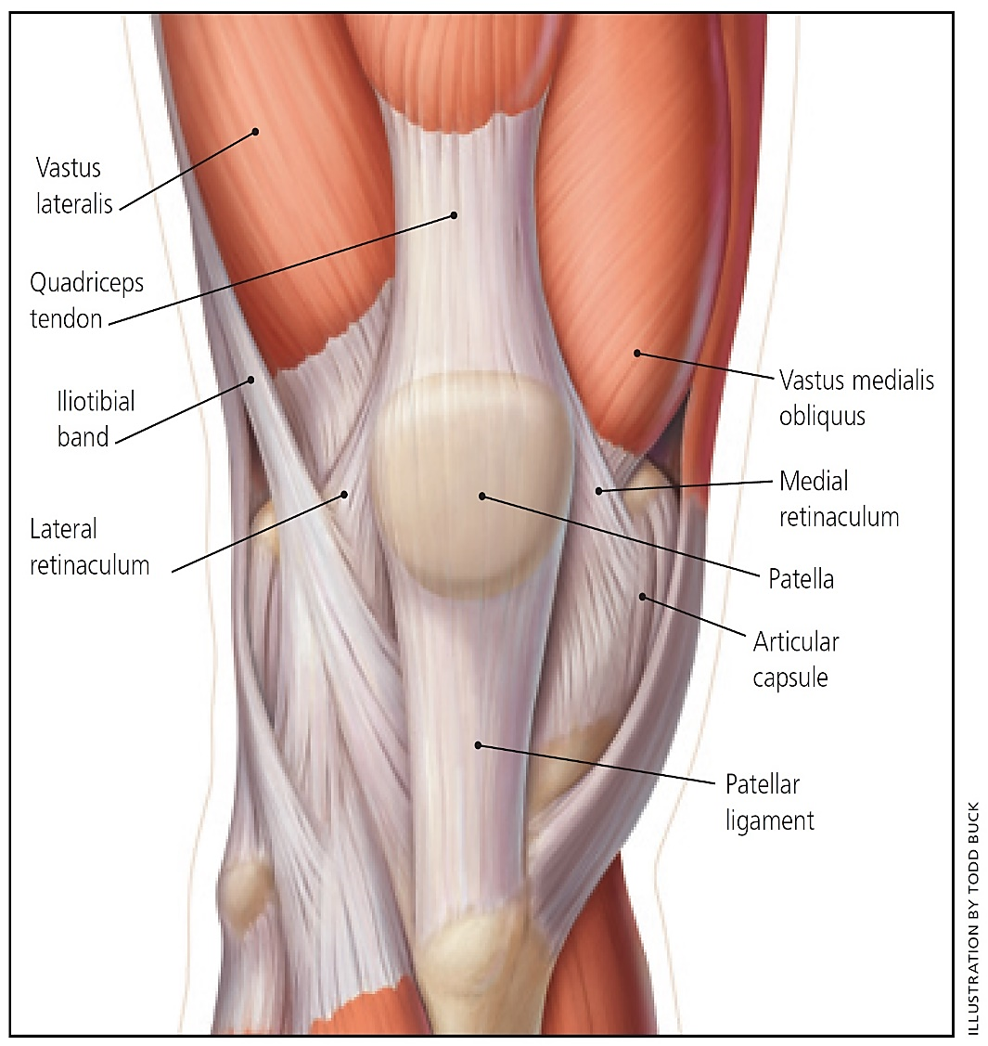

Figure 2: The image below shows force vector angles of each component of the quadriceps, as related to their fiber orientation and attachment site on the patella. This image is reproduced from Waryasz and McDermott, 2008.⁹
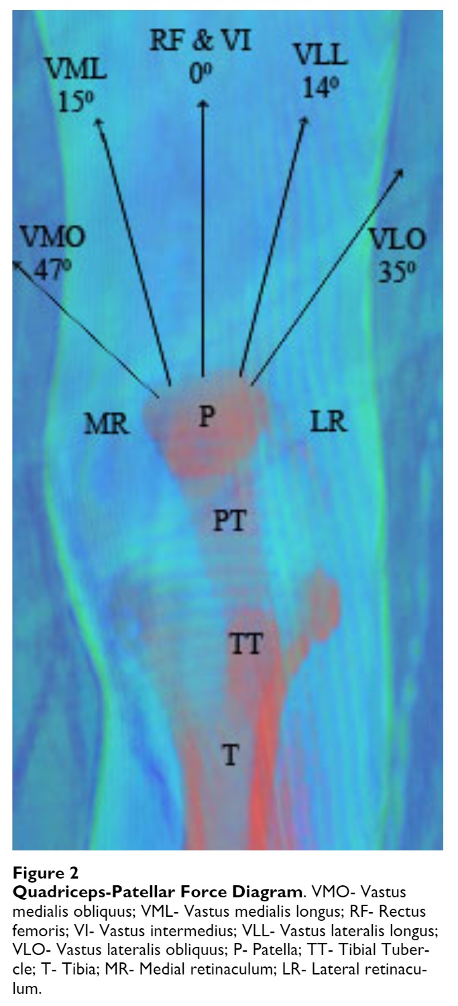

Appendix B- Etiological Factors
Figure 1: The image below demonstrates the lines created by bony landmarks that are used to determine Q-angle. An increased Q-angle has been implicated as a risk factor for PFPS. This image is reproduced from Juhn MS, 1999.¹¹
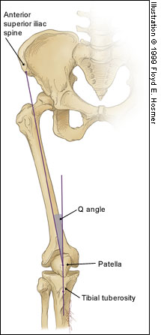

Appendix C- Assessment and Diagnosis
Figure 1: The image below shows the patella with a lateral glide, lateral tilt, and a combination of both in comparison to a normally oriented patella. Lateral glide and/or tilt is commonly found in PFPS. This image is reproduced from Collado and Fredericson, 2010.²⁰
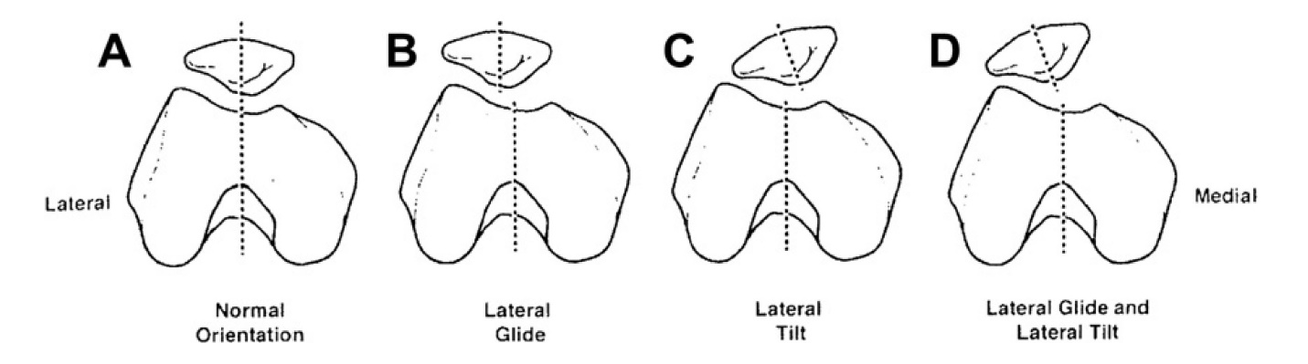

Figure 2: The illustration below demonstrates the performance of the patellar tilt test. Decreased ability to bring the lateral border to a neutral height relative to the medial border is a positive result. This image is reproduced from Dixit S, et al., 2007.⁵
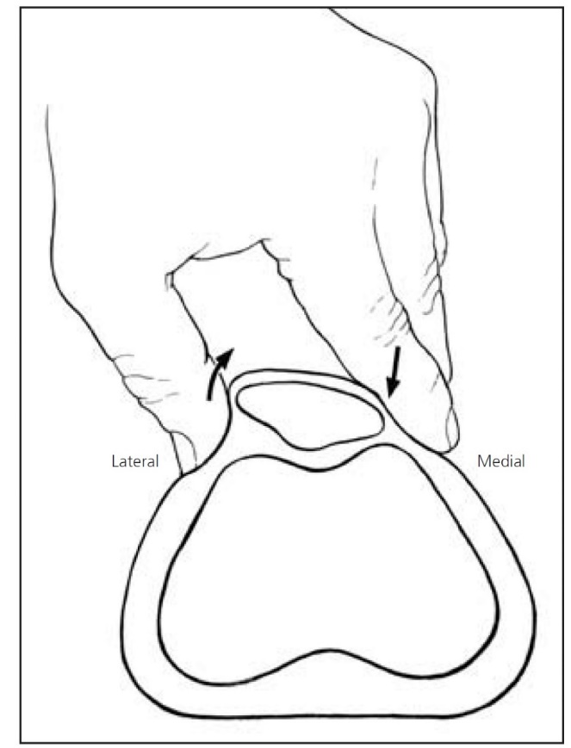

Figure 3: The illustration below shows the path of the patella when excessive lateral forces create the “J” sign during knee extension. This image is reproduced from Dixit S, et al., 2007.⁵

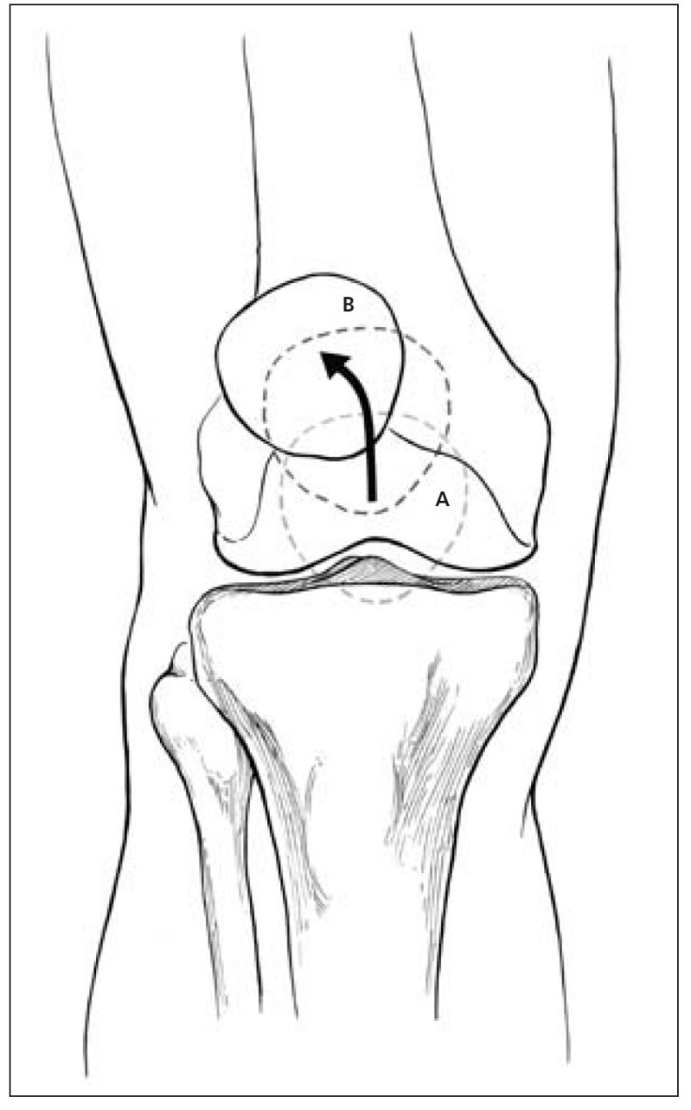

Figure 3: The table below summarizes common knee pathologies that may present similarly to PFPS, with PFPS included for reference. This image is reproduced from Dixit S, et al., 2007.⁵
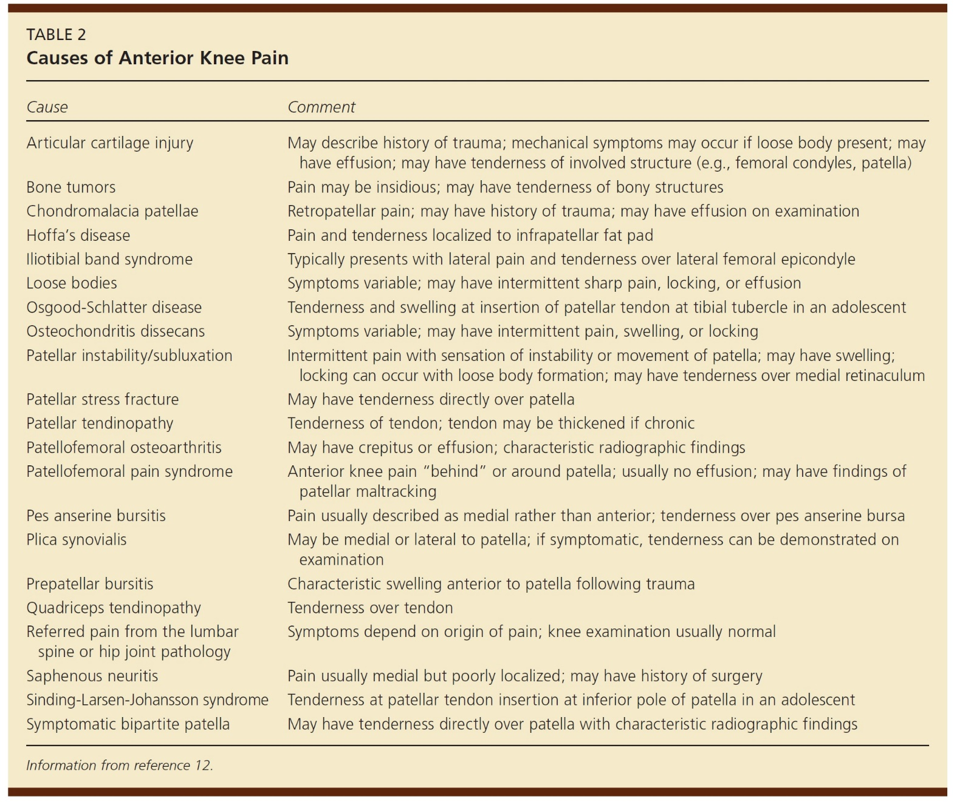

References
1. Lin F, Wilson NA, Makhsous M, et al. In vivo patellar tracking induced by individual quadriceps components in individuals with patellofemoral pain. J Biomech 2010;43(2):235-241. doi:10.1016/j.jbiomech.2009.08.043.
2. Van Middelkoop M, van Linschoten R, Berger MY, Koes BW, Bierma-Zeinstra SM. Knee complaints seen in general practice: active sport participants versus non-sport participants. BMC Musculoskelet Disord 2008;9:36. doi:10.1186/1471-2474-9-36.
3. Sawatsky A, Bourne D, Horisberger M, Jinha A, Herzog W. Changes in patellofemoral joint contact pressures caused by vastus medialis muscle weakness. Clin Biomech (Bristol, Avon) 2012;27(6):595-601. doi:10.1016/j.clinbiomech.2011.12.011.
4. Boling M, Padua D, Marshall S, Guskiewicz K, Pyne S, Beutler A. Gender differences in the incidence and prevalence of patellofemoral pain syndrome. Scand J Med Sci Sports 2010;20(5):725-730. doi:10.1111/j.1600-0838.2009.00996.x.
5. Dixit S, DiFiori JP, Burton M, Mines B. Management of patellofemoral pain syndrome. Am Fam Physician 2007;75(2):194-202.
6. Wyndow N, Collins N, Vicenzino B, Tucker K, Crossley K. Is there a biomechanical link between patellofemoral pain and osteoarthritis? A narrative review. Sports Med 2016;46(12):1797-1808. doi:10.1007/s40279-016-0545-6.
7. Myer GD, Ford KR, Di Stasi SL, Foss KDB, Micheli LJ, Hewett TE. High knee abduction moments are common risk factors for patellofemoral pain (PFP) and anterior cruciate ligament (ACL) injury in girls: is PFP itself a predictor for subsequent ACL injury? Br J Sports Med 2015;49(2):118-122. doi:10.1136/bjsports-2013-092536.
8. Negahban H, Etemadi M, Naghibi S, et al. The effects of muscle fatigue on dynamic standing balance in people with and without patellofemoral pain syndrome. Gait Posture 2013;37(3):336-339. doi:10.1016/j.gaitpost.2012.07.025.
9. Waryasz GR, McDermott AY. Patellofemoral pain syndrome (PFPS): a systematic review of anatomy and potential risk factors. Dyn Med 2008;7:9. doi:10.1186/1476-5918-7-9.
10. Petersen W, Ellermann A, Gösele-Koppenburg A, et al. Patellofemoral pain syndrome. Knee Surg Sports Traumatol Arthrosc 2014;22(10):2264-2274. doi:10.1007/s00167-013-2759-6.
11. Juhn MS. Patellofemoral Pain Syndrome: A Review and Guidelines for Treatment. Am Fam Physician 1999;60(7):2012-2018.
12. Park S-K, Stefanyshyn DJ. Greater Q angle may not be a risk factor of patellofemoral pain syndrome. Clin Biomech (Bristol, Avon) 2011;26(4):392-396. doi:10.1016/j.clinbiomech.2010.11.015.
13. Liebensteiner MC, Szubski C, Raschner C, et al. Frontal plane leg alignment and muscular activity during maximum eccentric contractions in individuals with and without patellofemoral pain syndrome. Knee 2008;15(3):180-186. doi:10.1016/j.knee.2008.01.009.
14. Neal BS, Barton CJ, Gallie R, O’Halloran P, Morrissey D. Runners with patellofemoral pain have altered biomechanics which targeted interventions can modify: A systematic review and meta-analysis. Gait Posture 2016;45:69-82. doi:10.1016/j.gaitpost.2015.11.018.
15. Barton CJ, Levinger P, Menz HB, Webster KE. Kinematic gait characteristics associated with patellofemoral pain syndrome: a systematic review. Gait Posture 2009;30(4):405-416. doi:10.1016/j.gaitpost.2009.07.109.
16. Cowan SM, Bennell KL, Hodges PW, Crossley KM, McConnell J. Delayed onset of electromyographic activity of vastus medialis obliquus relative to vastus lateralis in subjects with patellofemoral pain syndrome. Arch Phys Med Rehabil 2001;82(2):183-189. doi:10.1053/apmr.2001.19022.
17. Cavazzuti L, Merlo A, Orlandi F, Campanini I. Delayed onset of electromyographic activity of vastus medialis obliquus relative to vastus lateralis in subjects with patellofemoral pain syndrome. Gait Posture 2010;32(3):290-295. doi:10.1016/j.gaitpost.2010.06.025.
18. Besier TF, Fredericson M, Gold GE, Beaupré GS, Delp SL. Knee muscle forces during walking and running in patellofemoral pain patients and pain-free controls. J Biomech 2009;42(7):898-905. doi:10.1016/j.jbiomech.2009.01.032.
19. Patil S, Dixon J, White LC, Jones AP, Hui ACW. An electromyographic exploratory study comparing the difference in the onset of hamstring and quadriceps contraction in patients with anterior knee pain. Knee 2011;18(5):329-332. doi:10.1016/j.knee.2010.07.007.
20. Collado H, Fredericson M. Patellofemoral pain syndrome. Clin Sports Med 2010;29(3):379-398. doi:10.1016/j.csm.2010.03.012.
21. Nunes GS, Stapait EL, Kirsten MH, de Noronha M, Santos GM. Clinical test for diagnosis of patellofemoral pain syndrome: Systematic review with meta-analysis. Phys Ther Sport 2013;14(1):54-59. doi:10.1016/j.ptsp.2012.11.003.
22. Lenhart RL, Smith CR, Vignos MF, Kaiser J, Heiderscheit BC, Thelen DG. Influence of step rate and quadriceps load distribution on patellofemoral cartilage contact pressures during running. J Biomech 2015;48(11):2871-2878. doi:10.1016/j.jbiomech.2015.04.036.
23. Rixe JA, Glick JE, Brady J, Olympia RP. A review of the management of patellofemoral pain syndrome. Phys Sportsmed 2013;41(3):19-28. doi:10.3810/psm.2013.09.2023.
24. Choi B, Kim M, Jeon H-S. The effects of an isometric knee extension with hip adduction (KEWHA) exercise on selective VMO muscle strengthening. J Electromyogr Kinesiol 2011;21(6):1011-1016. doi:10.1016/j.jelekin.2011.08.008.
25. Peng H-T, Kernozek TW, Song C-Y. Muscle activation of vastus medialis obliquus and vastus lateralis during a dynamic leg press exercise with and without isometric hip adduction. Phys Ther Sport 2013;14(1):44-49. doi:10.1016/j.ptsp.2012.02.006.
26. Syme G, Rowe P, Martin D, Daly G. Disability in patients with chronic patellofemoral pain syndrome: a randomised controlled trial of VMO selective training versus general quadriceps strengthening. Man Ther 2009;14(3):252-263. doi:10.1016/j.math.2008.02.007.
27. Barton CJ, Lack S, Hemmings S, Tufail S, Morrissey D. The “Best Practice Guide to Conservative Management of Patellofemoral Pain”: incorporating level 1 evidence with expert clinical reasoning. Br J Sports Med 2015;49(14):923-934. doi:10.1136/bjsports-2014-093637.
28. Khayambashi K, Fallah A, Movahedi A, Bagwell J, Powers C. Posterolateral hip muscle strengthening versus quadriceps strengthening for patellofemoral pain: a comparative control trial. Arch Phys Med Rehabil 2014;95(5):900-907. doi:10.1016/j.apmr.2013.12.022.
29. Lack S, Barton C, Woledge R, Laupheimer M, Morrissey D. The immediate effects of foot orthoses on hip and knee kinematics and muscle activity during a functional step-up task in individuals with patellofemoral pain. Clin Biomech (Bristol, Avon) 2014;29(9):1056-1062. doi:10.1016/j.clinbiomech.2014.08.005.
30. Collins N, Crossley K, Beller E, Darnell R, McPoil T, Vicenzino B. Foot orthoses and physiotherapy in the treatment of patellofemoral pain syndrome: randomised clinical trial. BMJ 2008;337:a1735. doi:10.1136/bmj.a1735.
31. Espí-López GV, Arnal-Gómez A, Balasch-Bernat M, Inglés M. Effectiveness of manual therapy combined with physical therapy in treatment of patellofemoral pain syndrome: systematic review. J Chiropr Med 2017;16(2):139-146. doi:10.1016/j.jcm.2016.10.003.
32. Van den Dolder PA, Roberts DL. Six sessions of manual therapy increase knee flexion and improve activity in people with anterior knee pain: a randomised controlled trial. Aust J Physiother 2006;52(4):261-264.
33. Crossley K, Bennell K, Green S, McConnell J. A systematic review of physical interventions for patellofemoral pain syndrome. Clin J Sport Med 2001;11(2):103-110.
34. Hains G, Hains F. Patellofemoral pain syndrome managed by ischemic compression to the trigger points located in the peri-patellar and retro-patellar areas: A randomized clinical trial. Clinical Chiropractic 2010;13(3):201-209. doi:10.1016/j.clch.2010.05.001.
35. Telles G, Cristovão DR, Belache FATC, Santos MRA, Almeida RS de, Nogueira LAC. The effect of adding myofascial techniques to an exercise programme for patients with anterior knee pain. J Bodyw Mov Ther 2016;20(4):844-850. doi:10.1016/j.jbmt.2016.02.007.
36. Peng H-T, Song C-Y. Predictors of treatment response to strengthening and stretching exercises for patellofemoral pain: An examination of patellar alignment. Knee 2015;22(6):494-498. doi:10.1016/j.knee.2014.10.012.
37. Glaviano NR, Saliba SA. Immediate effect of patterned electrical neuromuscular stimulation on pain and muscle activation in individuals with patellofemoral pain. J Athl Train 2016;51(2):118-128. doi:10.4085/1062-6050-51.4.06.
38. Rodriguez-Merchan EC. Evidence Based Conservative Management of Patello-femoral Syndrome. Arch Bone Jt Surg 2014;2(1):4-6.
39. Araújo CGA, de Souza Guerino Macedo C, Ferreira D, Shigaki L, da Silva RA. Mcconnell’s patellar taping does not alter knee and hip muscle activation differences during proprioceptive exercises: A randomized placebo-controlled trial in women with patellofemoral pain syndrome. J Electromyogr Kinesiol 2016;31:72-80. doi:10.1016/j.jelekin.2016.09.006.
40. Heintjes E, Berger MY, Bierma-Zeinstra SMA, Bernsen RMD, Verhaar JAN, Koes BW. Pharmacotherapy for patellofemoral pain syndrome. Cochrane Database Syst Rev 2004;(3):CD003470. doi:10.1002/14651858.CD003470.pub2.
41. Fonseca LPRM da, Kawatake EH, Pochini A de C. Lateral patellar retinacular release: changes over the last ten years. Rev Bras Ortop 2017;52(4):442-449. doi:10.1016/j.rboe.2017.06.003.
42. McCarthy MM, Strickland SM. Patellofemoral pain: an update on diagnostic and treatment options. Curr Rev Musculoskelet Med 2013;6(2):188-194. doi:10.1007/s12178-013-9159-x.
43. Ostermeier S, Holst M, Hurschler C, Windhagen H, Stukenborg-Colsman C. Dynamic measurement of patellofemoral kinematics and contact pressure after lateral retinacular release: an in vitro study. Knee Surg Sports Traumatol Arthrosc 2007;15(5):547-554. doi:10.1007/s00167-006-0261-0.
44. Fulkerson JP, Becker GJ, Meaney JA, Miranda M, Folcik MA. Anteromedial tibial tubercle transfer without bone graft. Am J Sports Med 1990;18(5):490-6; discussion 496. doi:10.1177/036354659001800508.
45. Dannawi Z, Khanduja V, Palmer CR, El-Zebdeh M. Evaluation of the modified Elmslie-Trillat procedure for patellofemoral dysfunction. Orthopedics 2010;33(1):13. doi:10.3928/01477447-20091124-07.

