Diagnosis and Treatment of Dermatomyositis in Middle-Aged Adults

Dermatomyositis, one of only three known inflammatory myopathies, is a systemic disease that mainly affects the skin and muscles in afflicted individuals but can also affect other areas of the body such as joints, the esophagus, lungs and heart.^{1,2} Inflammatory myopathies are generally considered to be autoimmune diseases that cause chronic muscle inflammation, swelling and weakness; however, the causes for these diseases can vary greatly. While many causes remain to be idiopathic, evidence suggests that genetic, immune and environmental factors may also play a role. Certain individuals are predisposed to the disease by inheriting an increased frequency of human leukocyte antigens (HLAs) such as the HLA-DR3, HLA-DR52 and HLA-DR6 subtypes.²⁻⁴ Additional autoimmune responses attributable to the disease include viral infections or cancer in which the body reacts too strongly against the host’s antigens thus causing dermatomyositis. It has been found that 7-30% of the cases of dermatomyositis arose from cancer, most commonly associated with ovarian, breast and lung cancer.⁵ Individuals who are genetically predisposed to acquiring the disease may develop dermatomyositis following certain infectious agents such as: coxsackie virus, parvovirus, echovirus, HIV, human T-cell lymphotrophic virus Type 1 and Toxoplasma and Borrelia species.² Infections and cancer types are not the only link to acquiring the disease as certain medication types such as –statins have been found to exacerbate the condition in addition to interferon therapy which is used in the treatment of cancer. Other medications linked to the development of dermatomyositis include penicillamine, quinidine and phenylbutazone.² Additional causes of the disease that are worth mentioning include ultraviolet radiation, vitamin D deficiency, environmental factors occurring in the months of April-May, collagen injections and even silicone breast implants!^{2,4}
Although the disease can affect anyone from infancy through the age of 80, it has been more commonly found to occur in females with a 2:1 ratio when compared to males.^{2,3} Interestingly, dermatomyositis is commonly found in middle-aged adults from age 40-60 and within children aged 5-15.^{2,3} While rarely acquired for any age group, it is more commonly to occur in middle-aged individuals than children. The estimated incidence of dermatomyositis is 9.63 per 1,000,000 overall, with juvenile dermatomyositis affecting approximately 3 in 1,000,000 children.² Signs and symptoms are consistent among the age groups; however, children are more likely to develop subcutaneous calcifications and/or a tiptoe gait secondary to flexion contracture of the ankles as well as becoming more likely to have extramuscular/systemic manifestations.¹⁻³
Clinical features of dermatomyositis, both systemically and cutaneously, have been found to significantly reduce quality of life in affected individuals.⁶ Drouet et al retrospectively examined 28 patients with the disease to evaluate the impact of the cutaneous manifestations of dermatomyositis on quality of life. The authors found that more than half of the patients demonstrated easy fatigability, decreased exercise tolerance and abnormal respiratory function parameters with one-third of the patients reporting difficulty with performing physical activities.⁷ Pruritis, otherwise known as “itchy” skin”, has been noted as a significant contributor to negatively impacting quality of life scores in patients with dermatomyositis. When compared with dermatitis and psoriasis, dermatomyositis has been found to produce worse scores in regards to symptoms, emotions and overall function when utilizing the Skindex-16 outcome measure as shown in Appendix A: figure 1.⁶ Utilizing questionnaires with clinical, laboratory and immunological items, Parodi et. al were able to retrospectively study 132 patients with dermatomyositis in order to evaluate the prevalence of symptoms associated with the disease. As shown in Appendix A: figure 2, several cutaneous symptoms have been found to occur more frequently than others such as heliotrope erythema, a purplish-red rash.⁸ Characteristic cutaneous features include this heliotrope erythema of the mid-face as well as Gottron papules, shown in Appendix A: figure 3.⁸⁻¹⁰ As mentioned earlier, another common feature of dermatomyositis includes pruritis of skin lesions that are sometimes intense enough to disturb one’s ability to sleep. Additional cutaneous symptoms include changes in the nailfolds of the fingers, scaly scalp or diffuse hair loss, eruption of the skin on photo-exposed surfaces as well as on the upper outer thighs, dorsal hands over the knuckles and along the eyelid margins, with or without periorbital edema. Bluish-purple and patchy rashes may occur on the face and eyelids as well as on the chest, nail cuticles, knuckles, knees or elbows.^{1,2,8-10} Three cutaneous signs have been deemed as characteristic features of the disease as well: V-neck sign, Shawl sign and Holster sign, shown in Appendix A: figures 4-6.¹¹ The V-neck sign is a continuation of the malar and macular erythema that extends over the lower anterior neck and upper anterior chest, frequently observed in dermatomyositis patients. The Shawl sign refers to erythema over the upper back, posterior neck and shoulders while sometimes extending to the lateral arms; whereas, the holster sign refers to erythema occurring in areas that are considered to be non-sun-exposed areas such as the lower back and lateral thighs as well as the scalp beneath the hair.¹¹ Contracture of the joints as well as the formation of calcium deposits underneath the skin may occur in individuals with the disease; however, it is more likely to be seen in the pediatric population.
Skin lesions that are frequently observed in dermatomyositis have been found to produce systemic issues as well when considering that ~23% of patients will develop malignancies caused by the lesions.⁸ When evaluating patients for the first time, it is important to assess for previous or current malignancies in all patients, particularly in the adult population and make appropriate referrals as needed. Although not life-threatening, Raynaud’s phenomenon has been found to occur in ~11% of patients, further complicating the ability for one to manage the disease.⁸ Initially, patients experience progressive muscle weakness that usually starts with the neck, arm and hips proximally and bilaterally. Typically, individuals have greater muscle weakness in extensor muscle groups such as the triceps, hamstrings and gluteus maximus; however, profound weakness is also frequently noticed within the hip abductors, hip flexors and shoulder abductors as well.¹² With more severe involvement, patients report having distal muscle weakness in addition to weakness of neck extensor/flexor muscles leading to head drop.¹¹ Unless the patient’s muscles have become severely weak and atrophic, the patient’s distal strength, sensation and tendon reflexes are maintained. Patients subjectively report having difficulty and weakness with rising from a seated or supine position without support, climbing stairs, manipulating objects, walking, combing/washing hair or reaching for items in cabinets above their shoulders. Myalgias and muscle tenderness can occur in up to 30% of patients; as the disease progresses, patients may develop more serious conditions such as dysphagia, dysphonia, and weakness in the muscles of respiration. A particularly concerning source of morbidity and mortality in this patient population is due to interstitial lung disease which is found to occur with approximately 35-40% of patients with dermatomyositis during the course of their lifetime.¹¹ Systemic involvement may also include gastroesophageal reflex, gastric ulcer, gastrointestinal infections, fatigue, fever, malaise, arthralgia, atrioventricular defects, tacharrhythmias, dilated cardiomyopathies and unintentional weight loss.⁸⁻¹² The differential diagnosis of dermatomyositis between other inflammatory myopathies that can cause muscle weakness is less complex than would be expected due to the fact that none of the other disorders have an association with skin lesions. Additionally, myalgia associated with dermatomyositis is considered to be milder than with other conditions such as polymyalgia rheumatic, fibromyalgia and viral or bacterial myositis.¹³
Although many of the clinical features are easy to recognize and diagnose through physical examination such as the Gottron papules and heliotrope rash skin manifestations, many other forms of diagnosis exist. Muscle biopsies are usually performed in a proximal muscle group of the legs or arms whenever there is suspected muscle involvement impairing the individual’s ability to function.¹⁴ The areas of suspected weak muscle should have muscle biopsies performed after being assessed by physical exam or having shown areas of inflammation through MRI. Specific muscle biopsy markers for differentiating myositis types from other muscular diseases, particularly other dystrophies, include the MHC-1/CD8 complex. A diagnosis of dermatomyositis is considered definite whenever the aforementioned muscle histopathology is present while also accompanied by the characteristic rash of the disease.¹⁴ Muscles contralateral to those identified as abnormal on electromyographies (EMG) may also justify the need to perform muscle biopsies to rule out other similar diseases and confirm the diagnosis of dermatomyositis.^{11,14} In early stages of the disease, EMG studies are able to show typical findings associated with the disease including “increased spontaneous and insertional activity with fibrillation potentials, positive sharp waves, complex repetitive discharges, early recruitment and small polyphasic motor unit potentials.” According to Fiorentino et. al, these abnormal findings are visible in 70-90% of cases but are non-specific to the disease thus necessitating another diagnostic tool for confirmation.¹¹ Magnetic resonance imaging (MRI) has shown to be a sensitive technique for evaluating forms of myositis whenever edema is present.¹¹ Aside from properly addressing the muscle biopsy site, MRI is able to provide a detailed view of the extent of muscle involvement; T2-weighted images and short tau inversion recovery (STIR) are able to display symmetric muscular edema correlated with the disease activity; whereas, T1-weighted images are able to show fatty atrophy of the musculature as seen in the chronic phase of the disease.¹⁴ Although MRI is sensitive in identifying the muscular changes due to the accumulation of edema, muscular ultrasound (US) can measure perfusion abnormalities and help identify acute muscle inflammation whenever MRI is not available. Given that muscular US was the first technique developed for evaluating muscle groups, this tool is widely available and cheap to use and may serve as a follow-up of muscle lesions to reveal if any other complications exist such as fibrosis or cystic hematomas.¹⁴ Blood analysis is useful to detecting elevated levels of muscle enzymes such as creatine kinase that are characteristic of muscle involvement associated with the disease. Serum creative kinase is the most sensitive muscle enzyme during the acute phase of the disease as this substance is released following muscle damage. Elevations in other enzymes such as serum aldolase, myoglobin, lactate dehydrogenase, aspartate and alanine aminotransferase may also occur as well.^{11,14} Additional inflammatory biomarkers may also be increased during the active phase of the disease, including erythrocyte sedimentation rate, and c-reactive protein.¹⁴ Myositis-specific autoantibodies (MSA), such as the Anti-Mi-2 antibody is associated with dermatomyositis and is the most commonly found MSA found in these patients. Several other autoantigens have been reported to exist in these patients, particularly when one has interstitial lung disease and/or cancer.¹⁴ Anti-CADM-140 (MDA5), an antibody associated with interstitial lung disease and Anti-p155/140, a cancer associated antibody are found to occur in 50% and 40-75% of dermatomyositis cases, respectively.¹⁴ Pulmonary function tests (PFTs) that include assessment of diffusion capacity may be used to assess more serious cases of dermatomyositis where interstitial lung disease is suspected. Individuals with interstitial lung disease typically have lower lung functioning abilities, such as having a reduced total lung capacity as well as restrictive lung function deficits. Various determinants of improvement or deterioration have been found to be significant when treating idiopathic pulmonary fibrosis, a component of interstitial lung disease. A change of greater than 10% in total lung capacity and/or a change of greater than 15% in diffusing capacity for carbon monoxide have both been found to significantly affect treatment of the disorders.¹⁵ Assessments for transfer of carbon monoxide may be performed with a spirometer using a single-breath technique with values being adjusted for alveolar volume. When dermatomyositis is expected, PFTs displaying abnormal diffusion capacity for carbon monoxide may provide support for the diagnosis, especially when total lung capacity is less than 80% of their maximum.¹⁵ Lastly, high-resolution computerized tomography (HRCT) scanning may be used to track the disease progression as HRCT is able to identify characteristic features of interstitial lung disease associated with dermatomyositis such as linear opacities, fibrosis and nodules. For individuals who are chronically immunosuppressed, bronchoscopy with bronchoalveolar lavage may be helpful for ruling out any occult infections.¹¹ Following a confirmed diagnosis, patients should be assessed for any esophageal, pulmonary and/or cardiac involvement that may be present through the use of barium swallow tests and/or esophageal motility studies. These tests, in addition to ones mentioned earlier such as PFTs may also determine the severity of the disease and help identify any malignancies that may exist.¹⁶
When treating patients with dermatomyositis, several general measures and safety precautions should be considered especially in patients with more serious involvement. While bedrest is considered to be of value in those with progressive weakness, too much bedrest is contraindicated as these individuals may develop contractures. Given the nature of the disease, patients should participate in an exercise program that aims to maintain any preserved strength as well as implement the use of range-of-motion stretches, actively and/or passively to prevent contractures from developing.¹⁶ When considering more advanced deficits associated with the disease such as dysphagia, one should inform their patients to have their head of bed elevated and avoid eating meals immediately before bed in order to prevent aspiration and other respiratory complications.¹⁶ Unfortunately, the only FDA approved treatment for dermatomyositis is through the use of glucocorticoids.¹⁷ As Dr. Gross has mentioned, individuals taking prednisone for extended periods of time often have chronic systemic inflammatory diseases such as dermatomyositis which is challenging to treat without any of the side effects associated with the medication. In addition to the common unfavorable effects of the drug such as muscle and skin wasting, glucocorticoid use has also been shown to cause facial rounding, hirsutism, diminished carbohydrate tolerance, insomnia, restlessness, weakness, transitory mental clouding, acne, increased skin pigmentation and vague abdominal distress.^{18,19} Some individuals have also reported having depressive symptoms and difficulties with sleeping.¹⁸ Sleep disturbances such as insomnia have been shown to have negative impacts on the healing mechanisms of the body such as tissue repair and pain modulation.²⁰ So not only does prednisone directly harm or hinder progress made with our patients, it can also indirectly cause complications with the healing process. Additionally, it has been found that ~25% of patients with dermatomyositis will have no effect from taking systemic corticosteroids, and 25-50% of these patients will develop significant side-effects due to steroid use.¹⁷ When treating patients who are taking corticosteroids, it is important to remember the substantial damage that can occur to the bones and other musculoskeletal tissues within their bodies from their medication. Shah and Gecys found that the use of glucocorticoids can cause rapid bone loss with decreases in bone mineral density as much as 10-20% within 3 months.²³ Furthermore, the use of glucocorticoids can further exacerbate eugeric changes or create new problems including osteopenia/osteoporosis and severely thinned soft tissues.¹⁹ Given the aforementioned, it is imperative to screen these at-risk individuals for osteoporosis when considering treatments involving weight-bearing activity. Taking all of this into consideration, although the use of glucocorticoids has many undesirable effects, the American Academy of Dermatology continues to recommend initial doses of oral prednisone prescribed at 0.5-1.5 mg/kg/day for these individuals.¹⁷ Dr. M. Hertl has stated that glucocorticoid use should only be used until the disease has become clinically and enzymatically inactive at which point patients should then begin to taper from the medication. In order to safely taper from the medication, patients should slowly increase their dosage over a period that is 1.5 to 2 times longer than their period of active treatment.¹⁶ Dr. M. Hertl has suggested the use of steroid-sparing agents during the early stages of the disease in order to effectively induce or maintain a remission cycle. Many of these steroid-sparing agents are immunosuppressive agents such as methotrexate, azathioprine, cyclophosphamide, mycophenolate mofetil, chlorambucil or cyclosporine. One study found that ½ to ¾ of patients with dermatomyositis treated with immunosuppressive agents will positively respond to the medication with an increase in strength, a decrease in enzyme levels as well as being able to safely reduce their corticosteroid use.¹⁶
Since many patients with dermatomyositis present with cutaneous lesions as well as other photo-sensitive rashes, it has been recommended that these individuals use a topical broad-spectrum sunscreen with a high sun-protective factor for daily use.¹⁷ These patients should either attempt to reduce the amount of time spent outside or utilize some form of photo-protective clothing in order to reduce their sun exposure levels. Hydroxychloroquine, an anti-malarial drug, may be used topically to treat persistent rashes that appear in affected individuals.^{16,17} If patients do not respond well to hydroxychloroquine, they may be switched over to chloroquine phosphate or quinacrine as an alternative method for treating rashes. However, patients should be warned prior to anti-malarial drug use that there appears to be a greater frequency of drug eruptions in patients with dermatomyositis using these drugs and should have frequent blood counts and ophthalmologic examinations performed.¹⁶
Cutaneous lesions have also been cleared in some patients by taking monthly intravenous injections of immunoglobulins.¹⁷ By using immunoglobulin infusions, Dalakas et. al were able to decrease serum creatine kinase levels by 50% in patients with dermatomyositis who had up to 10 times the normal amount of serum creatine kinase.²¹ Two of the participants reported severe headaches associated with each infusion but stated that the benefit from the treatment greatly outweighed this adverse effect. Immunoglobulin therapy was able to significantly improve muscle characteristics such as having an increase in muscle-fiber diameter, as shown in Appendix B: figure 1.²¹ The MHC-1 complex, a characteristic muscle biopsy marker for dermatomyositis mentioned earlier, was hardly detectable following immunoglobulin treatment, as shown in Appendix B: figure 2.²¹ Individuals who experience adverse effects from intravenous immunoglobulin therapy or who have insufficient peripheral or central vein access may benefit from using a subcutaneous application of immunoglobulins (SCIG). Five patients receiving treatment for dermatomyositis through the use of SCIGs reported having tolerated the therapy well and were able to achieve ideal levels of IgG; however, a sudden surge of IgG has been proposed to cause adverse effects thus suggesting that one should have more frequent, yet less potent administrations of SCIGS to have more stable plasma levels.¹⁷ Whenever subcutaneous doses were given at ¼ the normal dose but 4 times more frequently, patients were able to tolerate therapy better while also having an increase in muscle strength and normalization of muscle enyzmes.¹⁷
Calcinosis, a formation of calcium deposits beneath soft tissues, is a complication of the disease that is usually only seen in children or adolescents.¹⁶ When treated early and aggressively with intravenous methylprednisolone, calcinosis eruption may be able to be decreased and less severe.¹⁶ Other medical treatments for calcinosis include immunosuppressives, IVIG, topical metabisulfite, diltiazem, oral aluminum hydroxide, warfarin, colchicine and alendronate.^{16,17} When treating larger calcinosis lesions, surgical removal appears to the most effective treatment discovered thus far.¹⁷
Physical therapy, an alternative treatment option for many conditions including dermatomyositis, can help reduce pain and improve or restore mobility in individuals through the guidance of a licensed physical therapist. Authors at the Karolinska Institute in Sweden examined how 10 patients with poly- or dermatomyositis reacted physically to the implementation of a home exercise program that included neck, trunk and upper/lower extremity strengthening exercises as well as stretching. During the 12-week intervention, patients would exercise for 15 minutes followed by a 15 minute walk for 5 days each week. Using MRIs, muscle biopsies, a muscle function index, serum analysis, walking tests and a short-form questionnaire pre- and post-treatment, the authors found that after 12 weeks of exercise, no signs of increased disease activity were present. Additionally, all of the patients showed an increase in their walking distance ability as well as increasing their upper/lower limb muscle function with six of the ten patients reaching statistical significance.²² Another low-intensity resistance training program was also able to produce significantly higher levels of muscle strength in participants while also maintaining stable levels of muscle enzymes.¹⁷ Endurance training has been found to improve the aerobic capacity and reduce disease activity in both adults and children by performing at low-intensities for one hour three times per week.¹⁷ Given the aforementioned, the implementation of low-intensity training programs including resistance and aerobic training components with physical therapist supervision and/or management is safe and effective at improving the quality of life, muscle strength and endurance in patients with dermatomyositis. Due to the unique pathophysiology of interstitial lung disease that is found in later stages of dermatomyositis, exercise rehabilitation for these individuals requires individualized treatment plans as well as continuous modification of their exercise prescription. Supplemental components of therapy would include the instruction of how to perform efficient breathing techniques that are focused on controlled, diaphragmatic breathing with pacing and energy conservation. Additional educational topics to be included in therapy include oxygen use and relaxation techniques in conjunction with providing additional sources of psychosocial support or palliative care in regards to later stages of the disease.^{24,25} All rehabilitation should occur where supplemental oxygen can be easily administered to maintain normal levels of oxygen saturation.
Many health providers such as physical therapists do more than just treat specific ailments with figurative Band-Aids. By incorporating a holistic approach to health care practice, physical therapists are able to treat the whole person, not simply symptoms. Due to the impaired ability to utilize oxygen and expel carbon dioxide in patients with interstitial lung disease, it is worth noting that cognitive and psychiatric impairments may be present. In such cases, it may be worth utilizing the Montreal Cognitive Assessment (MoCA) when a patient is of questionable psychological functioning to help determine clinical prognoses and assure that the patient’s safety is not being jeopardized. Given that the MoCA is free, covers a variety of cognitive domains, takes only 10 minutes to administer and is able to detect mild cognitive impairment with high sensitivity and specificity, it is being proposed to administer this test during chronic stages of dermatomyositis. Lastly, it is important for all healthcare professionals to communicate with each other when treating patients with chronic disease and perform reviews of patients’ medication histories in order to prevent any harm or consequent risks from occurring.

References
- Dermatomyositis | Genetic and Rare Diseases Information Center (GARD) – an NCATS Program. Rarediseasesinfonihgov. 2017. Available at: https://rarediseases.info.nih.gov/diseases/6263/dermatomyositis.
- Dermatomyositis - NORD (National Organization for Rare Disorders). NORD (National Organization for Rare Disorders). 2017. Available at: https://rarediseases.org/rare-diseases/dermatomyositis/.
- Polymyositis and Dermatomyositis - Musculoskeletal and Connective Tissue Disorders - MSD Manual Professional Edition. MSD Manual Professional Edition. 2017. Available at: http://www.merckmanuals.com/professional/musculoskeletal-and-connective-tissue-disorders/autoimmune-rheumatic-disorders/polymyositis-and-dermatomyositis.
- Thompson C, Piguet V, Choy E. The pathogenesis of dermatomyositis. British Journal of Dermatology. 2017. doi:10.1111/bjd.15607.
- Di Rollo D, Abeni D, Tracanna M, Capo A, Amerio P. Cancer risk in dermatomyositis: a systematic review of the literature. G Ital Dermatol Venereol. 2014:149(5):525-537.
- Hundley J, Carroll C, Lang W et al. Cutaneous symptoms of dermatomyositis significantly impact patients' quality of life. Journal of the American Academy of Dermatology. 2006;54(2):217-220. doi:10.1016/j.jaad.2004.12.015.
- Drouet B, Le Loet X, Vittecog O, Nouvet G, Genevois A, Lauret P, Tron P, Menard JF, Czernichow P, Muir JF, Mallet E. A study of long-term survival, functional outcome and quality of life in patients with polymyositis or dermatomyositis. Rev Rhum Engl Ed. 1996:63(5):321-330.
- Parodi A, Caproni M, Marzano A et al. Dermatomyositis in 132 Patients with Different Clinical Subtypes: Cutaneous Signs, Constitutional Symptoms and Circulating Antibodies. Acta Dermato-Venereologica. 2002;82(1):48-51. doi:10.1080/000155502753600894.
- Ricceri F, Prignano F. Gottron papules: a pathognomonic sign of dermatomyositis. Canadian Medical Association Journal. 2012;185(2):148-148. doi:10.1503/cmaj.111791.
- Morganroth P, Werth V. Adult-Onset Dermatomyositis: The Clinical Dermatologist’s Perspective. CML Dermatology. 2017:15(3)
- Fiorentino D, Marvi U, Chung L. Clinical presentation and evaluation of dermatomyositis. Indian Journal of Dermatology. 2012;57(5):375. doi:10.4103/0019-5154.100486.
- Harris-Love M, Shrader J, Koziol D et al. Distribution and severity of weakness among patients with polymyositis, dermatomyositis and juvenile dermatomyositis. Rheumatology. 2008;48(2):134-139. doi:10.1093/rheumatology/ken441.
- Miller M, Targoff I, Shefner J, Callen J, Curtis M. Diagnosis and differential diagnosis of dermatomyositis and polymyositis in adults. UpToDate. 2016.
- Iaccarino L, Ghirardello A, Bettio S et al. The clinical features, diagnosis and classification of dermatomyositis. Journal of Autoimmunity. 2014;48-49:122-127. doi:10.1016/j.jaut.2013.11.005.
- Fathi M, Vikgren J, Boijsen M et al. Interstitial lung disease in polymyositis and dermatomyositis: Longitudinal evaluation by pulmonary function and radiology. Arthritis & Rheumatism. 2008;59(5):677-685. doi:10.1002/art.23571.
- Hertl M. Chapter 6: Dermatomyositis. Autoimmune Diseases of the Skin Pathogenesis, Diagnosis, Management. 2nd ed. Marburg, Germany: Springer-Verlag Wien;2005:250.
- Isak V, Jorizzo J. Recent developments on treatment strategies and the prognosis of dermatomyositis: a review. Journal of Dermatological Treatment. 2017:1-10. doi:10.1080/09546634.2017.1403549.
- Bollet A. Major Undesirable Side-Effects Resulting From Prednisolone and Prednisone. Journal of the American Medical Association. 1955;158(6):459. doi:10.1001/jama.1955.02960060017005.
- Gross, M. (2017). Bone: Composition, Structure, Mechanical Properties and Healing. Retrieved from: https://unc.voicethread.com/myvoice/thread/166168/884921/928080.
- Siengsukon C, Al-dughmi M, Stevens S. Sleep Health Promotion: Practical Information for Physical Therapists. Physical Therapy. 2017;97(8):826-836. doi:10.1093/ptj/pzx057.
- Dalakas M, Illa I, Dambrosia J et al. A Controlled Trial of High-Dose Intravenous Immune Globulin Infusions as Treatment for Dermatomyositis. New England Journal of Medicine. 1993;329(27):1993-2000. doi:10.1056/nejm199312303292704.
- Alexanderson H. Safety of a home exercise programme in patients with polymyositis and dermatomyositis: a pilot study. Rheumatology. 1999;38(7):608-611. doi:10.1093/rheumatology/38.7.608.
- Shah S, Gecys G. Prednisone-induced osteoporosis: an overlooked and undertreated adverse effect. Journal of American Orthopathic Association. 2006;106(11).
- Morisset J, Dubé B, Garvey C et al. The Unmet Educational Needs of Patients with Interstitial Lung Disease. Setting the Stage for Tailored Pulmonary Rehabilitation. Annals of the American Thoracic Society. 2016;13(7):1026-1033. doi:10.1513/annalsats.201512-836oc.
- Holland A. Exercise Rehabilitation for Interstitial Lung Disease. ILD Care Today. 2016;9(16):38-40.

Appendices

Appendix A

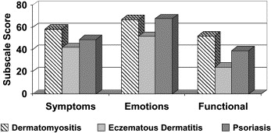
Fig. 1: Comparison of symptomatic, emotional and functional subscale scores within the Skindex-16 outcome measure for patients with dermatomyositis, eczematous dermatitis and psoriasis.

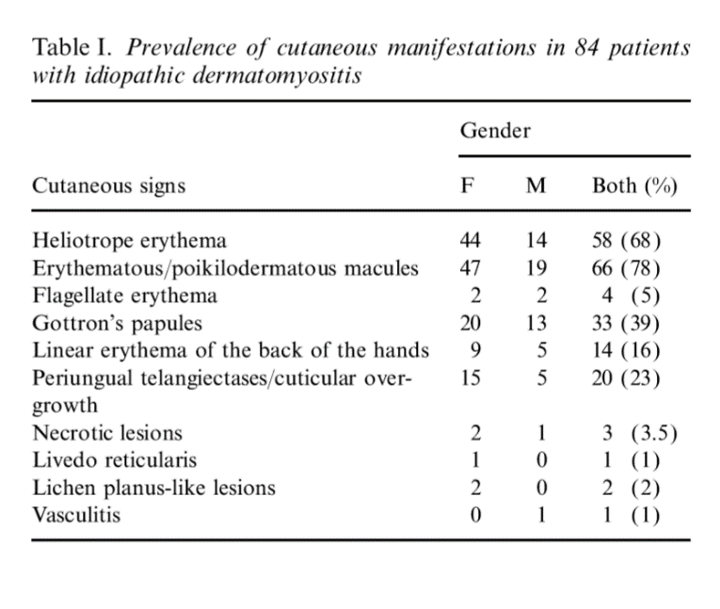
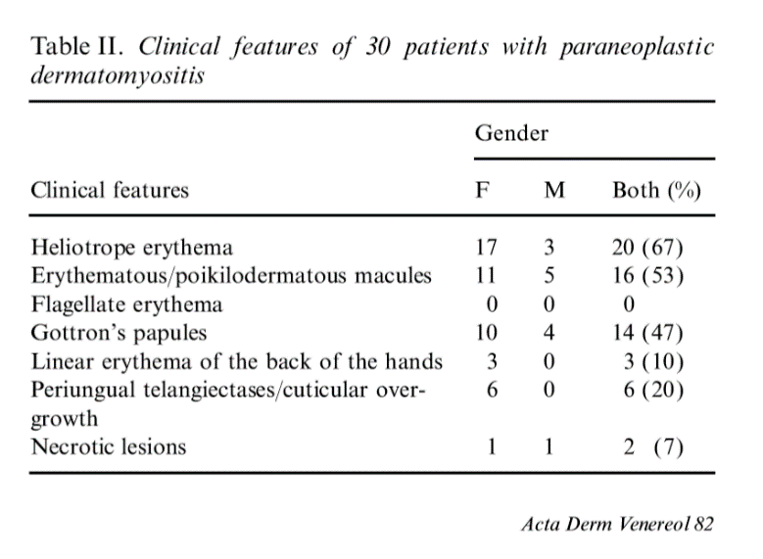
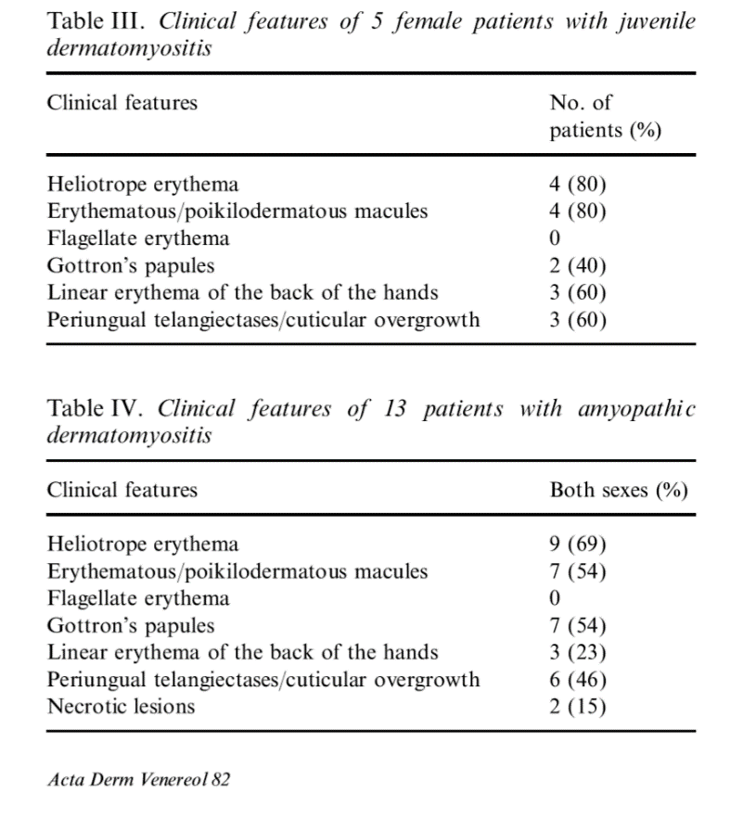
Fig. 2: Common cutaneous clinical features of dermatomyositis as shown in juvenile and adult populations.
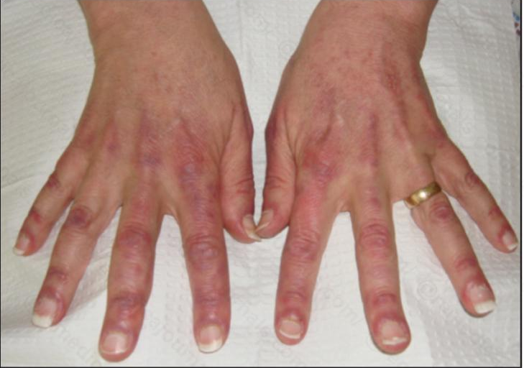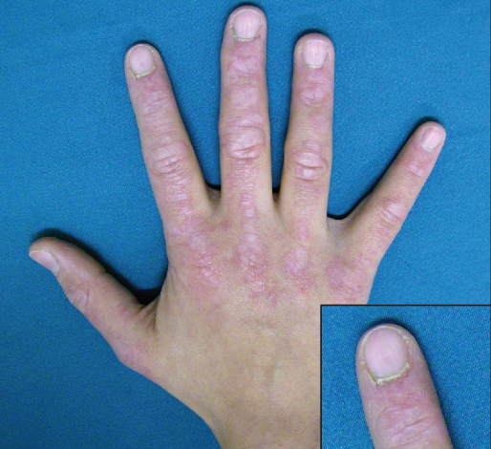
Fig. 3: Gottron papules, a frequently observed cutaneous lesion in patients with dermatomyositis.

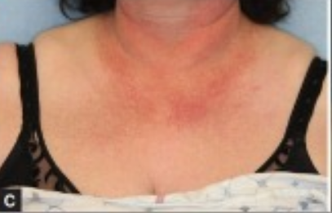
Fig. 4: The “V-neck sign”, a frequently observed cutaneous lesion in patients with dermatomyositis.

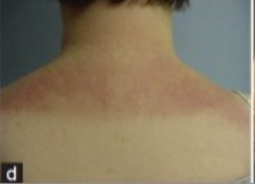
Fig. 5: The “Shawl sign”, a frequently observed cutaneous lesion in patients with dermatomyositis.

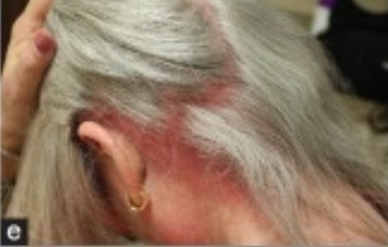
Fig. 6: The “Holster sign”, a frequently observed cutaneous lesion in patients with dermatomyositis.

Appendix B
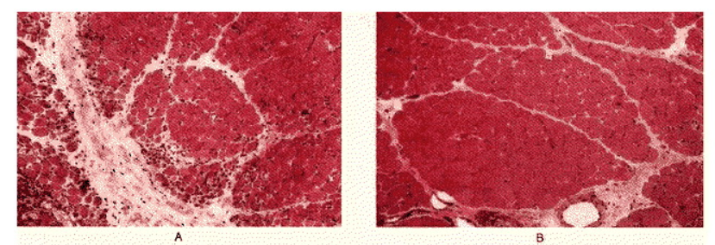
Fig. 1: Muscle biopsies before immunoglobulin treatment (image A) show that there are many small muscle fibers, lymphocytic infiltrates and an increased amount of connective tissue present. Following therapy (image B), there was a significant increase in the size of muscle fibers as well as diminishment of inflammation.

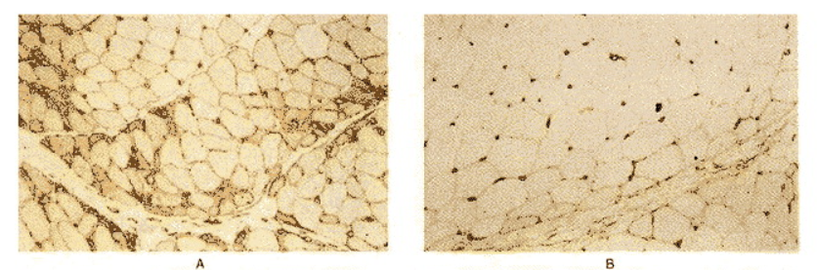
Fig. 2: Prior to immunoglobulin treatment, cross-sectional frozen muscle biopsies were stained with monoclonal antibodies to MHC-1 complex (image A). Following the treatment, muscle biopsies displayed a suppression of MHC-1 complexes as well as an increase in muscle fiber size (image B).

