Introduction
Femoral Acetabular Impingement (FAI) is a term used to describe “abnormal contact between the femoral head and the acetabular labrum” during normal or vigorous activity.^{1,2} Over the past decade, there have been few diseases that have gathered as much “debate and controversy as FAI”.³ The examination process is complex due to competing pathologies that have similar clinical presentation making it difficult to make a clear diagnosis.¹⁰ Despite the plethora of literature, researchers notes how controversy still exists in terms of its clinical relevance, incidence, diagnosis, and treatment.³ In fact, as much as sixty percent of hip arthroscopic patients are initially misdiagnosed.¹⁰ Misdiagnosis could lead to delay of appropriate care as well as utilization of unnecessary healthcare resources.¹⁰ Due to the growing recognition of FAI, physical therapists should have a complete understanding of the condition in order to provide effective intervention and management strategies.¹⁰
Clinical Presentation
FAI is usually divided into cam and pincer varieties.³ Both types are usually associated with femoral head (e.g., Legg-Calve-Perthes disease, slipped capital femoral epiphysis) or acetabular dysplasia.⁴ The cam impingement is more common in men and usually “manifests between 20 and 30 years of age”; pincer impingement is more common in women and usually manifests at a slightly older age.³ However, these two impingements are not mutually exclusive, there have been several studies that document a mixed pattern with one type predominating.^{5,6} The cam type impingement is commonly due to impingement of a “large aspherical femoral head in a tight acetabulum”.⁴ The deformed head leads to shearing of the acetabular cartilage and labrum.⁴ The cam impingement may also be a precursor to athletic pubalgia secondary to the increased stress at the symphysis pubis.⁴ The pincer type impingement is due to “over coverage of the humeral head by a prominent acetabular rim leading to pinching of the femoral neck against the labrum”.⁴ These two main impingements processes will eventually produce “chronic patterns of acetabular labrum and articular cartilage damage”.³ See Figure 1 for detailed images of the different femoral acetabular impingements.
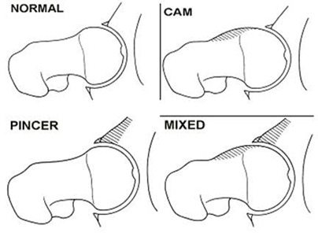
DB
B
B
B
A
C

Figure 1: Femoral Acetabular impingement (FAI). A. Normal hip. B. Reduced femoral head-neck offset (cam-type impingement).⁴ C. Excessive over coverage of the femoral head (pincer-type impingement).⁴ D. Combination of cam and pincer types of impingement.⁴

Patients will commonly present with groin pain, which may migrate to the buttocks or greater trochanter.⁸ Patients often describe a deep “anterior groin related pain” but may cup their hand around the anterior hip region which is called the “C-sign” and is indicative of intraarticular pathology.¹⁴ See Figure 2 for a detailed image of the “C-sign”. Other signs and symptoms that this patient may present with include: restricted range of motion, locking, and a sensation of instability.⁹ Groin pain may be exacerbated by activities that require the patient to perform flexion, adduction and internal rotation of the hip; however, pain can also present after prolonged sitting secondary to the proximity of the femur and acetabulum in this position.⁹ “The majority of the hip pain may be from articular structures since the hip is primarily innervated by the femoral and obturator nerve which innervate the anterior and medial hip joint”.¹⁵ Symptoms may be accompanied by posterior or lateral hip discomfort or mechanical symptoms.¹⁰ Reiman et al. found that “sharp pain with clicking and give away” may be related to an intraarticular pathology (sensitivity 100%, specificity 85%).¹⁷ Cheatham et al. recommends that the therapist be aware of key signs and symptoms revealed during the history portion of the exam in order to develop a hypothesis that can be tested during the objective portion.¹⁰
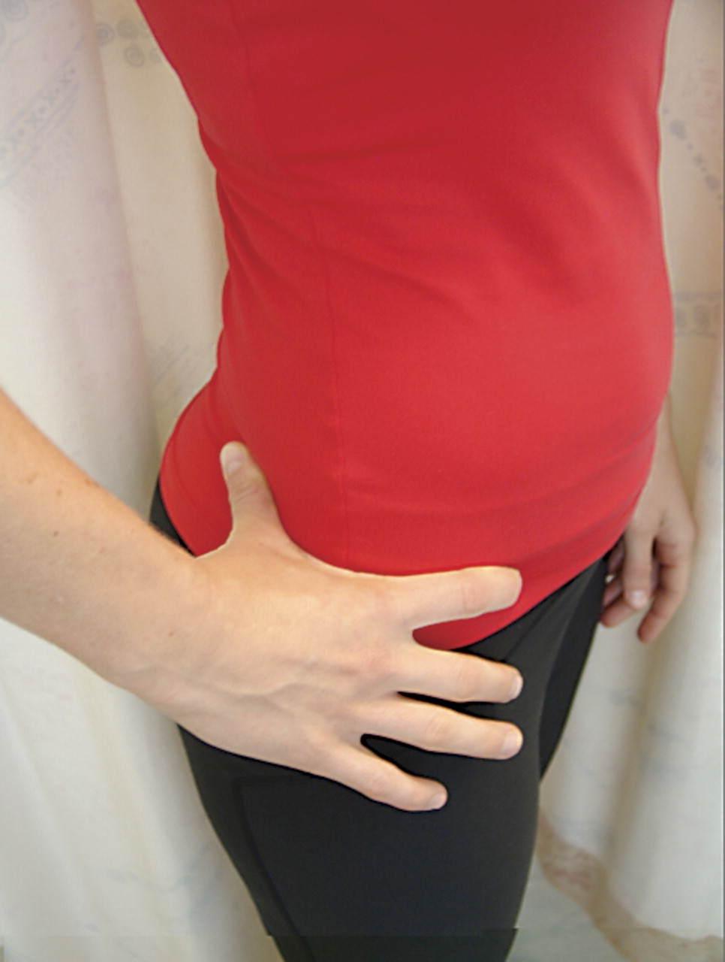
Figure 2: “C-Sign”
Differential Diagnosis
A thorough patient history will help the clinician determine what measures and tests are needed in order to formulate a diagnosis.¹⁰ During the differential diagnosis aspect of the exam, it is important to determine if the impingement is intra-articular or extra-articular.¹⁰ A growing body of literature reports external causes of hip impingement in younger patients (non-arthritic) which may include: iliopsoas impingment, subspine impingement and ischiofemoral impingement.¹⁰ Iliopsoas impingement presents with anterior hip pain and is linked to labral tears.¹⁰ The impingement can be caused by two suggested mechanisms: 1. a tight or inflamed iliopsoas tendon 2. a repetitive traction injury by the iliopsoas tendon. This pathology is often treated with a surgical release of the tendon.¹² Subspine impingement is caused by a “prominent anterior inferior iliac spine (AIIS) abnormally contacting the distal femoral neck” during flexion.¹⁰ This pathology could be caused by excessive activity of the rectus femoris during repetitive knee flexion with hip extension resulting in an avulsion injury of the AIIS.¹³ This type of injury is common in running sports and sports involving high energy kicking (e.g., soccer).¹³ Upon healing, this often results in an “enlarged bony protrusion” at the AIIS which will abnormally contact the femoral neck.¹⁰ Ischiofemoral impingement is characterized by a narrowed space between the lesser trochanter and ischial tuberosity which results in pinching of the quadratus femoris muscle.¹⁰ Sutter and Pfirrmann note that this impingement has been reported to be mainly congenital but may also be acquired via hip fracture.¹⁶ Other forms of hip impingement include extreme hip motions, abnormal pelvic and acetabular tilt, abnormal femoral antetorsion, greater trochanteric/pelvic impingement.¹⁶ Figure 3 will provide a summary of the external impingement pathologies.
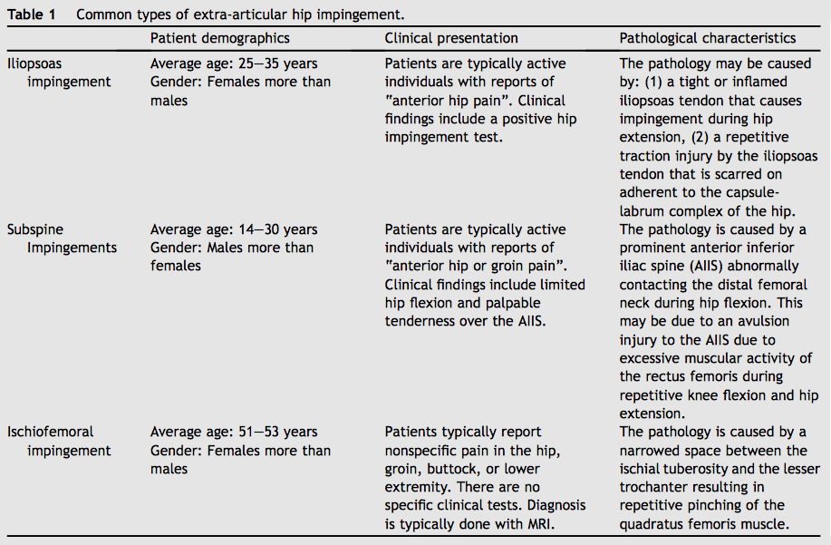
Figure 3: Common Types of Extra-Articular Hip Impingement¹⁰

Pelvic Position
Ida et al. observed a pattern of static pelvic positions in patients diagnosed with FAI.¹⁸ The researchers examined 94 patients with symptomatic hip dysplasia. All patients went through radiographic and computed tomography (CT) examinations.¹⁸ In the results section, the researchers found that 38 patients (40%) had both cam-type FAI and acetabular dysplasia and assumed a greater standing anterior pelvic tilt.¹⁸ This morphological issue (greater anterior pelvic tilt) could potentially induce secondary symptoms in these patients.¹⁸ Ross et al. examined preoperative pelvic CT scans in 48 patients who underwent surgery for FAI.¹⁹ The authors created computer models that analyzed various pelvic tilt and hip positons.¹⁹ They found that an anterior pelvic tilt resulted in the following: 1. Significant acetabular retroversion 2. Decrease in femoral internal rotation 3. 90 degrees of flexion and 15 degrees of adduction.¹⁹ A posterior pelvic tilt resulted in the following: 1. Increase in femoral internal rotation 2. 90 degrees of flexion and 15 degrees of adduction.¹⁹ Ross et al. concluded that dynamic anterior tilting is a predictor for earlier occurrences of FAI, whereas posterior pelvic tilt will result in later occurrence of FAI.¹⁹ These findings are also supported by Lewis et al. that found that individuals with anterior hip pain walk in a sway back posture (posterior pelvic tilt) which may increase anterior joint forces during walking/running secondary to the hip being in more extension.¹⁰
Joint and Soft Tissue Restrictions
There is no consensus as to whether joint hypomobility, tight soft tissues or muscle length deficits are risk factors/contributors to the symptoms of FAI.¹⁰ However, several studies have observed a connection between the issues above and FAI. Domb et al. were the first to report the “association between the iliopsoas tendon and anterior hip labral tears”.²⁰ The results showed that impingement of the iliopsoas tendon resulted in an anterior hip labral tear in 25 patients.²⁰ These findings are also supported by by other studies (Cascio et al., 2013; Nelson and Keene, 2014).¹⁰ Common treatment of iliopsoas impingement is a tenotomy and labral repair or debridement.²⁰ Currently, there are no clinical trials that have measured the effects of manual therapy for this pathology.²⁰
Kennedy et al. reported observing gait difference in hip abduction, sagittal and frontal plane hip ROM in subjects with unilateral FAI (cam type) when compared to a control group.²¹ When researchers compared the FAI group to the control group, they found the following: 1. Lower peak hip abduction 2. Lower frontal range of motion (ROM) 3. Lower pelvic frontal ROM.²¹ In the conclusion section, the authors note how these differences “may be caused by soft-tissue restriction in the hip and limited lumbosacral mobility.²¹ The case report by Cashman and their colleagues found muscle length deficits, soft-tissue and joint restrictions around the hip and lumbopelvis in subjects diagnosed with FAI.¹⁰
Cheatham et al. note how the correlation between soft-tissue restrictions and FAI is still under investigation.¹⁰ Whether these findings are “sequela or a causative factor” of an FAI pathology is still to be determined.¹⁰
Muscle Weakness
Several studies have found weakness in the hip musculature surrounding the symptomatic hip FAI.¹⁰ Casartelli et al. explored hip strength in in 22 patients with FAI when compared to a matched control group.²² The researchers used measured the maximum voluntary contraction (MVC) strength of all hip muscle groups using dynamometry (hand-held and isokinetic).²² They also measured electromyographic (EMG) activity of the tensor fascia latae and rectus femoris.²² In the results section, the patients with FAI had significantly lower strength than controls: hip flexion (26%), abduction (11%), adduction (28%) and external rotation (18%).²² The TFL EMG activity was “also significantly lower in patients with FAI than controls”.²²
Nepple et al. performed a similar investigation in 2015. The researchers measured preoperative MVC isometric strength in all hip muscle groups in patients with unilateral FAI and labral tears.²³ They found that hip abduction weakness was present in 46% of the patients and hip flexor weakness in 42% of the patients.²³ Lastly, they found was an 8% decrease in hip flexion and an 8.7% decrease in hip abduction of the involved hip when compared to the uninvolved.²³
Lewis et al. notes that patients with an intra-articular pathology tend to demonstrate decreased force of the gluteal muscles during hip extension and the iliopsoas during hip flexion.²⁴ The research that they presented suggests that patients with symptomatic FAI may present with global hip weakness.²⁴ The hip flexors and abductors are the two most common muscle weaknesses and should be considered during the evaluation of the patient.²⁴
Function and Gait
Cheatham et al. reports that patients with intra-articular pathologies such as FAI tend to limit their motion during function and gait secondary to pain and fear.¹⁰ Two of the top reasons for having surgery for FAI include: “alleviation of pain” and “fear of worsening”.¹⁰ Lamontagne et al. observed limited pelvic ROM in patients with FAI in comparison to a matched group during a maximum squat.²⁷ Diamond et al. performed a systematic review looking at both the physical and activity limitations in patients with FAI.²⁷ The most commonly reported impairment was decreased ROM in the direction of the hip impingement.²⁷ They also observed decreased internal rotation and sagittal plan ROM during stair climbing and walking.²⁷
Patients with FAI may demonstrate a compensatory gait pattern. Hunt et al. observed kinematic and kinetic differences in patients with FAI and a matched control group.²⁸ Patients with FAI exhibited the following: 1. A slower cadence 2. Less peak hip extension 3. Less peak hip adduction 4. Less peak internal rotation during stance 5. Less peak hip flexion 5. Less peak external rotation.²⁸ Physical therapists should integrate gait observation and functional tests, such as squats or stair climbing, into the examination process to understand the patient’s functional abilities. influence the patient’s performance.¹⁰
Special Testing
“Several special tests are used during the clinical examination of a suspected inta-articular hip pathology”.¹⁰ Among the tests, the flexion-abduction-external rotation (FABER) test and flexion-adduction-internal rotation (FADIR) are commonly used.¹⁰ Kapron et al. conducted a study using fluoroscopy during the supine clinical examination using the FADIR and FABER tests in patients with FAI.²⁵ The researchers found that patients with FAI had significantly less internal rotation and adduction during the FADIR exam and less abduction and external rotation during the FABER exam.²⁵ The authors also noted substantial pelvic motion during the two exam.²⁵
Other special tests include: Thomas test, resisted straight leg raise, log roll test, flexion-internal-rotation test and impingement provocation test.¹⁰ The statistical strength of these tests are still under investigation.¹⁹ Laborie et al. found that a positive anterior hip impingement test is “not uncommon” in healthy adult males.¹⁰ Cheatham et al. recommends using a combination of clinical tests with imaging for active patients with anterior hip pain.¹⁰ Cheetham et al. notes that impingement testing should be part of a comprehensive examination.¹⁰ Figure 4 will provide a summary of the special test involved with examining FAI.

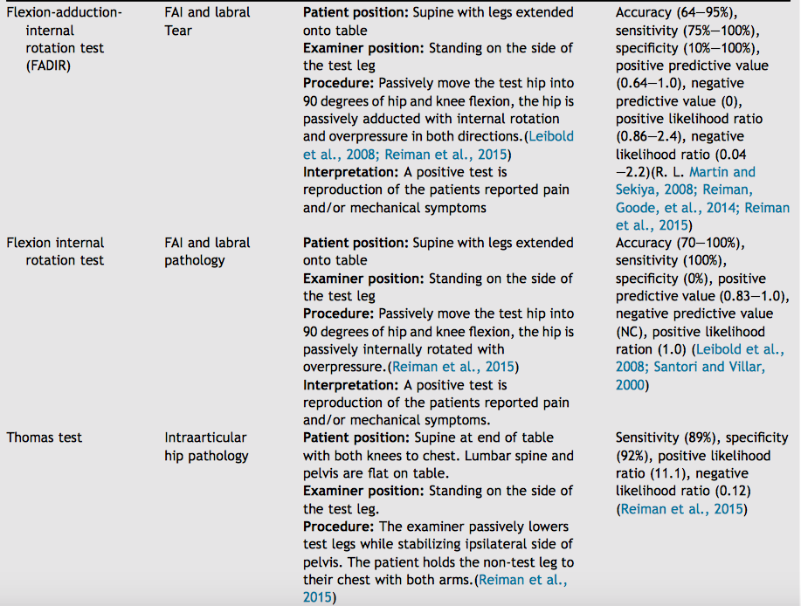

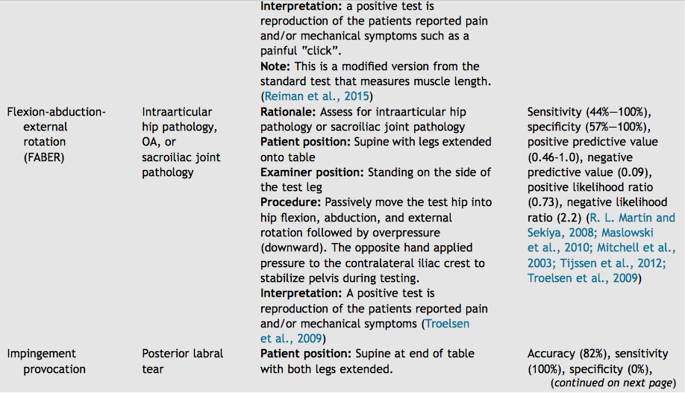

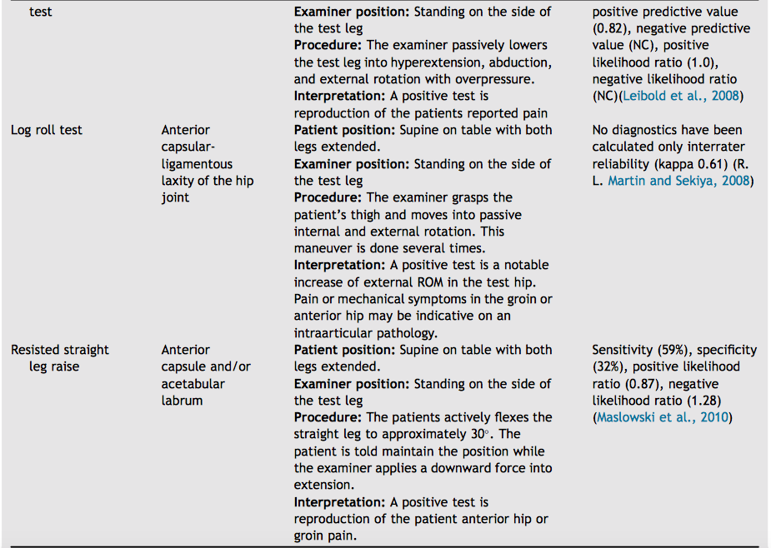

Figure 4: Special Tests for FAI¹⁰

Figure 4: Special Tests for FAI¹⁰

Imaging
Imaging can be used to confirm a clinical diagnosis of FAI.¹⁰ Several types of imaging are used to diagnose FAI and labral tears and include: magnetic resonance arthrography (MRA), diagnostic ultra sound (US), magnetic resonance imaging (MRI), computer tomography (CT), radiographs.¹⁰ Radiographs are typically used to assess the bony architecture of the coxa femoral joint to assess for bony abnormalities such as joint space, abnormal density, positional changes and shape of bone.¹⁰ Criteria for diagnosing pincer-type include: “a lateral center edge angle >40 degrees and acetabular includes of less that 0 degrees”.¹⁰ Criteria for diagnosing cam-type include: “an alpha angle >50.5 degrees and head-neck offset less than 8 mm”.¹⁰ Other findings for diagnosing FAI include acetabular crossover sign, pistol-grip deformity and prominent posterior wall sign.¹⁰ CT scans have shown good diagnostic accuracy for FAI.¹⁰ Diagnostic US is an emerging test that has a sensitivity of 82% and specificity of 60% for diagnosing labral tears.²⁶ MRI and MRA are the preferred techniques for diagnosing intra-articular hip pathologies.¹⁰ MRI has a sensitivity of 66% and specificity of 79% for diagnosing FAI. MRA has a sensitivity of 91% and specificity of 80%.¹⁰ MRI and MRA have both shown moderate sensitivity and specificity for diagnosing labral tears.¹⁰ Cheatman et al. note that imaging is often used to confirm the finding from the clinical examination and determine what structures are involved.¹⁰
Outcome Measures
Outcome measures should be included in the examination process in order to obtain a more objective, repeatable measure of the patient’s process.¹⁰ For groin pathologies of non-arthritic young middle age adults, the following are recommended: 1. Copenhagen Hip and Groin Outcome Score (HAGOS), Hip Outcomes Score (HOS), International Hip Outcome Tool-33 (IHOT-33) and IHOT-12 (short version).²⁹ All of the questionnaires have good clinometric properties, test-retest reliability and construct and content validity.²⁹ The HAGOS contains six separate subscales: “pain, symptoms, physical function in daily living, physical function in sports and recreational activity, participation in physical activity and hip and/ or groin quality of life”.²⁹ The HOS has twenty four questions that measure activities of daily living and function during sports.²⁹ The IHOT tools measure hip related symptoms, function, sports, function with occupational activities and quality of life.¹⁰
Treatment
Hendry et al. note that the goal of treatment in FAI is to: 1. Relieve the pain secondary to impingement 2. Slow or stop the progression of joint degeneration 3. Maintain joint functionality.³ Although acute hip pain may predominantly be caused by labral damage, research has shown that treating the labral pathology without addressing osseous abnomalites will continue to produce symptoms.³ Tanzer and Noiseaux found that when treating the labral pathology in patients who had underlying cam-type FAI, only twenty five percent of patients had relief from their pain.
Appropriate treatment strategy for FAI should be determined post evaluation of the patient’s history, physical examination findings and detailed imaging studies.³⁰ Conservative management options should be used and many include: nonsteroidal anti-inflammatory drugs, physical therapy, activity modification and intraarticular injections.³⁰ However, continued FAI can lead to progressive injury to both the labrum and cartilage.³⁰ Therefore, patients should be followed closely, and surgical intervention could be offered if symptoms continue to persist.³⁰ Surgery must be tailored to the individual’s pathology.³⁰ Some pathologies may necessitate and arthroscopic technique while other may be addressed with an open approach.³⁰ Early results of both techniques are encouraging, with most patients reporting 95% reduction in pain and improved function.³⁰
Physical Therapy
Short et al. performed a combined treatment approach emphasizing impairment based manual therapy and exercise for hip related compensatory injuries in elite athletes.³¹ Five athletes were clinically diagnosed by a physical therapist with primary pathologies including adductor-related groin pain (ARGP), FAI with acetabular labral lesion and acute, mechanical low back pain.³¹ Similar subjective and objective findings were found in all five athletes.³¹ Common findings included: decreased hip ROM, impaired lumbopelvic motor control and strength, lumbar hypomobility and positive FADIR special test.³¹ Short et al. performed a three phase physical therapy program to resolve primary complaints and return subjects to desired level of function.³¹ Acute phase consisted of manual therapy and fundamental motor control exercises.³¹ Progression to subacute and terminal phases was based on improved subjective pain and progress with functional impairments.³¹ As the subjects progressed through phases, there was a decrease in manual therapies and an increase emphasis on graded exercise.³¹ The researchers found that the athletes had significant reductions in pain, improved function via Hip and Groin Outcome score and continued participation in sport in all cases without the need for surgical intervention.³¹ The researchers note how the athletes involved in this case make up a common clinical sub-group defined by hip and lumbopelvic restrictions and motor control impairments.³¹ They suggest a comprehensive treatment strategy for athletes with the shared impairments listed above. Figures 5-10 list the protocol that they used in their treatment plan.³¹
Manual Interventions:
Acute Phase (Day 1-5)

Manual Therapy Sets/Repetitions Frequency
Intervention Technique

Hip Long Axis 3*30 seconds 3*5 weekly
Distraction Mobilization
and Manipulation

Anterior to Posterior Hip Mobilization 3*30 secondds 3*5 weekly

Inferior Hip Mobilization 3*30 seconds 3*5 weekly

Lumbopelvic 1*1-2 3*5 weekly
Manipulation

Thoracic and 1*1-2 3*5 weekly
Thoracolumber Manipulation

Lumbar Central and 3*30 seconds 3*5 weekly
Unilateral Posterior to
Anterior Mobilization

Lumbopelvie Sof Tissue Until Change in Reported 3*5 weekly
Mobilization

Dry Needling (Adductor Longus, 1-6 Twitch Responses 3*5 weekly
Tensor Fasciae Latae)

Figure 5: Manual Therapy Interventions: Acute Phase (Day 1-5)³¹
Sub-Acute Phase (Day 6-19)

Manual Therapy Sets/Repetitions Frequency
Intervention Technique

Hip Long Axis 3*30 seconds 1-3x weekly
Distraction Mobilization
And Manipulation

Anterior to Posterior Hip 3*30 seconds 1-3x weekly
Mobilization

Interior Hip Mobilization 3*30 seconds 1-3x weekly

Lumbopelvic 1*1-2 1-3x weekly
Manipulation

Thoracic and 1*1-2 1-3x weekly
Thoracolumbar
Manipulation

Lumbar Central and 3*30 seconds 1-3x weekly
Unilateral Posterior to
Anterior Mobilization

Lumbopelvic Soft Tissue Until Change in Reported 1-3x weekly
Mobilization

Dry Needling (Adductor 1-6 Twitch Responses 1-3x weekly
Longus, Tensor Fasciae
Latae)

Hip Mobilization With 3*15 1-3x weekly
Movement Variations

Self-Soft Tissue Each Lower Extremity 1-3x weekly
Mobilization (Foam Muscle Group
Rolling)
Figure 6 Manual Therapy Interventions: Sub-Acute Phase (Day 6-19)³¹

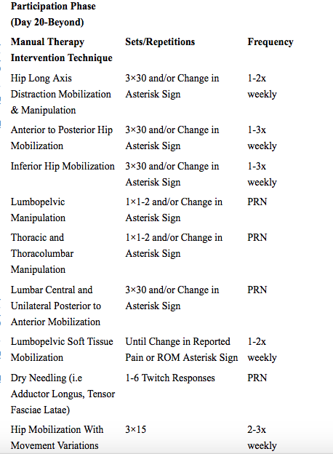

Figure 7 Manual Therapy Interventions: Participation Phase (Day 20 and more)³¹
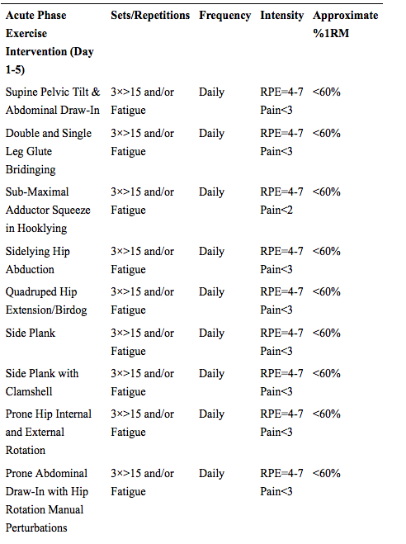Figure 8 Exercise Therapy Interventions: Acute Phase (Day 1-5)³¹
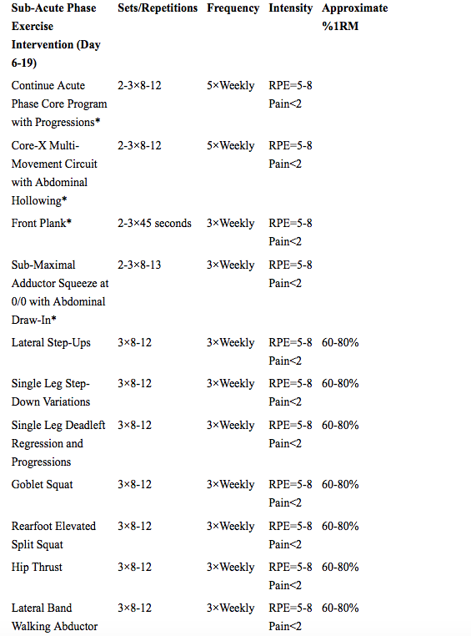
Figure 9 Exercise Therapy Interventions: Sub-Acute Phase (Day 6-19)³¹
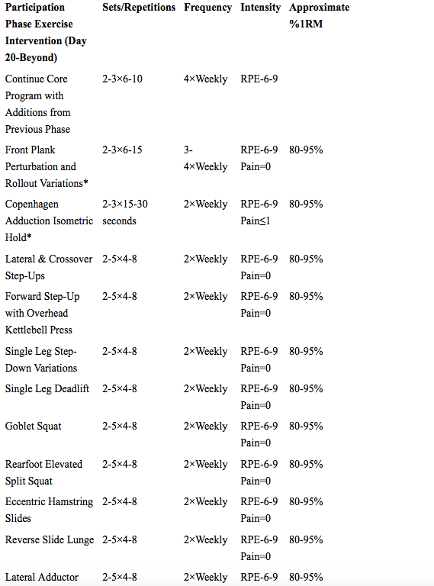
Figure 10 Exercise Therapy Interventions: Participation Phase (Day 20 plus)³¹
Resources:
- Bardakos NV, Villar RN. Predictors of progression of osteoarthritis in femoroacetabular impingement: A radiological study with a minimum of ten years follow-up. J Bone Joint Surg Br. 2009;91:162-169.
- Leunig M, Beaulé PE, Ganz R: The concept of femoroacetabular im- pingement: Current status and future perspectives. Clin Orthop Relat Res. 2009;467:616-622.
- Hendry D, England E, Kenter K, Wissman R. Femoral Acetabular Impingement. Seminars in Roentgenology. 2013;48(2):158-166.
- Magee D. Orthopedic Physical Assessment. Sixth Edition. St. Louis, Missouri: Elsevier Saunders; 2014.
- Beck M, Kalhor M, Leunig M. Hip morphology influences the pattern of damage to the acetabular cartilage. J Bone Joint Surg Br. 2005; 87-B:1012-1018.
- Pfirrmann CW, Duc SR, Zanetti M. MR arthrography of acetabular cartilage delamination in femoroacetabular cam impingement. Radiology. 2008; 249:236-241.
- Anderson LA, Peters CL, Park BB, et al: Acetabular cartilage delamination in femoroacetabular impingement. Risk factors and magnetic resonance imaging diagnosis. J Bone Joint Surg Am 91:305-313, 2009
- Wagner S, Hofstetter W, Chiquet M. Early osteoarthritic changes of human femoral head cartilage subsequent to femoro-acetabular impingement. Osteoarthritis Cartilage. 2003;11:508-518.
- Beck M, Chegini S, Ferguson S. Mechanism of femoroacetabular impingement, in Marín-Peña Ó (ed): Femoroacetabular Impingement. Berlin, Heidelberg, Germany, SpringerVerlag. 2012; pp 9-22.
- Cheatham S, Enseki K, Kolber M. The clinical presentation of individual with femoral acetabular impingement and labral tears: A narrative review of evidence. Journal of Bodywork and Movement Therapies. 2016;20:346-355.
- Clohisy J, Baca G, Beaule P, Kim Y, Larson C, Millis M, Zaltz I. Descriptive epidemiology of femo- roacetabular impingement: a North American cohort of patients undergoing surgery. Am. J. Sports Med. 2013;41 (6):1348-1356.
- Domb B, Shindle M, McArthur B, Voos J, Magennis E, Kelly B. Iliopsoas impingement: a newly identified cause of labral pathology in the hip. HSS J. 2011;7(2):145-150.
- de Sa D, Alradwan H, Cargnelli S, Thawer Z, Simunovic N, Cadet E, Ayeni O. Extra-articular hip impingement: a systematic review examining operative treatment of psoas, subspine, ischiofemoral, and greater trochanteric/pelvic impingement. Arthroscopy. 2014;30(8):1026-1041.
- Byrd,J. Evaluation of the hip: history and physical ex- amination. N. Am. J. Sports Phys. Ther.2007;2(4): 231-240.
- Frank R, Slabaugh M, Grumet R, Virkus W, Bush- Joseph C, Nho S. Posterior hip pain in an athletic population: differential diagnosis and treatment options. Sports Health. 2010;2(3):237-246.
- Sutter R, Pfirrmann C. Atypical hip impingement. Am. J. Roentgenol. 2013;201 (3):W437-W442.
- Reiman M, Thorborg K. Clinical examination and physical assessment of hip joint-related pain in athletes. Int. J. Sports Phys. Ther. 2014;9(6):737-755.
- Ida T, Nakamura Y, Hagio T, Naito M. Prevalence and characteristics of cam-type femoroacetabular deformity in 100 hips with symptomatic acetabular dysplasia: a case control study. J. Orthop. Surg. 2014;9:3.
- Ross J, Nepple J, Philippon M, Kelly B, Larson C, Bedi A. Effect of changes in pelvic tilt on range of motion to impingement and radiographic parameters of acetabular morphologic characteristics. Am. J. Sports Med. 2014;42(10): 2402-2409.
- Domb B, Shindle M, McArthur B, Voos J, Magennis E, Kelly B. Iliopsoas impingement: a newly identified cause of labral pathology in the hip. HSS J. 2011;7(2): 145-150.
- Kennedy M, Lamontagne M, Beaule P. Femo- roacetabular impingement alters hip and pelvic biomechanics during gait walking biomechanics of FAI. Gait Posture. 2009;30(1): 41-44.
- Casartelli N, Maffiuletti N, Item-Glatthorn J, Staehli S, Bizzini M, Impellizzeri F, Leunig M. Hip muscle weakness in patients with symptomatic femoroacetabular impingement. Osteoarthr. Cartil.2011;19(7):816-821.
- Nepple J, Goljan P, Briggs K, Garvey S, Ryan M, Philippon M. Hip strength deficits in patients with symptomatic femoroacetabular impingement and labral tears. Arthroscopy. 2015.
- Lewis C, Sahrmann S, Moran D. Anterior hip joint force increases with hip extension, decreased gluteal force, or decreased iliopsoas force. J. Biomech. 2007;40(16):3725-3731.
- Kapron A, Aoki S, Peters C, Anderson A. In-vivo hip arthrokinematics during supine clinical exams: application to the study of femoroacetabular impingement. J. Biomech. 2015.
- Kong A, Van der Vliet A, Zadow S.MRI and US of gluteal tendinopathy in greater trochanteric pain syndrome. Eur. Radiol. 2007;`1(7):1772-1783.
- Lamontagne M, Kennedy M, Beaule P. The effect of cam FAI on hip and pelvic motion during maximum squat. Clin. Orthop. Relat. 2009;467 (3): 645-650.
- Hunt M, Guenther J, Gilbart M. Kinematic and kinetic differences during walking in patients with and without symptomatic femoroacetabular impingement. Clin. Biomech. 2013;28(5):519-523.
- Thorborg K, Holmich P, Christensen R, Petersen J, Roos E. The copenhagen hip and groin outcome score (HAGOS): development and validation according to the COSMIN checklist. Br. J. Sports Med. 2011;45(6):478-491.
- Amanatullah D, Pillay K, Toupadakis C. Femoracetabular Impingement: Current Concepts in Diagnosis and Treatment. Orthopedics. 2015;38(3):185-99.
- Short S, Short G, Strack D, Anloague P, Brewster B. A COMBINED TREATMENT APPROACH EMPHASIZING IMPAIRMENT-BASED MANUAL THERAPY AND EXERCISE FOR HIP-RELATED COMPENSATORY INJURY IN ELITE ATHLETES: A CASE SERIES. International Journal of Sports Physical Therapy. 2017;12(6):994-1010.

