Whiplash and Whiplash Associated Disorders
In 2016, nearly 300,000 car crashes occurred in North Carolina, resulting in approximately 130,000 persons injured¹. Whiplash is the most common injury that is associated with motor vehicle crashes, occurring in 83% of people, and whiplash associated disorders (WAD) have been estimated to occur in 4 out of every 1,000 persons in the United States². It is important to clearly differentiate the terms whiplash and whiplash associated disorders because, although they are interrelated, they are two distinct terms. Whiplash is the bony and/or soft tissue injuries that result from “rear-end or side impact, predominantly in motor vehicle accidents”². Whiplash occurs secondary to an acceleration-deceleration mechanism, which will be discusses later in this review². In contrast, whiplash associated disorders are the clinical manifestations that come about as a result of a whiplash injury, and thus what physical therapists will encounter in practice². The high prevalence of whiplash and whiplash associated disorders warrants further exploration into the manifestation, evaluation, and treatment of such conditions. The economic burden associated with whiplash injuries further justifies this exploration, as it is estimated that 3.9 billion dollars are spent each year on medical care, disability, and sick leave for those with whiplash injuries². This figure does not include litigation spending, which leads to costs greater than 29 billion dollars annually². Whiplash can also occur in athletes involved in contact sports, but the prevalence is much lower than in motor vehicle crashes, and thus it will not be addressed in this particular review³.
Whiplash injuries are traditionally defined as acceleration-deceleration injuries³. The most common mechanism of injury, responsible for 85% of all whiplash injuries, are rear-end collisions³. Research and understanding of the biomechanics of whiplash injuries is limited, and focused primarily on rear-end collisions. A hallmark study by Grauer et al. in 1997 contributed greatly to what is known about the kinematics of whiplash injuries⁴. This study used six cadaveric specimens that consisted of the occiput to C7/T1⁴. The specimens were mounted to an apparatus, with the distal end of the spine specimens attached to the sled and the proximal end attached to a surrogate head representing the 50th percentile for human head weight⁴. A picture of the apparatus is provided in Appendix A-1 for better understanding of the study methods⁴. A rear-end collision was simulated as the sled on the tracks of the apparatus was hit from behind, accelerated to its maximum velocity, decelerated as the breaks were hit, and then came to rest⁴. Data in the form of intervertebral rotation angles, as compared to the physiologic limits determined previously, were collected for four different acceleration conditions that represented greater velocities at collision⁴. The authors concluded that, contrary to previous studies and wide-spread beliefs, the head did not extend beyond physiologic limits, and thus pure hyperextension is not the cause of the injuries seen with whiplash⁴. Rather, the physiologic limits of extension were exceeded at the levels of C6-C7 and C7-T1 during a time period in which the cervical spine mimicked an S-shaped curvature⁴. The S-shape curvature represents upper cervical flexion and lower cervical extension. Only after this did the cervical spine assume the C-shaped curvature that represents total cervical extension⁴. This C-shaped curvature was found to have a lesser potential for soft-tissue injury as compared to the S-shaped curvature⁴. It was postulated that the S-shaped curve was associated with greater injury and structural damage secondary to the great degree of extension required in the lower cervical spine to compensate for the upper cervical flexion⁴.
This study was further expounded upon by Luan et al. that utilized the same methods as the Grauer et al. study^{4,5}. The study reported that neck kinematics with rear-end collisions and whiplash injuries can be divided into three stages⁵. In the first stage (0-100ms after impact), there is a flexion of the upper and lower cervical spine and loss of the natural cervical lordosis⁵. Shear forces are transmitted first through the lower cervical levels and then through the upper cervical levels, which leads to the loss of cervical lordosis⁵. The axial forces of the neck during this stage are compressive in nature for the first 60ms, and then change to tensile stresses⁵. During the second stage, which is 30ms in duration, the cervical spine forms the S-shaped curvature described previously^{4,5}. Shear forces are present and acting at all levels of the cervical spine, and there is a tensile axial force of the neck⁵. The third and final stage is when the cervical spine assumes the C-shaped curvature, and the entire neck is in extension^{4,5}. There are shear forces acting at all levels of the cervical spine and tensile axial forces acting at the neck⁵. At 180ms post-collision, the head reaches maximum extension and starts to rebound, thereby reducing the extension moment⁵. An image from the Luan paper, demonstrating the kinematics of the cervical spine during each of the three stages, is provided in Appendix A-2⁵.
With a mechanism of injury as complex as whiplash injuries there are many possible sites of injury that include: the facet joints and capsules, ligaments, intervertebral discs, vertebral arteries, nerve roots, and muscles⁶. It is important to explore the mechanisms that lead to these tissue-specific injuries, as they explain the common signs and symptoms seen following whiplash injuries. The cervical facet joints have been reported to be the most common source of neck pain, particularly in patients with chronic whiplash⁶. Two mechanisms of facet joint injury have been commonly cited in the literature; pinching of the synovial fold and excessive capsular strain⁶. The synovial fold is a component of the innermost part of the facet capsule that encloses the individual facet joints⁶. During a whiplash injury, the cervical vertebrae rotate excessively, and this abnormal motion leads to the synovial fold being compressed between the two adjacent articular facets⁶. The excessive capsular strain mechanism of injury is also highly supported in the literature⁶. It has been found that during whiplash conditions, there are peak strains of 29-40% of the facet capsule, as compared to the approximately 6% strain that occurs during normal motion⁶. Additionally, the maximum capsule strain seen with partial capsular failure is 35-65%, which indicates that whiplash conditions can lead to partial ruptures⁶. Lastly, there have been studies that have linked capsular strain with afferent nociceptive fibers, and thus pain symptoms⁶. Tensile loading of the C5-C6 facet joint, producing capsular strains of around 10%, has been shown to activate the nociceptive afferents and led to pain⁶. Furthermore, it has been demonstrated that a strain of at least 21% can lead to persistent sensitivity of the nociceptive fibers, and thus chronic pain symptoms⁶. As seen in the literature, the capsular strains that are typically produced in a whiplash injury are enough to lead to both acute and chronic neck pain⁶.
The next potential location of injury following whiplash are the ligaments of the neck, which include the alar, transverse, anterior and posterior longitudinal, interspinous, supraspinous, and the ligamentum flavum⁶. A picture depicting the location of these major ligaments, is provided in Appendix B-1⁶. The ligaments of the cervical spine serve many important functions, with three of the pertinent to whiplash rehabilitation being: energy absorption during high-speed traumas like motor vehicle crashes, providing stability, and providing joint position sense during motion⁶. As such, injury to these cervical spine ligaments can lead to neck pain, spinal instability, abnormal muscle response patterns, decreased mobility, and decreased proprioception⁶. With rear-end collisions, strains of the anterior longitudinal ligament are most frequently seen⁶. With frontal, or head-on, collisions, the supraspinous ligament, interspinous ligament, and ligamentum flavum are at greatest risk for injury⁶. Of interesting note, injuries to the alar and transverse ligaments are more likely and severe in patients who have their head rotated at the time of impact⁶. This information validates the critical need to collect detailed information from the patient regarding the crash details, as well as head position at impact if possible.
The intervertebral discs have also been found to be a tissue that are vulnerable to damage following whiplash injuries⁶. In rear-end collisions, the C5-C6 disc is at greatest risk of injury, whereas the C2-C3 disc is at greatest risk with frontal collisions⁶. Another structure that can be damaged in whiplash injuries are the vertebral arteries, which can lead to symptoms of headache, blurred vision, tinnitus, dizziness, and vertigo⁶. There are three theorized mechanisms of injury that have been reported for the vertebral arteries, and they include: injury from combined extension and rotation of the upper cervical spine, vertebral artery elongation, and stretching or pinching of the vessel along its path through the cervical transverse processes to the brain⁶.
Injury to the cervical nerve roots are have also been documented, and can lead to symptoms such as neck pain, cervicogenic headache, vertigo, vision disturbances, and neurological symptoms in the upper extremities⁶. Injury to the nerve roots helps to explain the hypersensitivity to pressure that is frequently seen in patients post-whiplash injury⁶. In addition to decreased pain thresholds, there is also an electrical excitability seen in the spinal cord post-whiplash, which is indicative of a malfunction in central pain processing⁶. This, over time, can lead to chronic pain, which is common in patients post-whiplash⁶. Lastly, the impacted nerve roots lead to larger areas of referred pain in patients with whiplash injuries, which makes assessment and treatment more challenging⁶.
The mechanisms by which the cervical nerve roots are injured include changes in fluid volume within the spinal canal and nerve root deformation⁶. With normal cervical motions, there are changes in blood volume within the spinal canal, which are compensated for by the low resistance to fluid motion⁶. With whiplash injuries, which occur so quickly, there is an increased resistance to blood flow that leads to pressure gradients that load and damage the nerve roots⁶. Specifically, there is a drop in pressure within the spinal canal, and a resulting increase in pressure outside of the canal which load the nerve roots and spinal nerves and lead to damage⁶. In considering the second mechanism of nerve root injury, nerve root deformation, it has been found that the diameter of the neural foramen decreases at the extremes of cervical motion, and thus can compress the nerve root within it⁶. Studies have reported that this decrease in diameter with whiplash caliber impacts can be up to 20% for segments C4-C7, and as much as 1.8mm for C5-C6⁶. The average neural foramen width is about 8.3mm for level C2-C3, 7.2mm for C3-C4, 6.8mm for C4-C5, 6.9mm for C5-C6, 7.1mm for C6-C7, and 6.9mm for C7-T1⁷. Combining this information, the lower cervical segments are at greater risk of nerve root compression secondary to greater decrease in diameter as compared to the upper segments.
The last tissue that is frequently damaged in whiplash is cervical musculature⁶. A picture of the musculature commonly involved in whiplash injuries is provided in Appendix B-2⁶. It has been found in numerous studies that the percentage strain of the sternocleidomastoid (maximum of 15%) and the posterior musculature (maximum 50%) during rear-end collisions exceeds the percentage strain that has been associated with muscle injury (5-20%)⁶. Therefore, muscle injuries are possible and likely following whiplash injuries. The mechanism that leads to muscle injury following whiplash is an eccentric contraction with subsequent muscle lengthening, and it has been found that during rear-end collisions both anterior and posterior cervical muscles are affected⁶. The sternocleidomastoid is typically injured during the first two, and into the third, phases of whiplash where the neck assumes the S-shaped curve followed by the C-shaped curve⁶. After that point, as the head starts to rebound, the posterior musculature is more likely to be injured⁶.
In addition to a direct injury to the musculature that can lead to whiplash symptoms, it is also important to consider the fact that the muscles of the cervical spine interact with and are innervated by the other tissues previously discussed, like the facet capsules and nerve roots⁶. Therefore, it is critical during evaluation to assess whether the presenting symptoms are of purely musculoskeletal origin, or if they could be of neuromuscular origin. Furthermore, it is necessary to consider what other tissues could be impacted as a result of the strain that muscle activation causes within other tissues.
The whiplash associated disorders following whiplash injury include neck pain, neck stiffness, upper quarter pain/paresthesia, temporomandibular dysfunction, headache, visual disturbances, dizziness, vertigo, memory and concentration disturbances, decreased joint position sense/ cervical proprioception, and psychological symptoms such as depression and anxiety^{2,6}. As the focus of this paper shifts towards evaluation and treatment, it is important to be cognizant of risk factors associated with prolonged recovery and poorer outcomes. They have been found to include: female sex, older age, high initial pain intensity (>5.5/10), the involvement of a lawyer, neurological symptoms, pre-existing neck pain, concomitant low back pain, dizziness post-injury, an initial Neck Disability Index score of greater than 29%, symptoms of post-traumatic stress, high catastrophizing, and the patient having poor expectations for recovery ^{2,8,9}.
A thorough clinical evaluation of a patient presenting with symptoms consistent with whiplash and its associated disorders is essential, as the diagnosis is purely clinical². Whiplash injuries typically cannot be identified radiographically, and there are currently no special tests that can diagnose such injuries². It is important to note, however, that imaging is indicated for patients with suspected disc injury, spinal cord injury, fracture, or ligamentous injury leading to cervical instability. The physical therapy evaluation of a patient presenting post-whiplash injury should follow the layout of a typical cervical examination.
Some of the outcome measures that have been validated for use in the whiplash population are the Pain Catastrophizing Scale, the Neck Disability Index, and the Core Whiplash Outcome Measure^{9,10,11,12}. The Pain Catastrophizing Scale is particularly useful secondary to the association of catastrophizing with poor outcome⁹. This scale is 13-item measure that asks patients to rate on a 5-point scale, from not at all to all the time, how frequently they experience certain thoughts and feelings about their pain¹⁰. The score can range from 0 to 52, with a score of greater than 24 being clinically relevant for high pain catastrophizing^{9,10}. The next outcome measure, the Neck Disability Index is composed of ten sections that assess how severely neck pain is impacting functioning¹¹. The ten sections include pain intensity, personal care, lifting, reading, headaches, concentration, work, driving, sleeping, and recreation¹¹. Each section is scored from 0-5 points, thus the overall score is out of 50, which can then be converted to a percentage disability score¹¹. Mild pain and disability is indicated by a score of 10-28%, moderate by a score of 30-48%, severe by a score of 50-68%, and complete disability by a score of >70%⁹. The last outcome measure, which is relatively new, is the Core Whiplash Outcome Measure¹². It consists of 5 questions that evaluate symptoms, function, well-being and disability¹². Because this is a relatively new outcome measure to practice, a copy of it is provided in Appendix C-1¹². Though cut-off scores have not been defined to date, the Core Whiplash Outcome Measure has been found to have excellent internal consistency and convergent validity with the Functional Rating Index, the Neck Disability Index, and the SF-36¹². Thus, it is an appropriate and beneficial measure to use in the clinic, and it is quick to administer and score¹².
Because the examination of patients presenting post-whiplash injury follows a typical cervical screening, an overview of important components will be discussed, but the details of every test and measure will not be provided. The subjective examination should comprise, in addition to the questions typically included, detailed questioning about the accident, including speed at impact, whether the patient was restrained, and if the patient loss consciousness. It should also be noted whether the patient has seen a physician or has had any imaging done. Red flags that indicate cervical myelopathy, upper cervical ligamentous instability, vertebral artery insufficiency, and fracture should be assessed and appropriate referrals should be made if necessary¹³. A postural assessment, examination of active and passive ranges of motion, and manual muscle testing should be performed as indicated, noting which motions produce pain¹³. In addition to this, segmental mobility should be assessed via joint mobilizations to the patient’s tolerance¹³. An assessment of dermatomes and myotomes should also be included secondary to the potential involvement of cervical nerve roots¹³. Cervical palpation and soft tissue mobilization should also be included in an evaluation of a patient following whiplash, keeping in mind that hypersensitivity is common, to assess for muscle tightness and specific tissues that are causing pain¹³. Lastly, there are a plethora of special tests that can be utilized in this population depending on patient presentation and chief complaints. Some of these special tests include: Spurling’s Test, Cervical Distraction, Upper Limb Tension Test A (median nerve bias), the Alar Ligament Test, the Sharp-Purser Test, the Craniocervical Flexion Test, and Vertebral Artery Testing¹³. If the patient reports dizziness or vertigo, the Dix Hallpike Test should be administered, and the therapist should assess vision and oculomotor control by looking at smooth pursuits, gaze stability, the vestibulo-ocular reflex, vestibulo-ocular reflex cancellation, visual acuity, convergence, and the Head Thrust Test¹³. Though the subjective report from the patient is typically all that is needed to make a clinical diagnosis, a thorough examination allows for the development of a comprehensive plan of care to address all affected tissues.
The 2017 revised Clinical Practice Guidelines from the Orthopedic Section of the APTA
provide the basis for interventions in patient’s post-whiplash¹⁴. In addition to a summary of these guidelines, research on the use of dry-needling and interventions targeting sensorimotor control will also be provided. When considering interventions for whiplash associated disorders, the patient can fall into the acute, subacute, or chronic category, and the interventions that are most effective are dependent upon that staging¹⁴. The staging of the patient is determined via the prognostic factors mentioned earlier, or it may be clear in cases in which a patient comes in so many months’ post-whiplash with persistent symptoms¹⁴. For the purposes of the APTA Clinical Practice Guidelines, acute is defined as less than a 6-week recovery, subacute is a 6-12-week recovery, and chronic is greater than 12 weeks¹⁴. It is important to note that recovery for majority of patients with whiplash associated disorders is expected to occur within 2 to 3 months¹⁴.
For patients in the acute and subacute stages, the interventional components are very similar and should include exercises, education, manual therapy, and modalities¹⁴. The research on therapeutic exercises has shown that exercise alone is not effective in reducing pain and disability, and thus multimodal treatment plans are ideal¹⁴. There has also not been any data to justify the superiority of one exercise approach over another¹⁴. Generally, however, the types of therapeutic exercises supported in the literature include: postural stabilization, active cervical range of motion, motor control exercises, isometric low-load strengthening, stretching of the cervical musculature, and cervical kinesthetic training¹⁴. The use of manual therapy interventions is also not effective when used in isolation, and thus must be part of a multi-faceted treatment plan¹⁴. Massage, soft tissue mobilization, and cervical joint mobilizations are the three techniques supported in the literature, but the research in this area is weak overall¹⁴. The last piece of the puzzle for patients in the acute and subacute stages is education, which has been demonstrated to play a major role in recovery¹⁴. The educational components that should be included are: instructions to minimize the use of a cervical collar, appropriate postural corrections, coping strategies, reassuring the patient about prognosis and typical recovery times, and, most importantly, encouraging the patient to remain active and to “act as usual”¹⁴. Lastly, in these stages, it has been demonstrated in the literature that the use of physical agents and modalities are beneficial in improving pain¹⁴. The three interventions that are recommended by the APTA are ice, heat, and TENS¹⁴. Laser therapy, pulsed ultrasound, and iontophoresis have not been found to be beneficial, and the use of Kinesiotape has demonstrated some small, clinically questionable benefits¹⁴.
For patients in the chronic stage of recovery for whiplash injuries, an individualized, multimodal, progressive treatment program should be implemented¹⁴. The interventions should comprise education, manual therapy, therapeutic exercises, and modalities¹⁴. Education for patients in the chronic stage of recovery from whiplash associated disorders should be focused on encouraging continued activity, prognosis, encouragement, and assurance¹⁴. Much like the acute and subacute stages, there has not been research that has shown that one method of exercise is superior to others in improving pain and disability in patients with chronic whiplash associated disorders¹⁴. Therefore, it is necessary to base therapeutic exercise prescription on evaluation findings and the patient’s PT problem list. The types of therapeutic exercises demonstrated to be effective for use in the chronic stage of whiplash injuries include: mixed cervical and scapulothoracic strengthening, cervical muscle endurance, cervical kinesthetic training, aerobic exercise, vestibular rehabilitation for patients with dizziness, oculomotor control and eye-head coordination exercises, stretching, and postural training¹⁴. The manual therapy techniques supported in the literature for patients in the chronic category are soft tissue mobilization, massage, cervical mobilization and manipulation, and thoracic mobilization and manipulation¹⁴. Lastly, modalities that have been demonstrated to be beneficial in patients fitting this criterion are TENS, laser therapy, and dry needling¹⁴.
One particular intervention that has gained notoriety in the chronic whiplash associated disorders population is dry needling. A study by Sterling et al. explored the effects of a combination dry-needling and exercise intervention on Neck Disability Index scores, self-rated recovery (on a scale from vastly worse to completely recovered), pain intensity, the Whiplash Disability Questionnaire, quality of life as measured by the SF-36, functional ability as measured by the Patient-Specific Functional Scale, and the Pain Catastrophizing Scale¹⁵. This study had a dry-needling and exercise group and a sham dry-needling and exercise group serving as the control¹⁵. The protocol was 6-weeks in duration, and participants in both groups received 6 treatments in the first 3 weeks of the intervention, and 4 treatments in the last three weeks of the program¹⁵. The sites of dry needling were determined by the physical therapist administering treatment, but only the posterior muscles of the cervical spine and upper thoracic spine were treated¹⁵. Some examples included: the trapezius, levator scapulae, splenius capitis, and semispinalis muscles¹⁵. Each of the muscles that were needled underwent 2-3 needle insertions, and each needling session was 30 minutes in duration¹⁵. On the other hand, the exercise program was a maximum of one hour in duration and was individually tailored to the participant¹⁵. Some of the exercises included: craniocervial flexion strengthening, cervical extensor strengthening, scapular strengthening, postural education, and sensorimotor exercises¹⁵. The main findings of the study were that the dry-needling and exercise group demonstrated significantly better, and clinically meaningful improvements in Neck Disability Index and Pain Catastrophizing Scale scores at long-term 6 and 12 month follow-ups. Interestingly, the same was not true at the short-term 6 and 12 week follow-ups¹⁵. The authors concluded that dry-needling is an effective intervention for individuals with chronic whiplash associated disorders, and that it is more effective in “sustaining initial treatment effects” as compared to interventions that don’t include dry-needling¹⁵. This study is also particularly applicable to the patient population of interest because it utilizes many of the types of exercises supported in the Clinical Practice Guideline mentioned above, and provides specific examples of exercises that therapists can employ.
The last intervention, which is often neglected in treating patients with chronic whiplash associated disorders, is sensorimotor training. Patients with whiplash associated disorders, particularly those that are chronic, often present with deficits in sensorimotor control¹⁶. Some of the typical findings that a clinician will see on evaluation of a patient post-whiplash injury are greater cervical joint position errors; less accuracy with fine motor control of the neck; disturbances in the perception of vertical alignment; static and dynamic balance dysfunction; and abnormalities in eye follow, gaze stability, vergence, saccades, and vestibulo-ocular reflex activity¹⁶. Due to the interconnectedness of the somatosensory, vestibular, and visual systems, a combined treatment approach should be employed to address patients with such sensorimotor disturbances¹⁶. An example treatment approach provided by Kristjansson and Treleaven utilizes manual therapy, education, activation of the deep cervical flexors and the scapular muscles, postural retraining, joint position sense training, oculomotor retraining, co-contraction exercises, cervical and scapular motor control exercises, strengthening exercises, and balance exercises¹⁷. As many of these treatments were discussed above, only specifics on the sensorimotor control exercises will be provided.
If a patient demonstrates impaired cervical joint position sense, an appropriate exercise is to have the patient place a headband with a laser on their head and relocate their head back to neutral from all different directions¹⁷. A target can be utilized for feedback during this exercise, and progressions can include: completing the task with eyes closed, increasing the speed, completing the task in standing, and completing the task on an unstable surface¹⁷. A picture of the set-up of this exercise is provided in Appendix D-1¹⁷. An exercise for working on cervical movement sense also utilizes a similar process, but the patient instead is tasked with tracing a pattern placed on the wall with the laser¹⁷. Suggested progressions include increasing the speed of the task and utilizing a more complicated pattern¹⁷. Eye follow can be worked on by having the patient follow an object with their eyes while keeping their head still¹⁷. This task can be progressed by requiring the patient to move their eyes in a more complex pattern, increasing speed, increasing the range of movements of the eyes, performing the task in standing, and performing the task on an unstable surface¹⁷. If the patient presents with saccadic dysfunction, an exercise that requires the patient to quickly move their eyes and focus on dot targets on the wall is beneficial and appropriate¹⁷. This exercise can be progressed by increasing the distance between the target or adding background interference to make focusing more challenging¹⁷. Gaze stability, and thus the vestibulo-ocular reflex, can be worked on via tasks that require the patient to maintain gaze on a target while actively moving the head and neck in all directions¹⁷. This exercise can be progressed by increasing the speed of head movements, increasing the range of motion of head movements, performing the task in standing, performing the task on unstable surfaces, and introducing more background interference¹⁷. Lastly, balance can be worked on by requiring the patient to maintain standing with eyes open, eyes closed, on firm surfaces, on foam surfaces, and in different stances¹⁷. This can be progressed by having the patient walk with head movements while maintaining gait speed and direction¹⁷.
As is evident from the literature presented in this review, whiplash injuries and whiplash associated disorders are complex and multi-dimensional, requiring thorough evaluation and a multimodal treatment plan. Chronic whiplash associated disorders are of great concerns for health care professionals, as they are associated with a significant economic burden and can lead to prolonged disability in patients. It is critical for physical therapists to assess and treat beyond the musculoskeletal system, as it has been established that patients with whiplash associated disorders can, and likely do, have visual, neuromuscular, and vestibular impairments too. The literature surrounding interventions for whiplash associated disorders is deficient, and thus an area of future research in order to best serve patients who present with such conditions.

Appendix A
1.) Depicted below is the apparatus used in the Grauer et al. paper that explored the mechanism of injury for whiplash injuries⁴

2.) Below is a pictorial representation of the three stages of whiplash injury as proposed by Luan et al⁵
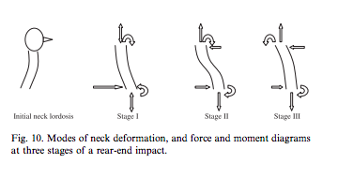

Appendix B
1.) The major ligaments of the cervical spine and their anatomical locations from the Siegmund et al. paper⁶
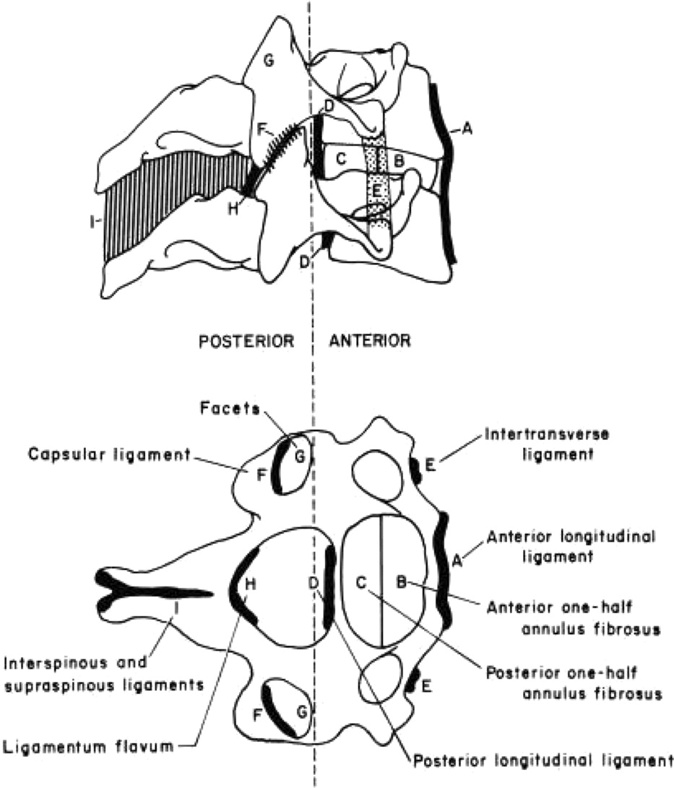

2.) Cervical and thoracic musculature from the Siegmund et al. paper⁶
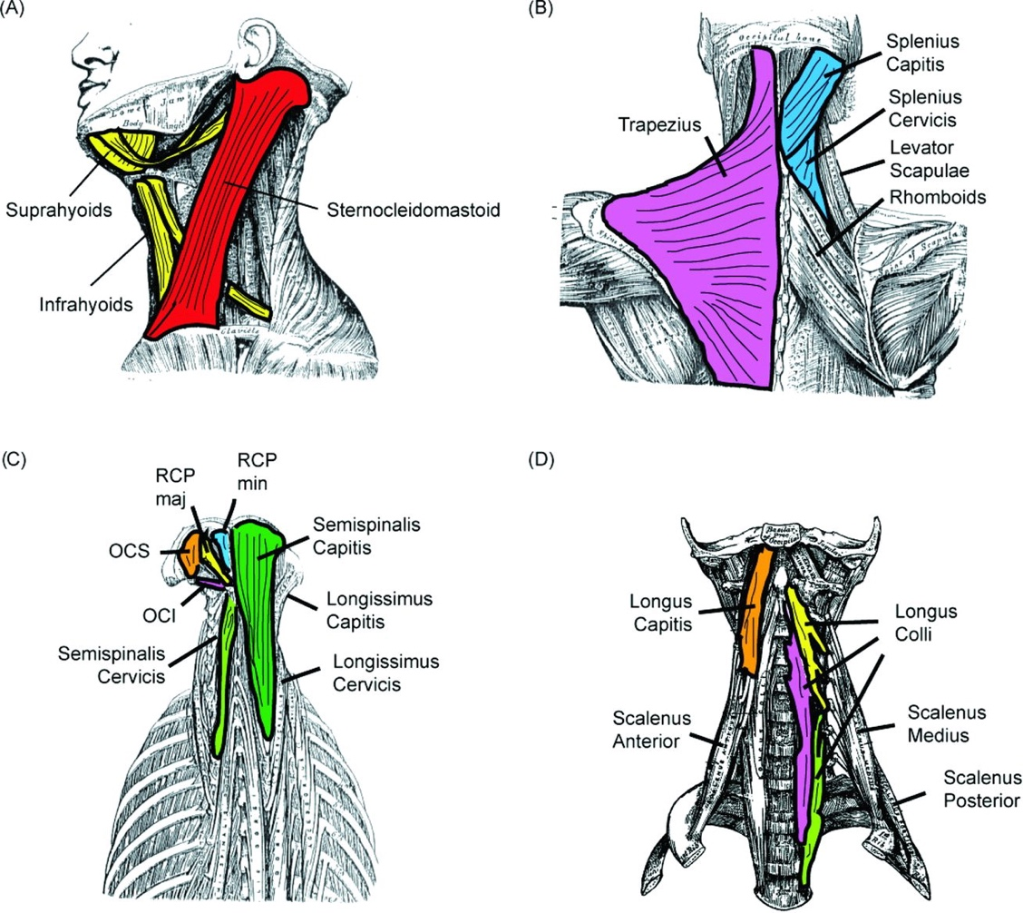

Appendix C
1.) The Core Whiplash Outcome Measure from the Rebbeck et al. paper¹²

Core Whiplash Outcome Measure

Instructions for patient: Please answer questions 1 to 5
Date questions 1 to 6 completed: ……………….

1. During the past week, how bothersome have your whiplash symptoms been? | 1 Not at all bothersome  2 Slightly bothersome  3 Moderately bothersome  4 Very bothersome  5 Extremely bothersome
2. During the past week, how much did your whiplash injury interfere with your normal work (including both work outside the home and housework)? | not at all  a little bit  moderately  quite a bit  extremely
3. If you had to spend the rest of your life with the whiplash symptoms you have right now, how would you feel about it? | very dissatisfied  somewhat dissatisfied  neither satisfied nor dissatisfied  somewhat satisfied  very satisfied
4. During the past 4 weeks, about how many days did you cut down on the things you usually do for more than half the day because of your whiplash symptoms? | ____________number of days
5. During the past four weeks, how many days did your whiplash symptoms keep you from going to work or school? | ____________number of days

Appendix D
1.) The set-up for the cervical joint position sense exercise suggested in the Kristjansson et al. paper. Image from the Treleaven article¹⁶

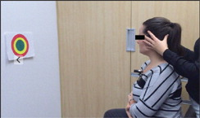

References

1. North Carolina 2016 Crash Facts. North Carolina Division of Motor Vehicles. Available at: https://connect.ncdot.gov/business/DMV/DMV%20Documents/2016%20Crash%20Facts.pdf [Accessed November 28, 2017].
2. Yadla S, Ratliff JK, Harrop JS. Whiplash: diagnosis, treatment, and associated injuries. Curr Rev Musculoskelet Med. 2008;1(1):65-68.
3. Hertling D, Blakney M. Cervical Spine. In: Management of Common Musculoskeletal Disorders: Physical Therapy Principles and Methods. 4th ed. Philadelphia: Lippincott Williams & Wilkins; 2006:707-764.
4. Grauer JN, Panjabi MM, Cholewicki J, Nibu K, Dvorak J. Whiplash produces an S-shaped curvature of the neck with hyperextension at lower levels. Spine (Phila Pa 1976). 1997;22(21):2489-2494. http://www.ncbi.nlm.nih.gov/pubmed/9383854. Accessed November 29, 2017.
5. Luan F, Yang KH, Deng B, Begeman PC, Tashman S, King AI. Qualitative analysis of neck kinematics during low-speed rear-end impact. Clin Biomech (Bristol, Avon). 2000;15(9):649-657. http://www.ncbi.nlm.nih.gov/pubmed/10946097. Accessed November 29, 2017.
6. Siegmund GP, Winkelstein BA, Ivancic PC, Svensson MY, Vasavada A. The anatomy and biomechanics of acute and chronic whiplash injury. Traffic Inj Prev. 2009;10(2):101-112.
7. Lentell G, Kruse M, Chock B, Wilson K, Iwamoto M, Martin R. Dimensions of the Cervical Neural Foramina in Resting and Retracted Positions Using Magnetic Resonance Imaging. http://www.jospt.org/doi/pdf/10.2519/jospt.2002.32.8.380?code=jospt-site. Accessed December 1, 2017.
8. Oka H, Matsudaira K, Fujii T, et al. Risk Factors for Prolonged Treatment of Whiplash-Associated Disorders. Verdejo-García A, ed. PLoS One. 2015;10(7):e0132191.
9. Sterling M. Physiotherapy management of whiplash-associated disorders (WAD). J Physiother. 2014;60(1):5-12.
10. Sullivan MJ. The Pain Catastrophizing Scale User Manual. 1995. http://www.aci.health.nsw.gov.au/__data/assets/pdf_file/0004/257422/Pain_Catastrophizing_Scale_Manual.pdf [Accessed December 1, 2017].
11. Neck Disability Index. American Academy of Orthopedic Surgeons. Available at: https://www.aaos.org/uploadedFiles/NDI.pdf [Accessed December 1, 2017].
12. Rebbeck TJ, Refshauge KM, Maher CG, Stewart M. Evaluation of the Core Outcome Measure in Whiplash. Spine (Phila Pa 1976). 2007;32(6):696-702.
13. Magee D. Cervical Spine. In: Orthopedic Physical Assessment. 6th ed. St. Louis: Elsevier Saunders; 2014:148-223.
14. Blanpied PR, Gross AR, Elliott JM, et al. Neck Pain: Revision 2017. J Orthop Sport Phys Ther. 2017;47(7): A1-A83.
15. Sterling M, Vicenzino B, Souvlis T, Connelly LB. Dry-needling and exercise for chronic whiplash-associated disorders. Pain. 2015;156(4):635-643.
16. Treleaven J. Dizziness, Unsteadiness, Visual Disturbances, and Sensorimotor Control in Traumatic Neck Pain. J Orthop Sport Phys Ther. 2017;47(7):492-502.
17. Kristjansson E, Treleaven J. Sensorimotor Function and Dizziness in Neck Pain: Implications for Assessment and Management. J Orthop Sport Phys Ther. 2009;39(5):364-377.

