Lauren Kozar
Diagnosis and Treatment of SLAP Tears in Elite Baseball Pitchers
Baseball has been known as America’s greatest pastime for well over a century. Since 1845, when the first team to play under modern rules was founded, dedicated fans have packed stadiums to see their favorite teams play the game.^{1,2} “At its basic structure, baseball is played with nine players per team, and the core of the battle lies in a pitcher’s duel with each hitter.”² In other words, a team’s success is largely dependent upon the talent and health of their pitchers.² Unfortunately, the highest upper extremity injury rates are found in baseball pitchers compared to all other positions.³ Current evidence suggests that these injuries occur most frequently to the shoulder joint.³ One of the most common shoulder injures seen in the throwing arm of elite baseball pitchers is a Superior Labral Anterior-Posterior (SLAP) lesion, which is characterized by disruption of the attachment site of the long head of the biceps from the superior anterior labrum.³ These injuries have gained notoriety over the past decade due to their high prevalence rate and potential to cause “dead arm,” a career-ending affliction.^{4,5} Although there are some discrepancies amongst published works regarding the exact prevalence of SLAP lesions among the elite pitching population, the best available evidence at this time suggests prevalence rates range from 83%-91%.⁴ Thus, injury prevention and appropriate, comprehensive medical intervention are imperative to pitcher and team success. Physical therapists play a key part in the health care management of SLAP tears, and in order for them to provide elite pitchers with optimal, state of the art rehabilitation, it is important for them to have an understanding of the anatomy and biomechanics of the shoulder complex, overhand pitching mechanics, the stresses this motion places on the upper extremity, and the muscles required to counterbalance said forces to provide stability to the joint. It would also behoove therapists to have an understanding of the pathogenesis of SLAP tears in the overhead athlete, diagnostic screening tools for SLAP lesions, different treatment options and their prognoses, and evidence-based rehabilitation guidelines for surgically repaired SLAP tears, including a return to throwing protocol.
The anatomy and biomechanics of the shoulder are rather complex, and an in-depth analysis of the shoulder’s structure and arthrokinematics are beyond the scope of this paper; however, it is important for therapists to understand that the shoulder is the most mobile and least stable joint in the body.¹ There are four articulations that construct the shoulder complex and allow for full shoulder range of motion.⁶ These articulations include the sternoclavicular joint, the acromioclavicular joint, the scapulothoracic joint, and the glenohumeral joint.⁶ The sternoclavicular joint serves as the only attachment of the upper extremity to the axial skeleton.⁶ It is a saddle joint with three degrees of freedom, and it gains support from the meniscus, joint capsule, sternoclavicular ligament, costoclavicular ligament, and interclavicular ligament.⁶ The sternoclavicular joint is also responsible for absorbing and distributing forces from the upper extremity to the thorax.⁶ The acromioclavicular (AC) joint attaches the clavicle to the scapula.⁶ It also has three degrees of freedom, and is supported by a dense, yet weak joint capsule, the acromioclavicular ligament, and the coracoclavicular ligament.⁶ The AC joint “maintains the relationship between the scapula and clavicle, allows full rotation of the scapula and clavicle so the individual can achieve full shoulder flexion, it transmits and distributes forces from the arm to axial structures, it prevents superior dislocation of the clavicle on the acromion, and it limits clavicle rotation.”⁶ The scapulothoracic joint is not a true anatomical joint because there is no bony articulation between the scapula and thorax.⁶ The thorax and scapula are only connected via muscular attachments.⁶ Thus, it is a relatively unstable “articulation, ” however, the large degree of mobility at this “joint” enables full shoulder range of motion.⁶ The scapula is oriented approximately 35° anterior to the frontal plane, and the glenoid has about 5° of retroversion and 5° of upwards vertical inclination relative to the vertical.⁶ Thus, the humeral head is positioned slightly posteriorly and superiorly so it can fit into the glenoid. This articulation between the glenoid and humerus is the true shoulder joint, but therapists must have a basic understanding of the other three articulations because the glenohumeral joint cannot achieve full range of motion without movement occurring at the other joints as well.⁶ The surface area of the humeral head is approximately three to four times larger than the surface area of the glenoid resulting in a relatively unstable joint.⁶ Thus, active support from surrounding musculature and passive support from the bony anatomy, joint capsule, surrounding ligaments, and glenoid labrum are imperative to its stability.
The glenoid labrum is the primary structure involved in SLAP lesions. It is a fibrous ring that is strongly attached to the periphery of the glenoid.^{4,6} It serves as an anchor for the capsoligamentous structures of the joint, and it contributes to joint stability by increasing contact surface area between the glenoid and humeral head.^{4,6} It achieves greater contact area by increasing socket depth approximately fifty percent in all directions.⁶ Although it is composed mostly of fibrous cartilage, recent studies have found that it is also comprised of dense fibrous collagen tissue.⁴ Other works have found that the superior and inferior labrum exhibit significantly different anatomies, and that the specific appearance of each portion of the labrum is dependent upon the amount of humeral rotation.⁴ The superior labrum is loosely attached to the glenoid rim via loose connective fibers, and its cross-sectional shape resembles that of a knee meniscus.⁴ It is a triangular structure with a sharp, free edge that points towards the joint center.⁴ In some instances, the free edge is more prominent than normal and can extend into the joint center.⁴ This normal anatomic variation is considered non-pathological, but it may result in an incorrect diagnosis of a SLAP tear based on clinical examination findings and magnetic resonance imaging (MRI) interpretation.⁴ Although these “meniscoid-type” superior labrums are common anatomical variations, they can pre-dispose overhead athletes to SLAP lesions.⁴ Unlike the superior labrum, the inferior labrum is strongly attached to the glenoid rim via inelastic fibrous tissue, making it appear as though it were an immobile, rounded extension of the joint’s articular cartilage.^{4,7}
The inferior and posterior regions of the labrum gain vascularity from their peripheral attachments to the joint capsule.^{4,6} Their vascular supply arises from the suprascapular artery, the circumflex scapular branch of the subscapular artery, and the posterior humeral circumflex artery.⁶ Unfortunately, the inner labrum is avascular, and the superior and anterosuperior labrum are significantly less vascular than the posterior and inferior regions predisposing these areas to injury.³ The superior labrum is also known to be the have the most loose attachment to the glenoid rim further increasing the risk for injury in this location.⁴ To make matters worse, approximately fifty percent of the fibers of the long head of the biceps brachii, a powerful soft tissue structure, originate from the superior labrum.⁴ At the insertion site the collagen fibers of the labrum blend with the fibers of the biceps brachii.⁴ This interwoven network of fibers continues posteriorly forming a periarticular fiber bundle, which makes up a majority of the labrum.⁴ See appendix A for detailed images of the glenohumeral joint.
As previously stated, the attachment of the biceps brachii anchor into the superior glenoid labrum, where the glenoid labrum is most loosely attached to the glenoid rim and the vascular supply is minimal at best, predisposes this region to injury because it is not designed to withstand the large tensile stresses acting on the weak attachment site every time the bicep muscle contracts;⁸ however, the risk of injury is significantly greater in baseball pitchers due to the pitching mechanics and the extreme forces placed on the shoulder throughout the pitching cycle. Therapists must have a comprehensive understanding of the fundamental mechanics to baseball pitching in order to truly understand why this population is at such a great risk for SLAP lesions.
The throwing motion is initiated during the wind-up phase,⁹ which is defined as the period from initial movement to maximum knee lift of the stride leg.¹⁰ During this phase, the pitcher’s stance leg maintains a position of balance in slight knee flexion via isometric quad contraction and hip abductor activation.⁹ Thus, pitchers require strong quadriceps muscles and hip abductor muscles, otherwise they will have a very unstable base. Stage two of the pitching cycle, the stride phase, is responsible for developing linear velocity towards home plate.⁹ During the stride phase, the stride hip is externally rotated, while the stance hip is internally rotated.¹² Appropriate stride length is approximately 75-90% of the pitcher’s body height, and the stride foot should land about 15° away from the center of the mound in order to minimize the forces placed on the shoulder.⁹ Also during this phase, the shoulder is abducted to approximately 90°.⁹ Stage three, the arm cocking phase, begins when the stride foot makes contact with the ground and concludes when the arm is in maximum external rotation.⁹ Maximum external rotation of 165°-180° is achieved via humerothoracic rotation, and is known as terminal arm cocking, or the critical moment.⁹ During the critical moment there are extremely high forces imposed upon the glenohumeral joint.⁹ During this phase the stride leg creates a stable base as rapid sequential rotation of the pelvis and torso cause a temporal lag in distal arm acceleration compared to hip and trunk acceleration, resulting in large distraction forces on the glenohumeral joint.^{9,11,12} The rotator cuff muscles must generate a compressive force of 550 N to 770 N to resist these large forces .¹¹ Phase four, or arm acceleration, begins with max external rotation of the arm and concludes at the moment of ball release.⁹ During this phase the trunk moves from hyperextension into forward flexion, the stride leg extends, and the shoulder moves into internal rotation with an arm velocity in excess of 7,000°/sec.^{9,13,14} Also during the acceleration phase, the elbow extends at approximately 3000°/sec.⁹ When the ball is finally released, the shoulder should be elevated to 90° and the elbow flexed to 15°-20°.⁹ Arm deceleration occurs during stage five, which is defined as the period from ball release to max shoulder internal rotation.⁹ During stage five, the arm continues to internally rotate as it horizontally adducts across the pitcher’s body.⁹ Eccentric contraction of the elbow flexors decelerates elbow extension, while explosive contraction of the rotator cuff muscles and activation of other surrounding shoulder girdle muscles oppose the excessive distraction forces placed on the shoulder during arm deceleration, which are typically 100-150% of the pitcher’s body weight.^{9,12} The final stage of the pitching cycle, stage six, is known as the follow through period.⁹ During this phase the rotator cuff continues to decelerate the shoulder as the trunk flexes over the stride leg.⁹ See appendix B for a schematic breakdown of the pitching cycle.
Although some speculation exists regarding the injury mechanisms responsible for creating SLAP lesions, the best available evidence at this time suggests that these injuries result from the large distraction forces imposed on the shoulder during the late arm cocking and deceleration stages of the pitching cycle.^{4,14} “The eccentric biceps activity during deceleration may serve to weaken the biceps‐labrum complex,” while the position of abduction and maximal external rotation in the late-cocking phase produces a torsional force at the base of the biceps that is transmitted to the anchor, resulting in increased strain on the superior labrum and possible posteropsuperior detachment of the labral anchor.⁴ The latter mechanism is referred to as the peel-back mechanism (appendix C), and it produces greater strain on the superior labrum compared to the excessive eccentric contraction by the biceps brachii.¹⁵ Unfortunately, the biceps anchor has a significantly weaker ultimate strength during the peel back loading mechanism, only able to withstand 202 N compared to the 508 N observed during tensile loading from bicep brachii contraction.¹⁶ In other words, repetitive overhand pitching likely causes gradually weakening at the location of the biceps anchor into the superior labrum due to constant eccentric contraction of the biceps brachii during the deceleration phase of pitching; however, the peel back force ultimately causes detachment of the superior labrum from anterior to posterior.
Another proposed mechanism is glenohumeral anterior instability. Over time, baseball pitchers typically gain more external rotation of the shoulder due to posterior capsule contractures and weakened anterocapsular ligaments, a condition referred to as Glenohumeral Internal Rotation Deficit (GIRD). GIRD causes the humeral head to shift posterosuperiorly with max external rotation, which can facilitate the progression of internal impingement on the posterosuperior glenoid rim, resulting in labral weakness.^{4,17} As the pitcher achieves greater and greater external rotation, there will also be “increased torsional loads on the superior labrum from the more posteriorly oriented biceps tendon.”¹⁷ Thus, pitchers with GIRD are 25% more likely to sustain a SLAP lesion.¹⁸
This injury was first identified via arthroscopy by Andrews et al in 1985, and was later classified by Synder et al in 1990.¹⁹ Under the original classification system, SLAP lesions were divided into four types.¹⁹ Type I SLAP lesions involve fraying of the superior labrum without any detachment or frank tears.^{19,20} Type II SLAP lesions, the most common form of SLAP lesions, are characterized by detachment of the biceps anchor and the anterior and superior aspects of the labrum from the superior glenoid rim.^{19,20} Type III lesions involve a bucket-handle tear to the superior labrum without detachment of the biceps anchor, and type IV lesions are extensions of type III tears into the biceps tendon.^{19,20} In 2006, Maffet et al performed a study to further evaluate SLAP lesions because they felt that some patterns of biceps tendon-superior labrum lesions did not fit the Synder et al classification.²¹ Using diagnostic glenohumeral arthroscopy, Maffet and his colleagues concluded that only 62% of the observed shoulders exhibited SLAP lesions that fit the original classification system.²¹ The study included 84 subjects, of which, “fourteen had a continuation of a Bankart lesion superiorly to include the biceps tendon and superior labrum, seven had either an anterior or posterior labral flap tear in conjunction with the biceps tendon separation superiorly, and eleven patients had detachment of the biceps tendon-superior labrum with separation that extended anteriorly to include the middle glenohumeral ligament.”²¹ Thus, the researchers added three additional types of SLAP lesions to the original classification system. Type V slap tears include “anterior-inferior bankart lesions that continue superiorly to include separation of the biceps tendon.”²¹ Type VI lesions are characterized by an unstable flap tear of the labrum combined with biceps tendon separation, and type VII SLAP lesions involves detachment of the superior labrum-biceps tendon complex from the glenoid rim with separation that extends anteriorly to the middle glenohumeral ligament.²¹ SLAP types V-VII are very uncommon in overhead athletes, and typically result from falls or dislocations.² Additional changes to the classification system came in 1998 when Morgan et al decided to divided Type II SLAP lesions into three subtypes.²² Morgan and his colleagues observed three different versions of type II SLAP lesions, and they decided a modification to the original classification system was warranted that used anatomical location of the lesions to further classify type II SLAP tears.²² Type IIA is an anterosuperior type II SLAP lesion, type IIB is a posterosuperior type II SLAP lesion that they termed the ‘‘posterior SLAP lesion,’’ and type IIC is a combined anterior and posterior type II SLAP lesion that they have termed the ‘‘combined SLAP lesion.²² See appendix D for detailed images of the different variations of SLAP lesions.
The clinical diagnosis of a SLAP lesion is very difficult to establish because these injuries are usually coupled with concomitant pathologies. For example, 73% of baseball pitchers with superior labral lesions have concomitant partial thickness tears to their supraspinatus muscle.⁴ Another common finding is traumatic instability with Type II SLAP tears.⁴ In order to improve diagnostic accuracy, it is imperative to include a thorough subjective evaluation, objective physical examination that includes a cluster of special tests, and enhanced magnetic resonance arthrography (MRI).⁴ Although these injuries normally occur secondary to micro trauma from repetitive overhand throwing, acute traumatic mechanisms are possible.¹³ Typically, the patient presents with anterolateral shoulder pain that radiates down the biceps muscle because the long head of the biceps is highly innervated with pain fibers.¹³ Although pain is usually isolated to the anterolateral shoulder, some patients do present with pain in the posterosuperior aspect of the shoulder.¹³ The shoulder pain is usually exacerbated by overhead activities like pitching, typically during the late cocking and deceleration phases; throwing; and lifting of objects overhead; however, the pain should subside with rest.^{4,13} Patients may also report a decrease in pitch velocity and accuracy, along with feelings of instability.⁴ If patients also have glenohumeral instability they may complain of mechanical clicking, popping, catching, and/or audible snapping.¹³ These symptoms can also occur if the SLAP tear is unstable; however, this specific condition is rare in baseball pitchers.¹³ Other common concomitant injuries like “rotator cuff tears, subacromial impingement, anterior capsular disorder, and glenohumeral chondral defects may obscure or overlap with the symptoms generated” by the SLAP lesion.¹³ Complaints of shoulder weakness are typical indicators that a secondary injury, such as those previously described, is present.⁴
During the physical exam of the shoulder it is important to include inspection; palpation; range of motion testing to the cervical spine and shoulder, noting for GIRD; manual muscle testing, especially to the rotator cuff muscles, distal neurovascular testing, and special tests.¹³ A plethora of special tests have been established that can indicate the presence of a SLAP lesion; however, a majority of these tests lack sensitivity and specificity, reducing their effectiveness for diagnosing said injury.² Despite these deficits, several tests have been widely accepted by the medical community for the diagnosis of SLAP lesions.² These tests include: O’Brien’s test, the Crank Test, Neer’s Test, the Hawkins-Kennedy Test, the Biceps Load Test, the Biceps Load II Test (greater sensitivity than Biceps Load Test), the Pain Provocation Test, the Passive Compression Test, the Active Compression Test, the Resisted Supination and External Rotation test, the Pronated Load Test, and the SLAPrehension Test.^{2,4,13} Due to the difficulty associated with using the before-mentioned special tests to rule in SLAP lesions, current evidence suggests coupling the subjective history and clinical examination findings with information gained from the use of enhanced MRA of the shoulder.⁴ Unlike magnetic resonance imaging of the shoulder, which has poor reliability in the detection of SLAP lesions, MRA has a sensitivity of 89%, a specificity of 91%, and an accuracy of 90% in detecting SLAP lesions.⁴ That being said, definitive diagnosis of SLAP lesions requires arthroscopy of the shoulder joint.⁴
Following a SLAP lesion diagnosis, most physicians opt for conservative management as the first line of defense unless the injury is a type II or type IV SLAP lesion with concomitant pathologies like labral instability and glenohumeral instability.⁴ In such instances, surgical intervention is typically warranted.⁴ Although non-operative treatment is usually the first recommendation for all other SLAP lesion conditions; rehabilitation is usually unsuccessful.⁴ Thus, a majority of type I SLAP lesions, which usually result from internal impingement in baseball pitchers, are eventually debrided back to a stable glenoid rim.⁴ Type III lesions are also excised and debrided back to a stable glenoid rim unless the lesion includes a Buford complex,⁴ which is a congenital glenoid labrum variant characterized by absence of the anterosuperior labrum from the 1-3 o’clock position and the presence of a thickened middle glenohumeral ligament that originates directly from the labrum at the base of the biceps tendon anchor and that crosses over the subscapularis tendon as it inserts into the humerus.²³ When the physician opts for a conservative treatment, the patient must begin with complete cessation of all overhead activities along with the use of anti-inflammatory drugs.² Once the patient’s pain resolves, the physical therapist can implement interventions targeted at improving stability, flexibility, and strength of the shoulder complex.² Stretches should be isolated to the tight posterior capsule in order to regain internal rotation of the glenohumeral joint without further increasing laxity in the anterior shoulder; however, individual differences may warrant alternative stretching patterns.² Once the joint is stable and the range of motion is restored, then the therapist can begin strengthening exercises. Although strengthening to the rotator cuff muscles and surrounding scapular muscles is needed, it is also important to improve the pitchers core strength because pitchers must have a strong and stable core during the pitching motion to minimize forces imposed on the shoulder joint.² The patient can then begin a return to throwing progression approximately three-months post-injury.² As previously stated this non-operative treatment is not usually successful because it does not facilitate an environment where the torn labrum can reattach to the glenoid rim, but isolated debridement surgery also has poor reliability in relieving symptoms long-term.²
Type II and IV SLAP lesions with concomitant pathologies have poor outcomes following debridement so they usually require surgical repair.⁴ Type II SLAP lesions can be treated with either a SLAP repair or a biceps tenodesis; however, a majority of MLB surgeons elect to perform a SLAP repair for type II lesions and view the biceps tenodesis as a viable salvage option for failed SLAP repairs.^{24,25} That being said, recent evidence has shown that “baseball pitchers who undergo biceps tenodesis have a more reliable return of upper extremity thoracic rotation and neuromuscular control compared to those that underwent SLAP repairs.”²⁴ SLAP repairs are also linked to altered pitching mechanics and high patient dissatisfaction rates (60% dissatisfied) secondary to persistent pain and low rates of return to preinjury level (57% rate of return to preinjury level), whereas biceps tenodesis procedures are associated with 93% satisfaction rates and 87% return rates to pre-injury level of pitching.^{24,26}
Surgical treatment of type IV lesions depend on the extent to which the biceps anchor is involved.⁴ If 30% or less of the biceps anchor is involved, then surgeons generally resect the torn tissue and reattach the superior labrum.⁴ When more than 30% of the biceps anchor is involved, then surgeons will likely reattach the superior labrum and utilize a side-to-side technique to repair the biceps tendon, unless the tear is extensive enough to substantially alter the biceps origin.⁴ In such instances, a biceps tenodesis or tenotomy is more practical than a direct repair.”⁴ Type V SLAP lesions are repaired using the same surgical technical as type II SLAP lesions, but the surgeons use additional anchors to reattach the bankhart lesion.²⁷ Type VI lesions have the best prognosis if the surgeon debrides the flap tear and utilizes the same surgical technique used in the repair type II SLAP lesions to repair the labral tear.²⁷ Type VII lesions are also treated with the same surgical fixation method used in type II SLAP repairs, but the surgeon must also suture the middle glenohumeral ligament through the anterior rotator interval.²⁷
The goal of all surgical repairs is to create a strong repair that allows the pitcher to aggressively rehabilitate so he can return to full competition.⁴ In order to achieve this strong fixation, surgeons utilize arthroscopic surgery to mobilize the superior labrum along the entire length of the detachment site using a 4.5 mm shaver to remove any frayed edges or fibrous adhesions, and then they abrade the attachment site to promote bleeding in the area to facilitate healing.⁴ They also debride the labral surface slightly, and then attach the biceps anchor to the superior labrum using bioabsorbable suture anchors.⁴ The surgeon may opt to include part of the biceps tendon near the junction of the biceps with the labrum in order to further increase the strength of the biceps anchor.⁴ After all suture anchors are in place the surgeon should pull on the sutures to ensure the strength and security of the surgical fixation before suturing closed the arthroscopic incisions in the skin of the shoulder.⁴
Post-surgical rehabilitation is dependent upon the severity of the pathology, the type of SLAP lesion, the surgical procedure performed, and any additional procedures performed for concomitant pathologies.⁴ The rehabilitation process is also dependent upon individual differences and should be altered to meet each patient’s specific needs.⁴ Despite these differences, all post-operative rehabilitation protocols should focus on relieving pain and improving stability, flexibility, and strength of the shoulder complex.⁴ Physical therapists should also provide patient’s with recommendations on how to avoid imposing adverse stresses to the healing tissues.⁴ For example, if a pitcher sustains a SLAP lesion from a compressive injury, then he should avoid upper-extremity weight bearing activities early on in the rehabilitation process to minimize the amount of compressive forces placed on the superior labrum.⁴ Other examples of protective restrictions for the healing tissue include avoidance of excessive eccentric contractions of the biceps brachii in patients who sustain SLAP lesions from traction mechanisms, and avoidance of excessive external rotation of the shoulder in those who sustain SLAP lesions from the peel-back mechanism.⁴ In other words, the mechanism of injury is important in selecting the appropriate rehabilitation protocols and in establishing restrictions to prevent excessive loading of the healing tissue to reduce the risk of re-injury. Typically, the patient can begin a return to throwing progression by week 7 following type I and type III labral debridement, by week 12 following biceps tenodesis, and by weeks 16-20 following a SLAP repair. Appendix E has specific rehabilitation guidelines for each surgical technique, in addition to specific return to throwing and mound progressions.
Overall, SLAP lesions are rather complex injuries that are difficult to diagnosis due to the wide variety in lesion presentation and the high risk for concomitant injuries that can mask or obscure the signs and symptoms of labral tears. It is of the upmost importance for health care professionals, including physical therapists, to perform very thorough subjective evaluations and objective examinations that incorporate MRA findings because the type of lesion, severity of lesion, mechanism of injury, and presence of additional pathologies will dictate the type of surgical treatment and post-operative rehabilitation protocol required to improve the pitchers chances of returning to the pre-injury level. This information can also help with the generation of patient prognoses and patient education on expected outcomes during the rehabilitation process. Due to the large role physical therapist plays in the diagnosis and treatment of SLAP lesions, it is imperative for their professional development and the treatment of their patients that they have an understanding of the concepts addressed in this paper.

Appendix A – Anatomical Review
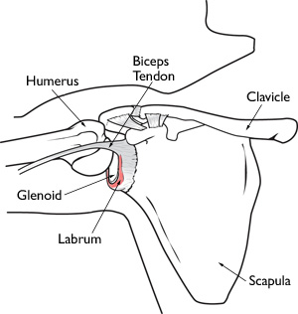
Figure 1: The labrum creates greater contact area between the glenoid and humeral head by increasing socket depth approximately fifty percent in all directions. Imagine reprinted from OrthoInfo, 2011.²⁸

Figure 2: Note how the fibers of biceps brachii originate from both the supraglenoid tubercle and the superior labrum. (A) is a coronal view and (B) is a coronal cut through the glenoid. Imagine reprinted form Musculoskeletal Key, 2016. Image reprinted from Musculoskeletal Key, 2016.²⁹

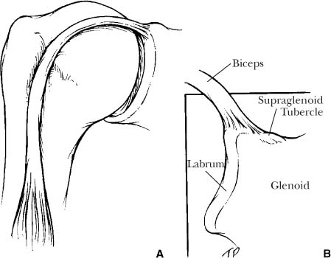

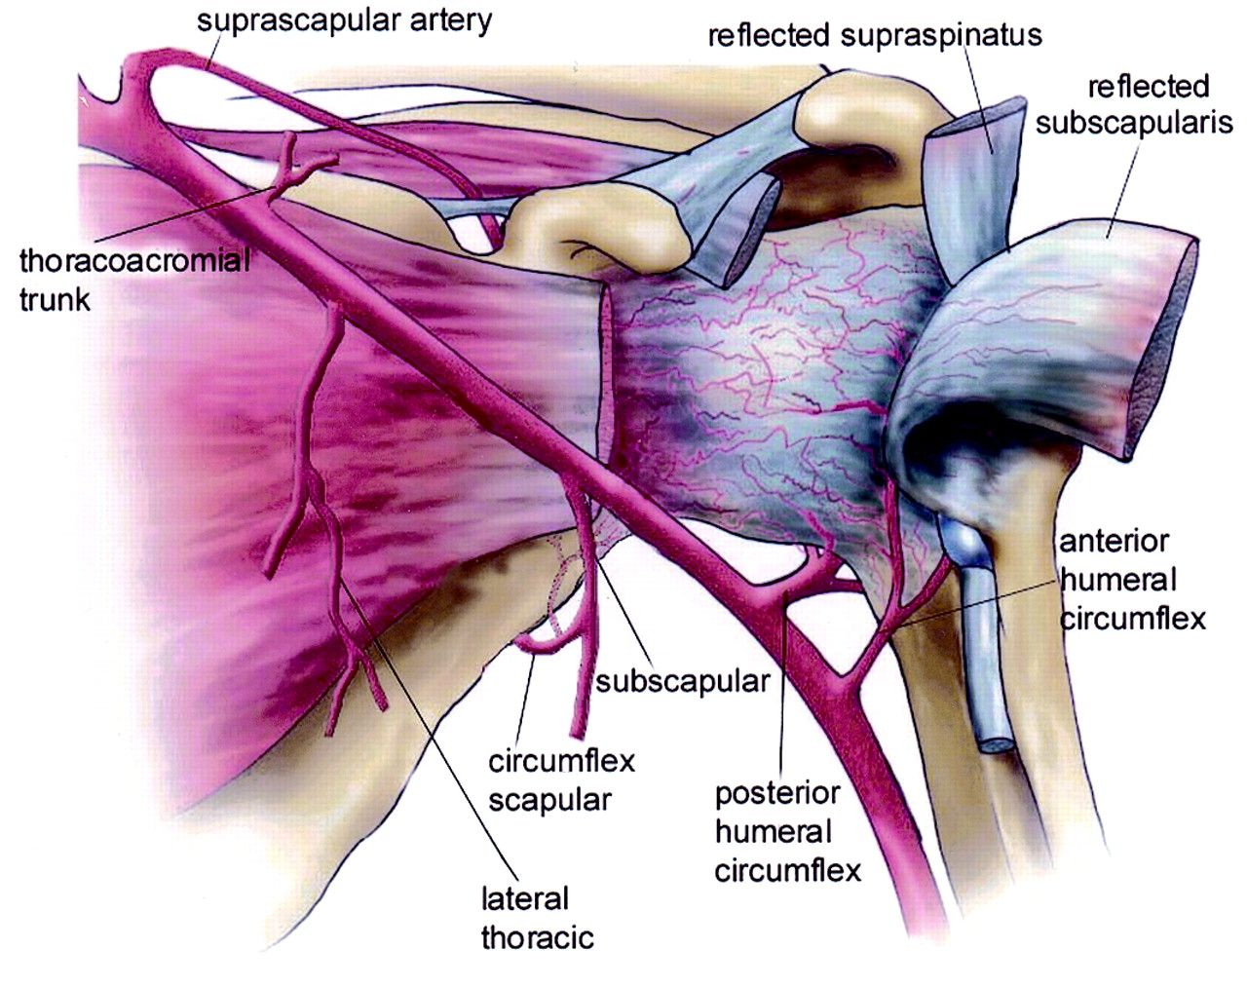
Figure 3: Depicted below is a schematic of the anterior shoulder, demonstrating the blood supply to the glenohumeral joint capsule and labrum. The glenoid labrum receives blood from the suprascapular artery, the circumflex scapular branch of the subscapular artery, and the posterior humeral circumflex artery.⁶ Image reprinted from Andary JL et al, 2002.³⁰
Appendix B – Pitching Mechanics
Figure 1: Depicted below is a schematic representation of all six stages in the overhand pitching motion. Citation: Thrower’s shoulder.

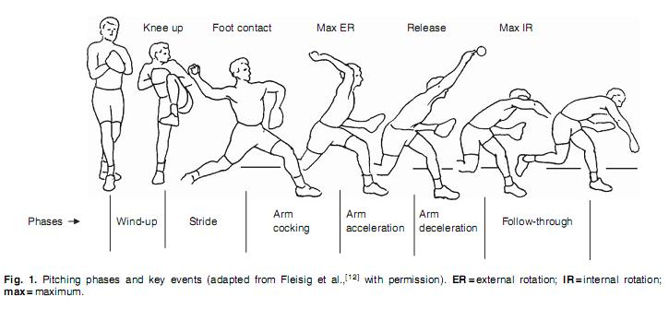

Thrower’s Shoulder, reprinted from physiopedia³¹

Figure 2: Pictured below is a diagram of proper body alignment during stage two of the pitching motion. Recall from earlier, that during stage two, or the stride phase, the stride hip is externally rotated, while the stance hip is internally rotated.⁹ Appropriate stride length is approximately 75-90% of the pitcher’s body height, and the stride foot should land about 15° away from the center of the mound in order to minimize the forces placed on the shoulder.⁹ Image reprinted from Flesig GS, 1994.³²

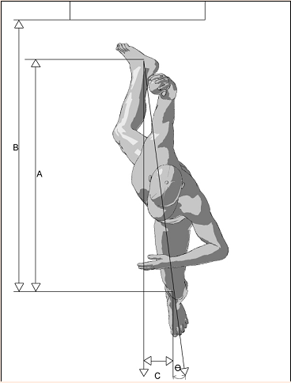

Appendix C – Peel-back Mechanism
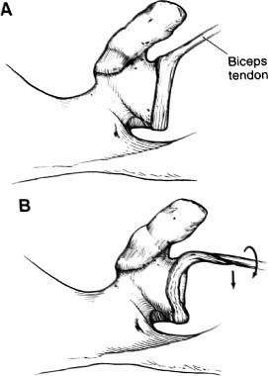
Figure 3: Pictured below is a graphical representation of the peel-back mechanism for SLAP lesions. Recall that during the peel-back mechanism a torsional force is imposed on the labrum. Image reprinted from Morgan CD et al, 1998.³³
Appendix D – SLAP Lesion Classification
Figure 1: Depicted below are the four original SLAP lesion classifications by Snyder et al. (A) Type I, (B) Type 2, (C) Type III, and (D) Type IV. Image reprinted from Snyder SJ et al, 1990.³⁴

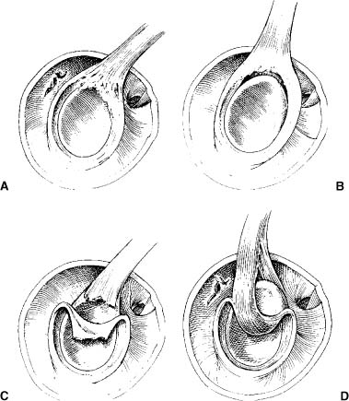

Figure 2: The images below depict the three additional labral pathologies that Maffet al added to the original classification of SLAP lesions. Image reprinted from Maffet MW et al, 1995.³⁵

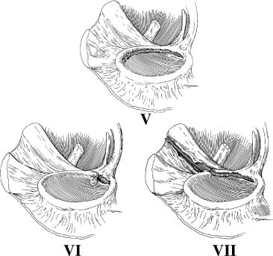

Figure 3: The images below represent the three subcategories of Type II SLAP lesions as described by Morgan et al. (A) anterior, (B) posterior, (C) combined anterior and posterior. Image reprinted from Morgan CD, 1998.³⁶

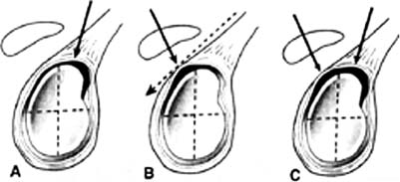

Appendix E – Rehabilitation Protocols
Rehabilitation Protocol Following Arthroscopic Debridement of Type I and Type III SLAP Lesions
THE FOLLOWING REHAB PROTOCOL IS DIRECTLY FROM THE WILK ET AL ARTICLE⁴
PHASE I – MOTION PHASE (Day 1 to Day 10)
- Goals:
  - Re‐establish non‐painful Range of Motion
  - Retard Muscular Atrophy
  - Decrease pain/inflammation
- Range of Motion (PROM/AAROM)
  - Pendulum Exercise
  - Rope and Pulley
  - L‐bar exercises
    - Flexion/Extension
    - Abduction/Adduction
    - ER/IR (Begin at 0 degrees AB, progress to 45 degrees AB, then 90 degrees AB)
  - Self‐stretches (capsular stretches)
- Exercises:
  - Isometrics
  - NO BICEPS Isometrics for 5–7 days Post‐Op
  - May initiate tubing for ER/IR at 0 degrees AB late phase (Usually 7–10 days Post‐Op)
- Decrease Pain/Inflammation:
  - Ice, NSAIDS, Modalities
PHASE II – INTERMEDIATE PHASE (Week 2–4)
- Goals:
  - Regain & Improve Muscular Strength
  - Normalize Arthrokinematics
  - Improve Neuromuscular Control of Shoulder Complex
- Criteria To Progress to Phase II
  - Full PROM
  - Minimal Pain & Tenderness
  - 4/5 MMT of IR, ER, Flex
- Week 2:
  - Exercises:
    - Initiate Isotonic Program with Dumbbells
      - GH and scapulothoracic musculature
      - Scapulothoracic
      - Tubing ER/IR at 0 degrees Abduction
      - Sidelying External Rotation
      - Prone Rowing External Rotation
      - PNF Manual Resistance with Dynamic Stabilization
    - Normalize Arthrokinematics of Shoulder Complex
      - Joint Mobilization
      - Continue Stretching of Shoulder (ER/IR at 90 degrees of Abduction)
    - Initiate Neuromuscular Control Exercises
    - Initiate Proprioception Training
    - Initiate Trunk Exercises
    - Initiate UE Endurance Exercises
  - Decrease Pain/Inflammation:
    - Continue use of modalities, ice, as needed
- Week 3:
  - Exercises:
    - Throwers Ten Program
    - Emphasis Rotator Cuff & Scapular Strengthening
    - Dynamic Stabilization Drills
PHASE III – DYNAMIC STRENGTHENING PHASE – Advanced Strengthening Phase (Week 4–6)
- Goals:
  - Improve Strength/Power/Endurance
  - Improve Neuromuscular Control
  - Prepare athlete to begin to throw, etc.
- Criteria To Enter Phase III:
  - Full non‐painful AROM & PROM
  - No pain or tenderness
  - Strength 70% compared to contralateral side with handheld dynamometer
- Exercises:
  - Continue Throwers Ten Program
  - Continue dumbbell strengthening (supraspinatus, deltoid)
  - Initiate Tubing Exercises in the 90/90 degree position for ER/IR (slow/fast sets)
  - Exercises for scapulothoracic musculature
  - Tubing exercises for biceps
  - Initiate Plyometrics (2 hand drills progress to 1 hand drills)
  - Diagonal Patterns (PNF)
  - Initiate Isokinetic Strengthening
  - Continue endurance exercises: neuromuscular control exercises
  - Continue Proprioception Exercises
PHASE IV – RETURN TO ACTIVITY PHASE (Week 7 and Beyond)
- Goals:
  - Progressively Increase Activities to prepare patient for full functional return
- Criteria To Progress to Phase IV
  - Full PROM
  - No pain or tenderness
  - Isokinetic Test that fulfills criteria to throw
  - Satisfactory Clinical Exam
- Exercises:
  - Initiate Interval Sport Program (i.e., Throwing, Tennis, etc.)
    - Continue all exercises as in Phase III (Throw and Train on Same Day), (LE and ROM on Opposite Days)
    - Progress Interval Program
  - Follow‐Up Visits:
    - Isokinetic Tests
    - Clinical Exam

Rehabilitation Protocol Following Arthroscopic Type II SLAP Repair Fixation Technique
THE FOLLOWING REHAB PROTOCOL IS DIRECTLY FROM THE WILK ET AL ARTICLE⁴
PHASE I – IMMEDIATE POSTOPERATIVE PHASE “PROTECTED MOTION” (Day 1 To Week 6)
- Goals:
  - Protect the anatomic repair
  - Prevent negative effects of immobilization
  - Promote dynamic stability
  - Diminish pain and inflammation
- Week 0–2:
  - Sling for 4 weeks
  - Sleep in abduction pillow for 4 weeks
  - Elbow/hand PROM
  - Hand gripping exercises
  - Passive and gentle shoulder active assistive ROM exercise
    - Flexion to 60° (Week2: Flexion to 75°)
    - Elevation in scapular plane to 60°
    - ER/IR with arm in scapular plane
    - ER to 10–15°
    - IR to 45°
    - NO active ER or Extension or Abduction
  - Submaximal isometrics for shoulder musculature
  - NO Isolated Biceps Contractions
  - Cryotherapy, modalities as indicated
- Week 3–4
  - Discontinue use of sling at 4 weeks
  - Sleep in abduction pillow until Week 4
  - Continue gentle ROM exercises (PROM and AAROM)
    - Flexion to 90°
    - Abduction to 75–85°
    - ER in scapular plane to 25–30°
    - IR in scapular plane to 55–60°
    - NOTE: Rate of progression based on evaluation of the patient.
  - No active ER, Extension or Elevation
  - Initiate rhythmic stabilization drills
  - Initiate proprioception training
  - Tubing ER/IR at 0° Abduction
  - Continue isometrics
  - Continue use of cryotherapy
- Week 5–6
  - Gradually improve ROM
    - Flexion to 145°
    - ER at 45° abduction: 45–50°
    - ER at 45° abduction: 55–60°
  - May initiate stretching exercises
  - May initiate light (easy) ROM at 90° Abduction
  - Continue tubing ER/IR (arm at side)
  - PNF manual resistance
  - Initiate Active Shoulder Abduction (without resistance)
  - Initiate “Full Can” Exercise (only using weight of arm)
  - Initiate Prone Rowing, Prone Horizontal Abduction
  - NO Biceps Strengthening
PHASE II – INTERMEDIATE PHASE: MODERATE PROTECTION PHASE (Week 7–12)
- Goals:
  - Gradually restore full ROM (week 10)
  - Preserve the integrity of the surgical repair
  - Restore muscular strength and balance
- Week 7–9
  - Gradually progress ROM:
    - Flexion to 180°
    - ER at 90° abduction: 90–95°
    - IR at 90° abduction: 70–75°
  - Continue to progress isotonic strengthening program
  - Continue PNF strengthening
  - Initiate Throwers Ten Program
  - May begin AROM biceps
- Week 10–12
  - May initiate slightly more aggressive strengthening
  - Progress ER to Throwers Motion
    - ER at 90° abduction: 110–115° in throwers (Week 10–12)
  - Progress isotonic strengthening exercises
  - Continue all stretching exercises
    - Progress ROM to functional demands (i.e. overhead athlete)
  - Continue all strengthening exercises
PHASE III – MINIMAL PROTECTION PHASE (Week 12–20)
- Goals:
  - Establish and maintain full PROM & AROM
  - Improve muscular strength, power and endurance
  - Gradually initiate functional activities
- Criteria to enter Phase III:
  - Full non‐painful AROM
  - Satisfactory stability
  - Muscular strength (4/5 or better)
  - No pain or tenderness
- Week 12–16
  - Continue all stretching exercises (capsular stretches)
  - Maintain Throwers Motion (Especially ER)
  - May begin resisted biceps and forearm supination exercises
  - Continue strengthening exercises:
    - Throwers Ten Program or Fundamental Exercises
    - PNF Manual Resistance
    - Endurance training
    - Initiate light plyometric program
    - Restricted sport activities (light swimming, half golf swings)
- Week 16 – 20
  - Continue all exercise listed above
  - Continue all stretching
  - Continue Throwers Ten Program
  - Continue Plyometric Program
    - Initiate interval sport program (throwing, etc.)
      - See Interval Throwing Program
PHASE IV – ADVANCED STRENGTHENING PHASE (Week 20–26)
- Goals:
  - Enhance muscular strength, power and endurance
  - Progress functional activities
  - Maintain shoulder mobility
- Criteria to enter Phase IV
  - Full non‐painful AROM
  - Satisfactory static stability
  - Muscular strength 75–80% of contralateral side
  - No pain or tenderness
- Week 20–26
  - Continue flexibility exercises
  - Continue isotonic strengthening program
  - PNF manual resistance patterns
  - Plyometric strengthening
  - Progress interval sport programs
PHASE V – RETURN TO ACTIVITY PHASE (Month 6 to 9)
- Goals:
  - Gradual return to sport activities
  - Maintain strength, mobility and stability
- Criteria to enter Phase V:
  - Full functional ROM
  - Muscular performance isokinetic (fulfills criteria)
  - Satisfactory shoulder stability
  - No pain or tenderness
- Exercises:
  - Gradually progress sport activities to unrestrictive participation
  - Continue stretching and strengthening program

Rehabilitation Protocol Following Biceps Tenodesis
THE FOLLOWING REHAB PROTOCOL IS DIRECTLY FROM THE OHIO STATE UNIVERSITY WEXNER MEDICAL CENTER AND WAS CREATED BY PINTAR J.³⁷
SUMMARY OF RECOMMENDATIONS:
- Risk Factors
  - Limit shoulder ER to 40° and no extension or horizontal extension for 4 to 6 weeks
  - Concomitant surgeries
- Precautions
  - Use sling for 4 weeks
  - No excessive biceps loading for 8 weeks
  - Initiate soft tissue mobilization at 2 weeks (avoid or cross friction massage for 6 weeks)
  - No isolated biceps activation with elbow flexion or straight arm resisted flexion/ supination for 8 weeks
- Manual Therapy
- PROM exercises and GH joint mobilizations (phase I & II)
- Scar massage is appropriate in phase II
- Corrective Interventions
  - Sling for comfort per surgeons recommendations
  - Cryotherapy for pain and inflammation
  - Manual Therapy
- Functional Outcome Measures
  - Disability of Arm Shoulder and Hand (DASH) Questionnaire
  - Kerlan-Jobe Orthopaedic Clinic (KJOC) Questionnaire
- Criteria for Discharge
  - >90% with patient-reported outcome
  - Full AROM, strength, and able to demonstrate pain-free, sports specific movements without compensatory movements
PHASE 1: PROTECTION TO PROM (0-2 Weeks)
- Decrease Pain and Inflammation
  - Education: No extremity AROM, incisions clean and dry, ace wrap or lymphatic drainage taught for upper extremity swelling control
  - Initiate passive pendulums as warm-up
  - Modalities including vasopneumatic device or E-stim
  - No friction massage
  - Sleep with sling, place towel under elbow to prevent extension
- Restore Passive Shoulder Range of Motion
  - Limit shoulder ER to 40° for 4 weeks
  - No extension or horizontal extension for 4 weeks
- Begin Home Exercise Program
  - Posture education
  - Arm immobilized seated scapular retractions
  - Scapular clocks progressed to scapular isometrics
  - PROM elbow flexion/ extension & forearm supination/ pronation
  - AROM wrist/ hand & ball squeezes
  - No computer activity: 4 weeks
- Criterion to Progress to Phase II
  - Full passive shoulder range of motion
  - Full passive elbow flexion/extension
  - Full passive forearm supination/pronation
PHASE II: PROM to AROM (2-6 Weeks)
- Minimize Pain and Inflammation
  - No bicep tension for 6 weeks
- Post-op Weeks 2-6
  - NO ER>40deg and Limit shoulder extension in frontal and sagittal planes (4weeks)
  - PROM-AAROM for all planes to tolerance and within limits at shoulder, wrist, and elbow
  - Scar massage, no cross friction
- Post-op Weeks 4-6
  - Initiation of shoulder submaximal-isometrics: IR, ER, ABD, & ADD
  - Increase AAROM – AROM muscle endurance from supine to standing for waist level function, maintaining proper scapular kinematics
- Criterion to Progress to Phase III
- Pain-free, full shoulder AROM
- Pain-free, full AROM elbow flexion and extension
- Pain-free, full AROM forearm and supination
- Proper static posture and dynamic scapular control with AROM
PHASE III: STRENGTH PHASE (6-12 Weeks)
- Pain-free, Progressive Restoration of AROM and Strength
  - No pain, inflammation or strengthening in plane until ROM in almost full
  - Avoid long lever arm resistance for elbow supination and flexion
  - Normalize strength, endurance, neuromuscular control starting below chest level, working up to overheard functional activities
- Post-op Weeks 6-8
  - Continue PROM to AROM of shoulder and elbow, gaining muscle endurance with high reps, low resistance
  - Isotonic IR and ER light resistance resisted movement with wrist in neutral (no supination)
  - Supine ABC & SA punches with high reps, low resistance
  - Week 7 begin prone scapular stability program
- Post-op Weeks 8-12
  - Progress prone Scap 6 to Supine 5
  - Resisted IR and ER at 30° ABD progressing to 90°
  - Resisted SA punch & bear hugs, standing
  - Resisted low row, prone 30°/45°/90° to standing
  - Push-up plus: wall, counter, knees on the floor, & floor
  - Rhythmic stabilization: ER & IR in scapular plane; flexion, extension, ABD & ADD at various angles of elevation
  - Supine to standing diagonal patterns: D1 & D2
  - Resisted biceps curl, supination, & pronation
  - Begin closed chain stabilization exercises
- Return to Activity After Week 8
  - Running, biking, & Stairmaster
  - Golf with proper kinematics
- Criterion to Progress to Phase IV
  - Pain-free, full AROM of shoulder and elbow with normal scapulohumeral rhythm
  - 5/5 MMT scores for RTC at 90° ABD in scapular plane
  - 5/5 MMT for scapulothoracic musculature
PHASE IV: RETURN TO SPORT/ACTIVITY (Week 12+)
- Goals
  - Maintain full non-painful AROM
  - Progress strength and power without compensatory strategies
  - Avoid excessive anterior capsule stress (NO military press, upright row, or wide grip bench)
  - Return to sports progression: throwing/ swimming
  - Analysis of sports specific movements
- Exercises Weeks 12+
  - Initiate plyometric training below shoulder to overhead: begin with both arms and progress to a single arm
  - Low to higher velocity strengthening and plyometric activities: ball drops in prone to D2 reverse throws
- Criterion to Return to Sport Activity, Weeks 12+
  - Pain-free, stability & control with higher velocity movements including sports specific patterns and change of direction movements
  - Proper kinematic control transfer from the hip & core to the shoulder with dynamic movement

Return to Throwing Progression
THE FOLLOWING REHAB PROTOCOL IS DIRECTLY FROM THE OHIO STATE UNIVERSITY WEXNER MEDICAL CENTER³⁸
IN ORDER TO BEGIN THE PROGRAM, ATHLETES MUST MEET THE FOLLOWING REQUIREMENTS:
- Clearance from physician
- Pain free
- Full range of motion of shoulder and elbow
- Completion of strengthening program for upper body, lower body and core
THROUGHOUT THE PROGRAM, THE FOLLOWING MUST BE OBSERVED
- General
  - Minimum of 1 rest day between throwing sessions – per rehab professionals discretion
  - Athletes must warm up prior to each session
  - Throwing distances and volumes are non-negotiable and not be exceeded without clearance by medical team member
  - Proper mechanics must be utilized at all times
  - If an athlete becomes fatigued prior to completion of a session they should immediately stop throwing that day
  - If an athlete notices pain during a session they should immediately stop and contact a member of the medical team
  - Normal, diffuse muscle soreness after a throwing session is acceptable and to be expected
  - A resistance-training program must supplement the return to throwing program. This should never be completed prior to throwing.
- Warm-up
  - Athletes should jog until they begin to slightly sweat. This ensures that the body is warm and prepared to throw. An active warm-up may accompany jogging
- Stretching
  - Shoulder, elbow, trunk, and lower extremity stretches should be completed after jogging. Consult your physical therapist or athletic trainer for an individualized stretching program.
- Band Warm-up
  - One set or 15 repetitions of 3-4 shoulder exercises using a medium resistance band should be completed to fully prepare the shoulder for throwing. These exercises should not be fatiguing.
- Throwing
  - Athletes must complete all throws in the session utilizing a crow-hop.
  - Throws should be on a line (slight arch) and hit partner in the chest
  - Following through after each throw is critical to shoulder health
  - If pain occurs during the session, the athlete must immediately stop for the day
  - The athlete will rest a minimum of 1 day and until all pain is gone
  - The next session will be the step before the last, painful session (ex: if session 10 was painful, rest, and attempt session 9 next time)
  - No breaking balls until completion of all mound work
THROWING PRGRESSION
WORKOUT | WARM-UP THROWING | # of THROWS | REPEAT
#1 | up to 45' | 25
#2 | up to 45' | 25 | Rest 10 min and repeat
#3 | up to 45' | 25 | Rest 10 min and repeat two times
#4 | up to 60' | 25
#5 | up to 60' | 25 | Rest 10 min and repeat
#6 | up to 60' | 25 | Rest 10 min and repeat two times
#7 | up to 90' | 25
#8 | up to 90' | 25 | Rest 10 min and repeat
#9 | up to 90' | 25 | Rest 10 min and repeat two times
#10 | up to 120' | 25
#11 | up to 120' | 25 | Rest 10 min and repeat
#12 | up to 120' | 25 | Rest 10 min and repeat two times
#13 | up to 150' | 25
#14 | up to 150' | 25 | Rest 10 min and repeat
#15 | up to 150' | 25 | Rest 10 min and repeat two times

MOUND PROGRESSION
MOUND DAY | WARM-UP THROWING TO 120' USING PROPER MECHANICS AND CROW-HOP
#1 | 20 pitchers @ 1/2 speed
#2 | 30 pitches @ 1/2 speed (15, rest 5 min, 15)
#3 | 45 pitches @ 1/2 speed (15, rest 5 min, 15, rest 5 min, 15, rest 5 min)
#4 | 10 pitches @ 1/2 speed; 15 pitches @ 3/4, 10 pitches @ 1/2 speed
#5 | 10 pitches @ 1/2 speed; 30 pitches @ 3/4 (15, rest 5 min, 15); 10 pitches @ 1/2 speed
#6 | 10 pitches @ 1/2 speed; 45 pitches @ 3/4 speed (15, rest 5 min, 15, rest 5 min, 15, rest 5 min); 10 pitches @ 1/2
#7 | 10 pitches @ 3/4 speed; 15 pitches @ full speed; 10 pitches @ 3/4 speed
#8 | 10 pitches @ 3/4 speed; 30 pitches @ full speed (15, rest 5 min, 515; 10 pitches @ 3/4 speed
#9 | 10 pitches @ 3/4 speed; 45 pitches @ full speed (15, rest 5 min, 15, rest 5 min, 15, rest 5 min); 10 pitches @ 3/4 speed

Work Cited
- History of Baseball in the United States. Baseball Reference. http://www.baseball-reference.com/bullpen/History_of_baseball_in_the_United_States. Updated May 16, 2016. Accessed November 30, 2016.
- Koscso J. The SLAP tear: a modern baseball focus. [Thesis]. Tampa, FL: The University of South Florida; 2011.
- Shanley E, Thigpen C. Throwing injuries in the adolescent athlete. Int J Sports Phys Ther. 2013 Oct; 8(5): 630–640.
- Wilk KE, Macrina LC, Cain EL, Dugas JR, Andrews JR. The recognition and treatment of superior labral (SLAP) lesions in the overhead athlete. Int J Sports Phys Ther. 2013 Oct; 8(5): 579–600.
- Burkhart SS, Morgan CD, Kibler WB. The disabled throwing shoulder: spectrum of pathology part I: pathoanatomy and biomechanics. Journal of Arthroscopic Related Surgery. 2003; 19(4):404-420.
- Lewek M. Lecture Presented: Shoulder Girdle at The University of North Carolina DPT Program; Spring 2015; Chapel Hill, NC.
- Cooper DE, Arnoczky SP, O’Brien SJ, DiCarlo E, Allen AA. Anatomy, histology, and vascularity of the glenoid labrum: an anatomical study. J Bone Joint Surg Am. 1992 Jan;74(1):46 -52 .
- Gross M. Tendons: Composition, Structure, Function, Mechanical Properties, and Healing. [PowerPoint]. Chapel Hill, NC: UNC DPT Program; 2016.
- Sgori T. Biomechanics: are our bodies made to throw a baseball? Lecture Presented at: HSS Sports Medicine Symposium; April 8th, 2016; New York City, NY.
- Escamilla R, Andrews JR. Shoulder Muscle Recruitment Patterns and Biomechanics during Upper Extremity Sports. Sports Med 2009; 39 (7): 569-590.
- Oyama S. Baseball pitching kinematics, joint loads, and injury prevention. Journal of Sport and Health Science. 2012; 1(2):80-91.
- Seroyer ST, Nho SJ, Bach BR, Bush-Joseph CA, Nicholson GP, Romeo AA. The kinetic chain in overhand pitching. Sports Health. 2010; 2(2):135-146.
- Chalmers PN, Verma NN. Proximal biceps overload in athletes. Clinics in Sports Medicine. 2016; 35(1):163-79. doi: 10.1016/j.csm.2015.08.009.
- Oyama S. Baseball pitching kinematics, joint loads, and injury prevention. Journal of Sport and Health Science. 2012; 1(2):80-91.
- Pradhan RL, Itoi E, Hatakeyama Y, Urayama M, Sato K. Superior labral strain during the throwing motion: a cadaveric study. Am J Sports Med. 2001 Jul-Aug;29(4):488-92.
- Shepard MF, Dugas JR, Zeng N, Andrews JR. Differences in the ultimate strength of the biceps anchor and the generation of type II superior labral anterior posterior lesions in a cadaveric model. Am J Sports Med. 2004 Jul-Aug;32(5):1197-201.
- Keener JD, Brophy RH. Superior labral tears of the shoulder: pathogenesis, evaluation, and treatment. J Am Acad Orthop Surg. 2009 Oct;17(10):627-37.
- Jones T, Miller M. Glenohumeral Internal Rotation Deficit (GIRD). Orthobullets. http://www.orthobullets.com/sports/3055/glenohumeral-internal-rotation-deficit-gird. Published 2016. Accessed December 2, 2016.
- ORTJOPEDIC Staff. Examination of the Biceps Tendon and Superior Labrum Anterior and Posterior (SLAP) Lesions. Musculoskeletal Key. Superior labrum-biceps tendon complex lesions of the shoulder. Published 2016. Accessed December 2, 2016.
- Shoulder Doc Staff. Biceps anchor/SLAP classifications. Shoulderdoc.co.uk. https://www.shoulderdoc.co.uk/article/1450. Published 2016. Accessed December 2, 2016.
- Maffet MW, Gartsman GM, Moseley B. Superior labrum-biceps tendon complex lesions of the shoulder. American Journal of Sports Medicine. 1995; 23(1):93-98.
- Morgan CD, Burkhart SS, Palmeri M, Gillespie M. Type II SLAP lesions: three subtypes and their relationships to superior instability and rotator cuff tears. Arthroscopy. 1998 Sep;14(6):553-65.
- Goel A, Gaillard F. Buford Complex. Radiopaedia. https://radiopaedia.org/articles/buford-complex. Published 2016. Accessed December 3, 2016.
- Erickson BJ, Harris JD, Fillingham YA, Cvetanovich GL, Bush-Joseph CA, Bach BR Jr, Romeo AA, Verma NN. Treatment of Ulnar Collateral Ligament Injuries and Superior Labral Tears by Major League Baseball Team Physicians. Arthroscopy. 2016 Jul;32(7):1271-6. doi: 10.1016/j.arthro.2016.01.034.
- Werner BC, Pehlivan HC, Hart JM, Lyons ML, Gilmore CJ, Garrett CB, Carson EW, Diduch DR, Miller MD, Brockmeier SE. Biceps tenodesis is a viable option for salvage of failed SLAP repair. Journal of Shoulder and Elbow Surgery. 2014;23(8):179-184.
- Neri BR, ElAttrache NS, Owsley KC, Mohr K, Yocum LA. Outcome of type II superior labral anterior posterior repairs in elite overhead athletes: effect of concomitant partial-thickness rotator cuff tears. The American Journal of Sports Medicine. 2011;39(1):114-120.
- Powell SE, Nord KD, Ryu RKN. The diagnosis classification, and treatment of SLAP lesions. Operative Techniques in Sports Medicine. 2004;12:99-110.
- Citation for work cited: Budge MD. Anatomy of glenoid labrum. OrthoInfo. http://orthoinfo.aaos.org/topic.cfm?topic=A00627. Published August 2011. Accessed December 1, 2016.
- Picture Citation: Administration of ORTHOPEDIC. Biceps Attachment Anatomy. Musculoskeletal Key. http://musculoskeletalkey.com/examination-of-the-biceps-tendon-and-superior-labrum-anterior-and-posterior-slap-lesions/. Published August 21, 2016. Accessed December 1, 2016.
- Citation: Andary JL, Peterson SA. The Vascular anatomy of the glenohumeral Joint: an anatomic study. The Journal of Bone and Joint Surgery. 2002;84-A(12):2258-2265.
- Thrower’s shoulder. Physiopedia. http://www.physio-pedia.com/Thrower's_Shoulder. Accessed April 10, 2016.
- Fleisig GS, Andrews JR. Prevention of elbow injuries in youth baseball pitchers. Sports Health. 2012 Sep;4(5):419-24.
- Morgan CD, Burkhart SS, Palmeri M, Gillespie M. Type II SLAP lesions: three subtypes and their relationships to superior instability and rotators cuff tears. Arthroscopy 1998;14(6):553–565.
- Snyder SJ, et al. SLAP lesions of the shoulder. Arthroscopy. 1990;6(4):274-279.
- Maffet MW, Gartsman GM, Moseley B. Superior labrum-biceps tendon complex lesions of the shoulder. Am J Sports Med 1995;23(1):93–98.
- Morgan CD, Burkhart SS, Palmeri M, Gillespie M. Type II SLAP lesions: three subtypes and their relationships to superior instability and rotators cuff tears. Arthroscopy 1998;14(6):553–565.
- Pintar J. Biceps Tenodesis Clinical Practice Guideline. Wexner Medical Center. https://wexnermedical.osu.edu/~/media/Files/WexnerMedical/Patient-Care/Healthcare-Services/Sports-Medicine/Education/Medical-Professionals/BicepsTenodesis.pdf?la=en. Published April 8, 2016. Accessed December 3, 2016.
- Throwing Progression. Wexner Medical Center. https://wexnermedical.osu.edu/~/media/Files/WexnerMedical/Patient-Care/Healthcare-Services/Sports-Medicine/Education/Medical-Professionals/ThrowingProgressionBaseball.pdf?la=en. Accessed December 3, 2016.

