Tummy Time

Updated by Elizabeth Lynch, SPT (2017)

What is tummy time?
- Tummy time is an intervention in which infants are placed in the prone position for supervised play, allowing them the opportunity to learn motor skills that require extension against gravity.¹ Since the American Academy of Pediatrics began recommending in 1992 that infants sleep on their backs in order to reduce the risk of Sudden Infant Death Syndrome, the practice of tummy time has become less frequently utilized.¹ However, it remains an important experience for infants during their first six months of life in order to gain the necessary motor control for achieving early motor milestones such as rolling and crawling.¹

Why is tummy time important?
- Tummy time promotes…
  - Normal infant development
  - Achievement of early motor milestones
  - Improved muscle tone
  - Strength of the neck and back extensors against gravity
  - Strength of the core and shoulder musculature
  - Upper extremity bone growth and density
  - Proper head shaping and prevention of flat spots
  - Environmental exploration
  - Interaction with caregivers

How much tummy time do babies need?
- In 2008, the American Academy of Pediatrics (AAP) put forth the recommendation that tummy time should begin as soon as the infant comes home from the hospital with 2 sessions per day of 3 minutes in length.² As tolerance of the prone position increases over time, the frequency should be gradually increased to 3 sessions per day of 5 minutes in length.²
- However, recent evidence has indicated that 81 minutes of tummy time per day is required for typically-developing infants to attain motor milestones without delay.¹ Therefore, this research suggests that the current AAP recommendation for tummy time frequency and duration may not be sufficient for promoting the optimal development of motor control.

Illustration of tummy time intervention

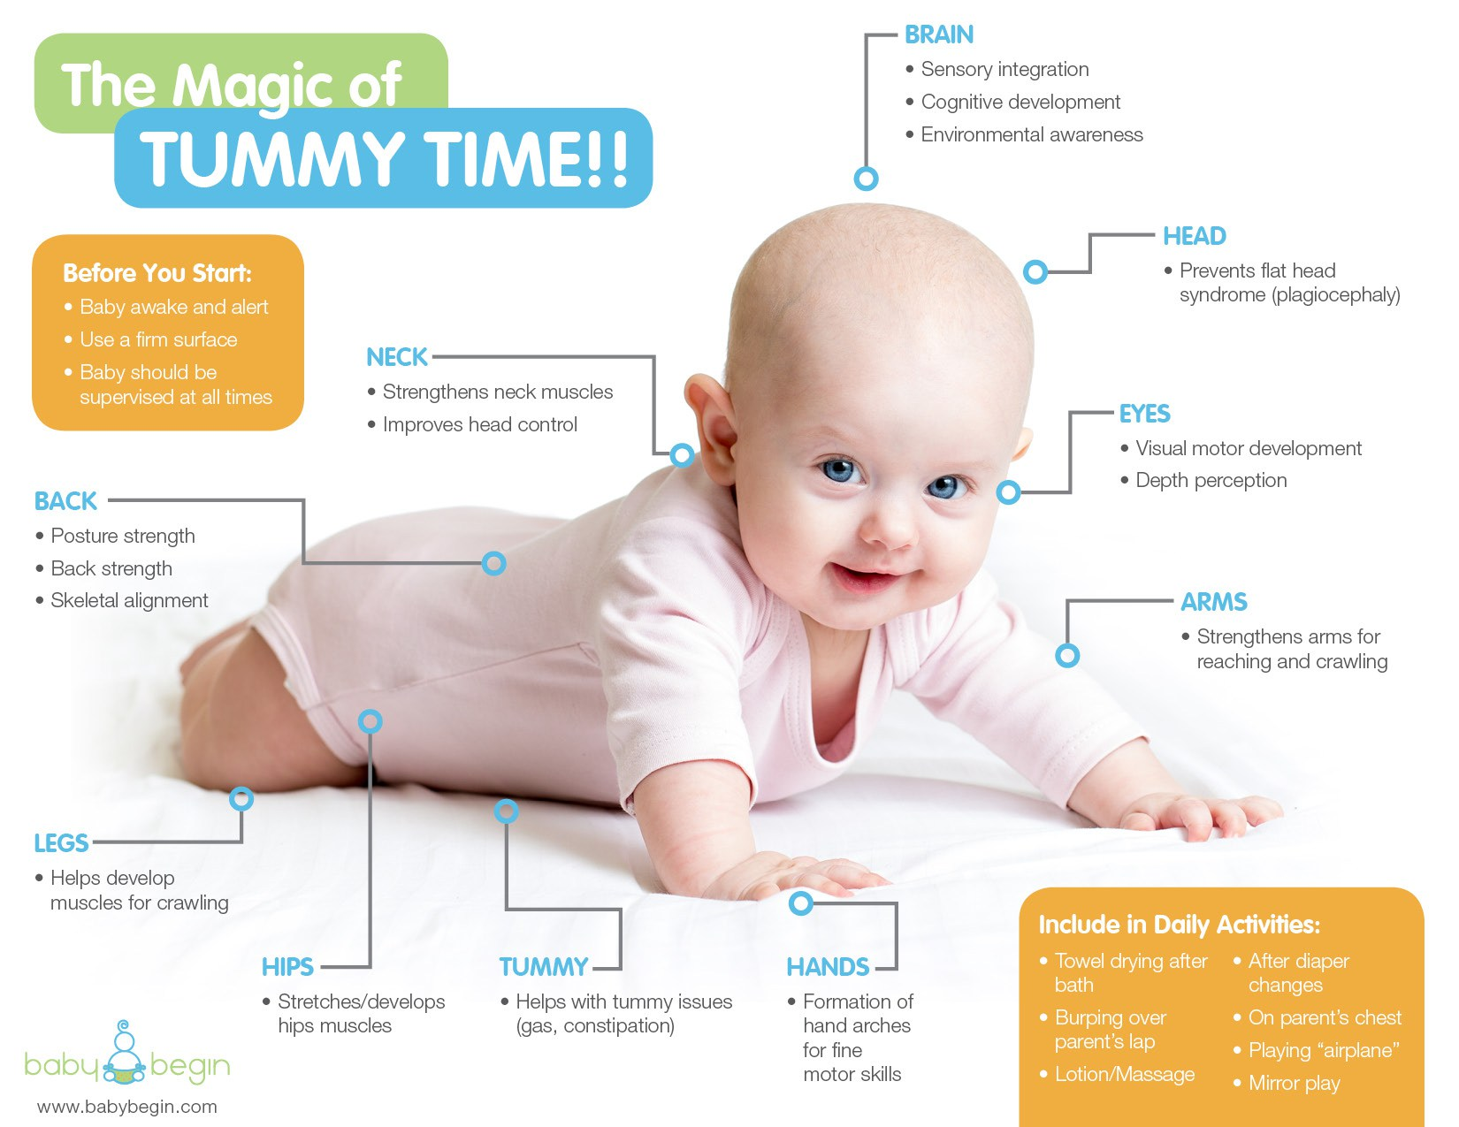

Example of tummy time activities and progressions

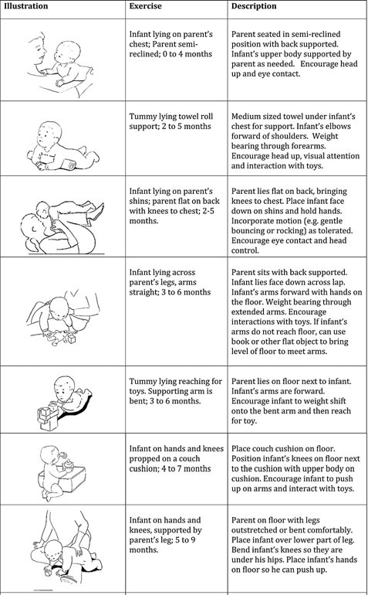¹
What patient populations have been shown to benefit from tummy time in recent literature?
- Tummy time is an interesting intervention in that it is utilized for infants who are typically developing, as well as for those who are developmentally delayed.¹ A recent study indicated that tummy time enhances the motor development of infants with Down Syndrome, especially when initiated prior to 11 weeks of age and carried out for approximately 90 minutes each day.¹ This article notes that parental administration of this intervention outside the clinic environment is even more important for individuals with Down Syndrome, as this population often has central nervous system limitations that result in learning deficits.¹ These infants need even more practice than is required for typically-developing children in order to attain new skills, which means that more than 81 minutes of tummy time per day will be necessary in order to optimize developmental outcomes.¹

Potential benefits of tummy time: ICF Model
- Tummy time is a very practical intervention that addresses various areas of the International Classification of Functioning model. Firstly, it improves body structure and function by increasing strength of the neck and back extensors against gravity, as well as the core and shoulder musculature.¹ It also promotes upper extremity weight bearing over time in order to encourage proper bone growth and density. In terms of activity, tummy time facilitates the development of essential motor milestones such as rolling, sitting, and crawling.¹ It also impacts participation through providing the opportunity for increased environmental exploration, play, and interaction with caregivers.¹

When is tummy time indicated / contraindicated?
- Indications:
  - Baby is home from the hospital
  - Baby is awake and alert
  - Adult is available for constant supervision
- Contraindications:
  - Baby is sleeping or very drowsy
  - Adult is unavailable for constant supervision

What resources are required for tummy time?
- Tummy time is an intervention that requires very minimal resources outside of “time” itself. Toys can be utilized to help keep the child engaged and improve tolerance of the prone position, though this is not a necessary component of this intervention. There is no intrinsic financial cost of tummy time, which makes it ideal for inclusion in home exercise programs for infants. In addition, there is no special training required, though caregiver education regarding the importance of this intervention and the various methods that can be utilized to achieve adequate tummy time may help with adherence to recommendations.

Reimbursement for intervention as PT
- Tummy time is an excellent intervention to incorporate into a home exercise program since it can be easily implemented by parents and caregivers. However, it may also be beneficial to integrate tummy time into physical therapy sessions in order to work towards the recommended 81 minutes per day.¹ Based on the specific goals of this intervention at the time that it is performed, there may be a few different CPT codes that can appropriately reflect tummy time as follows:
  - Therapeutic exercise:
    - This code could be used if the goal of the intervention is to improve the strength of weak cervical extensors.
  - Therapeutic activity:
    - This code could be used if the goal of the intervention is to improve the infant’s ability to engage in functional play.
  - Neuromuscular reeducation:
    - This code could be used if the goal of the intervention is to promote the necessary motor control for rolling and crawling.

Tummy time in the literature: 2014-2017
- The numerous benefits of tummy time have been detailed in earlier studies. The findings below have been obtained from recent literature published between 2014 and 2017:
  - Perrin et al, 2014¹⁰
    - This study examined the reports of 863 parents of various races/ethnicities regarding the feeding and activity behaviors of their 2-month-old infants.
    - Hispanic infants are less likely to engage in at least 30 minutes of daily tummy time (22%) than white infants (46%) and black infants (45%).
  - Yin et al, 2014¹¹
    - This study assessed the relationship between parental health literacy and certain infant care behaviors related to feeding content and physical activity.
    - Infants of parents with low health literacy are 3 times as likely to spend less than 30 minutes per day engaging in tummy time activities compared to infants with parents who have adequate health literacy.
  - Slining et al, 2014³
    - This study reviewed state regulations regarding physical activity in childcare facilities as compared to the recent Institute of Medicine recommendations.
    - Less than 20% of states have childcare center regulations that are consistent with the Institute of Medicine’s recommendation for daily tummy time for infants less than 6 months of age.³
  - Gross et al, 2017⁹
    - This randomized controlled trial assessed the efficacy of a primary care-based child obesity prevention program (“Starting Early”) for promoting infant activity in low-income Hispanic families as compared to standard pediatric primary care.
    - Inadequate health literacy in low-income Hispanic parents is associated with low tummy time in their infants.
  - Wentz, 2017¹
    - This study compared the motor development of infants with Down Syndrome who began a tummy time intervention before 11 weeks of age versus those who began the same intervention after 11 weeks of age.
    - Tummy time enhances the motor development of infants with Down Syndrome, especially when initiated prior to 11 weeks of age and carried out for approximately 90 minutes each day.

Translation to practice
- The Ottawa Model of Research Use (OMRU) is a framework for identifying the contextual factors that may influence the effectiveness of knowledge translation from research to practice.⁸ The OMRU is made up of six interrelated elements as follows:
- Evidence-based innovation
- Potential adopters
- The practice environment
- Implementation of interventions
- Adoption of the innovation
- Outcomes resulting from implementation of the innovation
- This model also emphasizes the continued assessment of barriers, monitoring of the intervention, and evaluation of outcomes in order to direct improvements in knowledge translation.⁸
- When considering tummy time as the innovation within this model, research has previously indicated that it is an effective intervention for promoting the motor development of typically developing infants, as well as those who are developmentally delayed. The potential adopters have also been determined as parents and any other caregivers that the infant might spend time with during the week (grandparents, nannies, daycare workers, etc.). The practice environment can also encompass many different settings including the home, daycare, park, or any other location in which the infant can be placed safely in prone with supervision. Simply holding the infant in a prone position or placing him/her across the caregiver’s legs in a prone position also qualifies as tummy time, so this factor expands the practice environment to virtually anywhere that the child is not required to be in a car seat or other containment device. Implementation and adoption of the innovation are the areas of this model that seem to be causing the disconnect between evidence and outcomes for tummy time due to various barriers, a few of which are described below.

- Containment
  - “Container Baby Syndrome” is a term that refers to the movement, behavior, and deformity issues that can develop over time when an infant is kept in a containing device for an excessive amount of time.⁷ A few commonly used containment devices are as follows:
    - Car seats
    - Strollers
    - High chairs
    - Bouncy seats or swings
    - Bumbo seats
  - Because several of these pieces of equipment are necessary for transportation or daily activity, parents often view them as a safe place for their infant to rest or play.⁷ However, since these devices cause infants to remain in a position of flexion and often supine positioning, they do not allow for a wide range of movement experiences and strengthening of the extensor musculature.⁷
    - In order to improve the translation of tummy time to practice, caregiver education must be provided and reinforced on the topic of minimizing the use of containment devices.
- “Back to Sleep”
  - In 1992, the American Academy of Pediatrics (AAP) introduced the recommendation that infants be placed on their back or side to sleep for the first 6 months of life in order to decrease the risk of sudden infant death syndrome (SIDS).⁴ This proposal arose from the identification of prone sleeping as a primary modifiable risk factor for SIDS.⁴ The United States Public Health Service further advocated for this recommendation in 1994 by coordinating the “Back to Sleep” campaign in order to disseminate this information to parents.⁵ Prior to the origination of this recommendation, approximately 74% of infants in the United States slept in the prone position, and this percentage had decreased to 20% by the year 2000.^{4,6} Overall, reducing the prevalence of prone sleeping has been successful in decreasing the occurrence of SIDS.⁶ However, this change in sleeping position has also resulted in a decrease in the utilization of tummy time during waking hours due to misunderstanding of the recommendation as well as continued fearfulness of SIDS.¹
    - In order to improve the translation of tummy time to practice, caregiver education must be provided and reinforced on the concept of “Tummy to Play” in addition to “Back to Sleep.”
- Lack of Time
  - Tummy time necessitates parent/caregiver adherence and direct supervision, as infants are unable to intentionally initiate this intervention independently. With the busyness of today’s society, parents often feel that they do not have the availability to devote 81 minutes of time each day to the constant supervision of their infant in the prone position, especially if they are working a full time job, caring for additional children, or have other time-consuming obligations.
    - In order to improve the translation of tummy time to practice, caregiver education must be provided and reinforced regarding ways that multiple short periods of tummy time can be integrated into the family’s daily routine, such as immediately following each diaper change.
- Various Caregivers
  - A recent study found that over 61% of children under 5 years of age spend regular time in childcare centers outside the home, and less than 20% of states have childcare facility regulations that are consistent with the Institute of Medicine’s recommendation for infants less than 6 months of age to engage in daily tummy time.³
    - In order to improve the translation of tummy time to practice, healthcare providers should ensure that all caregivers are included when it comes to providing comprehensive education regarding tummy time, not just the parents alone.
- Caregiver Characteristics
  - Evidence has shown that inadequate parental health literacy is associated with decreased amounts of tummy time for their infants.⁹ Studies have also indicated that parents with lower education levels tend to wait until after their infant is 3 weeks of age to begin tummy time, and they also place their infants in the prone position less often and for a shorter period of time.²
    - In order to improve the translation of tummy time to practice, caregiver education, both verbal and through written materials, must be provided at a health literacy level and in a language that the individual can understand.

Summary about utility of intervention for current practice
- Overall, since this intervention does not require equipment or intrinsic cost and can be implemented from birth in nearly any setting, tummy time is very feasible for use in real world clinical practice.¹ It is a practical and evidence-based intervention for promoting normal infant development, primarily from birth through 6 months of age. However, numerous barriers to implementation still remain as noted above, despite evidence that demonstrates the benefits of this intervention. Clear and consistent education provided to all caregivers regarding the importance of tummy time for infant development is critical to the utility of this intervention in current practice.

References
- Wentz E. Importance of Initiating a “Tummy Time” Intervention Early in Infants With Down Syndrome. Pediatric Physical Therapy. 2017;29(1):68-75. doi:10.1097/pep.0000000000000335.
- Koren A, Reece S, Kahn-D'angelo L, Medeiros D. Parental Information and Behaviors and Provider Practices Related to Tummy Time and Back to Sleep. Journal of Pediatric Health Care. 2010;24(4):222-230. doi:10.1016/j.pedhc.2009.05.002.
- Slining M, Benjamin Neelon S, Duffey K. A review of state regulations to promote infant physical activity in child care. International Journal of Behavioral Nutrition and Physical Activity. 2014;11(1). doi:10.1186/s12966-014-0139-3.
- Changing Concepts of Sudden Infant Death Syndrome: Implications for Infant Sleeping Environment and Sleep Position. PEDIATRICS. 2000;105(3):650-656. doi:10.1542/peds.105.3.650.
- Turk A, McCarthy J, Thome C, Wisoff J. The “Back to Sleep Campaign” and Deformational Plagiocephaly. Journal of Craniofacial Surgery. 1996;7(1):12-18. doi:10.1097/00001665-199601000-00006.
- Argenta L, David L, Wilson J, Bell W. An Increase in Infant Cranial Deformity with Supine Sleeping Position. Journal of Craniofacial Surgery. 1996;7(1):5-11.
- Avruskin A. Physical Therapist's Guide to Container Baby Syndrome. Move Forward PT. 2017. Available at: 7. http://www.moveforwardpt.com/symptomsconditionsdetail.aspx?cid=53d90264-1846-4b86-891f-0facc63db3e8. Accessed April 25, 2017.
- Sudsawad P. Knowledge Translation: Introduction to Models, Strategies, and Measures. The National Center for the Dissemination of Disability Research. 2007.
- Gross R, Mendelsohn A, Yin H. Randomized controlled trial of an early child obesity prevention intervention: Impacts on infant tummy time. Obesity. 2017;25(5):920-927. doi:10.1002/oby.21779.
- Perrin E, Rothman R, Sanders L. Racial and Ethnic Differences Associated With Feeding- and Activity-Related Behaviors in Infants. PEDIATRICS. 2014;133(4):e857-e867. doi:10.1542/peds.2013-1326.
- Yin H, Sanders L, Rothman R. Parent Health Literacy and “Obesogenic” Feeding and Physical Activity-Related Infant Care Behaviors. The Journal of Pediatrics. 2014;164(3):577-583.e1. doi:10.1016/j.jpeds.2013.11.014.

