LEEWAY
(Lymphedema Empowerment Exercise With Adapted Yoga)
a group yoga-based intervention program to manage the physical and psychosocial influence of lymphedema in breast cancer survivors

Statement of Need

LEEWAY is a health promotion program serving breast-cancer survivors with lymphedema symptoms. Breast cancer is the most common cancer found in women, with approximately 12% of women developing invasive breast cancer over the course of their lifetime in the United States.¹ Compared to other states in the United States, North Carolina has an alarmingly high incidence rate, with 126.1 women with breast cancer out of every 100,000 women in 2013.² In Wake County alone, the North Carolina Central Cancer Registry projected 895 new breast cancer cases in 2016.² It has been estimated that 90% of women will survive breast cancer due to early detection efforts and aggressive treatment strategies.¹ However, treatments for breast cancer often result in disabling upper extremity side-effects, such as lymphedema.³ The incidence of breast cancer related lymphedema vary, with a low rate of 3% for sentinel node biopsy with irradiation, to as high as 58% for women undergoing a radical mastectomy.³ Impairments from breast-cancer related lymphedema may include decreased arm function, range of motion and strength, increased arm swelling, pain, a sense of heaviness in the extremity.⁴ Additionally, many women also experience adverse psychosocial side effects with lymphedema such as emotional distress, anxiety, problems with social relationships, and a disturbance of body image.^{4,5} Together, these physical and psychosocial complications of lymphedema reduce this population’s quality
of life and burdens their ability to perform daily activities.⁵ Data analysis has also conveyed that breast cancer survivors are at a life-time risk of developing lymphedema. Additionally, lymphedema impairments are considered to require lifelong management to prevent serious health consequences.⁶ Therefore, there is a need to implement a physical therapy intervention program, such as LEEWAY, to help women effectively and safely manage their lymphedema symptoms and dysfunction.

Background

Several quality studies have conveyed that yoga-based interventions, upper extremity exercises, and patient education on self-management are effective means to reduce adverse lymphedema symptoms in breast cancer survivors. A pilot study by Fisher et al. reports a statistically significant decline in arm volume following 8 weeks of modified Hatha yoga participation that included meditation, progression of low-impact, modified poses, and stretching and isometric exercises that focused on the shoulders, arms, and chest.⁷ The authors of this study theorize the breathing exercises and poses incorporated through yoga practice provide assistance to the draining of lymph into the lymphatic system.⁷ Greenlee et al. performed a systematic review of randomized controlled trials on the use of integrative therapies for breast cancer treatment. Substantial evidence from the systematic review support the use of meditation to improve quality of life among breast cancer patients, as well as yoga to improve mood in women with breast cancer symptoms.⁸ A study by Mirandola et al. demonstrated promising results, in that 8 weeks of exercise-specific interventions (including breathing exercises, upper extremity stretching and ROM movements, and posture/core stabilization exercises) improved shoulder function and ROM, decreased mobility differences between the two upper extremities, and a reduced pain and psychological distress in breast cancer survivors.⁵ A study by Narahari et al. suggests a yoga intervention program incorporate breathing exercises and slow, methodical joint movements to improve pain, reduce fibrosis, improve range of motion, and effectively reduce volume and heaviness in lymphedema extremities in breast cancer survivors with lymphedema symptoms.⁹ It should be noted that this study also included patient counseling and education of self-management as part of it’s protocol.⁹ Yoga has not been demonstrated to induce or exacerbate lymphedema and is a safe activity for breast cancer survivors.¹⁰ Therefore, a yoga-based intervention, such as LEEWAY, that incorporates upper extremity and core strengthening and stretching exercises, breathing and mediation exercises, and patient education on self-management, may be effective in reducing adverse lymphedema symptoms and improving quality of life in breast cancer survivors.
It is important to recognize that the LEEWAY participants’ beliefs or perceptions are going to be the main motivation for their behavior change and compliance.¹¹ Adequate self-management can help avoid serious health consequences such as compartment syndrome, cellulitis, or loss of sensation and limb function when educating participants on lymphedema management.¹² Self-efficacy will be an important determinant in LEEWAY, as the program’s foundation is empowerment over lymphedema. Self-efficacy may be promoted by reminding participants why they chose to participate in the program and supplementing their confidence by recognizing where changes and successes have already been made.^{5,13} This promotion of self-efficacy, may enhance LEEWAY participants’ beliefs in their ability to perform and achieve the interventions successfully.¹³ Building participants confidence in their ability to complete the program may increase their compliance and improve success.¹³ This participant confidence may also be increased through means such as teaching the program in a stress free environment and providing positive verbal feedback.¹³ Participants’ knowledge, skills, and social support network will also be determinants targeted by the LEEWAY program. LEEWAY will strive to improve participants’ knowledge and skills by providing valuable lymphedema management information and lifestyle modification education. Additionally, building a network of social support for participants in LEEWAY is likely to be beneficial, as the collaborative group discussion and sharing of experiences may help promote a healthy lifestyle change and improve adherence.¹⁴

Program Goals

To enhance breast cancer survivors’ ability to effectively and safely manage their lymphedema symptoms, improve pain and function of their upper extremities, and alleviate the psychosocial influence of lymphedema, the following goals for health improvements will be established.

- LEEWAY will offer evidence-based, meaningful, yoga-based exercise interventions that will result in a reduction of lymphatic swelling (at least a 25% circumferential reduction of 3 measured points along the upper extremity), decrease in pain and discomfort (11 mm difference on the Visual Analog Scale), and improvement in upper extremity function (10-point improvement on DASH questionnaire) for breast cancer survivors with lymphedema after 8 weeks.
- LEEWAY will enhance participants’ independence with lymphedema prevention and risk factor reduction strategies that will result in a reduction of flare-ups or worsening of symptoms, as reported in self-report reflections at the completion of the program.
- Striving to promote empowerment and freedom of movement, participants in LEEWAY will report at least a 15% improvement in health-related quality of life scale component of the SF-36 at the completion of the 8-week program.
- As a group-based health promotion program, LEEWAY will provide valuable social support to it’s participants, encouraging group discussion and promoting a supportive and encouraging atmosphere. Participants will demonstrate at least a 15% improvement on the social functioning scale component of the SF-36 8-weeks after commencement.

Program Description

Evidence has demonstrated that yoga-based interventions, upper extremity exercises, and/or patient education on self-management are effective means to reduce adverse lymphedema symptoms in breast cancer survivors.^{5,7,8,9} Participants of LEEWAY will engage in varying types exercises (1-hour sessions/two days per week for 8 weeks), as exercises have demonstrated to promote upper extremity function and mobility, improve sense of well-being, and reduce lymphatic swelling in breast cancer survivors.⁵ Mirandola et al. reported benefits from direct visual feedback provided by mirrors in an upper-limb exercise program for breast cancer survivors.⁵ Therefore, exercises will be performed in front of a mirror to provide feedback and improve participant’s perception of body image. Exercises will include: (1) Breathing and meditation/relaxation exercises, (2) Low-impact, modified yoga poses (Figure 1), (3) Progressive shoulder and upper extremity exercises exercises emphasizing ROM movements of the shoulders, arms, and chest (Figure 2).^{5,7} Lymphedema impairments are considered to require lifelong management to prevent serious health consequences.⁶ Therefore, LEEWAY will include a weekly educational component based on published guidelines that will address signs and symptoms of lymphedema, suggestions for preventing the onset of lymphedema, and self-management skills that include skin care and self-massage, compression, arm elevation techniques.⁹ As previously noted, many women experience adverse psychosocial side effects with lymphedema, such as emotional distress, anxiety, problems with social relationships, and a disturbance of body image.^{3,5} To address this, social support will be provided to participants during educational sessions. Group discussion will be encouraged to promote a supportive and encouraging atmosphere. This educational component may help reduce the risk of flare-ups or worsening of symptoms for participants.⁹ Outcome assessments and questionnaires will be completed prior to the commencement of the program as well as at the end of the 8-week program. ROM, pain and circumferential upper extremity measurements will be completed on a weekly basis. A certified lymphedema therapist and a yoga instructor will co-instruct LEEWAY to optimize the exercise interventions for this patient population with unique precautions and needs. The trained lymphedema therapist will instruct all self-management educational components of LEEWAY. The program will be implemented in available aerobic studios in Wake County. LEEWAY will value the personal, environmental, and behavioral determinants that may effect participants’ optimal health, as well has promote health and psychosocial well-being in every breast cancer survivor participant. By providing a safe and stress-free environment for effective lymphedema exercises and activities, as well as offering an outlet for meaningful social support, the LEEWAY health promotion program will address the physical and psychosocial influences of lymphedema in breast cancer survivors.

Program Evaluation

Program goals will be predominately evaluated by outcome measures and clinical measurements. Assessment of lymphatic swelling will be completed by performing circumferential tape measurements of both upper extremities every 8 cm starting just distal to the MCP joints up to the shoulder girdle.¹⁵ Pain and discomfort will be assessed with the Visual Analogue Scale (VAS), as this scale has demonstrated to be reliable and valid with this patient population.^{12,16} An 11 mm improvement will be considered clinically significant, as this is the scales MCID.¹⁶ The Disabilities of the Arm, Shoulder, and Hand (DASH) questionnaire will be a self-report measure utilized to evaluate upper arm function and mobility.¹⁷ The minimal clinically important difference (MCID) for the DASH questionnaire has been estimated to be 10 points, therefore a change of 10 points will be necessary to observe a meaningful effect from LEEWAY.¹⁷ Change in upper extremity mobility will assessed through ROM measurements of both upper extremities using a goniometer. Comparisons of ROM measurements between affected and unaffected upper extremities will be made to determine ROM limitations.
Women with diagnosed lymphedema have been conveyed to have statistically significant lower mean quality of life measurements (SF-36 scores) compared to women without lymphedema.¹⁸ LEEWAY aims to promote empowerment and freedom of movement, while also providing valuable social support to it’s participants. Therefore, it would be valuable to assess how LEEWAY may influence health-related and social quality of life measurements. The SF-36 questionnaire has proven to be sensitive in detecting positive changes in all subscales for breast cancer survivors enrolled in a yoga intervention program.¹⁹ Participants will compete the SF-36 questionnaire prior to commencement of the program and at completion of the 8-week program. Improvements in quality of life will be evaluated regarding the health-related quality of life scale and the social functioning scale of the SF-36. To assess the effect of lymphedema management and lifestyle modification education, patients will self-report perception of flare-ups and symptoms prior to commencement of the program, at the completion of the program, and at a 2-month follow-up point.
With the evaluation of the goal outcomes and relevant demographic/medical variables in mind, changes for future implementation of the program will be considered. For example, the predominant staging of lymphedema may impact the exercise interventions to be implemented- a stage 3 lymphedema participant may have more difficulty completing the exercises and poses compared to a stage 1 participant. Separate classes also may be necessary for differing levels of endurance and physical ability. Additionally, interventions and measurement tools may be modified if outcome measures do not have the sensitivity or specificity to examine change over time.

References

- Breast Cancer. Centers for Disease Control and Prevention website. https://www.cdc.gov/cancer/breast/statistics/state.htm Last updated July 19, 2016. Accessed November 10, 2016.
- Projected New Cancer Cases and Deaths by County. North Carolina State Center for Health Statistics. North Carolina Public Health website. http://www.schs.state.nc.us/data/databook/ Updated October 21, 2016. Accessed November 10, 2016.
- O’Toole J, Jammallo L, Skolny M, Miller C, Elliot K, et al. Lymphedema following treatment for breast cancer: a new approach to an old problem. Crit Rev Oncol Hematol. 2013; 88(2):437-446.
- Lymphoedema Framework. Best Practice for the Management of Lymphoedema. International Consensus. London: MEP Ltd; 2006.
- Mirandola D, Miccinesi G, Muraca MG, Sgambati E, et al. Evidence for adapted physical activity as an effective intervention for upper limb mobility and quality of life in breast cancer survivors. Journal of Physical Activity and Health. 2014; 11:814-822.
- Armer Jm, Stewart BR. Post-breast cancer lymphedema: incidence increases from 12 to 30 to 60 months. Lymphology. 2010; 43(3):118-127.
- Fisher MI, Donahoe-Fillmore B, O’Malley C, Merriman H. Effects of yoga on arm volume among women with breast cancer related lymphedema: A pilot study. Journal of Bodywork and Movement Therapies. 2014; 18:559-565.
- Greenlee H, Balneaves LG, Carlson LE, Cohen M, et al. Clinical practice guidelines on the use of integrative therapies as supportive care in patients treated for breast cancer. Journal of the National Cancer Institute Monographs. 2014; 50:346-358.
- Narahari SR, Aggithaya MG, Thernoe L, Bose KS, et al. Yoga protocol for treatment of breast cancer-related lymphedema. International Journal of Yoga. 2016;9:145-155.
- Lai YT, Hsieh C, Huang LS, Liu WS, et al. The effects of upper limb exercise through yoga on limb swelling in Chinese breast cancer survivors- a pilot study. Rehabilitation Nursing. 2015;1-10.
- Skinner CS, Tiro J, Champion VL. The health belief model. In: Glaz K, Rimer BK, Viswanath K, ed. Health Behavior: Theory, Research, and Practice. 5th ed. San Francisco, CA: Jossey-Bass; 2015: 75-94.
- Schmitz KH, Troxel AB, Cheville A, Grant LL, et al. Physical activity and lymphedema (The PAL Trial): assessing the safety of progressive strength training in breast cancer survivors. Contemp Clin Trials. 2009; 30(3):233-245.
- Kelder SH, Hoelscher D, Perry CL. How individuals, environments, and health behaviors interact: social cognitive theory. In: Glaz K, Rimer BK, Viswanath K, ed. Health Behavior: Theory, Research, and Practice. 5th ed. San Francisco, CA: Jossey-Bass; 2015: 159-182.
- Sallis JF, Owen N. Ecological models of health behavior. In: Glaz K, Rimer BK, Viswanath K, ed. Health Behavior: Theory, Research, and Practice. 5th ed. San Francisco, CA: Jossey-Bass; 2015: 43-61.
- Standard of Care: Lymphedema: The Brigham and Women’s Hospital, Inc. Department of Rehabilation. Brigham and Women’s Hospital Website. http://www.brighamandwomens.org/Patients_Visitors/pcs/rehabilitationservices/Physical-Therapy-Standards-of-Care-and-Protocols/General%20-%20Lymphedema.pdf Last updated November 11, 2016. Accessed December 10, 2016.
- Kelly, AM. The minimum clinically significant difference in visual analogue scale pain score does not differ with severity of pain. Emerg Med J. 2001;18:205-207. Doi: 10.1136/emj.18.3.205
- Roy JS, MacDermid JC, Woodhouse Lj. Measuring shoulder function: a systematic review of four questionnaires. Arthritis Rheum. 2009; 61(5):623-632. Doi: 10.1002/art.24396.
- Ahmed RL, Prizment A, Lazovich D, Schmitz KH. Lymphedema and quality of life in breast cancer survivors : the Iowa women’s health study. Journal of Clinical Oncology. 2008;26(35):5689-5696.
- Bower K, Caret D, Sternlieb B. Yoga for persistent fatigue in breast cancer survivors: results of a pilot study. Evid Based Complement.Alernat. Med. 2011;8(1):1-8

Figure 1. Yoga Sequences and Poses as presented in the 2014 Fisher et al. pilot study.⁷

Warm-ups and Centering
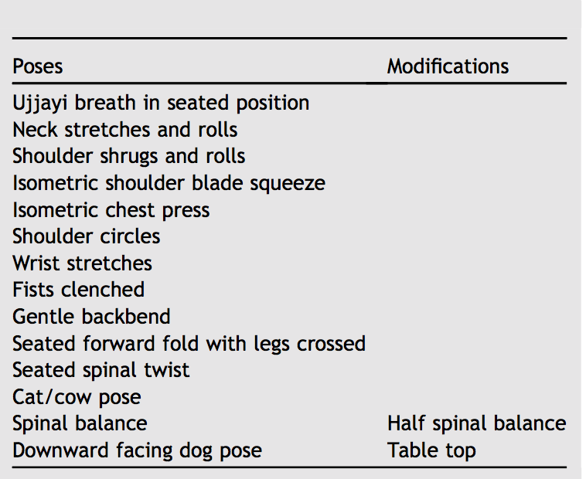

Standing Poses
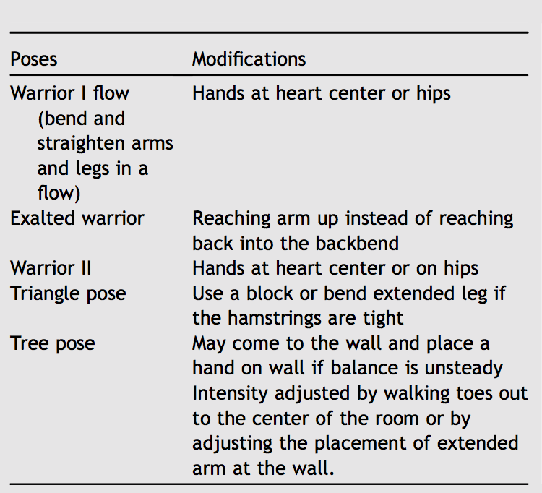

Seated Poses
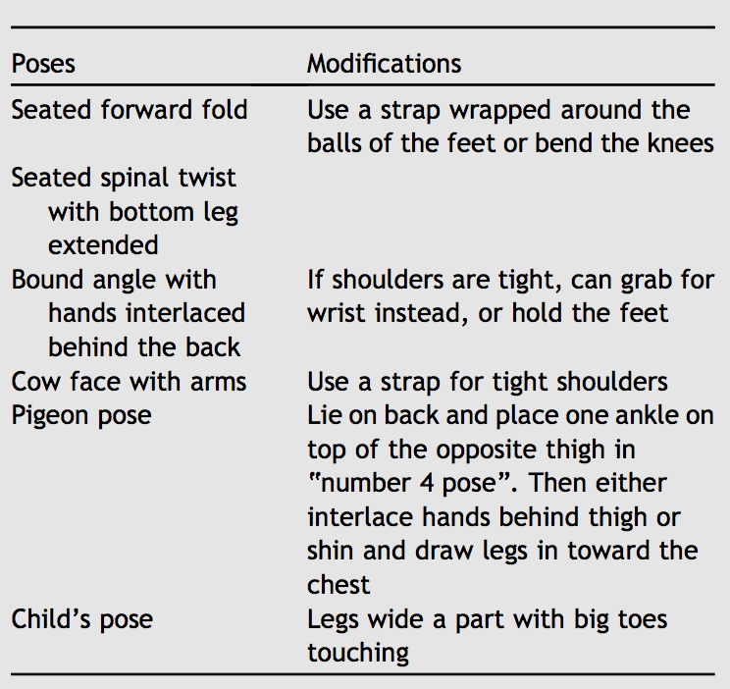

Finishing Poses

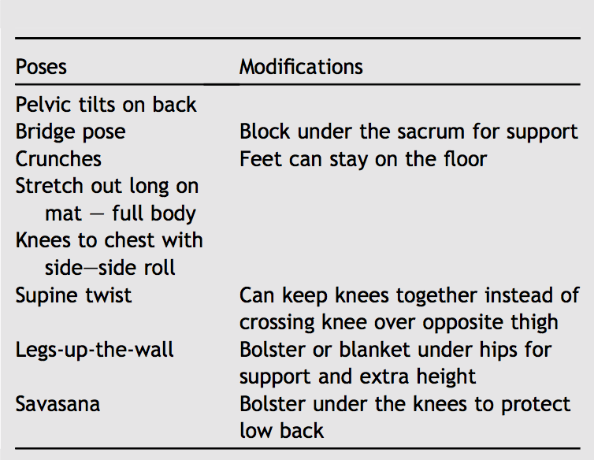

Figure 2. Exercise Activity Program with progressions as presented in the 2014 Mirandola et al. study.⁵

