Introduction
Running has steadily become one of the most popular forms of physical activity in the United States, with an estimated 20% of Americans running regularly for fitness.¹ The increase in running popularity over the years is likely attributable to its health benefits. Many studies have provided evidence revealing running as one of the most efficient ways to achieve physical fitness and longevity.^{2,3} More specifically, running can reduce the incidence of obesity, cardiovascular disease, and various other chronic health conditions.⁴ While it has many health benefits, running does come with an increased risk of musculoskeletal injury.
Estimates place the incidence of lower extremity (LE) running injuries anywhere from 19.4% to 79.3% depending on definition of injury, study population, and follow-up periods.^{2,4} At any rate, roughly half of runners will incur an injury that will require them to stop running any given year.¹ The most predominant site of injury is the knee. A systematic review completed by Van Gent et al. revealed that knee specific injuries accounts for 7.2% to 50% of all injuries, followed by the lower leg (9.0-32.2%), foot (5.7-39.3%), and upper leg (3.4-38.1%). The most common diagnoses of knee pain in runners, patellofemoral pain syndrome (PFPS), constitutes 25% of knee injuries treated in sports clinics.⁵
PFPS can be caused by a multitude of factors, some of which include anatomical variants and biomechanical factors that affect running form, orthotics, training errors, soft tissue flexibility, and muscle flexibility, strength, and endurance (table 1). Due to the wide range of possible risk factors of PFPS, it is important that clinicians have the expertise to properly diagnose and treat this issue. Without proper treatment, excessive knee pain could deter individuals from participating in physical activity, which would inherently put them at risk for developing chronic health conditions. With the proper knowledge and tools in hand, clinicians can effectively address their patients’ knee pain and facilitate a safe and progressive return to running.
Causes of Patellofemoral Pain
The exact pathogenesis of patellofemoral pain (PFP) is not clearly understood and likely has multiple origins. The most commonly accepted hypothesis amongst researchers and clinicians, however, relates PFP with increased patellofemoral joint stress and the resultant damage to articular cartilage.^{6,7} Indeed, individuals with PFP exhibit greater peak and mean hydrostatic pressures and octahedral shear stresses compared to healthy controls.⁸ Disruption to articular cartilage increases the stress placed on the underlying subchondral bone, thereby causing nociceptive pain. Other possible structures subject to the effects of increased patellofemoral joint stress are the patellar retinaculum, peripatellar synovium, and the surrounding muscles and nerves.⁹
Increased patellofemoral joint pressures could be a result of abnormal patellar alignment within the trochlear grove and/or abnormal patellar tracking during knee movement. Static and dynamic patellar malalignment result in decreased contact area between the patella and the femoral condyles, thereby driving up contact pressure and causing degenerative changes to the underlying articular cartilage and subchondral bone. A second possible mechanism of PFP is repetitive and high-frequency overload of the patellofemoral joint. Activities such as running, which requires repetitive and frequent loading of the knee, could result in chronic overload and degenerative changes of the surrounding knee tissues. Runners who subject their knees to repetitive and frequent overload and who also have abnormal patellar alignment and/or tracking would be especially susceptible to PFP. As stated previously, the factors contributing to large patellofemoral joint pressure are diverse and widespread. Whether it be aberrant patellar alignment and tracking and/or overload of the joint, clinicians must conduct a careful and detailed evaluation to determine all the factors that may be contributing to a runner’s PFP.
Diagnoses
History
Examination should begin with a thorough history to determine symptom onset and location. The onset of PFP is usually spontaneous and insidious. Blunt trauma to the knee, however, can crush the underlying articular cartilage and cause persistent patellofemoral pain as well.⁷ PFP is usually described as a dull ache localized diffusely to the anterior knee, but in some cases can be described as sharp.^{6,7} It may be helpful to ask patients to point with one finger where their pain is located in an attempt to narrow down the possible affected tissues. PFP is typically exacerbated by any activities that increases stress to the patellofemoral joint. Aggravating factors may include ascending or descending stairs, running, jumping, squatting, or prolonged knee flexion (aka the movie theater sign).^{6,7} Patients may also complain of knee buckling, catching, or feelings of instability during running or walking.^{6,7} Feelings of instability may be attributable to knee pain inhibiting activity of the quadriceps, but clinicians must rule out instability arising from patellar dislocation, subluxation, or ligamentous injury.⁶ Patients may also exhibit swelling of the knee. Swelling, however, is not a prominent feature of PFPS and may be indicative of another issue.⁷
The patient’s training habits should be discussed during the interview to assess whether they are making any training errors that are predisposing them to PFP (table 1, column 3). Important consideration must be given to habits that result in frequent overload of the patellofemoral joint. If the patient’s pain is consistently aggravated by uphill or downhill running, which significantly increases patellofemoral joint stress, he or she should be advised to avoid hills as much as possible or to run these hills in a zig-zag pattern. Clinicians should also determine if the individual has abruptly escalated their duration, frequency, or intensity of running, as these factors subject knee tissues to forces that have not yet established resiliency to the increased demands they are being subjected to. Novice runners are also at a higher risk for developing PFPS. An analysis on 874 runners found that new runners who increased their weekly mileage by more than 30% over a two-week period were at an increased risk for running-related injuries.¹⁰ Finally, the patient’s weekly mileage should be discussed. High weekly mileage beyond 20-40 miles a week significantly increases the incidence of PFPS.⁷

Physical Examination
Physical examination should begin with an assessment of LE alignment with the patient in standing. Individuals with PFP may have excessive internal rotation (IR) of their femur, which may be indicated by inward-pointing patella and tibial external rotation (ER).⁷ Excessive femoral IR under a semi-fixed patella causes a relative lateral displacement of the patella⁷, which reduces contact area between the patella and trochlear grove and increases patellofemoral joint contact pressure. Another common measurement of LE alignment is Q-angle, or the angle formed by the line connecting the ASIS to the patella and the line connecting the patella to the anterior tibial tuberosity (figure 1).⁶ The Q-angle is thought to represent the force vector created by the quadriceps. Theoretically, a large Q-angle would increase the lateral force placed on the patella, which would increase the contact pressure between the articulating surfaces of the patella and lateral femoral condyle (figure 1). While the evidence is inconsistent, many researchers support the finding that a Q-angle larger than 16° is a risk factor for developing PFPS.⁶ Clinicians should also look for genu valgum or varum deformities of the knee, the presence of which would alter Q-angle and patellar tracking during movement.
Alignment of the LE should be assessed dynamically, as malalignment not present in a static position may emerge due to LE weakness or poor neuromuscular control. Dynamic malalignment of the LE can be assessed through a single leg squat test in which the patient slowly completes a squat from 45° to 60° of knee flexion.⁷ As the patient descends, the clinician should observe for contralateral hip drop and ipsilateral hip adduction, femoral IR, knee abduction, and/or tibial ER (figure 2). These features would be indicative of weak hip abductors, weak hip external rotators, and/or poor motor control of LE musculature. Under normal conditions, a patella travels smoothly along a straight or slightly curved path through the trochlear groove.⁶ If, however, the patient has excessive hip adduction and femoral IR during movement, the patella may track laterally in the trochlear grove and drive up patellofemoral contact pressures (figure 3). Supporting this view is a study completed by Powers et al. who obtained dynamic magnetic resonance images (MRI) of subjects’ LEs while completing a single leg squat. These dynamic MRIs provided evidence of greater femoral internal rotation in patients who were diagnosed with PFPS.¹¹
In supine, measurements of patellar glide, tilt, and mobility can be noted. The glide test assesses medial and lateral displacement of the patella by measuring distance from the middle of the patella to both the lateral and medial femoral epicondyles with the knee flexed to 20°.⁶ If the distance to the medial femoral condyle exceeds the distance of the patella to the lateral condyle by more than 0.5 cm, the patient may have excessive tightness of lateral restraints (lateral retinaculum and ITB) or reduced vastus medialis tension.¹² These results should be interpreted with caution, however, as clinical assessment of patellar glide may overestimate lateral glide measured on a MRI.¹¹ Secondly, patellar tilt should be assessed by comparing the height of the medial and lateral borders of the anterior aspect of the patella in the transverse plane. The two borders should be level under normal conditions. Difficulty palpating the lateral border of the patella during an isometric contraction indicates a severe lateral tilt, which may lead to lateral patellar compression syndrome.⁶ Lastly, patellar mobility test can further quantify mediolateral range of motion of the patella. The patella is divided into four longitudinal quadrants. With the knee flexed to 20°, the clinician glides the patella medially and laterally. Medial translation of the patella less than one quadrant indicates tightness of lateral restraints, which would increase contact pressure between the patella and lateral trochlear facet.^{6,7}
Soft tissue flexibility is another factor that may contribute to PFP, which can be assessed with the patient in supine. Quadriceps flexibility can be measured with Ely’s test. Tight quadriceps can directly increase the resultant force vector between the quadriceps and patellar tendon, thereby driving up contact pressure between the patella and the femur. ^{6,7} Tight hamstrings have likewise been implicated as a causative factor for PFP. In theory, tight hamstrings induce a constant knee flexion moment, thereby requiring the quadriceps to contract more forcibly to produce knee extension.¹³ This increase in quadriceps activity, in turn, increases patellofemoral joint reaction forces. Gastrocnemius length can also be assessed, as gastrocnemius tightness has been associated with PFP as well. Researchers suggest a tight gastrocnemius limits talocrural dorsiflexion, thereby producing compensatory subtalar joint pronation in order to achieve the proper amount of dorsiflexion required for running.⁶ During a closed chain activity such as running, overpronation may induce compensatory femoral IR and lateral maltracking of the patella. Lastly, ITB tightness should be assessed in sidelying with an Ober’s test. Tightness of the ITB has been reported in 67% of runners with PFP¹⁴, with several other studies supporting a link between ITB tightness and the development of PFP in other populations as well.⁶ As the fibers of the distal ITB blend in with the lateral patellar retinaculum, tightness of the ITB could cause abnormal lateral tracking of the patella and increased patellofemoral joint stress.
The most important aspect of the examination of a runner suspected to have PFPS is a running gait analysis. As in the single-leg squat test, clinicians should observe for excessive hip adduction and internal rotation during single leg stance on the affected limb. A study completed by Souza and Powers on women with PFP found greater hip internal rotation during running compared to healthy controls.¹⁵ These running gait impairments may be due to weak hip musculature, as another study conducted on a group runners with PFPS revealed weak hip abductor strength and increased hip adduction during running.¹⁶ These effects become more pronounced towards the end of a run, indicating that poor hip muscule endurance could lead to increased hip adduction and IR as well.¹⁶ Clinicians must also consider the patient’s neuromuscular control during single-leg stance. Souza and Powers found altered neuromuscular activity of the gluteus medius and maximus in their cohort of female runners with PFP.¹⁵ It could be that runners who are unable to maintain stability and normal LE alignment during single-leg stance are at risk for developing PFPS. Lastly, the clinician should observe for signs of excessive loading of the affected knee throughout the gait cycle. Thijs et al. hypothesize that excessive impact-sock during heel strike and during the propulsion phase of running may increase an individual’s risk of developing PFP. They found that runners who developed PFP had higher vertical peak force through the lateral heel and metatarsals 2 and 3.¹⁷ Clinicians may be able to discern high impact loading by observing the patient’s vertical displacement during running and by listening to how much noise the patient makes when landing with each step. Large vertical displacement and loud footsteps may be indicative of high impact loaders, which may constitute increased patellofemoral joint stress during impact.
A certain amount of foot pronation is required during walking and running for shock absorption. As discussed previously, however, excessive foot pronation during the gait cycle could lead to compensatory motions up the kinetic chain that result in patellar maltracking. More specifically, Tiberio theorizes that excessive subtalar joint (STJ) pronation during midstance of the gait cycle could result in compensatory hip IR to allow for knee extension to occur. During early contact of normal gait, the STJ pronates and the tibia internally rotates as a result of closed chain pronation. Once the foot reaches midstance, the STJ should begin to supinate and the tibia externally rotate, thereby allowing the knee to extend. However, individuals who have prolonged or excessive STJ pronation will remain pronated during midstance, thereby preventing tibial external rotation and knee extension. Tiberio hypothesizes that in these situations, the hip will compensate by internally rotating, which theoretically would allow for the knee to extend properly.¹⁸ As discussed previously, excessive hip IR results in lateral displacement of the patella and increased contact pressure between the patella and femur. Therefore, clinicians should look for signs of pronation during gait analysis and through inspection of the patient’s running shoes wear pattern.
Treatment
The range of possible risk factors for development of PFPS make treatment difficult. Unless all risk factors are addressed, it is likely that any short-term resolution of symptoms will reemerge as the individuals returns to running. Therefore, it is important that clinicians develop an individualized and comprehensive plan of care that addresses all the risk factors gleaned in the initial examination (table 2).
Exercise Therapy
Quadriceps strengthening is one of the most commonly utilized treatments for PFPS, as many patients with PFPS exhibit quadriceps weakness. Quadriceps strengthening routines have been found to significantly reduce symptoms of PFPS,^{6,7} however the mechanism by which quadriceps strength decreases pain and improves functional impairment is not clearly understood. A randomized control trial completed by Herrington et al. compared the effect of weight-bearing (WB) and non-weight bearing (NWB) quadriceps exercises for PFP. WB quadriceps exercise (open-chain) consisted of knee extensions from 90° of knee flexion, while individuals in the NWB quadriceps exercise (closed-chain) groups performed seated leg press. After the 6-week program, both groups had decreased pain and increased muscle strength and functional performance compared to a no-treatment control group.¹⁹ Open-chain exercises may be more beneficial early in the acute stage if the patient is unable to tolerate WB exercises. However, open chain quad exercises should be completed with caution; quadriceps muscle force increases as the knee extends from 90° flexion to full extension while the contact area between the patella and femur decreases during this same arc of motion.⁶ The simultaneous increase in muscle force and decrease in contact area results in large patellofemoral contact pressures. Closed chain exercises, on the other hand, require less quadriceps muscle force in full knee extension. Open chain exercises can be completed within pain-free arcs of motion until the patient can tolerate WB exercises, at which point closed chain exercises can be prescribed.
If excessive hip IR and adduction is present during dynamic activity, a rehabilitation program that includes strengthening of hip abductors and external rotators may be indicated. A study completed by Nakagawa et al. assessed the effect of adding hip abductor and ER muscle strengthening exercises to a quadriceps exercise rehabilitation program for patients with PFPS. Both the control and intervention groups received patellar mobilization, stretching, and open and closed chain quadriceps exercises. The intervention group received additional hip adductor and external rotator strengthening exercises. Compared to the control group, the intervention group had improved pain, knee extension torque, and gluteus medius EMG activity. The authors speculate that the addition of hip exercises resulted in improved hip motor control, which may have reduced the amount of hip adduction and IR of the stance limb during gait.²⁰ An exercise intervention that addresses both quadriceps and hip musculature may therefore be warranted in this population. A Cochrane Review supports this finding, which suggest that a combination of knee and hip exercises is better than knee exercises alone at reducing PFP during activity.²¹
Taping and Bracing
If patients are having difficulty completing strengthening exercises due to pain, McConnell taping may be a good addition to an exercise program. The goal of McConnell taping is to control abnormal patellar tilt, glide, or rotation based on findings in the patient examination.²² An MRI study found that McConnell taping improves patellar position within the trochlear grove, thereby increasing contact area and reducing contact pressure between the patella and femur.²³ A study completed by Whittingham et al. investigated the effectiveness of tapping and exercise on pain and function in patients with PFPS. A total of three groups took part in the study; group 1 received taping and a standardized exercise program, group 2 received placebo taping and exercise, and group 3 received exercise alone. The group receiving taping and exercise had better pain and function scores after 4 weeks of treatment compared to both control groups.²⁴ Taping is therefore a good addition to exercise programs for patients who are found to have abnormal patellar alignment or maltracking.
Similar to taping, some researchers have supported the use of bracing to improve patellar kinematics and reduce symptoms of PFPS. Powers et al. examined the effect of two different braces on women with PFP, both of which were designed to apply a medially directed force to the patella. MRIs were taken of the braced and unbraced knees at varying degrees of knee flexion as well as with the knee extensors contracted. Both braces resulted in approximately 50% reduction in pain and significantly increased patellofemoral contact area.²⁵ Level 1 evidence supports the use of patellar brace to reduce lateral tracking and provide immediate pain relief, however, evidence for the long term effectiveness of knee bracing is inconsistent.²⁶ Medially directed patellar bracing may therefore be more effective for short-term pain relief to improve the patients’ ability to participate in early therapeutic exercise programs.
Stretching and Flexibility
Patients who display muscle tightness during physical examination will likely benefit from a stretching program to increase muscle flexibility. As mentioned previously, tight quadriceps, hamstrings, gastrocnemius, and ITB have been implicated as risk factors for PFPS. An intervention that incorporates stretching of inflexible tissues may therefore improve outcomes. Moyano et al. compared the effectiveness of three interventions at improving symptoms of PFPS; proprioceptive neuromuscular facilitation (PNF) combined with aerobic exercise, classic stretching and strengthening exercises, and educational intervention alone (control). After 16 weeks, both intervention groups had improved pain, knee range of motion, and knee functional scores. The results show that classic stretching and PNF stretching used in conjunction with exercise are effective at improving PFP. Moyano et al. did find that PNF stretching, which combines passive and isometric stretching, resulted in better improvements than classic stretching techniques.²⁷ Evidence supporting LE stretching in patients with PFPS is lacking. It stands to reason, however, that patients demonstrating inflexibility will benefit from stretching techniques. Clinicians may decide to pay particular attention to ITB tightness due to its role in increasing lateral patellar tilt and compression.⁷
Foot Orthoses
Individuals exhibiting excessive foot pronation may benefit from foot orthotics to prevent compensatory LE IR, thereby reducing lateral displacement of the patella. Studies demonstrating the efficacy of foot orthoses in the management of PFPS is mixed. Barton et al. substantiate the use of prefabricated foot orthoses to immediately improve pain and various other functional outcome measures in patients with PFPS. In a study by Johnston and Gross, custom foot orthotics were found to reduce subjects’ pain and stiffness subscale scores on the Western Ontario and McMaster Universities Osteoarthritis Index (WOMAC) two weeks following foot orthotic intervention.²⁸ After three months, all WOMAC subscale scores (pain, stiffness, and physical function) were significantly improved compared to pre-intervention measurements.²⁸ On the other hand, a systematic review on the efficacy of foot orthoses determined that limited evidence exist demonstrating the use of prefabricated foot orthoses to reduce transverse plane knee rotation and provide greater short-term improvements compared to flat inserts.²⁹ There is, however, some evidence that combining physical therapy with foot orthotics may be better than physical therapy alone.²⁹ Most published research has examined the effect of prefabricated foot orthotics on PFPS. Further research comparing prefabricated and custom foot orthotics may demonstrate custom orthotics as having a greater effect on reducing PFPS symptoms.
Gait Retraining
Some studies have shown the benefit of providing real-time visual and auditory feedback in reducing aberrant LE kinematics while running on a treadmill.^{30,31} In a cohort of ten runners with PFPS, Noehren et al. provided real time kinematic feedback of hip adduction during stance while also providing verbal cues to contract gluteal muscles, run with knees pointing straight head, and to maintain a level pelvis³⁰ (figure 4). Following eight training sessions, subjects had a significant reduction in hip adduction, contralateral pelvic drop, PFP, and function, all of which were maintained at 1-month follow up.³⁰ Willy et al. found similar results in 10 female runners with PFP using full-length mirrors as a form of visual feedback while simultaneously providing verbal feedback on their LE alignment while running. At 1 and 3-month post intervention, subjects exhibited reduced peak hip adduction, contralateral pelvic drop, and hip abduction moment during running. Subjects also reported improvements in knee pain and function.³¹ The results of these two studies suggest the efficacy of using gait retraining to reduce hip adduction and contralateral pelvic drop in runners with PFPS. In theory, fixing these faulty mechanics could reduce lateral tracking of the patella and therefore reduce symptoms of PFPS.
Correcting Training Errors and Overuse
Initial management for PFPS in runners should consist of activity modification and education regarding training errors that may put a runner at risk for developing PFPS (table 1, column 3). Activity modification is important to control pain and stimulate recovery in the initial period of treatment.⁷ Patients should be told to modify their intensity, frequency, or duration of running to pain free levels. Running through the pain will only serve to prolong recovery and could lead to poorer long-term outcomes. Mentioned previously, runners reporting excessive hill work should be told to avoid hilly routes. Running downhill significantly increases ground reaction forces compared to uphill running.³² If runners do run downhill, they should be informed to run in a zig-zag pattern in order to reduce GRF and, in turn, reduce patellofemoral contact pressure. Patients should also be educated regarding adequate rest time and strategies to safely progress running intensity, frequency, and duration. Runners who progress their weekly mileage by less than 10% each week are less likely to injure themselves than those who progress their mileage by 30% over two weeks.¹⁰ Once the patient’s symptoms have improved, activity can be reintroduced at an appropriate rate that does not reproduce PFP or associated symptoms.⁷
Conclusion
PFPS is a common condition amongst runners that can have long-term repercussions if not addressed properly. There are a large number of variables that have been identified as risk factors for development of PFPS. Therefore, it is imperative that clinicians conduct a thorough examination to identify all the factors contributing to their patient’s PFP. An individualized, comprehensive plan of care that addresses all the risk factors extracted from the examination will result in the best treatment outcomes. Otherwise, patients run the risk of redeveloping their symptoms and causing permanent degenerative changes to their patellofemoral joint.
Tables and Figures
Local Joint Factors | LE Biomechanics | Training Considerations
- Patellar maltracking or hypermobility  - Quadriceps weakness  - Soft tissue inflexibility  - Quadriceps  - Gastrocnemius  - Iliotibial band  - Hamstring | - Hip muscle dysfunction  - Hip abductor/ER weakness  - Impaired hip muscle endurance  - Neuromuscular incoordination  - Foot overpronation  - Gait deviations  - Excessive hip adduction/femoral IR  - Increased peak GRF  - Heel foot-strike pattern | - Novice runners  - Abrupt escalation in exercise  - Increased intensity  - Increased frequency  - Excessive hill work  - Inadequate recovery time  - High weekly mileage
Table 1. Risk factors for development of patellofemoral pain⁷

Risk Factor | Examination Finding | Treatment
Quadriceps weakness | - Knee extensor weakness | Quadriceps strengthening
Hip weakness | - Abductor weakness  - ER weakness  - Dynamic knee valgum  - Excessive hip adduction during dynamic activity  - Contralateral hip drop with dynamic activity | Hip Strengthening
Patellar maltracking | - Lateral patellar tilt  - Lateral patellar glide | Patellar taping and bracing
Soft tissue flexibility | - Quadriceps tightness  Gastrocnemius tightness  ITB tightness  - Hamstring tightness | Stretching (standard or PNF stretching
Foot alignment | - Foot overpronation during gait  - Forefoot varus deformity  - Hindfoot varus deformity | Foot orthotics
Gait abnormality | - Excessive ipsilateral hip adduction  - Excessive contralateral hip drop  - High impact loading (heel strike, vertical displacement) | Gait retraining
Training errors | - Abrupt increasing in training intensity, mileage, or improper recovery | Correct training errors, patient education
Table 2. Risk factors for PFPS, related examination findings, and possible treatment options⁷

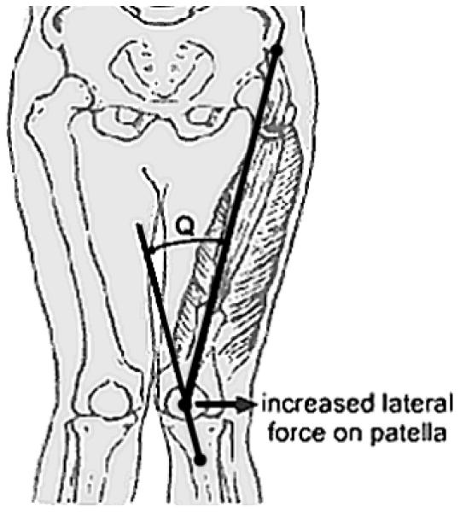
Figure 1. Increased Q-angle and resultant lateral force on patella³³
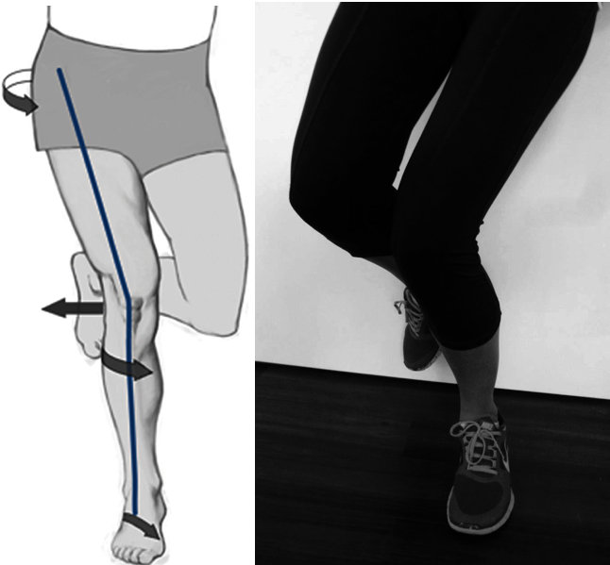
Figure 2. Dynamic valgus of LE during single leg squat can be caused by IR of the femur, IR of the tibia, and/or rear-foot eversion, all of which could lead to lateral patella maltracking³⁴

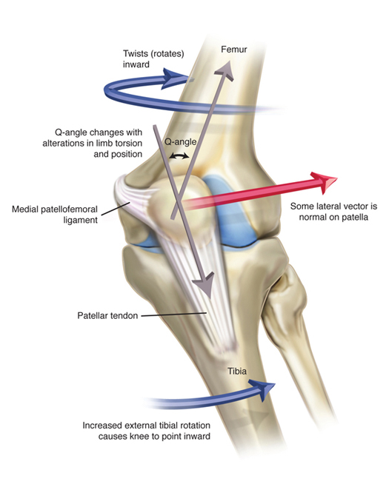
Figure 3. Femoral IR and/or increased external tibial rotation increases lateral vector of patella.³⁵

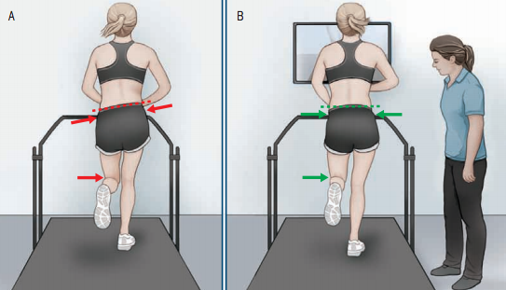
Figure 4. (A) Runner demonstrating aberrant running form (excessive hip adduction, pelvic drop, and hip IR). (B) Correction of running form using visual feedback and auditory cues from a physical therapist. Photo from Agresta et. al, 2015.³⁶

References
1. Fields KB. Running Injuries - Changing Trends and Demographics. Curr Sports Med Rep. 2011;10(5):299-303. doi:10.1249/JSR.0b013e31822d403f.
2. van der Worp MP, ten Haaf DSM, van Cingel R, de Wijer A, Nijhuis-van der Sanden MWG, Staal JB. Injuries in runners; a systematic review on risk factors and sex differences. PLoS One. 2015;10(2):e0114937. doi:10.1371/journal.pone.0114937.
3. Fields KB, Sykes JC, Walker KM, Jackson JC. Prevention of Running Injuries. Curr Sports Med Rep. 2010;9(3):176-182. doi:10.1249/JSR.0b013e3181de7ec5.
4. Van Gent RN, Siem D, Van Middeloop M, et al. Incidence and determinants of lower extremity running injuries in long distance runners: A systematic review. Sport en Geneeskd. 2007;40(4):16-29. doi:10.1136/bjsm.2006.033548.
5. Earl JE, Vetter CS. Patellofemoral Pain. Phys Med Rehabil Clin N Am. 2007;18(3):439-458. doi:10.1016/j.pmr.2007.05.004.
6. Collado H, Fredericson M. Patellofemoral pain syndrome. Clin Sports Med. 2010;29(3):379-398. doi:10.1016/j.csm.2010.03.012.
7. Dutton RA, Khadavi MJ, Fredericson M. Patellofemoral Pain. Phys Med Rehabil Clin N Am. 2016;27(1):31-52. doi:10.1016/j.pmr.2015.08.002.
8. Farrokhi S, Keyak JH, Powers CM, et al. Individuals with patellofemoral pain exhibit greater patellofemoral joint stress: a finite element analysis study. Osteoarthr Cartil. 2011;19(3):287-294. doi:10.1016/j.joca.2010.12.001.
9. Fulkerson JP. Diagnosis and Treatment of Patients with Patellofemoral Pain. Am J Sport Med. 2002;30(3):447-456. doi:10.1177/0363546513493599.
10. Nielsen RØ, Parner ET, Nohr EA, Sørensen H, Lind M, Rasmussen S. Excessive Progression in Weekly Running Distance and Risk of Running-Related Injuries: An Association Which Varies According to Type of Injury. J Orthop Sport Phys Ther. 2014;44(10):739-747. doi:10.2519/jospt.2014.5164.
11. Powers CM, Ward SR, Fredericson M, Guillet M, Shellock FG. Patellofemoral Kinematics During Weight-Bearing and Non-Weight-Bearing Knee Extension in Persons With Lateral Subluxation of the Patella: A Preliminary Study. J Orthop Sport Phys Ther. 2003;33(11):677-685. doi:10.2519/jospt.2003.33.11.677.
12. Watson CJ, Propps M, Galt W, et al. Reliability of McConnell’s classification of patellar orientation in symptomatic and asymptomatic subjects. J Orthop Sports Phys Ther. 1999;29(7):378-85-93. doi:10.2519/jospt.1999.29.7.378.
13. White LC, Dolphin P, Dixon J. Hamstring length in patellofemoral pain syndrome. Physiotherapy. 2009;95(1):24-28. doi:10.1016/j.physio.2008.05.009.
14. Waryasz GR, McDermott AY. Patellofemoral pain syndrome (PFPS): a systematic review of anatomy and potential risk factors. Dyn Med. 2008;7:9. doi:10.1186/1476-5918-7-9.
15. Souza RB, Powers CM. Differences in Hip Kinematics, Muscle Strength, and Muscle Activation Between Subjects With and Without Patellofemoral Pain. J Orthop Sport Phys Ther. 2009;39(1):12-19. doi:10.2519/jospt.2009.2885.
16. Dierks TA, Manal KT, Hamill J, Davis IS. Proximal and distal influences on hip and knee kinematics in runners with patellofemoral pain during a prolonged run. J Orthop Sports Phys Ther. 2008;38(8):448-456. doi:10.2519/jospt.2008.2490.
17. Thijs Y, De Clercq D, Roosen P, Witvrouw E. Gait-related intrinsic risk factors for patellofemoral pain in novice recreational runners. Br J Sports Med. 2008;42(6):466-471. doi:10.1136/bjsm.2008.046649.
18. Tiberio D. The effect of excessive subtalar joint pronation on patellofemoral mechanics: a theoretical model. J Orthop Sports Phys Ther. 1987;9(4):160-165. doi:1911 [pii].
19. Herrington L, Al-Sherhi A. A controlled trial of weight-bearing versus non-weight-bearing exercises for patellofemoral pain. J Orthop Sports Phys Ther. 2007;37(4):155-160. doi:10.2519/jospt.2007.2433.
20. Nakagawa TH, Muniz TB, Baldon RDM, Dias Maciel C, de Menezes Reiff RB, Serrão FV. The effect of additional strengthening of hip abductor and lateral rotator muscles in patellofemoral pain syndrome: a randomized controlled pilot study. Clin Rehabil. 2008;22(12):1051-1060. doi:10.1177/0269215508095357.
21. M van der HRLN van LRB-ZS van M. Exercise for treating patellofemoral pain syndrome (Cochrane review) [with consumer summary]. Cochrane Database Syst Rev 2015;Issue 1. 2015;(1). doi:10.1002/14651858.CD010387.pub2.www.cochranelibrary.com.
22. Crossley K, Cowan SM, Bennell KL, McConnell J. Patellar taping: is clinical success supported by scientific evidence? Man Ther. 2000;5:142-150. doi:10.1054/math.2000.0354.
23. Derasari A, Brindle TJ, Alter KE, Sheehan FT. McConnell Taping Shifts the Patella Inferiorly in Patients With Patellofemoral Pain: A Dynamic Magnetic Resonance Imaging Study.
24. Whittingham M. Effects of Taping on Pain and Function in Patellofemoral Pain Syndrome: A Randomized Controlled Trial. J Orthop Sports Phys Ther. 2004;34(9):504-510. doi:10.2519/jospt.2004.1484.
25. Powers CM, Ward SR, Chan L Der, Chen YJ, Terk MR. The effect of bracing on patella alignment and patellofemoral joint contact area. Med Sci Sports Exerc. 2004;36(7):1226-1232. doi:10.1249/01.MSS.0000132376.50984.27.
26. Barton CJ, Lack S, Hemmings S, Tufail S, Morrissey D. The “Best Practice Guide to Conservative Management of Patellofemoral Pain”: incorporating level 1 evidence with expert clinical reasoning. Br J Sports Med. 2015;49(14):923-934. doi:10.1136/bjsports-2014-093637.
27. Moyano FR, Valenza MC, Martin LM, Caballero YC, Gonzalez-Jimenez E, Demet GV. Effectiveness of different exercises and stretching physiotherapy on pain and movement in patellofemoral pain syndrome: a randomized controlled trial. Clin Rehabil. 2013;27(5):409-417. doi:10.1177/0269215512459277.
28. Johnston LB, Gross MT. Effects of foot orthoses on quality of life for individuals with patellofemoral pain syndrome. J Orthop Sport Phys Ther. 2004;34(8):440-448. doi:10.2519/jospt.2004.34.8.440.
29. Barton CJ, Munteanu SE, Menz HB, Crossley KM. The Efficacy of Foot Orthoses in the Treatment of Individuals with Patellofemoral Pain Syndrome A Systematic Review.
30. Noehren B, Scholz J, Davis I. The effect of real-time gait retraining on hip kinematics, pain and function in subjects with patellofemoral pain syndrome. Br J Sports Med. 2011;45(9):691-696. doi:10.1136/bjsm.2009.069112.
31. Willy RW, Scholz JP, Davis IS, Willy R. Mirror gait retraining for the treatment of patellofemoral pain in female runners. Clin Biomech (Bristol, Avon). 2012;27(10):1045-1051. doi:10.1016/j.clinbiomech.
32. Gottschall JS, Kram R. Ground reaction forces during downhill and uphill running. J Biomech. 2005;38(3):445-452. doi:10.1016/j.jbiomech.2004.04.023.
33. Gross KD, Niu J, Stefanik JJ, et al. Breaking the Law of Valgus: the surprising and unexplained prevalence of medial patellofemoral cartilage damage. Ann Rheum Dis. 2012;71(11):1827-1832. doi:10.1136/annrheumdis-2011-200606.
34. Petersen W, Ellermann A, Gösele-Koppenburg A, et al. Patellofemoral pain syndrome. Knee Surg Sports Traumatol Arthrosc. 2014;22(10):2264-2274. doi:10.1007/s00167-013-2759-6.
35. The Noyes Knee Institute. Noyes Knee Institute – Unstable Kneecap. http://noyeskneeinstitute.com/unstable-kneecap/.
36. Agresta C, Brown A. Gait Retraining for Injured and Healthy Runners Using Augmented Feedback: A Systematic Literature Review. J Orthop Sports Phys Ther. 2015;45(8):576-584. doi:10.2519/jospt.2015.5823.

