AQUATIC THERAPY

Who is appropriate for aquatic therapy?

Almost anyone! Kids, adults, and the elderly are all appropriate for aquatic therapy. Appropriate individuals for aquatic therapy include anyone who has decreased balance, control, posture, flexibility, tone, strength, endurance, respiratory or circulatory problems, or anyone who has joint replacements, neurological disorders, and orthopedic injuries/trauma. Aquatic therapy can also be used as a reward with patients to increase participation! Using inflatable balls and equipment that floats can assist with making exercises challenging and fun.

What are indications and contraindications for aquatic therapy?

Indications | Contraindications
Anyone willing to try aquatic PT, enjoys water, has a high risk of falling, decreased strength or endurance, balance or postural limitations, swelling, or problems with walking. | Anyone who is afraid of water, allergic to pool chemicals, medically unstable, has an open wound or active infection, incontinent or has a indwelling catheter.

Stretching Recommendations
* Hold each stretch for 30-60 seconds.*

Upper Extremity Stretches:
Shoulder Flexion | Shoulder Abduction | Shoulder Adduction | Pectoralis Stretch
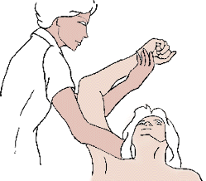 | 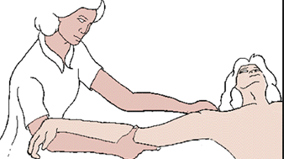 | 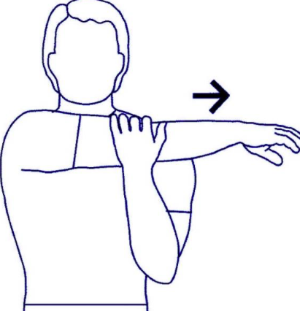 | 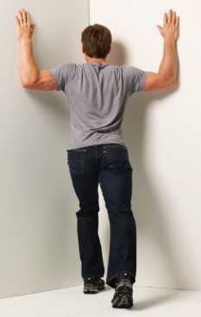

Lower Extremity Stretches:
Hamstrings | Hip Flexor & Quadriceps | Gastrocs | Hip Abductors
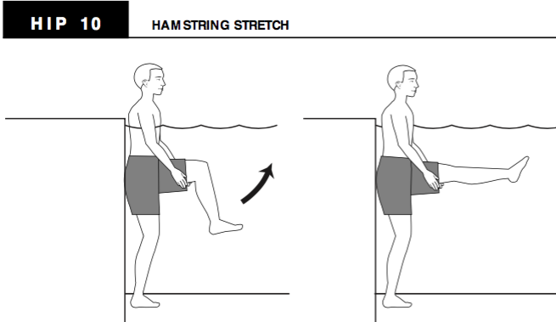 | 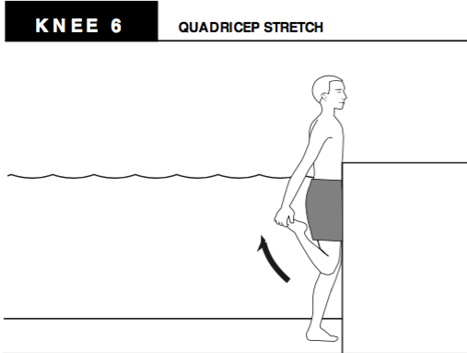 | 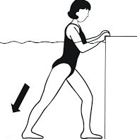 | 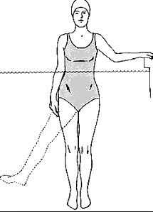

Strengthening Recommendations

Lower Extremity Exercises

Hip Flexion & Extension | Hip Abduction & Adduction | Knee Flexion and Extension | Ankle Plantarflexion and Dorsiflexion
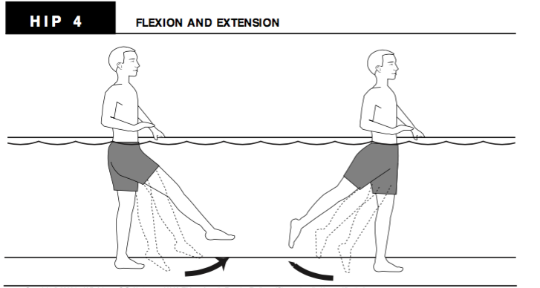 | 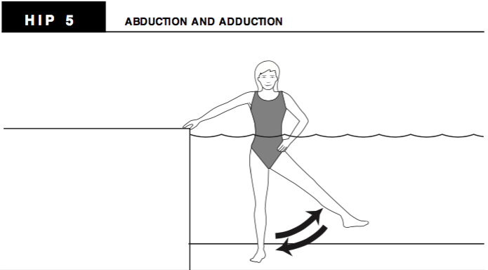 | 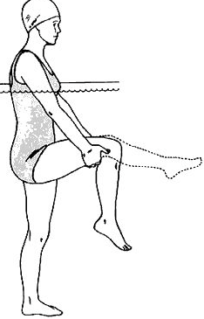 | 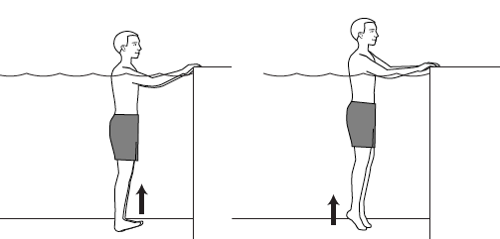
Kicking | Step Ups | Single Leg Step Ups | Squats
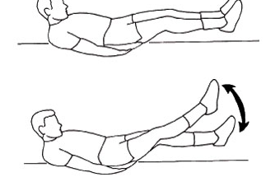 | 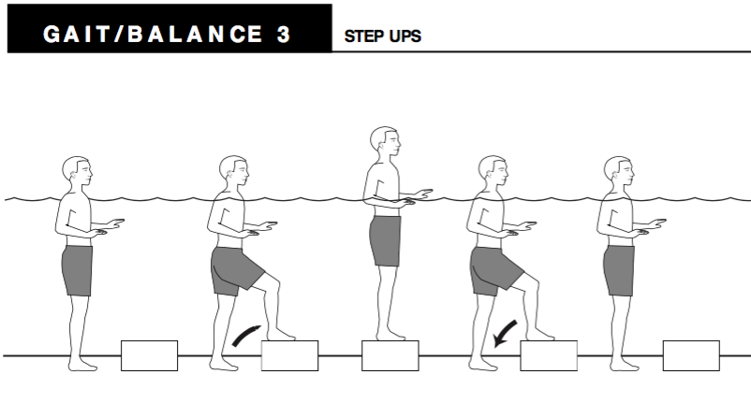 | 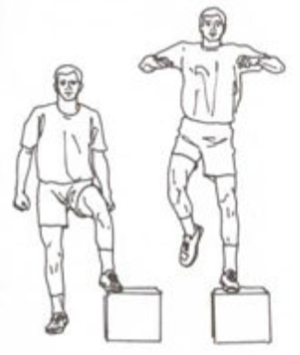 | 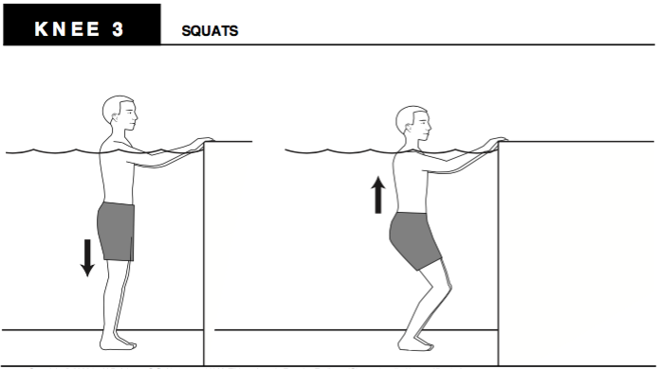

Upper Extremity Exercises:

Shoulder flexion & Extension | Shoulder Abduction & Adduction | Elbow flexion & Extension | Elbow Supination & Pronation
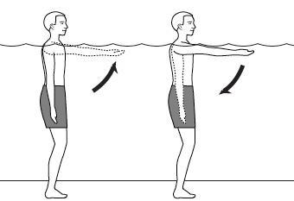 | 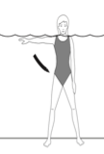 | 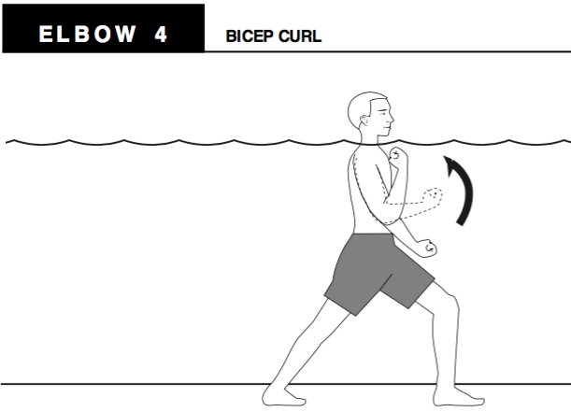 | 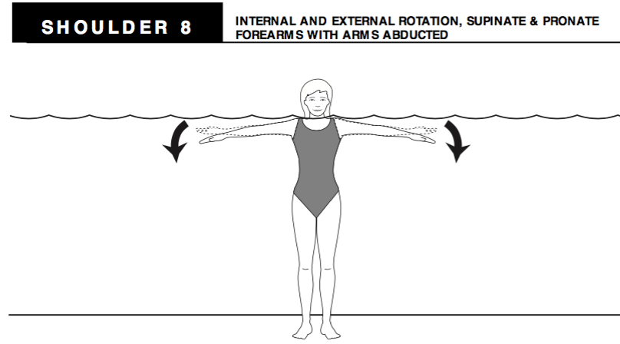

Balance Exercises

Walking forwards | Walking backwards | Walking laterally
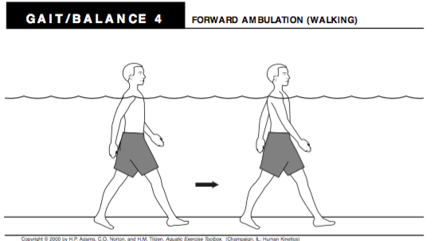 | 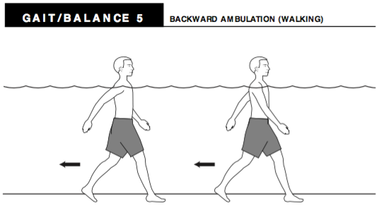 | 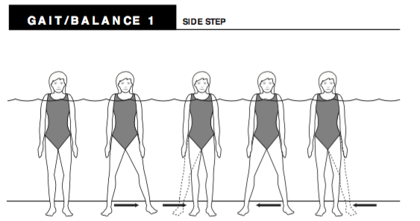
Picture References:
- Adams HP, Norton CO & Tilden HM. Aquatic Exercise Toolbox. [CD-ROM] 1st ed. Champaign, IL: Human Kinetics; 2000.
- Movement Disorders In Spinal Cord Injury: Range Of Motion (Rom) Exercises: Passive Stretching (Upper Extremity). Rehab Team Site Website. Published at http://calder.med.miami.edu/pointis/upper.html. Accessed April 2016.
- Proper way to stretch pectorals. Physical Fitness Beta Website. Published at http://fitness.stackexchange.com/questions/11837/proper-way-to-stretch-the-pectoral-muscles. Accessed April 2016.
- Shoulder strength and conditioning. CargoCollective Website. Published at http://cargocollective.com/holisticathlete/Shoulder-Strength-Conditioning. Accessed April 2016.
- Norma, S. Water is a workout. Dry is not an option website. Published at http://dryisnotanoption.blogspot.com/2010/09/whats-in-water-workout.html. Accessed April 2016.
- Water Exercises. UW Medicine Website. Published at http://www.orthop.washington.edu/?q=patient-care/articles/arthritis/water-exercises.html. Accessed April 2016.
- APFT Calisthenics Exercises. Army Real Website. Published at http://www.armyreal.com/apft/item/5293. Accessed April 2016.
- Fitness Challenge Day. Ficus Fitness Website. Published at http://www.fiscusfitness.com/post/425/Fitness-Challenge-Day-53. Accessed April 2016.

