Standers are important to:  - Increase bone strength to prevent broken bones  - Maintain joints’ ability to move (hips, knees, ankles)  - Improve the way your child’s hips move  - Stretch muscles and reduce tightness  - Improve bowel function and decrease constipation^{1,2} |  |  | Your child thanks YOU for using a stander to improve their health.  It is not easy to care for a child with special needs. If you need help or advice, feel free to use the resources listed below.  - Federation for Children with Special Needs:  fcsn.org  - Family Voices:  www.familyvoices.org  - Or call your child’s doctor, physical therapist, social worker, or teachers for tips or advice.  Resource Created by: Chelsea Parker, SPT  References:  - Paleg G.S., Smith B.A., Glickman L.B. Systematic review and evidence-based clinical recommendations for dosing of pediatric supported standing programs. Pediatric Physical Therapy 2013; 25(3):232-247  - Herman D., May R., Vogel L., Johnson J., Henderson R.C. Quantifying weight bearing by children with Cerebral Palsy while in passive standers. Pediatric Physical Therapy, 2007; 19(4):283-287  - ,  - 2007 2007l |  |  | Standers: Why and How?

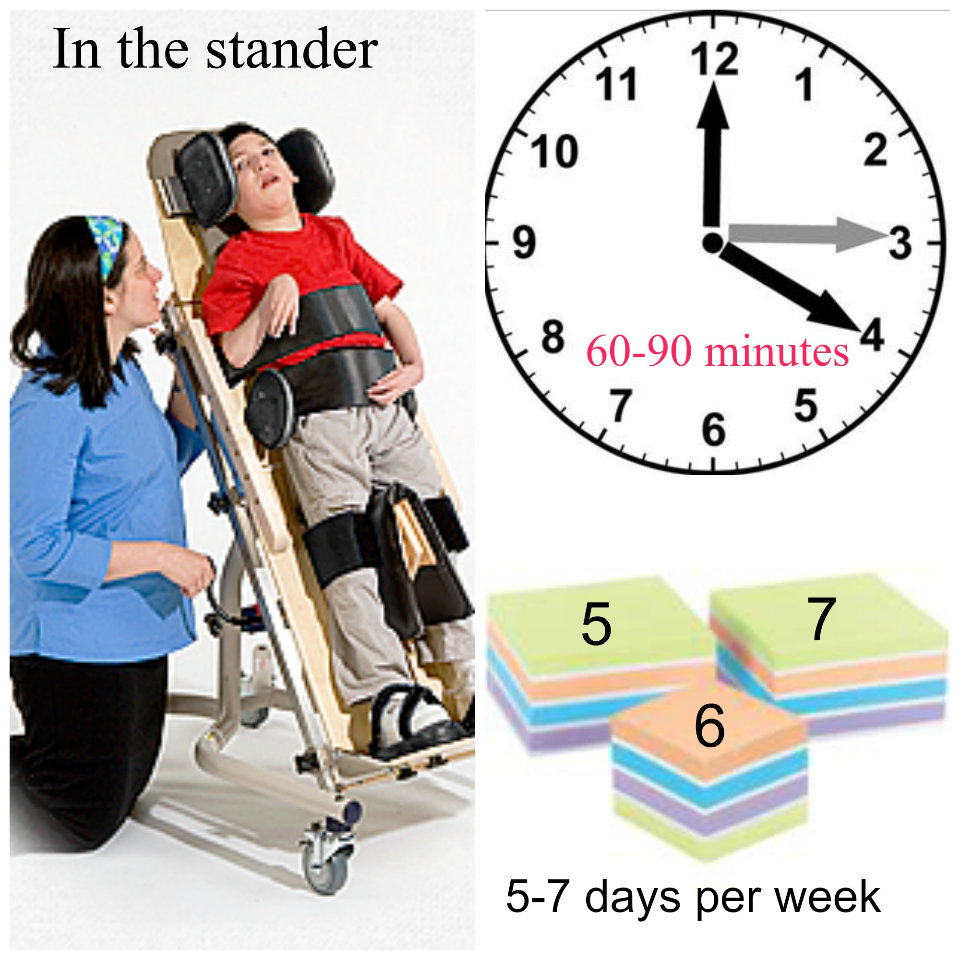  How long/how often to use the Stander:  - 60-90 minutes at a time. One hour (60 minutes) is the shortest period of time your child should spend in the stander in order to get the benefits.  - 5-7 days a week. Ideally, the school will use the stander with your child during the week – ask them about how many times they are doing so to reach the goal of 5-7 days.¹ |  |  | What can I do while my child is in the stander?  With a busy schedule, it may be hard to give up 60-90 minutes of your day. Below are some things you can do while your child is in their stander.  - Cook, clean, watch TV, read, or wash dishes with your child in the same room. It is ok to do other things while your child is in the stander, but you still need to be able to keep an eye on them for safety.  - Set your child up to watch videos, complete lesson plans, or eat.  - Talk and spend time with your child. Find out likes/dislikes that you may not have known before.  - Clean parts of the wheelchair that are difficult to get to while your child is in it. |  |  | Who should I call if I have questions?  Your child’s Physical Therapist is a great resource if you have questions/concerns about the stander. Below are a few other people who may be able to help.  Questions about how your child fits in the stander or how to use it:  - ***INSERT PT INFO***  Questions about missing or broken parts:  - ***INSERT EQUIPMENT VENDOR INFO***  Health Concerns:  - If you have health concerns, please contact your child’s doctor.

