Differential Diagnosis of Low Back Pain and Pelvic Girdle Pain in Pregnant Women

Introduction
According to the European Guidelines ¹ “pelvic girdle pain arises in relation to pregnancy, trauma, arthritis and osteoarthritis. Pain is experienced between the posterior iliac crest and the gluteal fold, particularly in the vicinity of the sacroiliac joint. The pain may radiate in the posterior thigh and can also occur in conjunction with/or separately in the symphysis.” (pg. 795) Low back pain (LBP) is defined as pain localized below the ribs, but above the gluteal folds, with or without radiation down the legs. ²
Approximately 50% of women will experience lumbopelvic pain during their pregnancy. ² The prevalence of pelvic girdle pain (PGP) increases with the duration of pregnancy, whereas the incidence of low back pain is similar in pregnant and non-pregnant populations. ² Evidence indicates that PGP is a more common diagnosis for women with lumbopelvic pain. Pregnancy-related lumbopelvic pain has been associated with increased leave from work and increased risk for long-term back pain. ² The prognosis for PGP is relatively good with recovery rates ranging from 57%-67%. However, many women reported persistent pain at 6 months postpartum (43%) and 3-years after pregnancy (20%). ² Thus, it is important to be able to identify lumbopelvic pain with a thorough history and evaluation, and offer appropriate treatment for the pregnant and postpartum women.
Pathoanatomy & Physiological Changes
During the course of pregnancy a number of physiological and anatomical changes occur. Due to increasing levels of relaxin, progesterone, and estrogen joint laxity increases during pregnancy. ³ Relaxin is produces by both the corpus luteum and the placenta, and steadily increases in early pregnancy and peaks at the end of the first trimester. It then remains consistently elevated until late pregnancy. Elevated levels of estrogen facilitates relaxin receptor sensitivity, which enhances its effects on joint laxity. ³ Studies have shown that pregnant women with LBP and PGP demonstrate higher levels of relaxin ⁴ and estradiol/progesterone ⁵. Although relaxin, estrogen, and progesterone levels have been associated with pregnancy related joint pain, a causal relationship has not been established. ^{5,6} Joint laxity, however, is considered one of the etiologies of PGP in pregnant women. Pregnant women with moderate to severe posterior pelvic pain demonstrate significant sacroiliac joint laxity ⁷ and pubic symphysis mobility ⁸ when compared to their asymptomatic counterparts.
In addition to profound physiological changes, the body is also undergoing dramatic physical changes as well. The most obvious, of course, is weight gain and enlargement of the uterus. Recommended weight gain for normal-weight women during pregnancy is 25 to 35 lbs, half of which is gained in the abdomen. ^{9,10} The enlargement of the uterus stretches and weakens the abdominal muscles, which places additional strain on the lumbar muscles that compensate for the loss of abdominal strength. ^{3,11} Furthermore, the pelvis rotates anteriorly about the second sacral segment, and as the center of gravity shifts more anteriorly, greater load goes through the sacroiliac ligaments as these structures resist forward pelvic rotation (See Appendix A). This results in compensatory hyperlordosis as the gravid uterus shifts the woman’s center of gravity forward, thus creating an additional flexion moment on the lumbar spine, increasing the already large load on the lumbar spinal musculature (See Appendix B). ³ As the levels of relaxin, progesterone, and estrogen remain high, and the woman continues to gain weight in the gravid uterus, this mechanism becomes feed-forward negative with increasing anterior pelvic tilt and hyperlordosis, subsequently placing more strain on the pelvis and low back (See Appendix C). ^{3,12} An additional consideration is the axial weight gain’s contribution to intervertebral disc compression. Excessive compression may lead to decreased fluid in the disc and decreased disc height, contributing to LBP. ¹³
In addition to physiological and anatomical changes, there may also be vascular changes that contribute to LBP and PGP. In supine position, the enlarged gravid uterus can compress both the vena cava and aorta. This increases the risk of hypoxemia that compromises the metabolic activity of neural structures, leading to PGP and LBP. ^{3,14} Thus, the etiology of PGP and LBP is complex and multifaceted, which affects a number of different structures.
The main structures or issues that are likely to be affected in pregnancy-related PGP are the sacroiliac (SI) joint dysfunction, posterior innominate rotation, and potentially separation of the pubic symphysis. ¹⁵ During pregnancy, the SI joint can become a main source of pain due to the physiological and musculoskeletal changes. Major muscle groups surrounding the SI joint greatly influence rotation and potential movement.
Patients with posterior innominate rotations generally demonstrate unilateral buttock pain that is well localized over the posterior superior iliac spine (PSIS) on the involved side. Some or all of the following signs will be positive in individuals with posterior innominate rotation: PSIS is lower on the affected side, the affected side iliac crest and anterior superior iliac spine (ASIS) will be higher, and the leg on the involved side will appear longer in the supine-to-sit test. ¹⁵ Trained therapists can use mobilization an muscle energy techniques to correct both anterior and posterior innominate rotations, however the therapist should be experienced as it is more likely to injure ligamentous and connective tissue support, as well as the joints of the pelvic ring during pregnancy. ¹⁵
Patients with PGP may or may not demonstrate pubic symphysis pain. Pubic symphysis diastasis is a common widening of the pubic symphysis that can begin as early as 8-10 weeks’ gestation and progresses steadily throughout the pregnancy. ³ Acceptable physiologic widening is ≤ 10 mm, however some patients my experience pain or stinging around the pubic symphysis that may be exacerbated by stair climbing, walking, standing up, and carrying heavy objects. ³ Regardless of the treatment, after delivery pubic symphysis widening begins to reverse with symptoms generally resolving around the eighth postpartum week. ³
Evaluation & Differential Diagnosis
Pregnancy-related PGP typically causes pain between the posterior iliac crests and gluteal folds and may occur unilaterally or bilaterally. This may or may not include radiating symptoms into the posterior or anterior thigh. ^{1,3} Pain is typically intermittent, may be preceded by prolonged sustained postures, and usually occurs within 30 minutes of aggravating activities. ³
Pregnancy-related LBP is pain that occurs in the lumbar region, above the sacrum, that may radiate into the leg. According to Vermani et al ¹⁶, pain is often dull and exacerbated by forward flexion, demonstrates restricted spinal movement in the lumbar region, and palpation of the erector spinae muscles may intensify symptoms. Considering the overlapping definitions of PGP and LBP, it can be difficult to distinguish whether the patient has PGP, LBP, or a combination of the two.
The subjective examination should include questions regarding the etiology, such as onset, duration, intensity, location, pain description, and how the pain is affected by sitting, standing, walking or maintaining sustained postures. ^{3,17} It should be noted how far into the pregnancy the pain began or if there had been pain prior to the pregnancy and if there were any specific incidences that initially triggered the issue (i.e. a sudden sharp jolt to the leg such as stepping off a curb unexpectedly). ^{3,17} It should, however, be noted that for a pregnant woman the elevated levels of relaxin and increased joint laxity may be the only etiology necessary in causing PGP. ³ During the entirety of the evaluation, the clinician should be aware of possible differential diagnoses for both LBP and PGP in pregnancy (See Appendix D). ³ The differential diagnoses overlap between LBP and PGP, however a careful subjective and objective clinical examination can help in making a definitive diagnosis.
For pregnancy-related PGP the pain is intermittent, may be precipitated by prolonged sustained postures, and usually occurs within 30 minutes of common daily activities, mainly walking, sitting, or standing. ^{3,17} PGP typically presents for the first time during pregnancy and the pain is largely localized to the sacroiliac joint. Typical clinical presentation of pregnancy-related LBP is that the pain is often dull and exacerbated by forward flexion. Spinal movement can be restricted in the lumbar region, and palpation of the erector spinae muscles can intensify the symptoms. ³ See appendix E for a more thorough list of characteristics of LBP and PGP.
There are a number of different risk factors for LBP, PGP, or both during pregnancy. Strong predictors of lumbopelvic pain are previous lumbopelvic pain, a history of pregnancy-related LBP or PGP, and strenuous work. ³ LBP has been specifically associated in pregnant women with advanced maternal age, a history of back pain in a previous pregnancy, increased parity, a higher body mass index, and history of joint hypermobility. ^{18,19} PGP has been associated, in addition to previously stated risk factors, to a history of pelvic trauma. ^{1,20} Vermani et al ¹⁶, found that pregnant patients with PGP are usually more disabled than those with LBP, exhibit a higher pain score, and are more difficult to treat.
For any medical care provider who is treating pregnant women, it is important to be aware of the red flags that could indicate potential harm to the mother and the baby. Major red flags include vaginal bleeding, leaking fluid, severe abdominal or back pain, contractions, a decrease or sharp increase in the baby’s movements, changes is vision, frequent and painful headaches, swelling of hands, face, eyes or feet, all-over itching late in pregnancy, vomiting and diarrhea, pain or burning when urinating, fever or chills, an accident, a fall, or a blow to the belly, and having thoughts of harming herself or the unborn baby. ²¹ These red flags are consistent with a number of pregnancy related concerns that could be life threatening to the mother or the unborn child. Conditions to be aware of are miscarriage, ectopic pregnancy, issues with the placenta, preterm labor, fetal distress, pre-eclampsia, gestational diabetes, obstetric cholestasis, or infection.
Objective examination should include a thorough assessment for structural asymmetry in standing, sitting, and supine. The pelvis should be assessed through iliac crest height, posterior superior iliac spine (PSIS) position, anterior superior iliac spine (ASIS) position, and trochanteric levels. ¹⁷ Palpation of these boney landmarks will help to identify innominate rotations, innominate up-slips or down-slips, or potential limb length discrepancies. In standing the patient should be evaluated for iliosacral motion by conducting a standing flexion test and Gillet’s test. Active lumbar movements should be assessed as well for pain, decreased, and increased mobility. The patient’s gait should also be evaluated for abnormalities and muscular weakness. ^{3,22}
In either sitting or supine, the patient should be evaluated for limb length discrepancies, sacroiliac or lumbar involvement, and specific special testing. The sitting flexion test can be used to determine the type of dysfunction and the side of involvement for sacroiliac problems. The straight leg raise in another common clinical test used to evaluate low back pain. However, higher ranges (70-90°) of the arc may indicate the presence of a unilateral sacroiliac joint dysfunction as well. The long sitting leg length test is a useful examination technique to determine any limb length discrepancies that could either be caused from an innominate rotation or inherent skeletal malalignment. ^{17,22}
After evaluating skeletal/pelvic alignment, range of motion, pain provocation, and muscle testing, proper use of special tests can help definitively rule-in or rule-out PGP and LBP. Special tests that have a high predictive value for PGP include posterior pelvic pain provocation test ^{3,16,22}, flexion abduction external rotation test (FABER) ^{3,16,22}, long dorsal sacroiliac ligament test ^{3,16}, active straight leg raise test ^{3,16,17}, pain provocation of the pubic symphysis by modified Trendelenburg test ^{3,16}, provocative palpation ²², and an increase in distress and disability ratings ²². For a description of how to perform the provocative tests for diagnosing PGP and an indication of a positive test see appendix F. These tests have been found to have high specificity and low sensitivity and are very useful in PGP diagnosis. ³ Other specific tests that can be incorporated are the compression/separation test, Gasenslen test, lunge test, Trendelenburg test, and Menell’s Test. ²²
It should be noted that pregnant women should avoid the supine position for lengthy periods, as well as avoiding positions that compress the abdomen in late pregnancy. Therefore it is important to reduce the amount of time the patient is in the supine position, modify the tests as necessary, or remove completely if necessary. Absolute contraindications include: 1) positions that involve abdominal compression in mid- to late pregnancy, 2) positions that maintain the supine position longer than 3 minutes after the fourth month of pregnancy, 3) positions that have the buttocks higher then the chest, 4) positions that strain the pelvic floor and abdominal muscles, 5) positions that encourage vigorous stretching of hip adductors, 6) positions that involve rapid, uncontrolled bouncing or swinging movements, 7) positions of inversion, and 8) the use of deep heat modalities or electrical stimulation. ¹⁵
In addition to the physical evaluation, there are a number of different examination-outcome measures that have been validated for pregnancy and postpartum lumbopelvic pain. A list of the recommended outcome measures from the Section on Women’s Health and the Orthopaedic Section of the American Physical Therapy Association ²² include: the Disability-Rating Index (DRI), Oswestry Disability Index (ODI), Pelvic Girdle Questionnaire (PGQ), Fear-Avoidance Beliefs Questionnaire, Physical Activity Subscale (FABQ-PA), and the Pain Catastrophizing Scale (PCS). As there is a clear difference in disability between individuals with PGP and LBP, the DRI, ODI, and PGQ are helpful tools in further determining the correct diagnosis. These scales are also practical for determining baseline disability, function, and pain belief as well as measuring change throughout the course of therapy. ²²
Treatment Options
There are a number of different treatments to manage lumbopelvic pain, however the important concepts encompass increasing muscle strength for LBP and minimizing activities that exacerbate pain/rest for PGP. ^{2,17} A recent systematic review that evaluated 22 articles found that for pregnancy-related lumbopelvic pain, acupuncture and the use of the pelvic belt were the most effective methods of pain relief. ² Both of these modalities have strong evidence for pain reduction and increase in function during pregnancy and are recommended as a primary intervention. Pelvic belts help stabilize the pelvis, decrease mobility of the SI joint, and provide force closure. ^{2,15,22} The overall effectiveness of exercises in pregnancy, however, is controversial. ^{2,23} There was low-level evidence supporting specific stabilizing exercises in reducing pain during pregnancy, limited evidence supporting specific pelvic tilt in reducing pain, and no evidence supporting the efficacy of preventative exercises during pregnancy according to a recent systematic review. ² They described an overall weak effect for general and specific exercises on pain reduction in pregnancy-related lumbopelvic pain. ²
However, it should be noted that conflicting evidence exists on effective therapeutic interventions for lumbopelvic pain in pregnant women. Pennick and Liddles ²³ conducted a similar systematic review, which revealed evidence that exercise could be an effective intervention, whereas the use of pelvic belts, neuro-emotional techniques, and spinal manipulation were not effective. They did, however, agree with Gutke et al ² that acupuncture was the most effective pain reliever in pregnant women.
Some texts report spinal manipulation for both lumbar and pelvic girdle pain improved pain scores in pregnant women. ¹⁵ However, it should be noted that application of this type of therapy during pregnancy can be potentially dangerous, and for many therapists is an absolute contraindication. Other therapies that have limited support include various manual therapies, electrotherapy, yoga, patient education, progressive muscle relaxation, and self-management intervention. ²
For some of the more common impairments, such as SI joint issues and posterior innominate rotation, there are some specific treatment recommendations and patient education objectives that are helpful. For SI joint dysfunction it is commonly recommended that the therapist use application of local heat, rest, muscle correction, mobilization, pelvic belt utility, and a home exercise program. The patient should be instructed to avoid widely abducted legs when walking on uneven terrain, certain sexual positions, climbing stairs more than one step at a time, and swinging one leg out of bed when getting up. ¹⁵ Posterior innominate rotation requires anterior torsion force for correction. Depending on the therapist’s experience and comfort level this can be performed by the therapist or by patient self-correction techniques utilizing the iliopsoas contraction. ¹⁵ It is important that therapists use extreme caution with correction, especially since the pubic symphysis can separate in pregnancy and potentially rupture with excessive force. ¹⁵
For women who continue to experience PGP and LBP in the postpartum period, there is evidence to suggest that general exercise, specific stabilization exercise, and acupuncture are effective methods in pain reduction and improved disability scores. ^{2,22} Although there is noted conflicting evidence for both pregnant and postpartum women, the Section of Women’s Health and the Orthopaedic Section of the American Physical Therapy Association recommend considering the use of exercise in the antepartum population because of low risk and minimal adverse effects for this population. ²²
Conclusion
Considering the high prevalence rates of lumbopelvic pain during pregnancy, it is important, as a clinician, to be able to correctly diagnose and treat PGP and LBP in this population. Unfortunately, the research in this field is inconsistent and varied as to the potential treatments to offer pregnant and postpartum women with lumbopelvic pain. ^{2,22,23} The use of pelvic belts, exercise, and mobilization has been, controversially, reported to be effective treatment options. However, the most agreed upon treatment has been exclusively acupuncture. ^{2,23}
As there are many physiological and anatomical changes that occur during pregnancy, ²² it is important to be aware that many typical therapeutic techniques may be contraindicated ¹⁵ and it is especially important to utilize conservative methods of treatment that have been well researched. For many women lumbopelvic pain will resolve shortly after delivery, thus the treating clinician should be focused on pain reduction and reducing risk of further harm to the patient.

References
1. Vleeming A, Albert HB, Ostgaard HC, Sturesson B, Stuge B. European guidelines for the diagnosis and treatment of pelvic girdle pain. Eur Spine J. 2008;17(6):794-819. doi: 10.1007/s00586-008-0602-4 [doi].
2. Gutke A, Betten C, Degerskar K, Pousette S, Fagevik Olsen M. Treatments for pregnancy-related lumbopelvic pain: A systematic review of physiotherapy modalities. Acta Obstet Gynecol Scand. 2015;94(11):1156-1167. doi: 10.1111/aogs.12681 [doi].
3. Casagrande D, Gugala Z, Clark SM, Lindsey RW. Low back pain and pelvic girdle pain in pregnancy. J Am Acad Orthop Surg. 2015;23(9):539-549. doi: 10.5435/JAAOS-D-14-00248 [doi].
4. MacLennan AH, Nicolson R, Green RC, Bath M. Serum relaxin and pelvic pain of pregnancy. Lancet. 1986;2(8501):243-245. doi: S0140-6736(86)92069-6 [pii].
5. Marnach ML, Ramin KD, Ramsey PS, Song SW, Stensland JJ, An KN. Characterization of the relationship between joint laxity and maternal hormones in pregnancy. Obstet Gynecol. 2003;101(2):331-335. doi: S002978440202447X [pii].
6. Aldabe D, Ribeiro DC, Milosavljevic S, Dawn Bussey M. Pregnancy-related pelvic girdle pain and its relationship with relaxin levels during pregnancy: A systematic review. Eur Spine J. 2012;21(9):1769-1776. doi: 10.1007/s00586-012-2162-x [doi].
7. Damen L, Buyruk HM, Guler-Uysal F, Lotgering FK, Snijders CJ, Stam HJ. Pelvic pain during pregnancy is associated with asymmetric laxity of the sacroiliac joints. Acta Obstet Gynecol Scand. 2001;80(11):1019-1024. doi: 801109 [pii].
8. Mens JM, Pool-Goudzwaard A, Stam HJ. Mobility of the pelvic joints in pregnancy-related lumbopelvic pain: A systematic review. Obstet Gynecol Surv. 2009;64(3):200-208. doi: 10.1097/OGX.0b013e3181950f1b [doi].
9. American College of Obstetricians and Gynecologists. Weight gain during pregnancy. committee opinion no. 548. A Obstet Gynecol. 2013;121:210-2.
10. Chapman I DR. Antepartal period, in maternal-newborn nursing: The critical components of nursing care. 1st ed. Philadelphia, PA: FA Davis Company; 2009.
11. Sneag DB, Bendo JA. Pregnancy-related low back pain. Orthopedics. 2007;30(10):839-45; quiz 846-7.
12. Ritchie JR. Orthopedic considerations during pregnancy. Clin Obstet Gynecol. 2003;46(2):456-466.
13. Sabino J, Grauer JN. Pregnancy and low back pain. Curr Rev Musculoskelet Med. 2008;1(2):137-141. doi: 10.1007/s12178-008-9021-8 [doi].
14. Borg-Stein J, Dugan SA, Gruber J. Musculoskeletal aspects of pregnancy. Am J Phys Med Rehabil. 2005;84(3):180-192. doi: 00002060-200503000-00006 [pii].
15. Stephenson RG OL. Evaluation and treatment of maternal musculoskeletal disorders. In: Stephenson RG OL, ed. Obstetric and gynecologic care in physical therapy. Second ed. Thorofare, NJ: Slack Incorporated; 2000:175-191.
16. Vermani E, Mittal R, Weeks A. Pelvic girdle pain and low back pain in pregnancy: A review. Pain Pract. 2010;10(1):60-71. doi: 10.1111/j.1533-2500.2009.00327.x [doi].
17. Woerman AL. Evaluation and treatment of pelvic girdle dysfunctions. In: Saunders HD SR, ed. Evaluation, treatment and prevention of musculoskeletal disorders: Volume 1 spine. 3rd edition ed. Chaska, MN: The Saunders Group; 1993:161-189.
18. Mantle MJ, Greenwood RM, Currey HL. Backache in pregnancy. Rheumatol Rehabil. 1977;16(2):95-101.
19. Mogren IM, Pohjanen AI. Low back pain and pelvic pain during pregnancy: Prevalence and risk factors. Spine (Phila Pa 1976). 2005;30(8):983-991. doi: 00007632-200504150-00022 [pii].
20. Bastiaanssen JM, de Bie RA, Bastiaenen CH, Essed GG, van den Brandt PA. A historical perspective on pregnancy-related low back and/or pelvic girdle pain. Eur J Obstet Gynecol Reprod Biol. 2005;120(1):3-14. doi: S0301-2115(04)00610-4 [pii].
21. Red flags that should not be ignored . http://welladjusted.co/assets/downloads/Red-Flag-List-Pregnancy.pdf.
22. Clinton SC, Newell A, Downey PA, Ferreira K,. Pelvic girdle pain in the antepartum population: Physical therapy clinical practice guidelines linked to the international classification of functioning, disability, and health from the section on women's health and the orthopaedic section of the american physical therapy association. . Under Review:Accessed: November 3, 2015-www.womenshealthapta.org.
23. Pennick V, Liddle SD. Interventions for preventing and treating pelvic and back pain in pregnancy. Cochrane Database Syst Rev. 2013;8:CD001139. doi: 10.1002/14651858.CD001139.pub3 [doi].

Appendix A. ³

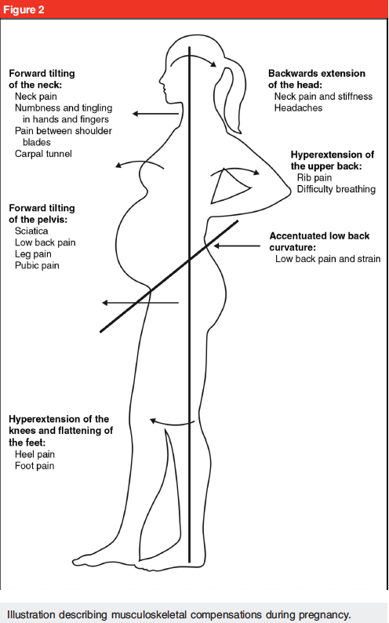

Appendix B. ³

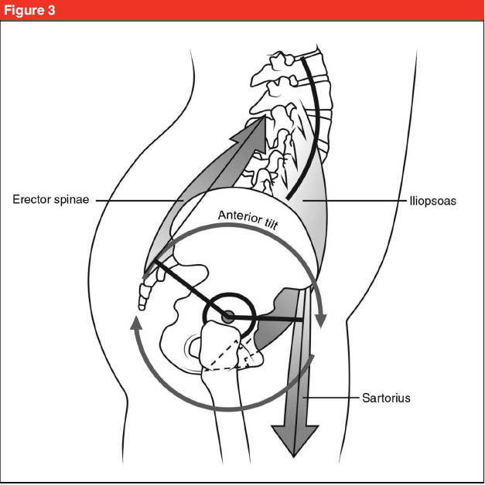

Appendix C. ³

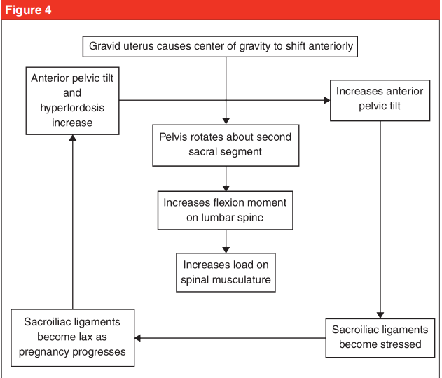

Appendix D. ³

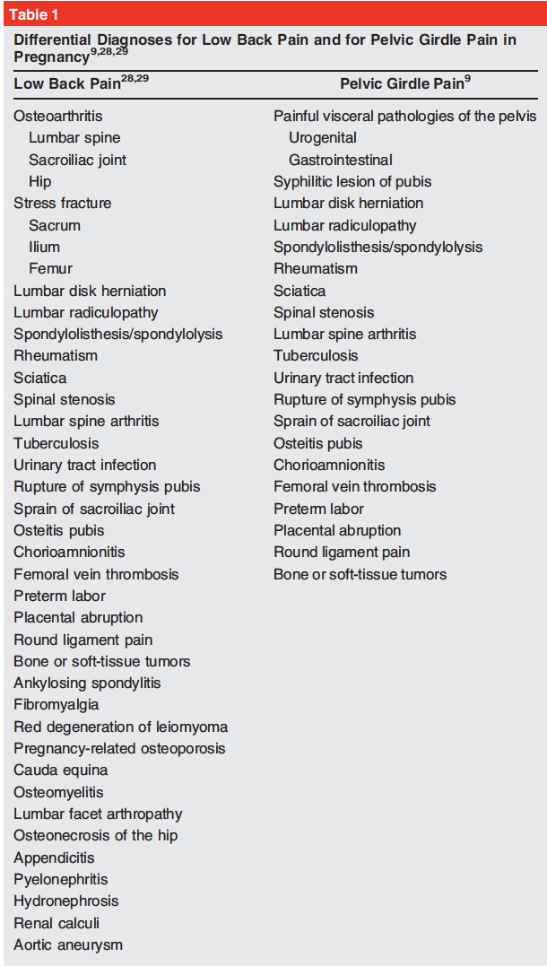
Appendix E. ³

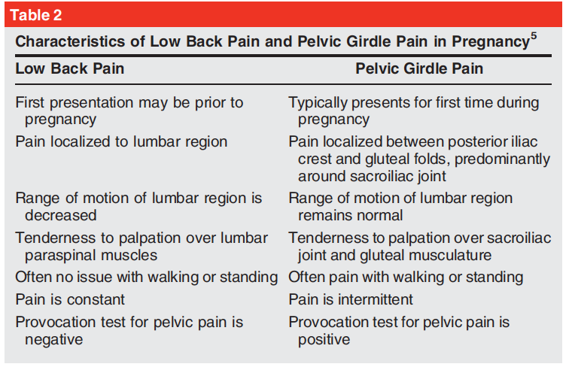

Appendix F. ³

