***Describe outcome measures and treatment activities that would be appropriate for a patient with post-concussive symptoms who is experiencing mild balance problems with vestibular complaints due to an orthopedic injury.  Is there evidence to support interventions for mild brain injury to improve balance or address post-concussive symptoms?***

The concept of the biopsychosocial model in medicine was introduced by Engel in 1977.1 Yet it was not fully realized by the World Health Organization (WHO) until the conceptual framework of the International Classification System of Functioning, Disability, and Health was adopted May 22, 2001.2 Further, the Institute of Medicine (IOM) did not issue a formal statement urging use of the biopsychosocial model until 2011 in its report, Relieving Pain in America: A Blueprint for Transforming Prevention, Care, Education, and Research, which said “*based on a biopsychosocial model of care, the patient-centered approach has been shown to be the most effective and cost-effective way to address pain.”*3 But most important is patient testimonial, the true touchstone for the biopsychosocial model. This one from the UK is no exception: *“The medical support keeps me alive, but it is the psychological and social support that enables me to live”.*4

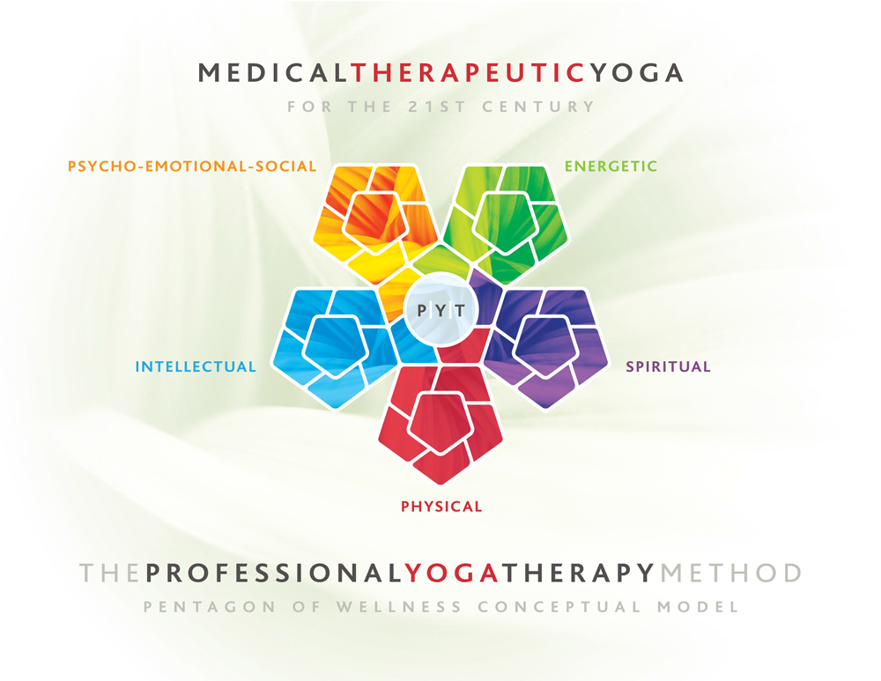A few thousand years prior, the biopsychosocial model existed under the realm of yogic medicine and philosophy and was recognized as the “panca maya” model, which is Sanskrit for, the “five-all-pervading” model.5,6 Used as a “pentagon of wellness” in integrative yoga practice, this biopsychosocial model represents five facets of the individual: physical, psycho-emotional-social, energetic, intellectual, and spiritual.5,6 (see figure 1 at right)

Although searches on CINAHL, Pubmed, and Scholar revealed no published literature that supports combining vestibular rehabilitation with an integrative yogic approach as of November 11, 2013, the nature of yoga directly addresses balance and involves the vestibular system. This relationship allows for extrapolations of the current evidence base using yoga as physical therapy for vestibular issues in athletes with post-concussion symptoms, which prepares an entry point for using yoga as a post-concussion intervention. This paper posits that current evidence which supports the efficacy of vestibular rehabilitation in the post-concussive individual can be applied through yoga with safety and clinical efficacy.

Figure 1 Yogic Biopsychosocial Model

**Post-Concussive Symptoms and Etiology**

Post-concussive symptoms in sport include dizziness, vertigo, reported unsteadiness, and oscillopsia.7 Individuals who report exertional post-concussive symptoms due to exercise or hyperthermia may also experience insidious neural deterioration in the “cerebellar and cerebral cortices,” evidenced by “widespread microglial activation” during mTBI, which carries major long-term implications for quality of life and health.8,9,10

Overall, post-concussion vestibular issues can be exacerbated by pain, difficulty concentrating, attention issues, any pre-existing or new temporomandibular joint dysfunction, headache (tension type), and activity and mental task tolerance issues.3,4 Vestibular issues which should be assessed include sensorimotor delays, abnormal eye movements (nystagmus), including visual acuity and target acquisition, gait instability, postural stability and balance, positional testing, and vestibulo-ocular reflex functioning including horizontal and vertical gaze stabiliizaiton.7  Additionally, the symptoms of concussion can be similar to or include post-traumatic stress disorder.6

**Current Recommendations for Return to Activity**

The general recommendation is to avoid all activities, both mental and physical, until all symptoms are resolved.7,8 Aligene and Lin suggest that individuals must be symptom-free not just at rest but also with introduction of full cognitive and physical activity.17  Hyperthermia and exertion/fatigue is also implicated in negatively affecting neurocognitive outcomes and long-term neurological health.9.10,11  If vestibular symptoms such as dizziness, gait, or balance issues are not resolved by rest, then vestibular rehabilitation is indicated.12 Additionally, premorbid functioning is reported to affect recovery after mild traumatic brain injury.12

**Other Causative Factors**

Other musculoskeletal issues that can be causative factors in treating post-concussion vestibular dysfunction include temporomandibular joint dysfunction (TMD) and neck pain, with the most common otologic symptoms of TMD including otaliga, tinnitus, and vertigo.13 Neck pain, tenderness in the sternocleidomastoid and along the nuchal line, and orthostatic hypotension can also be implicated in musculoskeletal differential diagnosis of vestibular dysfunction, especially in the 85% of orthopaedic injury-induced concussions that suffer vertigo and concomitantly present with musculoskeletal co-morbidities.14

**Outcome Measures**

There are many outcome measures in the literature with reported efficacy for measuring outcomes in vestibular rehabilitation.12, 17 ,18 Those include measures for gait and balance, differential diagnosis of unilateral vestibular hypofunction, as well as confidence that no fall would occur during functional activities.12, 17,18 The Dynamic Gait index uses 8 items to assess gait stability during head motions with speed changes with and without obstacles. 12,18 The Five Times Sit to Stand (FTSTS) can also be considered as an outcome measure for gait and postural stability.12 Other tests include the Activities-specific Balance Confidence (ABC) scale, which measures confidence in an indivdiual’s ability to complete functional tasks without loss of balance. 12 The Dizziness Handicap Inventory includes 25 items that quantitatively assess dizziness on physical, emotional, and functional health.12 Differential diagnosis for cervicogenic-induced vertigo should also be completed, via ruling out impairment of neck mobility and presence or absence of neck pain.17 Balance assessment outcome measures can include the Balance Error Scoring System (BESS) or the Sensory Organization Test.17,18 The ImPact tool (Post-Concussion Impact Assessment and Cognitive Testing) identifies cognitive versus neurophysiological functioning, and is suggested as a screening tool measuring subtle functional changes.17  Finally, the first-line pathology to rule out would be benign paroxysmal positional vertigo (BPPV) through the Canalith Repositioning (Hall-Pike) Maneuver.12,17

**Treatment Options**

There are six treatment options available for targeting vestibular issues in patients with post-concussion symptoms. Those include: 1)Canalith Repositioning Maneuver for Benign Paroxysmal Positional Vertigo (BPPV), 2-4) Vestibulo-ocular exercises which can include adaptation (to focus on affecting intact vestibular circuits through the use of retinal slip during head movement), habituation (enhance vestibular compensation via repetitive exercises), or substitution exercises (train ocular compensation in those with major vestibular impairment), 4) Balance exercises (including static and dynamic positional exercise with and without introduction of neurocognitive tasks), 5) Musculoskeletal assessment, differential diagnosis, and management as needed of cervical spine integrity, myofascial restriction, headaches, or temporomandibular joint function, and finally 6) Gait training (with and without inclusion of neurocognitive tasks and over both even and uneven terrain) and postural and trunk control and awareness which also includes testing the patient under aerobic conditions to identify exertion-induced neurophysiological or cognitive impairment.12,13,14,16,17 Additionally it is important to note that failure to progress by the six month mark should warrant further neurological workup and consult.17

**Vestibulo-Ocular Reflex (VOR) Exercises**

The VOR exercises prescribed in treating vestibular dysfunction with the yogic biopsychosocial model follow, and have been successfully used in two case studies.15 Figure 2 illustrates the six-part methodology proposed to help patients develop self-management strategies and facilitate a patient’s taking responsibility for their health and well-being. Use of yoga equipment (toys) included a yoga/sticky mat, 2 foam blocks, a chair, a wall, two Mexican-style blankets, and a nurturing therapeutic landscape. Therapeutic landscape describes the location and atmosphere of the treatment setting and is juxtaposed against the typical non-green-space biomedical landscape which can be often associated with a “harsh therapeutic landscape”.19 The clnical environment for these cases was a private, climate-controlled space with no outside noise or interuption; and one that had adjustable halogen or soft LED lighting (with dimmers available), pleasant paint colors and décor, and an overall non-sterile “hospital or clinic-like” standard setting.

Figure 2. Biopsychosocial Sensori-Motor Considerations in Vestibular Rehabilitation

VOR exercises were performed with two parameters: 1) Performance for 1-2 minutes until subtle nausea is experienced and/or 2) use of variable speed until just before the target falls out of focus. The intention for exercises included: eye tracking for gaze stabilization in a yoga pose, easy seated pose (suhkasana), which resembles tailor sitting but on tiered blankets for support and comfort. [All yoga poses will be in English with their Sanskrit description in (parentheses)]. Initially the patient sat in a chair secondary to concerns of excessive degrees of freedom imposed by lack of postural control and lumbopelvic awareness. See figures 3 and 4 for illustrations.

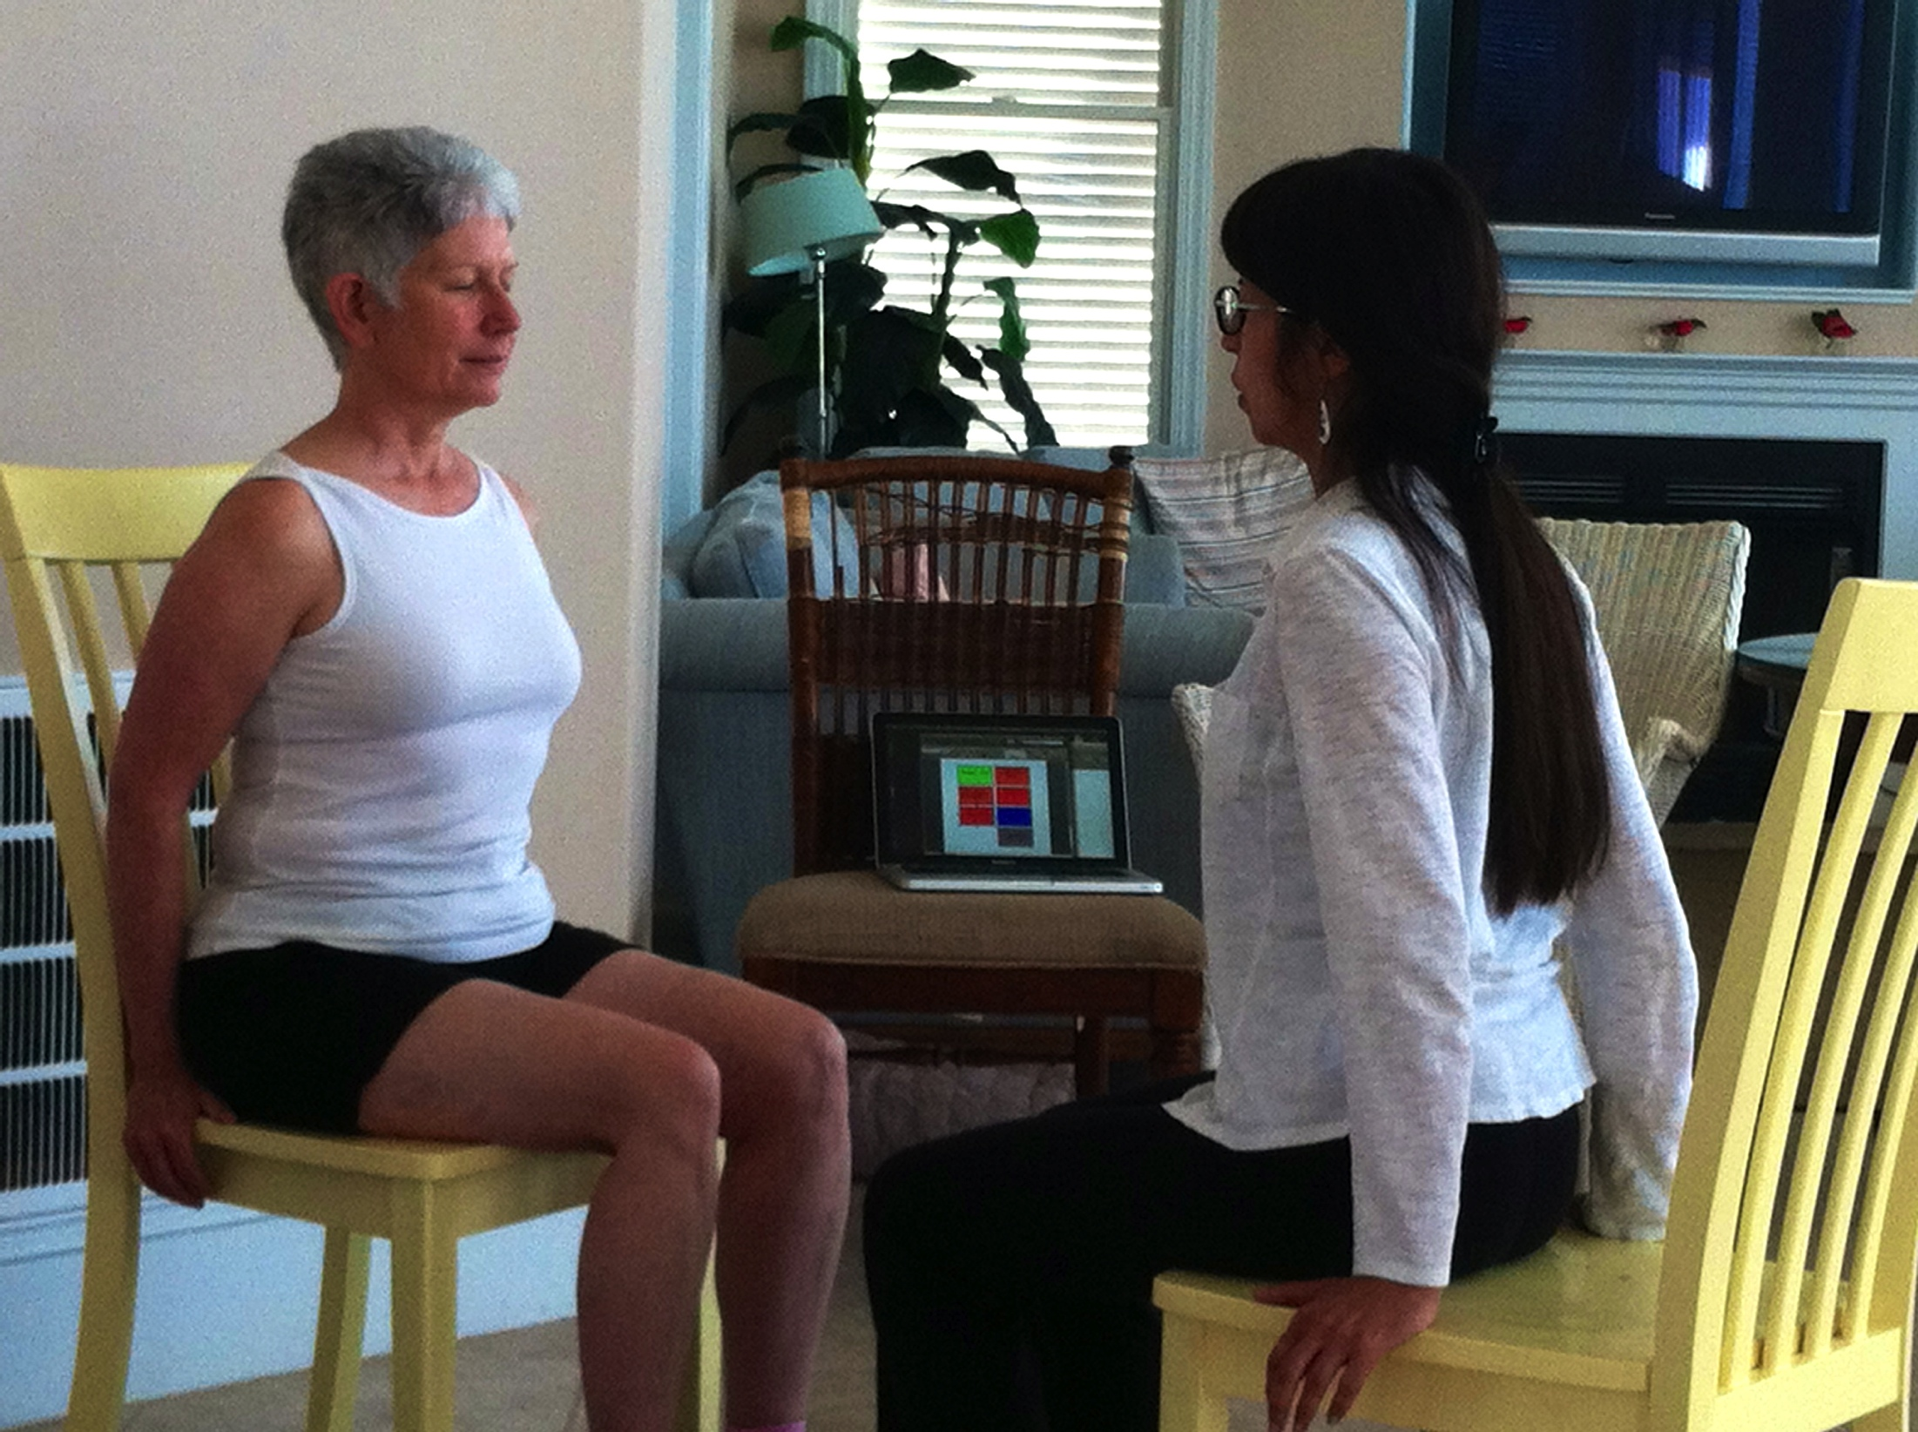

Figure 3 Patient and therapist (assisting) practicing VOR exercises

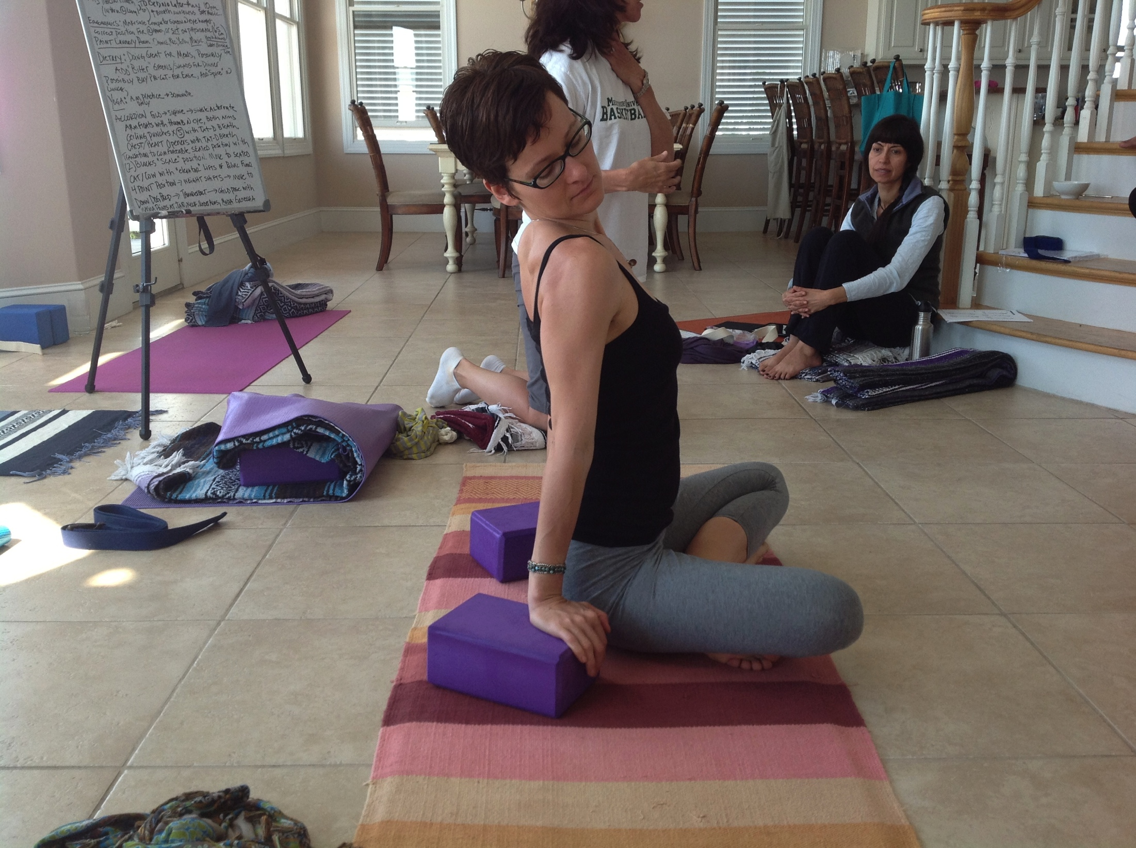

Figure 4 Author demonstrating neck range of motion on yoga mat/rug with block assist (2 blanket support not pictured)

Actions undertaken included: 1) movement of eyes in different directions (vertical, horizontal, diagonal, clock/counter-clockwise), 2) general tracking of finger tip or thumb (if no contraindications the upper extremity was used as related to cervical spine), 3) and tracking with candle for smooth pursuits. Also included were screening of plumb line alignment for postural awareness and pain-free active range of motion in the cervical spine.

The starting positions for therapy included progressing from seated in a chair to standing upright (mountain pose) to transitioning from stand to sit on the floor (easy seated pose) over a period of several sessions. Actions, in order of prescription follow:

Action:

* Practice of slippage of head on atlas (mild jalandhara bandha or chin lock)
* Eye movements while maintaining cervical retraction (mild jalandhara bandha)
* Nose circles while maintaining cervical retraction (mild jalandhara bandha)
* Atlas/axis rotation awareness
* Eye movements with cervical flexion, extension, side bending and rotation as indicated/pain free
* Targets for cervical rotation eye level target (x) to right, center, left, right x3
* Targets for cervical rotation eye level target (x) to left, center, right, left x3
* Chase flashlight (pain free)

Lastly, somatosensory processing should be considered, which is described in the literature as the amount of sensory input needed for an individual to learn and function psycho-emotionally-socially.20 Sensory integration and processing is a concept traditionally grounded in occupational therapy, however the interdisciplinary nature of applying the biopsychosocial model for optimal outcomes requires sensitivity to all aspects of the individual’s constitution and in this case, includes sensory processing.2,3,4,5,6,20  Occupational therapist Winnie Dunn offers a model for somatosensory classification that would place the patient in one or more of the following categories20:

1. High threshold active - seeker (energetic) -needs more input for learning
2. High threshold passive – bystander (quiet) – waits for others to present sensory information for learning
3. Low threshold active – avoider (fussy) – avoids sensory input and requires limited sensory information for best concentration
4. Low threshold passive – sensor (distractable) – most sensitive and a small amount of information overwhelms the individual and makes concentration difficult

For example, if a patient is a low threshold passive sensor, then he or she would respond to the smallest introduction of information in the therapeutic setting. This would require a more sensitive and subtle approach than the high threshold active seeker, who naturally needs more sensory input for learning.20

Finally, it is important to remember in the case of children and adolescents that recovery is often prolonged, and is attributed to their differences in biochemical and metabolic pathways, which means that return to play and sport will potentially be delayed and should allow for longer recovery time than adults.8,12,17,21,22

**Integrative Yoga Prescription for Vestibular Dysfunction**

A review of integrative yoga prescription for vestibular issues includes the following:

1) Provision of a supportive clinical environment and nurturing therapeutic landscape.19 Measures which could effect positive outcomes would include discussing time management with the patient to improve patient compliance with a prescribed home program, use of kinesthetic interventions that consider visual, auditory and tactile input, including light touch, deep pressure, proprioceptive sense, and vibration.5,6 Another intervention that could influence change is self-reflection activities like journaling, which are supported to facilitate cognitive processing and psycho-emotional-social health and well-being.23

2) Manual mobilization with movement during yoga postures in which the spine receives priority over the extremities for facilitating postural control and awareness, and where the breath also receives priority for neuroendocrine and neurophysiological functioning. 24,25,26,27 3) Autogenic training and biofeedback to influence sensorimotor delay(s), abnormal eye movements, positional testing for BPPV, vestibulo-ocular reflex functioning through horizontal and vertical gaze stabilization via saccades, visual acuity, and target acquisition, gait instability, and postural stability and balance.7,12,16,17 Additionally, mirrors and yoga equipment such as bolsters and blocks are also used for biofeedback.5,6,15

Lastly, an algorithm for vestibular intervention using a yogic model is provided in Figure 5, illustrating the progression of a 6 week treatment period for a 5th decade female who presented with vertigo with a 30 year history and per patient report unrelated to an accident or injury. She presented with self-reported intermittent bouts of “severe vertigo” that, when the vertigo was present, left her unable to perform activities of daily living or complete her duties as a realtor. After the six-week trial and with an eight-week follow up, the patient had no recurrence of vertigo and was able to lie in full supine-lying and complete all tasks on the algorithm and ADL’s without recurrence of vertigo. It was her first time lying supine and having eight consecutive weeks free of vertigo in 30 years.

This paper provides early evidence that supports the use of yogic methodology in managing vestibular dysfunction after concussion via extrapolation and integration of the current evidence-base in vestibular rehabilitation. Vestibular rehabilitation’s well-documented effect on post-concussion outcome provides a platform for evolution of the biomedical model to embrace a biopsychosocial approach using yoga in vestibular rehabilitation.



References

1. Engel GL. The need for a new medical model: a challenge for biomedicine. Science 1977;196:129-36.
2. World Health Organization (WHO) International Classification of Functioning, Disability and Health. Geneva, Switzerland. 2002.
3. Institute of Medicine. “Relieving Pain in America: A Blueprint for Transforming Prevention, Care, Education, and Research.” 2011
4. The Biopsychosocial Model of Disease. The Patient Patient 2013. <http://www.thepatientpatient2011.blogspot.co.uk/2013/04/the-biopsychosocial-model-of-disease.html> Last accessed November 8, 2013.
5. Garner, G. Medical Therapeutic Yoga. Prospectus for publication. Handspring Publishing. Scotland, UK. December 2014.
6. Garner, G. Professional Yoga Therapy Studies. Volume I-IV Continuing Education Course Manuals. 2001-2013.
7. Riechers RG,2nd, Ruff RL. Rehabilitation in the patient with mild traumatic brain injury. Continuum (Minneap Minn). 2010;16(6) Traumatic Brain Injury:128-149.
8. Purcell L. What are the most appropriate return-to-play guidelines for concussed child athletes? *Br J Sports Med*. 2009;43 Suppl 1:i51-5. doi: 10.1136/bjsm.2009.058214; 10.1136/bjsm.2009.058214.
9. McGrath N, Dinn WM, Collins MW, Lovell MR, Elbin RJ, Kontos AP. Post-exertion neurocognitive test failure among student-athletes following concussion. *Brain Inj*. 2013;27(1):103-113. doi: 10.3109/02699052.2012.729282; 10.3109/02699052.2012.729282.
10. Sakurai A, Atkins CM, Alonso OF, Bramlett HM, Dietrich WD. Mild hyperthermia worsens the neuropathological damage associated with mild traumatic brain injury in rats. *J Neurotrauma*. 2012;29(2):313-321. doi: 10.1089/neu.2011.2152; 10.1089/neu.2011.2152.
11. Griesbach GS, Tio DL, Nair S, Hovda DA. Temperature and heart rate responses to exercise following mild traumatic brain injury. *J Neurotrauma*. 2013;30(4):281-291. doi: 10.1089/neu.2012.2616; 10.1089/neu.2012.2616.
12. Alsalaheen BA, Mucha A, Morris LO, et al. Vestibular rehabilitation for dizziness and balance disorders after concussion. *J Neurol Phys Ther*. 2010;34(2):87-93. doi: 10.1097/NPT.0b013e3181dde568; 10.1097/NPT.0b013e3181dde568.
13. Badel T, Savic-Pavicin I, Zadravec D, Marotti M, Krolo I, Grbesa D. Temporomandibular joint development and functional disorders related to clinical otologic symptomatology. *Acta Clin Croat*. 2011;50(1):51-60.
14. Morinaka S. Musculoskeletal diseases as a causal factor of cervical vertigo. *Auris Nasus Larynx*. 2009;36(6):649-654. doi: <http://dx.doi.org.libproxy.lib.unc.edu/10.1016/j.anl.2009.04.009>.
15. Garner G. Presentation: Combining Integrative Medicine (Yoga) with Vestibular Rehabilitation. North Carolina Athletic Trainers’ Association Annual Fall Symposium. November 9, 2013.
16. Gurley JM, Hujsak BD, Kelly JL. Vestibular rehabilitation following mild traumatic brain injury. *NeuroRehabilitation*. 2013;32(3):519-528. doi: 10.3233/NRE-130874; 10.3233/NRE-130874.
17. Aligene K, Lin E. Vestibular and balance treatment of the concussed athlete. *NeuroRehabilitation*. 2013;32(3):543-553. doi: 10.3233/NRE-130876; 10.3233/NRE-130876.
18. Lei-Rivera L, Sutera J, Galatioto JA, Hujsak BD, Gurley JM. Special tools for the assessment of balance and dizziness in individuals with mild traumatic brain injury. *NeuroRehabilitation*. 2013;32(3):463-472. doi: 10.3233/NRE-130869; 10.3233/NRE-130869.
19. Groenewegen PP, van den Berg AE, de Vries S, Verheij RA. Vitamin G: Effects of green space on health, well-being, and social safety. *BMC Public Health*. 2006;6:149. doi: 10.1186/1471-2458-6-149.
20. Dunn W. Living Sensationally: Understanding Your Senses. Jessica Kingsley, 1st ed. 2009.
21. Harmon KG, Drezner JA, Gammons M, et al. American medical society for sports medicine position statement: Concussion in sport. *Br J Sports Med*. 2013;47(1):15-26. doi: 10.1136/bjsports-2012-091941; 10.1136/bjsports-2012-091941.
22. Driscoll SW. Concussion in children: What are the effects? Mayo Clinic. <http://www.mayoclinic.com/health/concussion-in-children/AN02059>. Last accessed November 3, 2013.
23. Ullrich PM. Journaling about stressful events: Effects of cognitive processing and emotional expression. *Annals of behavioral medicine*. 2002;24(3):244; 244-250; 250.
24. Streeter CC, Gerbarg PL, Saper RB, Ciraulo DA, Brown RP. Effects of yoga on the autonomic nervous system, gamma-aminobutyric-acid, and allostasis in epilepsy, depression, and post-traumatic stress disorder. *Med Hypotheses*. 2012;78(5):571-579. doi: 10.1016/j.mehy.2012.01.021; 10.1016/j.mehy.2012.01.021.
25. Bordoni B, Zanier E. Anatomic connections of the diaphragm: Influence of respiration on the body system. *J Multidiscip Healthc*. 2013;6:281-291. doi: 10.2147/JMDH.S45443; 10.2147/JMDH.S45443.
26. Kolar P, Sulc J, Kyncl M, et al. Stabilizing function of the diaphragm: Dynamic MRI and synchronized spirometric assessment. *J Appl Physiol*. 2010;109(4):1064-1071. doi: 10.1152/japplphysiol.01216.2009; 10.1152/japplphysiol.01216.2009.
27. Stokes IAF. Intra-abdominal pressure and abdominal wall muscular function: Spinal unloading mechanism. *Clinical biomechanics (Bristol)*. 2010;25(9):859; 859-866; 866.