The Second Metatarsophalangeal Joint and Associated Pathology
12-3-15
Annemarie N. Erich

To be such a seemingly small and insignificant joint, much chaos can occur at the second metatarsophalangeal joint (MTPJ). Functional importance of this joint, located in the heart of the metatarsal break, lies in its extensibility and ability to transfer the weight force during the push off stage of gait.² Current literature shows that medical management of second MTPJ pathology has been less than favorable. Of the pathologies that can occur here, two conditions, predislocation syndrome and Freiberg disease encompass most second MTPJ symptomatology.⁵ The purpose of this paper is to describe the second MTPJ and associated pathology, specifically predislocation syndrome and Freiberg disease.
The second MTPJ is surrounded my various intrinsic and extrinsic structures lending to it’s function.⁵ Among muscle constituents are the extensor digitorum tendons, longus and brevis, crossing the joint to dorsiflex the digits during swing phase and stabilize during propulsion. The sheaths of these two tendons, the lumbrical tendon, the plantar plate, and the deep transverse ligament collectively blend with the joint capsule of the second MTPJ. This anatomic arrangement provides strong dorsiflexion attitude, yet likely lends to the common injury of dorsal dislocation occurring proximally.⁵ Like the dislocation of the glenohumeral joint during a chest/bench press activity, sometimes the muscular pull is in the precise angle to push the joint past its ligamentous and bony boundaries.
The flexors of this joint pass along the plantar surface and cause what is described as passive plantarflexion force through the joint. The lumbrical at the second MTPJ provide an adduction force, which is balanced by passive structures including the lateral capsule, plantar plate, and lateral collateral ligaments. Additionally, there are two dorsal interosseous muscles providing stability in the transverse plane and the long flexor tendon lies directly below on the plantar surface of the joint. The anatomy of the other lesser toes allows for both dorsal and plantar interosseous muscles, as the second MTPJ lacks plantar interosseous, and a more medial positioning of the flexor muscles.⁵
A non-contractile, yet major structure, of the second MTPJ is the plantar plate, which has a strong attachment proximally at the base of the phalanx and a weak attachment on the metatarsal neck. This structure serves as a resistance to longitudinal tensile loads, especially in dorsiflexed position, and also to provide cushion (increases delta t) at the joint in weight bearing. For these reasons the plantar plate has been dubbed the main stabilizing structure of the second MTPJ in the transverse and sagittal planes.^{5, 10}
Bony anatomy of the second MTPJ is comprised of the concave proximal phalange and a convex second metatarsal bone. Arthrokinematically speaking, the roll and slide are occurring in opposite directions as the metatarsal bone moves on the proximal phalange during the push-off phase of gait.¹ Available, sagittal plane motion at the second MTPJ is approximately 60° of dorsiflexion and 20° plantarflexion. In some, second ray is longer and relatively hypomobile compared to the other rays, an occurrence predisposing it to greater stresses during gait.^{1, 2}
Branches of the medial deep plantar artery and the dorsal metatarsal artery provide the blood supply to the second MTPJ. The point where these branches enter the joint capsule is known to be fragile and it is probable that a portion of the population are lacking this particular vascularity altogether.⁶
The overall composition of the second MTPJ makes it more susceptible to pathology, though isolated pathology is rare and likely caused by dysfunction elsewhere in the foot (ie hallux valgus or pes planus).^{4, 6} Therefore, diagnosis and treatment of such malalignments should be the first course of action before moving to suspicion of more complex disease processes, although both may occur simultaneously. Two of the most common, more involved, pathologies occurring here are predislocation syndrome and avascular necrosis of the metatarsal head, also known as Freiberg Disease.⁶
Predislocation syndrome (see appendix, figure A) involving the second MTPJ is also known as submetatarsal 2 syndrome, chronic lesser MTPJ dislocation, floating toe syndrome, crossover second-toe deformity, and monoarticular non-traumatic synovitis and has been mentioned in the literature since 1995.⁶ This condition is a continuum of joint derangement where progression down the continuum results in weakening of the structures surrounding the MTPJ, further progressing to the next level of signs and symptoms. Etiology of this syndrome includes trauma (direct or repetitive microtrauma), neuromuscular, abnormal metatarsal parabola, hallux valgus, hypermobile 1st ray, anomalous muscle, hammertoe, and/or congenital causes.⁵ Of the malalignments associated with this condition, those with a longer second metatarsal and those with more pronated feet likely have increased chance for acceleration of symptom onset. Several researchers have postulated that the most likely cause is the inherited tendency combined with female sex, increasing age, and ill-fitting shoes, yet there is no definitive correlation in current literature. Structural abnormalities have shown as insignificant for causation while the persistent use of high heels shoes, other shoes with tight toe boxes, and age are all thought to be factors linked to lesser metatarsalgia.^{4,5,6}
Patients typically present with slight pain on the plantar aspect of the second MTPJ during ambulation. This pain comes with no apparent deformity, crepitus, or malalignment. The pain will increase to severe pain during ambulation and the patient may comment on feeling as though there is a stone in their sock. This condition will likely then progress to where the proximal phalanx dorsally dislocates with some degree of plantar plate rupture (typically graded 0-4). Or, the patient may be describing that the digit is “trying to dislocate” and appear raised compared to the metatarsal head.⁵ Eventually, the second digit will lose contact or purchase with the ground and demonstrate a “very” positive drawer test (also referred to as Lachman or vertical stress test). A positive test is indicated by a 5mm translation of the proximal phalanx on the metatarsal head. The final stage of this condition involves the crossing over of the second toe over the great toe, thus the name option of “cross over second-toe.”^{4,5} At this final stage, there are often skin lesions on the dorsal aspect of the second toe.⁵ Differential diagnosis for this syndrome entails discriminating between neuroma, lesser MTP joint capsulitis, hammertoe deformities, metatarsal stress fracture, OA, rheumatoid foot, pes cavus, and pes planus.⁴
Predislocation syndrome is most often misdiagnosed as neuroma. Though neuroma and predislocation syndrome are likely caused by similar factors, neuroma is the inflammation of the common interdigital nerve, not a problem with the joint itself. The common “Morton’s Neuroma” occurs in the 3rd intermetatarsal space. With neuroma, pain may be described as burning or radiating, with numbness and tingling, possible clicking sensation, and swelling.^{2, 4} Therefore, keep predislocation syndrome in mind unless pain can be localized more laterally and is described using similar terms as above. Imaging as radiographs, MRI, and sonogram are used to confirm diagnosis and monitor severity.⁵
Conservative treatment options for predislocation syndrome include NSAIDS, oral corticosteroids, padding, taping, immobilization, physical therapy, and orthotics. Multimodal interventions work best and are usually comprised of medication, splinting, and shoe wear modification to a wide toe box or rocker bottom type soles. Taping is done to place the toe in a more plantarflexed position and pads may be placed on the plantar surface under the remaining MTPJs to offload the joint.^{4,5} These conservative treatments aim to provide pain relief and slow progression of the disease.⁵ Note that use of intra-articular steroid injections for treatment of this condition is BAD. Many studies have commented that it weakens soft tissue around the joint, while one study reports a frank dislocation at this joint after receiving this particular intervention for predislocation.¹³ Other studies also demonstrated that there was significant loss of ligamentous tensile strength and destruction of fibrocytes around the area after a single injection.¹²
Optional surgeries include hammertoe repair, primary repair of the plantar plate or tendon re-routing, or metatarsal osteotomy. The focus of surgery is realignment to restore stability.⁵ More recently surgeries have shifted to repair of the plantar plate^{5, 10}, as it is the seminal deforming factor, from the dorsal surface, as incisions on the plantar surface tend to accompany increased complications impeding the healing process.⁵
Freiberg disease (see appendix, Figure B) is another anomaly occurring at the second MTPJ when osteonecrosis of the second metatarsal head leading to its collapse subsequent degeneration of the second MTPJ.^{5,6,9} This condition discovered by Freiberg in 1914 happens to be the fourth most common of the osteochondroses after Kohler’s disease, Panner’s disease, and Sever’s disease.⁷ The category of osteochondroses indicates a heterogeneous group of conditions affecting the bone and cartilage with its origin resulting from a disruption of the process of endochondral ossification. These conditions usually affect the epiphyses, physes, and apophyses of children.⁹ Females have a higher predisposition (5:1 female/male) and it usually occurs between 11-17 years of age. Freiberg disease is another consideration for differential diagnosis when the problem appears to be with the second MTPJ and especially in a young, athletic female patient.^{5,6,9}
A consensus as to the pathophysiology of Freiberg disease has not been established. However, causes are thought to be traumatic or vascular.⁶ Of Freiberg’s initial patients, he thought the majority of them to have had a traumatic causation. However, he later stated that he thought this was likely a simplistic view. Inherent causation could be in the longer length and relative hypomobility of the second ray meaning it is likely to first receive force and confers much of the stress to the distal metatarsal head.^{5,6} This is an example of great forces being transferred over a smaller area repetitively, which does not bode well for all tissues involved. The lack of mobility also means that contact is made abruptly, decreasing delta t. Again, wearing of high-heeled shoes could likely be a contributor to this issue, though never proven though scientific study, because of the increased pressure along the metatarsals along with the dorsiflexed position of the foot inside the shoe.^{1, 6} Vascular causes have also studied and described as complete cause or secondary contributor. Cadaveric studies have shown that the arteries that supply the second metatarsal are absent in some; one study reported two of six cadavers studies were missing this blood supply entirely.^{5,6} Another study suggests that as the small vessels penetrate the capsule of the joint itself, they can become impinged by swelling or joint effusion.⁶
In general, the natural history of osetochondroses follow a specific series of proceedings beginning with necrosis of bone and cartilage. After this damage comes revascularization, reorganization with granulation formation, osteoclast resorption, and lastly, osteoblasts lay down new bone.⁹ Smillie outlines the pathophysiology of the Freiberg disease in 5 stages. The first stage is development of a narrow fracture in the ischemic epiphysis. Then the central portion of cancellous bone is absorbed, allowing the overlying subchondral bone to collapse, which alters the contour of the articular surface. Stage three is a progression of this involving more absorption and worsening of stage two. Stage four involves further facture of the remaining bone and subsequent loose bodies of bone in the joint. Stage four marks the point at which the normal anatomy cannot be restored. Stage five entails arthrosis of the joint with marked flattening with sparing of the plantar portion of the metatarsal contour intact. The loose boney bodies are shrunken and the metatarsal bone is left thickened and dense.⁵
Clinical presentation of this condition will likely be unilateral involvement with pain localized to the second metatarsal head in a young woman. Only about 10% of cases are bilateral and neither side, right or left, tends to be more susceptible. Pain in weight bearing and relief with rest along with pain description of “ walking on a stone.” Swelling of the toe alone or in combination with the joint itself is often observed.^{5,6,9} Malalignments may be present that look exactly like predislocation syndrome including possible crossover second toe in chronic cases.⁶ Presence of palpable crepitus and ROM loss are likely, but variable. Unfortunately, the only physical sign that may be present early on is tenderness to palpation over the second metatarsal head/MTPJ.^{6, 11} Note, Freiberg disease may also occur in the third metatarsal head, although this is rare.⁹ As with predislocation, a Lachman or vertical stress test is typically performed and will likely reproduce “the pain.”⁶ Imaging used to confirm existence of Freiberg disease can involve weight bearing radiographs, MRI, CT, and bone scans, respectively. These imaging techniques are used along the way to reveal stages of the condition, with bone scan being most sensitive to show boney changes known as photopenic areas indicative of early stage avascular necrosis.^{5,6}
Conservative treatment of Freiberg disease aims to allay symptoms and preserve as much of the joints normal contour as possible. Typical interventions include activity modification, protected weight bearing, shoe-wear adjustments, and oral NSAID use.^{5,9} NSAID use was encouraged by some and discouraged by others due to this category of drugs ability to delay bone healing, with strongest evidence in animal studies. Those authors who discouraged NSAID use recommended acetaminophen instead.⁹ Protected weight bearing can be achieved with rocker bottom/stiff soled shoes, fracture boot, or cast.^{5,6,9} At times an early period of immobilization and non-weight bearing may be in the plan of care with casting and crutch use.⁹ Immobilization/casting has not proven to shorten the healing process for these patients, so consideration of the pros and cons of immobilization is imperative. Fracture boots allow for protected weight bearing, but cause a functional leg length discrepancy that will alter movement patterns and may cause other MSK problems up the chain. Orthotics to offload the second MTPJ will likely be successful at pain reduction and pressure attenuation. After symptoms wane guide the patient in a slow return to weight bearing activities. The vast majority of patients will respond to conservative treatment. Typically, radiographic proof of reossification may take up to 2-3 years.⁹
Given conservative treatment fails, surgical treatments are performed to both correct and halt progress of this condition or to address sequelae of later stages of disease. Those procedures meant to restore normal physiology and biomechanics of the joint are core decompression and corrective osteotomies. ⁵⁻¹¹ Those intending to restore congruency or address arthritis are debridement, osteotomy, grafting, and arthroplasty. New surgical options include osteochondral transplantation as we have discussed regarding cartilage restoration in the knee joint. As with the knee cartilage repair, the osteochondral plug placed in the second MTPJ is also harvested from the non-weight bearing surfaces of the knee.^{6, 7} Indications for surgery include persistence of severe pain after 3 months and failure of conservative treatment. Pre-existing malalignments as hallux valgus, medical comorbidities as diabetes, and/or former pathology of the second toe as infection are all contraindications for a surgical procedure. Evidence has shown good short-term results after surgery, however long-term results have not been well documented although there is always a risk of complications inherent with any surgery.^{7,8} Surgical complications specific to these surgeries and this condition include altering the conditions at the joint leading to the harm of the joint itself and the disruption of an already fragile blood supply both of which act to accelerate the condition.⁸
Two possible outcome measures used for conditions affecting the second MTPJ are the VAS pain scale and the Academy of Orthopedic Foot and Ankle Surgeons (AOFAS) Lesser Metatarsolphalangeal-Interphalangeal Scale (see appendix, Figure C). Both conditions discussed here are always initially described as painful in the available literature. Therefore, tracking pain is an excellent way to monitor the efficacy of conservative treatment and whether surgery is advisable. AOFAS’s scale for the lesser toes includes questions about pain, function, footwear, range of motion, stability, skin, and alignment. Each of these constructs are components likely affected in the conditions discussed here, making this a good measure to assist with diagnosing and monitoring of these patients.
The second MTPJ serves and important function and injury here can be debilitating for patients. The conditions described are likely not obvious until they are chronic so recognition in the early stages can give patients more favorable treatment options.^{4,5} Current literature recommends a high degree of suspicion and stout physical exam when a subjective interview causes you to consider the possibility of second MTPJ pathology.⁵
Appendix:
[A]
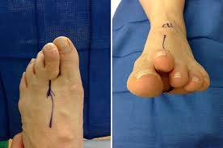
Predislocation³

[B]
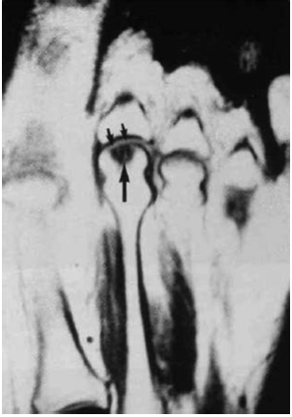
MRI demonstrating AVN of the second metatarsal head⁶

[C]
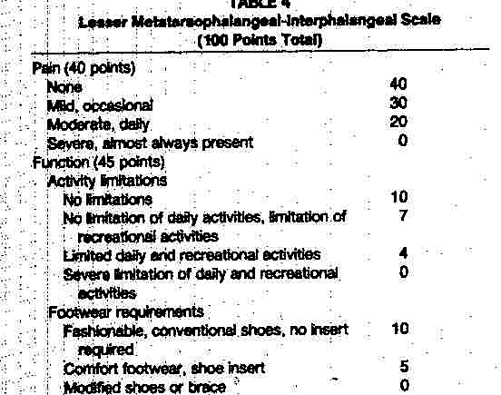
- Academy of Orthopedic Foot and Ankle Surgeon’s Scale for assessment of the lesser toes.

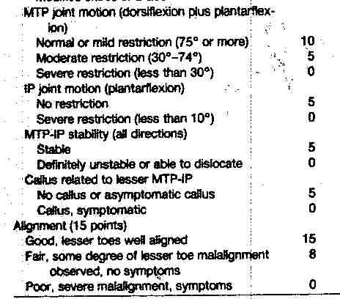
Resources:
- Levangie and Norkin. Joint Structure and Function: A comprehensive analysis (5th ed). FA Davis, Philadelphia, PA, 2011
- Orthopedic Physical Assessment, Magee, David, W.B. Saunders, sixth edition, 2014.
- McAlister J, Hyer C. The Direct Plantar Plate Repair Technique. Foot & Ankle Specialist. 2013;6(6):446-451. doi:10.1177/1938640013502723.
- http://..affinityhealth.org/Affinity-Files/2013-Ortho-symposium-Metatarsalgia-Hammond.pdf, Accessed Dec. 1st, 2015.
- Shane, A., Reeves, C., Wobst, G., & Thurston, P. (2013). Second metatarsophalangeal joint pathology and freiberg disease. Clinics in Podiatric Medicine and Surgery, 30(3), 313–25. http://doi.org/10.1016/j.cpm.2013.04.009
- Cerrato, R. a. (2011). Freiberg’s Disease. Foot and Ankle Clinics, 16(4), 647–658. http://doi.org/10.1016/j.fcl.2011.08.008
- Procedures, S. (2011). The American Journal of Sports Medicine Osteochondral Autograft Transplantation for Advanced Stage Freiberg Disease in Adolescent Athletes. http://doi.org/10.1177/0363546511420075
- Al-ashhab, M. E. A., Kandel, W. A., & Rizk, A. S. (2013). The Foot A simple surgical technique for treatment of Freiberg ’ s disease. The Foot, 23(1), 29–33. http://doi.org/10.1016/j.foot.2012.12.003
- Gillespie .. Osteochondroses and apophyseal injuries of the foot in the young athlete. Current Sports Medicine Reports (American College Of Sports Medicine) [serial online]. September 2010;9(5):265-268 4p. Available from: CINAHL Plus with Full Text, Ipswich, MA. Accessed December 3, 2015.
- Deland JT, Lee KT, Sobel M, et al. Anatomy of the plantar plate and its attach- ments in the lesser metatarsal phalangeal joint. Foot Ankle Int 1995;16:480–6.
- Helal B, Gibb P. Freiberg’s disease: A suggested pattern of management. Foot Ankle Int 1987;8:94–102.
- Reis ND, Karkabi S, Zinman C. Metatarsophalangeal joint dislocation after local steroid injection. J Bone Joint Surg Br 1989;71:864.
- Noyes FR, Nussbaum NS, DeLucas JL, et al. Biomechanical and ultrastructure changes in ligaments and tendons after corticosteroid injection. J Bone Joint Surg Am 1975;57:876.

