**FUNCTIONAL EXERCISE TRAINING**

Studies have shown that strengthening exercises using every day movements can help you maintain independence and function as you age, so that you can continue to live in your home. Exercise can help build strength and coordination for everyday activities such as activities of daily living (ADLs), which include: eating, bathing, dressing, toileting and transferring.

**Functional** exercises help not just one muscle, but multiple muscles and joints that work together to perform everyday activities. When we do everyday activities we perform continuous movements in more than one direction. Functional exercises use movements that often require more than one joint and help coordination between the nervous and muscular systems. These exercises focus on movements that help you in daily function not only individual muscle strength.

These exercises should be performed 2-3 times per week, work up to 10-15 repetitions with proper breathing. These exercises will include basic movements that you do every day.

* **Squatting-** getting off a toilet, getting in/out of a car
* **Stepping-** going up/down stairs
* **Lunging-** walking, moving out of the way of an obstacle
* **Pushing-** opening doors, moving boxes, getting out of bed
* **Pulling-** vacuuming, raking, opening doors

**Use caution when exercising**

* If you feel chest pain, dizziness or severe shortness of breath🡪**STOP**🡪 **if symptoms persist after 2-3 minutes of rest, seek medical attention immediately.**
* If you feel pain in your joints or muscles🡪 stop🡪**check your posture and position🡪** try again.
* Slight **muscle soreness** the next day or the day after exercise is normal.
* **Breathe** normally and don’t hold your breath.

**These exercises can be performed 2-3x/week. Aim to perform 10-15 repetitions for 1-2 sets of each exercise. Breathe in on the easy part and breathe out on the hard part. Do the best you can and track your progress.**

**Squatting**

Sit to Stand-Helps strengthen your hips and legs

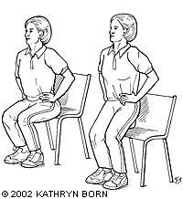

**-**Sit upright near the front of the chair

**-**Place your feet slightly back

**-**Lean forward slightly

**Stand up**

**-**use your hands on the chair if needed

**-**or keep your hands folded across your chest (just so you don’t use them)

**-**push through your feet

**Sit down**

**-**Step back until your legs touch the chair

**-Slowly** lower your bottom back into the chair

***Advanced modification*-** Just before your bottom gets to the seat of the chair, stand back up to the starting position in one motion, squeezing your buttocks and putting all the weight in your heels as you push back up.

Perform 2-3x/week. Aim to perform 10-15 repetitions for 1-2 sets. Do the best you can and track your progress.

**Stepping**

Marching in Place- Not only strengthens your legs and hips, but helps your balance

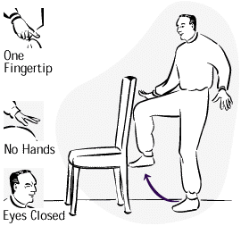

**-**Stand tall

**-**Hold chair or counter if needed

**-**March with even pace

**-**Let go of the chair or counter if you are comfortable

Perform for 1-2 minutes. Do the best you can and track your progress.

**Stepping**

Step ups**-** Will increase leg and hip strength as well as balance



**-**Step up and down on a step

**-**If you are unsteady, hold onto a railing or counter top if needed

**-**You can also try stepping up sideways-hold on if needed

**-**Use right leg and then left leg

Perform 2-3x/week. Aim to perform 10-15 repetitions for 1-2 sets. Do the best you can and track your progress.

**Lunging**

Front Lunges- Another good strength exercise for legs and hips as well as balance

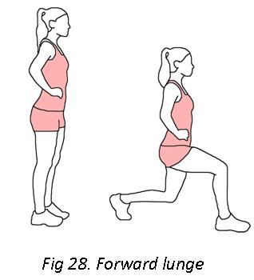 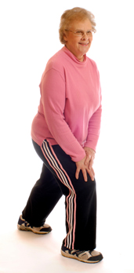

**-**Start with feet about 6 inches apart

**-**Step forward with one foot, as much as you feel comfortable

**-**Lower yourself only as much as you can manage, bending both knees (avoid lowering to point of pain)

**-**Raise yourself back up to the starting position

**-**Hold a railing if needed

**-**Use right leg and then left leg

Perform 2-3x/week. Aim to perform 10-15 repetitions for 1-2 sets. Do the best you can and track your progress.

**Pushing**

Wall push-ups- Helps strengthen your arms, shoulders, and chest

**-**Stand facing a wall so that you can straighten your arms and place your palms on the wall

**-**Keep your hands shoulder width apart (as shown in the picture to the left)

**-**Slowly bend your elbows and move your chest toward the wall

**-**Push yourself back up slowly and repeat.

**Advanced modification**- Use a counter instead of the wall



Perform 2-3x/week. Aim to perform 10-15 repetitions for 1-2 sets. Do the best you can and track your progress.

**Pulling**

Double Arm Rows- Strengthens upper back, shoulders, and neck muscles

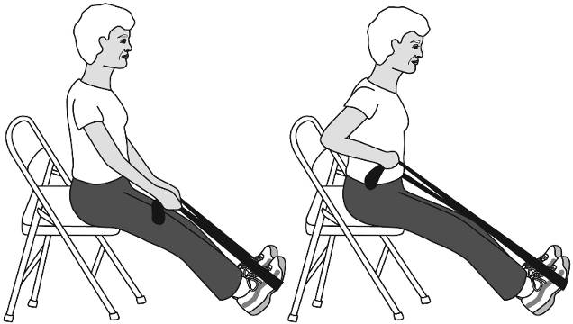

**-**Sit in a chair or firm couch that is secure, so it will not slide

**-**Sit toward the edge of the chair or couch

**-**Keep legs extended and heels on the floor with your toes pointed toward the ceiling

**-**Place the center of the resistance band under both feet

**-**Hold each end of the band with palms facing each other, so there is slight tension in the band

**-**If the band is too loose, place your hands down lower on the band

**-**Relax your shoulders and extend your arms beside your legs

**-**Keeping good posture, slowly pull the ends of the band toward your hips and repeat

Perform 2-3x/week. Aim to perform 10-15 repetitions for 1-2 sets. Do the best you can and track your progress.

Sources:

University of Georgia, National Institute on Aging, Postural Stability, Strength and Balance-Gawler, Hanna

Healthy aging Project. A community UNC partnership, [www.google.com](http://www.google.com), <http://www.acefitness.org/acefit/healthy-living-article/60/1452/what-is-functional-strength-training/>