CASE 2 Briarly White Reed & Jonathan Samuelson

Patient General/Social History:
BC is a 5’ 6” 155 lb, 72 year old female who lives with her older husband, who has some medical problems that require assistance in the home. A step son lives close by in Hillsborough. Her daughter lives in Baltimore, MD and her son lives in Greensborough, NC. Her goals are to stay active and independent and to “keep moving.” Her CC is her balance and degenerating vision.

Medical History:
BC has had arthritis, particularly in her back, since her early 60’s that has gotten worse in the last 5 years, sometimes resulting in back muscle spasms. She suffers from macular degeneration, resulting in vision problems such as hypersensitivity to bright sunlight and is scheduled to have cataracts removed in the near future. BC also suffers from occasional migraines. BC reports that her hearing is good and demonstrates no problems with two way conversation during the interview. BC sleeps 6-7 hours/night, at times interrupted/awakened by headaches.

Medication:
BC takes Hydrodiuril for hypertension (along with other medications), Crestor for high cholesterol, Topirimate to prevent migraines (but not for the pain once they occur). For the pain she takes Hydrocodone as well as the muscle relaxant Tyzanadine. The Tyzanadine also helps her sleep by alleviating headaches. She takes vitamin B2 (400mg) and D in part for her headaches.
NOTE: she does not carry a list of pharms with her and was not certain she was reporting the full list but claimed her physician has the complete list.

Home Environment:
BC lives in a one story house w/ basement, which contains the laundry room and is accessed by 15 steps. There are two entrances to the house. The side entrance, near the driveway, has eight steps leading to the door (which the patient uses most often), and the front entrance has 4 steps leading to the door. Both sets of steps have railings. The kitchen is tiled, and the rest of the house has carpet. The bathroom has no grab bars but does contain a shower bench. The sink is in close proximity to the toilet, providing a hand hold. The toilet is not elevated; the patient claims she can push up on the sink for extra assistance with transferring on and off.

Prior level of function:
BC currently drives and is independent with all ADLs. She does not do much heavy cleaning anymore d/t balance problems, which also prevents her using a ladder. She reports that her son helps her when he can with heavier cleaning or house projects she cannot manage.

Falls History/Risk:
BC has had multiple falls at home. She has not had any injuries from those falls but is concerned about them. She does not feel secure ambulating even short distances and “feels in danger.”

Physical Activity:
BC attends a strengthening and balance class titled “Strong and Steady” 2x/week at the Central Orange Senior Center in Hillsborough, which she described as not too challenging. She also uses the pool 1-2x/week for water walking for ~1 hour. Swimming is difficult d/t back arthritis pain, though the patient expresses a love of aquatic exercise. BC does participate in land based walking up to 3x/week with the use of a cane for 20-25 min/session (though she seemed to suggest she is not consistent with this program). She claims that walking triggers pain in her back, limiting the amount of time/distance; she has less trouble when using the cane but claims she finds it embarrassing and does not use it as often as she perhaps should. When she is unable to walk outside, she uses a treadmill with railings, which she has in her home and claims is also less painful for her back. Also at home, she inconsistently attempts to do balance exercises by the kitchen counter. She was prescribed a home exercise program based on the OTAGO model, but she performs the exercises infrequently (per self-report).

Social Activity:
BC maintains an active social life and civic engagements. She has lunch with different groups of friends Mondays and typically one other day each week, attends bible classes on Wednesday evenings, attends church services on Sundays, volunteers at her church once per month, and she frequently visits/takes food to older friends. She also visits with her grandchildren fairly often.

Objective Tests/Measures:

*30-second sit-to-stand Test:
- Pt completed 11 repetitions without using her hands for assistance
- Average for healthy adult females ages 70-74 = 10-15

*Single Leg Stand:
- Pt maintained position 2 seconds
- < 5 seconds = risk of fall

*Tandem Stance:
- Patient maintained position average of 6 seconds after multiple trials
- < 10 seconds = risk of fall

*These measures and norms were copied from materials utilized by the Faculty Practice of the Division of Physical Therapy-UNC Chapel Hill for purposes of the Fall Prevention Screening for Central Orange Senior Center dated September 13, 2013.

Personal/Social Factors that May Be Possible Barriers:
BC reported that she would like to be more active and that it is up to her. It is unclear whether she volunteered for this project out of a helping spirit or out of genuine interest in improving her mobility/fitness, so her level of motivation to “bump up” what she is doing now is questionable. She was seeing a PT for 3 months last year and claimed the PT “weaned her off”; it sounds she has not been following through despite her therapist checking in occasionally and urging her to pursue more land walking and OTAGO follow through. There is thus a question of whether anything we prescribe will be novel or make a difference in her choices.

Referral to Other Disciplines:
BC is clearly in close communication with an ophthalmologist regarding her vision, though she expresses some dissatisfaction with some of the current recommendations and/or lack of treatment options being offered. Given that she is very concerned about losing her ability to drive (she is the chief provider of transportation for her husband and herself) and that this may begin to further impact her ambulation and balance if it worsens, I recommend she seek a second opinion.

We are not sure how often she consults with a rheumatologist or other physician about her arthritis, but we would also recommend she continue to seek ways to keep pain from limiting her mobility.

Finally, if she has not aIready done so, since we do not have a complete list, we would recommend that she run all of her medications and supplements through Drugs.com or consult with her PCP or a pharmacist to review them and ensure there are no potentially harmful interactions. Just running the list she gave us through drugs.com resulted in a “major risk” of additive effects of Tizanadine and Hydrodiuril together on decreasing blood pressure, though complications usually arise in the beginning of treatment or when doses are increased.

BC’s Personal Health Plan
.
Walking: Consistent with the OTAGO program, try to walk on solid ground at least 2 times per week for a full 30 minutes at your normal pace and using whatever assistive device makes you feel secure and minimizes back discomfort. You may break this up initially into shorter 2 x 15-minute or 3 x 10-minute walks, gradually increasing your distance/time to complete a full consecutive 30 minutes. Taking a friend with you (perhaps make it part of a lunch date) or making this a regular activity with your spouse, if possible, will provide an accountability partner and make it more fun and motivating.
Balance: Continue taking “Strong and Steady” Tuesday and Thursday mornings for general strengthening/toning, gradually increasing your weights as you find the lifting becomes easy for you—the goal is fatiguing your muscles without pain (beyond typical soreness 1-2 days after a good workout). In addition, perform the attached exercises at home 5 days/wk or recommit to the fully prescribed OTAGO-based program provided by your physical therapist. Again, scheduling a regular time to complete these exercises with your spouse or a friend or making a habit of doing them during a particular television program will help you follow through consistently.
Group fitness classes: “Water Walking” class is offered Monday, Wednesday and Friday at the Sportsplex pool attached to Central Orange Senior Center and may help you “bump up” the intensity of the water walking you are already currently doing on your own. Taking this class 1-2 days per week and then walking in your neighborhood 2-3 other days each week as described above should provide a nice supplement to the “Strong and Steady” class, which involves more seated than standing exercises and does not include much cardiovascular exercise important for continued heart health and endurance.
Alternative: you might try out the aerobics class modeled by the Arthritis Foundation or the Pacesetter class, both offered free on Monday and Wednesday mornings at the Central Orange Senior Center. One of these may provide more standing cardiovascular exercise to supplement the sitting/chair toning exercises offered with “Strong and Steady” and could take the place of land walking one day per week if you preferred or found it more motivating and more fun.

Home Exercises for Improving Balance & Strength
Perform each exercise at least 5 days per week. You do not need to perform all exercises together at one time. To remain motivated and make it a habit, schedule this as a regular activity with your spouse or a friend or perform during your favorite weekday news program/TV show.

Wall Pushups: Stand facing a wall. Place your hands flat against the wall. Slowly lean your body into the wall, then slowly push back out to the starting position. Repeat 10-15 repetitions.
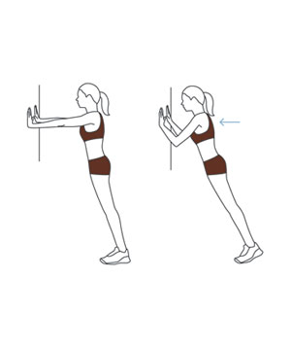
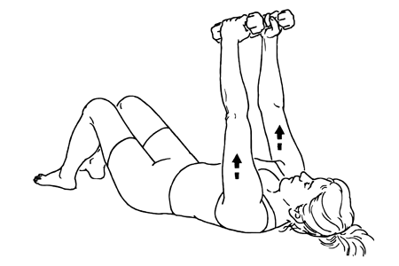
Shoulder Presses: This is an upper body exercise that will help with all daily activities. Lay with arms straight up towards ceiling and elbows straight. Bring hands down and touch your chest, keeping elbows pointed away from the body, then slowly straighten arms back up. Complete 10 repetitions. Perform holding light hand weights of 3+ pounds if you have them available (or two objects of comparable weight that you have in your house).

Chair Stands: Sit in a chair and cross your hands over your chest. Stand up, trying not to use your hands to help you. Sit down slowly and with control. Don’t flop into the chair. Repeat 10-15 repetitions.
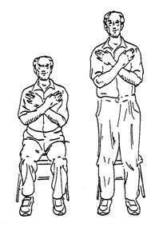
Step up Exercises: Step up and then back down on a stair, first leading with one leg and then the other. Repeat 10-15 repetitions each leg, holding onto a rail if you are unsteady.
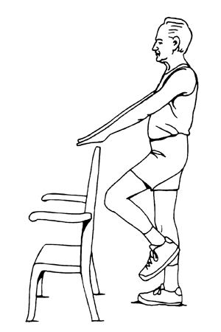
Stepping in Place: Begin by holding lightly on to a chair placed in front or to the side of you; lift first one knee and then the other, holding each knee up for a second before lowering with control and switching to the other leg, 15-20 repetitions each leg. To progress the difficulty, place only one fingertip on the chair, then no hands, and finally, add additional repetitions and sets up to 3 x 20.

Stand on one foot: The previous two exercises should help you improve this one, which is a great one for challenging and improving your balance. Stand near a wall or behind a chair for balance. Stand on one leg and count to 10. Switch legs and repeat. To progress the difficulty, try balancing without holding on.
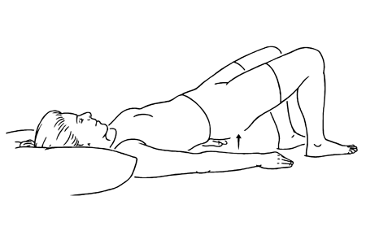
Bridges: Lay on your back with your knees bent and feet flat. Lift your hips up towards the ceiling and hold for 3 seconds, then lower your buttocks back down slowly. Repeat 10-15 repetitions. This exercise is good for building back muscles as well as leg and buttocks muscles—all important for balance.

Sources:
http://www.eldergym.com/exercises-for-improving-balance.html
Otago Exercise Programme: online PDF version of 2007 edition training manual available at http://www.acc.co.nz/PRD_EXT_CSMP/groups/external_providers/documents/publications_promotion/prd_ctrb118334.pdf
http://www.seniorabilitiesunlimited.com/fallprevention/fallpreventionexercises.html
Orange County’s Senior Times (Winter 2013 Issue): consulted for listings/descriptions of group classes

