Paget’s disease of bone has also been called “Osteitis deformans,” reflective of the name’s originator Sir James Paget¹. Paget published a description of an observed bone disorder in 1877 in a man and thought it to be stemming from a chronic inflammation of the bone. While his observations may have been correct, his suggested etiology was not. For purposes of clarity, Paget’s disease of bone (PDB) will be used in this paper. PDB is a “focal disruption in the continuous remodeling of bone through the normal relationship between bone resorption and reformation, resulting in a disorganized mechanical structure and formation of thickened, but structurally weakened bone¹.” While the exact cause is unknown, it is hypothesized that the main abnormality is increased osteoclast activity, and an increased number and size of osteoclasts⁴. PDB is not typically systemic; rather, it is typically a localized disease that affects a few bones in the body^{1-3, 9}. The pathogenesis of PDB can be classified into 3 main stages², with some including a fourth^{1, 5}. The first represents this initial increase in osteoclastic activity in localized areas (described previously) and is termed the osteolytic phase. The 2nd phase, a mixed phase, is when both osteoclastic and osteoblastic activity is occurring. The 3rd phase is one of osteoblastic activity, where new bone is stimulated to grow. The final stage is referred to as either an inactive sclerotic phase² or a malignant degeneration phase^{1, 5}. To better understand the effect these phases have on bone, a basic understanding of normal bone structure and formation is needed.
We know that the fiber component of bone is approximately 90% organic matrix of type I collagen⁶. The ground substance is composed of glycosaminoglycans, calcium salts and hyaluronic acid⁶. The cellular component of bone consists mainly of osteoblasts and osteoclasts⁶. The outer layer of bone, called cortical bone, accounts of about 80% of the total bone mas of an adult skeleton⁵. The interior of bone is filled with cancellous or trabecular bone, comprised of bone marrow and stem cells⁵. When looking at normal bone through a microscope, 2 types can be identified according to the pattern of collagen⁷. Woven bone is mechanically weak due to a “haphazard” organization of collagen fibers⁷. Lamellar bone is mechanically stronger due to a parallel arrangement of collagen fibers into sheets⁷. PDB, with its characteristically high turnover and constant remodeling of bone, causes trabecular numbers to increase rather than thickness¹. This results in an increase in cancellous bone volume and fibrosis at the trabecular bone surface, in addition to hypervasularity¹. The fibrous connective tissue that is laid down by osteoblasts is done so in a more random, “mosaic” pattern. The fibrous tissue fills in the spaces where the resorbed bone once was and is structurally weaker and similar to woven bone^{1,4,7}. Figure 1 shows the differences between healthy trabecular bone (bottom) compared with a bone affected by PDB. Of significance are the very high numbers of osteoblasts surrounding the unorganized and misshapen trabeculae in the bone affected by PDB. This contributes to the overall decrease in strength of remodeled bone from PDB. If you ever find yourself having trouble remembering how PDB is caused, just think “Osteoblasts Gone Wild” (not to be confused with a popular DVD series that can be bought online).
Interestingly, there appears to be both a genetic (or hereditary) and environmental component to this disease¹⁻⁵. A family history of PDB has been found in about 15% of positive cases and the risk of developing the disease increases by 7-10 times the general population^{1,5}. The gene SQSTM1 and the receptor RANK, along with certain regions of chromosome 5 and 6, are have been studied and identified as factors in the development of PDB^{1,4,5}. The gene SQSTM1 encodes a protein called p62 that is involved in regulating the activity of osteoclasts. Around 25-50% of those with familial PDB and 10-20% of those without a family history develop this gene mutation¹. The RANK receptor is a type I membrane protein that is housed on the surface of osteoclasts^{1,4}. It is involved in their activation once ligand binding has occured¹. Low-quality evidence has suggested the following environmental influences on PDB formation: low dietary calcium intake or vitamin D deficiency during childhood, zoonotic (spread from animal to human) infections, viral infections, and occupational exposure to toxins^{1,5}. The only environmental trigger that has been studied in-depth enough to form any conclusion is paramyxovirus infection¹⁻⁵. These are slow-virus infections and are composed of a single-strand of RNA (similar to mumps or measles)^{1,4}. These viruses have been found inside the nuclei and cytoplasm of osteoclasts in PDB, suggesting their possible involvement with this disease. However, published evidence has been inconclusive and controversial up to this point^{1,4}.
It has been reported that PDB is the second most common skeletal disorder after osteoporosis and that it affects men more than women (3:2)¹⁻⁵. Estimates of 1-2 million people in the US have Paget’s disease⁹. Estimates for prevalence in the US range from 1%-4% in individuals under the age of 50 and up to 11% in those over 70 years old^{1,3,4}. However, discrepancies exist in prevalence estimates, as one recent study showed estimates of 1-2% of the US population with almost identical distribution between whites and blacks, as well as between the sexes as well³. This could be due to the nature of diagnosing PDB, which will be discussed later. Patterns of geographic variation in PDB exist, with more people affected in Western Europe, Australia and New Zealand^{4,5}. It is thought that British migrants to Australia and New Zealand brought the disease over with them in years past. Particular towns or regions with much higher prevalence Africa, Asia, Scandinavia, India and Japan have the lowest rates of PDB on the planet^{1,2,4,5}. A recent systematic review discussed 9 paired surveys and the prevalence of PDB compared between surveys⁸. The authors found that prevalence had decreased by 36% over 8-19 years, with changes being most marked in areas with the highest prevalence^{1,8}. This suggests that environmental factors may have changed over the years in these countries and that there is interaction between genetic factors and environmental triggers, which may differ in different regions⁸.
There are a few standard methods for detection and diagnosis of PDB. The most common method of diagnosis is through the use of radiographic imaging¹⁻⁴. An x-ray is normally taken in at least one skeletal area (normally a painful spot); these can also help with the detection of fractures or other secondary conditions³. An isotopic bone scan, or Scintigraphy, is a highly sensitive but not necessarily a specific method of diagnosis¹⁻⁴. Scintigraphy will cause osteoblasts and osteoclasts to demonstrate increased uptake of the marker in all phases of the disease². PDB does not normally create new lesions over time, so scintigraphy can help track disease extent⁴. In addition, bone scintigraphy can detect lesions that are metabolically active, while those that are inactive will only show up on x-ray¹. This is why these two methods are commonly the primary means of detection in individuals suspected of having PDB. CT and MRIs are not used as commonly in this population, even though their resolutions are fairly high¹. Figure 2 shows numerous radiographic images of bones affected by PDB. They are used to help rule out possible differential diagnoses. It is not uncommon for the results of these radiographic image studies to be inconclusive, so a bone biopsy may also be performed to help confirm or rule out PDB^{1,3,4}. A fairly simple test to aid in the diagnosis of PDB is a blood test; PDB causes increased amounts of the enzyme serum alkaline phosphatase (ALP) to be produced¹⁻⁵. ALP is synthesized by osteoblasts and is thought to be involved with the calcification of bone matrix⁹. An elevated ALP, in combination with normal levels of calcium, phosphate, and aminotransferase in elderly patients is suggestive of PDB¹. Around 85% of patients with PDB have elevated levels of ALP, making it a fairly common test to use³.
Often times, a patient with Paget’s disease will not know that they have it (around 75%)². They can remain asymptomatic for years, well into their 50’s and 60’s¹⁻⁴. Patients typically see their PCP for either a related or unrelated symptom, have an x-ray, and find out they have PDB. Characteristics and clinical presentations of this disease are highly variable, as there are different levels of severity^{1,3}. The number one symptom characteristic of PDB is pain^{1-6, 9}. Common pain descriptors include “constant, deep, and aching³.” Joint pain involving swelling and stiffness can damage cartilage surrounding the joints³. Muscular pain may surface as referred pain from bony structures involved or as associated with mechanical changes from bone deficits³. Neurological pain due to a compressed spinal cord or nerve root may cause sharp pain, numbness, weakness, hearing loss, and double vision³. Common presenting symptoms are bone tenderness, increased focal temperature (due to hypervascularity), increased bone size, bowing deformities, kyphosis of the spine, decreased range of motion, fractures, and neurological involvement¹⁻⁵. As you can imagine, the multitude of symptoms can make it difficult to know which are caused by PDB and which are associated with complications from aging. The bones that are typically affected by PDB include all levels of the spine, pelvis, femur, tibia, skull, and ribs^{1,2,3}. Refer to Figure 2 for radiographs demonstrating how PDB affects many different bones and Figure 3 for photographs of clinical presentations of PDB.
PDB has many associated co-morbidities and can lead to the development of other harmful conditions. Involvement of the skull can cause narrowing of the cranial nerve foramina, resulting in deafness (~50%), seizures, brainstem syndromes, dizziness, and/or headaches^{1,5}. Deafness is common due to cranial nerve 8 compression. Cardiovascular problems may occur when 1/3 to 1/2 of the skeleton is involved^{1,3,9}. This is due to the increased arteriovenous connections (hypervascularity) that form in the bone³. The heart must pump harder to ensure adequate perfusion. Increased cardiac output can cause aortic valve calcification, with resulting stenosis and left ventricular hypertrophy, and eventually congestive heart failure^{1,2,3,9}. Arthritis in the leg can develop from bowing of bones and associated joint surface damage^{3,9}. As discussed, individuals with PDB have a much higher risk of fracturing involved bones. An epidemiological study in 2002 found that elderly patients with PDB are 3 times more likely to need a hip replacement and 7 times more likely to need a knee replacement than age-matched controls without the disease¹⁰. Vertebral compression fractures can occur in this population³. Kidney stones and hyperparathyroidism are more common in patients with PDB^{2,3,9}. When PDB affects the face and jaw, it may loosen teeth and make chewing more difficult^{3,9}. In some rare cases, PDB is associated with osteosarcoma (less than 1%)^{1,9}. It tends to affect men more, has a mean diagnosis of 66 years, and mostly involves the axial skeleton¹.
There are a few differential diagnoses that are typically ruled out when attempting to diagnose PDB. If there are skull lesions, hyperostosis frontalis interna should be ruled out². This is a benign thickening of the internal table of the frontal bone and is generally of no clinical significance². Another condition called fibrosus dysplagia usually affects the outer table more predominantly and typically affects children and young adults². This disease normally results in cranial asymmetry, nasal stuffiness, and unilateral blindness². Other differential diagnoses include multiple myeloma, osteomalacia, pseudogout, tuberous sclerosis, ankylosing spondylitis, osteoarthritis and osteoporosis^{1-4,9}.
Prognosis for patients with this disease is generally good, especially if treatment is given before major changes in affected bones have occured⁹. The short-term objective of PDB treatment is to control disease activity; the long-term objectives are to minimize or prevent disease progression and to decrease complications stemming from it^{1,9}. The “gold standard” and first line of treatment for PDB is the use of biphosphonates^{1,3,9}. These drugs affect osteoclasts and inhibit bone resorption, improve bone density, and increase the strength of the bone itself^{1,3}. Levels of ALP are monitored and these drugs can be administered when levels become too high. Therefore, these drugs are used more for symptomatic, as opposed to asymptomatic patients. There are currently 5 bisphosphonates available, with the most commonly prescribed being risedronate, alendronate, and pamidronate³. However, intravenous pamidronate and zoledronate are beginning to become more favorable due to their greater effectiveness in reducing bone turnover¹. One randomized controlled study confirmed that a single infusion of zoledronate produced a more rapid and complete response in PDB than daily treatments of risedronate¹¹. The authors compared a single does of 5 mg of zoledronate with a 2-month course of oral risedronate. After 2 years of treatment, only 2% of those treated with zoledronate had an ALP above normal range (> 200 IU/L is considered too high¹) , compared with 43% treated with risedronate¹¹. It is important to note that patients taking these medications should be taking 1000-1500 mg of calcium and at least 400 units of vitamin D daily^{5,9}. These patients typically already have a deficiency in these substances and this needs to be corrected prior to starting these drugs; otherwise, hypocalcemia or focal osteomalacia can occur¹. A cost-effective way to measure the success of these drug therapies is with an ALP measured 3 months after therapy and a decision to retreat by an ALP level at 6 months¹. With newer bisphosphonates, retreatment is often not necessary for a number of years¹. Remission is considered to have been achieved when normal levels of alkaline phosphatase are attained, and partial remission when there is a decrease in levels greater than 75% after three to six months of treatment¹².
Depending on the severity of changes and degree of pain, the second line of treatment often consists of NSAIDS and other anti-inflammatories to control pain^{1,3,9}. Orthopedic assistive devices such as shoe lifts and canes can be used, as well as hydrotherapy, physical therapy, and TENS^{3,4,5}. While the effectiveness of these strategies has not been assessed specifically in patients with PDB, these interventions have been shown to improve health-related quality of life, pain, and functional independence in patients with similar clinical presentations⁵. While there is no specific exercise program for patients with PDB, exercise has been shown to preserve skeletal health, prevent weight gain, and maintain joint mobility⁹. To avoid any harmful stress on affected bones, affected patients should talk with their doctor or physical therapist before starting any new exercise program or physical activity. Specific physical therapy interventions will be discussed at the end of this review.
Surgical intervention is indicated if a patient is resistant to pharmacological or conservative orthopedic interventions and/or if severe joint or bone breakdown is present^{1,3,5,9}. Osteoarthritis of the hip and knee joints is the most common indication for surgical replacement of these joints^{1,5}. Other common surgeries may include tibial and fibular osteotomies, surgeries to repair fractures, relieve neurological symptoms from nerve/spinal cord impingement, and prophylactic surgery in those with painful pseudofractures^{1,3,5,11}. It is important that patients with PDB get treated with bisphosphonates prior to major surgery to help reduce bone vascularity⁴. The reason for this lies in the fact that bones with active PDB have increased metabolism (overactive osteoclasts and osteoblasts) and increased blood flow⁴. Surgeries can cause substantial amounts of blood loss if the infected bone is hypervascular. Bisphosphonates can help protect against potentially harmful amounts of blood loss in these patients undergoing corrective or joint replacement surgery^{4,5}. For those patients who develop osteosarcoma, surgery may be needed and in rare cases, amputation⁵. Amputation is needed with neoplams due to the aggressive nature of this type of sarcoma⁹. The prognosis is poor for those who develop osteosarcoma; even with aggressive operative treatment, these patients have around a 5-year survival rate of 6%⁵. In cases of pagetic spinal stenosis and osseous compression, bisphosphonates can be used to help treat symptoms⁹. However, decompressive laminectomies have been used for persistent mechanical pain that is unresponsive to nonsurgical treatment⁹.
Because PDB has been said to be the 2nd most common skeletal disorder, there is a chance that we as physical therapists could encounter a patient with this disease. Understanding the pathophysiology behind PDB, as well as treatment options, can equip us with the best available knowledge and skills to help these patients. As mentioned previously, physical therapists are one of many heath care professionals who can provide services to patients with PDB. One of the most important interventions we can provide to our patients is education. Patients will be dealing with the complications of this disease for the rest of their lives and the complications will likely get worse over time as well^{1,13}. Ensuring that they understand the disease and the possible complications associated with it will help them identify when they require increased support and assistance. For example, sudden increase of localized pain should be reported to a physician immediately as this could be a sarcoma¹¹. Topics should include proper posture, body mechanics, avoidance of trauma, living in a clutter-free home to reduce falls risk, information on bone healing expectations and weight-bearing restrictions post-surgical interventions^{5,9,11}. Things to look out for during a PT physical examination are: skeletal deformities, abnormal gait, elevated temperature/erythema/tenderness over affected bones, hearing loss, dilated scalp veins, high output cardiac failure, and neurological findings¹⁴. While many of these symptoms or signs can be associated with other potential diagnoses, many individuals living with PDB are unaware that they have the disease and we may be one of the first to suspect it.
Assessing the quality of life in this population is important and lead to important referrals such as a psychologist, physician, or occupational therapist. One study conducted in 2007 used the Short-Form 36 questionnaire and Health Assessment Questionnaire Disability Index in 1,324 subjects with PDB in order to look at quality of life and its determinants¹⁵. They categorized patients’ ALP levels into 4 distinct groups in order to account for variation in reference ranges: low normal, normal, elevated and greatly elevated¹⁵. Physicians assessed whether patient-reported bone pain was due to PDB; commonly used criteria for this task included localization of pain to an affected site, response of pain at that site to previous treatment with bisphosphonates, pain at rest, and pain at night¹⁵. They found that increasing age, bone pain due to PDB and previous bisphosphonate therapy identified as negative predictors of the SF36 physical summary score, while ALP levels did not predict physical summary scores¹⁵. The overall mental summary score of the SF36 was only slightly reduced (but statistically significant) in those with PDB compared with the expected population norm, while the physical summary score was substantially reduced¹⁵. The general lack of correlation between ALP and quality of life discovered in this study reinforces the notion that health care professionals should be focusing on issues related to quality of life for those with PDB and not an individual’s ALP level¹⁵.
The main objectives for treatment of PDB are to relieve current symptoms, prevent progression of the disease, and help avoid future complications. Many of the treatment strategies discussed previously are aimed at one or more of these objectives. Physical therapists can help address these goals by helping to maintain or improve muscle strength, maintain joint range of motion and flexibility, increase endurance, and avoid deconditioning¹⁶. Physical therapists would obviously be involved in post-surgical interventions such as joint replacements, fracture repair, laminectomy or other corrective surgeries¹⁵. For extremely weak or ataxic patients, gait and balance training would be beneficial^{1,15}. Other important interventions therapists can provide are shoe inserts or orthotics to help correct leg length discrepancies or improper surface area/contact pressures between the ground and patients’ feet^{1,9,16}. While there is no standard exercise plan for PDB, encouraging patients to remain active and helping them identify physical activities fun for them is important. This will help them to keep excess weight off their joints, which can further complicate their condition. Increased weight gain can lead to increased joint damage, increased risk for bone fractures, and increased chance of immobility.
Paget’s disease of bone is a very serious skeletal disorder, characterized by overactive periods of bone resorption and deposition, constant bone pain, and can have very different manifestations in different individuals. The prevalence of this disease has decreased over recent years, but those who suffer from it must deal with their complications for life. With careful monitoring, successful drug therapy, and skilled physical therapy interventions, individuals affected by PDB can still live a fairly independent lifestyle. Future high-quality research is needed for pharmacological treatment options; prophylactic treatment to prevent complications is one area that researchers are investigating, as there is currently very limited evidence in this area⁵. Physical therapists are in a position to possibly be one of the first health care professionals to recognize signs and symptoms of PDB in their patients and should provide both skilled interventions and appropriate referrals to ensure optimal functional outcomes.

Figures
Figure 1: Comparison of Bone Affected by PDB (top) and Healthy Bone (bottom)
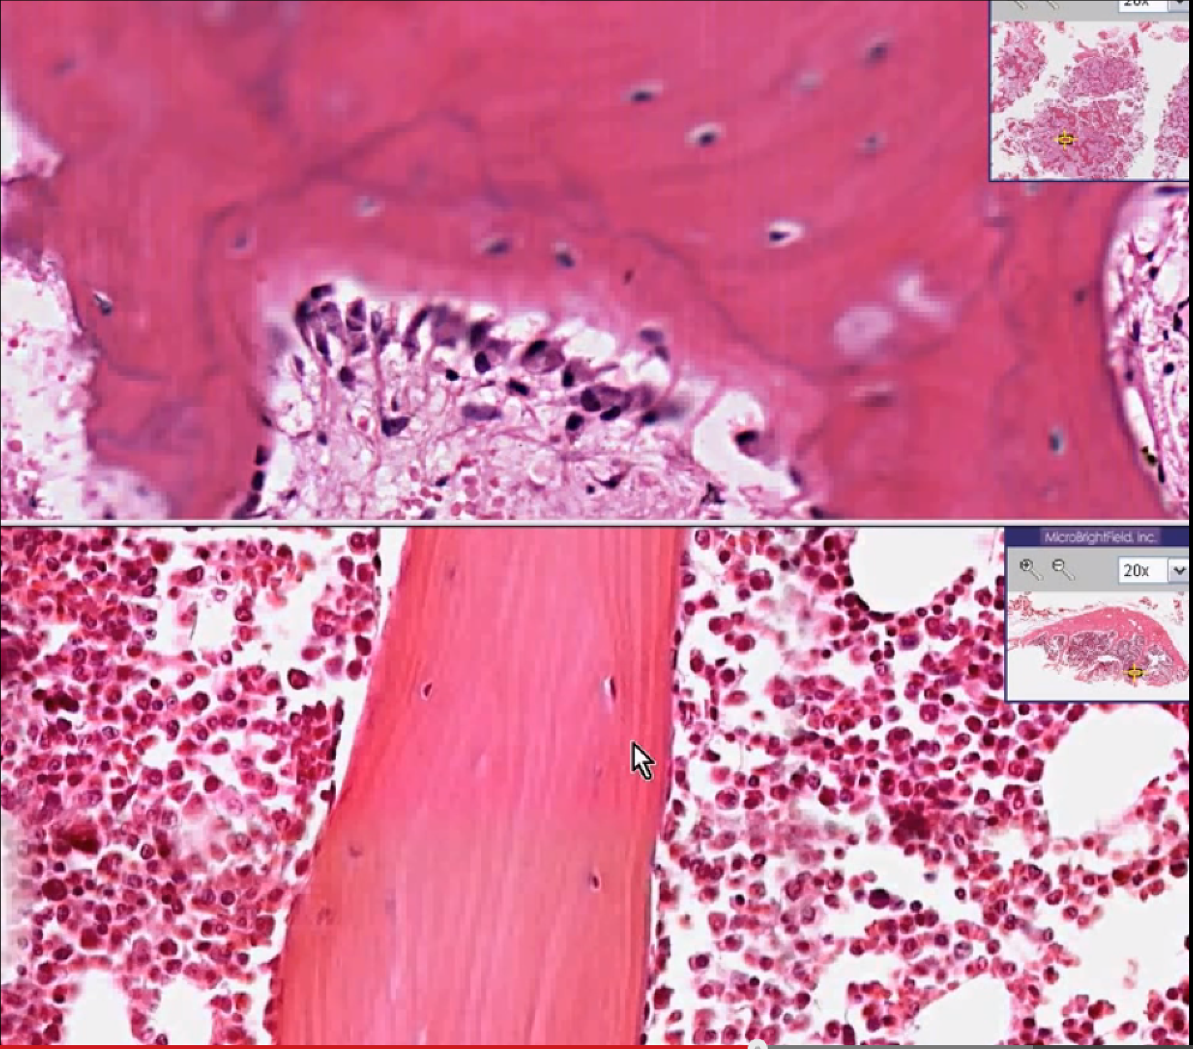
Credit: Histopathology Bone-Paget disease. YouTube. 2007. Assessed online at https://www.youtube.com/watch ?v=dC2TrqcEJEA#t=16
Top: Note the high number of overactive osteoblasts along the edges of the pink, “mosaic” trabeculae (green circle).
Bottom: The trabeculae are arranged in an organized, parallel fashion with an occasional osteoblast along its edge.

Figure 2: Radiographic Images of Bones Affected by PDB
All images in Figure 2 obtained from http://radiopaedia.org/articles/paget-disease-of-bone-2.

2a. X-ray of skull 2b. Radiograph of thoracolumbar spine
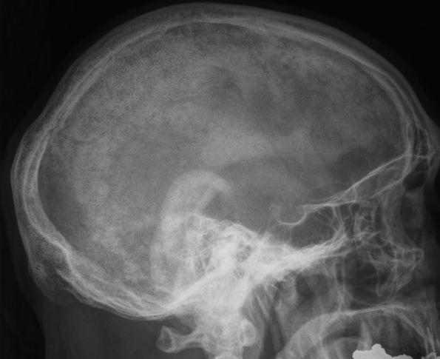

Characteristic “picture frame” vertebral body, caused by medullary bone resorption with dense cortical thickening.

Osteoporosis circumscripta: a large,
well-defined lytic lesion (arrows).
Figure 2c: Bone Scintigraphy Figure 2d: CT of Femur
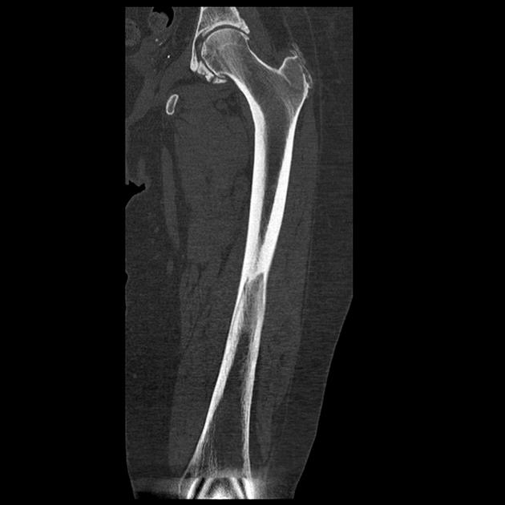
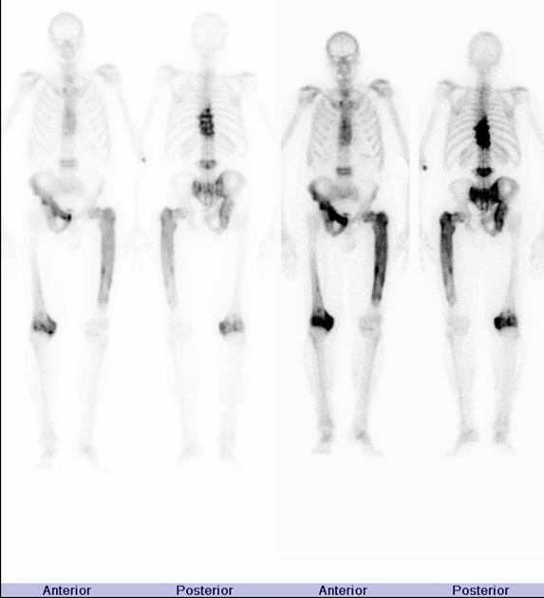

The “blade of grass” or “candle flame sign” refers to the lucent leading edge in long bones during the lytic phase of PDB.
Increased uptake of radiopharmaceutical in different
bones affected by PDB.

Figure 2e: Radiograph of diseased femur with common PDB findings
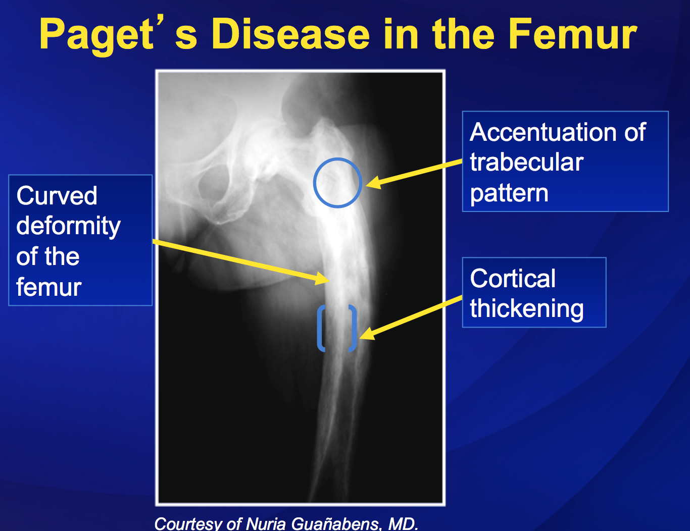
Photo credit: Nuria Guanabens, MD. www.paget.org

Figure 3: Common Observable Clinical Presentations of PDB

Figure 3a: Bowing of legs Figure 3b: Frontal bossing of skull
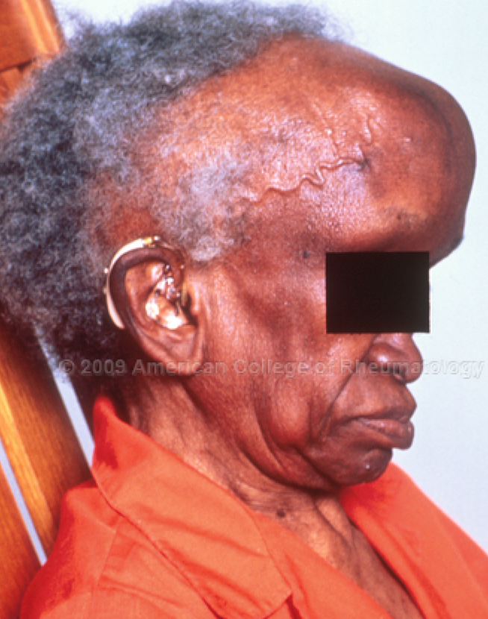
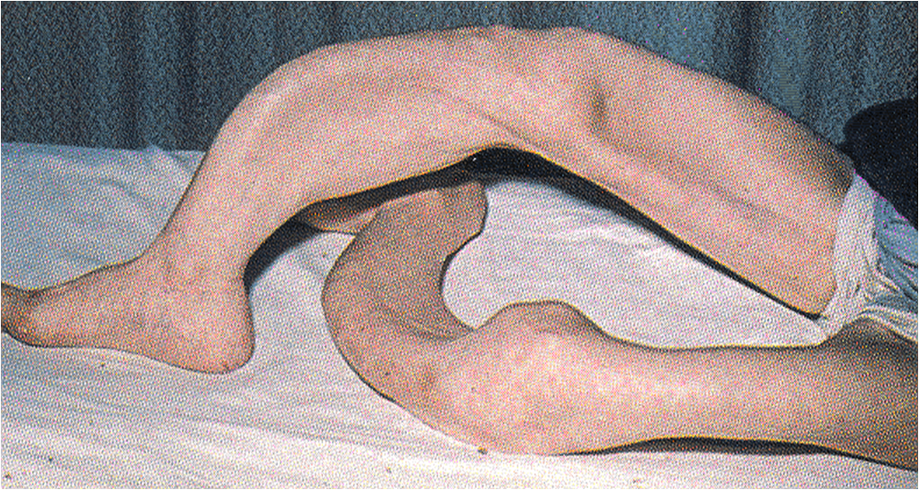

http://www.etsu.edu/com/medicalmystery/pagetsofbone.aspx http://images.rheumatology.org/viewphoto.php?imageId=2861840&albumId=75679

Figure 3c: “The Ugly Duchess”

http://www.theguardian.com/culture/2008/oct/11/art-painting
A famous painting by Quinten Massys (1513), it is now thought
that the sitter suffered from PDB. Notice her pronounced
forehead and enlarged jawbones.

Resources

1. Gruener G, Camacho P. Paget's disease of bone. Handb Clin Neurol. 2014;119:529-40. PubMed PMID: 24365317.
2. Knipe H, Gaillard F, et al. Paget disease of bone. Radiopaedia.org. Assessed December 1, 2014 online at http://radiopaedia.org/articles/paget-disease-of-bone-2.
3. Schoenfeld K, Pariser D, Lonnemann E. Paget’s Disease. Physiopedia. Assessed December 1, 2014 online at http://www.physio-pedia.com/Paget%27s_Disease#cite_ note-Goodman_and_Fuller-0.
4. Bolland MJ, Cundy T. Paget's disease of bone: clinical review and update. J Clin Pathol. 2013 Nov;66(11):924-7. PubMed PMID: 24043712.
5. Ralston SH, Langston AL, Reid IR. Pathogenesis and management of paget's disease of bone. The Lancet. 2008;372(9633):155-163. doi: http://dx.doi.org/10.1016/ S0140-6736(08)61035-1.
6. Gross, M. Bone: Composition, Structure, Mechanical Properties, and Healing. 2014. Accessed on December 1, 2014: https://voicethread.com/#u3595440. b166168.i884921.
7. Curry, J.D. The Structure of Bone Tissue. Bones: Structure and Mechanics. Princeton U. Press. Princeton, NJ. 2006;12–14.
8. Corral-Gudino L, Borao-Cengotita-Bengoa M, Del Pino-Montes J, Ralston S. Epidemiology of Paget's disease of bone: a systematic review and meta-analysis of secular changes. Bone. 2013 Aug;55(2):347-52. PubMed PMID: 23643679.
9. Information for Patients About Paget’s Disease of Bone. NIH Osteoporosis and Related Bone Diseases National Resource Center. 2012. Assessed December 2, 2014 online at http://www.niams.nih.gov/Health_Info/Bone/ Pagets/pagets_disease_ff.asp.
10. van Staa TP, Selby P, Leufkens HG, Lyles K, Sprafka JM, Cooper C. Incidence and natural history of Paget's disease of bone in England and Wales. J Bone Miner Res. 2002 Mar;17(3):465-71. PubMed PMID: 11878305.
11. Reid IR, Miller P, Lyles K, et al. Comparison of a single infusion of zoledronic acid with risedronate for paget's disease. N Engl J Med. 2005;353(9):898-908. http://dx.doi.org/10.1056/ NEJMoa044241. doi: 10.1056/NEJMoa044241.
12. Griz L, Fontan D, Mesquita P, Lazaretti-Castro M, Borba VZ, Borges JL, Fontenele T, Maia J, Bandeira F. Diagnosis and management of Paget?s disease of bone. Arq Bras Endocrinol Metabol. 2014 Aug;58(6):587-99. PubMed PMID: 25211441.
13. Alikhan MM, Driver K, Lohr KM. Paget Disease. Medscape. Updated March 2013. Assessed December 2, 2014 at http://emedicine.medscape.com/article/334607-overview.
14. Siris ES, Roodman GD. Paget’s disease of bone. In: Favus MJ, ed. Primer on the Metabolic Bone Diseases and Disorders of Mineral Metabolism. 5th ed. Washington, DC: American Society for Bone and Mineral Research; 2003:495-506.
15. Langston AL, Campbell MK, Fraser WD, Maclennan G, Selby P, Ralston SH. Clinical determinants of quality of life in Paget's disease of bone. Calcif Tissue Int. 2007 Jan;80(1):1-9. PubMed PMID: 17205328.
16. Chow D, Slipman CW. Rehabilitation for Paget Disease. Medscape. Updated Nov 2013. Assessed December 2, 2014 at http://emedicine.medscape.com/article/311688-overview#showall.

