Amy Gwynn
PHYT 875: Adv. Ortho.
Due Date: December 4, 2014

The Sternoclavicular Joint:
Anatomy, Function, Instability, Surgical, and Physical Therapy Interventions

The sternoclavicular joint (SCJ) is a diarthrodial synovial saddle joint, and is the only bony articulation between the upper extremity and the axial skeleton.^{1–4} The SCJ is comprised of the sternal end of the clavicle, the clavicular notch of the manubrium, and the cartilage of the first rib.⁵ The SCJ’s secondary role is to protect the underlying mediastinal structures, which include the subclavian vessels and brachial plexus posterolaterally, and the trachea and esophagus posteromedially.^{1,3,4}
Range of Motion
The SCJ functions in a range of thirty-five degrees of elevation, thirty-five degrees of protraction and retraction, and fifty degrees of rotation around its long axis.³ Functionally, the clavicle elevates four degrees for every ten degrees of humeral elevation through the first ninety degrees of forward elevation.⁴ When injured, there is frequently less sternoclavicular elevation at lower angles of scaption, and there is significantly reduced posterior rotation at the SCJ during humerothoracic elevation.⁶
Bony Anatomy
The clavicle is an S-shaped bone, which is cylindrical in shape and strong at the medial end, and flattens at the lateral end to allow for ligamentous and muscular attachment.¹ In 25% of patients, the medial end of the clavicle includes a facet for articulation with the first rib.⁴ The middle portion of the clavicle, which transitions in shape from cylindrical to flattened, is weak and prone to fracture.¹ Interestingly, while the clavicle is the first bone in the skeleton to ossify during the fifth intra-uterine week, it is also the last bone to fuse, between twenty-three and twenty-five years old.^{4,3} This can make diagnosing traumatic SCJ instability in patients younger than twenty-five years old as medial epiphyseal fracture-separations can still occur.⁴
The SCJ is also recognized as having the least bony stability of any major joint due to incongruent surfaces.^{1,3} The clavicle is convex in the anterior-posterior (AP) plane, and concave in the vertical plane, while only a small articular surface of the manubrium is convex.^{3,4} In other words, less than half of the surface of the medial saddle-shaped clavicle articulates with the articular facet on the manubrium, meaning the joint is forced to rely on ligament and soft tissue structures for stability.⁴
Surrounding Ligamentous and Muscular Anatomy
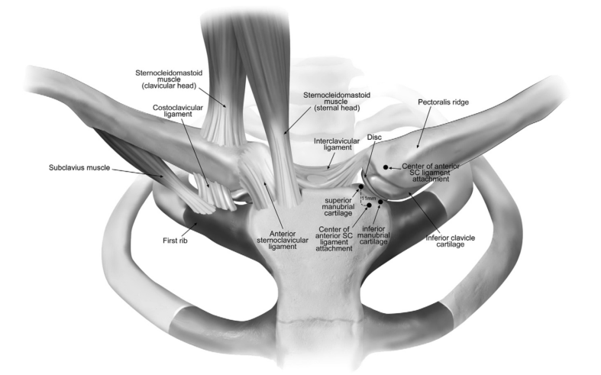
Figure 1: Anterior view of the SCJ anatomy Reproduced from: Lee JT, Campbell KJ, Michalski MP, et al. Surgical Anatomy of the Sternoclavicular Joint A Qualitative and Quantitative Anatomical Study. J Bone Jt. Surg Am 2014;166:1-10.

The primary ligamentous structures include the costoclavicular ligament (CCL), interclavicular, posterior sternoclavicular, and anterior sternoclavicular ligaments.^{2,5} The most common primary failures occurred of the anterior SC ligament during depression, the posterior SC ligament during protraction, and the anterior SC, CCL, and 1st rib during retraction.² More specifically, the CCL courses from the first rib to the costoclavicular tubercle on the medial end of the clavicle.⁷ The CCL consists of “anterior and posterior fasciculi with an interposed bursa from the inferior margin of the medial clavicle to the synchondral junction between the manubrium and first rib” (Martetschlager et al., pg. 4). Thus, the anterior fibers work to resist superior rotation and lateral displacement of the clavicle, while the posterior fibers resist inferior rotation and medial displacement.³ The interclavicular ligament resists superior migration of the medial clavicle.³ Overall, the ligamentous structures resist protraction and depression significantly better than retraction and elevation.²
Muscular insertions are also prominent in this region. Anteriorly, the “indirect aponeurotic insertion of the superficial part of the clavicular insertion of the sternocleidomastoid (SCM) is contiguous with the more direct insertion of the clavicular and sternal parts of the pectoralis major (PM) below, and covers the SCJ in a musculo-aponeurotic layer” (Sewell et al., pg. 722). This insertion of the clavicular head of the SCM can be seen in the figure above, as can the sternal insertion of the SCM, which covers the medial portion of the SCJ. The subclavius originates from the first rib lateral to the CCL, and inserts on the inferior surface of the clavicle.⁴ The structure of the subclavius suggests it may work to decrease the upward displacement of the clavicle during lateral compressive loads, acting as an extrinsic shock absorber for the SCJ.⁴ Posteriorly, the sternohyoid and sternothyroid muscles function to provide support for the SCJ. The sternohyoid is a thin strap muscle, which inserts onto the posterior portion of primarily the clavicle, but also the SCJ.⁷ The sternothyroid muscle is deeper than the sternohyoid and inserts more inferiorly on the posterior portion of the manubrium and costal cartilage.⁷
The joint surfaces are also protected by an intra-articular fibrocartilagenous disc attached to the anterior and posterior sternoclavicular ligaments and capsule, which divides the joint into two synovial-lined cavities.⁴ The disc often degenerates with age, and by the seventh or eighth decade is often incomplete, potentially explaining the presence of osteoarthritis, even as it’s rare in this joint.⁴
All of these surrounding structures make SCJ dislocations rare, comprising only 3% of all shoulder girdle injuries, and 1% of all dislocations.^{4,3} Even so, due to the SCJ’s location in relation to major neurovascular structures, an injury in this area, specifically a posteriorly directed one, can be particularly detrimental.^{1,3,4}
SCJ Instability
Classifying SCJ instability can be based on direction (anterior or posterior), cause (traumatic or atraumatic), severity (sprain, subluxation, or dislocation), and onset (acute or chronic).^{3,4} Grading chronic SCJ instability can be done based on the Stanmore triangle system.⁴ On this scale, there are three types: type I: traumatic structural, type II atraumatic structural, and type III muscle patterning non-structural pathology. The following chart organizes characteristics and pathologies based on this classification.⁴
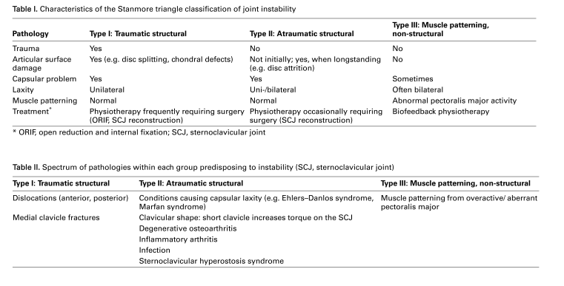Figure 2: reproduced from: Sewell MD, Al-Hadithy N, Le Leu a, Lambert SM. Instability of the sternoclavicular joint: current concepts in classification, treatment and outcomes. Bone Joint J. 2013;95-B(6):721-31. doi:10.1302/0301-620X.95B6.31064.

Grading acute injuries can be done based on level of ligament involvement. A level 1 injury is a sprain of the SC ligaments and capsule without subluxation or dislocation.³ A level 2 injury is a disruption of the SC ligaments and capsule and subluxation of the medial clavicle without dislocation.³ A level 3 injury is a rupture of all ligaments with complete anterior or posterior dislocation.³
SCJ Dislocation Type I: Traumatic Structural & Type II: Atraumatic Structural
When traumatic structural type I SCJ dislocations occur, 80% of them are attributed to motor vehicle collisions (MVCs) or sport-related injuries during which the shoulder was hit behind and forced anteriorly.¹ Type II atraumatic structural dislocations often occur because of generalized ligamentous laxity, often caused by Ehlers-Danlos or Marfan’s syndrome, or a short clavicle, which increases torque on the SCJ.⁴ This typically produces pain with overhead activities, and prominence of the medial clavicle.⁴
Overall, dislocations of the SC joint are more likely to be anterior than posterior.¹ With an anterior dislocation, the medial portion of the clavicle will often be prominent and palpable anterior relative to the sternum.¹ When posterior dislocations occur, they are more concerning due to the fact that for it to occur, the force must be 1.5 times greater than an anterior dislocation, and there is a much greater risk of damaging posterior mediastinal structures.^{1,3,4} A posterior dislocation is often produced by a large magnitude medially directed force with the arm in adduction and flexion.¹ Oftentimes, with a posterior dislocation, the medial end of the clavicle will not be palpable.¹ Signs and symptoms associated with the posterior dislocation related to compression of the mediastinal structures could include tachypnea, dyspnea, dysphagia, or noticeable venous congestion in the neck and face.¹
Imaging
In terms of imaging, SCJ dislocations can best be identified by CT scans, which also show the underlying mediastinal structures, however, much more commonly serendipity view radiographs are used.^{1,3,4,8} The Heinig view, which can be seen with the XR directly perpendicular to the joint with the patient in supine, allows for clearer identification of anterior and posterior dislocations relative to the manubrium.⁴
Treatment
For a type I SCJ dislocation, treatment includes ice immediately, immobilization for less than a week, and over-the-counter (OTC) anti-inflammatory pain medications followed by return to activities of daily living (ADLs).^{1,3} For a type II SCJ dislocation, recommended treatment includes ice, immobilization and stabilization with a figure-of-eight dressing and/or a sling for four to six weeks to allow the ligaments to heal, and protect the joint, with concurrent physical therapy (PT).^{1,3}
For a type III dislocation in an acute situation, closed reduction is tried first with conscious sedation in supine with a pad underneath the scapulae for anterior dislocations, and general anesthesia in supine with a pad underneath the scapulae, and a cardiothoracic surgeon on standby for posterior dislocations.³ Post-reduction, immobilization should occur for about six weeks to allow the SC ligaments to heal, with concurrent PT.³ Fortunately, this initial reduction typically works well and remains stable in the long-term for posterior dislocations, however for anterior locations, often repeat subluxation and dislocations occur, sometimes indicating surgical management of the instability.^{3,8–10}
Persistent dislocations in symptomatic patients are generally treated with steroid injections and physical therapy.⁴ If surgery is indicated based on severity and persistence of symptoms such as chronic instability, pain, and scapular dyskinesia, open reduction and stabilization by surgical resection of the medial clavicle with CCL reconstruction can be performed.⁴ There has been controversy over whether or not resection arthroplasty with excision of the medial clavicle in this region is safe.^{4,8} To avoid any dangers related to migration of or puncturing due to hardware, utilizing soft tissue reconstruction is essential. Tendon auto- or allograft to reconstruct the CCL has been used with many different tendons including: gracilis, semitendinosus, the sternal head of the sternocleidomastoid, subclavius, and Achilles.^{1,4,8,11,12} It seems as though the semitendinosus figure-of-eight plasty, as shown below, is able to produce the most similar level of stiffness to the native SCJ, though more research as to whether this remains true in the long-term is needed.¹¹
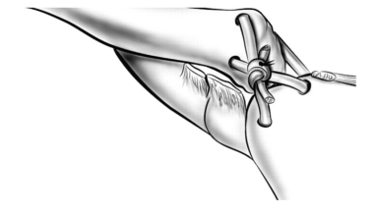
Figure 3: figure of eight plasty reproduced from: Spencer, Edwin., Kuhn J. Biomechanical analysis of reconstructions for sternoclavicular joint instability. J. Bone Jt. Surg. 2004;86-A(1):98-107.

Post-operatively, active-assisted shoulder external rotation, elevation, and progressive strengthening for periscapular musculature is recommended.⁴
Medial Clavicle Fractures: Type I Traumatic Structural
Most minimally displaced clavicle fractures can be treated with immobilization using a sling or a figure-of-eight brace for four to six weeks.¹ Usually a bridging callus can be noted on XR at this point, and patients are typically no longer tender to palpation.¹ Return to sport depends on age, severity of fracture, sport, and any complications, but typically return to non-contact sport can occur at six weeks, and contact sport at eight to twelve weeks.¹ If surgery is needed, an intramedullary pin or external plating may be used and then removed six to eight weeks later.¹
Arthritis of the SCJ: Type II Atraumatic Structural
Arthritis is the most common atraumatic disease to affect the SCJ.¹³ Primary osteoarthritis of the SCJ occurs in 90% of patients older than sixty, but could potentially be underdiagnosed and/or misattributed to nearby structures.¹⁴ Degenerative osteoarthritis of the SCJ, which typically occurs in the inferomedial articular cartilage of the dominant UE in postmenopausal women, can cause painful instability and crepitus.⁴ Often the push-down test on the medial clavicle, the cross-shoulder sign, and resisted GH abduction reproduce symptoms.¹⁵ Conservative treatment can include rest, ice, activity modification, anti-inflammatory medications, intra-articular corticosteroid injections, and physical therapy.^{3,15} If this conservative regimen fails, often resection arthroplasty of the medial clavicle with preservation of the CCL is often used followed by PT.^{3,15} This has just recently been introduced as an arthroscopic procedure to reduce recovery time and risk of damaging nearby anatomy, and improve visualization.³ This procedure has shown to be successful both clinically and cosmetically while allowing for PT early on.^{3,15}
Rheumatoid arthritis also occurs in in the SCJ in 31% of patients.⁴ Steroid injections and physical therapy are typically used for conservative treatment options.^{3,4} Similar to OA, surgical resection and debridement of the medial clavicle may be used, though more sparingly for patients with RA due to increased destruction of ligamentous tissue, which could necessitate ligamentous reconstructions as well.⁴
Septic arthritis of the SCJ may also occur insidiously and acutely as an inflamed joint with localized cellulitis.⁴ This typically occurs in immuno-compromised individuals, and aspiration under ultrasound guidance may be used to confirm the involved organism and remove fluid.^{4,16} The SCJ is not the joint that is most likely to be infected with septic arthritis, though it is typically any joint that is already undergoing arthritis processes.¹⁶ Aspiration or intravenous antibiotics can be used as well as open or arthroscopic lavage for treatments.⁴
Sternocostoclavicular Hyperostosis Syndrome (SCCH): Type II Atraumatic Structural
SCCH is hyperossification of the manubrium, sternum, clavicles, upper ribs, and peri-articular ligaments.⁴ SCCH has been most commonly diagnosed by exclusion in middle-aged Japanese men and may be related to diffuse idiopathic skeletal hyperostosis and ankylosing spondylitis.⁴ The etiology of this syndrome is unclear, but typically antibiotics can clear up any symptoms.⁴
Infection or Chondrosarcoma of the SCJ: Type II Atraumatic Structural
In an interesting recent case series, the second metatarsophalangeal joint and its vascular and nervous structures were harvested and used to reconstruct an excised SCJ post-infection of a chondrosarcoma.¹⁷ Other risk factors for infection in this area can include co-diagnosis of diabetes mellitus, immunosuppressive diseases, or uses of immunosuppressant, and placement of a subclavian central venous catheter.¹⁶ Including innervation in the reconstruction could help decrease the likelihood of developing a Charcot joint and future degeneration.¹⁷ Including vascularization in the reconstruction could help with decreasing risk of infection and radiotherapy-induced osteonecrosis.¹⁷ Unfortunately, one of the two patients in this series began to sublux again and had to have a tendon graft reconstruction of the CCL.¹⁷
Condensing Osteitis: Type II Atraumatic Structural
Condensing osteitis is an idiopathic issue which typically produces sclerosis and expansion of the inferior portion of the medial clavicle, accompanied by pain localized at the SCJ.¹⁸ This is a rare benign disorder that most commonly occurs unilaterally, usually on the side of dominance, in women of late child-bearing age.^{18,19} The pathophysiology is still questionable but may be related to osteonecrosis, an embolic event, marrow fibrosis, fibrocartilage-associated sclerosis of bone, or mild inflammation in the joint due to abnormal mechanical stress.¹⁹ Unfortunately, PT is not typically helpful in reducing symptoms.¹⁸ Another study suggests oral NSAIDs and corticosteroids, surgical resection, and surgical radiation are also not typically helpful in reducing symptoms.¹⁹ Whether or not steroid injections would be helpful is still questionable.^{18,19} The severity of pain has been shown to decrease just based on time in the intermediate-term.¹⁸
Muscle Patterning: Type III Atraumatic nonstructural
Some patients have been seen to have issues not with the strength or structure of the bones, ligaments, and musculature, but of poor coordination and recruitment of muscle tissue.⁴ This may be treated by biofeedback in physical therapy, or if there is a structural issue as well perhaps surgically.⁴ Interestingly, even post-operatively, the same type of muscle patterning can occur, potentially based on “centrally mediated mechanisms causing pain-generated muscle hypertonicity,” which is usually controlled by botulinum toxin injections (Sewell et al., 2013).
Thoracic Outlet Syndrome (TOS)
TOS is generally caused by compression of the brachial plexus, subclavian artery or subclavian vein at either the interscalene or costoclavicular triangle, or the subcoracoid space.²⁰ Due to the fact that a posterior SCJ dislocation decreases the space in the TO region, compression could occur in this area producing numbness, tingling, paresthesias, muscular weakness, fatigue, and/or fatigue in the affected UE.²⁰ A recent case report suggests anterior SCJ dislocations treated with surgical fixation of the medial clavicle can also cause TOS, though the reason why is unknown.²⁰ Physical therapy interventions for this issue included scapular and shoulder strengthening and stabilization exercises, simulated and actual boxing sequences, soft tissue massage, and joint mobilizations to the acromioclavicular joint, and first rib.²⁰ Custom and OTC orthoses were tried without success.²⁰
Overall, injuries to the SCJ which lead to chronic instability and degenerative changes are rare.^{1,3,8,21} This means there is limited evidence both in terms of quality and quantity—most evidence is small case series, case reports, and expert opinion, mostly focused on surgical techniques following traumatic dislocation.^{1,3,4} Therefore, it is important to emphasize the importance of recognizing and classifying these issues to encourage conservative treatment, and reduce long-term consequences and the need for surgical intervention.^{1,3,4} Future research is needed to determine and develop upon: which exercises are best for stabilizing the SCJ, a reliable and valid way to measure motion at the SCJ, which physical therapy interventions are the most appropriate, a practical, comfortable, and appropriate orthosis to prevent repeat subluxation and dislocation of the SCJ, and which surgical procedure for CCL reconstruction is best in the long-term.^{1,3,4,20} Further attention could also be paid to educate patients on the risks associated with repeat corticosteroid injections, and prolonged immobilization.

Works Cited
1. Balcik BJ, Monseau AJ, Krantz W. Evaluation and treatment of sternoclavicular, clavicular, and acromioclavicular injuries. Prim. Care 2013;40(4):911-23, viii-ix. doi:10.1016/j.pop.2013.08.008.
2. Negri JH, Malavolta E a, Assunção JH, et al. Assessment of the function and resistance of sternoclavicular ligaments: A biomechanical study in cadavers. Orthop. Traumatol. Surg. Res. 2014;100:727-731. doi:10.1016/j.otsr.2014.07.011.
3. Martetschläger F, Warth RJ, Millett PJ. Instability and degenerative arthritis of the sternoclavicular joint: a current concepts review. Am. J. Sports Med. 2014;42(4):999-1007. doi:10.1177/0363546513498990.
4. Sewell MD, Al-Hadithy N, Le Leu a, Lambert SM. Instability of the sternoclavicular joint: current concepts in classification, treatment and outcomes. Bone Joint J. 2013;95-B(6):721-31. doi:10.1302/0301-620X.95B6.31064.
5. Van Tongel a, MacDonald P, Leiter J, Pouliart N, Peeler J. A cadaveric study of the structural anatomy of the sternoclavicular joint. Clin. Anat. 2012;25(7):903-10. doi:10.1002/ca.22021.
6. Lawrence RL, Braman JP, Laprade RF, Ludewig PM. Comparison of 3-dimensional shoulder complex kinematics in individuals with and without shoulder pain, part 1: sternoclavicular, acromioclavicular, and scapulothoracic joints. J. Orthop. Sports Phys. Ther. 2014;44(9):636-A8. doi:10.2519/jospt.2014.5339.
7. Lee JT, Campbell KJ, Michalski MP, et al. Surgical Anatomy of the Sternoclavicular Joint A Qualitative and Quantitative Anatomical Study. J Bone Jt. Surg Am 2014;166:1-10.
8. Bak K, Fogh K. Reconstruction of the chronic anterior unstable sternoclavicular joint using a tendon autograft: medium-term to long-term follow-up results. J. Shoulder Elbow Surg. 2014;23(2):245-50. doi:10.1016/j.jse.2013.05.010.
9. Battaglia, T. C., Pannunzio, M. E., Chhabra, A. B., Degnan GG. Interposition Arthroplasty With Bone – Tendon Allograft : A Technique for Treatment of the Unstable. J Orthop Trauma 2005;19(2):124-129.
10. Stahel PF, Barlow B, Tepolt F, Mangan K, Mauffrey C. Safe surgical technique : reconstruction of the sternoclavicular joint for posttraumatic arthritis after posterior sternoclavicular dislocation Safe surgical technique : reconstruction of the sternoclavicular joint for posttraumatic arthritis after poster. Patient Saf. Surg. 2013;7(38):1-11.
11. Spencer, Edwin., Kuhn J. Biomechanical analysis of reconstructions for sternoclavicular joint instability. J. Bone Jt. Surg. 2004;86-A(1):98-107.
12. Quayle JM, Arnander MWT, Tr F. Artificial Ligament Reconstruction of Sternoclavicular Joint Instability : Report of a Novel Surgical Technique With Early Results. Tech. Hand Up. Extrem. Surg. 2014;18(1):31-35.
13. Sternheim A, Chechik O, Freedman Y, Steinberg EL. Transient sternoclavicular joint arthropathy, a self-limited disease. J. Shoulder Elbow Surg. 2014;23(4):548-52. doi:10.1016/j.jse.2013.08.013.
14. Thongngarm, Torpong., McMurray RW. Osteoarthritis of the Sternoclavicular Joint. J Clin Rhematol 2000;6:269-71.
15. Pingsmann A, Patsalis T, Michiels I. Resection arthroplasty of the sternoclavicular joint for the treatment of primary degenerative sternoclavicular arthritis. J. Bone Jt. Surg. 2002;84(4):513-517. doi:10.1302/0301-620X.84B4.12601.
16. Womack J. Septic arthritis of the sternoclavicular joint. J. Am. Board Fam. Med. 2012;25(6):908-12. doi:10.3122/jabfm.2012.06.110196.
17. Bendon CL, Giele HP. Second toe metatarsophalangeal joint transfer for sternoclavicular joint reconstruction. J. Hand Surg. Am. 2014;39(7):1327-32. doi:10.1016/j.jhsa.2014.03.027.
18. Sng KK, Chan BK, Glas F, et al. Condensing Osteitis of the Medial Clavicle – An Intermediate-term Follow-up. 2004;33(4):499-502.
19. Galla, Rekha., Basava, Veene., Conermann, Till., Kabazie A. Sternoclavicular Steroid Injection for Treatment of Pain in a Patient with Osteitis Condensans of the Clavicle. Pain Physician 2009;12:987-990.
20. Nichols D, Seiger C. Diagnosis and treatment of a patient with bilateral thoracic outlet syndrome secondary to anterior subluxation of bilateral sternoclavicular joints: a case report. Physiother. Theory Pract. 2013;29(7):562-71. doi:10.3109/09593985.2012.757684.
21. Spencer EE, Kuhn JE, Huston LJ, Carpenter JE, Hughes RE. Ligamentous restraints to anterior and posterior translation of the sternoclavicular joint. J. Shoulder Elbow Surg. 11(1):43-7. doi:10.1067/mse.2002.119394.

