Briarly White, PT DPT, GCS & Dale Hamilton, PT, DPT, GCS
  - On the Move Physical Therapy
November 26, 2013

Executive Summary
On the Move Physical Therapy, LLC is a privately owned physical therapy practice that offers outpatient services to adults of all ages, but with focus on individuals aged 65 and older. On the Move Physical Therapy will serve the areas of Cary, NC and Raleigh, NC where competitors have not yet saturated with plans to expand into Lee and Johnston counties. Co-owners Briarly White and Dale Hamilton are both licensed physical therapists that completed the doctoral degree program and earned additional Certificates in Aging at the University of North Carolina at Chapel Hill. Over the past 3 years since graduating and becoming licensed, Briarly and Dale have worked full time in skilled nursing and inpatient neurological rehabilitation settings while offering free fitness/wellness education at the Cary Senior Center and Five Points Center for Active Aging in Raleigh where they developed relationships that have allowed for the inception of this venture.

Mission Statement
On the Move Physical Therapy provides the highest quality physical therapy outpatient rehabilitative and wellness services for older adults in the convenient setting of their private homes, independent living facilities and community senior centers. We are passionate about assisting seniors in achieving or maintaining their maximum level of health and independence through provision of skilled, individualized care. We are committed to our patients and the relationships we build with them; we ensure clients will work with the same therapist every session, and we invite patients and their families to participate in their own goal setting and treatment planning. The clinicians of On The Move all have special training and substantial experience in caring for older adults, and we deliver services with professionalism, compassion and a personal touch.

Vision Statement
On The Move Therapy will be a leading provider of rehabilitative and wellness services in North Carolina, maximizing the well-being and independence of seniors in our community. We will educate and empower our clients to take an active role in their lifelong health and fitness. We will employ clinicians seeking to become autonomous, professional practitioners using evidence-based techniques to achieve optimal patient outcomes and who are guided by the core values and ethics of the American Physical Therapy Association. We will support their continuing education so our therapy team can deliver the most up-to-date, effective care to our clients.

Objectives
- To develop and continue to expand relationships with older adults, community senior centers, and other healthcare professionals providing care to seniors in an effort to spread the word about On the Move and the services it offers.
- To maintain a productivity or patient show rate of 95% (190 visits) monthly by year two of business.
- To hire one additional PT with at least 3 years of clinical experience with an older adult population on a part time contract basis to expand into new markets/regions in NC by year 3.
- To expand our business to partner with and service one assisted living facility in the Triangle area starting in year 3.
- To reimburse therapists for gas mileage by year 3.
- To increase profit margin by over 500% from year 1 to year 2.

Values Statement
On The Move Physical Therapy esteems and strives to demonstrate the following:
- Professionalism – We strive to integrate the best clinical evidence into our interventions in order to provide excellent physical therapy services.
- Respect – Our therapists treat every patient, healthcare professional, and one another with respect regardless of age, gender, race or religious background.
- Empowerment – We are committed to lifelong learning by investing in our employees to be the best therapists. We are also dedicated not only to optimizing our patients’ functional mobility and fitness, but also to educating them to continue/maintain improvements through self-care.
- Communication – We are committed to maintaining an open line of communication with our payers, patients and their families, as well as other healthcare providers.
- Accountability – We support a work atmosphere that promotes the high ethical standards holding each therapist personally accountable for their actions.

Company Summary
On the Move will serve primarily older adults, including patients with dementia and neurological disease, although we will provide service for any adults in the Triangle Area of North Carolina with plans to branch into surrounding NC regions in the future.
Company Slogan: Providing Superior Service to Seniors: Fitness, Wellness & Rehabilitation

Services Offered
- Outpatient rehabilitative and wellness physical therapy services (all performed by DPTs with GCS and Certificate in Aging)
- Musculoskeletal treatment (includes arthritis, hip fracture, total joint replacement surgery rehabilitation)
- Neurorehabilitation (includes stroke recovery, traumatic brain injury, Parkinson’s)
- Vestibular Rehabilitation
- Pulmonary and Cardiac care
- Wound care
- Balance screening, training and falls prevention
- Orthotics and assistive device assessment/training
- Chronic Pain management
- Patient education: achieving optimal health and mobility including prevention/management of diabetes, osteoporosis and other chronic illnesses
- Senior Fitness Test administration and fitness/exercise plan consultation

Keys to Success
The success of our business will be dependent on the following:
- Maintaining a relatively low overhead cost.
- Maintaining a minimum of 25 clients per therapist each per week by the end of the fifth month.
- Maintaining a cancellation rate of less than 10% monthly to break even for the first year.
- Continuing employee education.
- Maintaining a competitive marketing plan.
- Maintaining good relationships with senior centers, referring physicians, and leaders in the community.
- Maintaining the highest quality of care for our patients: serving with efficiency, proficiency, and compassion.
- Demonstrating a commitment to ethics in practice, from billing and documentation to hiring practices to patient treatment
- Staying abreast of and remaining compliant with all pertinent regulations: from third party payers, federal and state government, NC Board of PT Examiners, and APTA.
- Staying abreast of healthcare policy and its implications for our profession and clients.

Organizational / Legal structure
On the Move is a multimember LLC consisting of two partners who split profits and losses 50/50. Owners will guarantee the business through personal assets. Please refer to Figure 1 below for a representation of the organizational structure and what roles each owner/provider will play in operations.

Figure 1: Hierarchical representation of On the Move Therapy detailing job responsibilities for the first year.

Geographic Location and Facility Requirements
Rather than operate out of a clinic space where patients are expected to come to therapists, On the Move therapists will travel to the patients, providing services in senior centers as well as living communities and private residences of older adults. Our therapists will partner with NC senior centers to provide free health screenings, fitness and falls prevention classes, and workshops in exchange for rent-free office/treatment space and access to facilities for treatment of patients. Ideal senior center facilities will each include fitness and weight rooms, exercise equipment, and a pool of reasonably warm temperature (for aquatic therapy). In addition, therapists will travel to patients’ private homes or apartments in living communities in order to provide outpatient services at their convenience. At outset, the two owners will establish offices/services in two Triangle area senior centers of NC: the Cary Senior Center and the Five Points Center for Active Aging in Raleigh.

Personnel requirements:
Two owners/physical therapists who share practice management duties and each see patients.

Job descriptions for key personnel:
- Briarly: handles bookkeeping, finance/accounting, budgeting/billing, regulation requirement compliance, research and development.
- Dale: provides or arranges IT support, handles sales/marketing, creates and maintains website and social media pages.
- In addition to management duties, each partner acts as a clinician who will evaluate and provide outpatient PT services in the community or residence of the home health patient, including patient and caregiver education and consultation with other healthcare professionals, clinics or agencies providing patient care. Any additional PT hires will fulfill this same role.
Hours of Operation
Briarly
- Sees patients/manages office work in Cary Senior Center Monday through Friday mornings
- Offers “Balance” and “Strong and Fit” classes 1 hr, 1 day/wk each at Cary Senior Center, with once a month “bonus” classes on Saturdays (topics like “Strategies for Success: Managing Chronic Pain”
- Travels to patients’ homes to provide outpatient PT and fitness consultation/exercise instruction Monday through Friday afternoons
Dale
- Travels to patients’ homes to provide outpatient PT and fitness consultation/exercise instruction Monday through Friday mornings
- Sees patients/manages office work in Five Points Center Monday through Friday afternoons
- Offers “Balance” and “Strong and Fit” classes 1 hr, 1 day/wk each at Five Points Center; with once a month “bonus” classes on Saturdays (topics like “Strategies for Success: Managing Chronic Pain”

Regulatory Requirements
On the Move Physical Therapy employees pledge to do the following:
- Maintain patient confidentiality through employee communication and record-keeping in compliance with HIPAA regulations
- Maintain commitment to honest documentation/billing practices in obedience with regulations stipulated in the False Claims Act (plus Fraud Enforcement and Recovery Act amendments)
- Practice according to the licensure regulations, CEU requirements, rules and practice act set forth by the NC State Board of Physical Therapy Examiners
- Embody the ethical standards set forth by the American Physical Therapy Association
- Hire new employees based on candidate competence, training and ability to perform the duties of a licensed physical therapist without discrimination based on age, race, ethnicity, religion or other personal factors and in accordance with the Equal Pay Act, Age Discrimination in Employment Act of 1967, and Americans with Disabilities Act
- Reimburse employees for their services in accordance with the Fair Labor Standards Act
- Maintain compliance with all Medicare Part B regulations including documentation standards, billing practices, supervision and reporting of patient performance on appropriate standard outcome measures
- Create a corporate compliance plan detailing how we will ensure that we are knowledgeable of and adhering to these regulations in our practice
- Conduct a deliberate biannual search for any national, state, local government, professional organization or CMS/Medicare changes in regulations/policy impacting our practice
- Hold annual and as-needed all-employee training meetings to review our corporate compliance plan, educate employees about changes in regulations, and assess employee understanding of their responsibilities to uphold our compliance plan and commitment to ethical, legal, equitable practice

Start-up Requirements

Capital Budget/Start-up Costs
 | Purchased Equipment | $2,590.76
 | Stationary | $270
 | Legal & Accounting | $3,200
 | Rent | $0
 | Other | $326.99
Total Start-up Costs |  | $6,387.75

- Loan = startup/capital budget + 3 month operating costs
- $Minimal Loan = 6,387.75 + \left(\left(\frac{149,607.64}{12}\right)x3\right) =$
- For a full spreadsheet of items included in the startup costs, please refer to Appendix A.

Operating Budget
Variable Costs
 | Office Supplies |  | 1,200.00 | -
 | Postage |  | 300.00 | -
 | Advertising |  | 1,200.00 | -
 | Legal & Accounting |  | 2,500.00 | -
 | Total Variable Costs |  | 5,200.00 | 5,200.00
Fixed Costs
 | Documentation & Billing |  | 2,376.00 | -
 | Website |  | 83.88 | -
 | Salaries |  | 120,000.00 | -
 | Liability Insurance |  | 1,980.00 | -
 | FICA |  | 9,180.00 | -
 | Loan Payment |  | 10,787.76 | -
 | Total Fixed Costs |  | 144,407.64 | 144,407.64
Total Operating Costs |  |  |  | 149,607.64

- Total estimated annual operating costs for the first year of business = $149,607.64. For a full spreadsheet of annual costs, please refer to Appendix B.

SWOT Analysis

Strengths:
- Customer convenience, with services brought to patients in their daily environments: their local senior center, YMCA or their private residences/living community apartments
- No overhead costs for mortgage, lease or utilities
- Long-term positive personal relationships with older adults and families likely to have older adult parents in Cary through occupation/residence; similar relationships in Raleigh through fellow church congregation members and community service participants—for enhanced word of mouth marketing
- Relationships built with potential clients and managers of senior centers/YMCAs/church-affiliated wellness centers/independent and assisted living facilities in the local area: through providing free balance and fitness classes, screenings and presentations in these facilities
- Certifications/niche specialties: 2 Geriatric Certified Specialists with Certificates in Aging from UNC-CH

Weaknesses
- With being a new business, it will be a challenge for On The Move Therapy to become established in the area.
- Being relatively new graduates, the lack of experience could potentially deter new clients from trusting our clinical expertise.
- Being a small company with initially fewer resources, we would offer fewer specialized rehabilitation services and technology compared to our competitors.
- We will have partnerships with only a couple of senior centers/other businesses initially.

Opportunities
Senior Centers with Adequate Facilities and Open to a Service Partnership:
- Wake County: Targets for the first year of business
  - Cary Senior Center
  - Five Points Center for Active Aging: Raleigh
- Possibilities for later expansion within NC
  - Lee County: Enrichment Center (Sanford)
  - Johnston County: Clayton Senior Activity Center

Threats: Territories/Services Already Covered
- Care First PT/Rehab:
  - Operate their own clinic inside an urgent care on Cornerstone Drive in Cary, NC
  - Therapy services provided in patient’s homes in Apex, Morrisville, Cary, Raleigh and Holly Springs
  - Certifications/specialty areas: lymphedema massage, massage therapy, OT, PTA/COTA, PT
- Mobile Rehab:
  - Senior Center Partnership Offices in NC: Clayton, Emerald Pond (Durham), Marshall (Near Hot Springs), Pittsboro, Siler City, Asheville
  - Therapy Services Provided in patient’s homes: Weatherville, NC
  - Certifications/specialties: only 1 DPT (others masters level PT), 1 OCS, 1 personal trainer/massage & body work therapist, 1 spasticity management/NDT
  - Services: balance classes and training, falls presentations, free balance screenings
- Elderfit:
  - Senior Center Offices: Central Orange (Hillsborough), Durham Center for Senior Life (Preiss-Steele Retirement Community), Emerald Pond Retirement Center (Durham)
  - Therapy Services Provided in patient homes: Durham, Orange and Alamance counties
  - Distinctions: Lucy Blair Service Award APTA
  - Certifications/specialties: 1 board certified Geriatric Clinical Specialist/expert on Medicare reimbursement/consultant for Special Olympics Healthy Athletes, 1 liaison to NCPTA Falls Prevention Coalition, 1 neuromuscular rehab post-stroke, 1 OT w/ Interdisciplinary Certificate in Aging, 1 board certified Geriatric PT w/ vestibular rehab experience
  - Services: In-home or in community center outpatient PT, personal fitness consultation/exercise instruction, Balance and Fitness classes, Senior Fitness Screens, presentations for groups/community or to PTs, phone consultation

Marketing Plan

Unique Services to Advertise:
- Geriatric specialized fitness and rehabilitation knowledge and services
- Convenience of in-home or in-community center therapy services
- Chronic pain management
- Chronic disease management and prevention
- Diabetic footwear assessment and consultation
- Balance training using simple techniques and equipment in your home
- Vestibular rehabilitation for vertigo and disorientation
- Targeted strength and cardiovascular endurance training using equipment in patient’s home or local gym
- Neurorehabilitation for patients with CVA, TBI, Parkinson’s, MS, Guillain-Barré, etc.
- Assistance in assessing and obtaining appropriate orthotics, assistive devices or home modifications
- Effective strategies for patients with dementia to enhance communication and learning while addressing their mobility needs

Methods to reach our niche/target population:
- Offer free classes, screenings and presentations in Senior Centers for a few years to build relationships and establish our expertise in the community before opening practice
- Become actively involved in the Chamber of Commerce, where we are likely to spread word of our presence to local business owners who likewise champion the needs of the geriatric community
- General community service activities: operate a booth where we offer free balance screens or fitness tests/consultations or footwear assessments at charity walks and races for organizations like National MS Society, American Cancer Society, American Heart Association, etc.
- Health Fairs: participate in or organize public health fairs for the general public or seniors in particular in conjunction with other healthcare disciplines/practices (a great way to get our name out there for referrals!); use the same booth as above
- Brochures: create a “catchy” and easily understandable brochure featuring our services to disseminate at senior centers, churches, YMCAs, and above-mentioned community events where we operate a booth
- Foster relationships with local physicians and surgeons who specialize in care for adult/older adult population through professional events: journal clubs, lectures, conferences (versus cold calling or drop-in solicitation visits)
- Internet: create an easily navigable and “catchy” website and Social Media presence (Facebook)

Methods to maintain customer loyalty:
- Emphasize “safety first” in our practice and methods
- Listen to patients, know their goals and interests, and tailor treatment to meet their needs for physical improvement, engagement/meaningfulness, and hopefully even fun
- Communicate clearly in advance if there are interventions within the scope of PT services that the patient might benefit from but that Medicare B (or other insurance) will not cover
- Educate the patient about their health condition and planned treatments, how they work, any risks or possible discomfort that may be involved—to build trust in your expertise, to ensure informed consent, and also foster improved patient self-awareness and choice
- Demonstrate patience, compassion, acceptance and understanding; adjust interventions to the pace of the patient while continuing to encourage achievement of realistic goals
- Involve patients and caregivers in the patients’ care, empowering them to maintain long-term self-treatment (and only short-term PT treatment)
- Reassess progress towards goals each session and emphasize goal achievement with minimal necessary sessions for cost-effectiveness
- Routinely conduct between-session and post-discharge phone calls to inquire after progress with home exercise program and any questions/concerns that have arisen

Payer Source & Fee Schedules

Payer Mix/Revenue Source:
- Medicare B beneficiaries will make up the majority of our clients, perhaps as high as 90%
- Private insurers will serve as payers for a small percentage of patients
- State Health Plan for retirees or Medicare Advantage will make up another small percentage
- A small portion will likely reimburse through self-pay

Medicare Patients
- For Medicare Part B, we expect Medicare to pay 80% of Medicare’s fee schedule, and the patient or a secondary insurance will be responsible for paying the remaining 20%.

Private Insurance
- Reimbursements based on percentages of our practice fee schedule will be based on contracts negotiated with specific private payers.

Cash / Self Pay
- Initial Evaluation - $110
- Follow Up Assessment/Treatment: $65-85 based on total time and CPT codes billed for services

Estimated Collection Rates:
Accounts Receivable: our goal is to keep days in AR under 60 days.

Collection Strategies:
- Effective, timely communication with patients. Follow up right away if a patient is late on a payment. Do not wait until the 60-90 days in arrears to send another copy of the amount due. Prompt follow-up will project that our company, On the Move Physical Therapy, is organized.
- Follow-up calls to patients between sessions and no more than 14 days after discharge to check on their improvement and/or ask for feedback on quality of service may also naturally prompt them to remember to settle payment before due dates—and keep them happy.

Collection Policy:
- Collect co-pay at time of treatment
- Follow-up call to patient 14 days after the bill has been sent to remind of outstanding payment
- Repeat of bill sent after 30 days, along with another reminder call

Information management systems:
On the Move Physical Therapy LLC will use WebPT for EMR/documentation purposes based on ease of use and its compatibility with billing software (Kareo) into an integrated system for convenience. Furthermore, since it is an online service, WebPT provides a simple method for such a multiple-site business as ours to share information immediately to simplify billing, productivity estimates, etc. This process would be complicated or impossible with a paper-based record system.

Revenue Estimates
Productivity Projections

Total Revenue = Total annual UOS x Reimbursement per UOS = 2120 x $72 = $152,640
Profit Margin: Total Annual Revenue - Total Annual costs = $152,640 - $149,607.64 = $3032.36 for the first year.
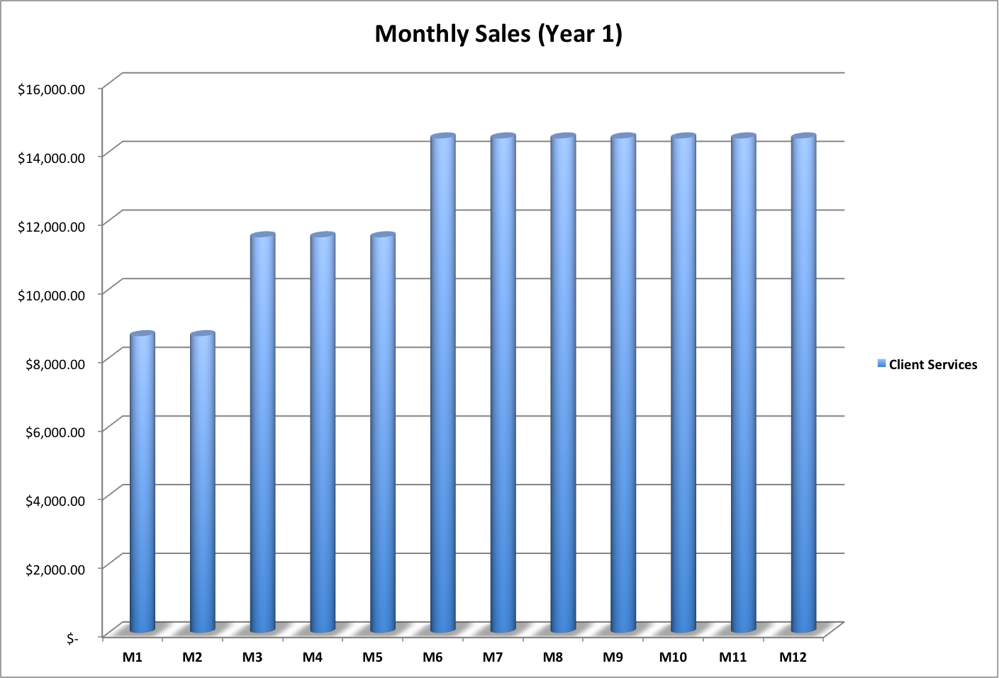
Figure 3: Profit estimations for the first 3 years of business. Year one of operation is based on 2120 UOS; year two of operation is based on 2400 UOS, while year 3 is based on 3120 UOS.

Break-Even Analysis

Breakeven Quantity
- Breakeven = Fixed costs / (price – (variable costs/units of service))
- 1 Unit of Service = 1 visit (for estimation purposes)
- Months 1-2: 3 visits/day x 2 therapists = 120 visits/month = 240 UOS
- Months 3-5: 4 visits/day x 2 therapists = 160 visits/month = 800 UOS
- Months 6-12: 5 visits/day x 2 therapists = 200visits/month = 1360 UOS
- Total UOS / year = 2120
- Average estimated price/visit = $72 (For third party payer fee schedule items assisting in arrival at this estimate, see Appendix C)
- Break-even annually = Total fixed costs/(price per visit/(total variable costs/total annual visits))
- Break-even annually = $144,407.64/ ($72-($5200/2120)) = ~2076 visits/year
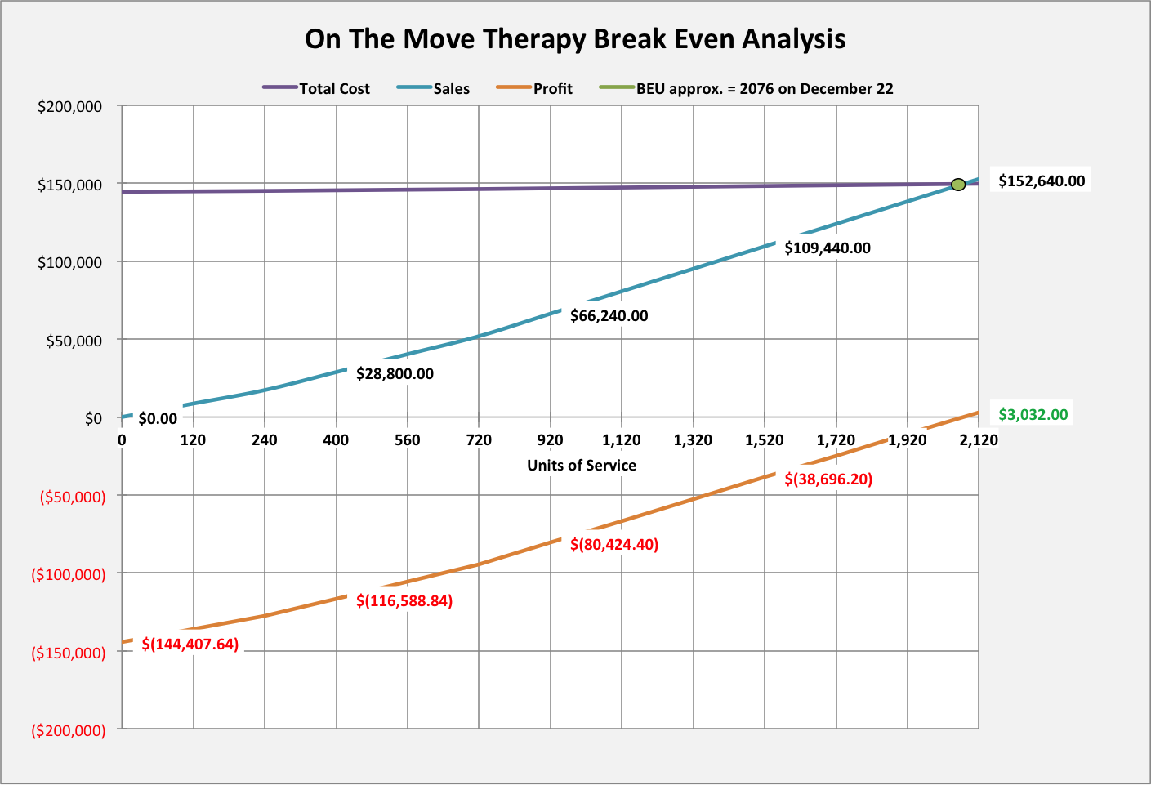
Figure 4: Break-even analysis for year one with projected break-even occurring on December 22 with 2076 UOS.

Annual Revenue Projections
On the Move Physical Therapy LLC anticipates gradual growth in value over the first three years of operation. From first to second year, increased profit will reflect an increased client base as therapists achieve full schedules of patient visits. From second to third year, hiring of a third physical therapy service provider and expanding to set up a treatment office/provide services in one local assisted living community will further increase revenue.
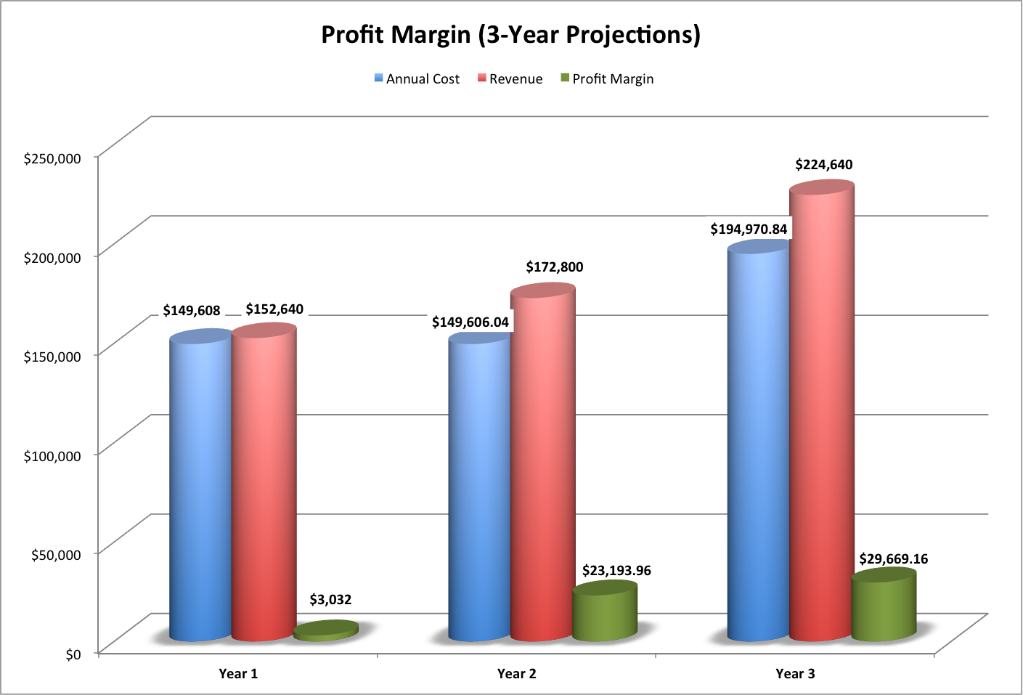
Figure 5: Estimated growth of On the Move in the first three years of operation

Outcomes Assessment Strategies

Clinical Outcomes Assessment Strategies:
- Since all of our services are outpatient, we must include appropriate outcome measures at least at initial evaluation and discharge for report of progress in order to be reimbursed by Medicare. This regulatory policy will assist us in documenting patient improvement through self-report and performance measures.
- Therapists at On the Move are also dedicated to reassessing patient progress at every session through repeated tests and activities followed by precise documentation of results in order to adjust the plan of care as needed on an ongoing basis throughout the course of treatment

Financial Outcomes Assessment Strategies:
- We will utilize Kareo billing system to keep track of revenues, AR, and all business costs
- Each year, we will set in advance our expectations for annual operating income, then break that down to monthly operating income goals and even further to productivity goals for each contributing staff therapist.
- Each month, we will conduct a review of operating income to assess overall practice and individual therapist’s performance in meeting or failing to meet these goals.
- If goals are not met, owners may need to meet with one another or with individual therapists or the whole staff to formulate a plan to address any problems preventing success: for example, a stronger patient cancellation policy or decrease costs through cutting or altering supplies.
- Annually, owners will meet to review profit margin and assess how it met or failed to meet expectations and perform the same types of problem-solving strategies as well as adjusted goal-setting for the next year, including additional hires or staff cuts, etc.

Exit Strategies
These strategies will be formulated through an owners’ operating agreement before we even open the practice. The negotiation of this agreement is the reason why we budgeted legal fees into our capital budget. The three strategies this agreement will include should cover most scenarios and include the following:
- In preparation for the unlikely but possible case of death of one of the partners, each partner in the LLC will purchase a life insurance plan on the other partner.
- In case one partner wishes to leave/quit the business, the other can buy out his/her 50% share.
- In the case of both partners mutually agreeing to dissolve the business, all assets will be sold, the proceeds paid to creditors, and any leftover profits split equally among shareholders.

Appendices

Appendix A: Capital Budget

Purchased Equipment
Hand Weights
3-8 lbs. | 57.06 | xxx
3-24 lbs. (2 each) | 368 | xxx
1-5 lbs. (2 each) | 79.84 | xxx
5 lbs. Ankle Weights (2) | 33.76 | xxx
Stopwatches (2) | 30 | xxx
TheraBand (2 of each) | xxx | xxx
Red, Yellow, Blue Black | 227.1 | xxx
Dynamometer | 170 | xxx
First Aid Kits (2) | 90 | xxx
Pulse Ox (2) | 100 | xxx
Blood Presure Cuffs (2) | 120 | xxx
Treatment Tables (2) | 1000 | xxx
TENS Units (2) | 220 | xxx
Portable US Machine | 95 | xxx
Total Purchased Equipment | xxx | 2590.76
Stationary | xxx | 270
Legal & Accounting | xxx | 3200
Rent | xxx | 0
Other | xxx | xxx
Website | 6.99 | xxx
Chairs (4) | 100 | xxx
Tables (2) | 220 | xxx
Total Other | xxx | 326.99
Total Capital Budget | xxx | 6387.75

Appendix B: Operating Budget
Variable Costs
Office Supplies | 1,200.00 |  | $100/month
Postage | 300.00 |  | $25/month
Advertising | 1,200.00 |  | $100/month
Legal & Accounting | 2,500.00 |  | Varies over the one year period
Total Variable Cost |  | 5,200.00
Fixed Costs
Documentation & Billing | 2,376.00 |  | $99/employee for WebPT-EMR/Kareo--billing integrated system
Website | 83.88 |  | $6.99/month
Salaries | 120,000.00 |  | $60,000 each per year
Liability Insurance | 1,980.00 |  | $990/year per employee for personal liability insurance with HPSO, providing services “off site”
FICA | 9,180.00 |  | 7.65% of salary
Loan Payment | 10,787.76 |  | $898.98/month (Loan for 46,500 on a 5 year repayment plan @ 6% interest www.bankrate.com)
Total Fixed Costs |  | 144,407.64
Total Operating Costs |  | 149,607.64

Appendix C: Price per Visit Estimate--Research & Analysis
We used MPPR Calculator (APTA website) to arrive at these figures. Medicare’s fee schedule serves as our best estimate, and our goal is to remain conservative in estimating overall average reimbursement per patient visit (which will vary between 30 minutes to over an hour if needed for some initial evaluation sessions).
For a typical first visit by patient:
CPT Codes | # Units | Reimbursement/unit
97001 (eval) | 1 | 71.97
97110 (therex) | 1 | 30.69
Total Reimbursement | 2 | $93.57

For a typical 1 hour treatment for impaired balance due to ROM limitations:
CPT Codes | # Units | Reimbursement/unit
97110 (therex) | 2 | 30.69
97112 (NMRE) | 1 | 31.95
97140 (manual) | 1 | 28.74
Total Reimbursement | 4 | $98.38

For a typical 45-minute treatment scenario:
CPT Codes | # Units | Reimbursement/unit
97110 (therex) | 2 | 30.69
97116 (gait) | 1 | 27.09
Total Reimbursement | 3 | $80.38

For a typical 30-minute treatment scenario:
CPT Codes | # Units | Reimbursement/unit
97110 (therex) | 2 | 30.69
Total Reimbursement | 2 | $52.94
Based on these scenarios, we determined a conservative charge for one patient visit (one UOS) to be $72.

