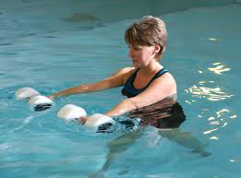

Exploring the Therapeutic Properties of Water & the Treatment of Multiple Impairments and Diagnosis.

Description: The therapeutic properties of water will be explored to better understand why water therapy is more advantageous than land-based therapy for some patients. And evidence based research will be provided on the effectiveness of aquatic therapy for specific conditions like low back pain, osteoarthritis of the knee and hip, etc.
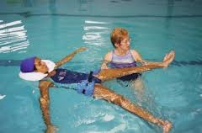
Objectives:
- Identify therapeutic properties of water.
- Identify contraindications and precautions to aquatic therapy.
- Identify patients that may benefit from aquatic therapy.
- Provide current literature on the benefits of aquatic therapy for different impairments and diagnoses.

Date: June 12, 2013
Time: 12-1pm
Presented by: Beverly Knight, SPT

