TUMMY TIME

Created by Jaime Emel, SPT 2013
What is tummy time?
Tummy time is any time during the day when your baby is on his/her belly. Tummy time can be during play on the floor or in your arms for bonding.
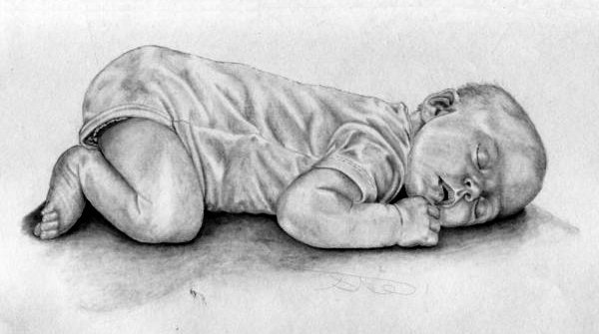
Why tummy time?
- Tummy time strengthens baby’s back and neck muscles
- Tummy time increases baby’s head control
- Tummy time prevents flat spots on baby’s head
- Tummy time helps baby explore
- Tummy time prepares baby for rolling, crawling, sitting and standing

When tummy time?
- Only when baby is awake and alert!
  - Baby should always sleep on his/her back, even during short naps, to prevent Sudden Infant Death Syndrome.
- Start with 1-2 minutes 2-3 times per day and work up to 1 hour spread throughout the day
- When baby can hold up his/her head by their self they should spend half of their awake time on their tummy.

What if my baby doesn’t like tummy time?
- Start slow, just 1-2 minutes at a time
- Place baby’s favorite toy in front of him/her when on tummy

- Lay baby’s tummy on your chest- your baby will like feeling the warmth of your body
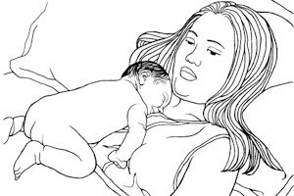
- Place a rolled towel or blanket under baby’s chest for support
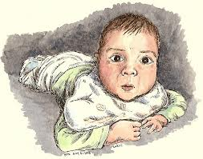

Tummy time ideas
- Story time- read to baby while he/she’s on their tummy, hold the book where baby needs to lift his/her head to see the pictures.
- Keep baby on tummy 2 minutes after every diaper change
- Place baby on tummy with his/her favorite toy within reach
- Hold baby on tummy against your chest every day after bath time

Summary
Tummy time is very important for your baby’s development. It will help him/her gain the strength needed to meet milestones including rolling, sitting and standing. Any time your baby spends on their belly counts as tummy time so it can fit into your daily routine. Remember: Back to sleep, tummy to play!
Positioning For Your Baby’s Development

Created by Jaime Emel, SPT 2013
Positioning:
When babies are born prematurely their muscles are not fully developed and strong. When you position your baby you want him/her to be in the position they would be in the womb. This will help your baby develop like a full term baby.

In the womb:
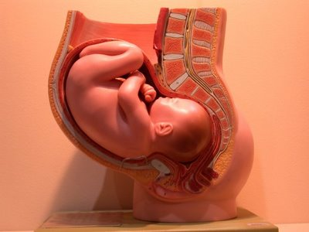
When a baby is developing inside the mother he/she is in the fetal position. In the fetal position the arms and legs are pulled in to the center of the body and the knees, hips, and elbows are flexed or bent. You want your baby to be in this position often and you can help by positioning him/her.

Ways to position
On Belly:
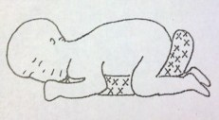
- Hips, knees and elbows flexed or bent and tucked under baby’s body.
- Turn baby’s head to one side (and switch sides every time).
- Place baby’s hand to their mouth.
- Place a pillow or rolled blaket under the center of baby’s chest and belly and out through the legs.
- This position helps baby develop head control and proper flexion.
- Baby should not sleep on belly unless you are watching at all times.
On Back:

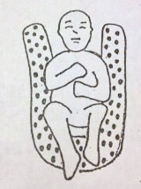

- Knees, hips and elbows flexed or bent with hands close to baby’s body.
- Arms and legs should be symmetrical or even and baby’s head should be in the center also called “midline.”
- Can also turn baby’s head right and left in this position to avoid flat spots
- Place a rolled blanket in a “U” shape under baby’s shoulders and knees for support.
- This position helps baby learn flexion and to bring his/her hands together.

On Right or Left Side:

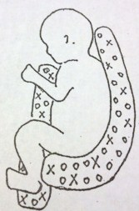

- Hips and knees flexed or bent with arms and shoulders forward.
- Baby’s head should be lined up in the center of his/her body.
- Place a rolled blanket behind baby’s back and bottom and another one between baby’s legs up to his/her chest with the top arm hugging the pillow.
- This position helps baby learn flexion and bringing his/her hand to mouth.

Positioning Tips
It is important for your baby to change positions throughout the day to strengthen every muscle equally. You can help your baby by changing positions during daily activies like carrying, diaper changes, and feeding. Limit the time your baby spends in swings, exersaucers, bouncy seats, jumpers and infant carriers. Baby should spend most of his/her time on the floor working to move their body against gravity to strengthen muscles.
Carrying positions:
- Change the hip you carry baby on and have him/her look, turn and balance in both directions.
- Carry baby over your shoulder and switch shoulders often.
- Hold baby facing away from you and allow him/her to look in both directions.

Diaper change positions:
- Change which end baby’s head is on the changing table each diaper change.
- Roll baby from side to side as you fasten the diaper.
- After changing roll baby onto his/her tummy for supervised tummy time.

Feeding positions:
- Change the arm you hold baby with for each feeding.

- Feed baby on your lap; bend your knees and place baby on your thighs facing you for a bottle. (see picture)

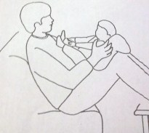

- Place baby on their belly on your lap for burping.
- When baby is ready to eat with a spoon, spoon feed baby with the spoon coming from the center and both directions to get him/her to turn their head.

