Shoulder Warm Up Routine

Do this routine before playing sports or exercising.

Shoulder Rolls (10 forward/10 backward on each arm)
Roll the shoulders down and back, starting with small circles and working up to larger circles. Do 10 circles backwards and then repeat forward circles.
Repeat with arms out to the sides (10 forward/10 backward on each arm)
Start with small circles and get bigger with each rotation.
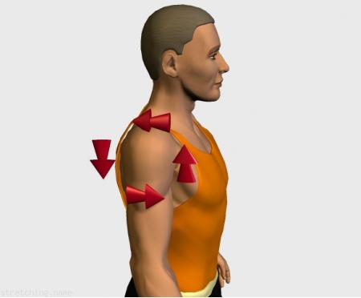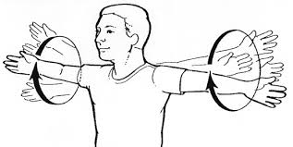

Wall Chest Stretch (30 sec x 2 on each arm)
Stretch your chest muscles by placing one hand on a wall corner and turning away from it until you feel a moderate stretch or your elbow is in line with or slightly behind your shoulders. Make sure that your shoulders do not roll forward or rise up toward your ears.
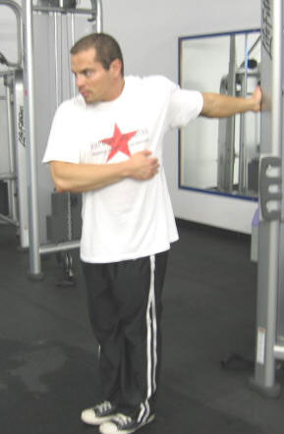 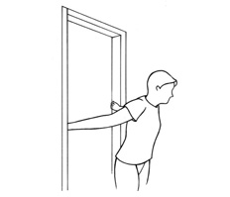

Dynamic Neck Stretch (10 reps on each side)
Turn your chin to the right and toward your chest. Place right hand on the head and gently press your head into the hand, then release and stretch. Continue to contract neck and press the head into hand. 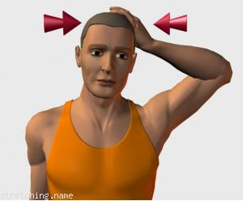
Seated Trapezius Stretch (Hold 30 seconds, twice on each side)  1. Reach the left arm down and away from the body as you drop the right ear to the right shoulder.  2. Place your right hand over the top of your head, and gently pull your head down toward the right (photo). You will feel a stretch in your left trapezius, and if you touch the left side of your neck with your left hand, you will feel the tight muscle being stretched.  3. Switch chin direction to the left. Place your left hand over the top of your head, and gently pull down to stretch your right side. | Seated trapezius stretch

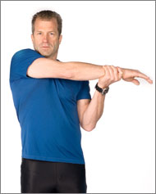  Shoulder stretch | Shoulder Stretch (Hold 30 seconds, twice on each side)  1. Stand with your feet shoulder width apart.  2. Raise your right arm up to shoulder height, and move it across the front of your body.  3. With your left arm, pull the right arm as close to your chest as possible, and hold it for 30 seconds (photo). You should feel the stretch across the back of your shoulder. Repeat, then switch to the left side.

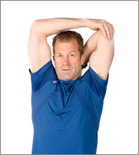  Triceps stretch | Triceps Stretch (Hold 30 seconds, twice on each side)  1. With your feet shoulder width apart, raise your right arm straight up and over your head.  2. Bend your elbow so that your right hand is reaching for your left shoulder.  3. Use your left hand to press back on your right elbow (photo). You will feel a great stretch in the back of your arm and upper shoulder. Repeat, then switch to the left side.

