Ryan Rubio
PHYT875 – Final Paper
COMMON MUSCULOSKELETAL MARTIAL ARTS INJURIES
INTRODUCTION
Practicing a form of martial art is a popular sporting activity, especially among young people. Participation has grown rapidly since the 1980s, and millions of Americans are currently involved in one of the many styles practiced today.¹ While the majority of martial artists are men, increasing numbers of women are now participating in order to maintain fitness and gain self-defense skills.¹ Martial arts are often recommended to provide children with discipline, focus, and self-confidence, but people of all ages can enjoy those benefits in addition to the sport’s ability to improve cardiovascular fitness, balance, strength, flexibility, and coordination.
There are many styles of martial arts, and most of them involve upper extremity blocking and striking techniques, kicking, grappling, and sparring. The focus of this sport should never be to cause harm to others, but since there is a combative element to martial arts, the risk for injuries is high. The purpose of this paper is to identify common musculoskeletal injuries that occur in martial arts practice, describe the mechanisms of those injuries, and provide suggestions on how to reduce the risk of suffering them.
MARTIAL ARTS STYLES
There are many styles of martial arts practiced in the United States. Differences in these forms can include a preference for joint-locking over striking attacks, or how much (if any) time is spent training with weapons. Some schools require the use of pads when sparring, while others may not allow for contact to be made at all. Needless to say, there are a multitude of factors that determine the risk of injury when practicing martial arts, and one of them is the type of techniques that an individual style focuses on.
When it comes to selecting a martial arts school, there is a wide array of styles to choose from. Some instructors combine elements of various styles to create their own eclectic form of martial arts. Some of the more common styles include:
- Karate: This means “empty hand,” and it is a traditional Japanese form that is normally practiced without weapons.²
- Tae kwon do means “the way of foot and fist.” It is a traditional Korean martial art that is one of the most commonly practiced styles. This form highlights discipline, respect, and personal growth and focuses on kicking techniques.²
- Judo means “gentle way” and is known for a variety of throwing techniques. In many ways it is more similar to wrestling than to the other martial arts.²
- Kung fu most commonly translates to “hard work” and is one of the oldest forms, and the term has come to be used to describe all of the hundreds of Chinese martial arts. Kung fu is mainly known for its powerful blocks.²
- Aikido means “way of harmony.” This Japanese martial art teaches a nonaggressive approach to self-defense, focusing on joint locks, throws, and restraining techniques. Aikido is especially popular among women and older adults.²
- Jujitsu means “the art of softness” and was first practiced in Japan. This style emphasizes techniques that allow a smaller fighter to overcome a bigger, stronger opponent, focusing on ground fighting and grappling. Many of the other martial arts styles have incorporated some of its techniques, some of which are used in law enforcement training across the globe.²
WHO TENDS TO GET HURT?
Research has been unable to consistently identify who is at the most risk for injury. Past studies have shown that men have a higher injury rate than women, but it should be noted that the number of women who practice martial arts has greatly increased over the last two decades.¹ A literature review on pediatric martial arts injuries published by Pieter in 2005 demonstrated that while the absolute number of injuries in girls is lower than in boys, when expressed relative to exposure, the injury rates of girls are higher.³ More current literature does not show any major detectable difference in injury rates between male and females.¹
There has also been mixed evidence when analyzing the effects of age on risk for injury. Zetaruk et al cite studies that show that both adult practitioners and younger participants under the age of 18 are at an increased risk of injury.¹ These conflicting results lead Zetaruk et al to suggest that it is a combination of age and experience level that is truly the determining factor.¹ They believe that the lower risk among less experienced youths may be explained by their lower body mass and strength, as well as less technical ability, which causes them to be unable to generate the same level of force that older, more experienced martial artists do. Pieter also concluded from a literature review that pediatric injury risk factors in martial arts include age, body weight and time spent in practice.³
Pieter also found that in pediatric practitioners, the tendency of an injury to a body region is reflected in the techniques of the specific martial art.³ In judo, the upper extremities tend to get injured more often while being thrown, karate punches tend to injure the head and face, and roundhouse kicks performed in Tae kwon do result in injury to the lower extremities.³
In 2009 Kazemi et al published a nine year retrospective longitudinal study on the injuries to Tae kwon do practitioners during competition. The authors found that those more likely to be injured tend to be younger than 18 years, and that the most prominent areas of injury were to the head, foot, and thigh.⁴ Zetaruk et al found that most Karate, Tae kwon do, and Kung fu injuries occurred in the lower extremities, and most Aikido injuries occurred in the upper extremity.¹ Aikido’s emphasis on joint techniques, which place the joints in extremes of range of motion, tends to cause injuries to muscle-tendon units and ligaments of the upper extremity.¹
Yard et al reviewed the pediatric martial arts injuries that presented to the emergency department between the years of 1990 and 2003. They used data information captured by the US Consumer Product Safety Commission's (CPSC) National Electronic Injury Surveillance System (NEISS). Out of an estimated 128,400 subjects, the authors found that the majority of injuries occurred to the lower leg/foot/ankle (30.1%) and hand/wrist (24.5%), with the most common diagnoses being sprains/strains (29.3%), contusions/abrasions (27.8%), and fractures (24.6%).⁵ Participants in judo sustained significantly higher proportions of shoulder/upper arm and neck injuries than karate or taekwondo participants.⁵
COMMON INJURIES

Some schools practice non-contact forms of martial arts, such as the Uechi-Ryu style, which understandably produce very few injuries.³ However, this practice is rare, and physical contact is an integral part of most martial arts styles. Many injuries occur during competition, which typically consist of point-based sparring matches, demonstrations of self-defense techniques, and the breaking of boards or bricks. While the use of gloves, footpads, and headgear can reduce the risk of injury, they cannot guarantee prevention. Injuries can include abrasions, concussions, and fractures, but most are not that severe. This section will focus on common non-serious musculoskeletal injuries resulting from martial arts practice and the steps that can be taken to prevent and rehabilitate them.

Hand and Foot Injuries

Proper form is crucial to preventing wrist, finger, and toe injuries, which can range from jams and sprains to fractures. With proper kicking technique, contact with the target is made with the heel, ball, or top of the foot (Figure 1). When punching, thumbs should not be curled under the fingers, the wrist should be in a neutral alignment, and fingers should be curled into a tight fist (Figure 2). The point of contact of a punch should be with the first two metacarpal-phalangeal (MCP) joints to avoid sustaining what is called “the boxer's fracture,” which is an injury to the fourth and/or fifth metacarpal bones. Signs and symptoms include swelling and pain on the backside of the hand and the fingers appearing to be twisted at the joint.⁶ Bruising to the fingers and the hand may also occur.⁶
If one of these injuries is sustained, first treat them by applying the RICE (Rest, Ice, Compression, Elevation) method and with the use of non-steroidal anti-inflammatory drugs (NSAIDs). If pain and swelling do not resolve after a few days, consult a physician. If a physician determines there is a fracture, the hand will be splinted for approximately four weeks after which range of motion exercises will be prescribed to facilitate healing.⁶
Prevention of these injuries depends on having proper technique. While the student needs to be aware of his/her form, it is the responsibility of the martial arts instructors to teach students the proper method for striking and kicking. To prevent recurrence of injuries to the hand, foot, and digits, modifying the behaviors of students so that they break any bad habits is required.^{2, 6}

Rotator Cuff Strain/Tear
Injury to the rotator cuff muscles occurs when the shoulder joint is twisted and pulled, which can easily occur from joint-locking techniques or take-downs.⁶ Signs and symptoms can include tenderness in the front of the shoulder, below the edge of the collarbone, or along the scapula.⁶ Also, pain will be felt while rotating and lifting the arm simultaneously.⁶
Follow the RICE method for the immediate care. Since it is easy to confuse an injury to the deltoid with one to the rotator cuff seek the care of a physician. Preventative and rehabilitative measures for this injury involve stretching the chest and the shoulder thoroughly prior to activity.⁶ The chest musculature can be stretched across a doorway, and the shoulder can be stretched across the body and by internally rotating the shoulder while in a side-lying position (Figure 3).

Patellar Tendonitis

Kicking is a critical aspect of martial arts training, and as a result lots of stress is placed on the knee. In basic kicks the leg starts in a chambered position, extends to strike, and then recoils back into the chamber. With roundhouse and front kicks, the knee is aimed at the target when the leg is in the chambered position (Figure 4). If a practitioner does not utilize correct form and begins knee extension before properly aiming, he can hyperextend the knee when trying to hit the target. These poor mechanics can lead to tendonitis and other chronic pains. Weak quadriceps can make it even more difficult to have proper mechanics, causing the joint to “pop out” into extension.⁸ Hyperextension of the knee causes strain to the posterior capsule of the joint, the patellar tendons, as well as compression of the patella, typically resulting in anterior knee pain.⁷
The RICE method is typically the most effective method of immediate care. If pain and swelling does not resolve, a physician should be consulted.⁸ Preventative strategies include proper stretching of the quadriceps and hamstring muscles prior to activity (Figure 5), and exercises such as squats to strengthen the quadriceps and stabilize the knee joint.⁸ During both recovery and regular training, kicks should be practiced at a slower speed in order to reduce stress on the joint and to focus on improving technique.⁸

Iliotibial (IT) Band Strain
IT band strains commonly result from a lack of pivoting on the stance leg during certain kicking techniques.⁸ Pivoting so that the foot of the stance leg faces away from the target gives the martial artist better range and support for the leg.⁸ If the rest of the body is not positioned to help support the leg in space, the IT band has to do more work to hold the leg up (Figure 6). Strain to the IT band can cause sharp pain in the lateral knee or hip, swelling at the lateral knee, and continuous pain following activity.⁹
Again, the RICE method should be followed for immediate care. To reduce the risk of injury, the IT Band needs to be properly stretched prior to activity (Figure 7).⁸ When rehabilitating the band, a foam roller can be used to break up any adhesions.⁸ Martial artists can benefit from core and hip strengthening exercises, which will allow the body to be stable while the arms and legs perform martial arts techniques.⁸ The prevention of this injury, as well as its recurrence, is dependent upon learning proper technique. Attention needs to be paid by the instructor as well as the student to the mechanics of the various kicking techniques in order to make the necessary corrections.
Hamstring Strain
Lower extremity muscle strains usually happen in the quadriceps or the hamstrings as a result of either kicking too high, landing awkwardly after a jump, or improper contact with a partner.² Front kicks, especially ones that are targeted above the waist, put a lot of stress on the hamstring muscles. Symptoms of a hamstring strain are a feeling of pain and/or tightness in the back of the thigh and lower buttock.⁸ These injuries are often overlooked as normal onset muscle soreness from a tough workout.⁸
Treatment should consist of the RICE method and consulting with a physician to determine the grade of strain and to prescribe the proper level of therapy. An injury to these muscles most often occurs from an improper warm-up. Ideally, a warm-up routine would consist of dynamic stretching and deep static stretching. Prior to activity a thorough warm-up should be performed.⁸ Stretching and strengthening of the muscles should progress at a slow rate, and should not produce painful symptoms.⁸

Ankle Sprain
The ankle sprain is a common injury in all sports, but the typical lack of supportive footwear in martial arts training frequently places the practitioner's ankle in a susceptible position. This injury is commonly acquired while sparring or during calisthenics, which require fast-paced footwork that can result in the “rolling in” motion that stresses the ligaments of the joint.⁸ Signs and symptoms of an ankle sprain can include swelling surrounding the lateral malleolus, some discoloration and loss of motion.⁸
As with hamstring strains, follow the RICE method and seek the care of a physician if the symptoms do not resolve so that the grade of sprain can be determined and the proper therapy can be prescribed. To rehabilitate and prevent future injury, strengthening of the lower leg musculature and the ankle wall should be carried out. These exercises can consist of calf raises and maintaining single-leg balance on increasingly unstable surfaces, such as a foam mat or a rocker board.

GENERAL SAFETY PREVENTION
In addition to the preventative/rehabilitation techniques mentioned, there are some general precautions that all martial arts instructors and students should take note of. All equipment, such as headgear, gloves, and foot pads should be regularly checked to make sure that they fit properly and are well maintained.² The environment should be investigated to verify that it is safe to practice in, as gaps between mats can cause sprained ankles and wet floors can cause slips and falls.²
Some precautions can be taken before martial arts training actually begins. These safety measures will be especially helpful for adults, as they can help to reduce the risk of overall injury that can occur when engaging in strenuous physical activity.
- Physical examination. This is required in almost all high school and college sports; however, community sports and martial arts tend not to require such documentation. A primary care doctor can carry out or recommend specialist consults for any cardiovascular, neurologic, or musculoskeletal examinations that should be carried out before any training has begun.¹⁰
- Maintain fitness. Being in good physical condition is advisable when you begin martial arts training. Many people participate in martial arts to improve their overall fitness, but they need to be careful because fatigue during training and competition often leads to poor technique and injury. Practitioners should not perform martial arts activities if they are too tired to do it safely. Activities such as running, jumping rope, biking, and swimming are good cardiovascular activities that can be done in conjunction with martial arts training that can help improve fitness level. Any martial arts practitioner should feel comfortable speaking with his/her instructor about any concerns regarding safety and fitness capability.¹⁰
- Warm up. This should always be done prior to class or before individual practice. If an instructor does not take the time to do this, then it needs to be addressed immediately.¹⁰
- Cool down and stretch. Stretching at the end of exercise is too often neglected but it can help reduce muscle soreness and keep muscles long and flexible. Stretching after each training session can reduce your risk for injury.¹⁰
- Hydrate. Even mild levels of dehydration can hurt athletic performance. If you have not had enough fluids, your body will not be able to effectively cool itself through sweat and evaporation.¹⁰
CONCLUSIONS
As with any sport or physical activity, the risk of injury in martial arts practice is unavoidable, but with the proper attention and preventative steps, these risks can be greatly reduced. Safe participation in martial arts can offer individuals a wide array of both physical and mental health benefits. It is a sport that can be practiced throughout the life span by people of all ages. Children can stay active while learning discipline and focus, and adults can preserve functional ability as they age by improving or maintaining their balance and flexibility. Participation in martial arts is an activity where the potential rewards outweigh the risks.

Reference Images
FIGURE 1:
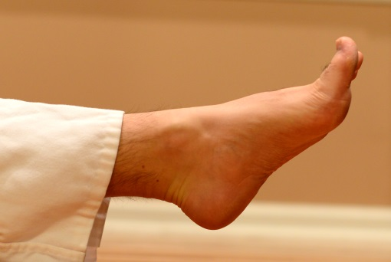
1a) This is the correct foot position when striking with a front kick. The ball of the foot should be the point of contact.
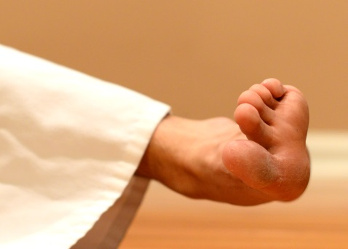
1b) This is the correct foot position when striking with a roundhouse kick. The toes are extended so that the ball of the foot is the point of contact.
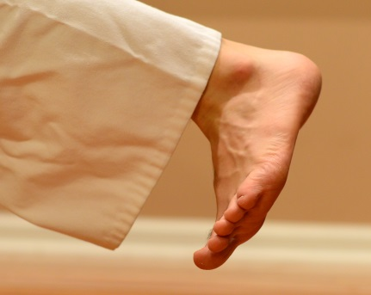
1c) This is the correct foot position when striking with a thrust sidekick. The ankle is dorsiflexed so that the heel is the point of contact.
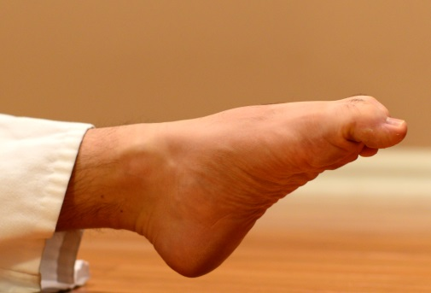
1d) This is the incorrect foot position when striking with a front kick. The curled toes can be jammed or fractures upon contact.
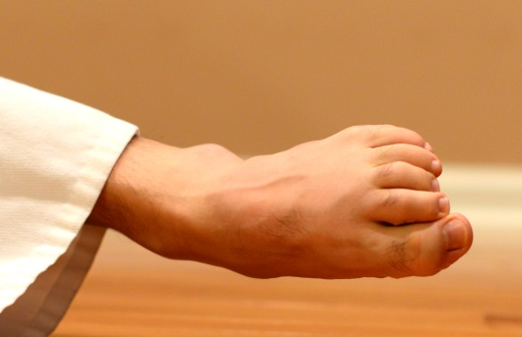
1e) This is the incorrect foot position when striking with a roundhouse kick. The curled toes can be jammed or fractures upon contact.

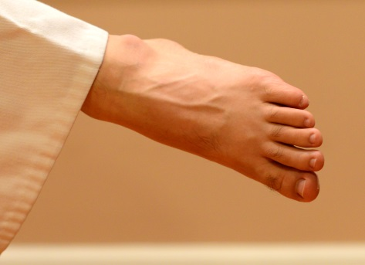
1f) This is the incorrect foot position when striking with a thrust sidekick. Not only will the kick lack force, but the ankle is in a loose packed position and more vulnerable to injury.

FIGURE 2:
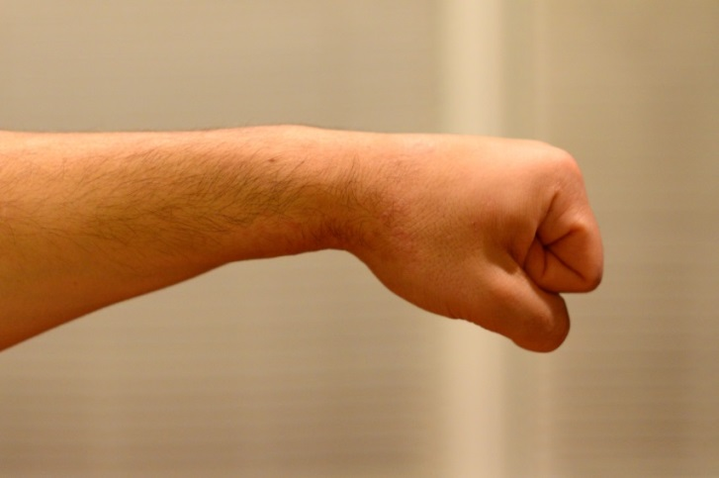
2a) This is the correct technique for a straight punch. The wrist is in a neutral alignment, the fingers are curled into the palm and the thumb is over top of them.
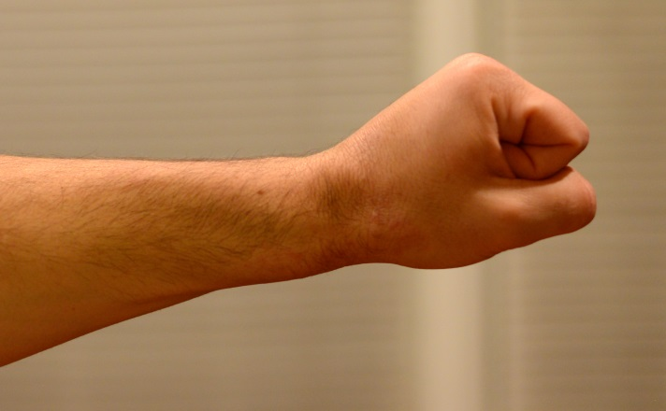
2b) This wrist is excessively extended, and damage to the wrist and/or fingers could occur upon contact.
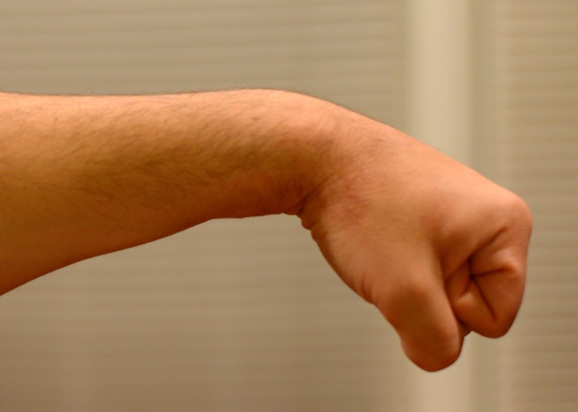
2c) This wrist is excessively flexed, and damage to the wrist and/or fingers could occur upon contact.

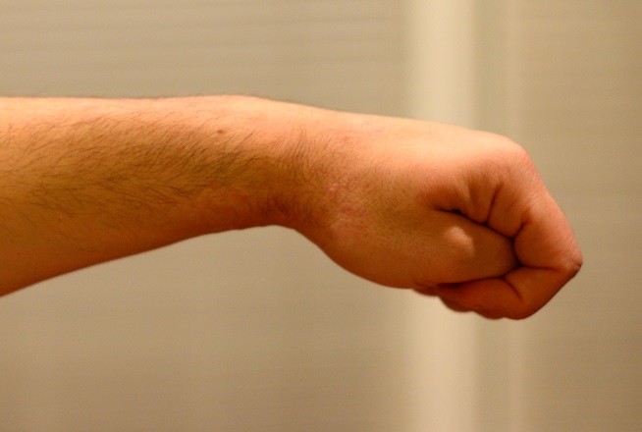
2d) The thumb is more prone to injury when it is flexed across the palm during striking.
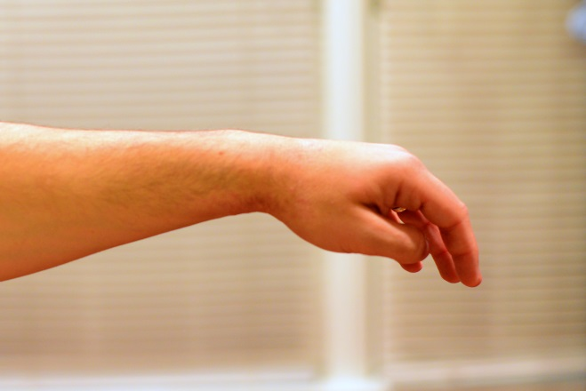
2e) The fingers are more prone to jamming or fracturing if they are extended or only loosely flexed when the punch contacts its target.

FIGURE 3:
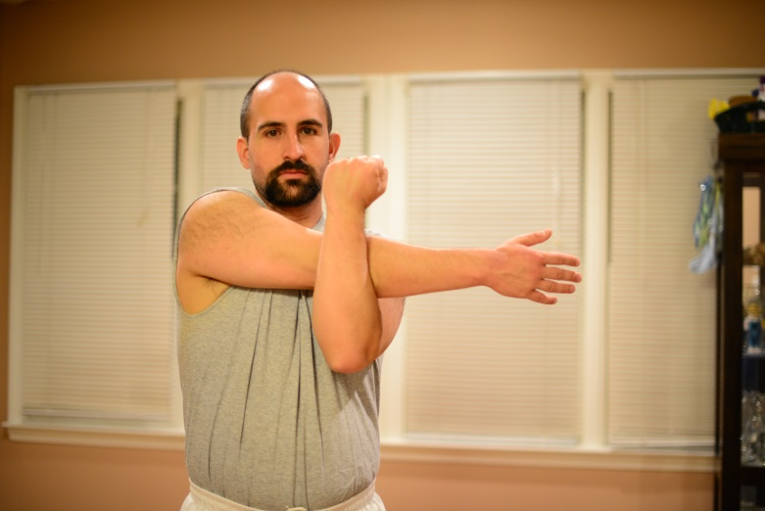
3a) This is a basic stretch for the rotator cuff musculature.
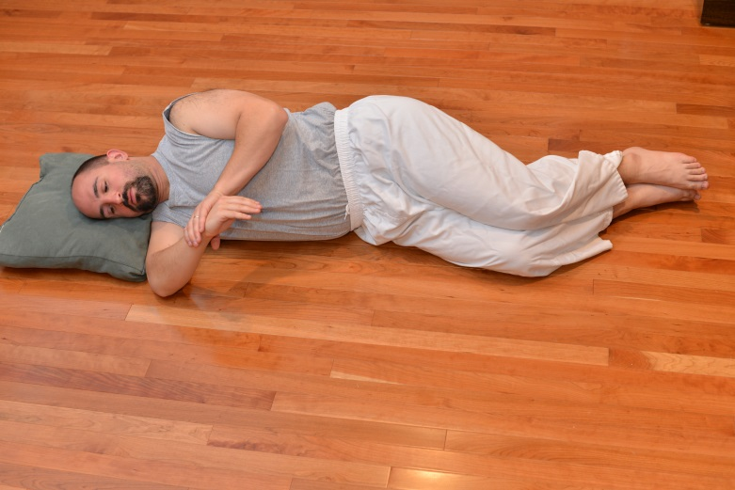
3b) This stretch targets the external rotators of the rotator cuff. In sidelying, flex the shoulder and elbow of the arm closest to the floor to 90 degrees. Keep the forearm pronated and with the opposite hand apply pressure to internally rotate the shoulder.
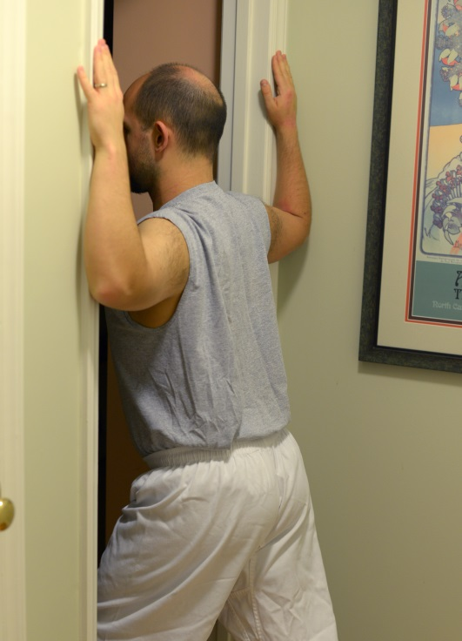
3c) This stretch targets the chest musculature. When performing this stretch, do not extend at the lumbar or thoracic spine.
FIGURE 4:
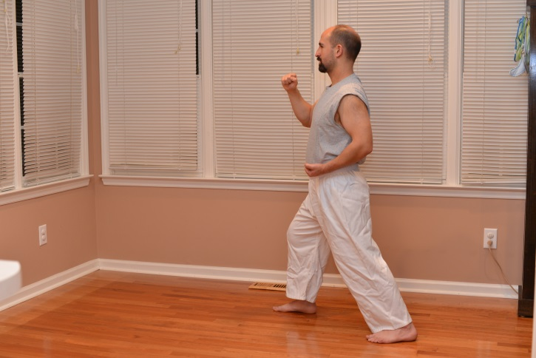
4a) Front stance.
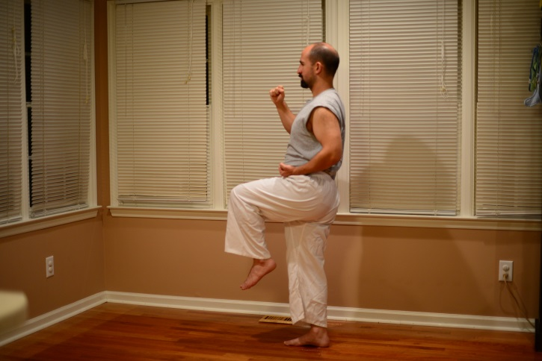
4b) Chambered position of the front kick.
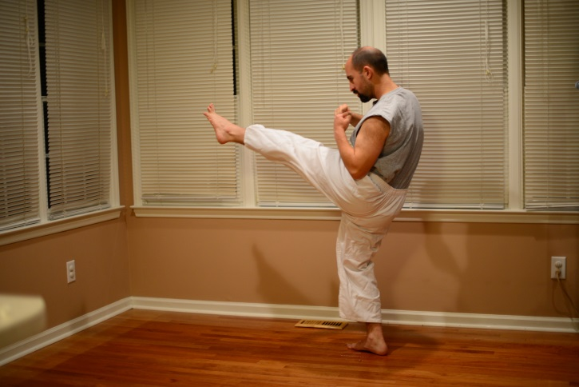
4c) Extended position of the front kick.

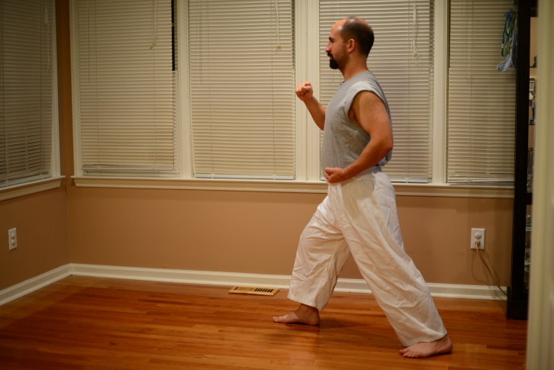
4d) Front stance.
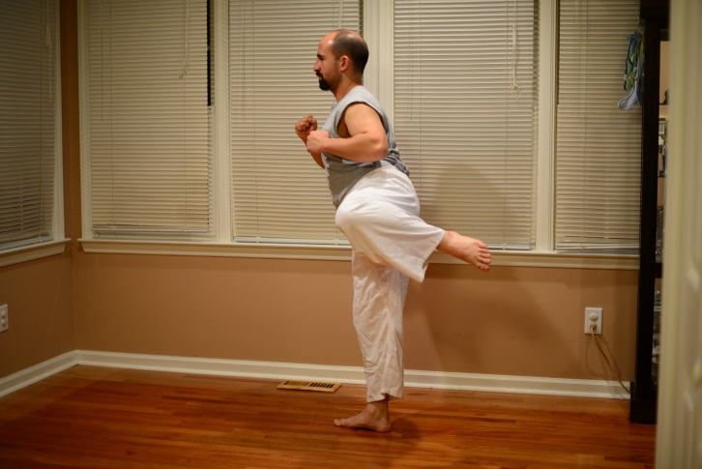
4e) Chambered position of the roundhouse kick.
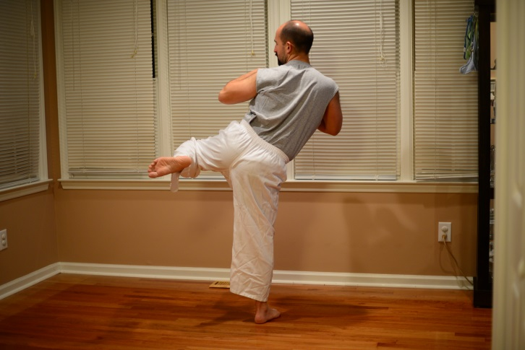
4f) Stance leg pivots 90 degrees.
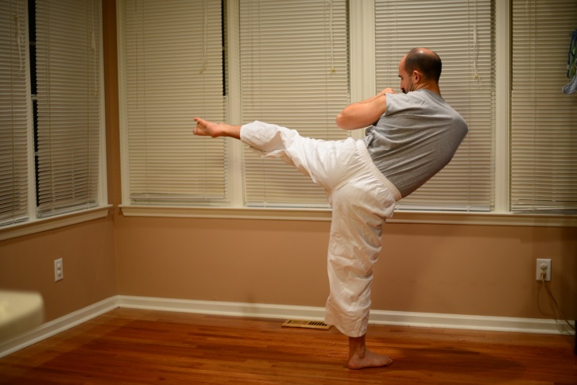
4g) Extended position of the roundhouse kick (posterior view).
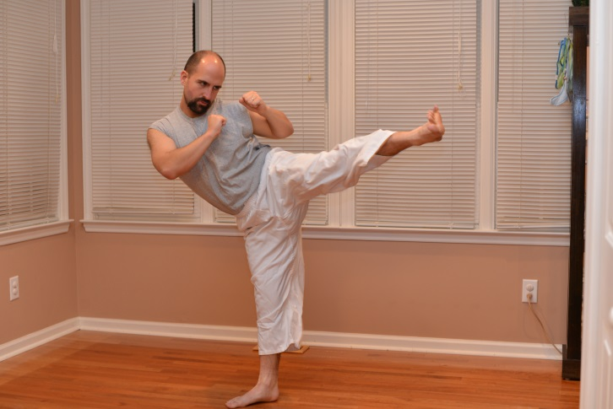
4h) Extended position of the roundhouse kick (anterior view).

FIGURE 5:
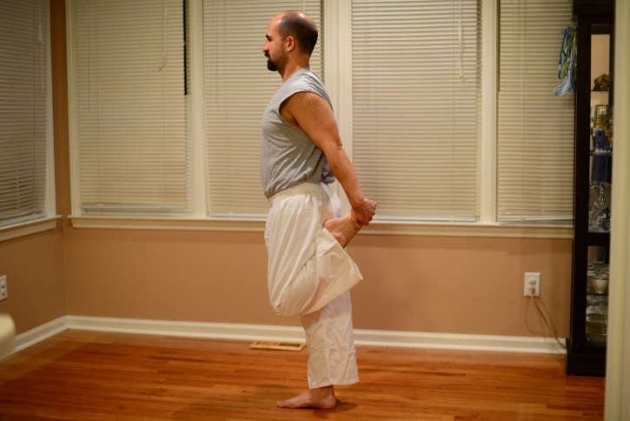
5a) Quadriceps stretch.
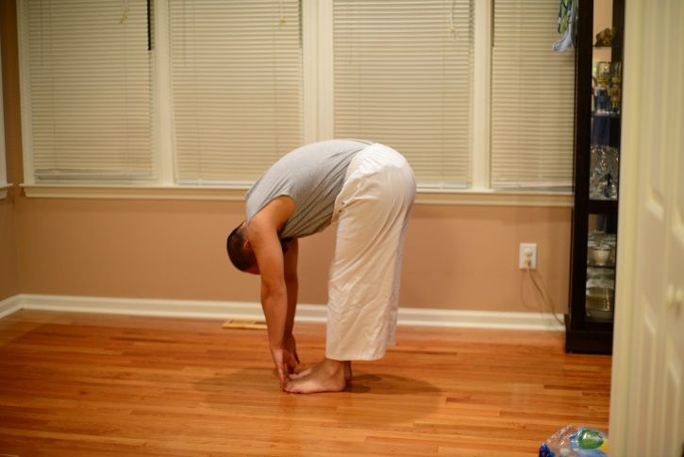
5b) Touching fingers to toes while keeping knees extended will stretch the hamstring muscles.
5c) Reaching for the toes while keeping the knee extended in a seated position stretches the hamstring muscles.

FIGURE 6:
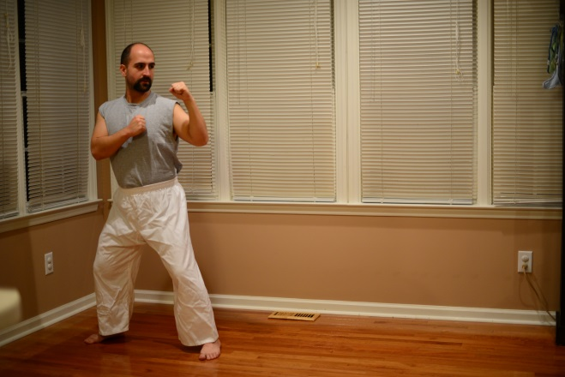
6a) Side stance.
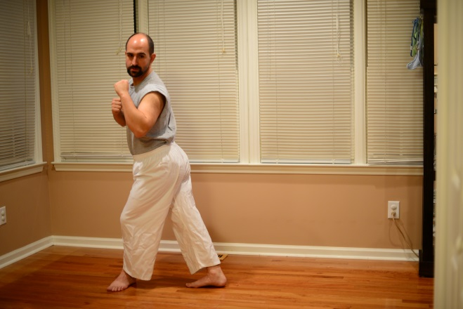
6b) The back leg moves forward with the heel pointing towards the target.
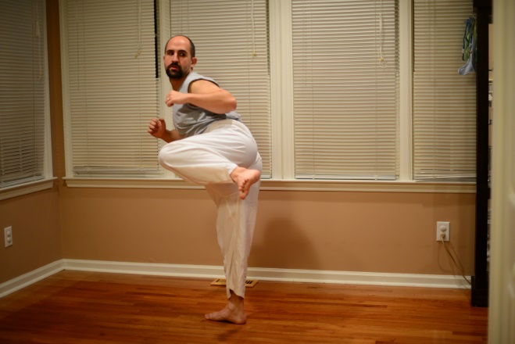
6c) Kicking leg is in the chambered position.
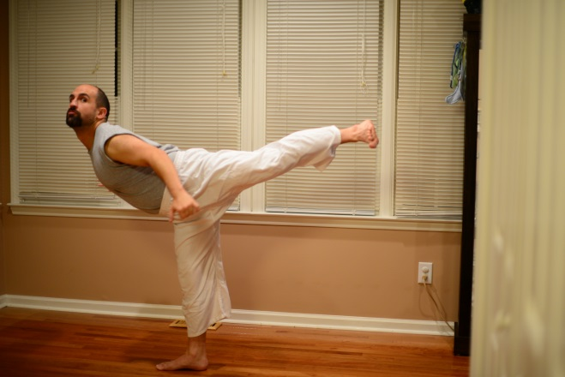
6d) Kicking leg is in the extended position. The trunk moves in the opposite direction of the kick. The stance leg remains pointed away from the target.
FIGURE 7:
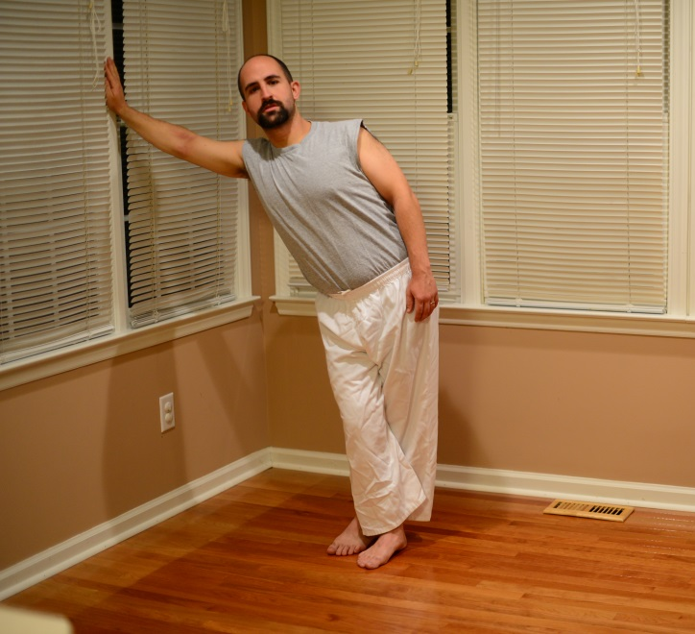
IT band stretch (this position stretches the left IT band).

References:
- Zetaruk MN, Violán MA, Zurakowski D, Micheli LJ. Injuries in martial arts: a comparison of five styles. Br J Sports Med. 2005 Jan;39(1):29-33. PubMed PMID: 15618336; PubMed Central PMCID: PMC1725005.
- Healthy Children.org. Healthy Living: Martial Arts. Available at: http://www.healthychildren.org/English/healthy-living/sports/Pages/Martial-Arts.aspx. Accessed November 22, 2013.
- Pieter W. Martial arts injuries. Med Sport Sci. 2005;48:59-73. Review. PubMed PMID: 16247253
- Kazemi M, Chudolinski A, Turgeon M, Simon A, Ho E, Coombe L. Nine year longitudinal retrospective study of Taekwondo injuries. J Can Chiropr Assoc. 2009 Dec;53(4):272-81. PubMed PMID: 20037692; PubMed Central PMCID: PMC2796946.
- Yard EE, Knox CL, Smith GA, Comstock RD. Pediatric martial arts injuries presenting to Emergency Departments, United States 1990-2003. J Sci Med Sport. 2007 Aug;10(4):219-26. Epub 2006 Aug 17. PubMed PMID: 16914371.
- Ogren, KR. POW! Mixed Martial Arts and Fitness. Common Injuries in the Martial Arts Part I: The Upper Body. Available at: http://www.chicagonow.com/pow-mixed-martial-arts/2009/07/common-injuries-in-the-martial-arts-part-i-upper-body/. Accessed November 22, 2013.
- Houston Methodist Orthopedics and Sports Medicine. A Patient’s Guide to Patellar Tendonitis. Available at: http://www.methodistorthopedics.com/patellar-tendonitis. Accessed December 2, 2013.
- Ogren, KR. POW! Mixed Martial Arts and Fitness. Common Injuries in the Martial Arts Part II: The Lower Body. Available at: http://www.chicagonow.com/pow-mixed-martial-arts/2009/07/common-injuries-in-the-martial-arts-part-ii-lower-body/. Accessed November 22, 2013.
- Move Forward. Physical Therapist’s Guide to Iliotibial Band Syndrome (ITBS). Available at: http://www.moveforwardpt.com/symptomsconditionsdetail.aspx?cid=089d992a-4c46-4fe0-9fbd-52069837345a. Accessed December 2, 2013.
- American Academy of Orthopaedic Surgeons. Martial Arts Injury Prevention. Available at: http://orthoinfo.aaos.org/topic.cfm?topic=A00681. Accessed December 2, 2013.

