Overhead Athletes and Their Hips: Femoral Acetabular Impingement, Hip Pathomechanics and The Kinetic Chain
It is extensively understood that the overhead athlete is at risk and prone to dominant upper extremity injury involving the shoulder and elbow.¹ Approximately 58% of all baseball related injuries and 75% of the total time away from sport are due to injuries in the upper extremity.⁶ However, these injuries can originate from dysfunction away from the injury site. Deficits and restrictions associated to the hip and pelvic girdle can cause increased stress and loading to other anatomical joints involved in the overhead activity.^{2,3} While these upper limb injuries may be more common and garner more attention, the mechanics related to overhead athletics can also predispose an athlete to hip injury.¹ Overhead movements, such as pitching or serving, involve complex and coordinated dynamic activity that require the entire body to work as a single unit.^{2,4} Forces and energy are produced and transferred by and through all the body segments to the distal terminal link of the dominant arm.⁴ Thus, just as repetitive overhead activity can cause excessive loading to the shoulder or elbow links, continual forceful hip rotation, which is also present during this motion, can create hip pathology.¹ To that end, pathologic stress to the trunk, shoulder, elbow and other anatomical links, may derive from the hip secondary to altered hip mechanics and/or insufficiencies.¹ It is critical for a sports medicine professional to understand the normal mechanics associated to the athlete’s specific overhead movement in order to effectively evaluate and assess potential pathomechanics causing or contributing to the injury.⁴ Moreover, the high demands placed on the hip as well as the essential function of this joint throughout the multidimensional overhead motion should be considered during clinical evaluation and intervention planning in order to permit efficient kinetic chain function.^{4,5}

The Kinetic Chain System:
The dominant upper-extremity is of obvious importance during overhead athletics. However, for most of these activities, “link sequencing” – the proximal-to-distal- sequencing of velocity, energy, and forces that allows the most appropriate shoulder function – starts at the ground.⁵ These individual “body links” are coordinated in their movements by muscle activity and body positions to generate and transfer force through these segments to the terminal link of the dominant upper extremity. This sequencing is usually termed the ‘kinetic chain.’⁵ The largest proportion of kinetic energy and force in this sequencing is derived from the larger proximal body segments.^{4,5} Studies have shown that 51% of the total kinetic energy and 54% of the total force generated in the tennis serve are created by the lower legs, hip, and trunk.^{4,5}
The energy that is generated in the proximal segments have to be transferred efficiently and must be regulated as they go through the funnel of the shoulder, the scapula.⁵ If the scapula does become deficient in motion or position, transmission of the large generated forces from the lower extremity to the upper extremity is impaired.⁵ Kibler et al, have developed a calculation that has shown that a 20% decrease in kinetic energy delivered from the hip and trunk to the arm necessitates an 80% increase in mass or a 34% increase in rotational velocity at the shoulder to deliver the same amount of resultant force to the hand.⁵ It should be stressed that sports medicine professionals design and develop conditioning programs, that are sport-specfic, as well as in the context of the kinetic chain, targeting all the segments of the body, including the legs and hips as well as the core musculature, to avoid injury and improve performance.
A deficiency in one of these links can cause an alteration or abnormal movement patterns throughout the whole unit.⁴ This change has been termed the “catch-up phenomenon,” where a deficit or altered motion in one segment can disrupt the entire sequencing and subsequent transfer of forces and energy.^{4,5} Scher and colleagues have demonstrated a decrease in a pitcher’s nondominant hip may increase the demands of the decelerating the body from the hip to the shoulder.² Under these circumstances, there would be a reduction in force through the larger trunk musculature and an increase in force through the shoulder, potentially increasing the risk for shoulder injury.² Similarly, overhead throwers tend to compensate for a decrease in dominant hip extension by increasing dominant shoulder external rotation in order to generate high ball velocities or throw long distances.² This compensation for restricted hip flexibility can increase soft tissue forces and loading at the shoulder and/or elbow.² This demonstrates the relationship and interaction present between hip and shoulder function during overhead activity. Clinicians can and should use this information to design sport-specific conditioning programs for their athletes. Exercises to improve hip flexibility as well as strength of the dominant hip flexors and extensors and nondominant hip external and internal rotators should be incorporated into an overhead athletes regimen to potentially prevent injury and enhance performance.²
Kinetic Chain Clinical Relevance to Overhead Athletes:
A better understanding of kinetic chain mechanics and their association to force and load throughout the musculoskeletal tissue can allow health professionals deisgn more effective injury prevention, treatment and rehab programs and perhaps improve performance as well.^{4,5} Additional research is necessary to evaluate the efficacy of exercises and theory surrounding training and conditioning in the context of the kinetic chain with regard to performance enhancement and injury prevention. These results can demonstrate that rehabilitation efforts for shoulder and/or upper extremity injury need to concentrate on allowing functional return of the shoulder joint in the context of the entire kinetic chain, including the all-important hip joints, for overhead athletic participation. Additionally, clinical evaluation of the shoulder could be improved secondary to the recognition that more than one anatomical system or link may be involved in shoulder pathology with regard to overhead athletes. A multifaceted approach is necessary for these multifactorial overhead movements in order to identify and subsequently restore the optimal anatomy and mechanics.^{4,5}
Baseball Players and The Role of Their Hips:
A baseball pitcher’s overhead throwing motion can be separated into five phases: windup, cocking, acceleration, deceleration, and follow through.⁷ As stated earlier, power, torque, and energy is developed and derived from the lower extremities.^{4,5} This “power” is then transmitted to the core, shoulder, elbow, wrist and finally the hand prior to being delivered to the ball.⁷ The contribution of the hips for this transfer of energy during the different phases is critical and involves both legs. The “lead leg” is the nondominant hip or the leg contralateral to the dominant arm and the “trail leg” is the dominant hip or the leg on the ipsilateral side of the dominant arm.⁷ Each hip has an important function during each phase:
1. Windup Phase: The entire body rests and must balance on the trail leg as the pitcher rotates away from their target in order to create potential energy prior to the acceleration phase. Sufficient isometric hip abduction strength is important here for the pitcher to maintain their balance, but also to “prevent downward tilt of the contralateral tilt of the contralateral pelvis.⁷
2. Cocking Phase: As the pitcher begins to propel their body forward, gluteus medius strength in the trail leg must be sufficient to ensure efficient and effective propulsion.⁷ Burkhart and colleagues have suggested that poor gluteus medieus strength can negatively affect the link sequencing of the kinetic chain and therefore increase stress at the shoulder.⁸ The authors demonstrated that 44% of their SLAP lesion patients presented with gluteus medius weakness through a positive Trendelenburg test.⁸
3. Acceleration Phase: Proper mechanics during this phase should result in the lead foot pointing towards the target. For this to occur, both of the hips need to rotate. The lead leg and hip needs to externally rotate while the trail leg and hip needs to internally rotate.⁹ These rotations need to occur to let the trunk and pitching arm rotate toward the target. If there is a restriction in range of motion in either of the hips, this could result in the athlete “throwing across their body,” which would decrease the amount of energy that is transmitted from the powerful lower extremities to the dominant upper extremity. Stodden et al have demonstrated a relationship between increased hip rotation range of motion and improved ball velocity.¹⁰
4 and 5. Deceleration and Follow Through Phases: Adequate hip range of motion continues to be important as both hips end up in internal rotation during these phases.⁷ Alterations in hip rotation can again lead to alterations in kinetic chain energy transfer and therefore increase loading at the dominant upper extremity joints as the athlete attempts to compensate for these deficits.⁷
These studies and analyses highlight the importance of addressing and considering limitations associated to a pitchers bilateral hips when initially evaluating and/or returning this athlete back to competition following an upper extremity injury.
Overhead Athletes and The Potential for Hip Injuries:
The biomechanics related to overhead athletics can predispose individuals to hip injuries.¹ Large and excessive forces are not limited to the dominant extremity alone.² As stated above, these repetitive forces and movements are dispersed across the entire body during overhead activity.² McCarthy and colleagues indicate that these athletes require high axial and torsional forces through bilateral hips which can in turn increase the risk for intraarticular pathologies such as femoral acetabular impingement (FAI) and/or focal rotational instabilites.¹¹ For example, the most common hip injury pattern is forceful hip external rotation “beyond normal physiologic limits,” which can stretch the iliofemoral ligament, leading to a rotational instability.¹ Moreover, excessive hip internal rotation can stretch out the ischiofemoral ligament with subsequent instability.¹ These injuries tend to occur secondary to the rapid and abrupt acceleration and deceleration combined with hip rotation related to overhead activity.¹ Overall, the activation and positional patterns associated to these complex overhead movements can cause a scenario where FAI and pathology to the acetabular labrum is possible.¹ The pitching phases will be revisited to demonstrate the mechanisms which can predispose a pitcher, or other overhead athlete, to FAI or other intraarticular pathologies (refer to the images below to get a visual for the motions occurring at the hip during the pitching mechanics):
1. Windup Phase: The lead leg moves into open-chain adduction-internal rotation then abduction-external rotation throughout constant hip flexion.¹ The athlete is susceptible to labral impingement in this scenario if cam- or pincer- type deformities are present.¹
2. Cocking Phase: As the pitcher begins to move the lead leg forward, hip abduction and external rotation occurs producing possible posterior-superior impingement.¹
3. Acceleration Phase: The pelvis begins to rotate forward and the lead legs hip moves into internal rotation, adduction, and flexion producing potential anterior-superior impingement.¹ The trunk and pelvis continue to move forward and the trail leg and hip move into external rotation, abduction and extension.¹ This movement pattern increases the risk for anterior rotational instability and posterior impingement.¹
4 and 5. Deceleration and Follow Through Phases: The pitchers body weight moves onto the lead leg with simultaneous lead hip flexion, internal rotation, and adduction.¹ This increases the potential for anterior-superior impingement.¹
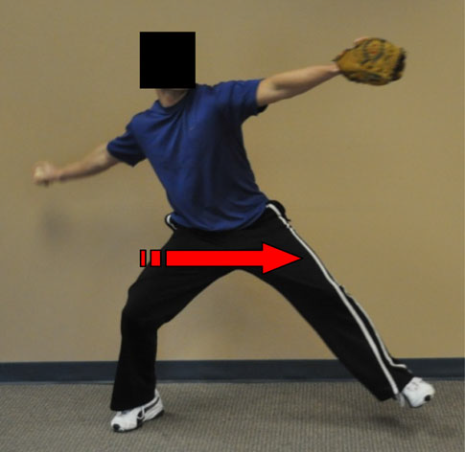
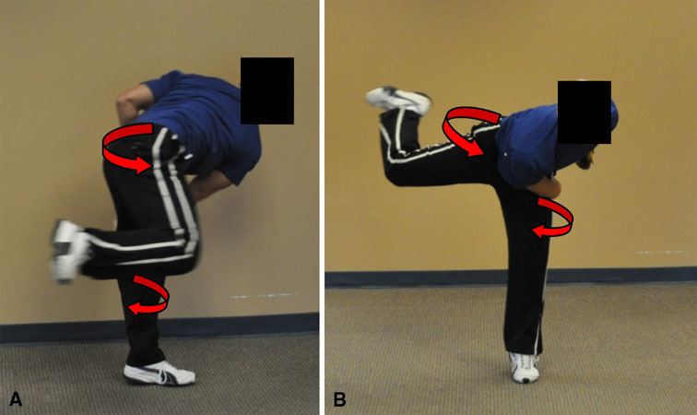
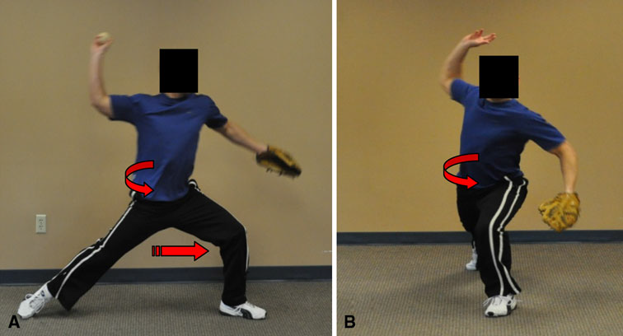
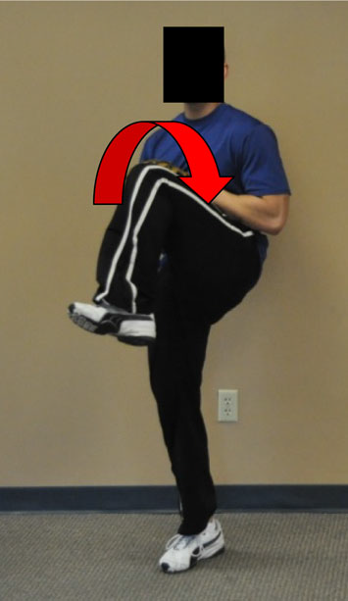
Windup Phase¹ Cocking Phase¹ Acceleration Phase¹ Deceleration and Follow Through¹

Klingenstein et al demonstrate potential altered mechanics and pathomechanics as well as the normal mechanics evident during overhead athletic activity.¹ Knowledge of these movement patterns is necessary for clinical evaluation as well as for intervention and rehabilitation design and protocol.¹ The potential for hip injury is often overlooked in overhead athletics. However, secondary to the information provided above, injury prevention programs as well as off- and in-season training need to focus on optimal hip function. This will not only reduce the likelihood of upper extremity injury but can also decrease the chance for hip and other lower extremity pathology as well.
More About Femoral Acetabular Impingement:
It is essential for a sports medicine clinician to understand the pathology and concepts related to femoral acetabular impingement and rotational instability in order to realize how overhead athletes are predisposed to intraarticular hip injury.¹ FAI is defined as “a pathologic abutment of the femoral head-neck junction against the acetabular rim.”¹² This suggests a pathologic mechanism that promotes excessive approximation between the femur and the acetabulum of the pelvis. It is currently known to be a pathology of various injurious sources to the acetabular labrum, cartilage damage, and osteoarthritic degeneration.¹² There are two types of FAI:
1. CAM-type FAI: This abnormality involves irregular outgrowth at the femoral head-neck junction.¹² It is also defined as a “loss of normal femoral head-neck offset or head asphericity.”¹ In this scenario, the labrum is prone to compression pathology, while the acetabular cartilage can be disposed to shear forces.¹
2. Pincer-type FAI: This irregularity involves “focal overcoverage” of the anterior acetabular rim.^{1,12} In this scenario, the overcoverage can cause a lesion to the labrum and can “cause repeated femoral subluxation, resulting in contre coup chondral lesions.”¹²
Each of these skeletal abnormalities can predispose and increase the likelihood of hip impingement in the overhead athlete.^{1,12} The severity and extent of the impingement will vary based on the anatomy and location of the deformity as well as the biomechanical forces and potential pathomechanics associated to the joint.¹ It is important to note the age differences connected to the development of FAI. In the adult patient, FAI usually occurs secondary to an idiopathic variable.¹³ While childhood or adolescent FAI can occur due to periacetabular osteotomies that are performed secondary to development dysplasia of the hip.¹² Wenger and colleagues also demonstrate the relationship between FAI and Legg-Calve-Perthes disease and slipped capital femoral epiphysis.¹³ When there is no history of the above disorders, irregular bone growth at the femoral head epiphysis is also known to be a possible causation.¹² It is important to understand the various causes and factors related to FAI. A clinicians needs to be able to investigate and discover the mechanics and/or factors that cause the symptoms and address these elements in order to truly help the patient. Without identifying and addressing the underlying etiology, the clinician cannot and probably will not help this individual with regard to long-term outcome.
Clinical Presentation and Examination of FAI:
Clinical Presentation:
Athletic competition that involves deep flexion as well as flexion-adduction or extension-abduction motions will exacerbate the pathological “rubbing” or joint approximation that is evident in cam- and pincer-type lesions.¹² The patient may also have a history of “hip pathology, hip dysplasia, Legg-Calve-Perthes, coxa vera, juvenile rheumatoid arthritis, or chondrolysis.”¹² The patients symptoms most commonly have an extended and persistent course (months to years), but the individual may be able to identify and pinpoint the specific time the pain started.¹² The pain is frequently concentrated at the inner hip or anterior groin area, however, patients have also reported symptoms near the lateral aspect of the hip in addition to the low back, SI joint, and buttock regions.^{12,14,15} Symptomatic and asymptomatic sensations include: locking, clicking, catching, and/or popping within the joint.^{12,14} Pain is usually described as “sharp” and a “C-sign” is commonly used visually demonstrate the location of the pain.¹² The onset and exacerbation of painful symptoms often occurs secondary to long periods of sitting and squat positions and some patients have complained of difficult with “walking up a hill and putting on socks and shoes.”^{12,14} Therefore, an adequate interview and subjective portion of the evaluation in addition to a review of the pertinent medical history is important to uncover potential causative factors.
Physical Examination:
A clinician should include the following standardized measures and special test tools during their physical examination of a patient with suspected FAI:
1. Palpation of Bony and Soft Tissue Structures: For differential diagnosis and evaluation of potential soft tissue injuries such as athletic pubalgia, osteitis pubis, soft tissue tumor, hip flexor tendinitis, low back pain, or even more serious pathology such as testicular pain.^{12,14}
2. Range of Motion Testing: Both of the patient’s hips should undergo full ROM testing for side-to-side comparison as one of the classic signs of FAI is restriction and pain with hip internal rotation.¹² Flexion and abduction are also commonly restricted as well.¹⁶
3. Gait Pattern Assessment: Gait is observed for possible antalgic or “gluteus medius” or “Trendelenburg” gait.^{12,16}
4. Anterior Impingement Test: This test is performed by placing the test hip in adduction and internal rotation while the hip is in 90 degrees of flexion.¹² This test has shown to be positive in more than 90% of patients who have been given the diagnosis of FAI, either radiographically or at the time of surgery.¹⁶ A positive test will consist of a “sharp pain” in the involved hip.^{12,16}
5. FABER Distance Test: This test measures the distance of the lateral knee to the clinician’s exam table while the involved lower extremity is in a combination of flexion-abduction-external rotation.¹² A positive test here would consist of symptom reproduction when the involved leg is >4cm off the table when compared to the contralateral lower extremity.
6. Hip Dial Test: This test evaluates capsular laxity in the involved hip and can be valuable during the assessment of instability.¹²
7. Imaging: If imaging is possible or available, 2 valuable radiograph views are the anteroposterior and cross-table lateral views.^{12,16} The clinician should assess “center-edge angle, acetabular coverage, joint space, and physeal status (in the case of skeletally-immature patients.”¹² Concavity of the head-neck junction, femoral head position and presence of “herniation pits” should also be assessed.”¹⁶ The presence of cam- and pincer-type deformities should also be evaluated.¹² Overall, imaging should not surpass the clinical impression and information gathered from a detailed history and physical examination.¹² A collection of signs and symptoms should alert the clinician towards the possibility of hip impingement and management should be planned accordingly.¹⁶
Treatment and Management of FAI:
FAI falls under the Practice Pattern 4D of The Guide to Physical Therapist Practice: impaired joint mobility, motor function, muscle performance, and range of motion associated with connective tissue dysfunction.¹⁷ The approximate range of number of visits per episode of care is 3 to 36, depending on severity and/or socioeconomic status.¹⁷ The main objectives surrounding physical therapy management include: decrease pain, increase range of motion, increase strength, improve gait efficiency and quality, maximize function and return to active lifestyle, and increase independence with a home exercise program.¹⁷ Conservative treatment can be attempted; however, in severe cases of impingement, surgical intervention is the most effective option in most cases.¹⁸ Phillipon and colleagues have demonstrated that a majority of athletes are able to return to sport within 1.6 years and highlight the importance of an effective physical therapy rehabilitation following the operation.¹⁸ The following protocol are guidelines based on evidence-based practice and literature and will vary based on facility and orthopedic surgeon.^{18,19} However, they are important to examine and observe to understand the goals following surgical intervention:
- PWB up to 20 pounds or toe touch WB status within the first 4 weeks to prevent the possibility of stress fracture to the femoral neck.^{18,19}
- A hip brace to limit hip abduction and rotation for 10 days post op.^{18,19}
- CPM 0-90 degrees for 8 hours a day for up to 4 weeks.^{18,19}
- Physical Therapy exercises should be implemented within 4 hours of surgery (important to reduce the risk of adhesions).^{18,19}
- Active hip flexion exercises should be limited within the first 4 to 6 weeks of treatment to reduce the possibility of hip flexor tendonitis.^{18,19}
- Abductor strengthening should be implemented immediately and continued in a HEP^{18,19}
- Impact activities such as running are not encouraged within the first 6 months.^{18,19}
- Post-op rehabilitation is extremely important for increased function outcomes. The general progression should be restoring passive ROM, followed by active ROM, and then strengthening.^{18,19}
Conservative treatment ideas include:
1. Stretching and Improving ROM: The important structures the clinician should target for the patient include the hip flexors, hip internal rotators and the hip adductors.¹⁸ The objective behind these stretches involves increasing the distance between the neck of the femur and the acetabulum.¹⁸
2. Strengthening: The significant structures that are important to strengthen include the core musculature, the gluteals, and the hamstrings.¹⁸ The main idea here is to encourage posterior pelvic tilt to again increase the distance between the femur and the acetabulum.¹⁸
3. Activity Modification and Avoidance: The clinician needs to assess the functional activities that produce or increase patient symptoms.^{12,16,18} Patient education and activity modification needs to be provided in order to intervene and avoid these positions and activities that are sustaining or causing the symptoms. Physical activity needs to continue but it is the clinician’s job to provide patients with the means to avoid exacerbation of symptoms.^{12,16} Examples of activity modification include: wide running courses that encourage abduction and external rotation, leaning back every 5 to 7 minutes when sitting for long periods of time, and/or using a recumbent bike that decrease hip flexion.¹⁸
4. Modality Use: The Guide to Physical Therapist Practice recommends the use of cryotherapy, hydrotherapy, ultrasound, infrared and laser, thermotherapy, compression, traction, TENS, and/or NSAIDs depending on severity and stage of healing.¹⁷
These are all intervention options that should be used in conjunction with a thorough biomechanical and/or mechanical investigation in order to optimally treat the current pathology, but also to prevent further deterioration of the condition.

References:
1. Klingenstein G, et al. Hip Injuries in the Overhead Athlete. Clin Orthop Relat Res. 2012; 470: 1579-1585.
2. Scher S, et al. Associations Among Hip and Shoulder Range of Motion and Shoulder Injury in Professional Baseball Players. Journal of Athletic Training. 2010;45(2):191-197.
3. Elliot B. Timing of the lower limb drive and throwing limb movement in baseball pitching. Intl J Sports Biomech. 1998;4(1):59–67.
4. Kibler B, et al. Mechanics and Pathomechanics in the Overhead Athlete. Clin Sports Med. 2013;32:637-651.
5. Kibler W, et al. The role of the scapula in throwing motion. Contemp Orthop. 1991; 22:525–532.
6. McFarland E, et al. Epidemiology of collegiate baseball injuries. Clin J Sport Med. 1998;8(1):10-13.
7. Wilk K, et al. Biomechanics of the overhead throwing motion. Sports Med Arthrosc. 2000;8(2):124-134.
8. Burkhart S, et al. The disabled throwing shoulder: spectrum of pathology Part III: The SICK scapula, scapular dyskinesis, the kinetic chain, and rehabilitation. Arthroscopy. 2003;19(6):641-661.
9. Tippett SR. Lower extremity strength and active range of motion in college baseball pitchers: a comparison between stance leg and kick leg. J Orthop Sports Phys Ther. 1986;8(1):10-14.
10. Stodden D, et al. Relationship of pelvis and upper torso kinematics to pitched baseball velocity. J Appl Biomech. 2001;17(2):164-172.
11. McCarthy J, et al. The Role of Hip Arthroscopy in the Elite Athlete. Clin Orthop Relat Res. 2003;406:71-74.
12. Philippon M, et al. Hip Arthroscopy and FAI in the Pediatric Patient. J Pediatr Orthop. 2013;33(1):126-130.
13. Wenger D, et al. Impingement and childhood hip disease. J Pediatr Orthop B. 2006;15:233-243.
14. Stanford Outpatient Center. Femoroacetabular Impingement. Stanford Hospitals Web Site. http://outpatient.stanfordhospital.org/clinics/orthopaedics/sportsmedicine/procedures/hip/fai.html Date Accessed: December 3, 2013.
15. Philippon M, et al. Screening of asymptomatic elite youth hockey players: clinical and MRI exam. Br J Sports Med. 2011;45:322.
16. Dooley, Paul. FAI Syndrome in Young Adults. Canadian Family Physician. 2008;54(1):42-17. APTA. Guide to Physical Therapist Practice. APTA Web Site. http://guidetoptpractice.apta.org. Date Accessed: December 5, 2013.
18. Philippon M, et al. Femoroacetabular impingement in 45 athletes: associated pathologies and return to sport following arthroscopic decompression. Knee Surg Sports Traumatol Arthrosc. 2007; 15(7): 908-914.
19. Clohisy J, et al. Treatment of anterior femoroacetabular impingement with combined hip arthroscopy and limited anterior decompression. Iowa Orthop J. 2005; 25:164-171.

