Use of a Novel Physical Therapy Approach for Decreasing Fall Risk and Improving Functional Mobility in a patient with Parkinson’s Disease: A Case Report

Introduction:
Parkinson’s disease (PD) is the second most common neurodegenerative disease in the United States, affecting approximately 1million Americans with prevalence estimates as high as 2/1000 people,. PD is characterized by a slow, progressive degeneration of dopaminergic neurons in the basal ganglia; a group of brain structures thought to be involved in the initiation and facilitation of voluntary movements¹. This dopamine deficiency results in a number of pathological motor symptoms including bradykinesia, rigidity, postural instability and tremor². Tremor is the trademark sign of the disease and it was originally named “shaking palsy” by neurologist James Parkinson, for whom the disease is now named for¹. The disease is progressive in nature and eventually leads to varying degrees of disability and loss of functional mobility. This can have a major impact on the individual’s quality of life, impacting the entire spectrum of the ICF model. Additionally, management of PD can be a financial burden, as in the US alone $25 billion is spent annually on management of the disease. There is no cure currently available for PD, however, management of the disease typically includes pharmaceutical treatments as well as various physical therapy interventions in order to delay or prevent declines in function.
While the exact cause of PD is unknown, there are numerous risk factors for developing the disease. Age is the primary known risk factor as the disease affects 2-4% of the population over 60 years old and incidence increases with age. The majority of cases are diagnosed between the ages of 50 and 79 years of age. Gender and ethnic background also impact risk for PD with slightly more men affected by the disease and slightly more Caucasians than African-Americans⁵. The most common type of Parkinsonism is called idiopathic PD which has unknown etiology and affects roughly 78% of patients with PD⁴. Secondary Parkinsonism is another category of the disease that occurs as a direct result of identified causes such as viruses, poisons, drugs, tumors, and some metabolic causes⁴. Both types of PD are basal ganglia disorders, which affect the planning and coordinating of movement^{1,4}.
Anatomically, the basal ganglia (BG) are a group of connected gray matter nuclei masses deep in the brain consisting of the caudate and putamen (collectively called the striatum) along with the globus pallidus, subthalamic nucleus, and the substantia nigra⁴. The BG receives input from the cerebral cortex primarily through pathways from the cortex to the striatum. BG output returns to the cortex via the globus pallidus and substantia nigra to the thalamus where it is then relayed to the cortex⁴. The BG is connected to the cortex via complex direct and indirect pathways. The direct pathway facilitates the BG output to the thalamus and motor cortex resulting in increased movement, and the indirect pathway results in the inhibition of certain movements^{1,4}. Balancing of these opposing pathways allows the BG to play a crucial role in planning and programming voluntary movements by organizing specific motor plans, translating thought into movement, and regulating levels of kinetic activity, muscle tone and muscle force^{1,4}.
Parkinson’s disease develops with the degeneration of neurons in the substantia nigra that produce the neurotransmitter dopamine which is essential for proper functioning of the BG pathways². As dopaminergic cells die, a dopamine deficiency sets in and creates an overactive indirect pathway and an underactive direct pathway⁴. The overall effect of this imbalance inhibits thalamic activity, in turn slowing signals to the cerebral cortex and resulting in less cortical activity. This yields slowed movement generated by the musculoskeletal system⁵.
The clinical presentation of PD is highly variable, however, it typically consists of cardinal symptoms including tremor, rigidity, bradykinesia, and postural instability^{1,2,4}. Tremor is the first symptom of the disease in 70% of patients and is typically referred to as a “resting tremor,” in reference to shaking that is present at rest but lessens or subsides with voluntary movement⁴. Rigidity refers to increased resistance to passive movement described by patients as “heaviness” and “stiffness” of the limbs⁴. As PD severity progresses, rigidity worsens leading to decreased ease of mobility demonstrated by loss of bed mobility or loss of trunk motion and arm swing during gait⁴. Bradykinesia typically refers to slowness and difficulty maintaining voluntary movement and results in decreased speed, range, and amplitude of movement⁴. Symptoms of bradykinesia can sometimes progress to the point where episodes of sudden “freezing,” or stopping of movement mid-task occur which can be very disabling and potentially dangerous⁴.
As PD progresses, increased postural instability develops. Patients experience increased difficulty maintaining balance during activities such as walking, reaching, and recovering from losses of balance also becomes more difficult⁴. Patients lose the ability to anticipate adjustments needed by postural muscles during voluntary movements as well as the ability to adapt to changing sensory conditions⁴. Over time, patients develop a flexed, stooped posture with increased flexion of neck, trunk, hips, and knees combined with a short, shuffling or festinating gait secondary to increased rigidity, bradykinesia, weakness, and postural instability⁴. In addition to the cardinal symptoms of PD, other problems such as voice hypophonia, dementia, depression, orthostatic hypotension, and medication side effects can further complicate functioning⁴. The progressive loss of balance and voluntary movement seen in PD ultimately leads to frequent falls in at least 2/3 of patients with the disease, often resulting in injury⁴. The high incidence of falls not only leads to injury, but fear of future injury, which results in greater disability and dependence, decreasing quality of life in the PD population⁴. All of these factors point to the need for clinical interventions to fight the progression of this disease, prevent falls, and maintain functional mobility.
Management of Parkinson’s disease typically involves a combination of medications, physical therapy, and in some cases surgery. Typically, motor symptoms of PD develop when 60% or more of the dopamine producing cells in the substantia nigra are destroyed². Dopamine replacement therapy is a common treatment that becomes necessary when symptoms significantly affect quality of life. Since the 1970’s, levodopa has been the “gold standard” drug used to treat bradykinesia and rigidity in PD.² However, nearly 70% of oral levodopa breaks down in the periphery and does not cross the blood-brain barrier leading to possible side effects such as orthostatic hypotension, hallucinations, nausea, and vomiting. To avoid these side effects and improve the ability of levodopa to cross the blood-brain barrier, the drug Carbidopa is added to the mix^{2,6}. This drug combination is known by the trade name Sinemet® and is commonly prescribed along with other classes of drugs to treat PD symptoms². Levodopa is highly effective at the correct dosage, however, a short half-life of 60-90 minutes means it must be given multiple times per day⁶. Care should be taken to schedule physical therapy sessions around the time of peak effectiveness or “on phase” which is typically one hour after administration^{2,6}.
Even with proper pharmacological management of PD symptoms, motor deficits continue to progress during the course of the disease leading to reduced physical activity and a decline in functional ability including decreased strength, balance, and an overall increased fall risk³. Physical exercise has been found to stimulate remaining dopaminergic cells to produce dopamine thereby reducing symptoms³. Many wide-ranging types of exercise interventions have been attempted and studied for effectiveness with varying degrees of success. Goodwin et al performed a systematic review of randomized controlled trials of physical therapy exercise interventions for PD³. Studies included interventions such as stretching, strength and balance training, aerobic exercise, home based therapy, and treadmill training³. The study found that exercise is beneficial to patients with PD in regard to physical functioning, health related quality of life, strength, balance, and gait speed with no clear evidence to support or refute that exercise results in a decreased fall risk for this population³. In addition to these RCT’s of standard exercise training, a number of unique interventions have been studied.
Numerous studies including a longitudinal study by Georgy et al, have suggested that in addition to regular exercise treatments, movement strategy training may be effective for improving gait patterns, mobility, decreasing gait freezing episodes, and reducing fall risk⁷. Movement strategy training often includes external cues and attention strategies that rely on cortical control mechanisms. The theory behind external cueing is based on the fact that internally generated, automatic movement sequences such as walking and performing sit-to-stand are initiated in part by the BG⁴. BG function is decreased in PD leading to a decreased ability to initiate internally guided, well-learned tasks⁴. External cues help facilitate movement by increasing conscious attention to the task, utilizing different brain areas, therefore bypassing the deficient BG to use alternative, more conscious motor control pathways.⁴ Participants in the study by Georgy et al underwent weekly sessions, which included a standardized regular exercise program along with cueing and cognitive strategy training⁷. The results revealed that the combined intervention had significant effects for decreasing gait freezing and falls, resulting in an increased quality of life.
Various studies have looked at types of balance training for PD and its effect on postural instability; a common symptom in middle to late stage PD that results from diminished or incorrect postural reactions to perturbations⁸. A randomized controlled trial by Smania et al determined that training specifically focused on improving balance control could significantly improve outcome scores for postural stability, confidence with balance activities, and fall frequency in patients with mild to moderate PD⁸. The experimental group underwent a standard regimen of balance exercises that included self-destabilization, externally induced destabilization, and coordination of upper and lower extremities during gait and obstacle avoidance. Tai chi is another intervention that has shown some success in this population. Tai chi is a balance-based exercise program that has proven successful in improving strength, balance, and physical fitness in older adults. These exercises are designed to challenge balance and gait using patterns of diagonal movements such as weight shifting, ankle sways, anterior-posterior and lateral stepping, and shifting center of mass outside of the base of support⁹. A study by Li et al. found that a program of tai chi for PD patients was more effective than standard resistance training for improving postural stability, gait characteristics and other functional outcomes⁹.
Bradykinesia associated with PD often leads to decreased gait speed in individuals with this disease. Evidence exists in favor of multiple treatment types aimed at improving gait speed including treadmill training and over-ground gait training focused on high repetitions and external cueing. One particular study presented Nordic Walking as a program to improve mobility in patients with PD. Nordic walking is defined as fitness walking with specially designed hand-held poles that create a full body walking workout with use of upper extremities in coordination with lower extremities. PD patients are thought to benefit from this type of walking because it requires more conscious awareness of walking through deliberate use of the arms and conscious increases in step length, which results in the bypassing of defective BG pathways¹². In this study, a 6-week Nordic walking program resulted in improved gait speed, timed up and go test, and quality of life scores, all of which were maintained at follow up¹².
A relatively new and promising treatment technique for treating bradykinesia and hypokinesia is a program called LSVT®BIG. The program is derived from LSVT®LOUD (Lee Silverman Voice Treatment) which is a speech therapy program for treating PD related hypophonia with substantial clinical evidence to support its use. LSVT®BIG focuses on performing high-amplitude, high intensity, complex, repetitive movements in order to improve movement perception and restore normal amplitude movements during tasks^{13,14}. The basic principle behind this program is that damaged BG feedback loops result in improper scaling of movement and so movements with insufficient speed and amplitude are selected regardless of the speed and amplitude required for the task^{13,14}. In other words, there is a mismatch between the movement amplitude perceived by the patient and the movement amplitude produced by the patient. This damaged sensorimotor processing system produces decreased motor commands for selecting and reinforcing correct movement amplitude resulting in small, slow, and low amplitude movements^{13,14}. The theory behind LSVT®BIG is that focusing training on increasing movement amplitude may enhance activation of BG pathways to a level that will allow for bigger, faster, and more normal movements with functional carryover. Unlike many physical therapy protocols that aim to bypass deficient BG function through the use of external cueing and compensatory movement strategies, LSVT®BIG is a “task-specific,” repetitive, high intensity protocol aimed at producing neuroplastic changes in the BG pathways^{13,14}. This idea of high amplitude/intensity, task-specific training to promote neuroplasticity is similar to “forced-use” therapy which has been effective for improving hemiparetic limb function in patients following stroke.
One major randomized controlled trial by Ebersbach et al compared treatment following the standardized LSVT®BIG protocol with a group that performed Nordic walking and a control group that performed unassisted home exercises. The standard LSVT protocol consists of 16 individual one hour PT sessions (4x/week for 4 weeks) that require intensive motivation and feedback from the therapist¹³. The Nordic walking group received the same number of PT contact hours during treatment but only twice weekly for 8 wks which is more consistent with standard care in the OP setting and has been shown to be effective for patients with PD^{12,13}. Fifty percent of LSVT treatment sessions consist of standardized multidirectional whole-body movements (appendix 1) that are repetitive and performed with maximal effort and amplitude¹³. The second half of treatments typically include practice of patient chosen, goal directed ADL tasks depending on the needs or desires of the patient, which are performed using high amplitude “BIG” movements¹³. Patients are encouraged to give at least 80% maximal effort and to practice bigger movements with daily activities. The results of the comparative intervention study showed that LSVT®BIG led to significantly improved motor performance on the United Parkinson’s Disease Rating Scale (UPDRS), TUG score, and gait speed¹³. PDQ-39 quality of life score also increased from LSVT BIG interventions¹³. These positive effects were found to be significantly greater than the effects of the Nordic walking intervention in patients with PD¹³.
There is a lot of evidence available to support the efficacy of traditional physical therapy interventions for patients with PD that are targeted at bypassing the faulty BG systems and maintaining functional status in patients with PD. However, all of these techniques are based on a behavioral strategy model of teaching compensations with the idea that neurophysiological changes are no longer possible¹⁴. It is the author’s belief that the focus of therapy for PD should follow a neuroplasticity or recovery model where the goal is to retrain deficient motor pathways to slow, prevent, or possibly even reverse the functional decline associated with PD. The purpose of this case report therefore is to provide a review of PD pathophysiology, discuss current treatment approaches for patients with Parkinson’s disease and describe the effects of a trial using a concept called LSVT®BIG that was implemented in a geriatric specialty clinic for management of a patient with PD.
Case description
Patient Classification:
This case report involved management of a 78 year old female with chronic, mid-stage PD by employing principles of the LSVT®BIG protocol in an attempt to improve functional mobility and decrease fall risk. The patient gave written consent to use her medical information and to try a new treatment program aimed at improving motor function specifically in PD patients. Parkinson’s disease and its management fall under the Guide to Physical Therapy practice pattern 5E: Impaired Motor Function and Sensory Integrity Associated with Progressive Disorders of the Central Nervous System¹⁵. The ICD-9 code used in this case was 332.0 for Parkinson’s disease¹⁵. Parkinson’s disease is progressive in nature with stages of disability and the patient’s current stage was classified using the Hoehn and Yahr Classification of Disability score of 3⁴. (Table 1.)
Table 1. Modified Hoehn and Yahr Staging
Stage 0 = | No signs of disease
Stage 1 = | Unilateral disease
Stage 1.5 = | Unilateral plus axial involvement
Stage 2 = | Bilateral disease, without impairment of balance
Stage 2.5 = | Mild bilateral disease, with recovery on pull test
Stage 3 = | Mild to moderate bilateral disease; some postural instability; physically independent
Stage 4 = | Severe disability; still able to walk or stand unassisted
Stage 5 = | Wheelchair bound or bedridden unless aided

Examinatio
The physical therapist performed a re-evaluation of the existing patient and reported the following information.
History:
The patient was a 78-year-old female who presented to physical therapy with a 14-year history of Parkinson’s disease, which had progressed slowly during that time. At the time of evaluation, she was an existing patient undergoing physical therapy at the geriatric specialty clinic connected to the assisted living facility to improve deficits in strength, endurance, and balance for maintaining safe and independent functioning and preventing falls. She had been receiving PT periodically for approximately 2.5 years with the current episode of care lasting longer than 6 months with therapy twice weekly. She stated that in the past when she had stopped PT for a few weeks at a time, she noticed a significant decline in her functioning. The patient was a resident of the assisted living facility and lived primarily independent with daily nursing checks. She stated that she enjoyed a variety of exercises and did not feel as if she had been improving much recently. After explanation of the new treatment program, she gave consent to try the treatment to see if there was any noticeable improvement in her functioning. The patient reported no significant health problems or past medical history besides Parkinson’s disease. She also stated that she had not experienced any falls in the past year but had fallen multiple times in the past. The patient’s medications included Sinemet® for PD symptom control which was administered 5 times daily at 6am, 10am, 12pm, 2pm, and 6pm.
Systems Review:
Cardiovascular/Pulmonary system: The patient’s cardiovascular system appeared to be grossly intact. Her resting blood pressure was 138/78 mmHg and her resting pulse was 63 bpm. She did not demonstrate any signs of edema.
Integumentary system: The patient’s integumentary system was grossly normal with no apparent scars and or other signs of injury. The skin had normal pliability, color and integrity.
Musculoskeletal system: The patient’s musculoskeletal system was grossly intact. Active range of motion appeared within normal limits for upper and lower extremities. Gross strength was mildly impaired for bilateral upper and lower extremities. She appeared to have grossly symmetrical musculature in standing and sitting.
Neuromuscular system: The patient’s neuromuscular system was impaired showing gross deficits in balance, gait, transfers, and ability for motor control and motor learning. Her sensory systems were intact but she did require eyeglasses for sufficient vision.
Objective Tests and Measures:
Pain: The patient reported 0/10 pain using a visual analogue scale.
Posture: The patient demonstrated a moderately flexed kyphotic posture, likely due to long term wheeled walker use, in both standing and sitting. She also appeared to have a mild torticollis on the left with her head turned to the right and up. She could move from this position so it was not a rigid posture.
Range of Motion: Lower extremity and upper extremity ROM was within normal limits. Trunk flexion, extension, and rotation ROM were decreased approximately 50-75% of normal but were not formally measured.
Strength: Manual muscle testing (MMT) was performed on the upper and lower extremities. MMT is a standard method of assessing a muscle or muscle group’s strength and has been found to have good inter-rater reliability but poor intra-rater reliability¹⁶. Patients with disorders of the central nervous system who demonstrate deficient or variable voluntary muscle control are typically difficult patients on which to perform detailed muscle testing¹⁶. It was difficult to assess minor differences in strength due to the patient’s resting tremor, but all muscle groups tested were rated between 4- to 4+/5.
Gait Description: The patient ambulated with the use of a four-wheeled walker as an assistive device (AD). She maintained a flexed kyphotic posture during gait and maintained a slow gait speed with short but relatively fluid step-through gait pattern. Gait speed was measured using the 10 meter walk test which has been shown to be predictive of falls, declines in function, hospitalization, and even survival in older adults¹⁷. The test involved instructing the patient to walk at her usual pace with AD along a 10m course and was timed with a stopwatch. The cutoff score for full community ambulation is classified as >0.80 m/s. The Timed Up and Go test (TUG) is another standard test for measuring functional mobility and gait speed and has also been shown to identify fall risk in patients with PD^{17,18}. During the TUG, the patient starts seated in a standard arm chair until told to “go”, then the patient stands up, walks 3m (with AD normally used) as fast and as safely as possible, turns around and walks back to the chair and finishes by sitting down. Time is measured from the word “go” until the patient returns to the chair and sits down¹⁷. Following a practice trial, the patient’s time is recorded and compared to the 13.50 second cutoff score that is indicative of low fall risk¹⁸. The patient’s results (Table 2) showed limitations in gait speed and functional mobility which classified her as high fall risk meaning that improving gait speed and mobility was an area on which to focus interventions.
Balance Assessment: A balance assessment was performed for the purpose of fall risk stratification using the Tinetti Performance-Oriented Mobility Assessment (POMA) or Tinetti Mobility Test (TMT). The TMT is a valid and reliable test for measuring balance and gait characteristics in the elderly population and has also been shown reliable and valid for assessing functional mobility and fall risk in patients with PD¹⁹. The TMT is a multi-item test that evaluates an individual’s ability to ambulate and transfer safely as well as his or her ability to perform actions such as turning, initiating gait, and slowing down to sit which are tasks that commonly lead to falls¹⁹. The test takes around 5 minutes to administer and has a gait score (out of 12) and a balance score (out of 16) that are summed for the overall test score (out of 28). The range of 19-24 is associated with moderate fall risk and <19 is associated with high fall risk in the elderly¹⁹. A study of the reliability and validity of the TMT for assessing fall risk in patients with PD was performed by Kegelmeyer et al. and found that the best cutoff score for high fall risk was <20 for the PD population¹⁹. The patient’s TMT score (Table 2) placed her at moderate fall risk and was very close to the cutoff point indicating the need for physical therapy intervention.
Table 2. Baseline Outcome Scores for Gait and Balance
Outcome Measure | Patient’s Baseline score | Cutoff scores for low fall risk.
Timed Up and Go (TUG) | 18.06 s | 13.50 s
Gait speed | 0.71 m/s | >0.80 m/s
Tinetti Mobility Test (TMT) | 20/28 (8/12 gait; 12/16 balance) | >25/28

Functional Mobility: The patient demonstrated good ability to ambulate over flat ground with the use of her 4-wheeled walker. She was able to navigate narrow areas and avoid most obstacles when using her walker. The patient needed no physical assistance to complete sit to stand transfers. She was however, unable to climb steps due to balance difficulties without moderate assistance. The patient was only able to tolerate approximately 15 minutes of continuous standing activity without a break and with no AD.
Psychosocial: The patient was in general very pleasant and engaged during the physical therapy exam and treatment sessions. On occasion she seemed slightly confused or forgetful but reported no history of diagnosed dementia. Her quality of life was assessed using the Parkinson’s Disease Questionnaire 39 (PDQ-39) which is a 39 item, self-administered test for assessing functional status, well-being, and overall health related quality of life in patients with PD²⁰. The PDQ-39 is widely validated for the PD population and asks questions across a whole spectrum of health dimensions including mobility, ADLs, emotional well-being, stigma, social support, cognition, communication, and bodily discomfort²⁰. Questions are graded on a 5 point Likert scale and can be summed for a single index score ranging from 0% perceived disability to 100% perceived disability^{20,21}. The PDQ-39 was administered to the patient and a single index score of 16.7% was calculated.

Evaluation, Diagnosis, Prognosis, and Goals
The patient was a 78-year-old female diagnosed with Parkinson’s disease, Hoehn and Yahr stage 3, who had been diagnosed with the disease for 14 years. She was undergoing pharmaceutical and physical therapy interventions to prevent decline, maintain independence, and hopefully restore functioning; however, her self-report, as well as the medical record, showed that she had made very minimal progress of late toward higher functioning. Following her examination, the patient was found to have primary deficits in UE, LE, and core strength, postural control, gait speed, and dynamic balance, which categorized her with an increased fall risk. A review of literature has shown that nearly 70% of patients with PD fall at least once annually and nearly 50% fall more than twice annually; these falls often occur in patients during ADLs when patients are properly medicated^{18,22}. Falls often result in significant injuries, fear of falling, reduced functional mobility, and resulting weakness and decreased fitness^{18,22}. As mentioned earlier, falls lead to a loss of independence as well as increased morbidity and mortality which further highlights the need for therapeutic interventions to help reduce fall risk in this patient as well as all patients with PD^{4,18,22}.
There do not appear to be clear predictors for who will likely benefit from physical therapy intervention, but the majority of studies reviewed had specific inclusion criteria. Most studies included patients with Hoehn & Yahr⁴ classifications (Table 1) ranging from I to IV with the majority classified as stages I-III indicating independent mobility. Patients were also typically included if they had no significant cognitive impairment or severe co-morbidities. Many studies have already shown that patients with PD can make significant improvements in muscular strength, endurance, gait speed, and balance following exercise interventions^{3,7-12,18}. The LSVT®BIG study by Ebersbach et al demonstrated that their treatment protocol produced superior improvement in motor performance compared to other active interventions¹³. The patient fit the basic inclusion criteria and had a good prognosis for improving her functional mobility thereby reducing her risk of falls through the use of a LSVT®BIG exercise program coupled with functional strengthening and balance training.
Based on evaluation of exam findings, the following physical therapy goals were set for the patient:
In order to demonstrate improved functional mobility and decreased fall risk, within 6 weeks:
1.) The patient will improve her Tinetti Mobility Test score to ≥ 25/28 indicating low fall risk.
2.) The patient will decrease her Timed Up and Go time to <13.50 seconds indicating low fall risk. .
3.) The patient will increase gait speed to >0.8 m/s indicating safe, full community ambulatory status.
In order to improve physical perception of her condition and enhance HRQOL, within 6 wks:
4.) The patient will improve her total PDQ-39 score by >7.74%, which is the MCID for this tool²³.
5.) The patient will improve PDQ-39 items #1-16 corresponding to improved mobility and ADL management.
6.) The patient will demonstrate improved posture and endurance for physical activity in order to increase participation in community programs at her ALF.
Intervention
Interventions took place during the patient’s twice weekly physical therapy sessions which typically lasted for one hour in duration and started one hour after her 12pm dose of Sinemet® making this the optimal time for effectiveness of her medications^{2,4}. Treatments were fairly homogenous throughout the plan of care and typically involved a combination of neuromuscular re-education, and therapeutic exercise or activity. In accordance with the model for interventions using the LSVT®BIG protocol¹³, approximately 30 minutes, or 50% of every treatment session consisted of standardized high amplitude, whole body movements. (Appendix 1.) The remaining 30 minutes were typically focused on an assortment of strengthening, balance, obstacle negotiation, and functional activities with a focus on attempting “BIG” movements with the goal of carryover for increased movement amplitude and accuracy to other tasks. Cardiovascular fitness exercise was also typically completed at the end of therapy sessions using the NuStep® machine. This machine required the reciprocal, coordinated use of both arms and legs which is beneficial for patients with PD¹².
Following evaluation during the first treatment, the patient was educated on BIG exercises #1-4 (Appendix 1) completing 10 repetitions of each in order to introduce her to the principles of this treatment technique and instruct her on the level of intensity that was expected during therapy. Standing exercises were performed with the patient wearing a gait belt and the aid of an assistant for maintaining balance and safety as these exercises maximally challenged her balance. The therapist visually modeled the exercises and simultaneously performed them. The full LSVT®BIG program encourages patients to practice the standard exercises at home as part of a home exercise program, but it was determined that this would be unsafe for the patient since she lived alone and did not have someone available who could assist her with maintaining balance. She was however given the exercise pictures and instructions to mentally rehearse the routine.
At the second treatment, the patient worked through 10 repetitions of exercises #1-6. She struggled with form initially, but this improved with verbal and tactile cueing along with visual modeling. She was also given education on how amplitude and intensity are more important than textbook correct form. During these exercises, her BP was measured at 158/60 mmHg with a HR of 87 bpm indicating that the exercise placed a level of stress on the cardiovascular system that was not excessive. Following the BIG protocol, she completed various balance/coordination activities such as cone weaving, 4 directional cone foot taps, forward/backward/sideways marching, and a 4 square stepping activity similar to the 4 square step test used for identifying multiple falling older adults²⁴. All of these exercises were initiated with the goal of challenging the balance control systems as well as working on turning and transitioning which are typically most difficult in patients with PD¹⁹.
The third treatment, like the second treatment consisted of BIG exercises #1-6 for 10 reps each. Balance and coordination tasks were repeated from the previous treatment with the addition of targeted stepping, small hurdle stepping, and trampoline marching. At the start of the fourth treatment, BP was recorded again and found to be 138/78 mmHg. This treatment included the addition of BIG exercise #7 which was held prior to this secondary to judgment that the patient lacked sufficient trunk rotation to complete the exercise. Her rotation was improving so the final exercise was added. Functional tasks including mini-squats and repeated sit to stands were added to her exercise regimen. The fifth treatment was completed similar to the last with only addition of upper extremity strengthening exercises and walking on a foam mat. During the mat walking exercise, the patient had one major loss of balance and required PT assist for recovery.
On the sixth treatment, the patient came to therapy with a stapled laceration on her head secondary to a fall out of bed over the weekend. She had no other injuries. Treatment was applied as before with no notable decline in performance demonstrated by the patient. The seventh treatment included the same basic regimen of exercises with the addition of a standing Physioball throw-catch exercise to work on anticipatory postural control and coordination. For the eighth and ninth visits, repetitions for BIG exercises were increased to 12 for all exercises. During both interventions, standing exercises were increased as well as exercises targeting the back extensors to promote improved upright posture and endurance for standing.
The tenth treatment once again included 12 repetitions of the standard LSVT®BIG exercises followed by balance and functional strengthening tasks. The patient’s vitals were once again recorded with BP measured at 132/78 mmHg and HR 64 bpm. This treatment also included reassessment of the patient.
Outcomes, Re-examination, & Termination of PT
Following 10 physical therapy sessions completed over 6 weeks (the patient cancelled twice) the patient was reassessed using the outcome measures tested during the initial evaluation. Ebersbach et al. found in their study of LSVT®BIG treatment that patients showed significant improvements in TUG and gait speed measures as well as numerical improvement in PDQ-39 single index score¹³. This patient showed similar results which can be seen in the following Table 3.
Table 3. Summary of Outcome Measures
Outcome Measure | Baseline score | Final score
Timed Up and Go (TUG) | 18.06 s | 13.37 s
Gait speed | 0.71 m/s | 0.71 m/s
Tinetti Mobility Test (TMT) | 20/28 | 21/28
PDQ-39 | 16.7% disabled | 8.97% disabled

The improvement in her TUG score was significant based on the MDC value (3.5s) reported²⁵ for this test and fell below the cutoff level of 13.50s, which delineates fall risk in adults¹⁹. She did not however show any change in gait speed following intervention, which remained at 0.71 m/s. The patient’s Tinetti Mobility Test -(TMT) score was a slightly improved from her baseline score, but did not show enough improvement to change her associated fall risk level. The PDQ-39 self-assessment for Parkinson’s disease related quality of life was also re-administered and this final value was significantly lower than the patient’s initial value. More specifically for the PDQ-39, the patient’s raw score improved numerically on questions 1-16 that involved mobility and ADLs from a total of 8 initially to 6 following intervention. This suggested that her self-perceived mobility may have improved.
From a qualitative standpoint, the patient was observed to demonstrate improved coordination for BIG exercises as well as some improvement for postural control during balance exercises aimed at destabilization. She also demonstrated improve tolerance for participating in standing activities with no AD following 6 weeks of therapy as she was able to complete the ~30 min set of BIG exercises without requiring a rest break.
Following 6 weeks of physical therapy intervention, the patient met 4 of the 6 initial goals set for therapy. Of these goals, only one of the functional mobility/fall risk assessment goals (#2) was met but all of the HRQOL and participation goals (#4, 5, 6) were met. Since not all of the goals were met and the patient still demonstrated limitations in motor performance and mobility that put her at increased risk of falls, it was determined that the patient would benefit from continued physical therapy care to determine if further gains in outcome scores could be made following a longer period of intervention.
Discussion
As discussed previously, PD is a prevalent and progressive neurodegenerative disease that leads to a decline in motor control and functional mobility, ultimately leading to falls in the majority of patients with the disease^{1-3,18}. These falls often cause significant injuries and these injuries can lead to the loss of independence, a need for institutionalization, or even death^{18,22}. Costs of frequent hospitalizations due to falls also factor into the over $25 billion spent on managing Parkinson’s disease annually in the US^{2,3}. PD is a serious disease that is increasing in prevalence and places a significant stress on an already challenged US healthcare system. It is therefore imperative that efforts be made to review past research as well as study new methods for treating this disease to determine the best, most evidence based course of action. Overall, the purpose of this single case report was to provide an overview of PD, discuss the varied traditional methods used in physical therapy to treat PD, and describe the outcomes seen in a patient treated with principles from a relatively new method of treatment called LSVT®BIG.
The review of literature on treatments for PD did not produce any clear consensus as to what was the best method for improving functional status is patients with PD. However, the majority of interventions reviewed followed a behavioral strategy model of rehab aimed at teaching compensatory strategies to maintain the ability to ambulate, balance, transfer, complete ADLs, and participate in leisure activities¹⁴. These therapeutic interventions typically were low to moderate intensity and were based on the hypothesis that PD symptoms and the disease process itself could not be directly changed in any way through therapy.¹⁴ The intervention applied in this case followed a neuroplasticity model of rehab aimed at high intensity therapy to retrain deficient motor pathways in the brain and prevent further decline in motor function; possibly even reverse the damage done by PD¹⁴. Very few research studies, including randomized controlled trials, have tried this approach to therapy, but the Berlin LSVT®BIG study by Ebersbach et al. was one such study that demonstrated the potential effects of a high intensity intervention aimed at improving motor performance so¹³. Due to the proposed effects, this model was chosen for the treatment of the patient in his case report.
Following the 6-week intervention period, the patient demonstrated improvements in functional outcome measures including her Timed Up and Go test score, Tinetti mobility test, and PDQ-39 questionnaire. Of these test scores, the TUG and PDQ-39 were the only tests that demonstrated a clinically significant level of change with her final TUG score falling below the cutoff for high fall risk. It was thought that changes might be seen in TUG and PDQ-39 scores following this intervention because it was shown in the study of LSVT®BIG that improved scores in these outcome measures were seen. However, by the same reasoning, it was thought that improvements in gait speed would also be seen but this was not the case for the patient. The patient showed improvement in her TMT score but this gain was minimal and did not alter her fall risk classification. In addition, the Tinetti mobility test has been shown effective for predicting fall risk in individuals with PD, but further research found that it has not been proven highly sensitive for detecting changes in gait and balance over time so it may have limited use as a long term outcome measure¹⁹. The patient’s somewhat mixed results for the outcome measures assessed made it more difficult to determine exactly what changes, if any, were made following intervention.
When looking at the overall results related to the physical therapy goals set for this patient, it is interesting to point out that only one of the functional mobility/fall risk assessment goals (#2) was met but all of the HRQOL and participation goals (#4, 5, 6) were met. These results pointed to the possibility that the patient may have benefitted more from the intervention in this case report in the areas of health related quality of life than for improved motor performance, functional mobility, and decreased fall risk. This result was somewhat unexpected since quality of life outcomes were the least improved scores in the “BIG” study, but this may actually be a more significant outcome for the patient in this case than any dramatic change in functional outcome measures as she was largely independent with daily activities required for her life. For example, the patient had a longstanding diagnosis of PD and lived at an assisted living facility. She also used a wheeled walker for mobility outside of the therapy clinic which supplied her with the stability she needed for her functional mobility requirements, which were relatively low when compared to a younger patient, perhaps with a family. The patient even rated her perceived level of disability prior to the intervention quite low using the PDQ-39 (16.7%). This value is quite low compared to the average pre-intervention scores reported in two studies that used the PDQ-39 with similar patients (average range 29.5 – 31.2%) and could have made it more difficult to show real improvement due to a ceiling effect^{7,13}. Her improved PDQ-39 score in spite of the relatively low initial rating pointed more strongly toward a significant quality of life improvement for the patient following the intervention. The patient also stated that she felt better physically having completed physical therapy.
It was previously stated that the patient had an improved TUG score, but did not show improved scores following the intervention for the 10-meter walk test or the Tinetti mobility test. These inconsistent results suggested that from a motor functioning and fall risk standpoint, the intervention applied in this case may not have had a significant effect. It was thought based on literature review that these functional measures might have all improved with the intervention described in this case, but there are many possible explanations for why the patient may have shown limited change.
First, the frequency of treatment for this patient was twice weekly for ~1 hour sessions. This amount of time was only half the frequency and number of PT contact hours described and recommended for the full LSVT®BIG protocol^{13,14}. This frequency of treatment was chosen based on the patient’s availability, transportation arrangements, and predicted tolerance for activity. It would have been ideal if the patient could have participated four times per week for 4 weeks as described in the literature, but this was not feasible in the case of this patient. The intervention period was increased to 6 weeks in an attempt to allow more therapy time to be completed between evaluations. In addition, the home exercise program aspect of the LSVT®BIG program was not included due to safety concerns, which decreased the therapy dosage from what was the standard recommendation. If this intervention were attempted again in the future, it would be interesting to see if an increased frequency of treatment resulted in stronger outcomes or more carryover.
Another factor that may have contributed to limited change in outcomes was the relative lack of specialized training and experience possessed by the therapist. The full LSVT®BIG program is typically applied by a physical therapist that is specially certified through an educational workshop²⁶. The author and treating therapist in this case was not a certified LSVT therapist, but was versed in the basic protocol and application of the BIG program. The BIG treatments are meant to be intensive and applied with large amounts of positive reinforcement and enthusiastic cueing for maximal effort. Due to a lack of specific, individualized training received by the therapist, it is possible that despite best efforts, the patient in this case was not pushed to the desired or appropriate level of intensity that is referenced in the literature.
One additional limitation of this case report may have been outcome measure selection for evaluating balance and fall risk. The outcome measures utilized in this case (TMT, TUG, 10 MWT ) were well validated and reliable measures for assessing balance and fall risk in the PD population. However, as stated earlier the TMT may not have been sensitive enough to show minor changes in balance performance.¹⁹ Using an additional outcome such as the Berg Balance Scale (BBS) may have provided more insight as to changes in balance skills that could influence fall risk. The BBS is a commonly used 14 item objective measure of balance skills designed to measure change in balance over time²⁷. The test has been shown both reliable and valid for the PD population and consists of relatively simple, everyday movement tasks making it simple and feasible to perform in the clinic²⁷. The BBS is meant to be performed with the use of no AD so it was not chosen initially due to the patient’s regular use of a 4 wheeled walker for ambulation. However, the patient was able to stand and walk without an AD for short periods of time and could have completed the test. The test scores range from 0-56, which allows for a more sensitive range for detecting small changes in balance performance²⁷. Adding the BBS to this case study may have allowed for a more specific examination of changes for balance skills following intervention.
Conclusion
There is a lot of research that has been conducted studying different exercise interventions and their efficacy for treating the symptoms of Parkinson’s disease. Despite all this research, there is no clear cut intervention that has been shown most effective. The LSVT®BIG method of physical therapy for PD has shown significant promise in this area and is a great example of the neuroplasticity or recovery model for therapy, but even less research has been published for this intervention. The implications are very significant because if the effects of PD can be slowed or ideally stopped through physical therapy intervention, this could potentially benefit millions suffering from the disease, decrease healthcare costs, and further promote the physical therapy profession within the healthcare system. Although no strong conclusions of effectiveness could be drawn from this case, it is important to note that the patient’s functional status did not decline following the intervention so it was not detrimental in any way and the patient stated that she felt this therapy had been beneficial. In conclusion, more research needs to be conducted comparing the LSVT®BIG program with other traditional treatments as well as looking at long term improvements, transfer effects, and possible neurological changes in patients with PD. More research is also needed to determine if prognosis for functional change using BIG interventions is related to disease stage.

Appendix 1. Standard BIG exercises
Multidirectional Sustained Movements
1) Floor to Ceiling
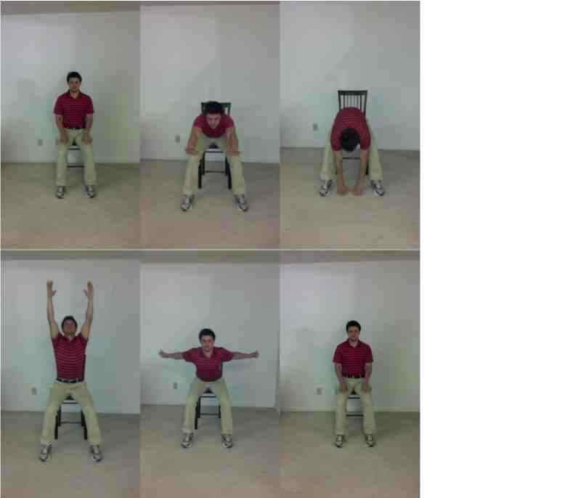
Hold position for 10 seconds

2.) Side to Side
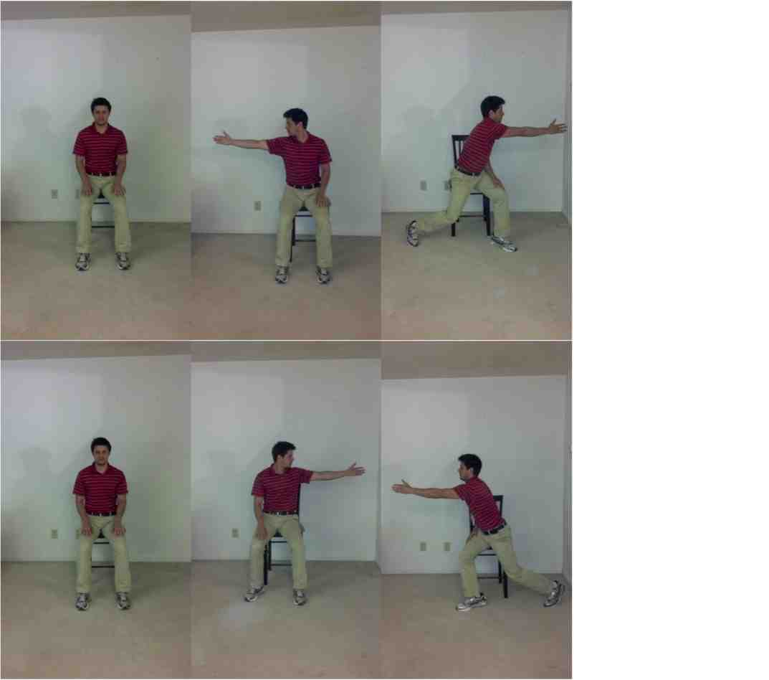Hold end position for 10 seconds.

Appendix 1.
Multidirectional Repetitive Movements
3.) Step forward and reach (repeat on each leg)
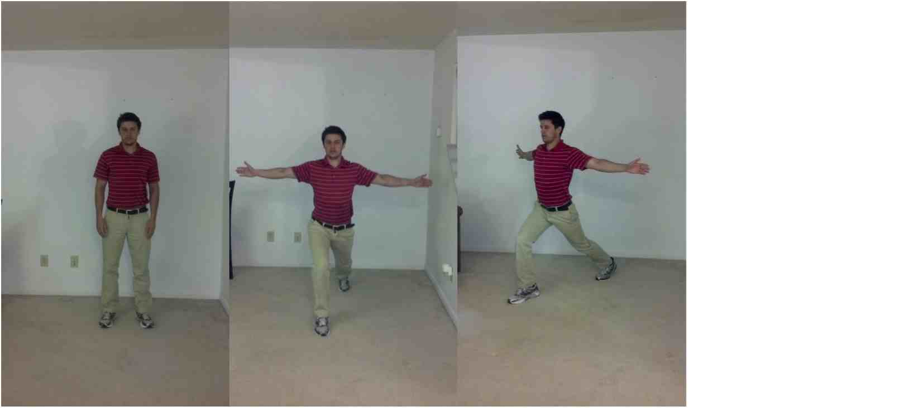
4.) Step sideways and reach (each direction)
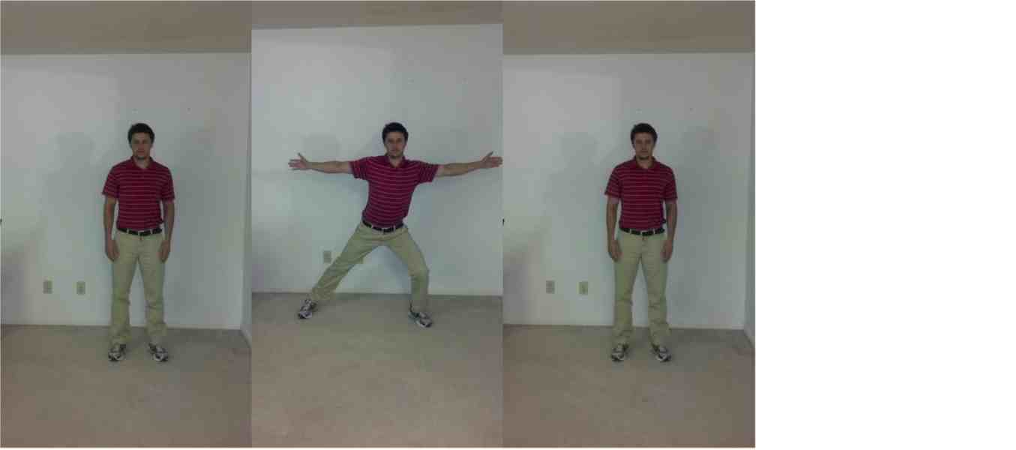

5.) Step backward and press arms back (repeat on each leg)
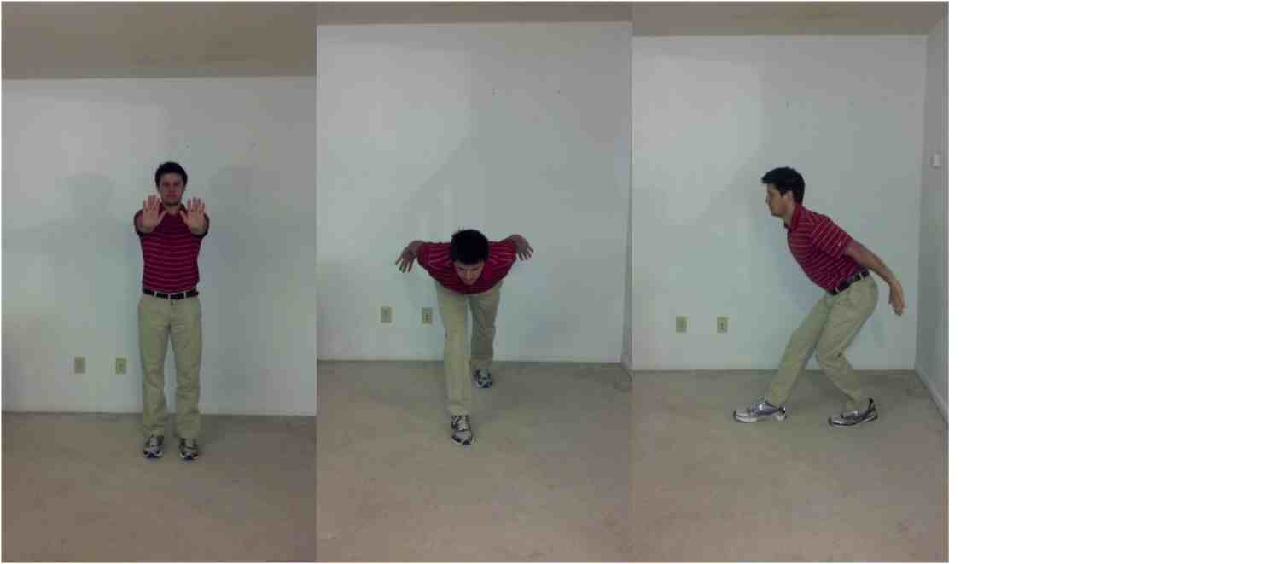

Appendix 1.
6.) Rock and reach – forward and backward
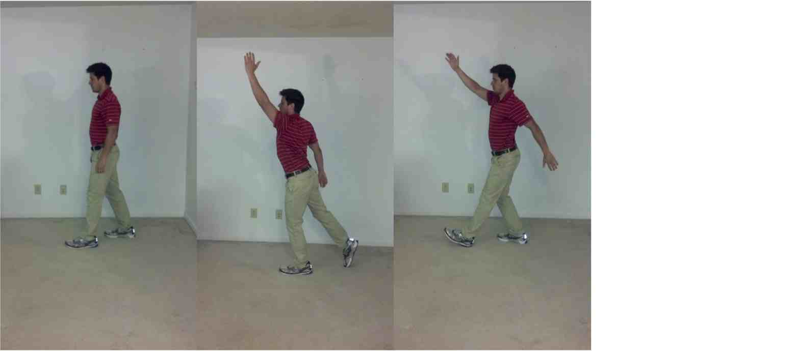

7.) Reach and twist – side to side
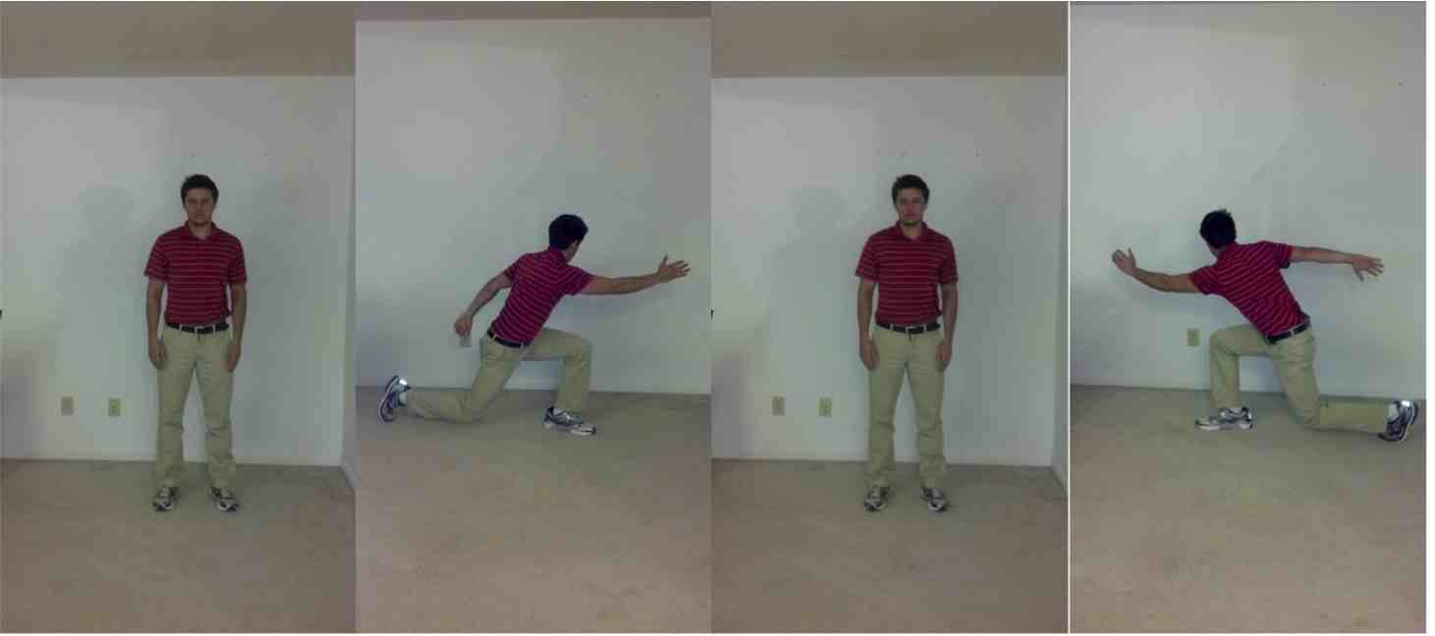

Resources: Bartels AL, Leenders KL. Parkinson's disease: The syndrome, the pathogenesis and pathophysiology. Cortex. 2009;45(8):915-921.
Spitzer AL, Hakim EW. Parkinson's disease: The interplay of medical and surgical treatment options with physical therapy. ACUTE CARE PERSPECT. 2008;17(4):8-15.
Goodwin VA, Richards SH, Taylor RS, Taylor AH, Campbell JL. The effectiveness of exercise interventions for people with parkinson's disease: A systematic review and meta-analysis. MOVEMENT DISORD. 2008;23(5):631-640.
O'Sullivan S, ed. Physical rehabilitation. 5th ed. FA Davis; 2007. O'Sullivan S. and Schmitz T., eds.
Goodman C, Fuller K, eds. Pathology: Implications for the physical therapist. 3rd ed. St. Louis, Missouri: Saunders Elsevier; 2009. Goodman CC and Fuller KS, eds. Pathology: Implications for the Physical Therapist.
Poulopoulos M, Waters C. Carbidopa/levodopa/entacapone: The evidence for its place in the treatment of parkinson's disease. CORE EVID. 2010;5(1):1-10.
Georgy E, Barsnley S, Chellappa R. Effect of physical exercise-movement strategies programme on mobility, falls, and quality of life in parkinson's disease. INT J THER REHABIL. 2012;19(2):88-96.
8. Smania N, Corato E, Tinazzi M, et al. Effect of balance training on postural instability in patients with idiopathic parkinson’s disease. Neurorehabil Neural Repair. 2010;24(9):826-834.
9. Li F, Harmer P, Fitzgerald K, et al. Tai chi and postural stability in patients with parkinson's disease. N Engl J Med. 2012;366(6):511-519
Mehrholz J, Friis R, Kugler J, Twork S, Storch A, Pohl M. Treadmill training for patients with parkinson's disease. Cochrane Database Syst Rev. 2010(1).
Nieuwboer A, Rochester L, Jones D. Cueing gait and gait-related mobility in patients with parkinson's disease: Developing a therapeutic method based on the international classification of functioning, disability, and health. TOP GERIATR REHABIL. 2008;24(2):151-165.
van Eijkeren F, Reijmers RS, Kleinveld MJ, Minten A, Bruggen JP, Bloem BR. Nordic walking improves mobility in parkinson's disease. MOVEMENT DISORD. 2008;23(15):2239-2243.
Ebersbach G, Ebersbach A, Edler D, et al. Comparing exercise in parkinson's disease -- the berlin LSVT(R)BIG study. MOVEMENT DISORD. 2010;25(12):1902-1908.
Farley BG, Fox CM, Ramig LO, McFarland DH. Intensive amplitude specific therapeutic approaches for parkinson's disease: Toward a neuroplasticity principled rehabilitation model. Topics in Geriatric Rehabilitation. 2008;24(2):99. 15. American Physical Therapy Association. Guide to physical therapist practice 2nd ed. Alexandria, Virginia; 2003. 16. Palmer LM, Epler ME. Fundamentals of musculoskeletal assessment techniques 2nd edition. Philadelphia, PA: Lippincott-Raven Publishers; 1998. 17. Viccaro L, J., Perera S, Studenski S, A. Is timed up and go better than gait speed in predicting health, function, and falls in older adults? J Am Geriatr Soc. 2011;59(5):887-892. 18. Dibble LE, Lange M. Predicting falls in individuals with parkinson disease: A reconsideration of clinical balance measures. J NEUROL PHYS THER. 2006;30(2):60-67. 19. Kegelmeyer DA, Kloos AD, Thomas KM, Kostyk SK. Reliability and validity of the tinetti mobility test for individuals with parkinson disease. Phys Ther. 2007;87(10):1369-1378. 20. Jenkinson C, Peto V, Fitzpatrick R, Greenhall R, Hyman N. Self-reported functioning and well-being in patients with parkinson's disease: Comparison of the short-form health survey (SF-36) and the parkinson's disease questionnaire (PDQ-39). Age Ageing. 1995;24(6):505-509. 21. Jenkinson C, Fitzpatrick R, Peto V, Greenhall R, Hyman N. The parkinson's disease questionnaire (PDQ-39): Development and validation of a parkinson's disease summary index score. Age Ageing. 1997;26(5):353-357. 22. Kerr GK, Worringham CJ, Cole MH, Lacherez PF, Wood JM, Silburn PA. Predictors of future falls in parkinson disease. Neurology. 2010;75. 23. Winter Y, Lubbe D, Oertel W, Dodel R. Determining minimal clinically important difference for health-related quality of life scales in parkinson's disease. MOVEMENT DISORD. 2012;27. 24. Dite W, Temple VA. A clinical test of stepping and change of direction to identify multiple falling older adults. Arch Phys Med Rehabil. 2002;83(11):1566-1571. 25. Huang S, Hsieh C, Wu R, Tai C, Lin C, Lu W. Minimal detectable change of the timed "up & go" test and the dynamic gait index in people with parkinson disease. Phys Ther. 2011;91(1):114-121. 26. LSVT global. www.lsvtglobal.com. Accessed February 2nd, 2013. 27. Qutubuddin AA, Pegg PO, Cifu DX, Brown R, McNamee S, Carne W. Validating the berg balance scale for patients with parkinson's disease: A key to rehabilitation evaluation. Arch Phys Med Rehabil. 2005;86(4):789-792.

